Sri Sivasubramaniya Nadar College of Engineering
(An Autonomous Institution, Affiliated with Anna University, Chennai)
Rajiv Gandhi Salai (OMR), Kalavakkam- 603 110

UEC3501 – DIGITAL COMMUNICATION

Project Report
On

ML – Based Automatic Modulation Classification

and Demodulation of BPSK, BFSK, QPSK,

16-QAM and DPSK Signals

V SEM Semester ECE, Section ‘B’
(2026-2027)

Name: SARAVANAN R
Reg No: 3122243002098
Dept & Section: ECE – B
Year: III Year

Table of Contents

Abstract
1.Introduction & Problem Statement 1
2.System Architecture 2
3.Signal and Channel Models 3
4.Algorithms 4
5.Demodulation Techniques 5
6.Evaluation Parameters & their Formulae 7
7.Results & Discussion 9
8.Limitations & Assumptions 22
References 23

ABSTRACT

In a cognitive or software-defined radio the receiver often does not know in advance how an incoming signal was modulated. This report describes a complete system that solves this problem with machine learning. A received IQ (in-phase / quadrature) signal is converted into ten numerical features (higher-order cumulants and spectral measurements), a trained classifier decides which of five modulations was used (BPSK, BFSK, QPSK, 16-QAM or DPSK), the matching demodulator is then selected automatically, and the transmitted bits are recovered. The system was trained and tested on simulated signals in additive white Gaussian noise (AWGN) with a random carrier phase, over a per-sample SNR range of -10 dB to +20 dB. On an independent test set of 3,200 frames (40 frames per modulation at each of 16 SNR values) the classifier reached an overall classification accuracy of 95.78 %, and 100 % accuracy for every SNR of -2 dB and above. Bit error rates of the five demodulators agree closely with textbook theory, and the complete chain (classify, then demodulate) showed no observed bit error from 2 dB (BPSK), 6 dB (BFSK, QPSK, DPSK) and 10 dB (16-QAM) upwards. Message-level tests with the text ‘nathaan Leo leo Dass ’ and ‘WHAT BRO VERY WRONG BRO’ confirmed that every modulation was identified correctly even at SNRs between -4 dB and +3 dB.

1.Introduction & Problem Statement
Problem statement:
Develop a Machine Learning based system that can automatically identify the modulation type of a received signal. The model is trained with datasets of BPSK, BFSK, QPSK, QAM and DPSK signals. When an unknown modulated signal is received, the system should (i) identify its modulation type, (ii) select the corresponding demodulation technique, and (iii) demodulate the signal and recover the transmitted data. The system must be tested under different SNR / noise conditions to evaluate its classification and demodulation accuracy.
Why it matters:
Automatic modulation classification (AMC) is used in cognitive radio, spectrum monitoring, electronic surveillance and adaptive communication links, where the transmitter may change its modulation scheme from one moment to the next without telling the receiver.

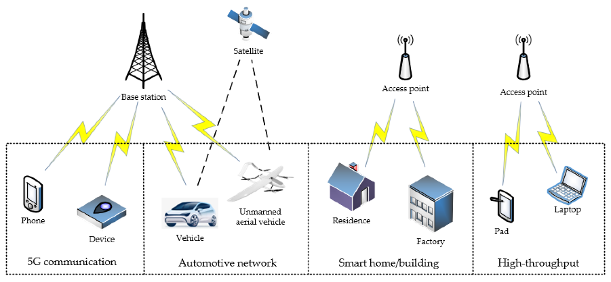
Fig 1.1 Cognitive Radio Technology
Objectives:
- Build a simulator that produces labelled IQ frames for the five modulations under a controllable SNR.
- Extract discriminative features and train machine-learning classifiers; compare at least three of them.
- Implement one demodulator per modulation and let the classifier decide which one runs.
- Evaluate classification accuracy, precision, recall, F1-score, specificity and kappa, and demodulation bit error rate (BER), frame error rate (FER) and end-to-end BER versus SNR.
2.System Architecture

The receiver is a pipeline of four stages (Fig 2.1). The received IQ samples are first reduced to a feature vector. The classifier turns the feature vector into a modulation decision with class probabilities. That decision acts as a switch that routes the same IQ samples into exactly one of five demodulators, and the demodulator outputs the recovered bits (and, in the demo, the recovered text).

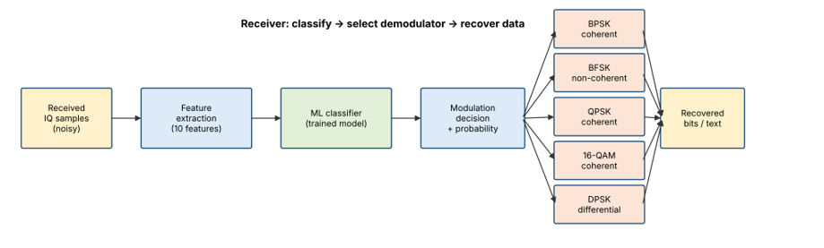
Fig 2.1: Block diagram of the classify-then-demodulate receiver.

Preamble 64 Known bits | Payload  User message bits | Random filler bits

The transmitter sends frames of the form [ 64-bit known preamble | payload bits | random filler bits]. The preamble lets the coherent demodulators remove the phase ambiguity left by blind carrier-phase estimation. The filler guarantees that the receiver always sees at least 256 symbols, so that the statistics used for classification are reliable even when the user message is short.

3. Signal and Channel Models

Let the data bits be $b_{k}∈\{0,1\}$, let $N=8$ be the number of samples per symbol (rectangular pulse), and let $n$ be the sample index with symbol index $k=⌊n/N⌋$. All signals are complex baseband (IQ) with unit average power.
Modulation | Bits per symbol (m) | Baseband model x[n]
BPSK | 1 | $$x\left[n\right]=a_{k}, a_{k}=1-2b_{k}∈\{±1\}$$
BFSK | 1 | xn=exp​j2πi≤n​fi, fi=±fd  for $b_{k}=1/0$, $f_{d}=1/N$
QPSK (Gray) | 2 | $$x\left[n\right]=\frac{\left(1-2b_{2k}\right)+j\left(1-2b_{2k+1}\right)}{\sqrt{2}}$$
16-QAM (Gray) | 4 | $$x\left[n\right]=\frac{A_{I}+jA_{Q}}{\sqrt{10}},$$  $$A_{I},A_{Q}∈\{-3,-1,+1,+3\}$$
DPSK ($π/4$-DQPSK) | 2 | $x\left[n\right]=e^{jϕ_{k}}, ϕ_{k}=ϕ_{k-1}+Δϕ_{k}$,  $$Δϕ_{k}∈\{±π/4,±3π/4\}$$

For DPSK the dibits $00,01,11,10$ map to the phase steps $+π/4, +3π/4, -3π/4, -π/4$, and a reference symbol ($ϕ_{0}=0$) is sent first. For 16-QAM, each axis uses the Gray map $00→-3, 01→-1, 11→+1, 10→+3$.
Modification: For random data, differential BPSK produces the same IQ statistics as ordinary BPSK, so no classifier can separate them from IQ samples alone. For this reason, DPSK is implemented here as $π/4$-D-QPSK, a standard differential scheme whose eight-point constellation is genuinely distinguishable from QPSK. This choice is stated openly so the results are not over-interpreted.
The received signal is
$$y\left[n\right]=e^{jθ} x\left[n\right]+w\left[n\right], θ∼U\left[0,2π\right), w\left[n\right]∼CN\left(0,σ^{2}\right),$$

where $θ$ is an unknown carrier phase offset and $w\left[n\right]$ is complex white Gaussian noise. Because the signal power is 1, the noise variance follows SNR
$σ^{2}={10}^{-SNR_{dB}/10}$

4. Algorithms

4.1 Algorithm 1: Creating the dataset
- Choose an SNR value from the grid and a modulation from the five classes.
- Choose a frame length of 128, 256 or 512 symbols at random.
- Generate random payload bits so that, together with the 64-bit preamble, they fill exactly that many symbols.
- Modulate the bits into complex IQ samples (8 samples per symbol).
- Rotate the signal by a random carrier phase and add Gaussian noise whose variance is set by the chosen SNR.
- Compute the ten features of the noisy frame and store them with the class label and the SNR.
- Repeat for every SNR, class and frame count. Build one pool for training and a separate pool, with a different random seed, for testing.

4.2 Algorithm 2: Training and model selection
- Split the training pool into 80 % for fitting and 20 % for validation, keeping the class proportions equal.
- Train three candidate classifiers: a Random Forest (300 trees), a Support Vector Machine with an RBF kernel, and a k-nearest-neighbour classifier ($k=7$). The SVM and kNN get their inputs standardised first.
- Measure the validation accuracy of each candidate and keep the best one.
- Re-train the winning model on the complete training pool.
- Touch the independent test set only now, to report the final performance.

4.3 Algorithm 3: Receiving an unknown signal
- Take the received IQ samples and compute the ten features.
- Give the feature vector to the trained classifier; it returns a probability for each of the five modulations.
- Declare the modulation with the highest probability to be the detected modulation.
- Pass the same IQ samples to the demodulator that belongs to the detected modulation (Section 7).
- Remove the 64 preamble bits from the demodulated stream; the remaining bits are the recovered payload (and may be decoded to text, 8 bits per character).

5. Demodulation Techniques

All demodulators first group the samples into symbols of $N=8$ samples. For the PSK/QAM/DPSK demodulators, the symbol value is the average of the $N$ samples (integrate-and-dump):
$$z_{k}=\frac{1}{N}\sum_{i=0}^{N-1}{y}\left[kN+i\right]$$

5.1 Coherent demodulation of BPSK, QPSK and 16-QAM
- Compute $z_{k}$ for every symbol and scale the sequence to unit average power.
- Estimate the unknown carrier phase blindly. For BPSK the squared symbols point in the direction $2θ$, so θ=12argk​zk2. For QPSK and 16-QAM the fourth power is used, θ=14argk​zk4-π.
- This estimate is only correct up to a multiple of $π$ (BPSK) or $π/2$ (QPSK, 16-QAM). Try every possible extra rotation, demodulate the 64 preamble bits each time, and keep the rotation with the fewest preamble errors.
- Rotate all symbols by $e^{-j\hat{θ}}$ (with the chosen extra rotation) and slice them with the Gray map: BPSK by the sign of the real part, QPSK by the signs of the real and imaginary parts, 16-QAM by comparing each axis with the levels $\{-3,-1,+1,+3\}/\sqrt{10}$.
- Join the bit pairs (or quadruples) into the output bit stream.

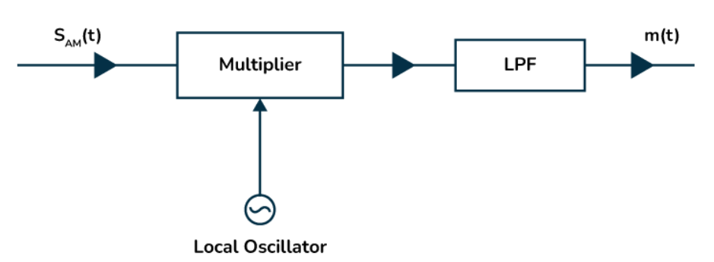
Fig 5.1 Coherent detection

5.2 Differential demodulation of DPSK
- Compute $z_{k}$ for every symbol, including the reference symbol.
- Multiply each symbol by the conjugate of the previous one: $d_{k}=z_{k}z_{k-1}^{*}$. The unknown carrier phase cancels in this product, so no phase recovery or preamble is needed.
- The angle of $d_{k}$ is the transmitted phase step. Decide the dibit from its quadrant: the first bit is 1 when $Im\left(d_{k}\right)<0$, the second bit is 1 when $Re\left(d_{k}\right)<0$.

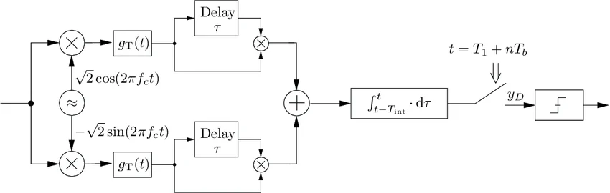
Fig 5.2 Differential demodulation

5.3 Non-coherent demodulation of BFSK
- For each symbol, correlate the $N$ samples with a complex tone at $+f_{d}$ and with a complex tone at $-f_{d}$:
E1=|i​yie-j2πfdi|, E0=|i​yie+j2πfdi|

- Decide bit 1 if $E_{1}>E_{0}$, otherwise bit 0. Taking magnitudes removes the dependence on the unknown phase, so no carrier recovery is needed.

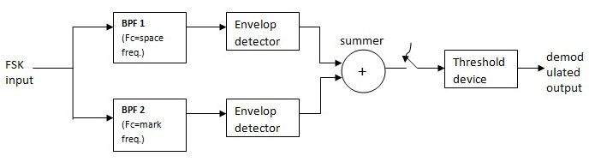
Fig 5.3 Non-Coherent demodulation

6. Evaluation Parameters and Their Formulae

Notation. For classification, $C$ is the confusion matrix whose entry $C_{ij}$ counts frames of true class $i$ that were predicted as class $j$; $M=5$ is the number of classes; T=i,j​Cij is the total number of frames. For class $c$: $TP_{c}=C_{cc}$, FNc=j≠c​Ccj, FPc=i≠c​Cic, $TN_{c}=T-TP_{c}-FN_{c}-FP_{c}$.

Parameter | Mathematical formula | Meaning
Signal-to-noise ratio (per sample) | $$SNR_{dB}=10\log_{10}\frac{P_{s}}{P_{n}}=10\log_{10}\frac{1}{σ^{2}}$$ | Signal power over noise power per complex sample ($P_{s}=1$)
Symbol SNR | $$\frac{E_{s}}{N_{0}}=SNR⋅N, {\left.\frac{E_{s}}{N_{0}}\right|}_{dB}=SNR_{dB}+10\log_{10}N$$ | Energy per symbol over noise density; $+9.03$ dB for $N=8$
Bit SNR | $$\frac{E_{b}}{N_{0}}=\frac{E_{s}/N_{0}}{m}$$ | Energy per bit over noise density; $m$ = bits per symbol
Overall accuracy | $$Acc=\frac{\sum_{c=1}^{M}{C_{cc}}}{T}$$ | Fraction of frames whose modulation was identified correctly
Accuracy at one SNR | $$Acc\left(γ\right)=\frac{\text{correct frames at SNR }γ}{\text{all frames at SNR }γ}$$ | Accuracy-versus-SNR curve
Per-class accuracy (= recall) | $${Acc}_{c}=\frac{TP_{c}}{TP_{c}+FN_{c}}$$ | Share of class $c$ frames that were detected
Precision | $${Prec}_{c}=\frac{TP_{c}}{TP_{c}+FP_{c}}$$ | When the system says class $c$, how often is it right
Recall (sensitivity) | $${Rec}_{c}=\frac{TP_{c}}{TP_{c}+FN_{c}}$$ | How many of the true class $c$ frames are found
F1-score | $$F1_{c}=\frac{2 {Prec}_{c} {Rec}_{c}}{{Prec}_{c}+{Rec}_{c}}$$ | Harmonic mean of precision and recall
Specificity | $${Spec}_{c}=\frac{TN_{c}}{TN_{c}+FP_{c}}$$ | How well other classes are not mistaken for class $c$
Macro average | $Macro\text{-}F1=\frac{1}{M}\sum_{c=1}^{M}{F}1_{c}$ (same for precision, recall) | Unweighted mean over classes
Cohen’s kappa | κ=po-pe1-pe, po=Acc, pe=1T2c​j​Ccji​Cic | Agreement beyond chance (1 = perfect, 0 = chance)
Bit error rate | $$BER=\frac{N_{err}}{N_{bits}}=\frac{\sum_{i=1}^{N_{bits}}{\left(b_{i}⊕{\hat{b}}_{i}\right)}}{N_{bits}}$$ | Fraction of payload bits received wrongly ($⊕$ = XOR)
Demodulation accuracy | $${Acc}_{demod}=1-BER$$ | Fraction of payload bits recovered correctly
Symbol error rate | $$SER=\frac{N_{sym,err}}{N_{sym}}$$ | Fraction of symbols decided wrongly (used in the notebook’s symbol-input test)
Frame error rate | $$FER=\frac{\text{frames with at least one bit error}}{\text{frames sent}}$$ | Share of frames not recovered perfectly
End-to-end BER | BERe2e=frames​Nerr+0.5 NmissingNbits | BER when the demodulator is chosen by the classifier; bits that a wrongly chosen demodulator fails to deliver count as coin flips (0.5 error each)
Theoretical BER, BPSK and Gray QPSK | $$P_{b}=Q​\left(\sqrt{2E_{b}/N_{0}}\right)=1/2 erfc​\left(\sqrt{E_{b}/N_{0}}\right)$$ | Reference curve for ideal coherent detection
Theoretical BER, Gray 16-QAM | $$P_{b}≈\frac{3}{8} erfc​\left(\sqrt{\frac{2}{5}\frac{E_{b}}{N_{0}}}\right)$$ | Reference curve for 16-QAM
Theoretical BER, non-coherent BFSK | $$P_{b}=1/2exp​\left(-\frac{E_{b}}{2N_{0}}\right)$$ | Reference curve for orthogonal non-coherent FSK
Q-function | $$Q\left(x\right)=\frac{1}{\sqrt{2π}}\int_{x}^{∞}{e^{-u^{2}/2}} du=1/2 erfc​\left(\frac{x}{\sqrt{2}}\right)$$ | Gaussian tail probability
Validation accuracy | $${Acc}_{val}=\frac{\text{correct predictions on the 20 \%hold-out}}{\text{hold-out size}}$$ | Used to choose between the candidate models

Formulas of the classifiers:

Classifier | Formula | Role
Standardisation | $$x'_{j}=\frac{x_{j}-μ_{j}}{s_{j}}$$ | Brings all features to zero mean and unit variance (SVM, kNN)
SVM with RBF kernel | Kx,x'=exp​-γ∥x-x'∥2, fx=i​αiyiKxi,x+b | Non-linear decision boundary; five classes by one-versus-one voting
SVM probability (Platt) | $$P\left(y=1∣f\right)=\frac{1}{1+exp\left(Af+B\right)}$$ | Turns the SVM score into the class probabilities shown in the demo
Random forest impurity | $$G=1-\sum_{c=1}^{M}{p_{c}^{2}}$$ | Node-splitting criterion; the feature-importance plot is the mean decrease of $G$
k-nearest neighbours | y=argmaxci∈Nkx​1yi=c | Majority vote among the $k$ closest training frames

7. Results and Discussion

The system was implemented in Python (NumPy, SciPy, scikit-learn, Matplotlib) as a small project with an interactive program (main.py) and an automated test (test_all_schemes.py). All numbers below come from one run of these programs with fixed random seeds (seed = 42 for the demonstrations), so they can be reproduced. The classification test set contained 3,200 frames (40 frames per modulation at each of 16 SNR values from -10 dB to +20 dB). The BER experiment used 40 frames per modulation at each of 14 SNR values from -10 dB to +16 dB. Because a point with no observed error only shows that BER is below the resolution of the experiment, such points are plotted at a floor of 1e-5.

7.1 Constellation plot of each modulation scheme

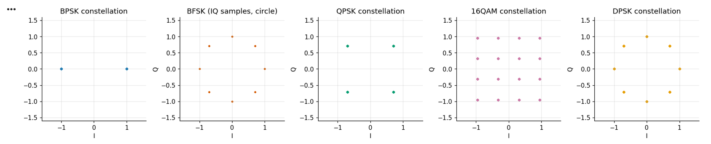
Fig 7.1
7.2 Model selection

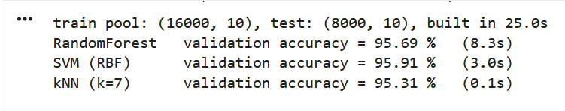

Since the SVM (RBF) Model provides the maximum validation accuracy of 95.91% on training and test validation.
7.3 Classification performance on independent test set

Pooled over all SNRs and all five modulations (3,200 test frames) the classifier reached an overall accuracy of 95.78 %.

Confusion matrices at three representative SNRs:

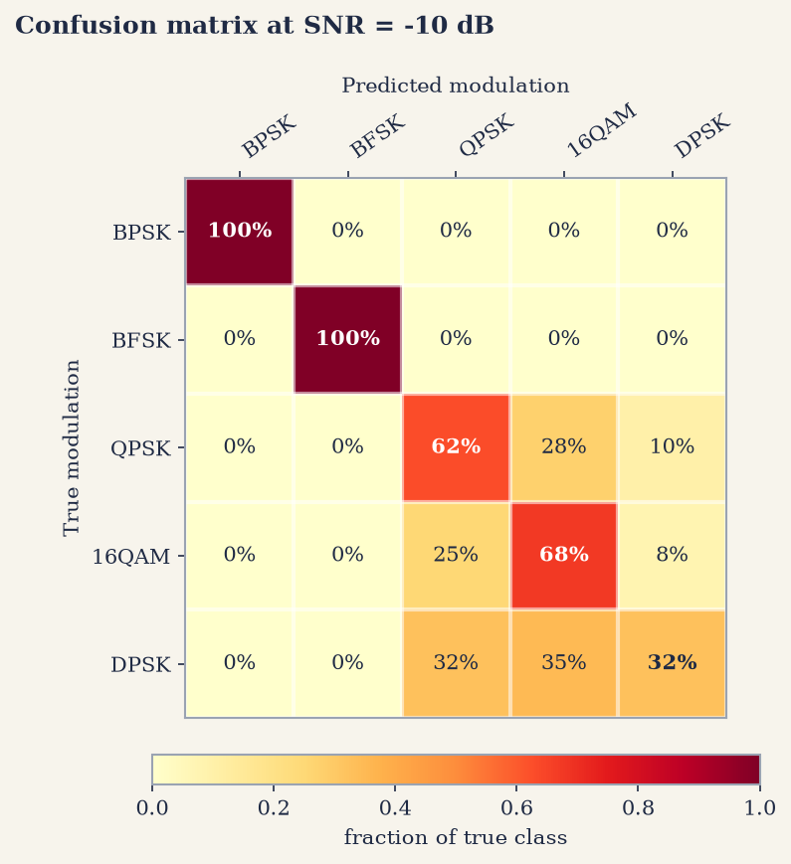
Fig 7.2 Confusion matrix at SNR = -10 dB

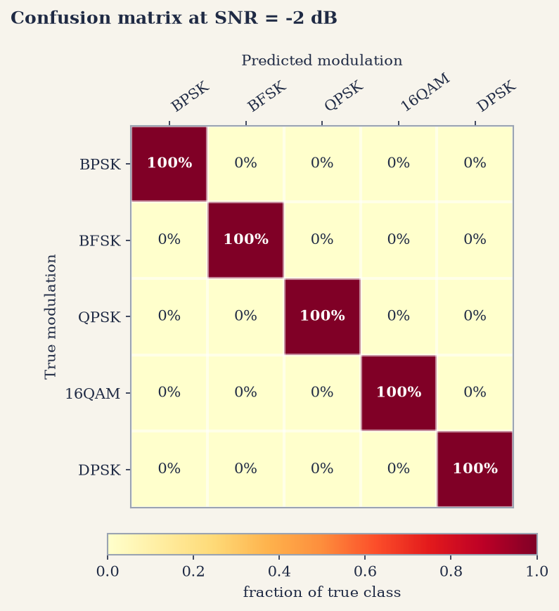
Fig 7.3 Confusion matrix at SNR = -2 dB
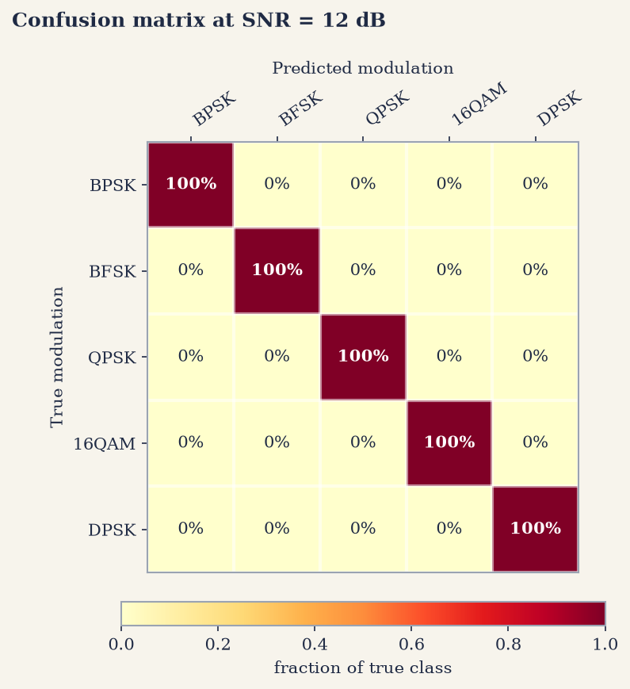
Fig 7.4 Confusion matrix at SNR = 12 dB
At -2 dB and at 12 dB the confusion matrices are perfectly diagonal, i.e. every frame was classified correctly. At -10 dB BPSK and BFSK are still classified 100 % correctly, whereas QPSK, 16-QAM and DPSK are mostly confused with each other (62 %, 68 % and 32 % correct respectively).

7.4 Modulation classification accuracy Vs SNR

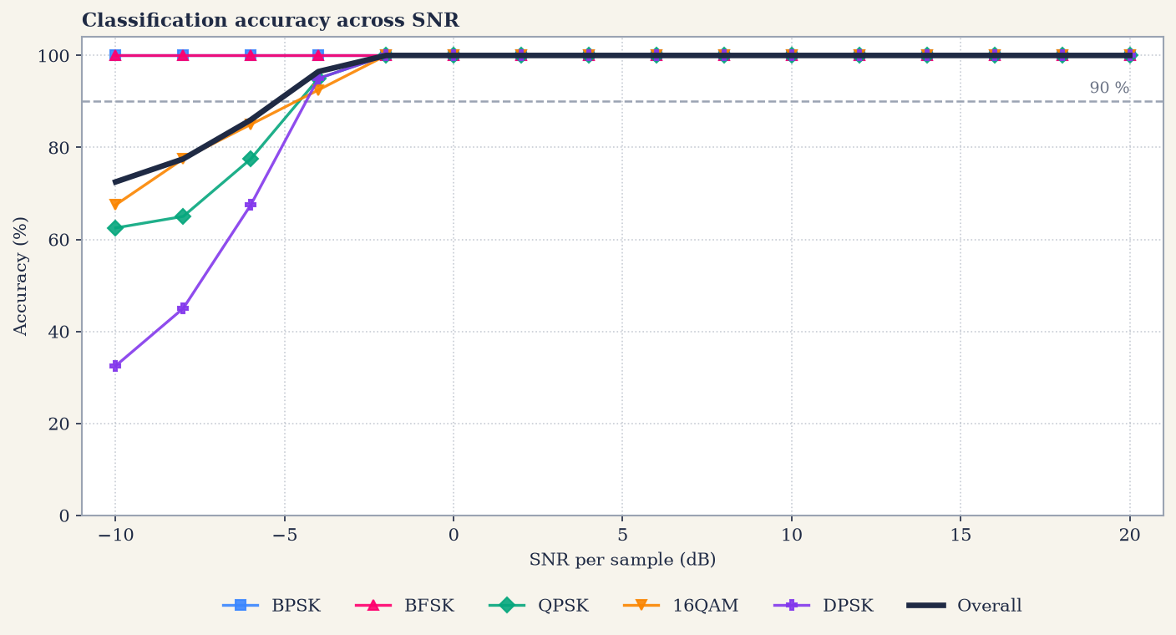
Fig 7.5 Classification accuracy versus SNR
Classification accuracy (%) on the test set at selected SNRs (40 frames per class per SNR):

SNR (dB) | BPSK | BFSK | QPSK | 16-QAM | DPSK | Overall
-10 | 100.0 | 100.0 | 62.5 | 67.5 | 32.5 | 72.5
-8 | 100.0 | 100.0 | 65.0 | 77.5 | 45.0 | 77.5
-6 | 100.0 | 100.0 | 77.5 | 85.0 | 67.5 | 86.0
-4 | 100.0 | 100.0 | 95.0 | 92.5 | 95.0 | 96.5
-2 | 100.0 | 100.0 | 100.0 | 100.0 | 100.0 | 100.0
0 | 100.0 | 100.0 | 100.0 | 100.0 | 100.0 | 100.0
10 | 100.0 | 100.0 | 100.0 | 100.0 | 100.0 | 100.0
20 | 100.0 | 100.0 | 100.0 | 100.0 | 100.0 | 100.0

Accuracy is 100 % for all classes from -2 dB upwards. BPSK and BFSK are classified correctly even at -10 dB. At -10 dB the accuracy of QPSK, 16-QAM and DPSK drops to 62.5 %, 67.5 % and 32.5 % respectively, which is expected: the per-sample SNR of -10 dB corresponds to a symbol SNR of only about -1 dB, where the three constellations are hard to tell apart. The overall accuracy is 96.5 % at -4 dB and exceeds 90 % from -4 dB upwards.

7.5 Demodulation Performance

Known modulation (oracle demodulator): This isolates the quality of the demodulators.
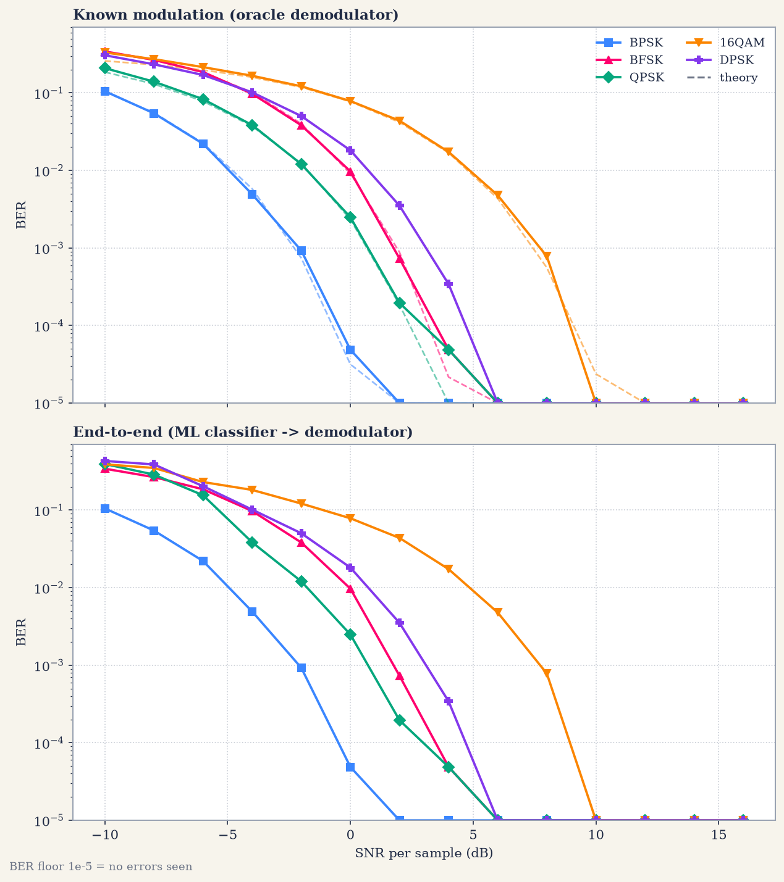
Fig 7.6 BER Vs SNR: (top) known modulation, oracle demodulator; (bottom) end-to-end system, ML classifier followed by demodulator
Two observations from Figure 7.6. First, the simulated BER of BPSK, QPSK, 16-QAM and BFSK follows the theoretical curves (dashed lines) very closely, which validates both the simulator and the demodulators (including the blind phase estimator). Second, the end-to-end curve coincides with the oracle curve wherever classification is perfect (from about -2 dB upwards) and is worse only at very low SNR, where a classification error sends the frame to a wrong demodulator.

End-to-end BER Vs SNR table (40 frames per point):

SNR (dB) | BPSK | BFSK | QPSK | 16-QAM | DPSK
-10 | 1.05e-01 | 3.42e-01 | 3.93e-01 | 3.90e-01 | 4.30e-01
-8 | 5.45e-02 | 2.67e-01 | 2.87e-01 | 3.49e-01 | 3.88e-01
-6 | 2.21e-02 | 1.86e-01 | 1.55e-01 | 2.30e-01 | 2.03e-01
-4 | 4.93e-03 | 9.75e-02 | 3.84e-02 | 1.82e-01 | 1.02e-01
-2 | 9.28e-04 | 3.82e-02 | 1.21e-02 | 1.22e-01 | 5.03e-02
0 | 4.88e-05 | 9.72e-03 | 2.49e-03 | 7.85e-02 | 1.82e-02
2 | 0.00e+00 | 7.32e-04 | 1.95e-04 | 4.37e-02 | 3.52e-03
4 | 0.00e+00 | 4.88e-05 | 4.88e-05 | 1.73e-02 | 3.42e-04
6 | 0.00e+00 | 0.00e+00 | 0.00e+00 | 4.79e-03 | 0.00e+00
8 | 0.00e+00 | 0.00e+00 | 0.00e+00 | 7.81e-04 | 0.00e+00
10 | 0.00e+00 | 0.00e+00 | 0.00e+00 | 0.00e+00 | 0.00e+00
12 | 0.00e+00 | 0.00e+00 | 0.00e+00 | 0.00e+00 | 0.00e+00
14 | 0.00e+00 | 0.00e+00 | 0.00e+00 | 0.00e+00 | 0.00e+00
16 | 0.00e+00 | 0.00e+00 | 0.00e+00 | 0.00e+00 | 0.00e+00
The table shows how low SNR affects the output at demodulation: as the SNR decreases the BER rises sharply and the transmitted information is increasingly corrupted. With the 40 frames used per point, no bit error was observed from 2 dB for BPSK, from 6 dB for BFSK, QPSK and DPSK, and from 10 dB for 16-QAM.
Therefore, the SNR must be high enough for reliable retrieval of the information at the receiver; BPSK needs the least SNR and the higher-order 16-QAM needs the most.

7.6 Manual Test: Message Transmission

The program lets a user type a message, select a modulation and an SNR, and shows the transmitted baseband IQ, the passband waveform, the classifier probabilities, the received constellation (or spectrum for BFSK), the sent and recovered bits and the decoded text. The automated test test_all_schemes.py sends the message ‘nathaan Leo leo Dass ’ (21 characters = 168 payload bits, seed 42) once through every modulation at a deliberately low SNR. The results are summarised in the table below and shown in Fig 7.7 to Fig 7.11.

Scheme | SNR (dB) | Classifier decision | Bit errors | BER | Recovered text
BPSK | -4.0 | BPSK | 3 / 168 | 0.0179 | ‘nathaan Mem0leo Dass ’
BFSK | -2.0 | BFSK | 8 / 168 | 0.0476 | ‘nathad~ Le�"leo(Da�{ ’
QPSK | -2.0 | QPSK | 4 / 168 | 0.0238 | ‘jathaan LEo leo\x00DAss ’
16-QAM | 2.0 | 16-QAM | 7 / 168 | 0.0417 | ‘nathaa~ Leo l%o$Dasu%’
DPSK | 0.0 | DPSK | 3 / 168 | 0.0179 | ‘�athaan Leo lgo DAss ’

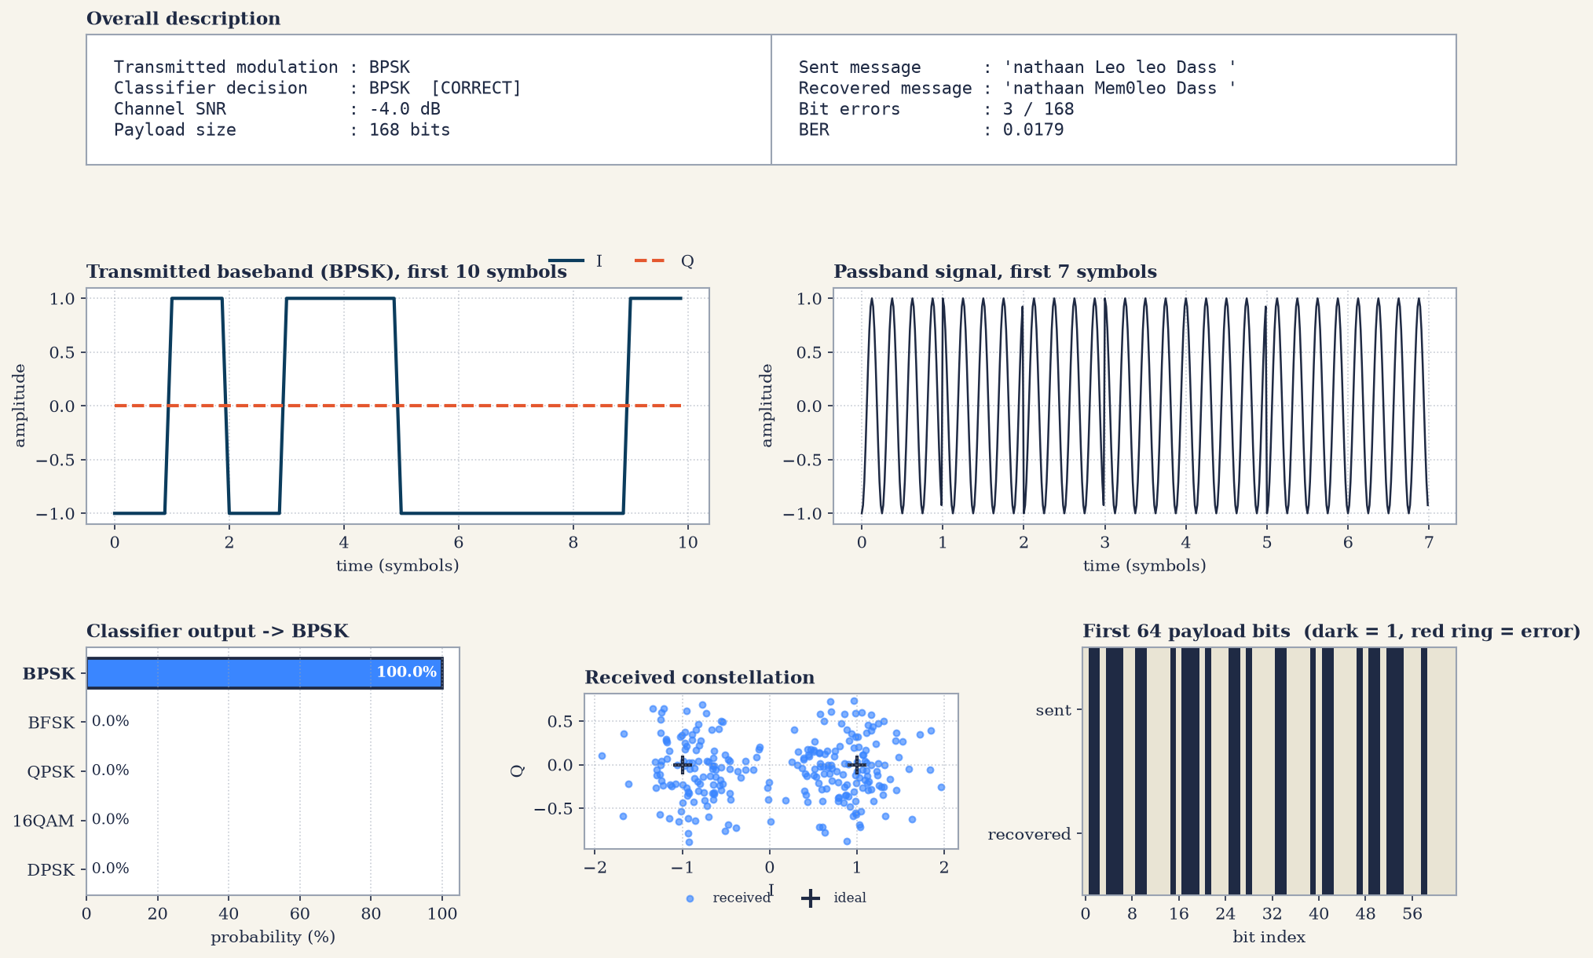
Fig 7.7 Message test: BPSK at -4 dB SNR
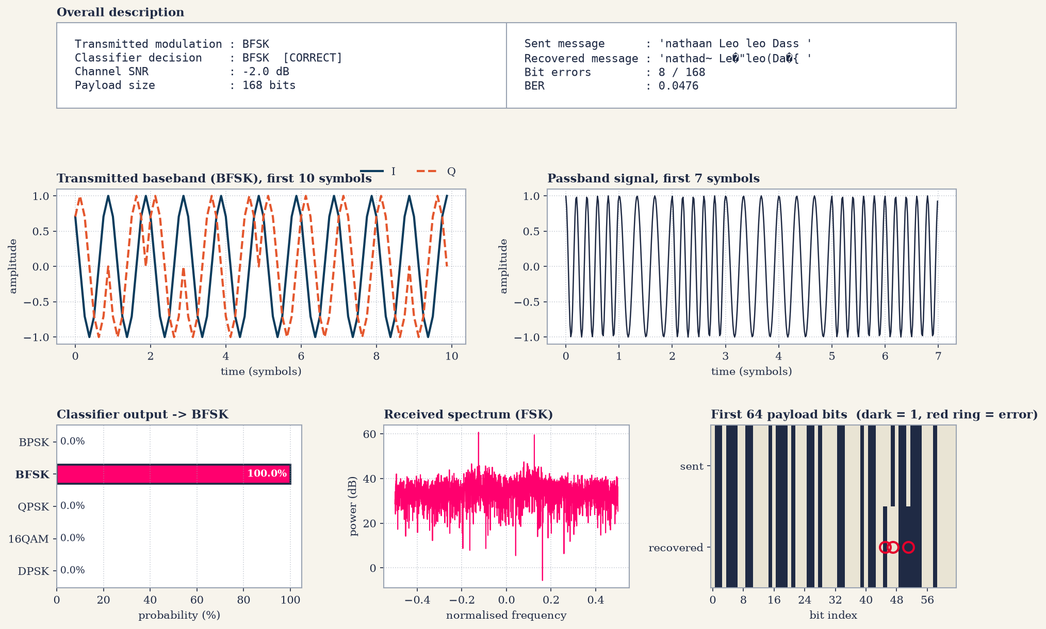
Fig 7.8 Message test: BFSK at -2 dB SNR
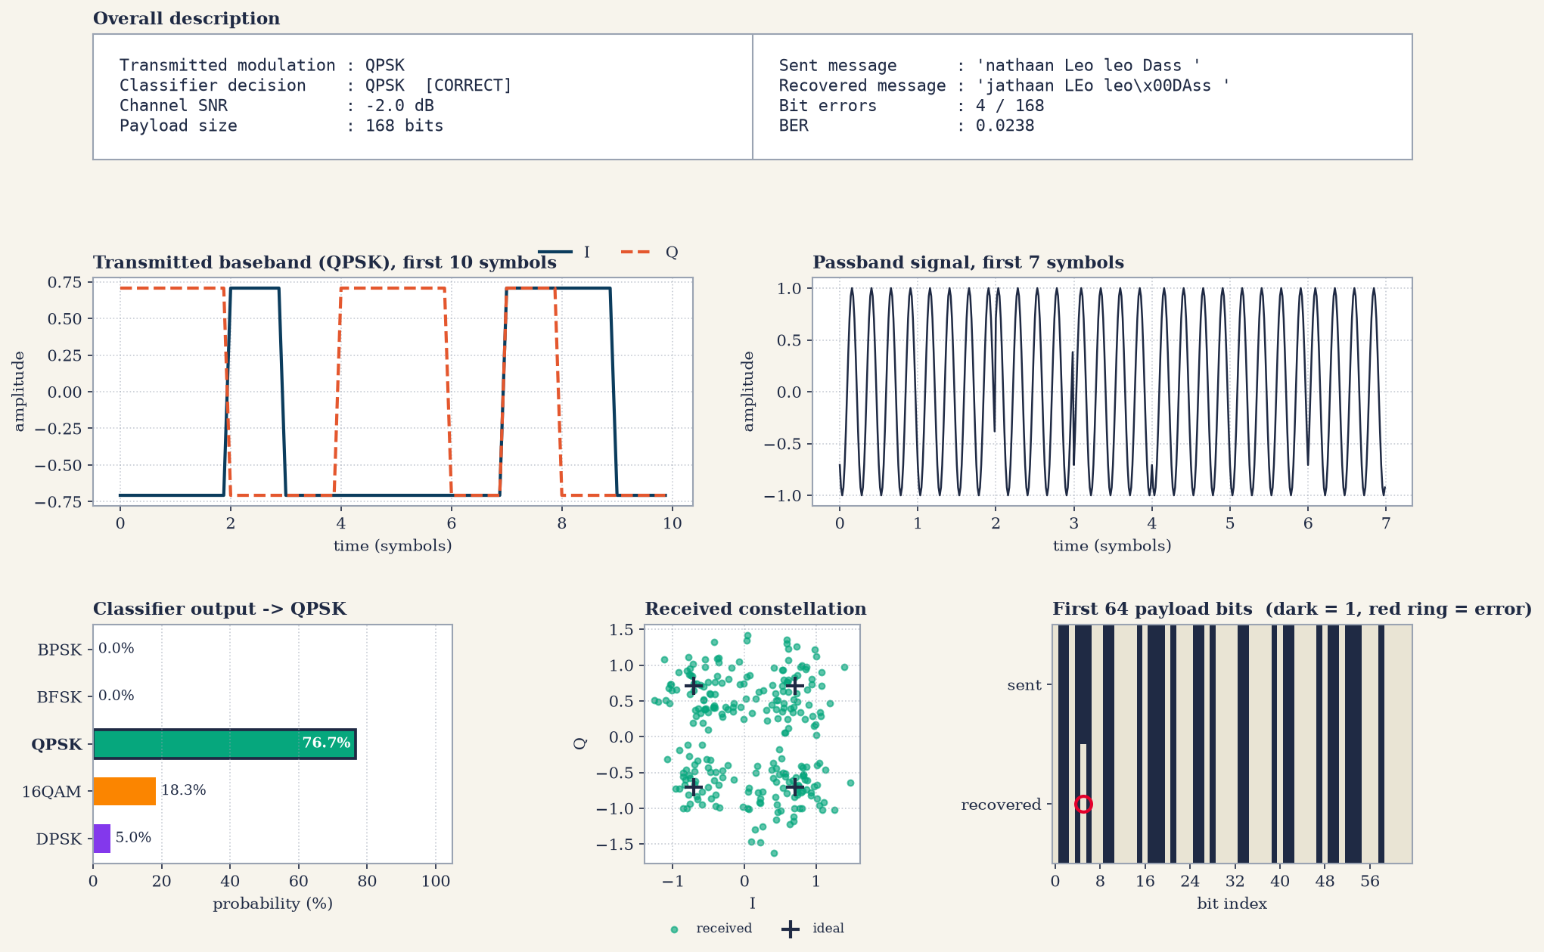
Fig 7.9 Message test: QPSK at -2 dB SNR
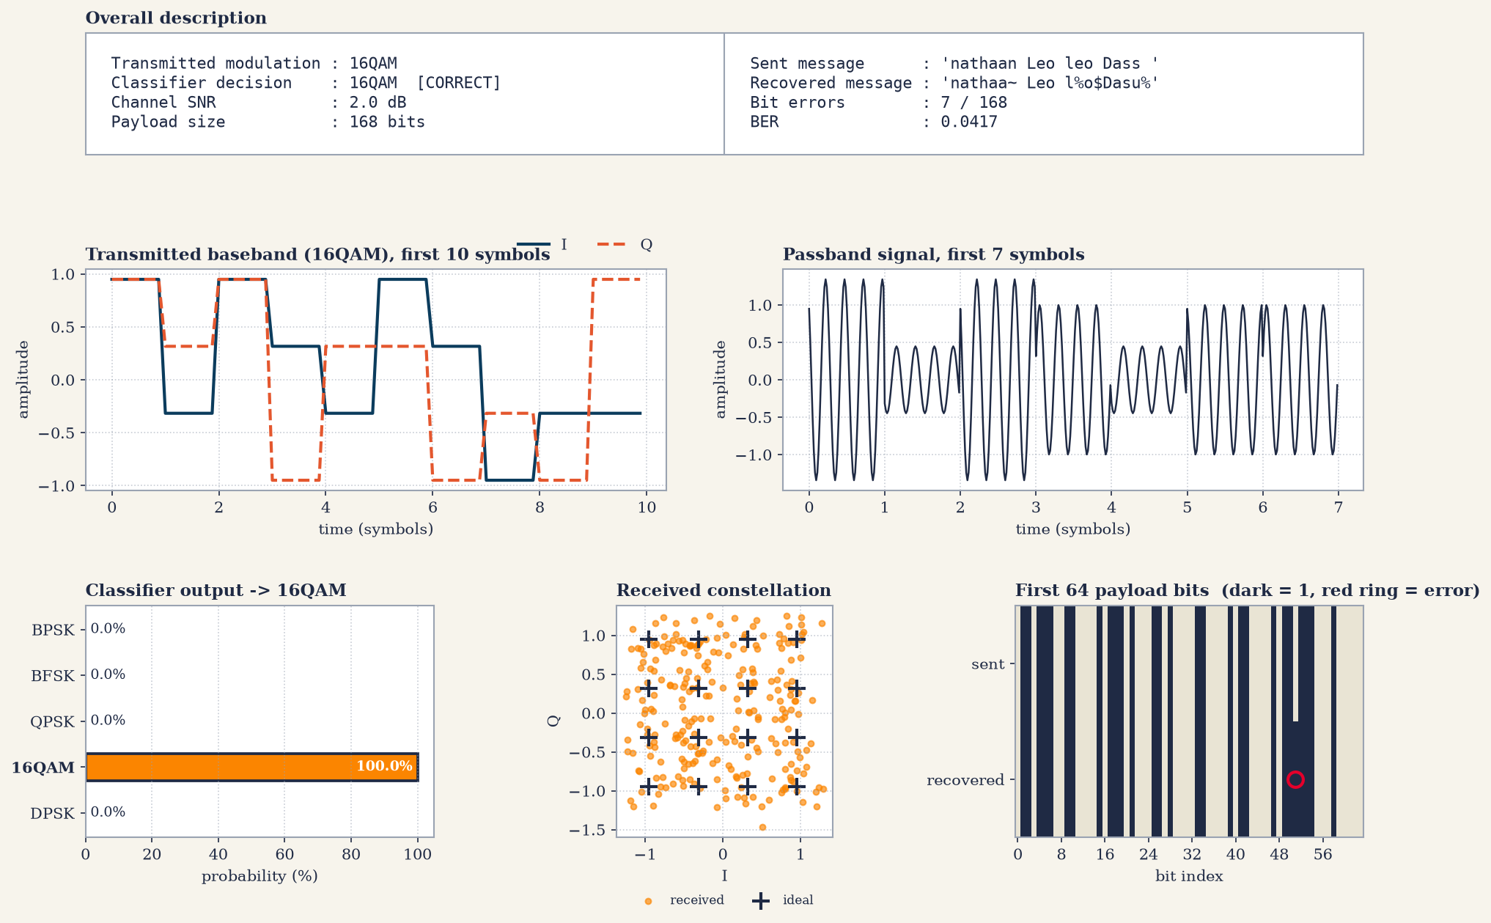
Fig 7.10 Message test: 16-QAM at 2 dB SNR
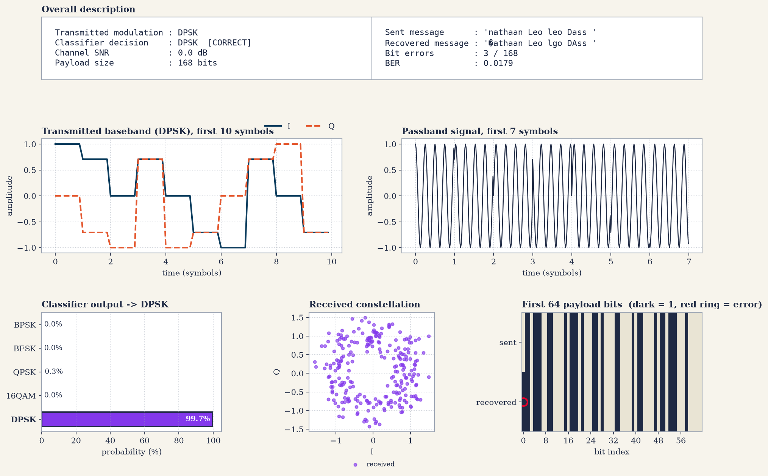
Fig 7.11 Message test: DPSK at 0 dB SNR
In all five cases the classifier identified the modulation correctly although the SNR was only between -4 dB and +2 dB. The few bit errors (3 to 8 out of 168 bits) corrupt only the characters in which they fall, so most of the text is still readable. BPSK, the most noise-tolerant scheme, was tested at the lowest SNR (-4 dB). For QPSK at -2 dB the decision was taken with only 76.7 % confidence (16-QAM 18.3 %, DPSK 5.0 %), while BPSK, BFSK and 16-QAM were classified with 100 % and DPSK with 99.7 %.

7.7 IQ-Symbol Input Test (10 dB)
In the second mode the user supplies I and Q values directly instead of a text message. Here the symbols of each constellation, rotated by a channel phase, were received at 10 dB SNR. The system classified the modulation and demodulated the symbols. All five modulations were classified correctly (table below, Fig 7.12 to Fig 7.16). For BPSK, QPSK, 16-QAM and DPSK the demodulated 48-bit stream was 011011100110000101110100011010000110000101100001, which decodes to the text ‘nathaa’.

Transmitted scheme | Classifier decision | Probability of decision
BPSK | BPSK | 100.0 %
BFSK | BFSK | 100.0 %
QPSK | QPSK | 99.0 %
16-QAM | 16-QAM | 49.0 % (QPSK 41.3 %)
DPSK | DPSK | 100.0 %

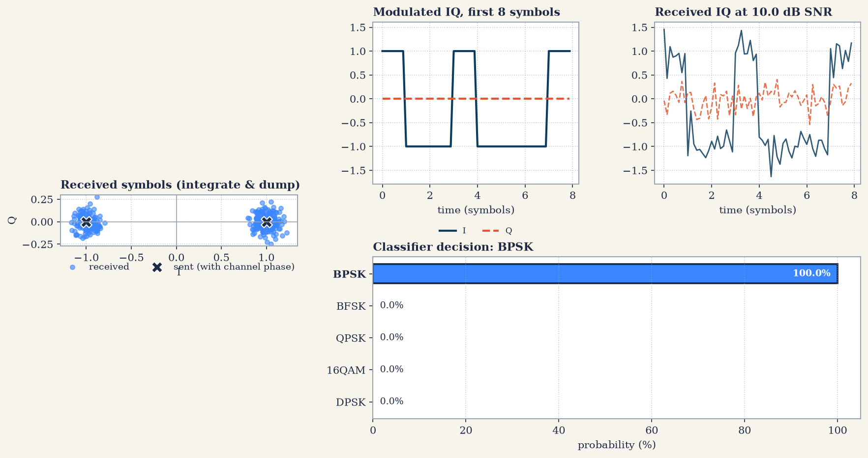
Fig 7.12 IQ-symbol test: BPSK at 10 dB SNR
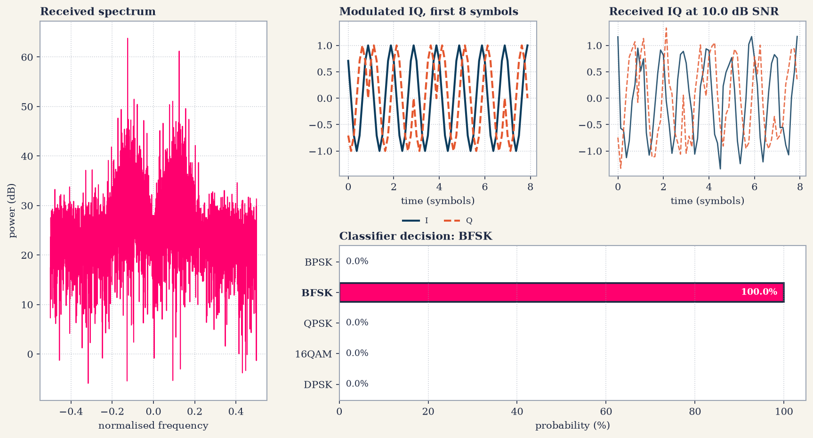
Fig 7.13 IQ-symbol test: BFSK at 10 dB SNR
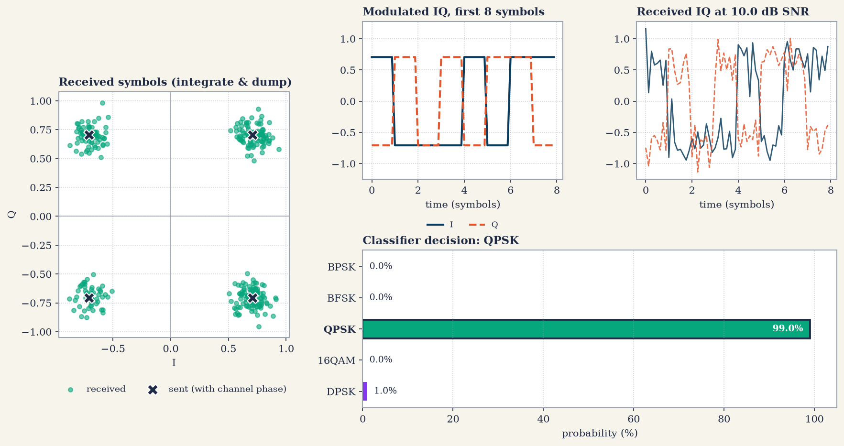
Fig 7.14 IQ-symbol test: QPSK at 10 dB SNR
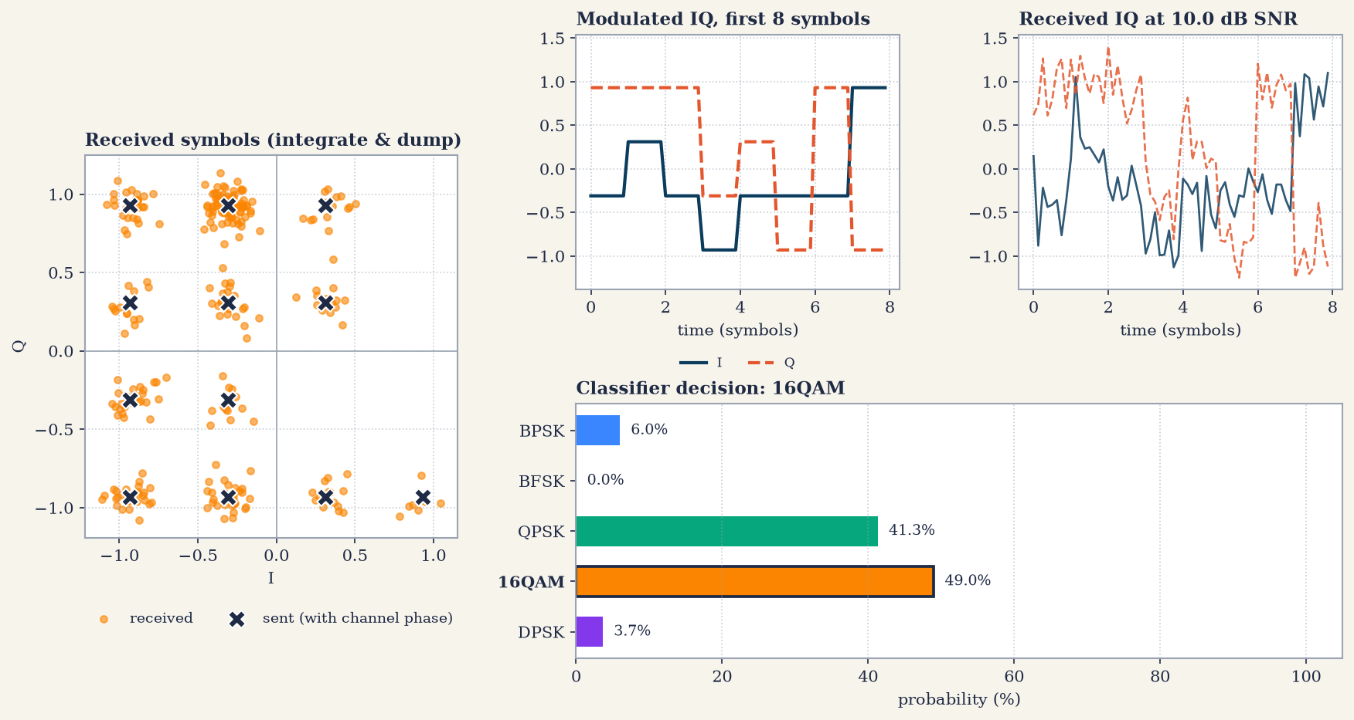
Fig 7.15 IQ-symbol test: 16-QAM at 10 dB SNR
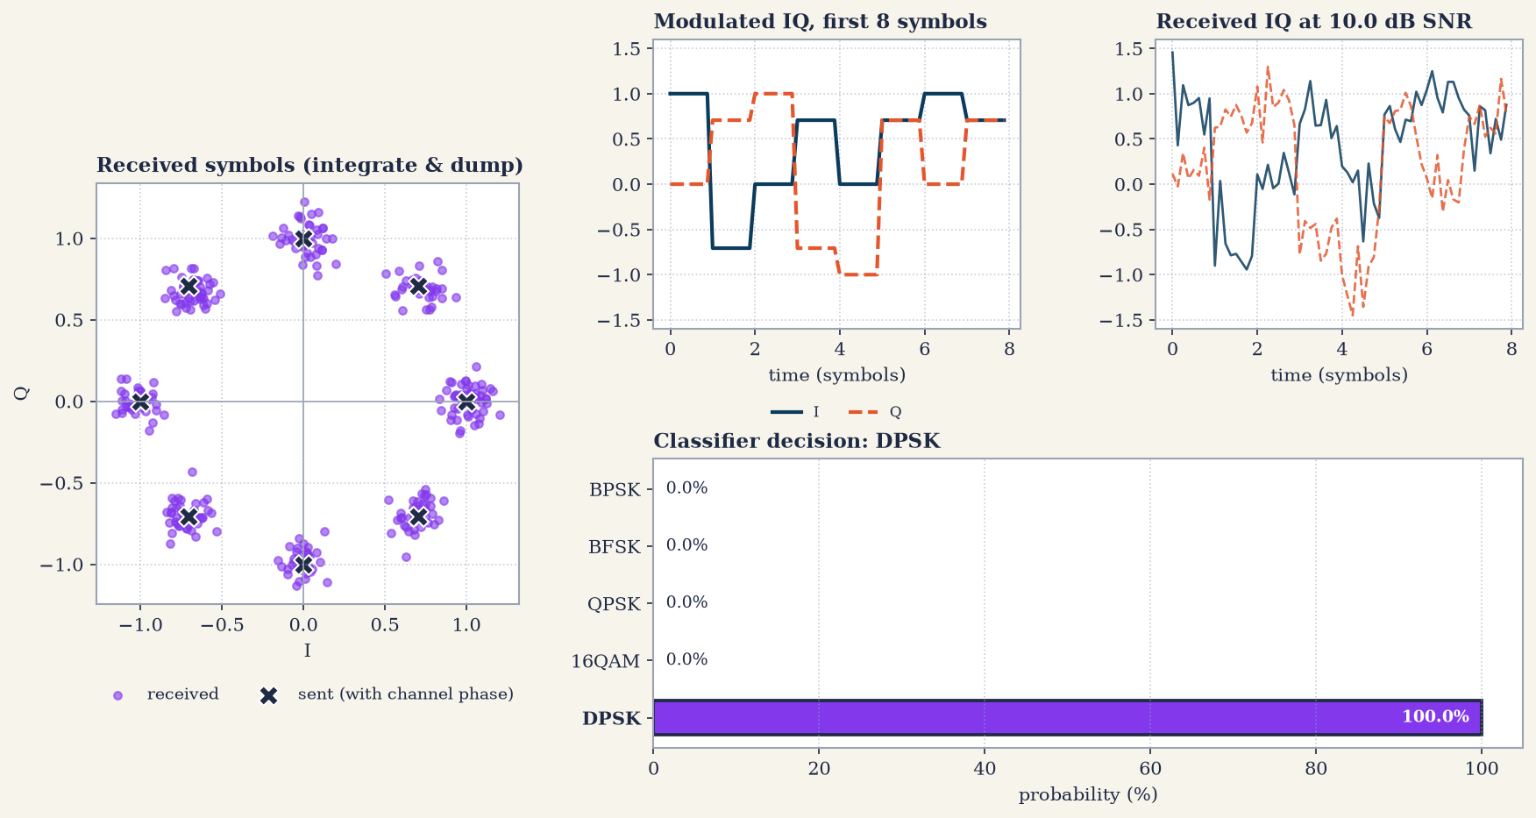
Fig 7.16 IQ-symbol test: DPSK at 10 dB SNR
The 16-QAM decision was the least certain (49.0 % against 41.3 % for QPSK): only a short symbol sequence is available in this mode, and from a few symbols the 16-QAM statistics are harder to separate from QPSK. The decision was nevertheless correct.

7.8 Interactive Run (main.py)
In the interactive run the message ‘WHAT BRO VERY WRONG BRO’ (23 characters = 184 bits) was sent with DPSK at 3 dB SNR (seed 42). The classifier chose DPSK with 99.3 % probability (QPSK 0.7 %), and the recovered message was identical to the sent one: 0 bit errors in 184 bits, BER = 0.0000 (Fig 7.17).
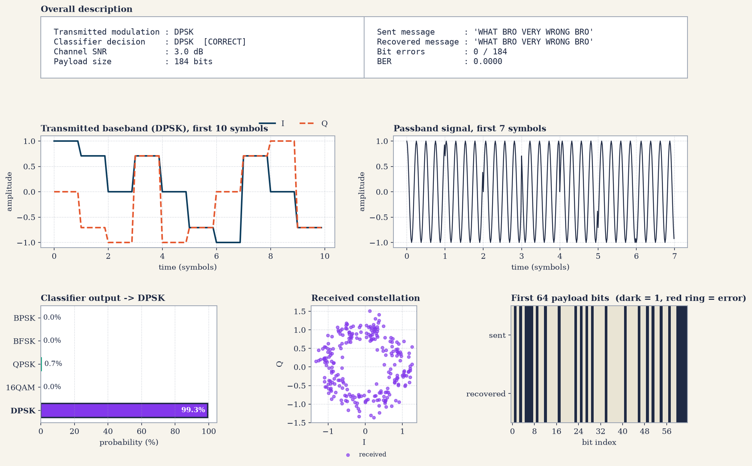
Fig 7.17 Interactive message test: DPSK at 3 dB SNR, BER = 0
For the IQ-symbol mode, the five DPSK constellation points (I = 1.0, 0.7071, 0.0, -0.7071, -1.0; Q = 0.0, 0.7071, 1.0, 0.7071, 0.0) were supplied at -1 dB SNR with 0° channel phase. Even at this low SNR the classifier returned DPSK with 89.7 % probability (16-QAM 5.3 %, QPSK 5.0 %) (Fig 7.18). Finally, the evaluation option of the program produced the accuracy-versus-SNR curve and confusion matrices (3,200 frames, 3.0 s, overall accuracy 95.78 %) and the BER-versus-SNR curves and table (14 SNR points × 5 modulations × 40 frames, 69.5 s) shown in Section 7.3 to 7.5.
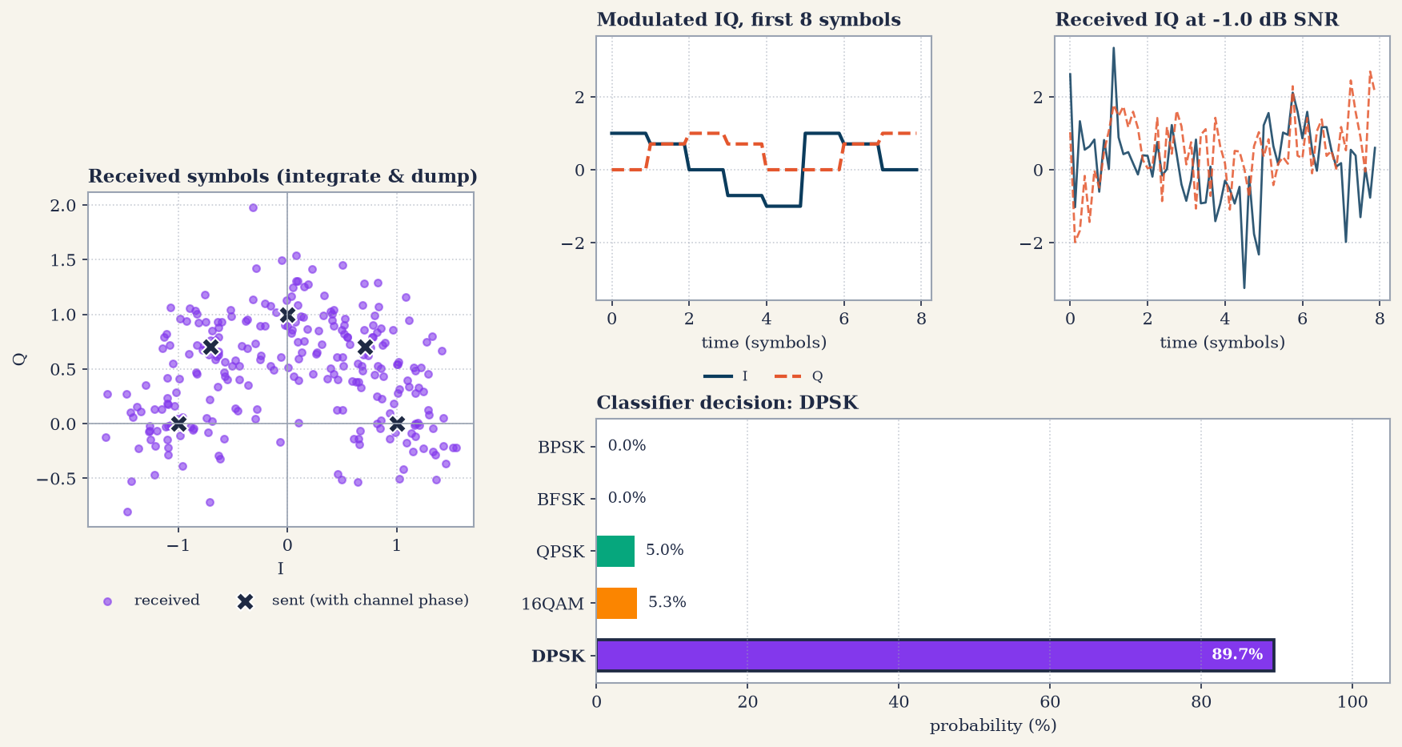
Fig 7.18 Interactive IQ-symbol test: DPSK at -1 dB SNR
Hence, the ML model is trained well for the five modulation schemes. When the SNR is high (for example 10 dB) the modulation is always identified correctly and the original message is decoded at the receiver exactly as sent by the transmitter. As the SNR is lowered, the classification of QPSK, 16-QAM and DPSK degrades first, and the demodulation of all schemes produces more bit errors, so that characters of the recovered text are corrupted.

8. Limitations & Assumptions

- Timing is known. Frames are symbol-aligned and the samples-per-symbol value is known to the receiver. A practical receiver needs a symbol-timing recovery stage first.

- No carrier frequency offset. Only a random constant carrier phase is modelled.

- SNR is per sample. Add 9.03 dB (for $N=8$) to obtain the symbol-level $E_{s}/N_{0}$, and subtract $10\log_{10}m$ to obtain $E_{b}/N_{0}$.

- DPSK is $π/4$-DQPSK, and 16-QAM is the only QAM order used. Differential BPSK cannot be separated from BPSK by any IQ-based classifier.

- A known preamble is required by the coherent demodulators to resolve the phase ambiguity.

- Statistical resolution. Each accuracy point uses 40 frames per class, so the accuracy of a class changes in steps of 2.5 % and values close to 100 % carry an uncertainty of several percent. BER points with no observed error are plotted at a floor of 1e-5 and only show that the BER is below the resolution of the experiment.

References

- O. A. Dobre, A. Abdi, Y. Bar-Ness and W. Su, “Survey of automatic modulation classification techniques: classical approaches and new trends,” IET Communications, vol. 1, no. 2, pp. 137-156, 2007.

- T. J. O’Shea, J. Corgan and T. C. Clancy, “Convolutional radio modulation recognition networks,” Engineering Applications of Neural Networks (EANN), 2016.

- L. Breiman, “Random forests,” Machine Learning, vol. 45, no. 1, pp. 5-32, 2001.

- F. Pedregosa et al., “Scikit-learn: machine learning in Python,” Journal of Machine Learning Research, vol. 12, pp. 2825-2830, 2011.

