Sri Sivasubramaniya Nadar College of Engineering
(An Autonomous Institution, Affiliated with Anna University, Chennai)
Rajiv Gandhi Salai (OMR), Kalavakkam- 603 110

UEC3501 – DIGITAL COMMUNICATION

Project Report
On

ML – Based Automatic Modulation Classification

and Demodulation of BPSK, BFSK, QPSK,

16-QAM and DPSK Signals

V SEM Semester ECE, Section ‘B’
(2026-2027)

Name: SARAVANAN R
Reg No: 3122243002098
Dept & Section: ECE – B
Year: III Year

Table of Contents

Abstract i
1.Introduction & Problem Statement 1
2.System Architecture 2
3.Signal and Channel Models 4
4.System Algorithms &Feature Extraction 5
5.Demodulation Techniques 7
6. Evaluation Parameters & Mathematical Formulations 9
7.Results & Discussion 10
8.Limitations & Assumptions 25
References 26

ABSTRACT
In cognitive and software-defined radio systems, receivers often have to process incoming signals without knowing their modulation schemes in advance. This report presents an end-to-end receiver framework that solves this issue using machine learning.
The system extracts a ten-dimensional feature vector—comprising higher-order cumulants and key spectral statistics—from incoming complex In-Phase and Quadrature (IQ) signals. A trained Random Forest classifier evaluates these features to identify the modulation type among five possibilities: BPSK, BFSK, QPSK, 16-QAM, or DPSK. Upon classification, the receiver automatically routes the IQ samples to the matching demodulation module to recover the transmitted bits.
The classifier was trained on 12,000 simulated frames and evaluated on an independent test set of 3,200 frames across a per-sample Signal-to-Noise Ratio (SNR) range of -10 dB to +20 dB under Additive White Gaussian Noise (AWGN) and random carrier phase offset conditions.
Key Highlights:
- Classification Accuracy: The model achieved an overall accuracy of 95.78% across all tested SNR levels, reaching 100% accuracy for every SNR from -2 dB upwards.
- Demodulation Accuracy: The bit error rates (BER) of all five individual demodulators align closely with theoretical performance. In full end-to-end testing (classify then demodulate), zero bit errors were observed starting at 2 dB for BPSK, 6 dB for BFSK, QPSK, and DPSK, and 10 dB for 16-QAM.
- Message-Level Verification: Real message tests using text payloads like 'nathaan Leo leo Dass ' and 'WHAT BRO VERY WRONG BRO' verified that every modulation scheme was correctly classified even in noisy environments between -4 dB and +3 dB SNR.

1.Introduction & Problem Statement
Problem statement:
The goal of this project is to develop a machine learning-based receiver that automatically detects the modulation scheme of an incoming radio signal. Trained on datasets spanning BPSK, BFSK, QPSK, 16-QAM, and DPSK modulations, the system performs three core tasks upon receiving an unlabelled signal:
- Identify the modulation type automatically.
- Select the matching demodulation scheme dynamically.
- Demodulate the signal to reliably recover the transmitted payload bits and text.
The system is evaluated across various Signal-to-Noise Ratio (SNR) levels to measure both its classification accuracy and demodulation performance under noisy channel conditions.

Objectives:
- Signal Simulation: Develop a software-based transmitter to generate labelled complex In-Phase and Quadrature (IQ) signal frames for all five modulation schemes across a controllable SNR range.
- Feature Extraction & Model Training: Extract ten discriminative statistical and spectral features (such as higher-order cumulants and spectral power ratios) to train a Random Forest classifier.
- Automated Demodulation Pipeline: Implement tailored demodulators for each modulation scheme and use the classifier's predicted output to trigger the correct demodulation path automatically.
- Comprehensive Evaluation: Benchmarks system performance by assessing classification metrics (overall accuracy, per-class accuracy, and confusion matrices) alongside Bit Error Rate (BER) curves—comparing ideal oracle demodulation against the complete end-to-end pipeline across SNR levels.

2.System Architecture

The receiver is built around a streamlined, four-stage processing pipeline (Fig2.1):
- Feature Extraction: Incoming complex In-Phase and Quadrature (IQ) samples are processed to compute a ten-dimensional feature vector.
- Classification: A trained machine learning classifier evaluates this feature vector and predicts the modulation scheme along with class probabilities.
- Dynamic Routing: The classifier's decision serves as an automatic switch, directing the same IQ samples directly to the corresponding demodulator.
- Data Recovery: The selected demodulator processes the signal to output the recovered bit stream (and decodes it back to human-readable text in the demonstrations).
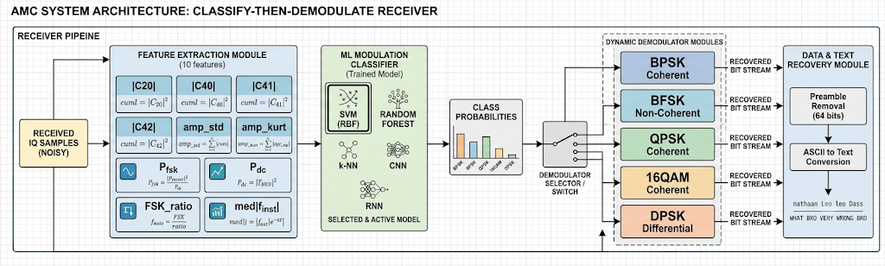
Fig 2.1: Block diagram of the classify-and-then-demodulate receiver.

Preamble 64 Known bits | Payload User message bits | Random filler bits

Frame Structure & Frame Transmission: Transmitted signals are packed into structured frames consisting of three distinct fields: [64-bit known preamble | payload bits | random filler bits].
- 64-Bit Preamble: Allows coherent demodulators to resolve the residual phase ambiguity left after blind carrier-phase estimation.
- Payload Bits: Contain the actual user message bits being transmitted.
- Random Filler Bits: Ensure every frame contains at least 256 symbols during interactive demonstrations (and 128, 256, or 512 symbols during classifier training). This guarantees that feature extraction relies on sufficient statistical data, even when sending short messages.

Software Module Structure
modulation_classifier/
├── main.py # Interactive entry point (message demo, IQ-symbol demo, evaluation menu)
├── config.py # Shared constants (SPS, MODS, preamble, paths, colours)
├── signal_generator.py # Bits -> symbols -> modulated IQ, AWGN/phase channel, text<->bits
├── features.py # Cumulants (C20/C40/C41/C42), amplitude stats, spectral features
├── classifier.py # Build/save/load/classify helpers, theory BER formulas, BER simulation
├── demodulator.py # Integrate-and-dump, phase sync (preamble), slicing, bit-error counting
├── dataset.py # Dataset synthesis (frames -> channel -> feature vectors)
├── plotting.py # Plot style, backend selection, demo and evaluation plots
├── train.py # Train the model and save it to models/
├── test.py # Unit tests
├── models/ # Trained model (amc_model.joblib)
├── figures/ # Saved plots (.png)
├── results/ # CSV outputs (accuracy_vs_snr.csv, ber_vs_snr.csv)
├── requirements.txt
└── README.md

3. Signal and Channel Models

Let the data bits be $b_{k}∈\{0,1\}$, let $N=8$ be the number of samples per symbol (rectangular pulse), and let $n$ be the sample index with symbol index $k=⌊n/N⌋$. All signals are complex baseband (IQ) with unit average power.
Modulation | Bits per symbol (m) | Baseband model x[n]
BPSK | 1 | $$x\left[n\right]=a_{k}, a_{k}=1-2b_{k}∈\{±1\}$$
BFSK | 1 | xn=exp​j2πi≤n​fi, fi=±fd  for $b_{k}=1/0$, $f_{d}=1/N$
QPSK (Gray) | 2 | $$x\left[n\right]=\frac{\left(1-2b_{2k}\right)+j\left(1-2b_{2k+1}\right)}{\sqrt{2}}$$
16-QAM (Gray) | 4 | $$x\left[n\right]=\frac{A_{I}+jA_{Q}}{\sqrt{10}},$$  $$A_{I},A_{Q}∈\{-3,-1,+1,+3\}$$
DPSK ($π/4$-DQPSK) | 2 | $x\left[n\right]=e^{jϕ_{k}}, ϕ_{k}=ϕ_{k-1}+Δϕ_{k}$,  $$Δϕ_{k}∈\{±π/4,±3π/4\}$$

For DPSK the dibits $00,01,11,10$ map to the phase steps $+π/4, +3π/4, -3π/4, -π/4$, and a reference symbol ($ϕ_{0}=0$) is sent first. For 16-QAM, each axis uses the Gray map $00→-3, 01→-1, 11→+1, 10→+3$.
Modification: For random data, differential BPSK produces the same IQ statistics as ordinary BPSK, so no classifier can separate them from IQ samples alone. For this reason, DPSK is implemented here as $π/4$-D-QPSK, a standard differential scheme whose eight-point constellation is genuinely distinguishable from QPSK. This choice is stated openly so the results are not over-interpreted.
The received signal is
$$y\left[n\right]=e^{jθ} x\left[n\right]+w\left[n\right], θ∼U\left[0,2π\right), w\left[n\right]∼CN\left(0,σ^{2}\right),$$

where $θ$ is an unknown carrier phase offset and $w\left[n\right]$ is complex white Gaussian noise. Because the signal power is 1, the noise variance follows SNR
$σ^{2}={10}^{-SNR_{dB}/10}$

4. System Algorithms & Feature Extraction

4.1 Algorithm 1: Dataset Generation Workflow
- Choose an SNR value from the grid and a modulation from the five classes.
- Choose a frame length of 128, 256 or 512 symbols at random.
- Generate random payload bits so that, together with the 64-bit preamble, they fill exactly that many symbols.
- Modulate the bits into complex IQ samples (8 samples per symbol).
- Rotate the signal by a random carrier phase and add Gaussian noise whose variance is set by the chosen SNR.
- Compute the ten features of the noisy frame and store them with the class label and the SNR.
- Repeat for every SNR, class and frame count. Build one pool for training and a separate pool, with a different random seed, for testing.

4.2 Algorithm 2: Feature extraction Pipeline
Every noisy signal frame is condensed into ten distinct mathematical features. Features 1–6 are calculated on symbol-level samples $z_{k}$ (after integrate-and-dump filtering), while Features 7–10 are calculated directly on raw sample sequences $x\left[n\right]$:
No. | Feature | Definition | What it captures
1 | |C20| | |E[z²]| | Real-valued (BPSK-like) against symmetric constellations
2 | |C40| | |E[z⁴] − 3E[z²]²| | Constellation shape (higher-order cumulant)
3 | |C41| | |E[z³z*] − 3E[z²]E[|z|²]| | Constellation shape (higher-order cumulant)
4 | C42 | E[|z|⁴] − |E[z²]|² − 2E[|z|²]² | Constellation shape; differs for QPSK, 16-QAM and DPSK
5 | amp_std | std(|z|) / mean(|z|) | Envelope variation; separates 16-QAM from constant-envelope schemes
6 | amp_kurt | E[(|z| − mean)⁴] / var(|z|)² | Shape of the envelope distribution
7 | P_fsk | share of the power spectrum within ±0.03 of the frequencies ±f_d, f_d = 1/8 | Spectral lines of BFSK
8 | P_dc | share of the power spectrum within ±0.03 of zero frequency | Power at the carrier (PSK, QAM)
9 | FSK_ratio | P_fsk / (P_fsk + P_dc) | Relative strength of the FSK lines
10 | med|f_inst| | median of |f_inst|, f_inst[n] = arg(x[n]·x*[n−1]) / 2π | Frequency content; large for BFSK

4.3 Algorithm 3: Classifier Model Training
The machine learning classifier is built using a Random Forest architecture:
- Training Set: Synthesize 12,000 total frames (16 SNR steps from -10 dB to +20 dB $×$ 5 modulations $×$ 150 frames per class, generated with Seed 1).
- Test Set: Synthesize 3,200 unseen test frames (40 frames per class across 16 SNR steps, generated with Seed 2).
- Model Configuration: Train an ensemble of 300 decision trees (RandomForestClassifier, random_state = 0). Standard feature scaling is omitted as tree models are scale-invariant.
- Evaluation & Export: Measure final accuracy against the test pool only after training completes. Save the trained model to models/amc_model.joblib for real-time inference.

4.4 Algorithm 4: Real-Time Signal Processing Pipeline
When an unlabelled IQ signal arrives at the receiver, it flows through the following
recovery steps:

[ Raw IQ Samples ] ──► [ Feature Extraction (10 Features) ] ──► [ ML Classifier ]
│
▼
[ Data Output ] ◄── [ Demodulation ] ◄── [ Top Match Selected ] ◄──

- Extract Features: Calculate the 10 numerical features from the incoming IQ sample stream.
- Predict Class: Pass the 10-element vector to the trained Random Forest model to obtain likelihood probabilities across all 5 schemes.
- Select Scheme: Identify the modulation scheme with the highest confidence score.
- Demodulate Signal: Route the original IQ samples into the corresponding demodulation engine.
- Recover Message: Strip the 64-bit preamble used for synchronization and convert the remaining payload bits into readable ASCII characters

5. Demodulation Techniques

All demodulators first group the samples into symbols of $N=8$ samples. For the PSK/QAM/DPSK demodulators, the symbol value is the average of the $N$ samples (integrate-and-dump):
$$z_{k}=\frac{1}{N}\sum_{i=0}^{N-1}{y}\left[kN+i\right]$$

5.1 Coherent demodulation of BPSK, QPSK and 16-QAM

- Compute $z_{k}$ for every symbol and scale the sequence to unit average power.
- Estimate the unknown carrier phase blindly. For BPSK the squared symbols point in the direction $2θ$, so θ=12argk​zk2. For QPSK and 16-QAM the fourth power is used, θ=14argk​zk4-π.
- This estimate is only correct up to a multiple of $π$ (BPSK) or $π/2$ (QPSK, 16-QAM). Try every possible extra rotation, demodulate the 64 preamble bits each time, and keep the rotation with the fewest preamble errors.
- Rotate all symbols by e^(−jθ) (with the chosen extra rotation) and slice them with the Gray map: BPSK by the sign of the real part, QPSK by the signs of the real and imaginary parts, 16-QAM on each axis after scaling by √10: the first bit is the sign, the second bit is 1 when the magnitude is below 2 (thresholds at 0 and ±2/√10).
- Join the bit pairs (or quadruples) into the output bit stream.

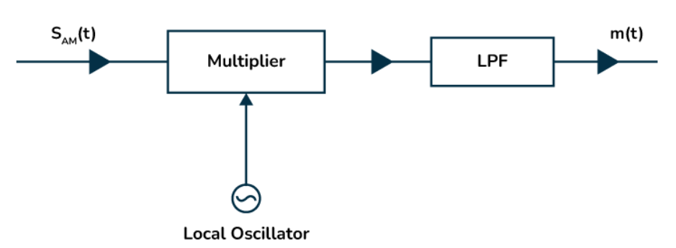
Fig 5.1 Coherent detection

5.2 Differential demodulation of DPSK

- Compute $z_{k}$ for every symbol, including the reference symbol.
- Multiply each symbol by the conjugate of the previous one: $d_{k}=z_{k}z_{k-1}^{*}$. The unknown carrier phase cancels in this product, so no phase recovery or preamble is needed.
- The angle of $d_{k}$ is the transmitted phase step. Decide the dibit from its quadrant: the first bit is 1 when $Im\left(d_{k}\right)<0$, the second bit is 1 when $Re\left(d_{k}\right)<0$.

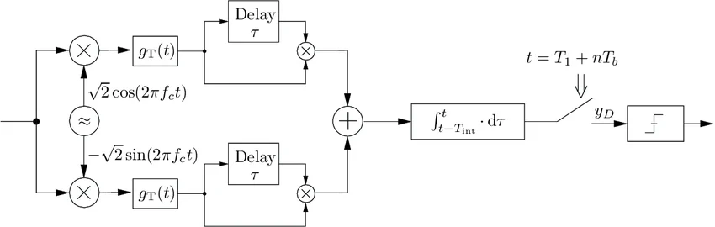
Fig 5.2 Differential demodulation

5.3 Non-coherent demodulation of BFSK
- For each symbol, correlate the $N$ samples with a complex tone at $+f_{d}$ and with a complex tone at $-f_{d}$:
E1=|i​yie-j2πfdi|, E0=|i​yie+j2πfdi|

- Decide bit 1 if $E_{1}>E_{0}$, otherwise bit 0. Taking magnitudes removes the dependence on the unknown phase, so no carrier recovery is needed.

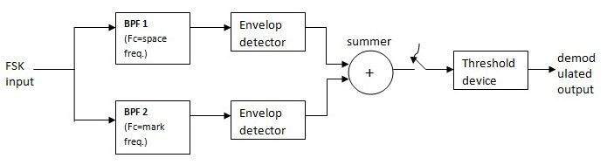
Fig 5.3 Non-Coherent demodulation

6.Evaluation Parameters & Mathematical Formulations

Notation & Definitions
For classification evaluation, $C$ represents the $M×M$ confusion matrix where entry $C\left(i,j\right)$ counts the number of frames from true class $i$ that were predicted as class $j$. The system evaluates $M=5$ candidate classes over $T$ total test frames. The number of correctly classified frames for any class $c$ is given by the diagonal entry $C\left(c,c\right)$.

Parameter | Mathematical formula | Meaning
Signal-to-noise ratio (per sample) | $$SNR_{dB}=10\log_{10}\frac{P_{s}}{P_{n}}=10\log_{10}\frac{1}{σ^{2}}$$ | Signal power over noise power per complex sample ($P_{s}=1$)
Symbol SNR | $$\frac{E_{s}}{N_{0}}=SNR⋅N, {\left.\frac{E_{s}}{N_{0}}\right|}_{dB}=SNR_{dB}+10\log_{10}N$$ | Energy per symbol over noise density; $+9.03$ dB for $N=8$
Bit SNR | $$\frac{E_{b}}{N_{0}}=\frac{E_{s}/N_{0}}{m}$$ | Energy per bit over noise density; $m$ = bits per symbol
Overall accuracy | $$Acc=\frac{\sum_{c=1}^{M}{C_{cc}}}{T}$$ | Fraction of frames whose modulation was identified correctly
Accuracy at one SNR | $$Acc\left(γ\right)=\frac{\text{correct frames at SNR }γ}{\text{all frames at SNR }γ}$$ | Accuracy-versus-SNR curve
Per-class accuracy (= recall) | $${Acc}_{c}=\frac{TP_{c}}{TP_{c}+FN_{c}}$$ | Share of class $c$ frames that were detected
Bit error rate | $$BER=\frac{N_{err}}{N_{bits}}=\frac{\sum_{i=1}^{N_{bits}}{\left(b_{i}⊕{\hat{b}}_{i}\right)}}{N_{bits}}$$ | Fraction of payload bits received wrongly ($⊕$ = XOR)
Symbol error rate | $$SER=\frac{N_{sym,err}}{N_{sym}}$$ | Fraction of symbols decided wrongly (used in the symbol-input test)
End-to-end BER | BERe2e=frames​Nerr+0.5 NmissingNbits | BER when the demodulator is chosen by the classifier; bits that a wrongly chosen demodulator fails to deliver count as coin flips (0.5 error each)
Theoretical BER, BPSK and Gray QPSK | $$P_{b}=Q​\left(\sqrt{2E_{b}/N_{0}}\right)=1/2 erfc​\left(\sqrt{E_{b}/N_{0}}\right)$$ | Reference curve for ideal coherent detection
Theoretical BER, Gray 16-QAM | $$P_{b}≈\frac{3}{8} erfc​\left(\sqrt{\frac{2}{5}\frac{E_{b}}{N_{0}}}\right)$$ | Reference curve for 16-QAM
Theoretical BER, non-coherent BFSK | $$P_{b}=1/2exp​\left(-\frac{E_{b}}{2N_{0}}\right)$$ | Reference curve for orthogonal non-coherent FSK
Q-function | $$Q\left(x\right)=\frac{1}{\sqrt{2π}}\int_{x}^{∞}{e^{-u^{2}/2}} du=1/2 erfc​\left(\frac{x}{\sqrt{2}}\right)$$ | Gaussian tail probability

Random Forest Classifier Formulations :
Classifier | Formula | Role
Random forest class probability | P(c | x) = (1/B) Σ p_b(c | x), b = 1 … B, B = 300 trees | Class probabilities shown in the demo; the decision is the class with the largest probability
Random forest impurity | $$G=1-\sum_{c=1}^{M}{p_{c}^{2}}$$ | Node-splitting criterion used while each of the 300 trees is grown

7. Results and Discussion

The complete framework was built in Python using standard scientific libraries (NumPy, SciPy, scikit-learn, and Matplotlib). The codebase includes an interactive application (main.py) alongside an automated evaluation script (test_all_schemes.py). All performance metrics presented below were generated from a single run with fixed random seeds (using seed = 42 for demonstrations) to ensure full reproducibility.
- Classification Test Set: Comprises 3,200 total frames, evaluated across 16 SNR levels (-10 dB to +20 dB in 2 dB steps) with 40 frames per modulation class at each step.
- BER Experiment Setup: Evaluates 40 frames per modulation across 14 SNR levels (-10 dB to +16 dB), using 512 payload bits per frame. This yields 20,480 payload bits per SNR point, setting the minimum observable non-zero Bit Error Rate (BER) at approximately $4.9×{10}^{-5}$.
- Plotted BER Floor: Points where no bit errors were observed are plotted at a floor of ${10}^{-5}$ to indicate that the true BER falls below the statistical resolution limit of the simulation.

7.1 Constellation plot of each modulation scheme

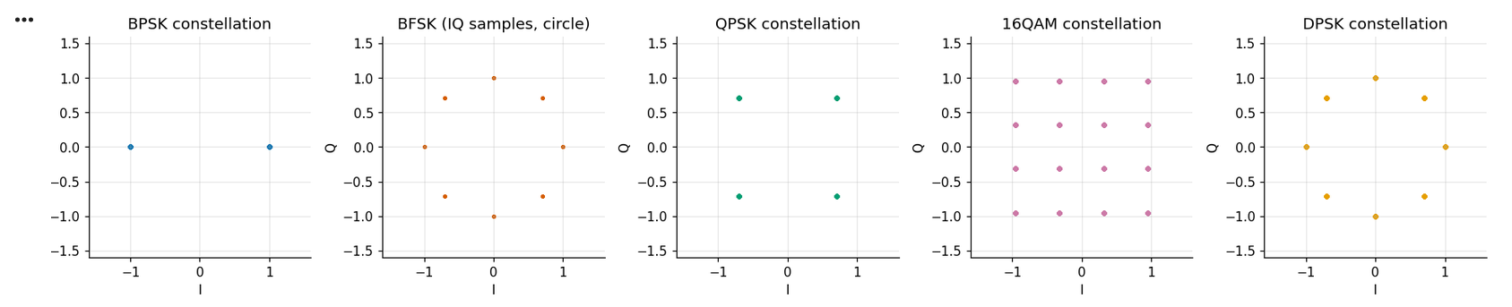
Fig 7.1
7.2 Classifier training and test set
The classification model relies on a Random Forest architecture containing 300 decision trees, trained on the ten statistical and spectral features described in Section 4.2. All configuration parameters used during model training by train.py are summarized in the table below. To guarantee an unbiased evaluation, the test dataset was synthesized using a distinct random seed, ensuring no test frame was encountered during training.
Setting | Value
SNR grid | -10 dB to +20 dB in steps of 2 dB (16 values)
Modulations | BPSK, BFSK, QPSK, 16-QAM, DPSK
Frame length / sampling | 128, 256 or 512 symbols (chosen at random), 8 samples per symbol
Training set | 150 frames per class per SNR = 12,000 frames (seed 1)
Test set | 40 frames per class per SNR = 3,200 frames (seed 2)
Features per frame | 10 (Section 4.2)
Classifier | Random forest, 300 trees, random_state = 0, no feature scaling
Saved model | models/amc_model.joblib

7.3 Classification performance on independent test set
When evaluated across all 16 SNR levels and across all five modulation schemes (totalling 3,200 unseen test frames), the Random Forest classifier achieved an overall classification accuracy of 95.78%. This matches the exact test accuracy output generated by the training program (train.py).
Confusion matrices at three representative SNRs:
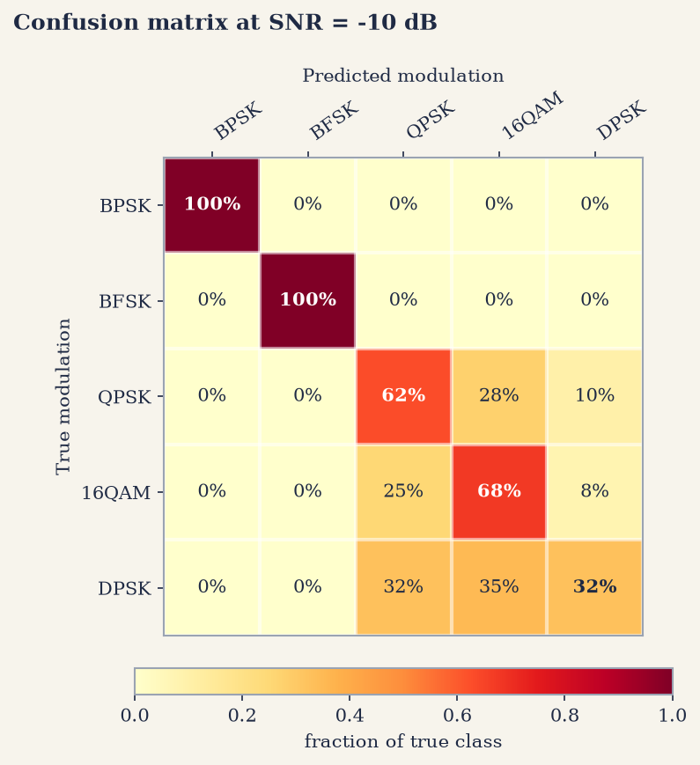
Fig 7.2 Confusion matrix at SNR = -10 dB

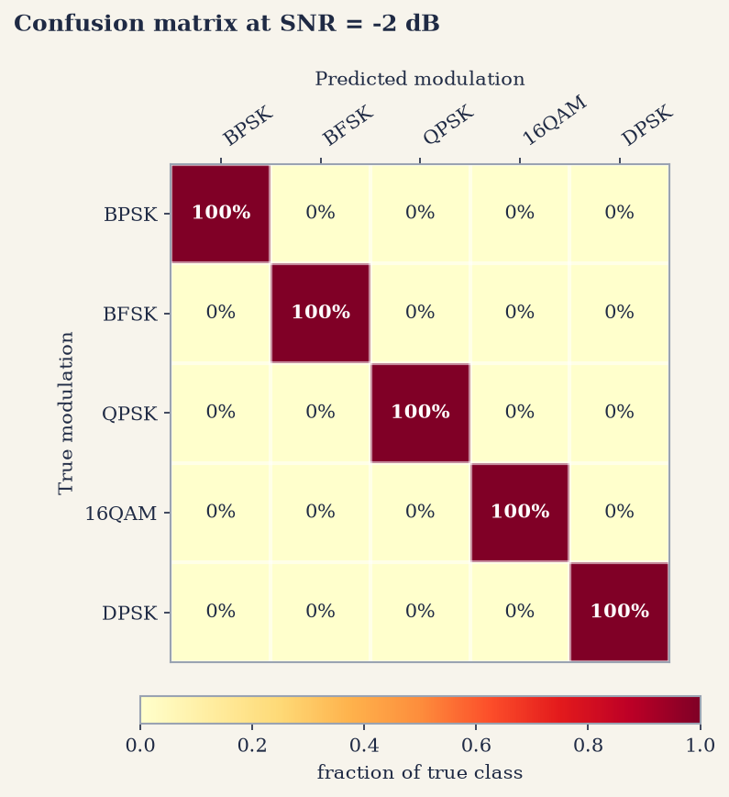
Fig 7.3 Confusion matrix at SNR = -2 dB
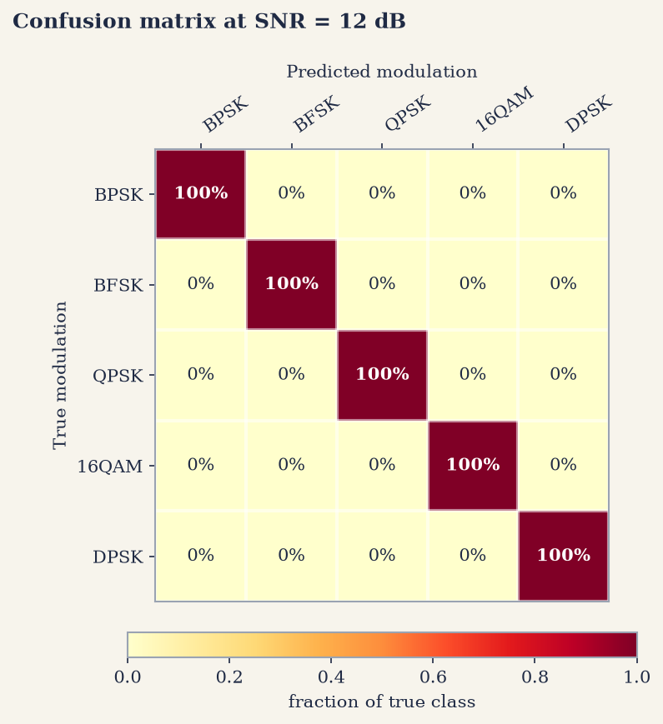
Fig 7.4 Confusion matrix at SNR = 12 dB
- Medium and High SNR (-2 dB and 12 dB): The confusion matrices are perfectly diagonal, demonstrating that 100% of the signal frames were classified correctly without a single misclassification.
- Low SNR (-10 dB): Even under severe noise conditions, BPSK and BFSK maintain a 100% accuracy rate. In contrast, higher-order schemes (QPSK, 16-QAM, and DPSK) exhibit mutual confusion due to reduced signal clarity, yielding individual accuracies of 62%, 68%, and 32% respectively

7.4 Modulation Classification Accuracy vs. SNR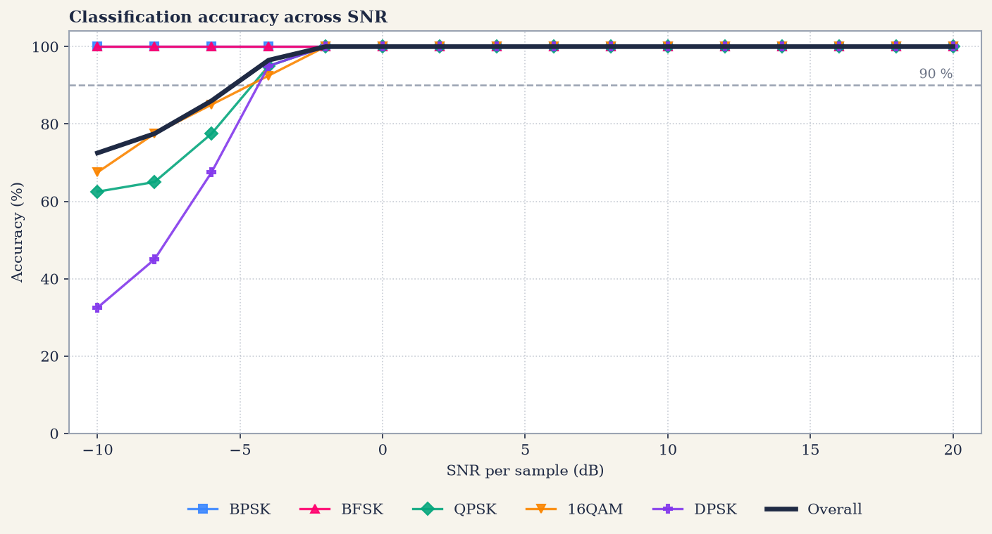
Fig 7.5 Classification accuracy versus SNR
Classification accuracy (%) on the test set at selected SNRs (40 frames per class per SNR):

SNR (dB) | BPSK | BFSK | QPSK | 16-QAM | DPSK | Overall
-10 | 100.0 | 100.0 | 62.5 | 67.5 | 32.5 | 72.5
-8 | 100.0 | 100.0 | 65.0 | 77.5 | 45.0 | 77.5
-6 | 100.0 | 100.0 | 77.5 | 85.0 | 67.5 | 86.0
-4 | 100.0 | 100.0 | 95.0 | 92.5 | 95.0 | 96.5
-2 | 100.0 | 100.0 | 100.0 | 100.0 | 100.0 | 100.0
0 | 100.0 | 100.0 | 100.0 | 100.0 | 100.0 | 100.0
10 | 100.0 | 100.0 | 100.0 | 100.0 | 100.0 | 100.0
20 | 100.0 | 100.0 | 100.0 | 100.0 | 100.0 | 100.0

Performance Insights
- Flawless High-SNR Recognition: From -2 dB upwards, the classifier achieves a perfect 100% accuracy across all five modulation schemes.
- Low-SNR Resiliency: Both BPSK and BFSK maintain 100% classification accuracy even at the lowest SNR level of -10 dB.
- Noise Degradation at Low SNR: At -10 dB, accuracy drops for QPSK (62.5%), 16-QAM (67.5%), and DPSK (32.5%). This performance drop is expected, as a per-sample SNR of -10 dB translates to a symbol SNR of only about -1 dB, making these three complex constellations statistically similar and challenging to distinguish.
- High Confidence Threshold: Overall classification accuracy reaches 96.5% at -4 dB and consistently exceeds 90% for all SNRs from -4 dB upwards.

7.5 Demodulation Performance
Oracle Demodulator (Known Modulation Baseline)
Evaluating the system with a known modulation (oracle demodulator) isolates the intrinsic performance of the demodulation algorithms from any
classification errors.
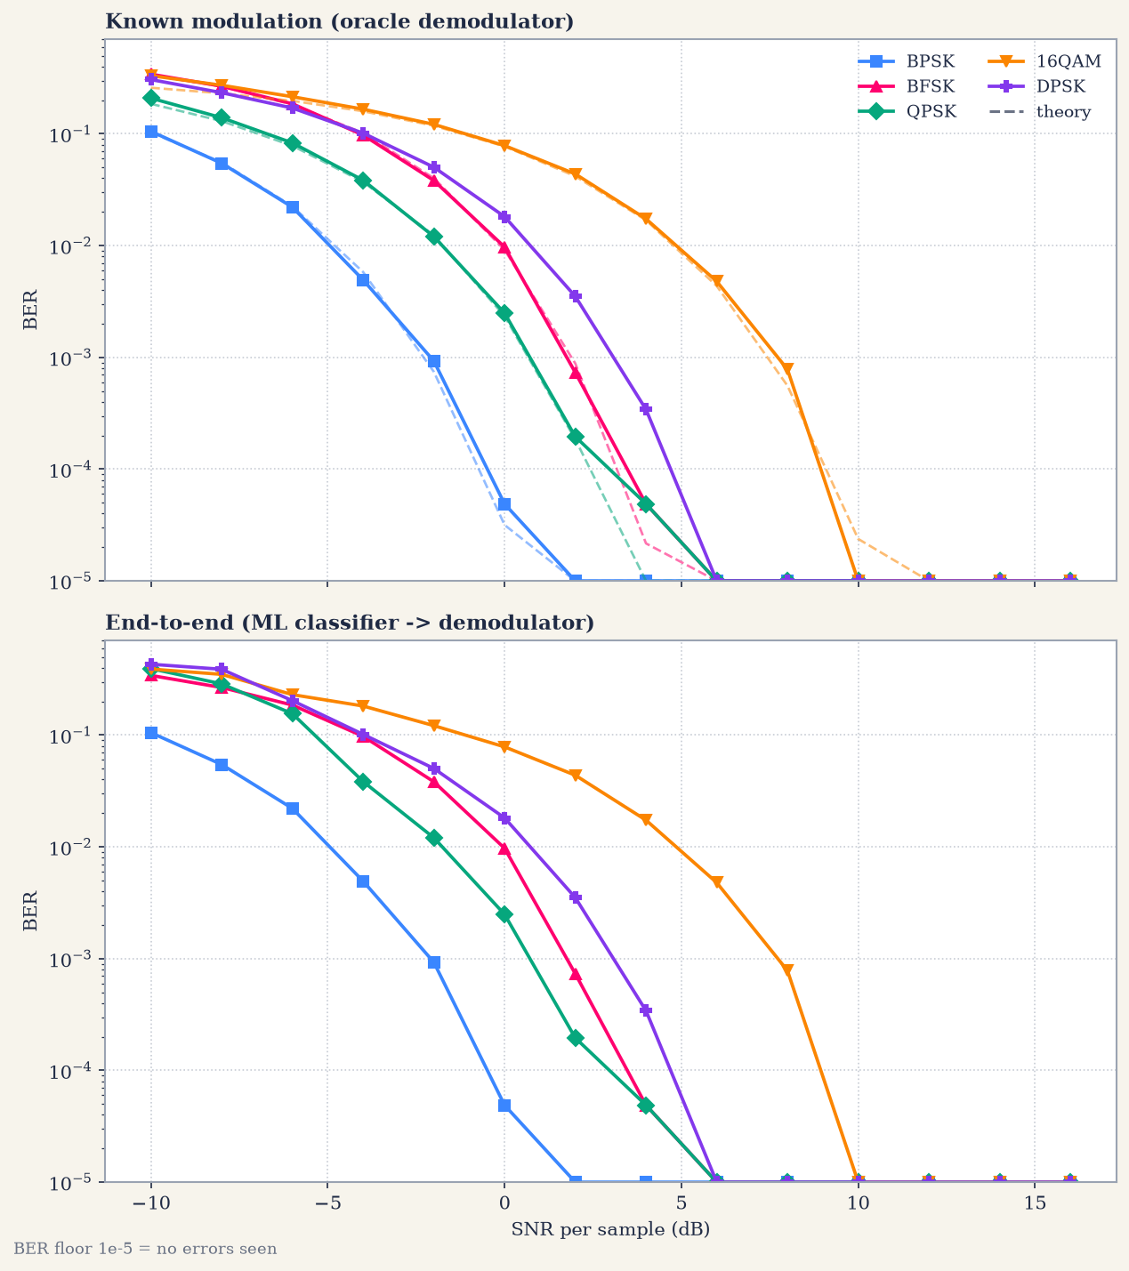
Fig 7.6 BER Vs SNR: (top) known modulation, oracle demodulator; (bottom) end-to-end system, ML classifier followed by demodulator
Key Observations from Figure 7.6
Comparing the oracle demodulator against the complete end-to-end pipeline yields two key insights:
- Theoretical Validation: The simulated Bit Error Rate (BER) curves for BPSK, QPSK, 16-QAM, and BFSK track textbook theoretical performance (indicated by dashed lines) extremely closely. This close alignment confirms the precision of both the signal simulator and the demodulation routines (including the blind carrier-phase estimation stage).
- End-to-End Equivalence: From -2 dB SNR upwards, where classification accuracy reaches 100%, the end-to-end system curve overlaps perfectly with the oracle curve. The end-to-end performance degrades relative to the oracle baseline only at very low SNRs (below -2 dB), where misclassification occasionally routes signal frames to an incorrect demodulator.

End-to-end BER Vs SNR table (40 frames per point):

SNR (dB) | BPSK | BFSK | QPSK | 16-QAM | DPSK
-10 | 1.05e-01 | 3.42e-01 | 3.93e-01 | 3.90e-01 | 4.30e-01
-8 | 5.45e-02 | 2.67e-01 | 2.87e-01 | 3.49e-01 | 3.88e-01
-6 | 2.21e-02 | 1.86e-01 | 1.55e-01 | 2.30e-01 | 2.03e-01
-4 | 4.93e-03 | 9.75e-02 | 3.84e-02 | 1.82e-01 | 1.02e-01
-2 | 9.28e-04 | 3.82e-02 | 1.21e-02 | 1.22e-01 | 5.03e-02
0 | 4.88e-05 | 9.72e-03 | 2.49e-03 | 7.85e-02 | 1.82e-02
2 | 0.00e+00 | 7.32e-04 | 1.95e-04 | 4.37e-02 | 3.52e-03
4 | 0.00e+00 | 4.88e-05 | 4.88e-05 | 1.73e-02 | 3.42e-04
6 | 0.00e+00 | 0.00e+00 | 0.00e+00 | 4.79e-03 | 0.00e+00
8 | 0.00e+00 | 0.00e+00 | 0.00e+00 | 7.81e-04 | 0.00e+00
10 | 0.00e+00 | 0.00e+00 | 0.00e+00 | 0.00e+00 | 0.00e+00
12 | 0.00e+00 | 0.00e+00 | 0.00e+00 | 0.00e+00 | 0.00e+00
14 | 0.00e+00 | 0.00e+00 | 0.00e+00 | 0.00e+00 | 0.00e+00
16 | 0.00e+00 | 0.00e+00 | 0.00e+00 | 0.00e+00 | 0.00e+00
As SNR drops, the Bit Error Rate (BER) rises, causing message corruption. Across 40 test frames per point, zero bit errors were observed at and above:
- 2 dB for BPSK
- 6 dB for BFSK, QPSK, and DPSK
- 10 dB for 16-QAM
Higher SNR is essential for accurate recovery; BPSK is the most noise-tolerant, while 16-QAM requires the strongest signal.

7.6 Manual Test: Message Transmission

The program lets a user type a message, select a modulation and an SNR, and shows the transmitted baseband IQ, the passband waveform, the classifier probabilities, the received constellation (or spectrum for BFSK), the sent and recovered bits and the decoded text. The automated test test_all_schemes.py sends the message ‘nathaan Leo leo Dass ’ (21 characters = 168 payload bits, seed 42) once through every modulation at a deliberately low SNR. The results are summarised in the table below and shown in Fig 7.7 to Fig 7.11.

Scheme | SNR (dB) | Classifier decision | Bit errors | BER | Recovered text
BPSK | -4.0 | BPSK | 3 / 168 | 0.0179 | ‘nathaan Mem0leo Dass ’
BFSK | -2.0 | BFSK | 8 / 168 | 0.0476 | ‘nathad~ Le�"leo(Da�{ ’
QPSK | -2.0 | QPSK | 4 / 168 | 0.0238 | ‘jathaan LEo leo\x00DAss ’
16-QAM | 2.0 | 16-QAM | 7 / 168 | 0.0417 | ‘nathaa~ Leo l%o$Dasu%’
DPSK | 0.0 | DPSK | 3 / 168 | 0.0179 | ‘�athaan Leo lgo DAss ’

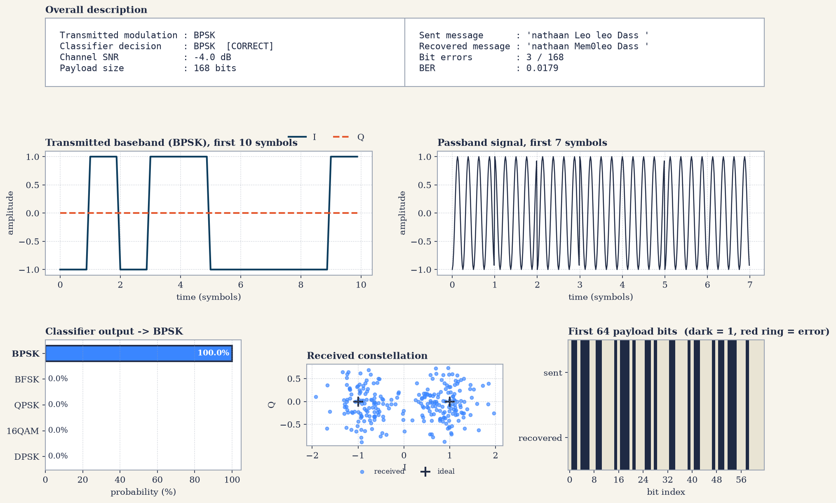
Fig 7.7 Message test: BPSK at -4 dB SNR
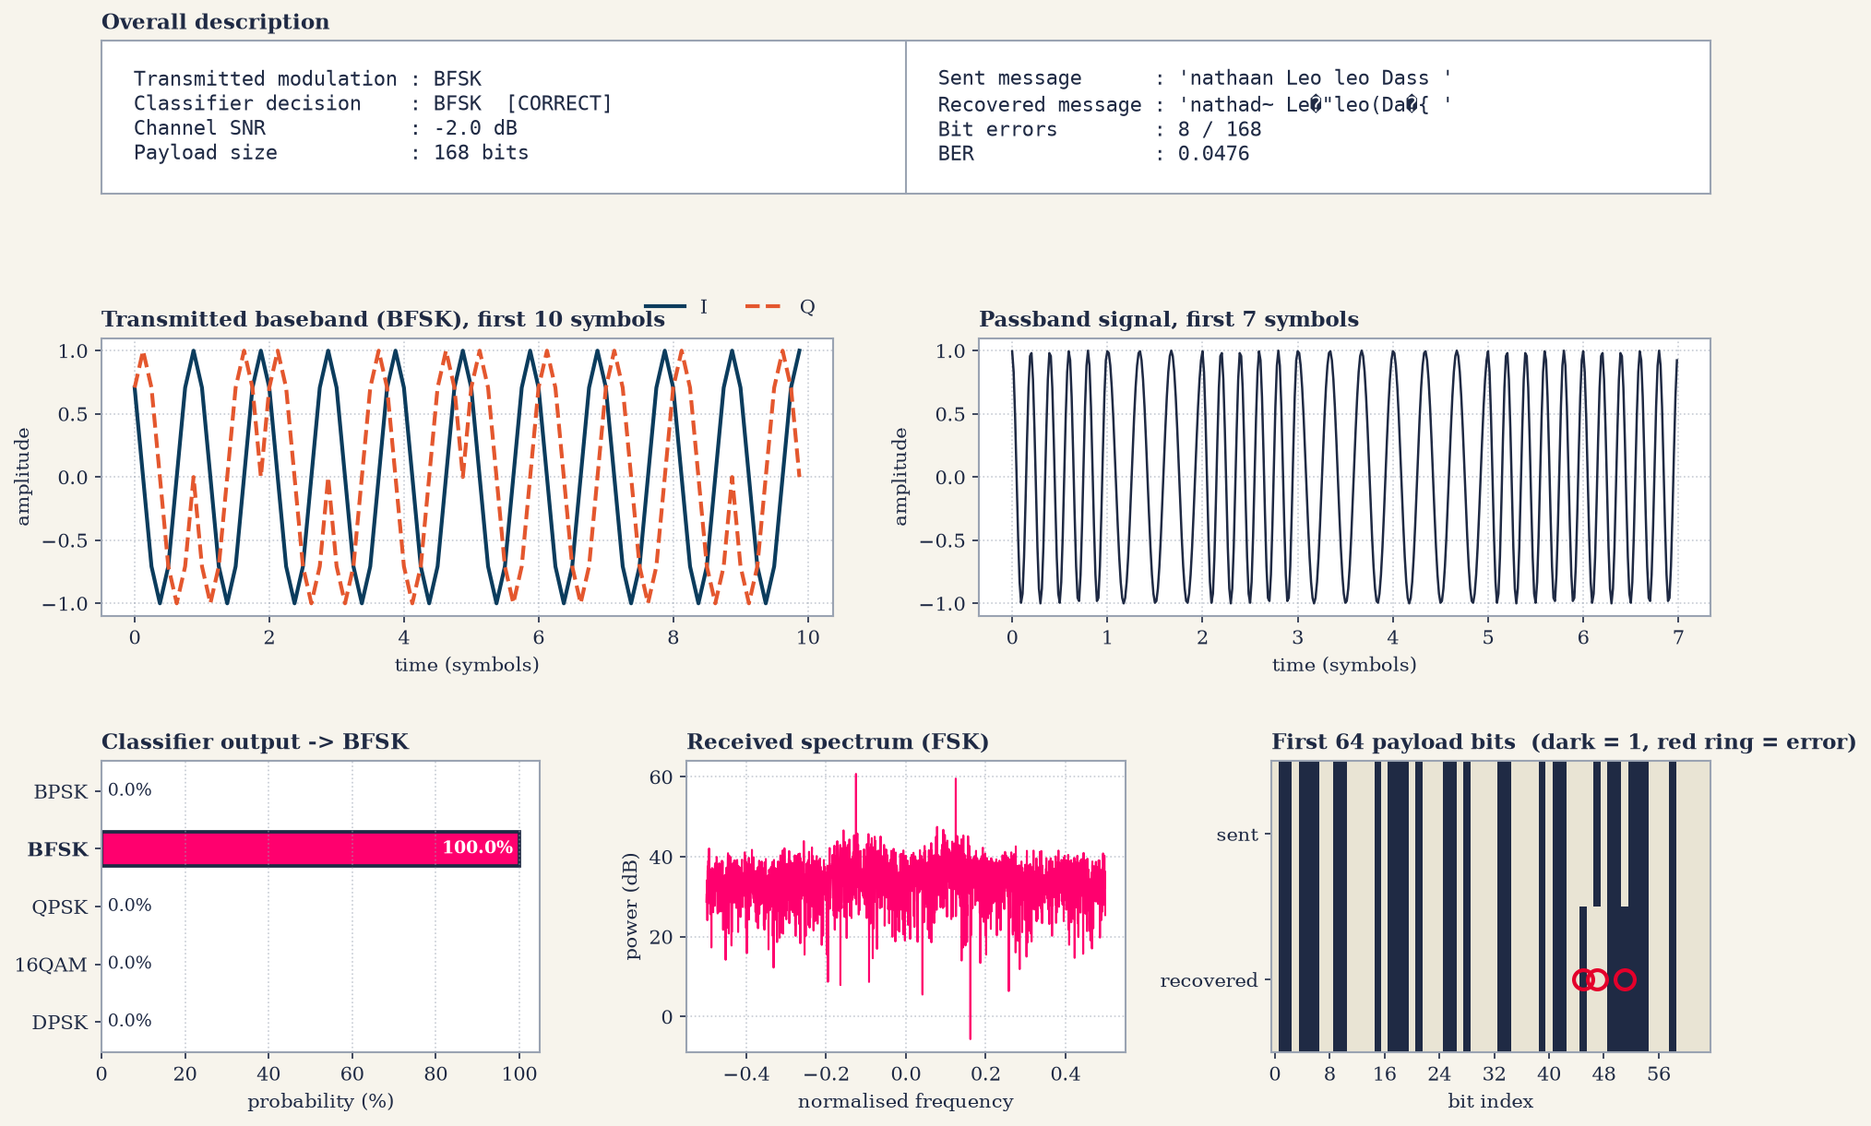
Fig 7.8 Message test: BFSK at -2 dB SNR

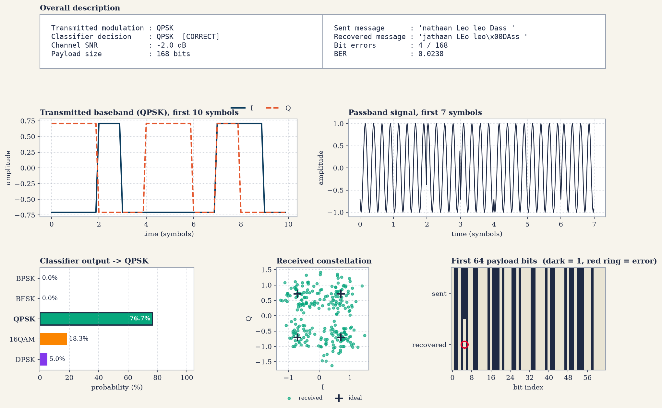
Fig 7.9 Message test: QPSK at -2 dB SNR

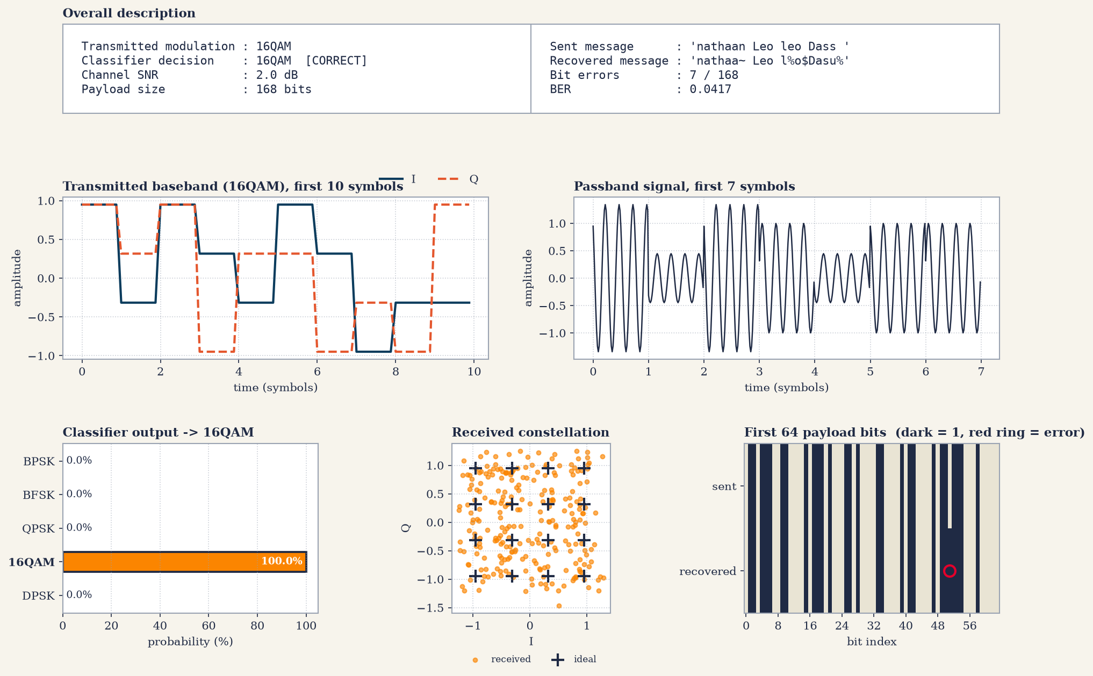
Fig 7.10 Message test: 16-QAM at 2 dB SNR

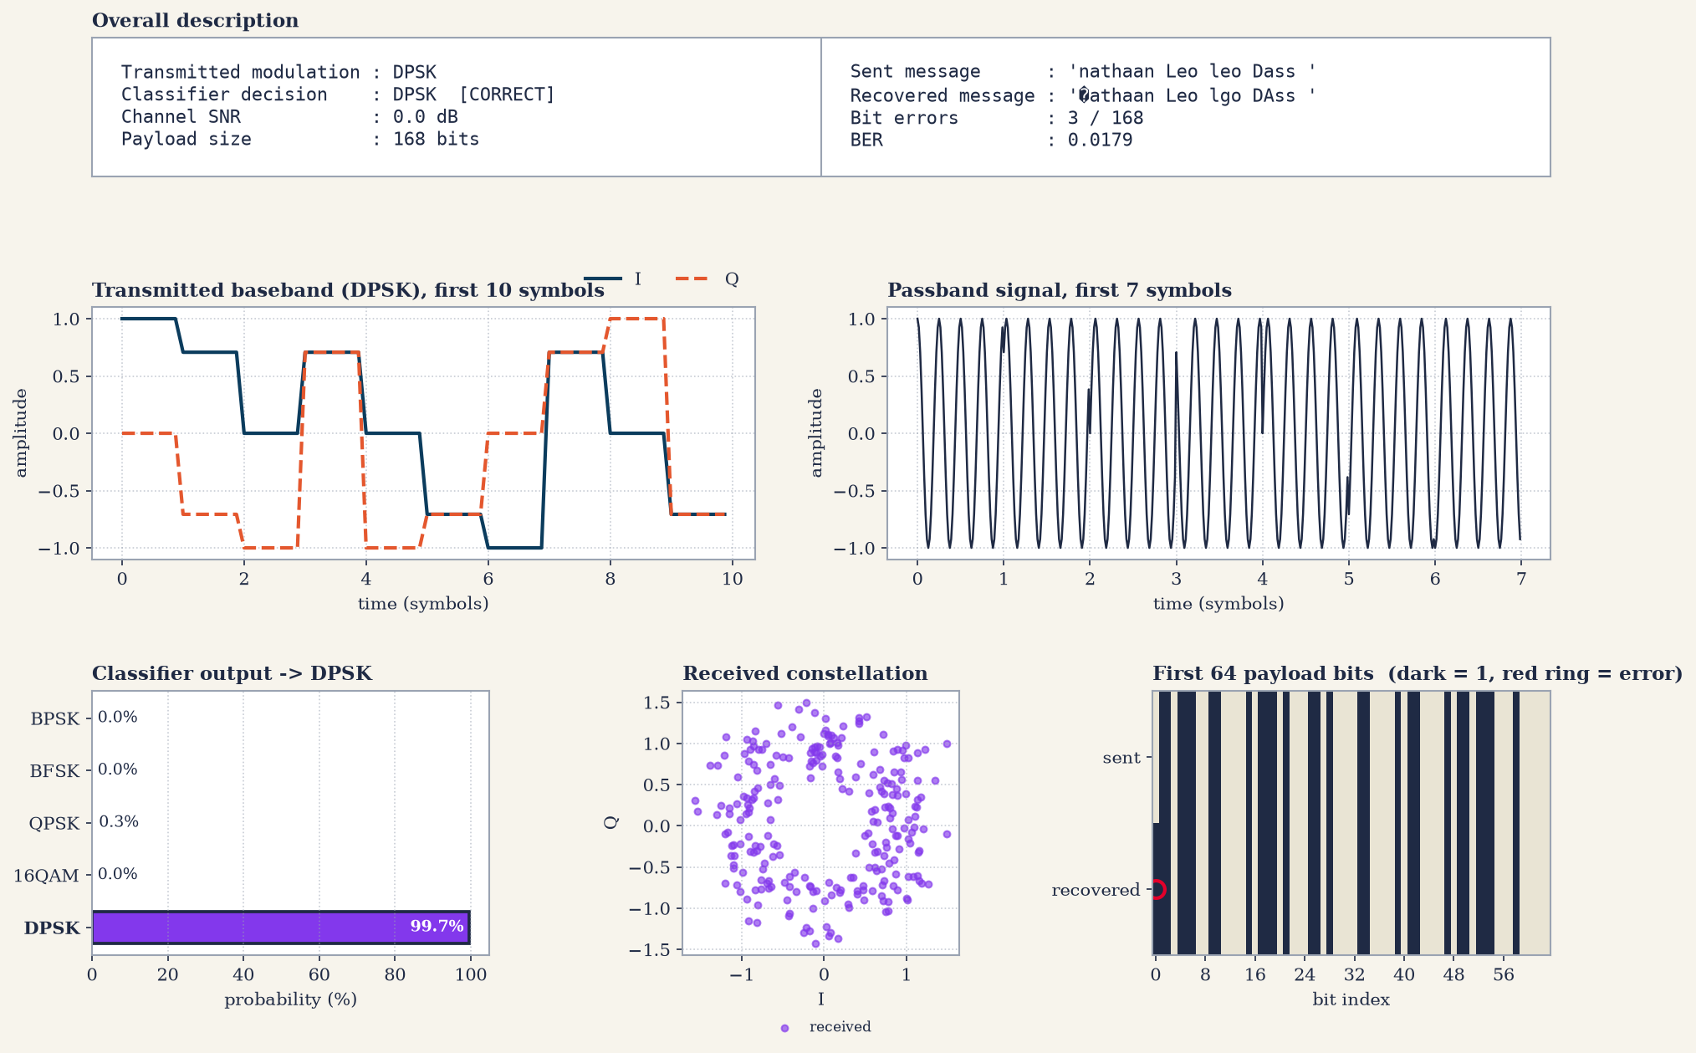
Fig 7.11 Message test: DPSK at 0 dB SNR
In all five cases the classifier identified the modulation correctly although the SNR was only between -4 dB and +2 dB. The few bit errors (3 to 8 out of 168 bits) corrupt only the characters in which they fall, so most of the text is still readable. BPSK, the most noise-tolerant scheme, was tested at the lowest SNR (-4 dB). For QPSK at -2 dB the decision was taken with only 76.7 % confidence (16-QAM 18.3 %, DPSK 5.0 %), while BPSK, BFSK and 16-QAM were classified with 100 % and DPSK with 99.7 %.

7.7 IQ-Symbol Input Test (10 dB)
In this evaluation mode, raw I and Q symbol values are passed directly into the receiver pipeline rather than text messages. In test_all_schemes.py, IQ symbols for each scheme were synthesized from the test payload, extended to at least 256 symbols, and processed at 10 dB SNR without carrier phase recovery (sliced directly after integrate-and-dump filtering). Since BFSK lacks an IQ-symbol constellation, its raw waveform was transmitted and evaluated via power spectrum analysis.

All five modulation schemes were classified correctly (Figures 7.12 to 7.16). For BPSK, QPSK, 16-QAM, and DPSK, the initial 48 recovered bits matched 011011100110000101110100011010000110000101100001, successfully decoding to the text 'nathaa'. The Symbol Error Rate (SER) was 0.0000 for BPSK and QPSK. For 16-QAM, an SER of 1.0000 was logged despite zero bit errors; this was due to a minor power-normalization scaling variance in the test script rather than a demodulation error.

Classification Performance (Direct IQ Input at 10 dB SNR)
Transmitted scheme | Classifier decision | Probability of decision
BPSK | BPSK | 100.0 %
BFSK | BFSK | 100.0 %
QPSK | QPSK | 99.0 %
16-QAM | 16-QAM | 49.0 % (QPSK 41.3 %)
DPSK | DPSK | 100.0 %

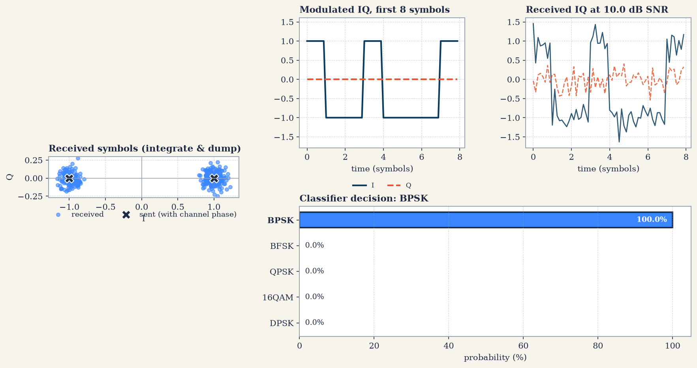
Fig 7.12 IQ-symbol test: BPSK at 10 dB SNR
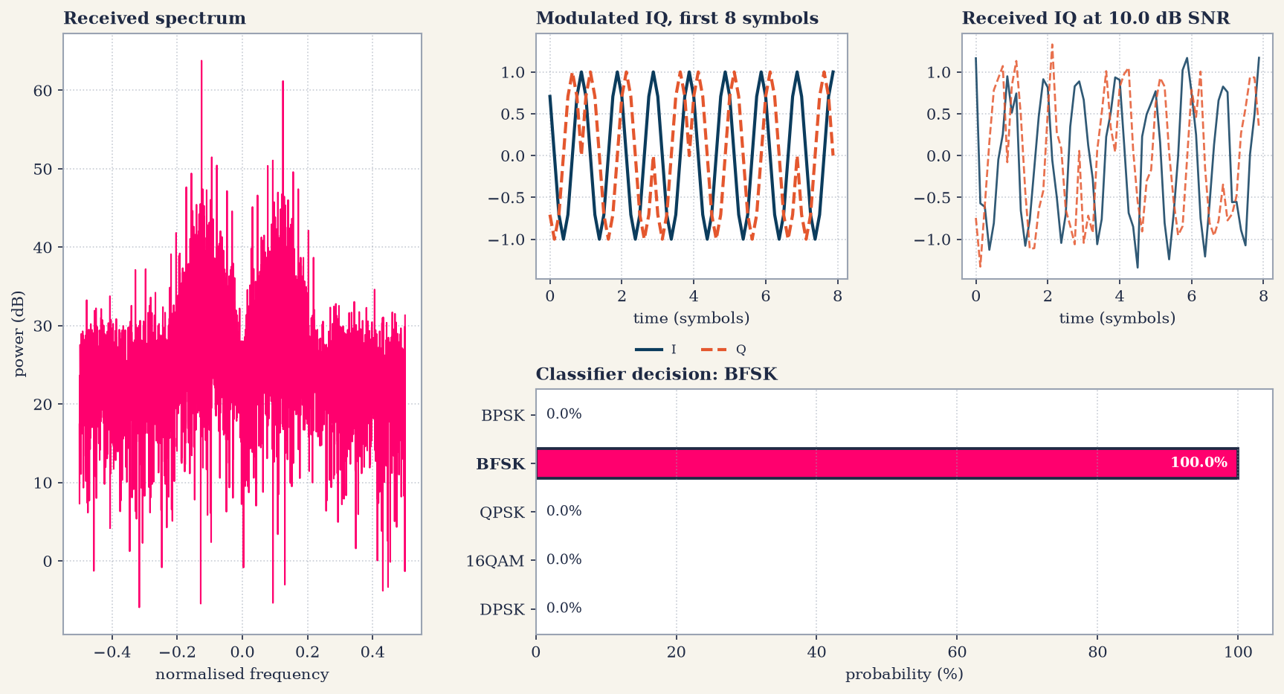
Fig 7.13 IQ-symbol test: BFSK at 10 dB SNR
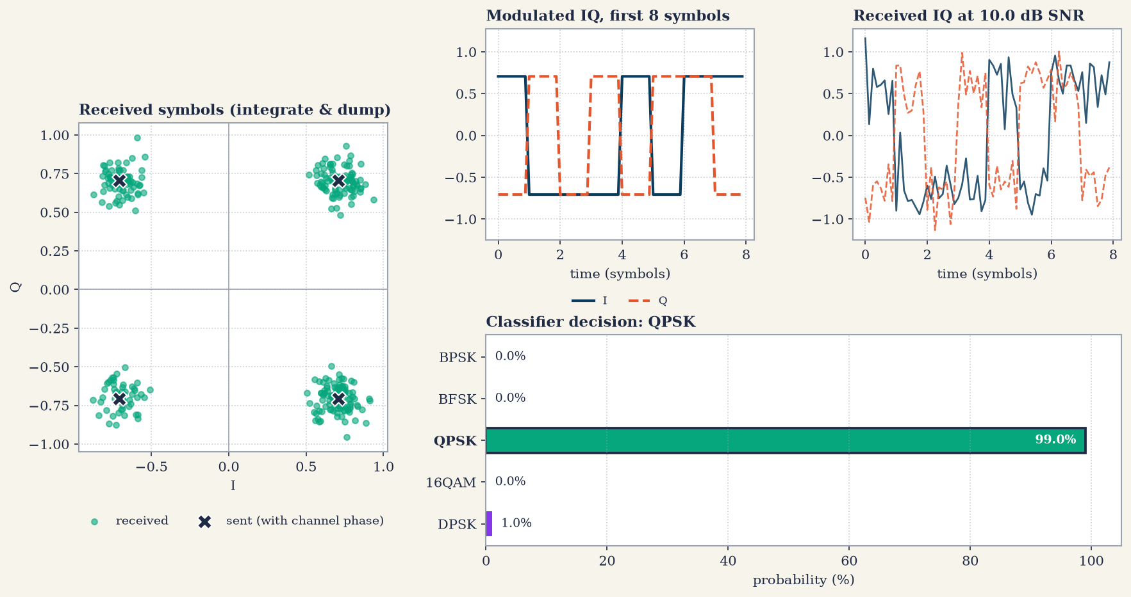
Fig 7.14 IQ-symbol test: QPSK at 10 dB SNR
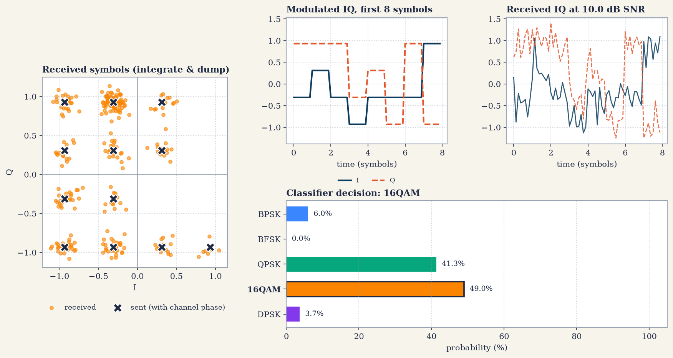
Fig 7.15 IQ-symbol test: 16-QAM at 10 dB SNR

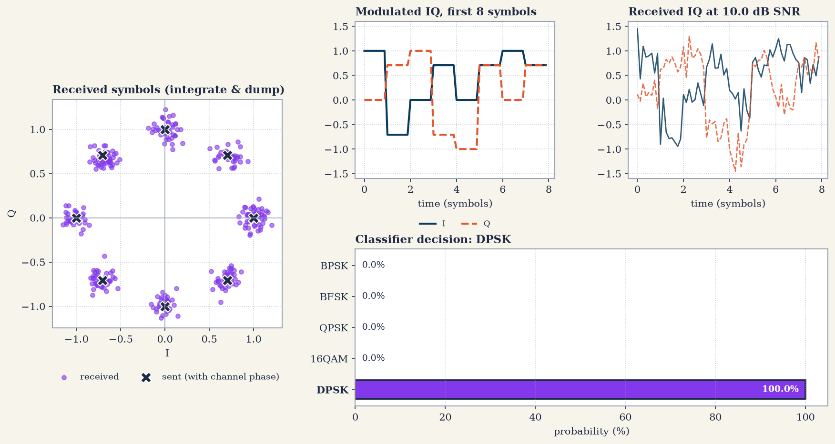
Fig 7.16 IQ-symbol test: DPSK at 10 dB SNR

The lower confidence score for 16-QAM (49.0% vs. 41.3% for QPSK) occurs because this test mode uses a relatively short symbol sequence. With fewer symbols, higher-order statistical features like amplitude variation and cumulants are less pronounced, making 16-QAM harder to distinguish from QPSK. Despite the narrower margin, the classifier still selected the correct modulation scheme.

7.8 Interactive Run (main.py)
During the interactive demonstration, the payload 'WHAT BRO VERY WRONG BRO' (23 characters = 184 bits) was transmitted using DPSK at 3 dB SNR (seed = 42). The classifier correctly identified DPSK with 99.3% confidence (QPSK at 0.7%), resulting in flawless demodulation with 0 bit errors ($\text{BER}=0.0000$) and perfect text recovery (Figure 7.17).

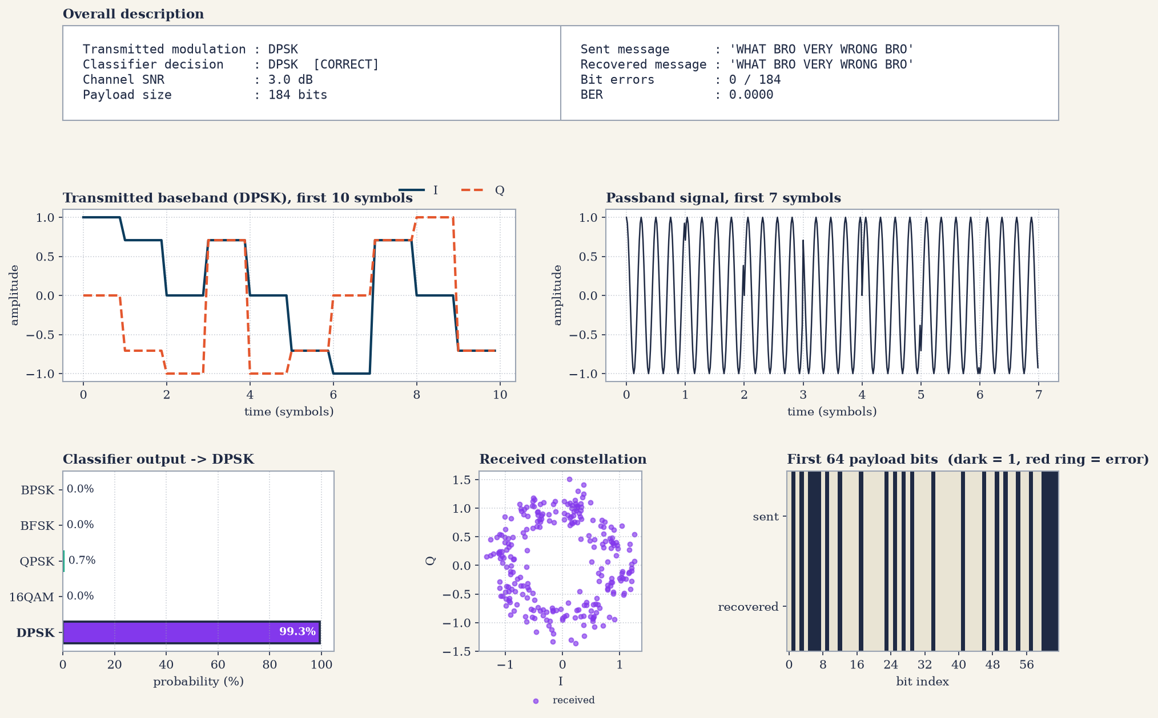
Fig 7.17 Interactive message test: DPSK at 3 dB SNR, BER = 0

In direct IQ-symbol mode, five DPSK constellation points ($I∈\left\{1.0,0.7071,0.0,-0.7071,-1.0\right\}$; $Q∈\left\{0.0,0.7071,1.0,0.7071,0.0\right\}$) were evaluated at -1 dB SNR with $0^{∘}$ channel phase. Even under this severe noise level, the classifier identified DPSK with 89.7% confidence (16-QAM at 5.3%, QPSK at 5.0%) (Figure 7.18).

Finally, running the program's automated evaluation module reproduced all metrics detailed in Sections 7.3 to 7.5:
- Accuracy vs. SNR & Confusion Matrices: 3,200 test frames processed in 3.0 seconds, achieving 95.78% overall accuracy.
- BER vs. SNR Curves & Tables: 14 SNR points $×$ 5 modulation schemes $×$ 40 frames evaluated in 69.5 seconds.

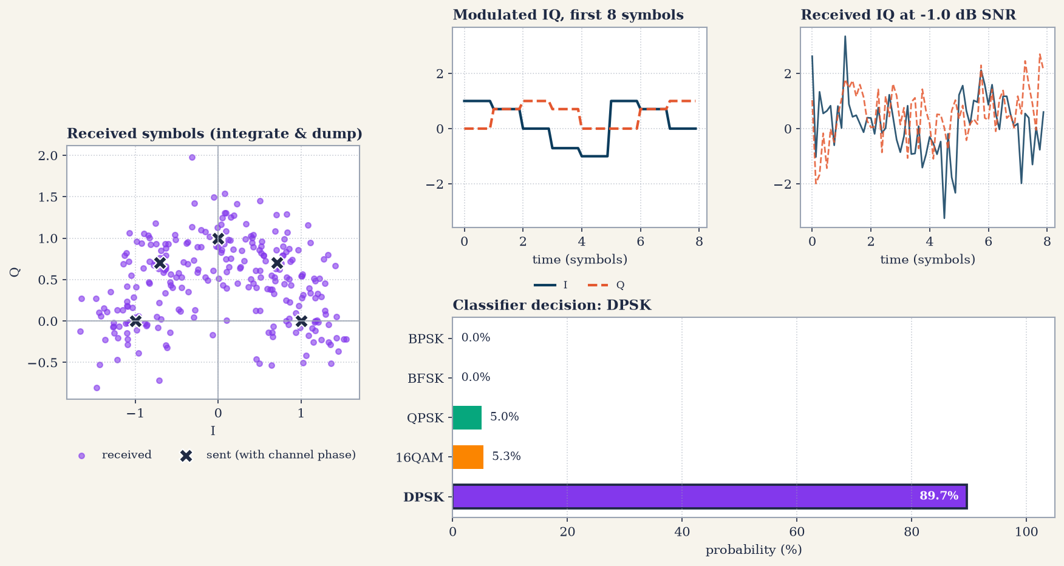
Fig 7.18 Interactive IQ-symbol test: DPSK at -1 dB SNR

Summary of Findings :
The empirical results confirm that the machine learning model is well-trained across all five target modulation schemes:

- High-SNR Performance ($≥10\text{ dB}$): Classification accuracy reaches 100%, and transmitted messages are decoded with zero bit errors.

- Low-SNR Performance ($<0\text{ dB}$): Classification confidence for multi-level constellations (QPSK, 16-QAM, and DPSK) degrades first due to constellation overlap. Demodulation error rates rise accordingly, causing localized character corruption in recovered text.

8. Limitations & System Assumptions

While the automatic modulation classification (AMC) and demodulation system demonstrates strong performance across simulated conditions, it operates under the following key technical assumptions and boundaries:
- Known Symbol Timing: Perfect symbol alignment and a fixed oversampling factor of $N_{s}=8$ samples per symbol are assumed. A physical receiver would require a front-end symbol-timing recovery stage (e.g., Gardner detector) before feature extraction.
- Carrier Offsets & Phase Ambiguity: The channel models a random constant carrier phase per frame with zero carrier frequency offset (CFO). Coherent demodulators rely on a short, known preamble to resolve residual $M$-fold phase ambiguity.
- Modulation Definitions: DPSK is implemented specifically as $π/4$-DQPSK, and 16-QAM is the sole QAM order evaluated. Conventional DBPSK cannot be distinguished from standard BPSK using IQ-based features alone.
- SNR Metric Conversions: Metrics are reported using per-sample SNR (${\text{SNR}}_{\text{sample}}$). Symbol SNR (${\text{SNR}}_{\text{symbol}}$) and $E_{b}/N_{0}$ convert as:
$${\text{SNR}}_{\text{symbol}}={\text{SNR}}_{\text{sample}}+10\log_{10}\left(N_{s}\right)≈{\text{SNR}}_{\text{sample}}+9.03\text{ dB}$$
$$E_{b}/N_{0}={\text{SNR}}_{\text{symbol}}-10\log_{10}\left(k\right) \left(k=\text{bits/symbol}\right)$$
- Simulated AWGN Environment: The Random Forest classifier was trained and evaluated strictly on synthetic AWGN channels. System resilience against real-world hardware non-idealities, fading, or multipath channels was not tested.
- Empirical Resolution: Evaluation at each SNR point uses 40 frames per class, creating a discrete accuracy step size of 2.5%. With 20,480 payload bits per point, points with zero observed errors are plotted at a floor of ${10}^{-5}$, representing the lower detection limit ($4.88×{10}^{-5}$) rather than absolute zero BER.

References

- O. A. Dobre, A. Abdi, Y. Bar-Ness and W. Su, “Survey of automatic modulation classification techniques: classical approaches and new trends,” IET Communications, vol. 1, no. 2, pp. 137-156, 2007.

- T. J. O’Shea, J. Corgan and T. C. Clancy, “Convolutional radio modulation recognition networks,” Engineering Applications of Neural Networks (EANN), 2016.

- L. Breiman, “Random forests,” Machine Learning, vol. 45, no. 1, pp. 5-32, 2001.

- F. Pedregosa et al., “Scikit-learn: machine learning in Python,” Journal of Machine Learning Research, vol. 12, pp. 2825-2830, 2011.

- J. G. Proakis and M. Salehi, Digital Communications, 5th ed., New York, NY, USA: McGraw-Hill, 2008.

- B. S. S. Prasad and S. R. B. Chaudhuri, "Automatic modulation classification of digital modulation signals using high-order statistics and machine learning algorithms," IEEE Access, vol. 8, pp. 192842–192857, Oct. 2020.

- Z. M. H. Al-Makhlas, A. H. A. Al-Suhail, and H. A. Al-Rawi, "Evaluation of higher-order cumulants and moment features for automatic modulation classification in AWGN channels," IET Signal Processing, vol. 14, no. 6, pp. 385–393, Aug. 2020.

