SRIVIN PLATFORMS
Delivery partner to RacingAhead / SportSeek
SportSeek — Unified Sports Ecosystem Platform
Work Breakdown Structure & Integrated Project Plan
Phase 2A, AI-native delivery: public launch on 20 October 2026, then two features every month to Phase 2A completion on 23 March 2027
Document control
Document | SRV-SPS-2A-PLN-001
Programme | SportSeek Phase 2 — Phase 2A (Harden & Unify)
Client | RacingAhead / SportSeek, Hyderabad
Prepared by | Srivin Platforms — Technical Programme Management Office
Version / date | v2.0 (AI-native release train) — 27 September 2026
Status | Issued for client review — supersedes v1.0
Reference baseline | SportSeek Phase 2 SOW v1.0 (15 Jul 2026); SportsSeek App High Level Requirements
Classification | Confidential — RacingAhead / SportSeek and Srivin Platforms only

Contents
1. Purpose and conventions
2. Executive summary
3. The AI-native delivery approach in brief
4. Feature catalogue: 12 features in 6 monthly releases
5. Date feasibility and release-train rules
6. Planning basis and assumptions
7. Work Breakdown Structure (WBS) and WBS dictionary
8. Integrated schedule
9. Detailed activity schedule
10. Dependency management
11. Critical path and schedule risk
12. Milestones, gates and acceptance evidence
13. Anatomy of a monthly release
14. Resource plan: AI-native pod, loading and technical skills
15. Baseline control and re-planning rules
Appendix A. SOW-to-WBS traceability

1. Purpose and conventions
This is the integrated project plan for Phase 2A of the SportSeek programme, prepared by Srivin Platforms as delivery partner to RacingAhead / SportSeek. It breaks the Phase 2A scope in the SportSeek Phase 2 SOW into 12 customer-facing features delivered in 6 monthly releases, schedules every work package, and dates every dependency on SportSeek and third parties.
Version 2.0 replaces the conventional plan in v1.0 with Srivin's AI-native delivery model. A small senior pod uses AI coding, testing and documentation agents under strict human review, so SportSeek gets features in production every month rather than every quarter. Where the SOW leaves an item open (marked ⚑ in the SOW), this plan does not assume an answer; it records a dated SportSeek decision (Section 10.3).
Companion document | Purpose
SRV-SPS-2A-DLM-002 Project Delivery Model | How the AI-native release train runs: AI-augmented lifecycle, cadence, governance, AI guardrails, quality, KT and support
SRV-SPS-2A-TAD-003 Technical Approach | Architecture on React Native / .NET / PostgreSQL, per-feature design, and the AI-accelerated engineering approach
SRV-SPS-2A-PLN-001a Project Plan workbook (.xlsx) | Schedule, dependency register, milestones and resource loading in spreadsheet form

- Dates are IST calendar dates; durations are working days (Mon–Fri). Public and festival holidays are applied once the joint holiday calendar is agreed.
- Owner: "Srivin", "SportSeek" or "Joint" (both, Srivin driving). Predecessors: a bare ID is Finish-to-Start, "SS" is Start-to-Start, "D-n" is an external dependency.
- R1–R6 are the monthly releases; F1–F12 are the features. SOW milestone numbers M1–M6 are kept in the traceability appendix.

2. Executive summary
SportSeek came to Srivin for a faster go-to-market. This plan delivers it. SportSeek goes public on 20 October 2026 with two new features on day one, and then receives two new features in production every month. The full Phase 2A scope is live by 23 March 2027, delivered by an AI-native pod of about 10 people.
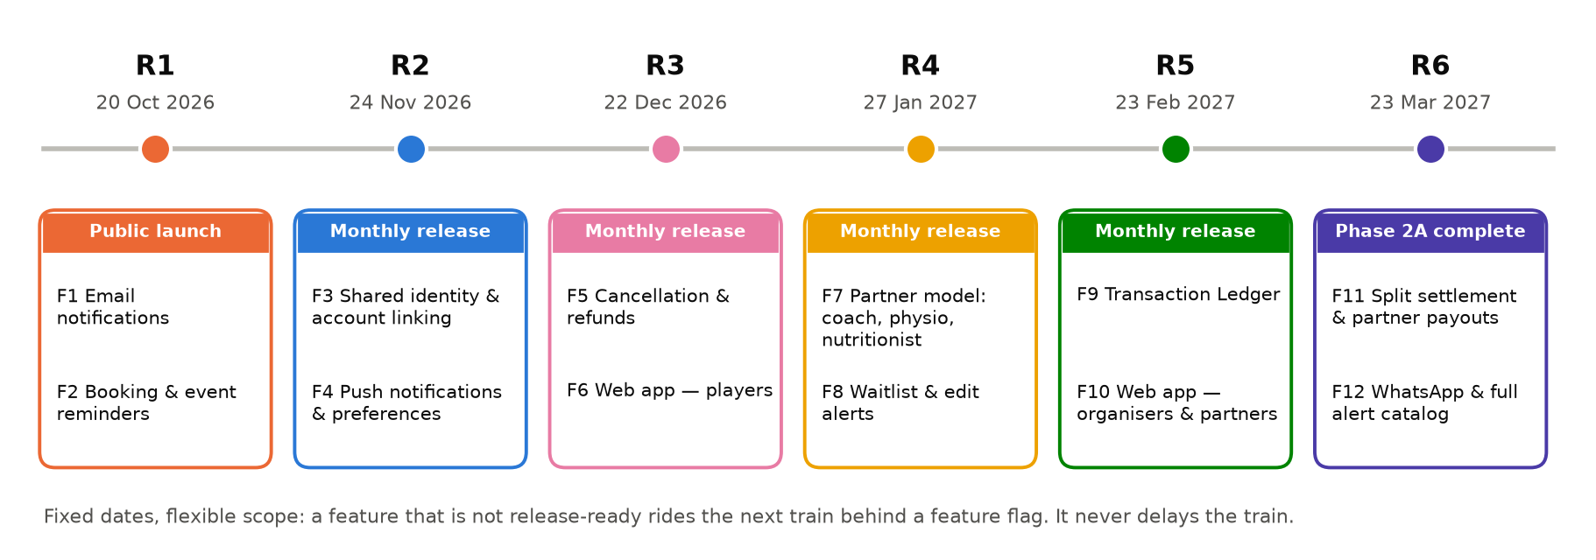
Figure 1 — Phase 2A release train: 6 releases, 12 features, one release every month
Release | Go-live | Features | SOW scope
R1 | Tue 20 Oct 2026 | Public launch of the hardened Phase 1 product + F1 Email notifications for all live alerts + F2 Booking & event reminders | Launch; M1 subset; M6 (part)
R2 | Tue 24 Nov 2026 | F3 Shared identity & account linking + F4 Push notifications & role-scoped preferences | M2; M6 (part)
R3 | Tue 22 Dec 2026 | F5 Cancellation & refunds + F6 Web app for players | M4 (part); Web app
R4 | Wed 27 Jan 2027 | F7 Generalised partner model (coach, physio, nutritionist) + F8 Waitlist & edit alerts | M5; M4 (part)
R5 | Tue 23 Feb 2027 | F9 Transaction Ledger + F10 Web app for organisers & partners | M3; Web app
R6 | Tue 23 Mar 2027 | F11 Split settlement & partner payouts + F12 WhatsApp & full alert catalog — Phase 2A complete | M5/M3 (payouts); M6

2.1 What changes versus a conventional plan
The comparison below is against Srivin's own conventional estimate for the same scope (plan v1.0), not a market benchmark.
Measure | Conventional (v1.0) | AI-native (this plan) | Difference
First new feature in production | Jan 2027 | 20 Oct 2026 (launch day) | ~3 months sooner
Release cadence | 4 releases in 7 months | 6 releases, one every month | Monthly value
Phase 2A complete | 4 May 2027 | 23 Mar 2027 | 6 weeks sooner
Peak Srivin team | ~24.5 FTE | ~12 FTE (launch month); ~10.5 steady state | ~55% smaller
Total Srivin effort | 154 person-months | 67.25 person-months | 56% less
Knowledge transfer | 2–4 weeks after each milestone | Continuous, with a signed checklist every release | No KT gaps

Key messages for the steering committee
1. Speed is designed in, not promised. AI agents write most first-draft code, tests and documentation from approved specifications, and senior engineers review and own every change. That is why a 10-person pod can release two features a month.
2. We are explicit about what AI does not speed up: SportSeek decisions, app-store review, UAT, penetration testing, and third-party approvals (Razorpay Route, DLT and WhatsApp templates). These are dated dependencies in Section 10.3. Each one is on SportSeek's side of the table and can move a feature to the next train.
3. Fixed dates, flexible scope. Every release date is fixed. If a feature is not release-ready, it rides the next monthly train behind a feature flag and the train still leaves on time.
4. Day-one prerequisite: SportSeek's approval of Srivin's AI tooling on its code (D21, by 29 Sep). Without it, the plan reverts to conventional pace and team size.

3. The AI-native delivery approach in brief
AI changes the economics of building software; it does not change who is accountable. Our model puts AI agents inside every engineering step and keeps a named senior engineer responsible for everything that merges. The full model is in the Project Delivery Model (SRV-SPS-2A-DLM-002). The planning consequences are below.
Where AI accelerates delivery | Where it does not, so the plan protects time for it
Reading and documenting the live Phase 1 code (architecture, ERD, API catalogue) in days instead of weeks | SportSeek decisions and approvals (scope, designs, refund policy, merge rules)
Drafting user stories, acceptance criteria, edge cases and UAT scripts from the SOW | App Store / Google Play review windows
Generating implementation code and unit tests from approved specifications | UAT by SportSeek testers
Generating API, regression and end-to-end tests; test data | Manual penetration testing (VAPT) before go-live
Porting existing mobile journeys to the web against the same APIs | Razorpay Route enablement, DLT template registration, WhatsApp template approval
Migration and reconciliation scripts; first-pass code review; living documentation | Production data migration windows and rehearsals

Planning assumption: AI-assisted build, test and documentation effort is planned at roughly 40–50% of our conventional estimate. No reduction is assumed for decisions, approvals, UAT or security testing. Actual velocity is measured from R2, and the plan is re-baselined at the R2 release review if needed (Section 15).

4. Feature catalogue: 12 features in 6 monthly releases
ID | Feature | What the user gets | Rel. | Depends on | SOW ref.
F1 | Email notifications | Email alongside SMS for OTP-free alerts: booking, registration and payment confirmations | R1 | D14 email provider | §10.1–10.2
F2 | Booking & event reminders | T-24h and T-2h reminders for bookings and events | R1 | D12 templates / DLT | §10.2
F3 | Shared identity & account linking | One account across User and Partner apps; OTP-verified linking; multiple roles; KYC reused | R2 | HLD (3.4) | §7, §9.1
F4 | Push notifications & preferences | Push on iOS/Android; notification preferences per role | R2 | F3 roles; D14 FCM/APNs | §7.4, §10
F5 | Cancellation & refunds | Cancel bookings and tournament registrations; refunds to original payment method via the gateway | R3 | D11 refund policy | §8.2, §9.3
F6 | Web app — players | Venue search, availability, booking, event registration and payment on the web | R3 | F3 login; design system | §3.1
F7 | Generalised partner model | Coach, physio and nutritionist partners onboard like facilities; new types enabled by admin configuration | R4 | F3 roles | §9.4
F8 | Waitlist & edit alerts | Join a waitlist for full slots/tournaments; alerts when a published event changes | R4 | F4 channels; F5 states | §9.3, §10.2
F9 | Transaction Ledger | Admin payment history, detail, filters, sorting, PDF/CSV statements, refund tracker | R5 | F3; F5; D15 | §8
F10 | Web app — organisers & partners | Events, tournaments, scheduling, scoring, service and booking management on the web | R5 | F6; F7 | §3.1
F11 | Split settlement & partner payouts | Razorpay Route linked accounts for all partner types; partner settlement view on web | R6 | F7; F9; D10 | §8.2–8.3
F12 | WhatsApp & full alert catalog | WhatsApp channel and every SOW §10.2 trigger live | R6 | F4; D13 | §10

Enablers ship inside releases but are not counted as features: platform foundation (R2), reconciliation of existing duplicate accounts (R3), data import tools for completed events (R6), and the infrastructure operations runbook (R6).

5. Date feasibility and release-train rules
As at the date of this plan (Sunday 27 September 2026) there are 16 working days before 20 October 2026. R1 is feasible because it adds only two low-risk, back-end-led features to a hardened Phase 1 product. The AI-generated regression suite and AI-assisted assessment compress the hardening work into the available window.
Launch-date conditions
The 20 Oct date holds only if: (a) the NDA/SOW is executed and access to code, infrastructure, store consoles and the gateway dashboard is granted by 29 Sep; (b) AI tooling is approved by 29 Sep (D21); (c) launch scope is frozen at the Scope Gate on 1 Oct; (d) legal content is supplied by 9 Oct; (e) UAT testers are available 15–19 Oct.
F1 and F2 need the email provider account and message templates by 5 Oct (D12, D14). If these are late, F1/F2 ship as a fast-follow within 2 weeks. The public launch itself is not delayed.

5.1 Release-train rules
- Release dates are fixed for the whole plan; they are the calendar SportSeek's marketing can plan around.
- Scope flexes between trains. A feature that misses its hardening entry criteria moves to the next train behind a feature flag. It is never forced into production.
- Every release passes the same gates: automated regression, security scans, UAT sign-off and Go/No-Go (Section 12). Security-sensitive releases (R2 identity, R3 refunds, R6 payouts) also get a targeted manual pen test, and R6 gets the full pre-completion VAPT.
- Back-end changes can deploy continuously behind flags; mobile store releases follow the monthly train.

6. Planning basis and assumptions
# | Assumption | If it does not hold
A1 | Kick-off Tue 29 Sep 2026 with NDA and SOW/PO executed. | Launch at risk day-for-day
A2 | Phase 1 source code, DB schema and API documentation provided before kick-off (SOW §5). | Launch hardening slips
A3 | All accounts are SportSeek-owned; Srivin works within them (SOW §5, §15). | Access requests on the critical path
A4 | A named SportSeek Product Owner decides within 1 working day and approves UI within 2 working days. | Features ride the next train
A5 | SportSeek testers run UAT in the hardening week of each release (3 days). | Release slips to next train
A6 | Stack as confirmed: React Native mobile, .NET back end, PostgreSQL. React/Next.js proposed for web. | Skills mix re-planned
A7 | SportSeek approves AI tooling under enterprise terms (no training on SportSeek code or data; no production personal data in prompts) (D21). | Plan reverts to conventional pace and team
A8 | Razorpay is the gateway; Route split settlement will be integrated (SOW §8.3 NOTE). | F11 re-planned via change request
A9 | Ledger scope is Admin + partner settlement view on web (SOW §8.1–8.2); any mobile ledger view is confirmed by D15. | Adds scope to a later train
A10 | AI-assisted build effort planned at ~40–50% of conventional; no reduction for approvals, UAT, VAPT. | Re-baseline at R2 review
A11 | Phase 2B/2C scope excluded; the same train can continue into Phase 2B from April 2027. | —

7. Work Breakdown Structure (WBS) and WBS dictionary
The WBS is organised by release, so each Level-1 element is something SportSeek can accept on its own. Every Phase 2A scope item in SOW §3.1 and every deliverable in SOW §13 maps to a work package (Appendix A).

7.1 WBS hierarchy (Levels 1–2)
L1 | Element | Level-2 work packages
1 | Programme Management & AI Delivery Governance | 1.1 Mobilisation & AI toolchain · 1.2 Kick-off · 1.3 Train plan, RAID, AI policy · 1.4 Governance cadence · 1.5 Change control · 1.6 Closure
2 | R1 — Public Launch + F1, F2 | 2.1 AI-assisted assessment · 2.2 Scope Gate · 2.3 Env/CI-CD · 2.4 AI-generated regression suite · 2.5 Defects · 2.6 Security & VAPT · 2.7 Load test · 2.8 Store & DPDP · 2.9 F1 · 2.10 F2 · 2.11 Freeze · 2.12 Store · 2.13 UAT · 2.14 Runbook · 2.15 Go/No-Go · 2.16 Launch · 2.17 Hypercare
3 | Discovery, Architecture & Design | 3.1 AI-generated as-is docs · 3.2 Story mapping · 3.3 HLD & ADRs · 3.4 HLD sign-off · 3.5 Design system · 3.6 Design approval · 3.7 Specs/UI/LLD one train ahead · 3.8 Open-item closure
4 | Platform Foundation (M1) | 4.1 IaC · 4.2 CI/CD gates incl. AI review · 4.3 Event bus, BFF, feature flags · 4.4 M1 acceptance
5 | R2 — F3, F4 | 5.1 F3 Shared identity · 5.2 F4 Push & preferences · 5.3 Hardening & UAT · 5.4 Go-live · 5.5 Hypercare & KT
6 | R3 — F5, F6 | 6.1 F5 Cancellation & refunds · 6.2 F6 Web (players) · 6.3 Account reconciliation · 6.4 Hardening · 6.5 Go-live · 6.6 Hypercare & KT
7 | R4 — F7, F8 | 7.1 F7 Partner model · 7.2 F8 Waitlist & edit alerts · 7.3 Hardening · 7.4 Go-live · 7.5 Hypercare & KT
8 | R5 — F9, F10 | 8.1 F9 Ledger · 8.2 F10 Web (organisers & partners) · 8.3 Hardening · 8.4 Go-live · 8.5 Hypercare & KT
9 | R6 — F11, F12 & Phase completion | 9.1 F11 Route payouts · 9.2 F12 WhatsApp & catalog · 9.3 Import tools · 9.4 Hardening & full VAPT · 9.5 Go-live · 9.6 Hypercare · 9.7 Ops runbook · 9.8 Final KT · 9.9 Acceptance
10 | Continuous Support | 10.1 Phase 1 production support · 10.2 90-day warranty per release

7.2 WBS dictionary — key work packages
WBS | Work package | Key deliverables | Completion / acceptance criteria | SOW
2.1 | AI-assisted Phase 1 assessment | Codebase map, ERD, API inventory, dependency and security findings, defect triage, launch risks | Reviewed at the Scope Gate; each launch risk owned and decided | 5, 16
2.4 | AI-generated regression suite | Automated API and mobile regression covering every live Phase 1 journey | Suite green on the RC build; runs on every merge from then on | 14.1
2.6 | Security baseline | SAST, dependency, DAST reports; VAPT of launch surface; remediation log | No open critical/high findings at Go/No-Go | 6.2
3.3 | HLD & ADRs | Target architecture, ADRs, integration and security design, NFR targets | Signed off by SportSeek (3.4) | 6, 13
3.7 | Feature specs & LLD | Per feature: spec, API contract (OpenAPI), DB changes, UI frames, acceptance tests. The spec is the input the AI agents build from. | Approved by PO and architect before its train starts | 9, 13
5.1 | F3 Shared identity | OIDC clients per app; OTP-verified linking; roles; KYC reuse | Existing User App phone/email registering on Partner App links to the same identity, with no duplicate | 7.3, 9.1
6.1 | F5 Cancellation & refunds | Policy rules; gateway refund API with idempotency; state machine; notifications | No double refund under retry; Phase 1 regression green | 8.2, 9.3
6.3 | Account reconciliation | Duplicate report; approved merge rules; migration & rollback scripts | Dry-run reconciles 100% of records; SportSeek approves (D18) | 7.3, 17
7.1 | F7 Partner model | Service-type registry; admin configuration; facility migration; verification per type | New type enabled without code; facility partners unaffected | 9.4
8.1 | F9 Transaction Ledger | Ingestion + reconciliation; admin screens; exports; refund tracker | Every gateway transaction appears within the sync window; exports match gateway exactly | 8.2
9.1 | F11 Split settlement | Route linked accounts for all partner types; settlement view on web | Test partners of every type receive split settlement in Razorpay test mode | 8.3
6.2, 8.2 | Web application | React/Next.js web app for players (R3), organisers & partners (R5) | Parity checklist vs mobile signed; browser and accessibility checks pass | 3.1
per release | KT checklist | AI-maintained docs, walkthrough, checklist per release | Checklist signed within 5 working days of each go-live | 12.2

8. Integrated schedule
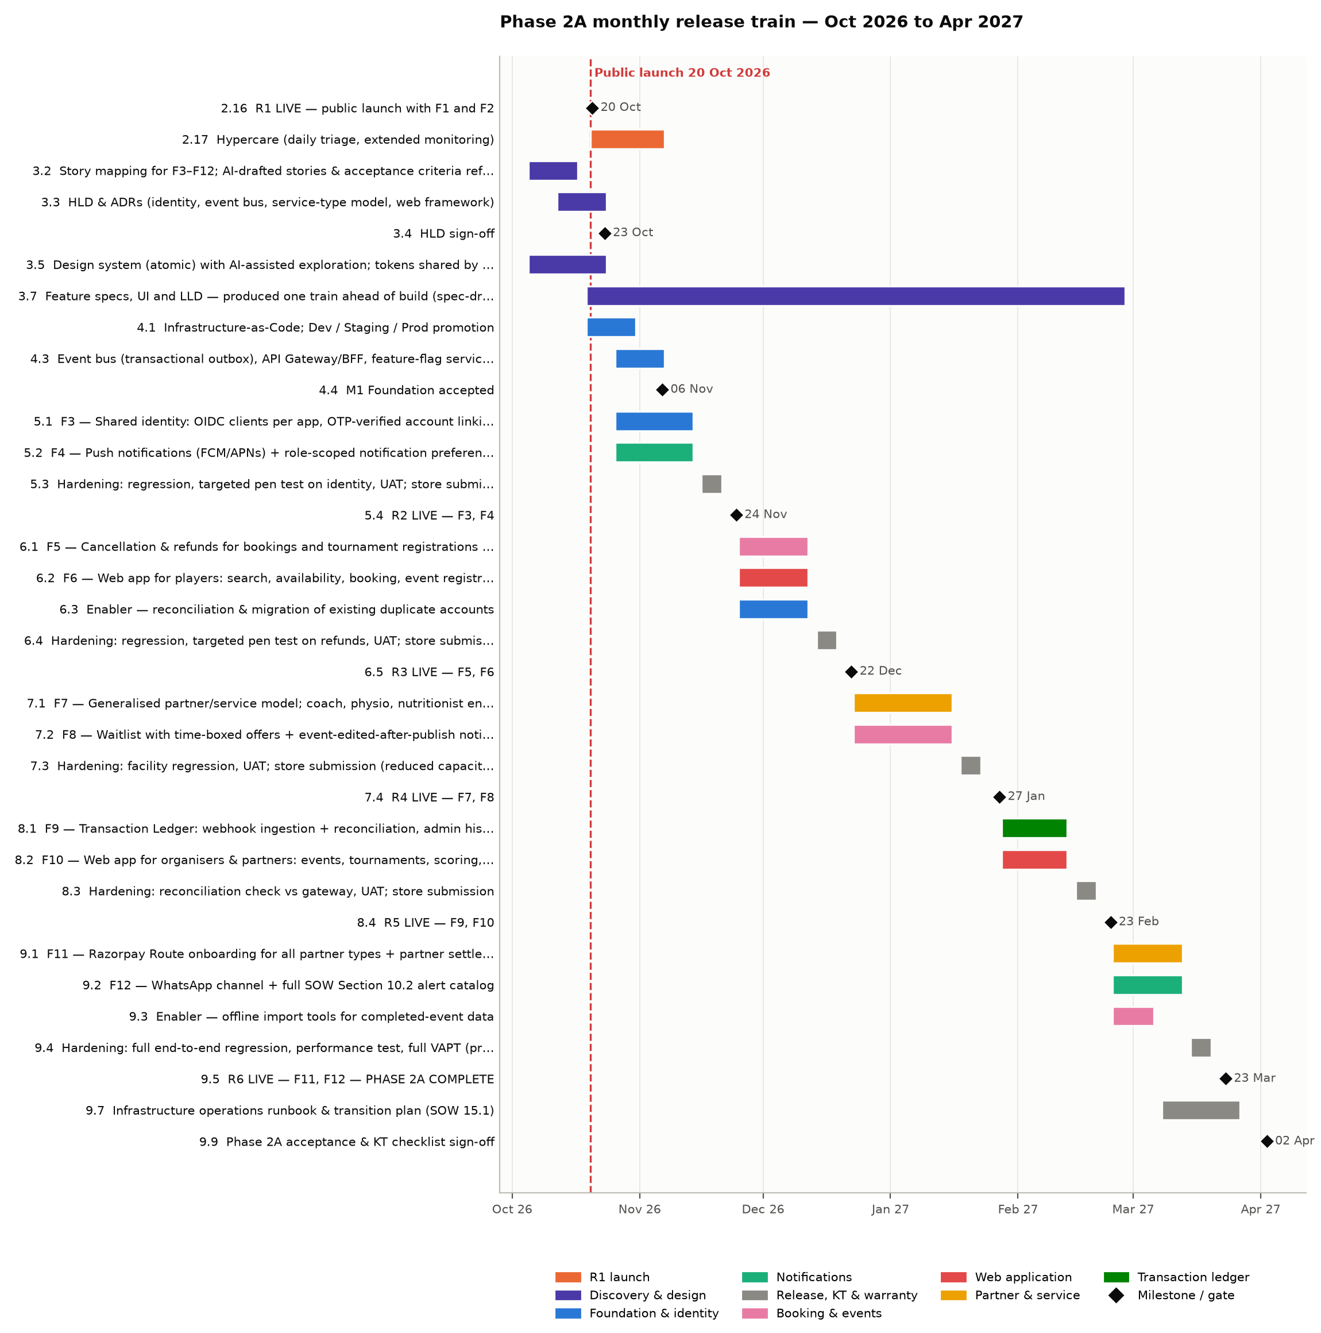
Figure 2 — Phase 2A monthly release train (summary level; all activities in Section 9)

8. Integrated schedule (continued)
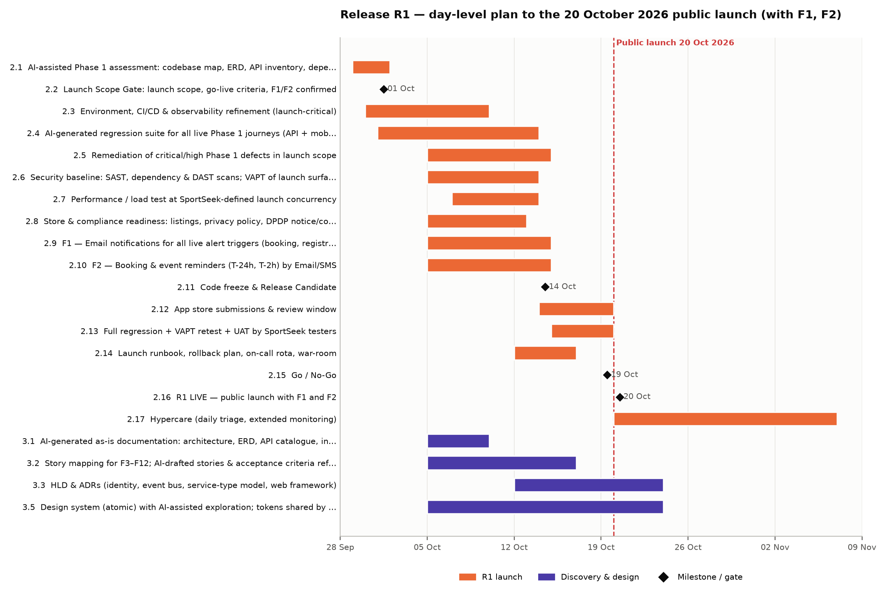
Figure 3 — Release R1: day-level plan to the 20 October 2026 public launch

9. Detailed activity schedule
Every activity with owner, dates, working-day duration and predecessors. The same data is in the workbook (SRV-SPS-2A-PLN-001a).
WBS | Activity | Owner | Start | Finish | Days | Predecessors
1 Programme Management & AI Delivery Governance (28 Sept 26 – 09 Apr 27)
1.1 | Mobilisation: NDA, SOW/PO, access; AI toolchain set up under SportSeek-approved terms (D21) | Joint | 28 Sept 26 | 30 Sept 26 | 3 | —
1.2 | ◆ Kick-off workshop (SportSeek + Srivin) | Joint | 29 Sept 26 | 29 Sept 26 | 0 | 1.1SS
1.3 | Release-train plan, RAID log, governance charter, AI usage policy | Srivin | 29 Sept 26 | 02 Oct 26 | 4 | 1.2
1.4 | Governance cadence: daily stand-up, weekly demo & status, monthly release review / steering | Srivin | 30 Sept 26 | 09 Apr 27 | 138 | 1.2
1.5 | Change control (SOW Section 18) — ongoing; scope flexes between trains, dates do not | Joint | 30 Sept 26 | 09 Apr 27 | 138 | 1.2
1.6 | Phase 2A closure: completion report, lessons learned, Phase 2B readiness | Joint | 05 Apr 27 | 09 Apr 27 | 5 | 9.9
2 Release R1 — Public Launch + F1, F2 (20 Oct 2026) (29 Sept 26 – 06 Nov 26)
2.1 | AI-assisted Phase 1 assessment: codebase map, ERD, API inventory, dependency & security scan, defect triage | Srivin | 29 Sept 26 | 01 Oct 26 | 3 | 1.2, D2
2.2 | ◆ Launch Scope Gate: launch scope, go-live criteria, F1/F2 confirmed | SportSeek | 01 Oct 26 | 01 Oct 26 | 0 | 2.1
2.3 | Environment, CI/CD & observability refinement (launch-critical) | Srivin | 30 Sept 26 | 09 Oct 26 | 8 | 1.2
2.4 | AI-generated regression suite for all live Phase 1 journeys (API + mobile) | Srivin | 01 Oct 26 | 13 Oct 26 | 9 | 2.1SS
2.5 | Remediation of critical/high Phase 1 defects in launch scope | Joint | 05 Oct 26 | 14 Oct 26 | 8 | 2.2
2.6 | Security baseline: SAST, dependency & DAST scans; VAPT of launch surface | Srivin | 05 Oct 26 | 13 Oct 26 | 7 | 2.2
2.7 | Performance / load test at SportSeek-defined launch concurrency | Srivin | 07 Oct 26 | 13 Oct 26 | 5 | 2.3SS, D5
2.8 | Store & compliance readiness: listings, privacy policy, DPDP notice/consent, account deletion | Joint | 05 Oct 26 | 12 Oct 26 | 6 | 2.2, D6
2.9 | F1 — Email notifications for all live alert triggers (booking, registration, payment) | Srivin | 05 Oct 26 | 14 Oct 26 | 8 | 2.2, D14
2.10 | F2 — Booking & event reminders (T-24h, T-2h) by Email/SMS | Srivin | 05 Oct 26 | 14 Oct 26 | 8 | 2.2, D12
2.11 | ◆ Code freeze & Release Candidate | Srivin | 14 Oct 26 | 14 Oct 26 | 0 | 2.5, 2.9, 2.10
2.12 | App store submissions & review window | Joint | 14 Oct 26 | 19 Oct 26 | 4 | 2.11, 2.8
2.13 | Full regression + VAPT retest + UAT by SportSeek testers | Joint | 15 Oct 26 | 19 Oct 26 | 3 | 2.11
2.14 | Launch runbook, rollback plan, on-call rota, war-room | Srivin | 12 Oct 26 | 16 Oct 26 | 5 | 2.3
2.15 | ◆ Go / No-Go | SportSeek | 19 Oct 26 | 19 Oct 26 | 0 | 2.12, 2.13, 2.14
2.16 | ◆ R1 LIVE — public launch with F1 and F2 | Joint | 20 Oct 26 | 20 Oct 26 | 0 | 2.15
2.17 | Hypercare (daily triage, extended monitoring) | Srivin | 20 Oct 26 | 06 Nov 26 | 14 | 2.16
3 Discovery, Architecture & Design (AI-assisted, runs alongside launch) (05 Oct 26 – 26 Feb 27)
3.1 | AI-generated as-is documentation: architecture, ERD, API catalogue, integration map | Srivin | 05 Oct 26 | 09 Oct 26 | 5 | 2.1
3.2 | Story mapping for F3–F12; AI-drafted stories & acceptance criteria refined with PO | Joint | 05 Oct 26 | 16 Oct 26 | 10 | 3.1SS, D8
3.3 | HLD & ADRs (identity, event bus, service-type model, web framework) | Srivin | 12 Oct 26 | 23 Oct 26 | 10 | 3.1
3.4 | ◆ HLD sign-off | SportSeek | 23 Oct 26 | 23 Oct 26 | 0 | 3.3
3.5 | Design system (atomic) with AI-assisted exploration; tokens shared by mobile & web | Srivin | 05 Oct 26 | 23 Oct 26 | 15 | 3.2SS
3.6 | ◆ Design system approval | SportSeek | 23 Oct 26 | 23 Oct 26 | 0 | 3.5
3.7 | Feature specs, UI and LLD — produced one train ahead of build (spec-driven development) | Joint | 19 Oct 26 | 26 Feb 27 | 95 | 3.3SS
3.8 | Closure of SOW open items (ledger visibility, alert catalog, SLAs, NFRs, refund policy, Route) | SportSeek | 05 Oct 26 | 08 Jan 27 | 70 | D10, D11, D15, D16, D20
4 Platform Foundation (M1) — built in the first build cycle (19 Oct 26 – 06 Nov 26)
4.1 | Infrastructure-as-Code; Dev / Staging / Prod promotion | Srivin | 19 Oct 26 | 30 Oct 26 | 10 | 3.3SS
4.2 | CI/CD quality gates incl. AI code review, SAST, dependency & secret scanning, coverage | Srivin | 19 Oct 26 | 30 Oct 26 | 10 | 3.3SS
4.3 | Event bus (transactional outbox), API Gateway/BFF, feature-flag service | Srivin | 26 Oct 26 | 06 Nov 26 | 10 | 3.4
4.4 | ◆ M1 Foundation accepted | SportSeek | 06 Nov 26 | 06 Nov 26 | 0 | 4.1, 4.2, 4.3
5 Release R2 — F3 Shared Identity, F4 Push & Preferences (24 Nov 2026) (26 Oct 26 – 30 Nov 26)
5.1 | F3 — Shared identity: OIDC clients per app, OTP-verified account linking, multi-role, KYC reuse | Joint | 26 Oct 26 | 13 Nov 26 | 15 | 3.4, 3.6
5.2 | F4 — Push notifications (FCM/APNs) + role-scoped notification preferences | Srivin | 26 Oct 26 | 13 Nov 26 | 15 | 3.4, D14
5.3 | Hardening: regression, targeted pen test on identity, UAT; store submission | Joint | 16 Nov 26 | 20 Nov 26 | 5 | 5.1, 5.2
5.4 | ◆ R2 LIVE — F3, F4 | Joint | 24 Nov 26 | 24 Nov 26 | 0 | 5.3
5.5 | Hypercare + KT checklist sign-off (R2) | Srivin | 24 Nov 26 | 30 Nov 26 | 5 | 5.4
6 Release R3 — F5 Cancellation & Refunds, F6 Web App (Players) (22 Dec 2026) (25 Nov 26 – 29 Dec 26)
6.1 | F5 — Cancellation & refunds for bookings and tournament registrations (gateway refund API, policy rules) | Srivin | 25 Nov 26 | 11 Dec 26 | 13 | 5.4, D11
6.2 | F6 — Web app for players: search, availability, booking, event registration, payments | Srivin | 25 Nov 26 | 11 Dec 26 | 13 | 5.4, 3.6
6.3 | Enabler — reconciliation & migration of existing duplicate accounts | Joint | 25 Nov 26 | 11 Dec 26 | 13 | 5.4, D18
6.4 | Hardening: regression, targeted pen test on refunds, UAT; store submission | Joint | 14 Dec 26 | 18 Dec 26 | 5 | 6.1, 6.2, 6.3
6.5 | ◆ R3 LIVE — F5, F6 | Joint | 22 Dec 26 | 22 Dec 26 | 0 | 6.4
6.6 | Hypercare + KT checklist sign-off (R3) | Srivin | 22 Dec 26 | 29 Dec 26 | 6 | 6.5
7 Release R4 — F7 Generalised Partner Model, F8 Waitlist & Edit Alerts (27 Jan 2027) (23 Dec 26 – 02 Feb 27)
7.1 | F7 — Generalised partner/service model; coach, physio, nutritionist enabled by admin configuration | Srivin | 23 Dec 26 | 15 Jan 27 | 18 | 6.5
7.2 | F8 — Waitlist with time-boxed offers + event-edited-after-publish notifications | Srivin | 23 Dec 26 | 15 Jan 27 | 18 | 6.5
7.3 | Hardening: facility regression, UAT; store submission (reduced capacity over year-end) | Joint | 18 Jan 27 | 22 Jan 27 | 5 | 7.1, 7.2
7.4 | ◆ R4 LIVE — F7, F8 | Joint | 27 Jan 27 | 27 Jan 27 | 0 | 7.3
7.5 | Hypercare + KT checklist sign-off (R4) | Srivin | 27 Jan 27 | 02 Feb 27 | 5 | 7.4
8 Release R5 — F9 Transaction Ledger, F10 Web App (Organisers & Partners) (23 Feb 2027) (28 Jan 27 – 02 Mar 27)
8.1 | F9 — Transaction Ledger: webhook ingestion + reconciliation, admin history/detail, PDF/CSV export, refund tracker | Srivin | 28 Jan 27 | 12 Feb 27 | 12 | 7.4, D15
8.2 | F10 — Web app for organisers & partners: events, tournaments, scoring, service & booking management | Srivin | 28 Jan 27 | 12 Feb 27 | 12 | 7.4
8.3 | Hardening: reconciliation check vs gateway, UAT; store submission | Joint | 15 Feb 27 | 19 Feb 27 | 5 | 8.1, 8.2
8.4 | ◆ R5 LIVE — F9, F10 | Joint | 23 Feb 27 | 23 Feb 27 | 0 | 8.3
8.5 | Hypercare + KT checklist sign-off (R5) | Srivin | 23 Feb 27 | 02 Mar 27 | 6 | 8.4
9 Release R6 — F11 Split Settlement & Partner Payouts, F12 WhatsApp & Full Alert Catalog (23 Mar 2027) (24 Feb 27 – 09 Apr 27)
9.1 | F11 — Razorpay Route onboarding for all partner types + partner settlement view (web) | Srivin | 24 Feb 27 | 12 Mar 27 | 13 | 8.4, D10
9.2 | F12 — WhatsApp channel + full SOW Section 10.2 alert catalog | Srivin | 24 Feb 27 | 12 Mar 27 | 13 | 8.4, D13
9.3 | Enabler — offline import tools for completed-event data | Srivin | 24 Feb 27 | 05 Mar 27 | 8 | 8.4, D19
9.4 | Hardening: full end-to-end regression, performance test, full VAPT (pre-completion), UAT | Joint | 15 Mar 27 | 19 Mar 27 | 5 | 9.1, 9.2, 9.3
9.5 | ◆ R6 LIVE — F11, F12 — PHASE 2A COMPLETE | Joint | 23 Mar 27 | 23 Mar 27 | 0 | 9.4
9.6 | Hypercare | Srivin | 23 Mar 27 | 02 Apr 27 | 9 | 9.5
9.7 | Infrastructure operations runbook & transition plan (SOW 15.1) | Srivin | 08 Mar 27 | 26 Mar 27 | 15 | 9.1SS
9.8 | Final KT: platform operations and architecture walkthrough | Srivin | 24 Mar 27 | 02 Apr 27 | 8 | 9.5
9.9 | ◆ Phase 2A acceptance & KT checklist sign-off | SportSeek | 02 Apr 27 | 02 Apr 27 | 0 | 9.7, 9.8
10 Continuous Support Obligations (20 Oct 26 – 21 Jun 27)
10.1 | Phase 1 production monitoring & bug fixes (SOW Section 16) | Srivin | 20 Oct 26 | 09 Apr 27 | 124 | 2.16
10.2 | 90-day warranty per release (R1 → 18 Jan 2027 … R6 → 21 Jun 2027) | Srivin | 20 Oct 26 | 21 Jun 27 | 175 | 2.16

10. Dependency management

10.1 Dependency types
Type | Meaning | How it is managed
FS / SS | Finish-to-Start / Start-to-Start between activities | Tracked in the schedule; reviewed at every weekly demo
Feature → feature | A feature needs another feature live first (e.g. F9 Ledger needs F5 refunds) | Encoded in the release order (Section 10.2); the order is the plan's backbone
External (D-n) | Input or approval from SportSeek or a SportSeek-contracted third party | Dated register (10.3); escalated 5 working days before the need-by date; a late item moves its feature to the next train

10.2 Feature dependency chain
# | Upstream | Downstream | Why
I1 | HLD & design system sign-off (23 Oct) | All features from R2 | Specs and UI are the inputs the AI agents build from
I2 | F3 Shared identity (R2) | F4, F6, F7, F9 | Roles, login and per-person aggregation all hang off the shared identity
I3 | F4 Push & preferences (R2) | F8 Waitlist & edit alerts, F12 | Waitlist offers and edit alerts are notification-driven
I4 | F5 Cancellation & refunds (R3) | F8 (booking states), F9 (refund tracker) | The Ledger reflects refunds; waitlist uses freed capacity
I5 | F6 Web app — players (R3) | F10 Web app — organisers & partners | Shared web shell, auth and design components
I6 | F7 Partner model (R4) | F10, F11 | Partner web journeys and payouts need all partner types
I7 | F9 Ledger (R5) | F11 settlement view | Settlements shown through the Ledger read model

10.3 External dependency register (SportSeek and third parties)
ID | Dependency | Owner | Need-by | Unblocks | Impact if late
D1 | Mutual NDA and SOW/PO executed | SportSeek | 29 Sept 26 | 1.1 | Start of all work
D2 | Phase 1 source code, DB schema, API docs; cloud, repo, store-console and gateway dashboard access | SportSeek | 29 Sept 26 | 2.1, 3.1 | Launch assessment cannot start
D3 | Named Product Owner (decisions within 1 working day); UAT testers for the last week of every release | SportSeek | 29 Sept 26 | 2.2, all UAT | Release slips to next train
D4 | Launch scope and go-live criteria sign-off | SportSeek | 01 Oct 26 | 2.2 | Freeze date at risk
D5 | Expected launch peak concurrent users (load-test target) | SportSeek | 05 Oct 26 | 2.7 | Load test runs against an assumed figure
D6 | Legal content: privacy policy, terms, DPDP notice text, store listing copy & assets | SportSeek | 09 Oct 26 | 2.8, 2.12 | Store submission blocked
D7 | Apple App Store & Google Play developer accounts (SportSeek-owned) with release rights | SportSeek | 29 Sept 26 | 2.12 | Store submission blocked
D8 | Requirement tool decision (JIRA or Trello) and workspace | SportSeek | 02 Oct 26 | 3.2 | Backlog managed off-tool temporarily
D9 | Names of SportSeek developers joining the pod (2 recommended) | SportSeek | 23 Oct 26 | R2 onward | Capacity plan re-baselined
D10 | Written confirmation that Razorpay Route (split settlement) is enabled for coach, physio and nutritionist partner categories | SportSeek / Razorpay | 06 Nov 26 | 9.1 | F11 moves to a later train; SOW 8.3 compliance design unconfirmed
D11 | Refund & cancellation business policy (approver, timeframes, non-refundable items) | SportSeek | 13 Nov 26 | 6.1 | F5 moves to a later train
D12 | Email/SMS templates for F1–F2 (SMS templates registered on DLT); full alert catalog and templates by 8 Jan 2027 | SportSeek | 05 Oct 26 | 2.9, 2.10, 9.2 | F2 SMS reminders ship as email-only; F12 slips
D13 | WhatsApp Business Solution Provider contract; Meta-approved message templates | SportSeek | 05 Feb 27 | 9.2 | WhatsApp part of F12 slips to next train
D14 | Email provider account (by 5 Oct) and FCM/APNs credentials (by 30 Oct) in SportSeek accounts | SportSeek | 05 Oct 26 | 2.9, 5.2 | F1 or F4 slips
D15 | Decision: Transaction Ledger in Admin + partner web only, or also in User/Partner apps (SOW 8.1 open item) | SportSeek | 08 Jan 27 | 8.1 | Ledger scope unconfirmed
D16 | Warranty SLA numbers (acknowledge/resolve times) — SOW Section 16 open item | SportSeek | 30 Oct 26 | Support model | Default proposal applies
D17 | UI/UX approvals turned around within 2 working days of submission | SportSeek | Rolling | 3.6, 3.7 | Feature rides the next train
D18 | Approval of account-merge rules for existing duplicate identities | SportSeek | 20 Nov 26 | 6.3 | Identity migration moves to R4
D19 | Historical completed-event data files for import | SportSeek | 19 Feb 27 | 9.3 | Import tool tested with synthetic data only
D20 | Phase 2A NFR targets: API p95 latency, peak concurrency, uptime SLA | SportSeek | 30 Oct 26 | 3.3, all hardening | Performance acceptance undefined
D21 | Approval of Srivin's AI tooling on SportSeek code (enterprise terms, no training on client data, data-handling rules) | SportSeek | 29 Sept 26 | All | Delivery falls back to conventional pace and team size

11. Critical path and schedule risk
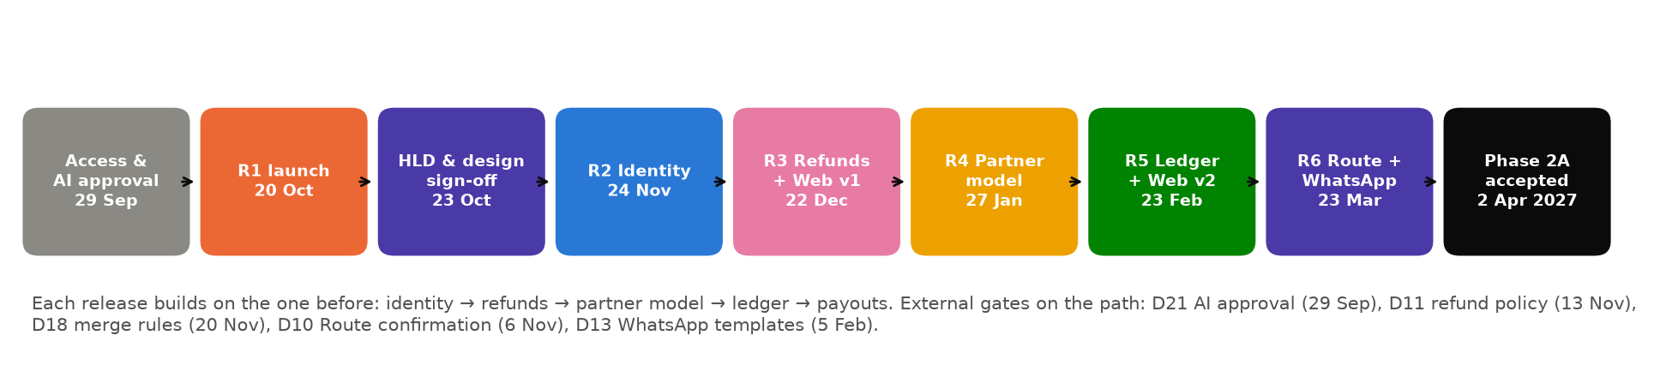
Figure 4 — Phase 2A critical path
In a release train every release date is fixed, so the critical path is the chain of feature dependencies: identity (R2) → refunds and web shell (R3) → partner model (R4) → ledger and partner web (R5) → payouts (R6). A slip in an upstream feature pushes its dependants to a later train. The mitigation is to protect the upstream features first: identity gets the strongest engineers and the earliest spec.

11.1 Schedule risks
Risk | Likelihood / impact | Mitigation built into this plan
AI tooling not approved on day one (D21) | Low–Medium / High | Enterprise-terms tooling and a written AI usage policy offered at kick-off; data-handling rules agreed up front
Phase 1 assessment reveals more launch blockers than fit before 14 Oct | Medium / High | AI-assisted assessment in 3 days; Scope Gate 1 Oct; F1/F2 dropped before the launch is risked
F3 identity in a 3-week build window is tight | Medium / High | Spec and HLD start 5 Oct in parallel with launch; spikes in October; strongest pair on F3; linking rules decided at HLD
SportSeek decisions and approvals cannot keep pace with a monthly train | Medium / High | 1-day decision / 2-day UI approval agreement (A4); weekly decision log; late items move to next train, not the whole release
Third-party approvals (Route, DLT, WhatsApp templates) | Medium / Medium | Dated in the register months ahead; F11/F12 sit in the last train to maximise lead time
AI-generated code quality or security regressions | Low–Medium / High | Human review of every merge, AI + SAST scans, full regression, targeted pen tests (Delivery Model §5, §14)
Year-end holidays reduce R4 capacity | High / Low | R4 build window extended to 3.5 weeks; holiday calendar agreed at kick-off

12. Milestones, gates and acceptance evidence
ID | Milestone / gate | Date | Decision owner | Acceptance evidence
1.2 | Kick-off | 29 Sep 2026 | Joint | Governance charter, AI usage policy, access checklist
2.2 | Launch Scope Gate | 01 Oct 2026 | SportSeek | Assessment report; frozen launch scope incl. F1/F2; go-live criteria
2.15 | R1 Go/No-Go | 19 Oct 2026 | SportSeek | UAT sign-off; VAPT retest clean; load test; runbook; store status
2.16 | R1 live — public launch | 20 Oct 2026 | Joint | Production smoke test; dashboards green
3.4 / 3.6 | HLD and design-system sign-off | 23 Oct 2026 | SportSeek | HLD, ADRs, design system
4.4 | M1 Foundation accepted | 06 Nov 2026 | SportSeek | IaC, CI/CD gates, observability
5.4 | R2 live | 24 Nov 2026 | SportSeek | UAT sign-off; identity pen test clean
6.5 | R3 live | 22 Dec 2026 | SportSeek | UAT sign-off; refund pen test clean; account reconciliation report
7.4 | R4 live | 27 Jan 2027 | SportSeek | UAT sign-off; facility regression green
8.4 | R5 live | 23 Feb 2027 | SportSeek | UAT sign-off; ledger reconciled to gateway
9.5 | R6 live — Phase 2A complete | 23 Mar 2027 | SportSeek | UAT sign-off; full VAPT with no open critical/high
9.9 | Phase 2A acceptance | 02 Apr 2027 | SportSeek | All SOW §13 deliverables; KT checklists signed

13. Anatomy of a monthly release
Every release R2–R6 follows the same four-week rhythm, so SportSeek's team always knows what happens when.
Week | Build pod | SportSeek | Gate
Week 1 | Plan from approved specs; AI agents generate implementation and tests; engineers review daily; next train's specs start | PO available for clarifications | Specs approved (DoR)
Week 2 | Build continues; integration on Staging behind feature flags; weekly demo | Weekly demo feedback | —
Week 3 | Feature complete (Friday); AI-generated regression and security scans; targeted pen test where applicable | UI approvals for next train | Feature complete
Week 4 | Hardening; UAT support; store submission; runbook update | UAT (3 days); Go/No-Go (Mon of release week) | UAT sign-off; Go/No-Go
Release week | Release on Tuesday; one week of hypercare; KT checklist | KT checklist sign-off | KT signed

14. Resource plan: AI-native pod, loading and technical skills
A small, senior, AI-augmented pod replaces the four-squad team of the conventional plan. Every engineer is senior enough to judge AI output, because in this model review quality determines product quality. Loading is monthly average FTE; October includes mobilisation from 28 September. SportSeek developers (Section 14.5) are additional.

14.1 Technology stack and the skills it demands
Layer | Technology | Skills we staff for
Mobile apps | React Native (TypeScript), iOS and Android | OIDC/PKCE on mobile, push (FCM/APNs), deep links, schema-driven forms, store release engineering
Back end | .NET — ASP.NET Core, C#, EF Core with Npgsql | Modular monolith, OIDC identity, outbox messaging, Razorpay payments/refunds/Route, idempotent APIs
Database | PostgreSQL (schema per domain) | Expand/contract migrations, JSONB, exclusion constraints, geo search, identity de-duplication
Web | React + TypeScript, Next.js (proposed) | Server rendering for SEO, shared design tokens, data-heavy admin screens
AI engineering | AI coding agents (e.g. Claude Code) and AI assistants under enterprise terms | Spec writing, context engineering, agent guardrails, critical review of generated code and tests
Quality & operations | xUnit, Testcontainers, Jest, Detox/Maestro, Playwright, k6; IaC; OpenTelemetry | AI-generated test suites curated by engineers; CI/CD and observability

14.2 Pod composition and technical skills
Role | Seniority | Peak FTE | Person-months | Key technical skills | How AI is used in the role
Delivery Lead / TPM (AI-native delivery) | Senior (12+ yrs) | 1 | 6.5 | Release-train planning and dependency management; stakeholder and steering management; RAID and change control; metrics-driven delivery; governance of AI usage (policy, audit trail, data handling) | AI-generated status reports, RAID and dependency tracking from JIRA/Trello and repository data; JIRA / Trello
Solution Architect & AI Engineering Lead | Senior (12+ yrs) | 1 | 6.25 | ASP.NET Core modular monolith and domain design; PostgreSQL architecture; OAuth2/OIDC; event-driven integration; Razorpay incl. Route; React Native and React architecture; OWASP ASVS. Owns the AI engineering playbook: specs, prompt/context standards, agent guardrails and review rules | AI coding agents (e.g. Claude Code) for codebase analysis, spike prototypes and ADR drafting; C4 diagrams
Product Analyst (AI-assisted BA) | Mid–Senior (6+ yrs) | 1 | 6.25 | Story mapping; Given/When/Then acceptance criteria; booking, payments/refunds and partner domains; SOW traceability; UAT scenario design | AI drafts stories, acceptance criteria, edge cases and UAT scripts from the SOW and specs; analyst and PO refine
Product Designer (UX/UI) | Mid–Senior (6+ yrs) | 1 | 4.75 | Atomic design system; mobile and responsive web UI; usability testing; accessibility (WCAG 2.1 AA); design tokens shared by React Native and React | AI-assisted layout and copy exploration and design-to-code token export; Figma or agreed tool
Senior .NET Engineer (AI-augmented) | Senior (8+ yrs) | 2 | 12.5 | C# / ASP.NET Core; EF Core with Npgsql; OIDC implementation (e.g. OpenIddict); Razorpay payments, refunds, Route and webhooks; notification channel integrations; idempotent APIs; background processing | Spec-driven development with AI coding agents: agents generate code and tests from the approved spec, engineers review, harden and own every merge
.NET & PostgreSQL Engineer (AI-augmented) | Senior (8+ yrs) | 1 | 6 | Schema-per-domain design; EF Core migrations (expand/contract); JSONB with schema validation; exclusion constraints against double-booking; geospatial queries; query tuning; identity de-duplication and data-migration scripts; reconciliation SQL | AI-generated migration and reconciliation scripts, verified against Testcontainers PostgreSQL before any environment
Senior React Native Engineer (AI-augmented) | Senior (7+ yrs) | 1 | 6.25 | React Native + TypeScript on iOS/Android; OIDC with PKCE; push (FCM/APNs); deep links and app-switch handling; schema-driven forms; store release engineering with Fastlane; minimum-version enforcement | AI agents generate screens from design tokens and specs, and component and E2E tests; engineer reviews and tunes on real devices
Senior React / Next.js Engineer (AI-augmented) | Senior (7+ yrs) | 1 | 4.5 | React + TypeScript with Next.js; server rendering for SEO; shared design tokens; data-heavy admin screens (ledger tables, filters, exports); WCAG 2.1 AA | AI agents port Phase 1 mobile journeys to web against the shared API; parity checks generated from the mobile journey inventory
QA Automation Engineer (AI-assisted) | Mid–Senior (6+ yrs) | 2 | 7.25 | Test strategy and quality gates; API, mobile and web automation; payment/refund scenarios in Razorpay test mode; UAT support | AI generates API tests from OpenAPI specs, regression suites from user journeys, and test data; engineer curates and maintains the suite
DevOps / SRE Engineer | Senior (7+ yrs) | 1 | 4.25 | Infrastructure as code in SportSeek's cloud; CI/CD for .NET and React Native; managed PostgreSQL; OpenTelemetry observability; secrets; release automation; on-call | AI-assisted IaC authoring, pipeline configuration and log/incident triage
Security Engineer (VAPT, on demand) | Senior (8+ yrs) | 0.5 | 1.75 | Web, API and mobile penetration testing (OWASP WSTG, MASTG); targeted pen tests on identity (R2), refunds (R3) and payouts (R6); full VAPT before Phase 2A completion | AI-assisted SAST triage and threat-model drafting; manual testing by the specialist
Performance Engineer (on demand) | Mid–Senior (6+ yrs) | 0.5 | 1 | Load test design; .NET API profiling; PostgreSQL query analysis; capacity recommendations | AI-generated k6 scripts from the API catalogue; engineer designs workload models
Total |  |  | 67.25

14. Resource plan (continued)

14.3 Monthly resource loading (FTE)
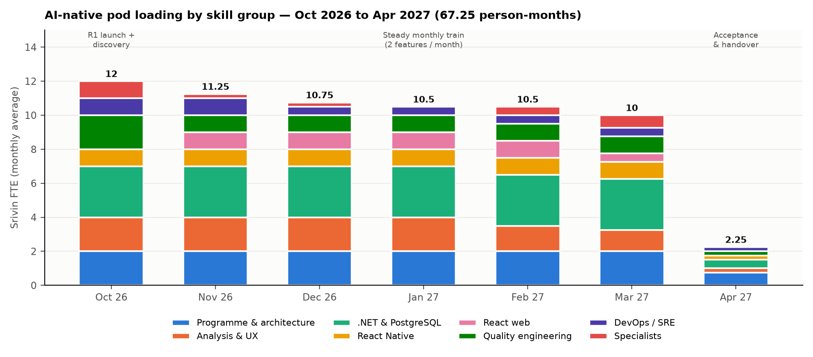
Figure 5 — AI-native pod loading by skill group
Role | Oct 26 | Nov 26 | Dec 26 | Jan 27 | Feb 27 | Mar 27 | Apr 27 | Person-months
Delivery Lead / TPM (AI-native delivery) | 1 | 1 | 1 | 1 | 1 | 1 | 0.5 | 6.5
Solution Architect & AI Engineering Lead | 1 | 1 | 1 | 1 | 1 | 1 | 0.25 | 6.25
Product Analyst (AI-assisted BA) | 1 | 1 | 1 | 1 | 1 | 1 | 0.25 | 6.25
Product Designer (UX/UI) | 1 | 1 | 1 | 1 | 0.5 | 0.25 | — | 4.75
Senior .NET Engineer (AI-augmented) | 2 | 2 | 2 | 2 | 2 | 2 | 0.5 | 12.5
.NET & PostgreSQL Engineer (AI-augmented) | 1 | 1 | 1 | 1 | 1 | 1 | — | 6
Senior React Native Engineer (AI-augmented) | 1 | 1 | 1 | 1 | 1 | 1 | 0.25 | 6.25
Senior React / Next.js Engineer (AI-augmented) | — | 1 | 1 | 1 | 1 | 0.5 | — | 4.5
QA Automation Engineer (AI-assisted) | 2 | 1 | 1 | 1 | 1 | 1 | 0.25 | 7.25
DevOps / SRE Engineer | 1 | 1 | 0.5 | 0.5 | 0.5 | 0.5 | 0.25 | 4.25
Security Engineer (VAPT, on demand) | 0.5 | 0.25 | 0.25 | — | 0.25 | 0.5 | — | 1.75
Performance Engineer (on demand) | 0.5 | — | — | — | 0.25 | 0.25 | — | 1
Total Srivin FTE | 12 | 11.25 | 10.75 | 10.5 | 10.5 | 10 | 2.25 | 67.25

How the loading follows the plan: October carries the launch (hardening, regression, VAPT, load test) alongside AI-assisted discovery, at 12 FTE. From November a steady pod of about 10–11 FTE runs the monthly train. Specialists (security, performance) join for the releases that need them. April is acceptance and handover only. SportSeek developers who have worked in the pod take over module ownership as Srivin rolls off.

14.4 Resource-to-WBS assignment matrix
● = primary responsibility; ○ = supporting or reviewing. Columns are the Level 1 WBS elements (Section 7.1).
Role | 1 PM | 2 R1 Launch | 3 Design | 4 Found. | 5 R2 | 6 R3 | 7 R4 | 8 R5 | 9 R6 | 10 Support
Delivery Lead / TPM (AI-native delivery) | ● | ● | ○ | ○ | ● | ● | ● | ● | ● | ○
Solution Architect & AI Engineering Lead | ○ | ● | ● | ● | ● | ● | ● | ● | ● | ○
Product Analyst (AI-assisted BA) |  | ○ | ● |  | ● | ● | ● | ● | ●
Product Designer (UX/UI) |  |  | ● |  | ○ | ● | ○ | ● | ○
Senior .NET Engineer (AI-augmented) |  | ● | ○ | ● | ● | ● | ● | ● | ● | ●
.NET & PostgreSQL Engineer (AI-augmented) |  | ○ | ○ | ○ | ● | ● | ● | ● | ● | ○
Senior React Native Engineer (AI-augmented) |  | ● | ○ |  | ● | ○ | ● | ○ | ○ | ●
Senior React / Next.js Engineer (AI-augmented) |  |  | ○ |  |  | ● |  | ● | ●
QA Automation Engineer (AI-assisted) |  | ● | ○ | ○ | ● | ● | ● | ● | ● | ○
DevOps / SRE Engineer |  | ● |  | ● | ○ | ○ | ○ | ○ | ● | ●
Security Engineer (VAPT, on demand) |  | ● |  |  | ● | ● |  |  | ●
Performance Engineer (on demand) |  | ● |  |  |  |  |  | ● | ●

14. Resource plan (continued)

14.5 SportSeek-provided resources
Role | Number | When | Responsibilities
Product Owner | 1 (named) | Throughout; decisions within 1 working day | Backlog priority, spec approval, acceptance, SOW open items
Technical reviewer | 1 (part-time) | HLD, ADRs, weekly demo | .NET / PostgreSQL / React Native review of designs
SportSeek developers | 2 recommended (D9) | From R2 (26 Oct 2026) | Full pod members working with AI agents; become module owners after handover
UAT testers | 2 recommended | Hardening week of every release; 15–19 Oct for R1 | Business scenario testing across User, Partner, Admin and Web
Operations lead | 1 | From R3 | Receives infrastructure handover (SOW §15.1)
Legal / compliance | As needed | By 9 Oct; per release as needed | Privacy, DPDP, refund policy, AI usage approval

14.6 Continuity and roll-off
- Named, senior, stable pod: the Delivery Lead, Architect, .NET, React Native and QA engineers stay for the whole engagement. Any change needs SportSeek notice and a two-week overlap.
- Two-deep on critical skills: .NET identity, PostgreSQL migrations, React Native releases and Razorpay integration are each held by at least two people across Srivin and SportSeek by R3.
- Roll-off after sign-off: engineers roll off only after the KT checklist for their features is signed. SportSeek keeps the AI-maintained documentation and the codebase assistant (Delivery Model §15).

15. Baseline control and re-planning rules
- Baselines: this plan is Baseline 0 (v2.0). Baseline 1 is set at the R2 release review (24 Nov 2026), using measured AI-assisted velocity from the first build cycle.
- Tolerances: release dates do not move. If a feature is forecast to miss its train, the PO decides within 2 working days whether to move it to the next train or swap in a later feature of similar size.
- Change: new scope follows SOW §18 (written request → impact assessment in 5 business days → SportSeek approval) and is slotted into a future train.
- Reporting: weekly demo and status (features on track per train, dependency register, RAID), plus a monthly release review with the sponsor.

Appendix A. SOW-to-WBS traceability
SOW reference | Requirement | Feature / WBS
§3.1 Shared Identity; §7; §9.1 (M2) | Unified accounts, linking, roles, KYC reuse | F3 (5.1); 6.3
§3.1 Transaction Ledger; §8 (M3) | Ledger dashboard, statements, refunds, partner view | F9 (8.1); F11 (9.1)
§3.1 Booking/Events; §9.3 (M4) | Cancellation, waitlist, edit alerts, data model, import tools | F5 (6.1); F8 (7.2); 9.3; 2.5
§3.1 Partner & Service; §9.4 (M5) | Generalised service types; admin configuration | F7 (7.1); F11 (9.1)
§3.1 Notification; §10 (M6) | Push, WhatsApp, Email; alert catalog | F1, F2 (2.9–2.10); F4 (5.2); F12 (9.2)
§3.1 Web application | Web app for all existing functionality | F6 (6.2); F10 (8.2)
§6.2 NFRs | Security, performance, availability, DPDP, environments, observability | 2.3, 2.6, 2.7, 4.x, all hardening WPs
§12.1 M1 | Foundation | 2.3, 4.1–4.4
§12.2 KT | KT after every milestone with checklist | KT per release (5.5, 6.6, 7.5, 8.5), 9.8
§13 Deliverables | Code, HLD/LLD, stories/tests, API docs, ERD, architecture, UI files, test suite, CI/CD, runbook, user docs, KT | 3.x, 4.2, 9.7, all feature WPs
§14 Acceptance | Technical and functional acceptance | Hardening + Go/No-Go per release; 9.9
§15.1 Infra transition | Operate-then-handover | 9.7
§16 Warranty & support | 90-day warranty; Phase 1 support | 10.1, 10.2
§18 Change management | Change process | 1.5

