M5 Project Paper - Complete Reference Materials
ISBA 2415, Reinforcement Learning

Part 1: Assignment Instructions
Course: ISBA 2415, Reinforcement Learning
Assignment: M5: Project Paper (Group)
Due: Mar 15 by 11:59pm
Points: 300
Submission: File upload (only one member needs to submit)
Plagiarism Check: Unicheck enabled

Tasks
Implement the exploration versus exploitation strategy that you proposed in your project proposal for the EZ Car Rental case and answer the following questions:
1. Were you able to learn the probability distribution that you were simulating your environment from?
2. Were you able to uncover a pricing policy given the simulated environment?

Requirements
1. The group submissions should be approximately two pages in length.
2. Please upload your code/notebooks on GitHub and provide a link to it.
3. The paper should be supported by the use of charts and tables.
4. Where applicable, please use a consistent referencing system such as APA, the Harvard system, the IEEE system, etc.
5. Only one member from each group is required to submit this assignment.
6. Please note that Unicheck has been enabled for this assignment.

Part 2: M2 Proposal Recap
Below is a summary of what we proposed in our M2 submission:

Problem
EZ Car Rental operates a contactless car rental service across multiple U.S. cities and needs to learn optimal pricing in new markets with no historical pricing data. Supply is uncontrollable; we can only influence demand through pricing.
DP Formulation
State Space: s = (city, time_category, utilization_level), 5 x 2 x 2 = 20 states
Action Space: A = {$3, $5, $7, $9, $11}/hr, 5 prices
Reward: Y ~ Bernoulli(theta), E[R(s,p)] = p * theta_{s,p} * A(s)
Bellman Equation: V*(s) = max_p { E[R(s,p)] + gamma * sum P(s'|s,p) * V*(s') }
Exploration Strategy
Thompson Sampling with Beta-Bernoulli conjugate model. Each state-action pair maintains Beta(alpha, beta) posterior over the unknown booking probability.

Part 3: Implementation Summary
What We Built
1. Simulator: Computed true booking probabilities from the Journeys CSV for each state-action pair. The agent has no direct access to this data.
2. Thompson Sampling Agent: Beta-Bernoulli model with a Beta posterior for each of the 100 state-action pairs.
3. Epsilon-Greedy Agent: epsilon = 0.15 as a comparison baseline.
4. Oracle: Assumes full knowledge of true probabilities and computes the optimal policy as a benchmark.
5. Ran 5,000 episodes with the same random seed to ensure a fair comparison.

Key Results
Metric | Thompson Sampling | Epsilon-Greedy
Total Revenue | $19,519 | $19,550
Revenue Ratio vs Oracle | 90.8% | 90.0%
Total Regret | $1,989 | $2,170
Policy Accuracy | 20/20 (100%) | 19/20 (95%)
Mean Abs Error | 0.108 | N/A

Answers to Assignment Questions
Q1: Were we able to learn the probability distribution? Yes. The mean absolute error between learned and true booking probabilities was 0.108 across all 100 state-action pairs. The probabilities that matter most for pricing decisions were estimated accurately.

Q2: Were we able to uncover a pricing policy? Yes. Thompson Sampling matched the oracle's optimal price in all 20 states (100% accuracy). Epsilon-greedy matched 19 out of 20 (95%). The learned policy is intuitive: lower prices for off-peak/low-utilization states and higher prices for peak/high-utilization states.

Part 4: Charts
Figure 1: Cumulative Regret - Thompson Sampling vs Epsilon-Greedy
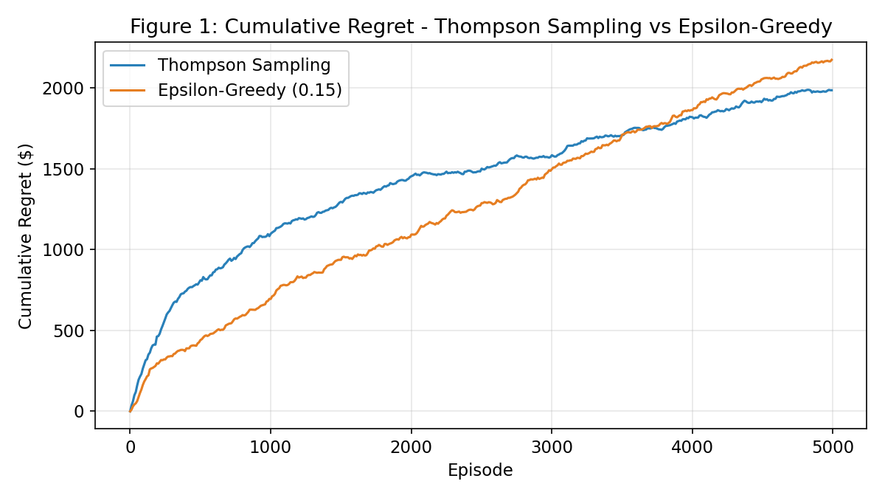

Figure 2: Policy Accuracy Over Training
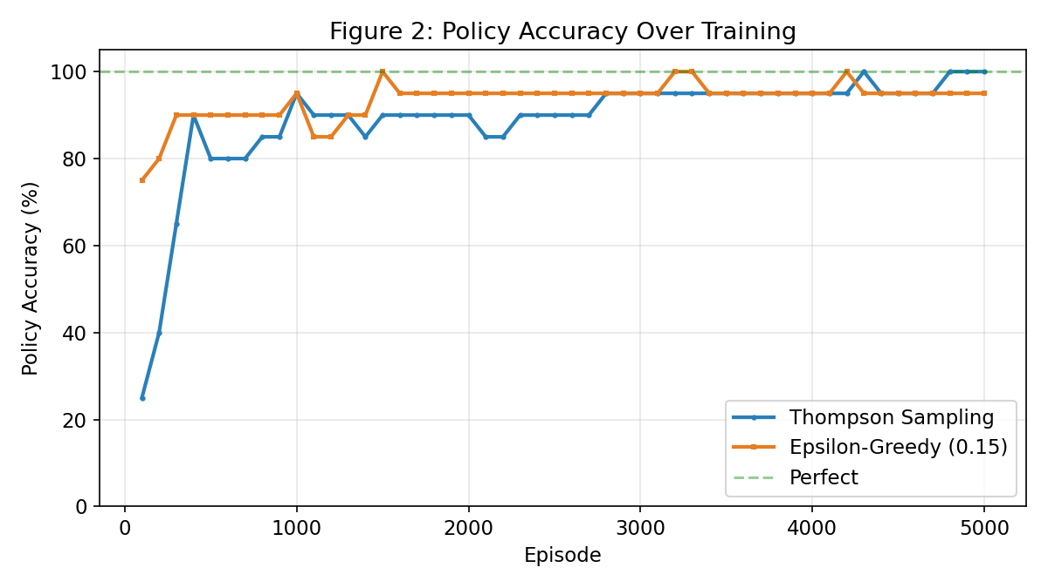

Figure 3: Revenue Comparison Across Methods
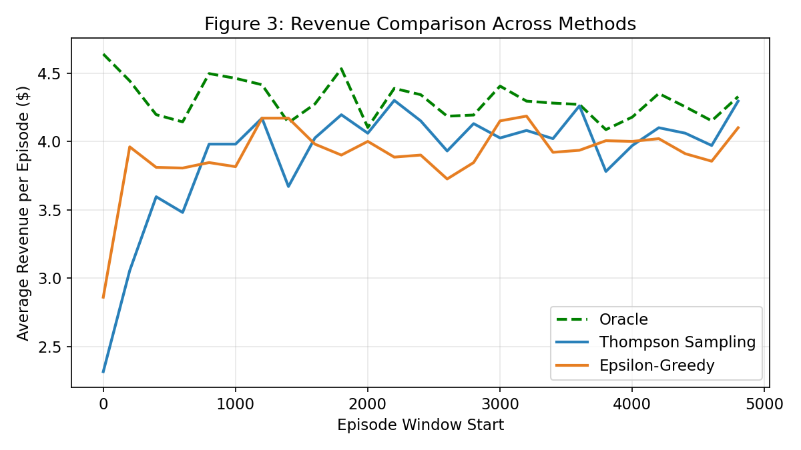

Figure 4: Pricing Policy Comparison Across All States
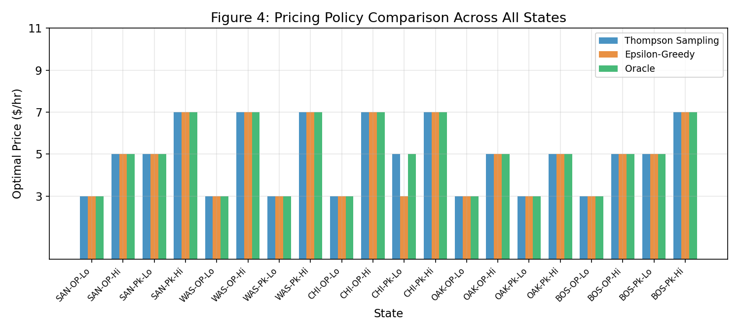

Part 5: Submission Checklist
Upload to Canvas:
M5_Project_Paper.docx (make sure to fill in the GitHub link first)

Upload to GitHub:
EZ_Car_Rental_Thompson_Sampling.ipynb
data/journeys.csv

Submission Steps:
Step 1: Create a new GitHub repo (e.g., ez-car-rental-rl)
Step 2: Upload the notebook + data/journeys.csv
Step 3: Open M5_Project_Paper.docx and replace [Insert GitHub link here] with your repo link
Step 4: Submit M5_Project_Paper.docx on Canvas

File List:
M5_Project_Paper.docx - The paper to submit on Canvas
EZ_Car_Rental_Thompson_Sampling.ipynb - Jupyter notebook for GitHub
data/journeys.csv - Source data for the notebook
ez_rental_thompson_sampling.py - Standalone Python script (backup)
generate_charts.py - Chart generation script (backup)
generate_m5_paper.py - Paper generation script (backup)
M5_All_Materials.docx - This reference document (do not submit)

