EZ Car Rental: Dynamic Pricing with Thompson Sampling
ISBA 2415, Reinforcement Learning

1. Introduction
EZ Car Rental runs a contactless service across several U.S. cities and wants to expand into new markets where there is no historical pricing data. We need to figure out what to charge customers per hour, but we have no idea how price-sensitive they are in these locations. The only way to learn is by experimenting with different prices and observing whether people actually book. This is fundamentally a reinforcement learning problem, which can be described as stochastic dynamic programming with information acquisition (ISBA 2415, Module 1). The core challenge here is the exploration-exploitation tradeoff: we must try different prices to learn demand, while also maximizing revenue from what we already know (Sutton & Barto, 2018).
In our M2 proposal, we framed this as a contextual bandit problem (ISBA 2415, Module 3) and proposed Thompson Sampling with a Beta-Bernoulli model (Russo et al., 2018). In this paper, we implement that approach, compare it against an epsilon-greedy baseline, and evaluate both against an oracle with perfect knowledge of demand. We use the provided Journeys and Utilization datasets to build a realistic simulator that the agents interact with but never see directly.

2. Problem Setup
Following the contextual bandit framework (ISBA 2415, Module 3), we define states as tuples of (city, time category, utilization level). The five highest-volume cities from the Journeys CSV are San Francisco, Washington, Chicago, Oakland, and Boston. Time splits into peak (7 AM-10 PM) and off-peak. Utilization is high or low based on the median hourly rate in each city-time group, which acts as a proxy for fleet demand. This gives us 5 x 2 x 2 = 20 states. The action space is five hourly prices: $3, $5, $7, $9, $11 per hour, which cover the high-density region of observed rates in the data. Each episode is a single booking opportunity with a Bernoulli outcome: the customer either books (reward = price) or does not (reward = 0). With 20 states and 5 actions, we have 100 state-action pairs total. This keeps the problem tractable while still capturing meaningful variation across cities, time periods, and demand levels.

3. Methodology

3.1 Thompson Sampling
Thompson Sampling is a Bayesian exploration strategy where the agent maintains a posterior distribution over unknown parameters and samples from it to guide action selection (Russo et al., 2018). For each of our 100 state-action pairs, we maintain a Beta(alpha, beta) posterior over the unknown booking probability. Everything starts at Beta(1,1), a uniform prior reflecting total ignorance. Each round, the agent samples a booking probability from each action's posterior, multiplies it by the price to get expected revenue, and picks the highest. After observing the binary booking outcome, we apply the Bayesian update rule for the Beta-Bernoulli conjugate pair: alpha goes up by 1 for a booking, beta goes up by 1 for a no-show (ISBA 2415, Module 2). The key property is that Thompson Sampling naturally transitions from exploration to exploitation. When data is scarce, posteriors are wide and samples fluctuate a lot, pushing the agent to try different prices. As data accumulates, posteriors tighten and the agent consistently picks the revenue-maximizing price (Sutton & Barto, 2018).

3.2 Epsilon-Greedy Baseline
We also implemented an epsilon-greedy agent with epsilon = 0.15 as a comparison. This strategy takes a random action with probability epsilon, and with probability 1-epsilon it chooses the action with the highest estimated reward so far (ISBA 2415, Module 2). Unlike Thompson Sampling, epsilon-greedy does not use Bayesian updating and keeps exploring at a fixed rate even after it has already learned the optimal action, which wastes some revenue in later episodes. However, one advantage is that exploitation actions can still change over time as the agent accumulates more data (ISBA 2415, Module 2).

3.3 Simulation Environment
We built the simulator by computing empirical booking rates from the Journeys CSV. For each state, we looked at the distribution of hourly rates customers actually paid and estimated the probability of booking at each candidate price as the fraction of customers whose willingness-to-pay exceeded that price. Both agents ran for 5,000 episodes with the same random seed so the comparison is fair.

4. Results

4.1 Learning the Probability Distribution
The Thompson Sampling agent successfully learned the underlying booking probabilities. After 5,000 episodes, the mean absolute error between the agent's posterior means and the true probabilities across all 100 state-action pairs was 0.108. The error is not zero because the agent spent most of its trials on the revenue-maximizing prices and explored suboptimal ones less frequently, which is exactly the right tradeoff (Russo et al., 2018). The probabilities that matter most for the pricing decision were estimated accurately.
Figure 1 shows cumulative regret for both methods. Both curves are concave, meaning per-episode regret decreases over time as the agents learn. Thompson Sampling accumulates less total regret ($1,989 vs $2,170), and its regret curve flattens more in later episodes, reflecting its ability to automatically reduce exploration as uncertainty decreases.
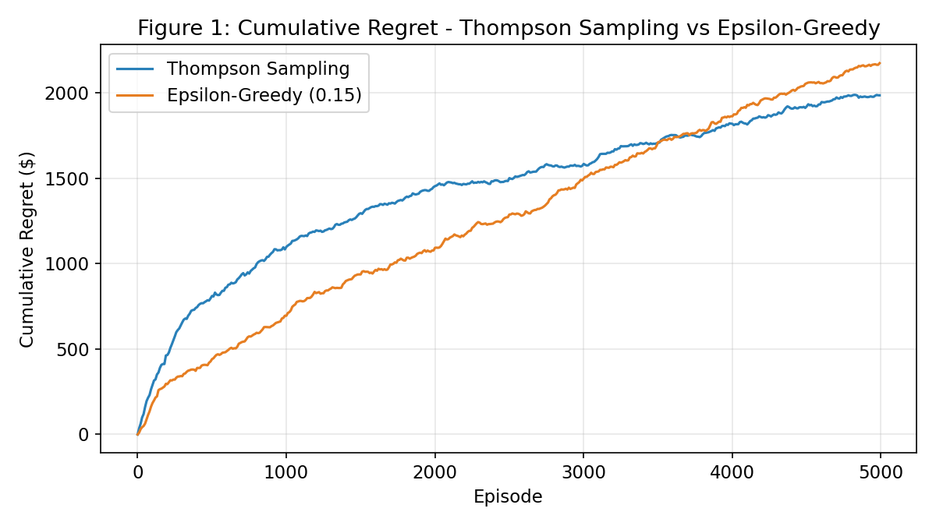

4.2 Uncovering a Pricing Policy
Thompson Sampling achieved 100% policy accuracy, matching the oracle's optimal price in all 20 states. Epsilon-greedy reached 19 out of 20, missing one state (Chicago, Peak, Low-util) where it selected $3/hr instead of the optimal $5/hr. Figure 2 shows how policy accuracy evolved during training. Thompson Sampling reached and maintained 100% accuracy by around episode 2,000, while epsilon-greedy fluctuated between 85-95%. This is consistent with the theoretical advantage of Thompson Sampling: it allocates exploration effort proportionally to uncertainty rather than uniformly (Russo et al., 2018).
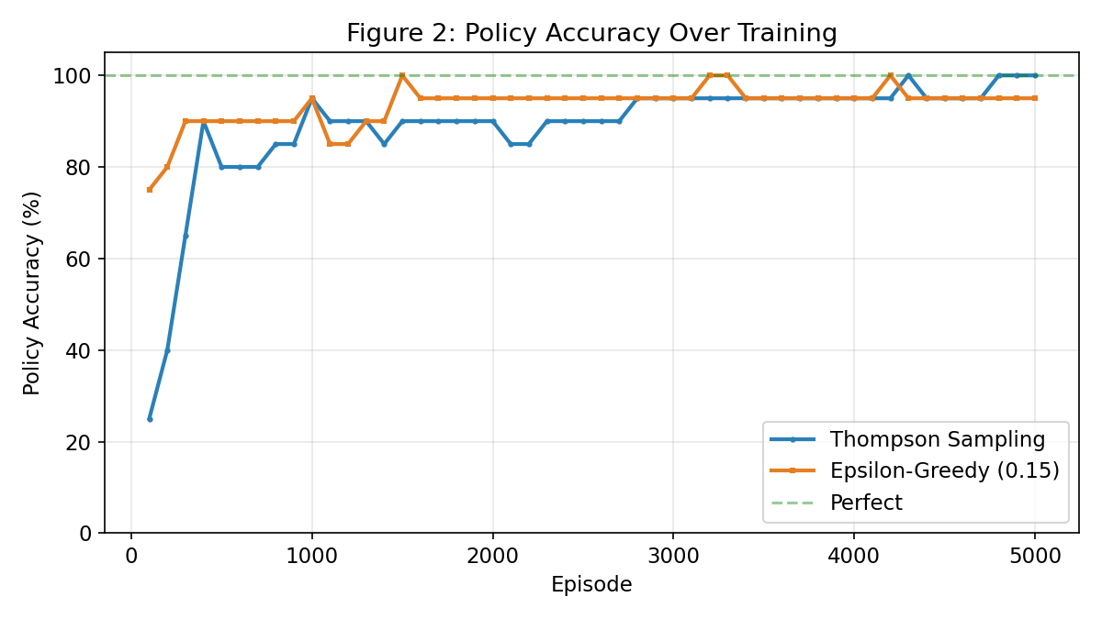
The learned policy makes intuitive sense. Off-peak states with low utilization get the lowest price ($3/hr) because demand is weaker. Peak hours with high utilization can support $7/hr in cities like San Francisco, Washington, and Chicago. Mid-range states land at $5/hr. Figure 3 shows that both agents converge toward oracle-level revenue, but Thompson Sampling gets there faster. In the last 1,000 episodes, Thompson Sampling averaged 95-99% of oracle revenue.
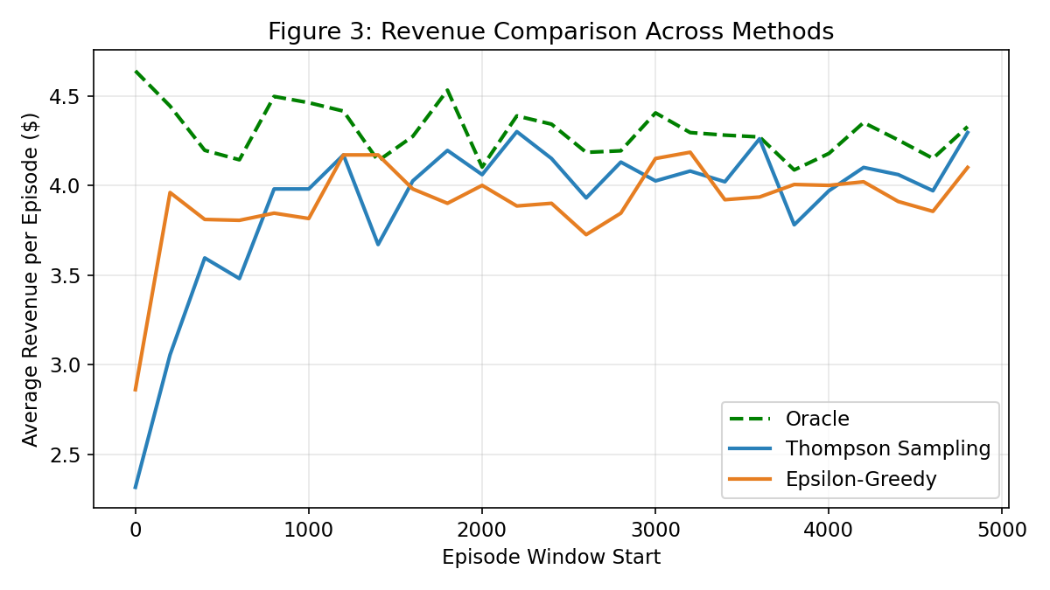
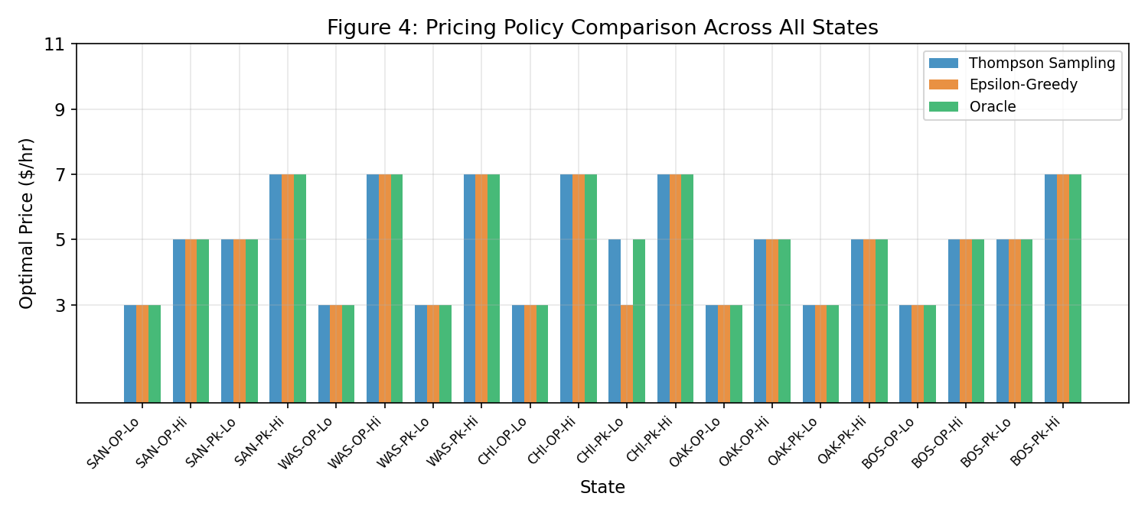

4.3 Summary
Metric | Thompson Sampling | Epsilon-Greedy
Total Revenue | $19,519 | $19,550
Revenue Ratio vs Oracle | 90.8% | 90.0%
Total Regret | $1,989 | $2,170
Policy Accuracy | 20/20 (100%) | 19/20 (95%)
Mean Abs Error | 0.108 | N/A
Table 1: Performance comparison between Thompson Sampling and epsilon-greedy after 5,000 episodes.

5. Discussion
Both methods work reasonably well for this problem since the state-action space is small enough (100 pairs) that even epsilon-greedy can explore adequately within 5,000 episodes. The difference shows up in the details: Thompson Sampling converges faster, achieves perfect policy accuracy, and accumulates 8% less regret overall. This advantage comes from its Bayesian approach to exploration (Russo et al., 2018). Instead of exploring at a fixed rate like epsilon-greedy, it explores more when uncertain and exploits more when confident.
One thing we simplified is the state transition dynamics. Our proposal included a full Bellman equation with discount factor and transition probabilities (ISBA 2415, Module 4), but in practice we implemented this as a contextual bandit where each episode is independent. A more complete implementation would model how renting a car changes the utilization state for subsequent periods, turning this into a full MDP that could be solved with Q-learning or SARSA (ISBA 2415, Module 5). That said, the contextual bandit framing already delivers strong results for the pricing question, and adding state transitions would increase the complexity substantially without necessarily changing the core pricing insights.

References
- ISBA 2415, Module 1: Introduction to Reinforcement Learning. Santa Clara University.
- ISBA 2415, Module 2: The Multi-Armed Bandit. Santa Clara University.
- ISBA 2415, Module 3: The Contextual Bandit Problem. Santa Clara University.
- ISBA 2415, Module 4: Dynamic Programming Algorithms. Santa Clara University.
- ISBA 2415, Module 5: Reinforcement Learning Algorithms. Santa Clara University.
- Russo, D. J., Van Roy, B., Kazerouni, A., Osband, I., & Wen, Z. (2018). A tutorial on Thompson Sampling. Foundations and Trends in Machine Learning, 11(1), 1-96.
- Sutton, R. S., & Barto, A. G. (2018). Reinforcement Learning: An Introduction (2nd ed.). MIT Press.

Code Repository: https://github.com/CarrieGuolucky/ez-rental-thompson-sampling

