BURP SUITE RANDOM NUMBER SEQUENCER ANALYZER:

1. STANDARD LIBRARY MODEL :

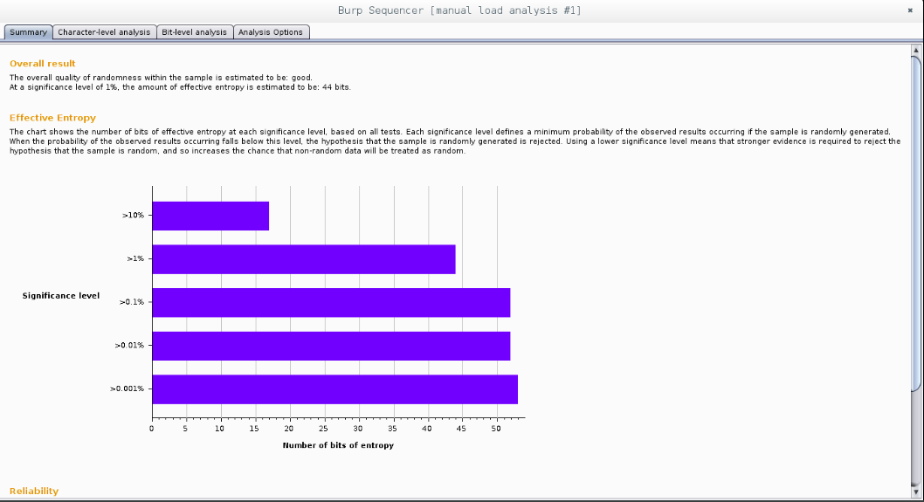

2. MONTE CARLO METHOD

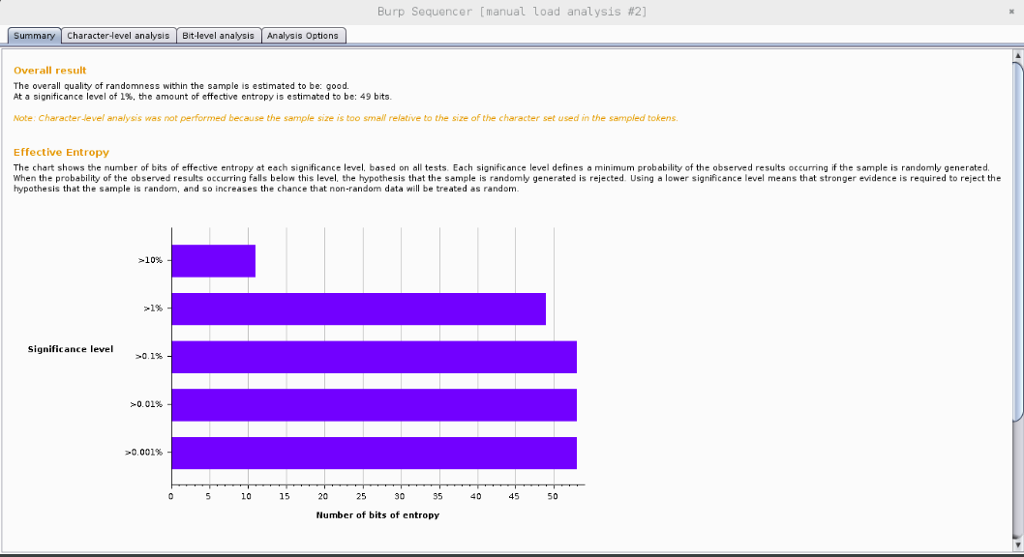

3: MERSENNE PRIME METHOD:

