CSV to H5P Interactive Video Converter - Manual

Using the desktop app (Windows) 2

Using the website (macOS) 3

How to enter questions into the spreadsheet 4

Timecodes 6

Reactions to correct or incorrect answers 6

Clickable links 6

# Using the desktop app (Windows)

1. **Start the application by double clicking on it**. You can cancel the firewall request if you get it. Should you get a warning from Windows Smart Screen or Windows defender, please bypass it as described here: <https://www.pcworld.com/article/406832/how-to-get-past-windows-defender-smartscreen-in-windows-10.html>

Two windows will appear. The first one is the server, as the converter is really a webserver that you open on your local machine:  
Ein Bild, das Text enthält.

Do not close the webserver window until you’ve finished with your work.

The second window is your browser. You do the actual conversion in there:Ein Bild, das Text enthält.

1. **Download the spreadsheet** template to your computer:  
   Ein Bild, das Text enthält.

   Automatisch generierte Beschreibung
2. **Open the template** in a spreadsheet program (i.e. Microsoft Excel)
3. Use the template to **fill in your question** in the spreadsheet program.
4. **Save the file** under a new name (as .xlsx) for later changes.
5. **Save the file as a CSV** **file with UTF-8**: Click on “Save as”, select “CSV UTF-8 (*.csv)” (or similar) as the file format and enter a filename.
6. Click onto the blue box in the converter window, **select the CSV file** from step 6.
7. Click on “**Convert to Interactive Video**”.
8. The conversion process will start and **the .h5p file will be downloaded**.
9. **Close** the browser window and the server window (black text window) when you are finished.

# Using the website (macOS)

You don’t have to do steps 1 and 2 from the guide above. Just navigate to <https://csvconverteridyorggx-webserver.functions.fnc.fr-par.scw.cloud> in your browser and do the conversion fully in your browser.

# How to enter questions into the spreadsheet

The spreadsheet template can be used as a guide when filling out your questions. It helps you by giving you examples and interactive tips.

1) Most cells have **help texts** that appear **when you click inside** them:

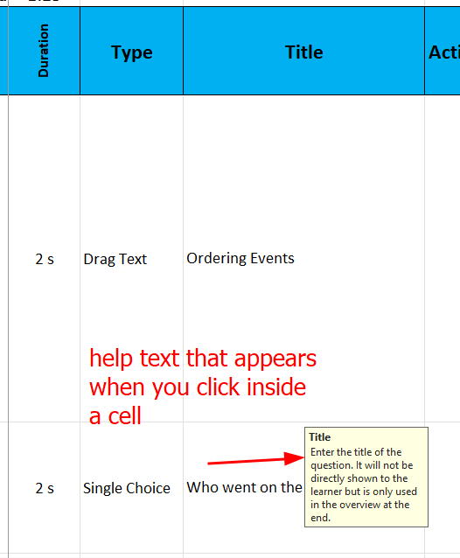

The “**Type**” column helps you avoid making typing mistakes with a **dropdown menu**. To open it, click onto a cell and then onto the button with the triangle. Then select the content type from the list.

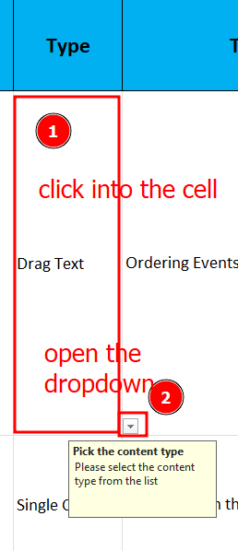

2) You need to enter some **general information** about the interactive video in the first three rows:

|  |  |
| --- | --- |
| **Title** | The title of the interactive video |
| **YouTube link** | The link to the YouTube page of the video, e.g. https://www.youtube.com/watch?v=FwdMr6cYcN0&amp |
| **Submit screen** | At which timecode the final submit screen (summary of all the scores) should be shown  3-5 seconds before the end of the video is a good place |

3) Add your questions by filling out the table. Use the help texts and the reference below to see how you must enter data for each content type.

|  |  |  |  |  |  |
| --- | --- | --- | --- | --- | --- |
| **Type** | **Title** | **Task description** | **Task / Question** | **Additional row 1** | **Additional row 2** |
| [**Drag Text**](https://h5p.org/drag-the-words) | Heading (visible in submit screen) | Text shown at the top of the question | The text of the question. Put asterisk (*) around text that you want to be blanks or draggable.  *Example:*  *\*Berlin* is the capital of the Germany.* |  |  |
| [**Fill in the Blanks**](https://h5p.org/fill-in-the-blanks) |
| [**Single Choice**](https://h5p.org/single-choice-set) | A list of answer options. Each option goes into its own line. The first one is the correct one.  *Example:*  *Correct Option*  *Distractor 1*  *Distractor 2*  *Distractor 3* | Question 2 | A list of answer options for question 2.  You can add as many questions and options as you like to the right. |
| **Free Text** | The placeholder in the text box (text shown to the user as a clue when the text box is empty) |  |  |
| [**Multiple Choice**](https://h5p.org/multichoice) | A list of answer options. Each option goes into its own line. Mark correct answers with an asterisk (*) at the begging of a line.  *Example:*  *Distractor 1*  *\* Correct 1*  *\* Correct 2*  *Distractor 2* |  |  |
| [**True False**](https://h5p.org/true-false) | The question text | Whether the answer is true or false: “true” or “false” (without the quotation marks) |  |  |
| [**Drag and Drop**](https://h5p.org/drag-and-drop) | Text shown at the top of the question |  | Dropzone name 1  -----  Dragable element text 1 | Dropzone name 2  -----  Dragable element text 2 (you can continue to the right) |
| **Text** |  |  |  |  |

Note: There’s a special mode for Drag and Drop. You can create one : many exercise with this markup:

|  |  |  |  |  |  |  |
| --- | --- | --- | --- | --- | --- | --- |
| Dropzone name 1  -----  1 | Dropzone name 2  ----- | Dropzone name 3  -----  2,3 | | | Dragable 1 | Dragable 2 | Dragable 3 |

# Timecodes

When you need to enter timecodes (column “shown at” and submit screen), you must use this format:

* m:ss (Example: 0:19)
* m:ss.ms (Example: 0:19.500)
* h:m:ss (Example: 1:05:10)
* h:m:ss.ms (Example: 1:05:10.250)

# Reactions to correct or incorrect answers

You can make the interactive video react to incorrect or correct answers of the learner. To do this, enter something into the “Action correct” or “Action incorrect” columns.

You can enter a message that the learner will see and optionally specify a timecode to which the video automatically jumps.

Example:

Try again! (2:30)

This will display “Try again!” to the user and the jump to the position 2 min 30 s.

# Clickable links

You can add clickable links to the text in these places:

* Drag Text: Task description
* Fill in the Blanks: Task description
* Text: Task description ( = actual text)

Add the links by entering them in [Markdown style](https://www.markdownguide.org/basic-syntax/#links):

You can read more [on our website](https://example.com)!

This is transformed to:

You can read more [on our website](https://example.com)!