Assessing Mytilus trossulus response to contaminants in Puget Sound using traditional biomarkers

Chris Mantegna^{1*}, Steven Roberts¹, Mariko Langness², Danielle Nordstrom², Alison Gardell³

- University of Washington, School of Aquatic and Fishery Sciences, 1122 NE Boat St, Box 355020 Seattle, WA 98195
- Washington Department of Fish and Wildlife, PO Box 43200, Olympia, WA 98504
- University of Washington- Tacoma, Sciences and Mathematics, Department of School of Interdisciplinary Arts and Sciences, 1900 Commerce Street, Box 358436, Tacoma, WA 98402

Corresponding author: Chris Mantegna, mantegna@uw.edu

Keywords: Mytilus trossulus, biomarkers, legacy contaminants, biomonitoring, heavy metals

Abstract
Nearshore ecosystems are increasingly impacted by complex mixtures of legacy contaminants, yet linking chemical exposure to organismal response remains a persistent challenge in environmental monitoring. In Puget Sound, long-term contaminant datasets provide extensive spatial coverage, but biological responses to these contaminants are less well understood. In this study, we integrated contaminant concentrations with established biomarkers and morphometric measurements in the Pacific blue mussel (Mytilus trossulus) deployed across 74 nearshore sites for approximately three months. We evaluated whether paired biomarkers of exposure, cytochrome P450 and superoxide dismutase (SOD), capture patterns of organismal response to contaminant mixtures at a regional scale. Contaminant indices, including PAHs, PCBs, and DDTs, exhibited strong and significant spatial clustering Contaminant indices showed strong spatial clustering, whereas biological responses exhibited weaker and often nonlinear spatial patterns. P450 activity varied regionally, and SOD patterns reflected broader environmental context; integrated biomarker response (IBR) indices had mixed directional relationships with specific analytes. The decoupling of contaminant distributions and biomarker activity suggests biomarkers integrate physiological state, exposure history, and environmental variability rather than serving as direct proxies for contaminant burden. Traditional biomarkers add value to monitoring when interpreted within spatial and environmental context; combining them with site covariates and molecular indicators will improve assessment of long-term ecological impacts.

Introduction
Nearshore marine environments represent a critical interface between terrestrial and aquatic systems, where contaminants from urbanization, industrial activity, and historical land use accumulate and persist (Gherras Touahri et al., 2016; Langness and West, 2020; Zhang et al., 2020). These systems are increasingly subject to interacting stressors, including climate- driven events such as marine heatwaves, which may exacerbate the biological impacts of chemical pollution (Beyer et al., 2017; Gosling, 2021; Lomartire et al., 2021). Understanding how legacy contaminants affect organismal health in nearshore ecosystems is therefore essential for assessing ecological risk and informing management and remediation strategies (Cajaraville et al., 2000; Dagnino et al., 2007).

Puget Sound is the second- largest estuarine system in the United States and forms part of the broader Salish Sea, a region whose ecological health is tightly coupled to that of the Pacific Ocean (Ecology and King County, 2011; Langness et al., 2022). Rapid population growth and sustained urban development have resulted in long- standing contamination of Puget Sound waterways, particularly by legacy contaminants, also known as persistent organic pollutants (POPs) such as polycyclic aromatic hydrocarbons (PAHs), polychlorinated biphenyls (PCBs), and organochlorine pesticides (Lanksbury et al., 2014). Although production of many of these compounds ceased decades ago, their persistence, bioaccumulative potential, and ongoing release from sediments and stormwater sources continue to pose risks to ecosystem and human health (Ecology and King County, 2011; Langness et al., 2022).

Long- term contaminant monitoring in Puget Sound has been led by the Washington Department of Fish and Wildlife (WDFW), building on NOAA’s National Mussel Watch Program established in 1986 (National Centers for Coastal Ocean Science, n.d.). Since 2011, WDFW has expanded site coverage substantially, increasing the number of monitored locations from approximately 15 to more than 150 statewide, with repeated sampling at many sites over more than a decade (Langness et al., 2022). While this program has generated one of the most comprehensive regional datasets of contaminant concentrations in the United States, chemical measurements alone do not directly reflect biological effects (Sun et al., 2022; Johnson, 2022). Linking contaminant presence to organismal response remains a critical gap in ecosystem assessment (Cajaraville et al. - 2000; Vlahogianni et al., 2007; Lomartire et al., 2021).

Bivalve mussels have long been used as biomonitors because of their sessile nature, high filtration rates, and ability to bioaccumulate contaminants (Cajaraville et al., 2000; Beyer et al., 2017; Chahouri et al., 2023). Mytilus trossulus, the Pacific blue mussel, is both a foundational species in Puget Sound nearshore ecosystems and a major aquaculture species in Washington State (Langness et al., 2018; Gosling, 2021). Through continuous filter feeding, M. trossulus integrates contaminant exposure over time while simultaneously influencing water quality, habitat structure, and trophic dynamics. Despite extensive chemical monitoring, organism- level physiological responses of M. trossulus to contaminant mixtures in field settings remain comparatively understudied (Counihan et al., 2019; Bowen et al., 2020).

Biochemical biomarkers provide a mechanistic link between contaminant exposure and organismal response. Cytochrome P450 enzymes play a central role in xenobiotic metabolism and are commonly induced by PAHs and other aromatic hydrocarbons, serving as indicators of detoxification pathway activation (Altenburger et al., 2003; Bebianno et al., 2007; Viarengo et al., 2007; Khan et al., 2020). Superoxide dismutase activity reflects oxidative stress and provides a more generalized measure of physiological perturbation associated with chemical exposure and environmental stressors (Fernández et al., 2010; Sureda et al., 2011; Chahouri et al. - 2023). When used together, these biomarkers offer complementary insight into organismal condition and sublethal effects (Beliaeff and Burgeot, 2002; Altenburger et al., 2003; Mattos et al., 2024).

In this study, we integrated contaminant concentration data from the Washington State Mussel Watch Program with biomarker and morphometric measurements in M. trossulus deployed across 74 nearshore sites in Puget Sound. Rather than assuming established biomarker– contaminant relationships observed under controlled conditions scale directly to complex field environments, we evaluated whether these relationships persist across spatially heterogeneous systems characterized by contaminant mixture exposure. Specifically, we examined patterns of cytochrome P450 and superoxide dismutase activity in relation to contaminant indices and assessed the degree to which organismal responses align with spatial patterns of contaminant distribution. By incorporating biological response metrics within an existing large- scale monitoring framework, this study aims to evaluate the extent to which biomarkers can inform ecological interpretation of contaminant data, and to identify the limitations and considerations necessary for integrating biological indicators into nearshore biomonitoring efforts.

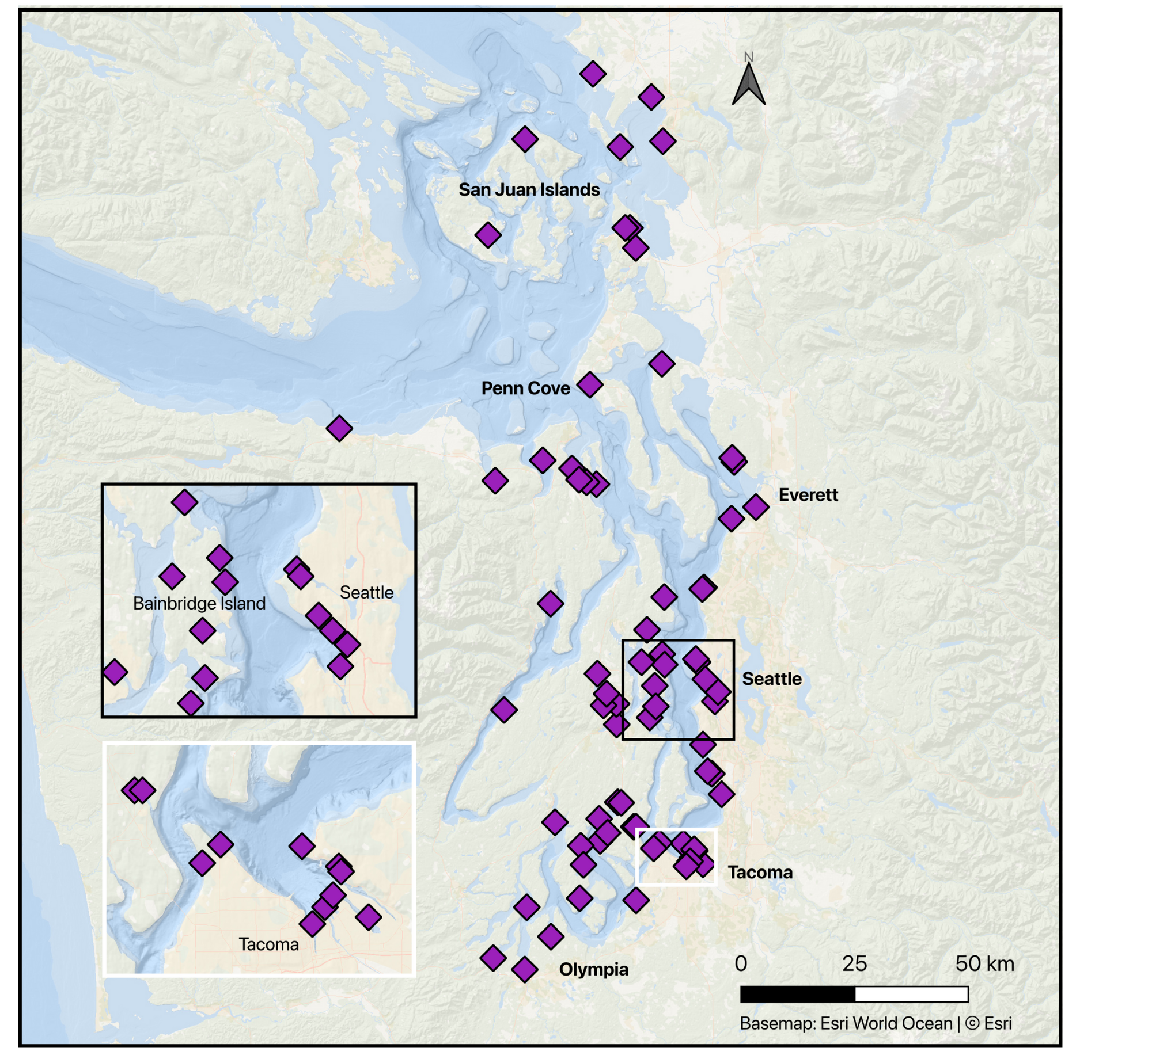
Methods

Figure 1. Sampling sites throughout the Salish Sea and Puget Sound. The purple diamond indicates sites where mussels were out-planted and retrieved in 2021-22.

Study Areas and Samples
Mussels used in this study were collected through the Washington Department of Fish and Wildlife (WDFW) Washington State Mussel Watch Program during the 2021–2022 monitoring cycle. A total of 74 nearshore sites were selected across the Salish Sea within Washington State, encompassing the major Puget Sound basins of Admiralty Inlet, Hood Canal, Whidbey Basin, Central Basin, and South Basin, as well as the northern waters of the San Juan Islands, Bellingham Bay, Padilla Bay, and the eastern Strait of Juan de Fuca (Fig. 1).

Sites were distributed to maximize geographic coverage while capturing a broad gradient of land-use intensity, ranging from minimally developed rural and agricultural watersheds to highly urbanized shorelines. Site selection incorporated both probabilistic spatial coverage and targeted sampling near known or suspected contaminant sources, allowing characterization of contaminant exposure and biological response across diverse environmental contexts.

Mussel deployment and collection
Pre- productive, cultured Pacific blue mussels (Mytilus trossulus) were sourced from a commercial aquaculture facility (Penn Cove Shellfish, Inc., Whidbey Island, WA) to ensure standardized age, size, and exposure history prior to deployment. At each site, mussels were deployed in a vinyl- coated wire mesh predator exclusion cage containing four heavy- duty polyethylene mesh bags, each holding 20 individuals (80 mussels per site). Cages were anchored within the mid- to low-intertidal zone between 0 and −1.5 ft mean lower low water (MLLW).

Deployments occurred in early November 2021, and mussels were retrieved in late January 2022 following approximately 85 days of in situ exposure. Upon retrieval, live mussels were transported on ice for subsequent tissue processing. Composite tissue samples were prepared from 32 mussels per site for contaminant analysis by homogenizing soft tissues and subsampling aliquots into solvent-rinsed glass jars. Samples were stored at −20 °C until chemical analysis. Detailed field handling, composite preparation, and contaminant analytical procedures are fully described in the program Quality Assurance Project Plan (Langness et al., 2022).

Whole mussel morphometrics
A total of 312 mussels (4–6 individuals per site) were transported on ice and stored at −80 °C in individual site- labeled bags prior to morphometric assessment and tissue dissection. Frozen mussels were thawed on ice, and wet mass, shell height, width, and length were recorded prior to dissection. Soft tissues including gill, mantle, digestive gland, posterior adductor muscle, and remaining viscera were dissected, flash frozen in liquid nitrogen, and stored at −80 °C until biochemical assays.

Shells were cleaned of residual tissue, air dried, and weighed. Shell thickness was measured using digital calipers at four predetermined points along each valve. Thickness values were averaged across left and right valves at each measurement point, then averaged across all points to generate a single mean thickness per individual mussel, minimizing potential bias associated with localized shell irregularities. Condition index was calculated following Higgins (1938) formula (below) where shell volume was estimated as length x width x height.

$$CI=\frac{wet tissue mass (g)}{shell volume (mm^{3})} x 100$$

Assays

Cytochrome P450 activity was quantified using a fluorescence- based assay following tissue preparation protocols established by Counihan et al. (2019). Digestive gland tissue (50 mg) from each individual mussel (n = 312) was homogenized in an ice-cold buffer at a 1:5 weight:volume ratio. Homogenates were centrifuged at 1,500 × g for 10 minutes at 2 °C, and the supernatant was subsequently centrifuged at 10,000 × g for 20 minutes at 2 °C. Each sample was resuspended in 200 µL of microsomal buffer and stored at −80 °C until analysis.

Total protein concentration was determined using the Pierce BCA Protein Assay Kit. For enzymatic analysis, 50 µL of sample were pipetted in triplicate into black 96-well microplates along with microsomal buffer blanks. 7-Benzyl-4-(trifluoromethyl)coumarin (BFC) solution was added to each well, and plates were incubated for four hours prior to addition of stop solution. Fluorescence was measured at 410 nm excitation and 530 nm emission using a SpectraMax iD3 microplate reader (Molecular Devices). Enzyme activity was averaged across technical replicates and normalized to total protein content.

Superoxide Dismutase activity was measured using a commercially available assay kit (Cayman Chemical), following the tissue preparation protocol of Counihan et al. (2019). Digestive gland tissue (50 mg) from each individual mussel (n = 312) was homogenized in an ice-cold buffer at a 1:5 (weight:volume) ratio and centrifuged at 1,550 × g for 5 minutes at 4 °C. Supernatants were stored at −80 °C until analysis.

As with cytochrome P450, total protein concentration was determined prior to samples (10 µL) being assayed in duplicate according to manufacturer protocols. Radical detector (200 µL) and xanthine oxidase (20 µL) were added sequentially, and plates were incubated at room temperature on a plate shaker (90 rpm) for 30 minutes. Absorbance was read at 450 nm using a SpectraMax iD3 microplate reader. Activity values were averaged across replicates and normalized to total protein content.

Analysis
Biomarker and morphometric data were evaluated for normality using Shapiro–Wilkes tests and for homogeneity of variance using Levene’s tests. Assumptions of normality were unmet, and data were log₂ transformed prior to analysis. Biomarker and morphometric variables were standardized relative to the Penn Cove reference site to facilitate cross- site comparisons; condition index values were scaled to the reference site without transformation as it is a composite value. Analyses were performed in R version 4.2.3. Key packages used included tidyverse (data handling), sf and sp (spatial data), spdep (Moran’s I and LISA), ggplot2 (figures), and stats/FSA (nonparametric tests).

IBR calculation and scaling. The integrated biomarker response (IBR) score was computed following Mattos et al. (2024), using biomarker values scaled and normalized to the Penn Cove reference site. Biomarker values were log2 transformed and standardized prior to index calculation; index construction preserved variability across biomarker activity (see Mattos et al. for rationale).

Contaminant index construction. For contaminant classes (i.e., PAH, PCB, metal) individual metal concentrations were converted to ng/g (from mg/kg) to be included without significant weighting as the non-metal analytes are reported in ng/g, and standardized (z score), to produce class indices. Individual analyte correlations reported use reported analyte concentrations, not the index. For total contaminant indices (i.e., high molecular weight PAHs), site values for each identified analyte within the class, without duplication, were summed prior to standardization to retain relative contributions across classes.

Spatial analyses and weight matrix. Global Moran’s I and Local Indicators of Spatial Association (LISA) were computed in QGIS (version 3.44.7), and verified in R. A distance-based weight matrix was used with a threshold equal to the maximum nearest neighbor distance that ensured each site had at least one neighbor (inverse distance weighting). Row standardized weights were applied.

Comparison testing and correlations. For pairwise post hoc tests, p values were adjusted using the Benjamini–Hochberg FDR method. Correlation analyses use Spearman’s ρ and Kendall’s τ to account for non-normal distributions and potential monotonic relationships.

Results
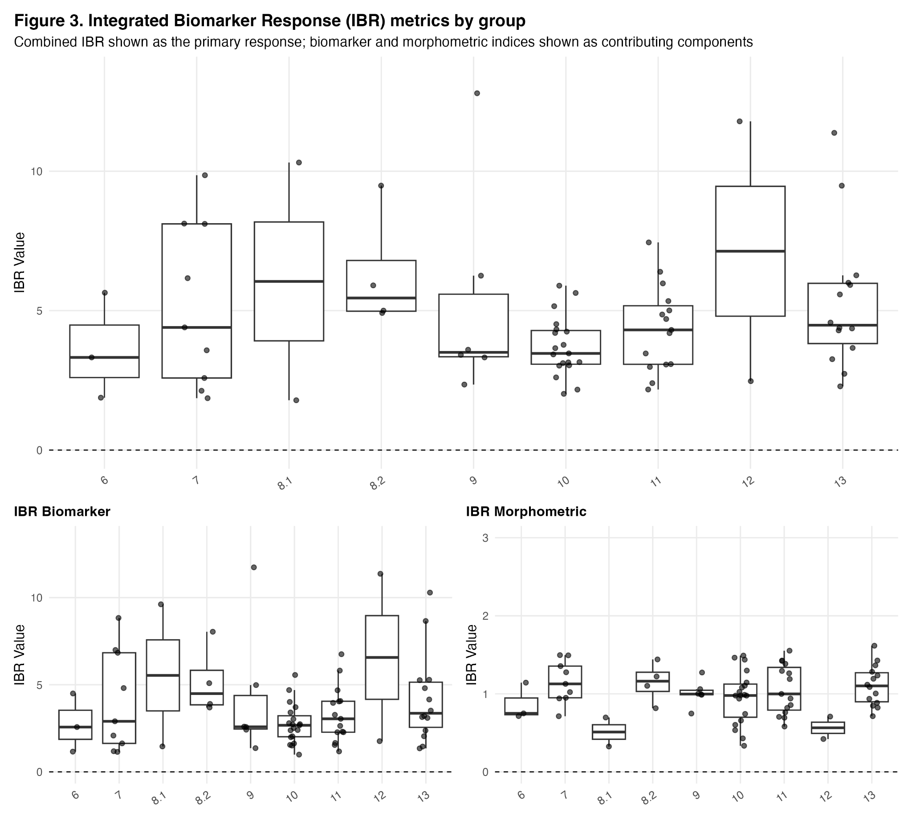
Figure 2. IBR.

Reporting Area Comparisons. Cytochrome P450 activity differed significantly among reporting areas across Puget Sound (Kruskal- Wallis test, H = 13.72, p = 0.012). Post hoc Dunn’s tests identified multiple pairwise differences, with Reporting Area 13 exhibiting significantly higher P450 activity than Reporting Area 12 (z = 4.25, adjusted p = 0.0008) and Reporting Area 11 (z = 3.78, adjusted p = 0.0028). In contrast, superoxide dismutase activity did not differ significantly among reporting areas (Kruskal- Wallis test, H = 6.01, p = 0.20; Fig. 3B).

Shell thickness differed significantly among individual sites (Kruskal- Wallis test, H = 18.64, p = 0.004), but no significant differences were detected among Reporting Areas (H = 4.83, p = 0.31).

Correlations. Correlation analyses revealed several statistically significant but moderate associations between biological metrics and contaminant indices. Superoxide dismutase activity was positively correlated with both the DDT index (Spearman’s ρ = 0.29, p = 0.011; Kendall’s τ = 0.20, p = 0.012) and the pesticide index (Spearman’s ρ = 0.29, p = 0.013; Kendall’s τ = 0.22, p = 0.015).
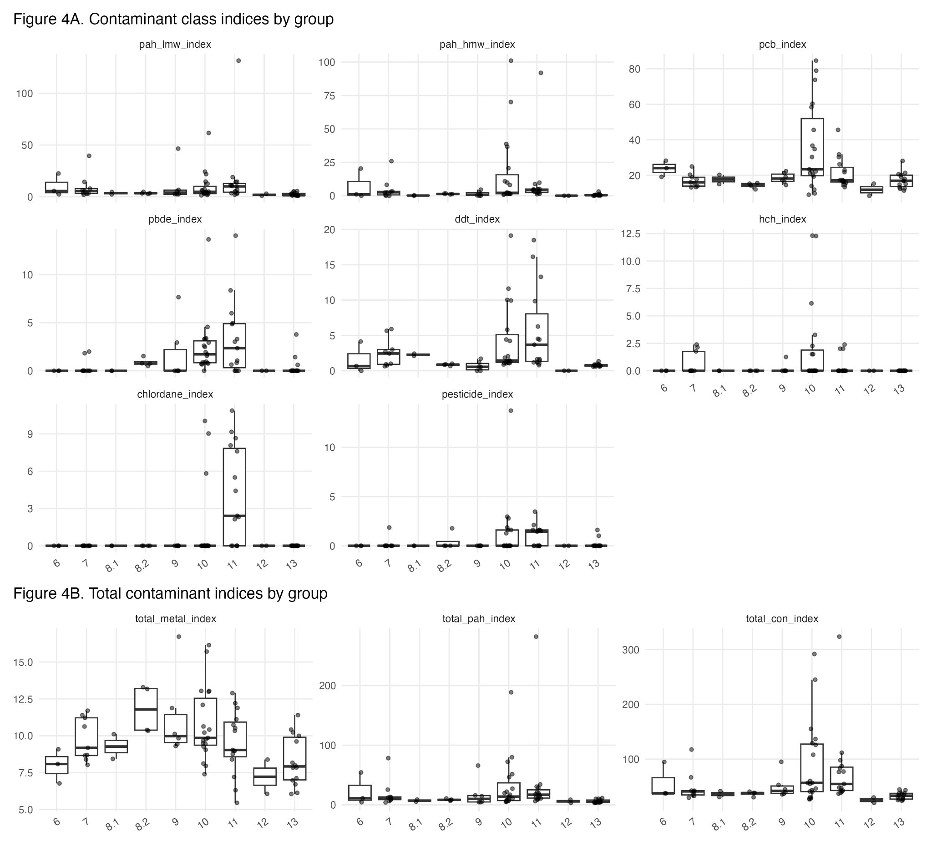

The biomarker- only integrated biomarker response (IBR) index was negatively correlated with the pesticide index (Spearman’s ρ = −0.28, p = 0.016; Kendall’s τ = −0.22, p = 0.018). At the individual analyte level, biomarker IBR values were negatively correlated with multiple PCB congeners, including PCB-138 (Spearman’s ρ = −0.37, p = 0.001; Kendall’s τ = −0.29, p = 0.002) and PCB-118 (Spearman’s ρ = −0.37, p = 0.001; Kendall’s τ = −0.29, p = 0.002).

In contrast, the combined IBR values exhibited mixed directional relationships with individual PCB congeners. For example, the combined IBR was positively correlated with PCB-66 (Spearman’s ρ = 0.34, p = 0.003), while negative correlations were observed with PCB-118 (Kendall’s τ = −0.27, p = 0.004), underscoring the influence of contaminant mixture composition on integrated organismal responses.
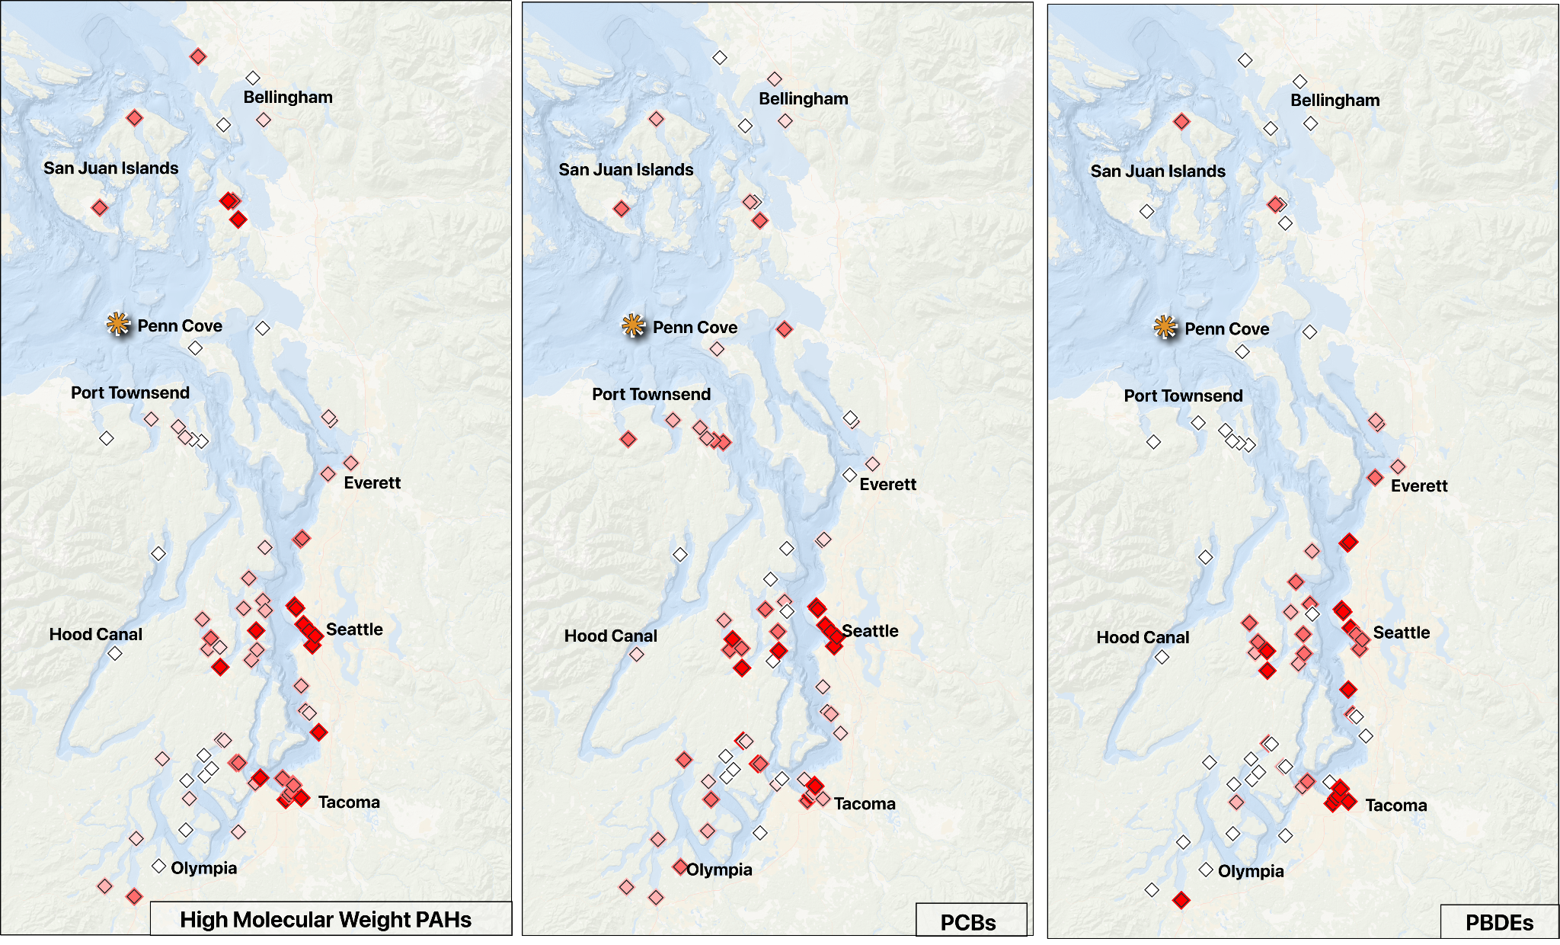

Global Spatial Autocorrelation. Global Moran’s I analysis identified significant positive spatial autocorrelation (p < 0.05) for P450 activity, multiple contaminant indices, and select morphometric variables (Table below). Cytochrome P450 activity and metals exhibited significant positive spatial autocorrelation, however, the strongest spatial clustering was observed in three of the eleven contaminant classes: chlordane, DDT, and PCB. Additional contaminant indices with significant positive spatial autocorrelation included the total contaminant index, PBDE, high molecular weight PAHs, pesticides, and HCH.

Moderate but significant spatial autocorrelation was further detected for the metal index (I = 0.075, z = 1.76, p = 0.0391), and shell thickness (I = 0.074, z = 1.76, p = 0.0393). All significant Global Moran’s I values were positive, indicating spatial clustering of similar values across sites.

First paragraph of GSA | Moran’s I | Z-Score | P-Value
Cytochrome P450 | (I = 0.165, z = 3.52, p < 0.001),
Chlordane Index | Moran’s I = 0.370, z = 7.80, p < 0.001)
DDT Index | (I = 0.352, z = 7.53, p < 0.001)
HCH Index | (I = 0.177, z = 4.44, p < 0.001)
Metals Index | (I = 0.156, z = 3.37, p < 0.001)
PAH, high molecular weight, Index | I = 0.215, z = 5.10, p < 0.001)
PBDE Index | (I = 0.248, z = 5.54, p < 0.001),
PCB Index | (I = 0.313, z = 6.79, p < 0.001)
Pesticide | I = 0.154, z = 5.06, p < 0.001),
Total Contaminant Index | (I = 0.249, z = 5.60, p < 0.001),
Local Indicators of Spatial Autocorrelation (LISA). Significant local spatial autocorrelation (p < 0.05) for individual biomarker activity and the combined IBR was identified. P450 activity exhibited the highest number of significant sites (n = 9), including Meyer’s Point, Henderson Inlet, Suquamish Stormwater Outfall, Skiff Point, Three Tree Point, West Bay Park, Squaxin Island, Penrose Point State Park, Eld Inlet, and Maristone Island Bridge. Superoxide dismutase activity was significant at Tulalip Bay only.

Both the biomarker and morphometric components of the combined IBR displayed significant autocorrelation, when separated into the biomarker and morphometric components to identify the driver of the combined IBR score significance, morphometric autocorrelation drove the combined score significance. The morphometric score revealed six significant sites (Chimacum Creek delta, Skunk Island (south), Chambers Bay Park, Discovery Bay, Oak Bay County Park, and Eagle Harbor Drive), whereas the biomarker score revealed two sites of significance (Tulalip Bay and Tulalip Reservation). A single site, Tulalip Bay, showed significant local spatial autocorrelation for sod.

Across all variables, most significant local Moran’s I values were positive. Negative local Moran’s I values were observed for P450 activity (not the IBR) at Meyer’s Point, Henderson Inlet and Skiff Point, and the morphometric component of the IBR score at Chimacum Creek delta and Eagle Harbor Drive.

Discussion and future directions
This study evaluated organismal responses of Mytilus trossulus to complex contaminant mixtures across Puget Sound by integrating traditionally- validated biomarkers, morphometric measurements, and spatial analyses within an established monitoring framework. By pairing long- term contaminant data with organism- level metrics, we assessed whether traditional biomarkers capture spatial patterns of biological response at a regional scale and how those responses align with known contaminant distributions.

Spatial structure in exposure versus organismal response. Strong spatial clustering was observed for multiple contaminant indices, including PCBs, DDTs, chlordanes, and total contaminant burden, consistent with localized sources, sediment dynamics, and basin- scale hydrodynamics in Puget Sound. In contrast, biological responses exhibited weaker and less consistent spatial structure. This decoupling between chemically structured exposure and organismal response underscores a key challenge in field- based biomonitoring. While contaminants may be spatially concentrated, biological responses integrate exposure across time and are mediated by physiological capacity, life- history traits, and environmental context.

While cytochrome P450 activity is commonly interpreted as a biomarker of exposure to polycyclic aromatic hydrocarbons (PAHs), the spatial structure of multiple contaminant classes in Puget Sound complicates this interpretation. Several contaminant indices that exhibited strong spatial autocorrelation, including PCBs, co-occurred in regions of elevated contaminant burden, particularly within urbanized basins. Because these contaminant classes are not independent in the environment, P450 activity measured in field-deployed mussels likely reflects integrated exposure to contaminant mixtures rather than a single class of compounds. PCBs, in particular, are known to interact with detoxification pathways, including cytochrome P450 enzyme systems, and may act as inducers, inhibitors, or modulators depending on congener composition and exposure context. As a result, the absence of a strong or consistent relationship between P450 activity and PAH indices may not indicate a lack of physiological response, but rather the influence of co-occurring contaminants that alter or confound expected biomarker patterns. These findings highlight a key limitation of interpreting single biomarkers in isolation within spatially complex systems, where overlapping contaminant distributions can obscure class-specific biological signals.

In contrast to cytochrome P450, superoxide dismutase activity exhibited patterns that complicate its interpretation as a contaminant-responsive biomarker within this system. Notably, SOD activity was elevated at the reference site, suggesting that baseline oxidative enzyme activity may be influenced by environmental conditions independent of contaminant burden. Because SOD functions as a key regulator of oxidative balance, its activity reflects both constitutive physiological state and inducible responses to stressors, including but not limited to chemical exposure. As a result, higher SOD activity does not necessarily correspond to greater contaminant-induced stress, but may instead indicate differences in metabolic activity, oxygen availability, or other site-specific environmental factors. This dynamic challenges the assumption that deviation from a reference condition represents increased stress and has direct implications for integrated indices such as IBR, where reference-based scaling may amplify or obscure biologically meaningful variation. Together, these findings suggest that SOD is better interpreted as an indicator of oxidative state within a given environmental context rather than a linear proxy for contaminant exposure.

Correlations between biomarkers and contaminant indices were statistically significant but moderate in magnitude. Positive associations between superoxide dismutase activity and both DDT and pesticide indices suggest increased oxidative stress at sites with higher burdens of these contaminant classes. However, negative correlations between the biomarker- only IBR and pesticide indices, as well as with several PCB congeners, highlight the non- linear nature of organismal responses to contaminant mixtures. These patterns are consistent with physiological buffering, compensatory responses, or acclimation, whereby organisms maintain homeostasis despite ongoing exposure.

Importantly, combined IBR metrics exhibited mixed directional relationships with individual PCB congeners, reinforcing the idea that contaminant mixture composition, rather than total burden alone, influences integrated biological responses. These findings caution against interpreting single biomarkers or composite indices as direct proxies for exposure severity and emphasize the need to consider biological responses as indicators of physiological engagement with stressors rather than deterministic measures of harm.

Local versus regional drivers of morphological variation. Shell thickness varied significantly among sites but not across Reporting Areas or geographic clusters, indicating that morphological traits are likely shaped by highly localized conditions. Factors such as food availability, hydrodynamics, sediment characteristics, and community composition may exert stronger influence on shell formation than regional contaminant gradients. This site- level variability further supports the interpretation that organismal responses operate across multiple spatial and temporal scales, with different biological endpoints responding to distinct drivers.

This study demonstrates that traditional biomarkers can provide meaningful insight into organismal responses to contaminant mixtures in Puget Sound when interpreted within a spatially explicit framework. Cytochrome P450 and superoxide dismutase activity revealed regional differentiation in physiological responses, while morphometric variation was primarily site- specific. Together, these findings highlight the importance of considering geographic context, exposure history, and biological scale when interpreting biomonitoring data.

At the same time, the results underscore the limitations of relying solely on short- term biochemical responses to assess long-term organismal impact. Moderate correlations, mixed directional responses, and weak spatial autocorrelation in biological metrics reflect the capacity of organisms to buffer, compensate, or acclimate to chronic exposure. These dynamics complicate direct translation of biomarker activity into measures of ecological harm, but do not diminish their value as indicators of physiological engagement with environmental stressors.

Expanding biomonitoring efforts to include biological response metrics therefore represents an opportunity not to replace existing frameworks, but to enrich them through a more integrative understanding of ecosystem health. Future work that incorporates finer temporal resolution, site-specific environmental covariates, and molecular-level indicators, including epigenetic modifications, may help resolve the disconnect between exposure and response observed in this study. Such approaches will be essential for advancing from contaminant surveillance toward a more mechanistic and ecologically relevant assessment of nearshore ecosystem condition

Acknowledgements
Penn Cove, WDFW, Ly if not added as author. No conflicts and all that jazz.

Funding
Alison- I have to add my NSF verbage, and I am sure that you have funding information to add as well

Data Availability
Zenodo link to the manuscript’s clean repo & links to the supplements

References

Bebianno, M. J., Lopes, B., Guerra, L., Hoarau, P., & Ferreira, A. M. (2007). Glutathione S-tranferases and cytochrome P450 activities in Mytilus galloprovincialis from the South coast of Portugal: Effect of abiotic factors. Environment International, 33(4), 550–558. https://doi.org/10.1016/j.envint.2006.11.002
Beyer, J., Green, N. W., Brooks, S., Allan, I. J., Ruus, A., Gomes, T., Bråte, I. L. N., & Schøyen, M. (2017). Blue mussels (Mytilus edulis spp.) as sentinel organisms in coastal pollution monitoring: A review. Marine Environmental Research, 130, 338–365. https://doi.org/10.1016/j.marenvres.2017.07.024
Bowen, L., Counihan, K. L., Ballachey, B., Coletti, H., Hollmen, T., Pister, B., & Wilson, T. L. (2020). Monitoring nearshore ecosystem health using Pacific razor clams (Siliqua patula) as an indicator species. PeerJ, 8, e8761. https://doi.org/10.7717/peerj.8761
Cajaraville, M. P., Bebianno, M. J., Blasco, J., Porte, C., Sarasquete, C., & Viarengo, A. (2000). The use of biomarkers to assess the impact of pollution in coastal environments of the Iberian Peninsula: A practical approach. Science of The Total Environment, 247(2), 295–311. https://doi.org/10.1016/S0048-9697(99)00499-4
Chahouri, A., Yacoubi, B., Moukrim, A., & Banaoui, A. (2023). Bivalve molluscs as bioindicators of multiple stressors in the marine environment: Recent advances. Continental Shelf Research, 264, 105056. https://doi.org/10.1016/j.csr.2023.105056
Counihan, K. L., Bowen, L., Ballachey, B., Coletti, H., Hollmen, T., Pister, B., & Wilson, T. L. (2019). Physiological and gene transcription assays to assess responses of mussels to environmental changes. PeerJ, 7, e7800. https://doi.org/10.7717/peerj.7800
Dagnino, A., Allen, J. I., Moore, M. N., Broeg, K., Canesi, L., & Viarengo, A. (2007). Development of an expert system for the integration of biomarker responses in mussels into an animal health index. Biomarkers, 12(2), 155–172. https://doi.org/10.1080/13547500601037171
Ecology and King County. (2011). Control of Toxic Chemicals in Puget Sound: Assessment of Selected Toxic Chemicals in the Puget Sound Basin, 2007-2011 (Nos. 11-03–055). Washington State Department of Ecology and King County Department of Natural Resources. www.ecy.wa.gov/biblio/1103055.html
Fernández, B., Campillo, J. A., Martínez-Gómez, C., & Benedicto, J. (2010). Antioxidant responses in gills of mussel (Mytilus galloprovincialis) as biomarkers of environmental stress along the Spanish Mediterranean coast. Aquatic Toxicology (Amsterdam, Netherlands), 99(2), 186–197. https://doi.org/10.1016/j.aquatox.2010.04.013
Gherras Touahri, H., Boutiba, Z., Benguedda, W., & Shaposhnikov, S. (2016). Active biomonitoring of mussels Mytilus galloprovincialis with integrated use of micronucleus assay and physiological indices to assess harbor pollution. Marine Pollution Bulletin, 110(1), 52–64. https://doi.org/10.1016/j.marpolbul.2016.06.029
Gosling, E. (2021). Ecology of Marine Mussels. In Marine Mussels (pp. 56–140). John Wiley & Sons, Ltd. https://doi.org/10.1002/9781119293927.ch3
Johnson, L., Bravo, C., O’Neill, S., West, J., Myers, M. S., Ylitalo, G., Scholz, N., & Collier, T. (2022). A TOXICS-FOCUSED BIOLOGICAL OBSERVING SYSTEM.
Khan, B., Ho, K. T., & Burgess, R. M. (2020). Application of Biomarker Tools Using Bivalve Models Toward the Development of Adverse Outcome Pathways for Contaminants of Emerging Concern. Environmental Toxicology and Chemistry, 39(8), 1472–1484. https://doi.org/10.1002/etc.4757
Langness, M., Nordstrom, D., & West, J. (n.d.). Stormwater Action Monitoring 2019/2020 Puget Sound Nearshore Mussel Monitoring Survey: Final Report.
Langness, M., Nordstrom, D., & West, J. E. (2022). Stormwater Action Monitoring 2019/2020 Puget Sound Nearshore Mussel Monitoring Survey | Washington Department of Fish & Wildlife (No. FPT 22-05). https://wdfw.wa.gov/publications/02345
Langness, M., & West, J. E. (2020). Stormwater Action Monitoring 2017/18 Mussel Monitoring Survey | Washington Department of Fish & Wildlife (No. FPT 20-13). WDFW. https://wdfw.wa.gov/publications/02184
Lanksbury, J. A., Niewolny, L. A., Carey, A. J., & West, J. E. (2014). Toxic contaminants in Puget Sound’s Nearshore Biota: A Large-Scale Synoptic Survey Using Transplanted Mussels (Mytilus trossulus).
Lomartire, S., Marques, J. C., & Gonçalves, A. M. M. (2021). Biomarkers based tools to assess environmental and chemical stressors in aquatic systems. Ecological Indicators, 122, 107207. https://doi.org/10.1016/j.ecolind.2020.107207
Mattos, J. J., Siebert, M. N., & Bainy, A. C. D. (2024). Integrated biomarker responses: A further improvement of IBR and IBRv2 indexes to preserve data variability in statistical analyses. Environmental Science and Pollution Research, 31(1), 871–881. https://doi.org/10.1007/s11356-023-31255-4
National Mussel Watch Program. (n.d.). National Centers for Coastal Ocean Sciences; NOAA https://coastalscience.noaa.gov/science-areas/pollution/mussel-watch/. https://coastalscience.noaa.gov/science-areas/pollution/mussel-watch/
Sun, J., Ma, Y., Qin, H., Li, Z., & Pan, L. (2022). An integrated approach using chemical ecological risk assessment and multi-integrated biomarker indexes approach to assess pollution: A case study of Ruditapes philippinarum in four bays on the Shandong Peninsula in China. Environmental Research, 203, 111793. https://doi.org/10.1016/j.envres.2021.111793
Sureda, A., Box, A., Tejada, S., Blanco, A., Caixach, J., & Deudero, S. (2011). Biochemical responses of Mytilus galloprovincialis as biomarkers of acute environmental pollution caused by the Don Pedro oil spill (Eivissa Island, Spain). Aquatic Toxicology, 101(3), 540–549. https://doi.org/10.1016/j.aquatox.2010.12.011
Viarengo, A., Lowe, D., Bolognesi, C., Fabbri, E., & Koehler, A. (2007). The use of biomarkers in biomonitoring: A 2-tier approach assessing the level of pollutant-induced stress syndrome in sentinel organisms. Comparative Biochemistry and Physiology Part C: Toxicology & Pharmacology, 146(3), 281–300. https://doi.org/10.1016/j.cbpc.2007.04.011
Vlahogianni, T., Dassenakis, M., Scoullos, M. J., & Valavanidis, A. (2007). Integrated use of biomarkers (superoxide dismutase, catalase and lipid peroxidation) in mussels Mytilus galloprovincialis for assessing heavy metals’ pollution in coastal areas from the Saronikos Gulf of Greece. Marine Pollution Bulletin, 54(9), 1361–1371. https://doi.org/10.1016/j.marpolbul.2007.05.018
Zhang, M., Chen, G., Luo, Z., Sun, X., & Xu, J. (2020). Spatial distribution, source identification, and risk assessment of heavy metals in seawater and sediments from Meishan Bay, Zhejiang coast, China. Marine Pollution Bulletin, 156, 111217. https://doi.org/10.1016/j.marpolbul.2020.111217

