Name:____________________ Fish310

Spring 2013

**Introduction to Cnidarians**

In today’s lab we will be observing members of the phylum Cnidaria. You will become familiar with the external and internal anatomy of 3 representative classes; Hydrozoa, Scyphozoa, and Anthozoa. A live sea anemone dissection will be performed so you will need to work in groups in order to conserve animals. **All animals have been anesthetized prior to dissection**. Remember to walk around the room and check out other people’s dissections and/or wet mounts. They may be able to see something you didn’t.

Cnidarians (“cnida” = nettle or stinging thread) are almost entirely marine with 10,000 living species described. Common cnidarians include jellyfish, corals, sea anemones, box jellies, fire corals, sea pens, and sea pansies. Two strikingly different body plans are found among cnidarians: a **polyp** form (typically asexual and benthic) and a **medusa** form (typically sexual and planktonic/pelagic). Some members of the phylum have both a polyp and medusa stage. Most cnidarians have radial symmetry, although sea pens have bilateral symmetry. Cnidarians do not have a head and are situated on an oral-aboral axis. Despite differences in body plans, both polyps and medusa share the same basic body construction; 2 layers of epithelium (**epidermis (=ectoderm) and gastrodermis (=endoderm)**) with **mesoglea** in between. Mesoglea is made of secreted mucopolysaccharides, collagen, and water and is **not** a true tissue.

1. What are 2 defining characteristics of the phylum Cnidaria?

2. Label the oral-aboral axis on the polyp and medusa figures below by filling in the boxes.

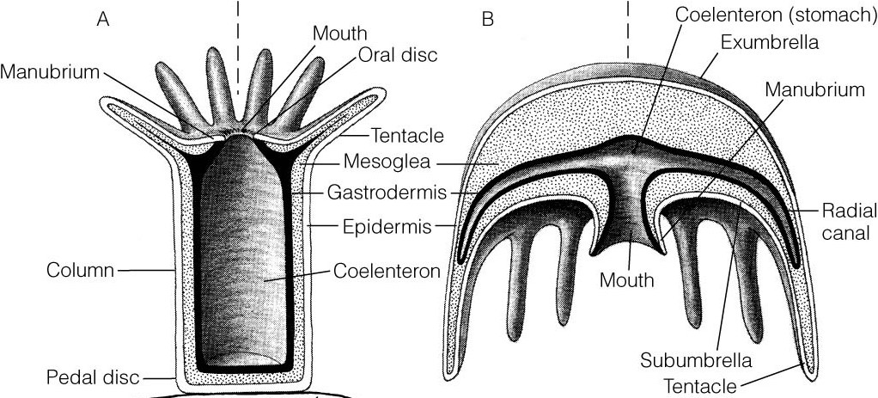

**Class Hydrozoa**

The class Hydrozoa contains ~3000 mostly marine species and is comprised of 3 major orders; Hydroida, Siphonophora, & Hydrocorallina. Hydrozoans are typically small (mm-cm) and have both polyp and medusa life stages with one often reduced or lost. In contrast to other cnidarians, the gastrodermal tissue of hydrozoans lacks nematocysts (restricted to epidermis) and no cells are found within the mesoglea.

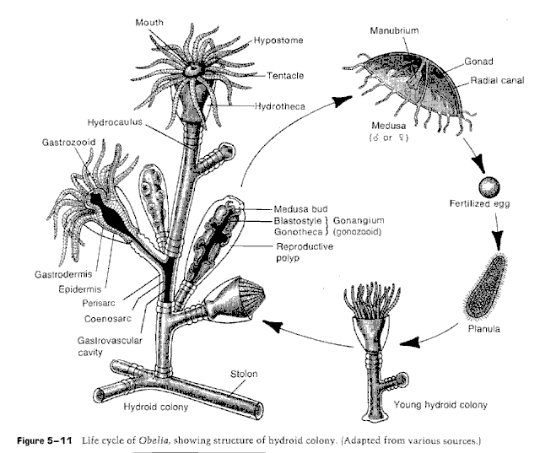

3. Examine a colonial hydrozoan polyp under a dissecting scope. Draw what you see and **try to identify what species** it is using a field guide - this can be tough, but give it a shot! The point is to become familiar with using a dichotomous key.

Note the following:

* Colony form – Is the colony encrusting or upright?
* Polymorphism – Are feeding or reproductive zooids present?

**Class Anthozoa**

Anthozoa is the only class of Cnidarians who **never** have a medusa stage; they are polyps only!

4. Look carefully at the external anatomy of the local sea anemone, *Anthopleura elegantissima*, under a dissecting scope. Draw and label external structures (mouth, tentacles, pedal disc, epidermis, and acrorhagi).

5. Now it’s time for dissections! An incision along the oral-aboral axis is probably most informative. Draw the internal anatomy, referencing the handout provided. Make sure to identify internal structures like the pharynx, siphonoglyph, mestenteries, and gonad.

6. Examine cnidea of your dissected anemone in a wet mount (make sure your tissue section is thin). Where do you expect to find them? If the cnidea are unfired, you may be able to make them fire with the addition of a tiny amount of dilute acetic acid (SWEET!). **Draw what you see**.

7. Look at a thin section tentacle of *Anthopleura elegantissima* in a wet mount. This anemone sometimes has two types of algal symbionts that you can distinguish by size and color – zoochlorellae (single-celled green algae) are green and 6-8µm in diameter and zooxanthellae (dinoflagellate of the genus *Symbiodinium*) are olive-brown and 10-12µm in diameter. Which do you see?

Make sure to check out various defensive/offensive structures – acontia in *Metridium*, and acrorhagi in *Anthopleura*. Observe deployment of these in live animals on demonstration.

**Class Scyphozoa**

The class Scyphozoa contains only a few hundred species, all of which are marine and many of which are quite large (up to 2m in diameter!) Scyphozoans are considered true jellyfishes because of their thick mesoglea layer and medusoid morphology.

8. Name one difference between Scyphozoans and Hydrozoans?

9. Observe and draw the planula larvae and the scyphistoma of *Aurelia aurita* (moon jelly). Name two characteristics of planula larvae? As the scyphistoma grows, it produces a saucer-like stack of young **ephyra** asexually. A process called what?

10. The club shaped structures that contain sensory tissues such as ocelli and statocysts are called what? Where are they located?

11. Observe our tiny Scyphozoan friends (*Euphysa* spp.) – what kind of behavior do you see? Try feeding *Anthopleura* some dried krill or watch *Metridium* filter feed on brine shrimp and note what type of behavior you see.

12. What is the fourth class of Cnidarians discussed in lecture that is not represented in lab today? Why do you think this is so? Name one defining characteristic of this class.