Name:__________________________

Class Crustacea: Senses, Development, and more Taxonomy

Crustacean Senses

Chemoreception: Chemoreception in crabs occurs in specialized sensory “hairs” (setae) that tend to be concentrated on the first antennae, the mouthparts, and the dactyls of crabs. Specialized sensory setae called aesthetascs on the first pair of antennae are primarily responsible for the sense of smell in decapod crustaceans.

Observe one of the larger crabs in the aquarium at the front of the room. Note the flicking of the first antennae, and position yourself so that you can see one side clearly. Use a counter to count the number of antennal flicks per minute of one of the first antennae.

1) How many flicks per minute do you observe? (0.5 points)

Once everyone has taken this ‘baseline’ reading, we will add some mussel juice to the tank and take another count. Watch the same specimen you used for number one.

2) How many flicks per minute after adding the juice?(0.5 points)

- Why do they flick their antennae this way? Did the crab show any other visible response to the smell?(0.5 points)

- Examine the setae under the compound microscope. These setae have various functions and were taken from a walking leg dactyl, the underside of the carapace, and a pleopod. Draw them or describe how they differ in form. What do you think is the probable function of each type?(2 points)

Touch: Setae extending from the cuticle of crustaceans are mechanoreceptors that are sensitive to touch, currents, and low frequency vibrations. These often possess directional sensitivity, and when bent convey information to the central nervous system. A special type of touch receptor is the statocyst, which is used to tell up from down. You will have the opportunity to examine a statocyst in a live Crangon shrimp later in this lab.

Sight: Crustaceans have compound eyes, made up of numerous visual units (ommatidia) each with its own lens. The image produced is probably like that of a digital image, made up of thousands of pixels.

Though superficially similar in appearance, there is a tremendous diversity of eye designs in crustaceans. The basic compound eye is an apposition eye. Each lens is directly apposed to the receiving rhabdom. Each lens is very small so each rhabdom receives very little light; apposition eyes work best in relatively bright light. In superposition eyes, numerous ommatidia combine to direct their light onto the same part of the retina, greatly boosting the animal’s ability to see in dim light.

- Please draw the crab eye and shrimp eye slides under a compound microscope. How do they differ? (2 points)

Reproduction and Development

Sexual reproduction is a general characteristic of arthropods. Fertilization tends to be internal but is external in some species. Most species are gonochoristic (dioecious) though some may be hermaphroditic or even exhibit some degree of asexual reproduction. The larval stage characteristic of Crustacea is the nauplius. Nauplius larvae are triangular in shape with a carapace and a median eye. The nauplius molts in order to grow or add/modify appendages. While most decapods pass through this stage while still in the egg, some Crustacea have free-swimming nauplii.

Nearly all decapod crustaceans carry (brood) their eggs on their pleopods until they hatch in a larval form called the zoea (in a few cases such as crayfish, larvae hatch at a later stage). Zoea larvae are characterized by a pair of large compound eyes and spines on the carapace. Crab zoea go through a number of zoeal stages before they metamorphose into the megalopae stage. The megalopae look more like adult crabs except the abdomen is not folded under the thorax. The exception to the brooding rule are penaeid shrimps that mate and release their fertilized eggs.

Development generally proceeds from the anterior end to the posterior end- so head appendages develop first, then thorax appendages, then abdominal. Likewise, swimming is done first with head appendages, then thorax, then abdominal.

For this next section, you will look at samples from the fresh and salt water plankton tows. Don’t mix the fresh and saltwater samples together, and be sure to not mix live and preserved dishes or pipettes. Once you have some specimens to examine, put the live extras back in the container. Use a baster to draw material from near the top of the saltwater container; for the freshwater sample it is easiest to just grab a blob of the filamentous algae and put it in pond water.

- Put some brine shrimp (Artemia) under a dissecting scope and observe their swimming. Describe their appendages. Which subclass do they belong to? Draw the Artemia and determine the lifestage. (1.5 points)

- Examine a live barnacle nauplius from the salt water plankton tow. How does it differ from the live Artemia nauplius?(0.5 points)

- Examine a live brachyuran crab zoea from the salt water plankton tow under the scope (put it in a tiny drop of water to restrict its movements). What appendages does it use for swimming? (0.5 points)

- How does the Dungeness crab (Cancer magister) megalops differ from the adult crab? (0.5 points)

- Examine the preserved phyllosoma larva of a spiny lobster (Order decapoda, infraorder palinura). Name two features that make it well suited to spending a long time in the plankton. (1 point)

Taxonomy: Copepods
Copepods are in the class Crustacea and the subclass Copepoda. Copepods are found in fresh, estuarine, and marine environments, and are found in all ocean waters from the surface to depths over 5000m. Copepods often dominate the marine zooplankton and are incredibly important in marine food chains. Copepods are eaten by larval fish and thus provide a critical link between primary production and higher trophic levels. Copepods can be either parasitic or free living. There are six orders of copepods but most free-living copepods belong to one of the three orders.

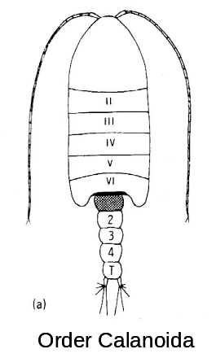
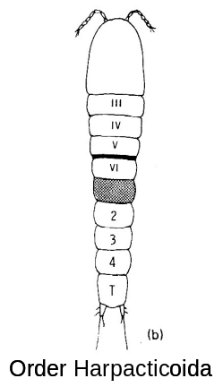
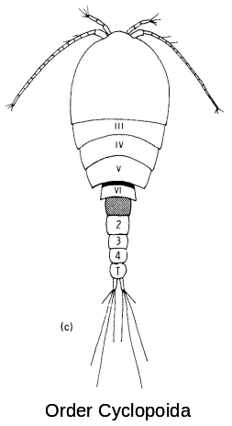
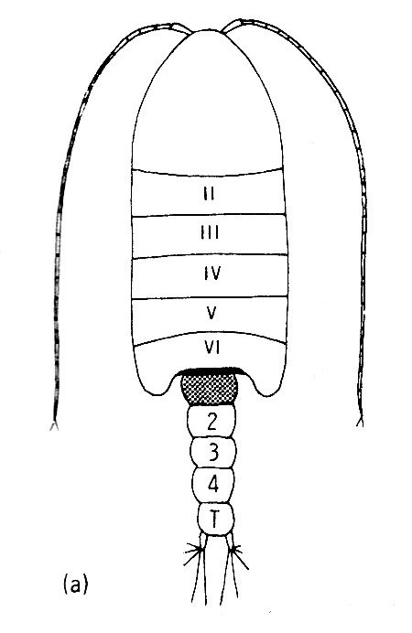

- Compare a copepod from the freshwater plankton tow to one from the saltwater planton tow. Which Order does each belong too? (2 points)

Taxonomy: The Subclass Branchiopoda

The subclass Branchiopoda is a diverse group of small, primarily freshwater crustaceans. Many of these organisms are found in harsh environments from temporary freshwater lakes to super saline areas. These animals may thrive here because their predators do not! Looking at these organisms, it is not immediately clear why they are grouped into a subclass. However, branchiopods have thoracic appendages modified into large, flat, paddles. These paddles are used both in locomotion and gas exchange—hence branchio (gill) pod (foot). Branchiopods are generally filter feeders but some are carnivorous. Most branchiopods have a bivalve carapace around their body, but some groups completely lack a carapace.

13) Draw or describe the representative organism and list a character that separates each order from the other three orders (4 points).

Anostraca are referred to in the book as brine shrimp and fairy shrimp. Anostracans produce eggs that can withstand desiccation and extreme temperatures.

Notostraca are referred to in the book as tadpole shrimp. They are found in temporary freshwater lakes and their eggs can withstand severe dehydration.

Cladocera are referred to in the book as water fleas. Cladocerans can dominate the zooplankton of freshwater lakes. Daphnia, a cladoceran genus, is common in Lake Washington.

Conchostraca are referred to in the book as clam shrimp. Conchostracans are common in temporary freshwater ponds and their eggs can withstand severe dehydration. Female conchostracans and cladocerans brood embryos within their carapace.

Taxonomy: Shrimp

Here is another example showing that common names cannot be used to determine taxonomy. The term ‘shrimp’ has been used for just about any crustacean that doesn’t look like a crab, lobster, or barnacle. For example: brine shrimp (subclass Branchiopoda, order Anostraca), mantis shrimp (subclass Malacostraca, order Stomatopoda), mysid/opossum shrimp (subclass Malacostraca, order Mysidacea), skeleton shrimp (Subclass Malacostraca, order Amphipoda) and two in the subclass Malacostraca, Superorder Eucarida, Order Decapoda: infraorder Penaeidea and infraorder Caridea. Penaeid shrimp are the only decapods that do not brood their embryos. Caridean shrimp are considered “true shrimp.”

14) Examine your preserved penaeid shrimp and compare it to your caridean shrimp. How can you distinguish between penaeid and caridean shrimp? (1 point).

15) Describe any unique morphology of the skeleton shrimp (see video). For extra credit, perform an interpretive dance describing the movement of the skeleton shrimp. Make sure your TA sees the dance! (1 point, plus 1 potential extra credit point)

Euphausiids (krill) belong to the superorder Eucarida, the same group as Decapods. Within the superorder Eucarida, euphausiids belong to the order Euphausiacea. Animals from this order are exclusively marine, found worldwide, and abundant in the open ocean. They form a major food source for baleen whales as well as other fish, squid, birds, and true shrimp. This is another “shrimpy” taxa.

16) How could you differentiate the euphausiid from the penaeid and caridean shrimp? (1 point)

Live shrimp (Crangon, from the infraorder caridea)

Coloration in crustaceans can be due to pigments deposited in the cuticle itself or the cuticle can be thin and transparent and pigments within the underlying tissues may show through. Many crustaceans have specialized structures called chromatosomes in the epidermis beneath the cuticle. Chromatosomes are groups of pigmented cells with radiating processes capable of rearranging their pigment granules. When large numbers of a particular color expand or contract they change the animal’s color. The rapid color change of many crustaceans is initiated by structures in the eyestalks that secrete hormones controlling the pigments within the chromatosomes.

17) Examine your live Crangon with the naked eye. What color is it? Now examine it under your dissecting scope. What colors of chromatosomes are present? (1 point)

19). Put your Crangon in one of the bowls of water that has sand in the bottom, and observe its burying behavior. What appendages does it use? (0.5 points)

20). How do you think your buried Crangon continues to breathe when buried like this? (0.5 points)

