qPCR

2023-07-21

library(tidyverse)

## ── Attaching core tidyverse packages ──────────────────────── tidyverse 2.0.0 ──  
## ✔ dplyr 1.1.2 ✔ readr 2.1.4  
## ✔ forcats 1.0.0 ✔ stringr 1.5.0  
## ✔ ggplot2 3.4.2 ✔ tibble 3.2.1  
## ✔ lubridate 1.9.2 ✔ tidyr 1.3.0  
## ✔ purrr 1.0.1   
## ── Conflicts ────────────────────────────────────────── tidyverse_conflicts() ──  
## ✖ dplyr::filter() masks stats::filter()  
## ✖ dplyr::lag() masks stats::lag()  
## ℹ Use the conflicted package (<http://conflicted.r-lib.org/>) to force all conflicts to become errors

Converted Cq value to aev with: =10^(-(0.3012 * E2) + 11.434)

qpcr <- read.csv("../data/SR-qpcr-data-1.csv", header = TRUE)

ggplot(data = qpcr, mapping = aes(x = Subgroup, y = CqMean)) +   
 geom_boxplot() +  
 facet_wrap('Target')

## Warning: Removed 1 rows containing non-finite values (`stat_boxplot()`).

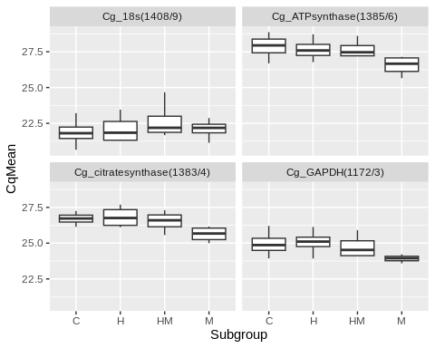

ggplot(data = qpcr, mapping = aes(x = Subgroup, y = aev)) +   
 geom_boxplot() +  
 facet_wrap('Target') +  
 coord_cartesian(ylim = c(1000, 175000))

## Warning: Removed 1 rows containing non-finite values (`stat_boxplot()`).

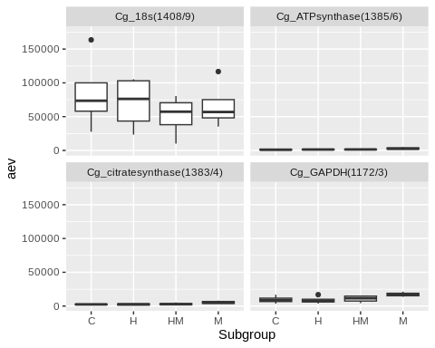

qpcr %>%  
 filter(Target == "Cg_18s(1408/9)") %>%  
ggplot(mapping = aes(x = Subgroup, y = aev)) +   
 geom_boxplot() +  
 geom_jitter(aes(color = history), width = 0.1, alpha = 0.7)

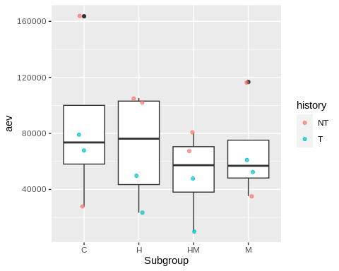

qpcr %>%  
 filter(Target == "Cg_GAPDH(1172/3)") %>%  
ggplot(mapping = aes(x = Subgroup, y = aev)) +   
 geom_boxplot() +  
 geom_jitter(aes(color = history), width = 0.1, alpha = 0.7)

## Warning: Removed 1 rows containing non-finite values (`stat_boxplot()`).

## Warning: Removed 1 rows containing missing values (`geom_point()`).

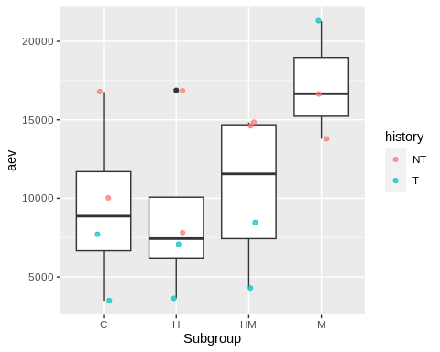

qpcr %>%  
 filter(Target == "Cg_ATPsynthase(1385/6)") %>%  
ggplot(mapping = aes(x = Subgroup, y = aev)) +   
 geom_boxplot() +  
 geom_jitter(aes(color = history), width = 0.1, alpha = 0.7)

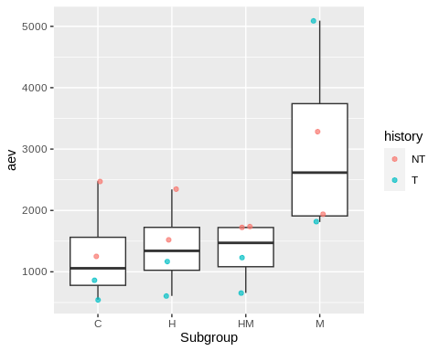

qpcr %>%  
 filter(Target == "Cg_citratesynthase(1383/4)") %>%  
ggplot(mapping = aes(x = Subgroup, y = aev)) +   
 geom_boxplot() +  
 geom_jitter(aes(color = history), width = 0.1, alpha = 0.7)

