qPCR-graphs-7-24

Noah Krebs

2023-07-24

library(tidyverse)

## ── Attaching core tidyverse packages ──────────────────────── tidyverse 2.0.0 ──  
## ✔ dplyr 1.1.2 ✔ readr 2.1.4  
## ✔ forcats 1.0.0 ✔ stringr 1.5.0  
## ✔ ggplot2 3.4.2 ✔ tibble 3.2.1  
## ✔ lubridate 1.9.2 ✔ tidyr 1.3.0  
## ✔ purrr 1.0.1   
## ── Conflicts ────────────────────────────────────────── tidyverse_conflicts() ──  
## ✖ dplyr::filter() masks stats::filter()  
## ✖ dplyr::lag() masks stats::lag()  
## ℹ Use the conflicted package (<http://conflicted.r-lib.org/>) to force all conflicts to become errors

qpcrm <- read.csv("../data/qPCR-data-7-24-1.csv", header = TRUE)

ggplot(data = qpcrm, mapping = aes(x = Subgroup, y = CqMean)) + geom_boxplot() +  
 facet_wrap('Target') +  
 coord_cartesian(ylim = c(0, 45))

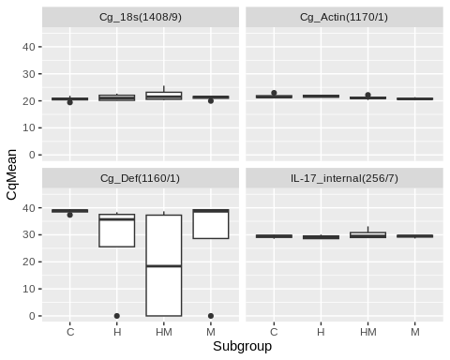

qpcrm %>%  
 filter(Target == "Cg_18s(1408/9)") %>%  
ggplot(mapping = aes(x = Subgroup, y = CqMean)) +   
 geom_boxplot() +  
 geom_jitter(aes(color = History), width = 0.1, alpha = 0.7)

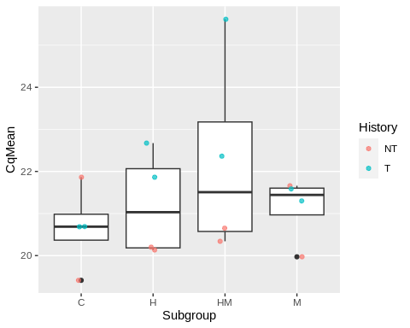

qpcrm %>%  
 filter(Target == "Cg_Actin(1170/1)") %>%  
ggplot(mapping = aes(x = Subgroup, y = CqMean)) +   
 geom_boxplot() +  
 geom_jitter(aes(color = History), width = 0.1, alpha = 0.7)

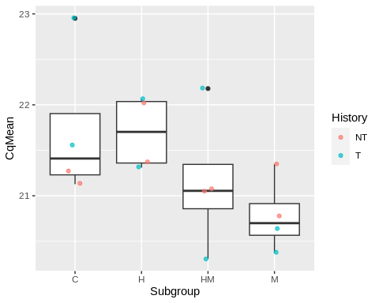

qpcrm %>%  
 filter(Target == "Cg_Def(1160/1)") %>%  
ggplot(mapping = aes(x = Subgroup, y = CqMean)) +   
 geom_boxplot() +  
 geom_jitter(aes(color = History), width = 0.1, alpha = 0.7)

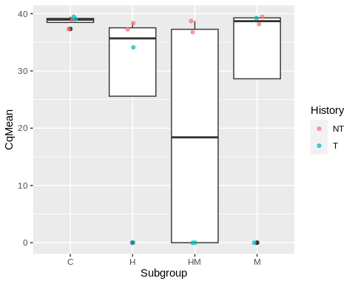

qpcrm %>%  
 filter(Target == "IL-17_internal(256/7)") %>%  
ggplot(mapping = aes(x = Subgroup, y = CqMean)) +   
 geom_boxplot() +  
 geom_jitter(aes(color = History), width = 0.1, alpha = 0.7)

