CLUSTERING OF HUMAN FACES
A
Mini Project Report
Submitted in partial fulfilment of the Requirements for the award of the Degree of
BACHELOR OF ENGINEERING
IN
INFORMATION TECHNOLOGY
By
PELLIVILLA UMA DEVI 1602-20-737-056
BHOOMA SRUTHI BHAVANA 1602-20-737-047 RAYELLA SRUJAN TEJA 1602-20-737-046


Department of Information Technology Vasavi College of Engineering (Autonomous)
ACCREDITED BY NAAC WITH 'A++' GRADE.
(Affiliated to Osmania University and Approved by AICTE) Ibrahim Bagh, Hyderabad-31 2022

VASAVI COLLEGE OF ENGINEERING (AUTONOMOUS)
(AFFILIATED TO OSMANIA UNIVERSITY) HYDERABAD - 500 030 Department of Information Technology
DECLARATION BY CANDIDATE

We, <PELLIVILLA UMA DEVI>, <BHOOMA SRUTHI BHAVANA>, <RAYELLA SRUJAN TEJA>, bearing hall ticket number, <1602-20-737-056>,<1602-20-737-047>,<1602-20-737-046> hereby declare that the project report entitled <RECREATING HUMAN FACES> Department of Information Technology, Vasavi College of Engineering, Hyderabad, is submitted in partial fulfilment of the requirement for the award of the degree of Bachelor of Engineering in Information Technology.
This is a record of Bonafide work carried out by me and the results embodied in this project report has not been submitted to any other university or institute for the award of any other degree or diploma.

<PELLIVILLA UMA DEVI>,<1602-20-737-056>
<BHOOMA SRUTHI BHAVANA>,<1602-20-737-047>
<RAYELLA SRUJAN TEJA >,<1602-20-737-046>

VASAVI COLLEGE OF ENGINEERING (AUTONOMOUS)
(AFFILIATED TO OSMANIA UNIVERSITY) HYDERABAD - 500 030 Department of Information Technology
BONAFIDE CERTIFICATE

This is to certify that the project entitled CLUSTERING OF HUMAN FACES” being submitted by PELLIVILLA UMA DEVI, BHOOMA SRUTHI BHAVANA, RAYELLA SRUJAN TEJA bearing1602-20-737-056,1602-20-737-047,1602-20-737-046, in partial fulfilment of the requirements for the completion of MINI PROJECT of bachelor of Engineering in Information Technology is a record of bonafide work carried out by them under my guidance.

Internal Guide External Examiner Dr. K Ram Mohan Rao
Professor & HOD,
Dept. of IT

ACKNOWLEDGEMENT

We extend our sincere thanks to Dr. S. V. Ramana, Principal, Vasavi College of Engineering for his encouragement.

We express our sincere gratitude to Dr. K. Ram Mohan Rao, Professor & Head, Department of Information Technology, Vasavi College of Engineering, for introducing the Mini-Project II module in our curriculum, and for his suggestions, motivation, and co-operation for the successful completion of our Mini Project.

We also want to thank and convey our gratitude towards our mini project coordinators C. Sireesha , K. Srinivas Chakravarthy and G. Swapna Sri, for guiding us in understanding the process of project development & giving us timely suggestions at every phase.

We would also like to sincerely thank the project reviewers for their valuable inputs and suggestions

TABLE OF CONTENTS

- Introduction
  - Overview
  - Features
  - Scope
- Technology
  - Software Requirements
  - Hardware Requirements
- Proposed Work
  - Design
  - Implementation
- Results
- Outcomes apart from curriculum
- Conclusion and future work
- References

INTRODUCTION

- Overview
The Main Objective of this Mini Project is to design a prototype system with advance techniques of image clustering and other technique to identify humans in real time video.

Features
  - User will upload the video and will be able to extract frames from video of and cropping the faces in
  - Grouping of similar face images recognized from video and recreating the final facial image will be done.
- Scope
i. Identification of faces will be easier by recreating faces. This could be used to find people whose faces are not clear or faces that are potrayed in different angles (so that it could be easier to find thieves easier). It could be helpful to identify and compare faces from a huge crowd.
ii. They can be segmented into blacklist and whitelist applications. Blacklist applications include the ones related to security & surveillance and identification of criminals.

Technology

- Software Requirements
  - Windows 7 & newer or MacOS 11 & newer
  - Applications Required Pre-Installed: VS-Code
  - Runtime Environment: Safari or Chrome
- Hardware Requirements
  - x86 64-bit CPU Processor
  - 4GB RAM
  - 5 GB of free disk space

PROPOSED WORK

- Design:
Use-Case Diagram:
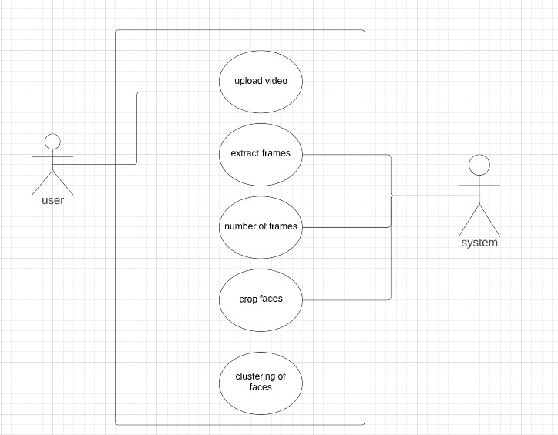

- Implementation:
Module-wise Code:
i. Extraction of frames
from datetime import timedelta
import cv2
import numpy as np
import os
SAVING_FRAMES_PER_SECOND = 1.0
def format_timedelta(td):
"""Utility function to format timedelta objects in a cool way (e.g 00:00:20.05)
omitting microseconds and retaining milliseconds"""
result = str(td)
try:
result, ms = result.split(".")
except ValueError:
return (result + ".00").replace(":", "-")
ms = int(ms)
ms = round(ms / 1e4)
return f"{result}.{ms:02}".replace(":", "-")

def get_saving_frames_durations(cap, saving_fps):
"""A function that returns the list of durations where to save the frames"""
s = []
# get the clip duration by dividing number of frames by the number of frames per second
clip_duration = cap.get(cv2.CAP_PROP_FRAME_COUNT) / cap.get(cv2.CAP_PROP_FPS)
# use np.arange() to make floating-point steps
for i in np.arange(0, clip_duration, 1 / saving_fps):
s.append(i)
return s

def main(video_file):
filename, _ = os.path.splitext(video_file)
filename += "-opencv"
# make a folder by the name of the video file
if not os.path.isdir(filename):
os.mkdir(filename)
# read the video file
cap = cv2.VideoCapture(video_file)
# get the FPS of the video
fps = cap.get(cv2.CAP_PROP_FPS)
# if the SAVING_FRAMES_PER_SECOND is above video FPS, then set it to FPS (as maximum)
saving_frames_per_second = min(fps, SAVING_FRAMES_PER_SECOND)
# get the list of duration spots to save
saving_frames_durations = get_saving_frames_durations(cap, saving_frames_per_second)
# start the loop
count = 0
while True:
is_read, frame = cap.read()
if not is_read:
# break out of the loop if there are no frames to read
break
# get the duration by dividing the frame count by the FPS
frame_duration = count / fps
try:
# get the earliest duration to save
closest_duration = saving_frames_durations[0]
except IndexError:
# the list is empty, all duration frames were saved
break
if frame_duration >= closest_duration:
# if closest duration is less than or equals the frame duration,
# then save the frame
frame_duration_formatted = format_timedelta(timedelta(seconds=frame_duration))
cv2.imwrite(os.path.join(filename, f"frame{frame_duration_formatted}.jpg"), frame)
# drop the duration spot from the list, since this duration spot is already saved
try:
saving_frames_durations.pop(0)
except IndexError:
pass
# increment the frame count
count += 1
#if name == "main":
import sys
video_file = sys.argv[1]
main(video_file)
ii)cropping of faces:

# import required libraries
import cv2

# read the input image
img = cv2.imread('v_frame6.jpg')

# convert to grayscale of each frames
gray = cv2.cvtColor(img, cv2.COLOR_BGR2GRAY)

# read the haarcascade to detect the faces in an image
face_cascade = cv2.CascadeClassifier(cv2.data.haarcascades +'haarcascade_frontalface_default.xml')

# detects faces in the input image
faces = face_cascade.detectMultiScale(gray, 1.3, 4)
print('Number of detected faces:', len(faces))

# loop over all detected faces
if len(faces) > 0:
for i, (x, y, w, h) in enumerate(faces):

# To draw a rectangle in a face
cv2.rectangle(img, (x, y), (x + w, y + h), (0, 1000, 1000), 2)
face = img[y:y + h, x:x + w]
cv2.imshow("Cropped Face", face)
cv2.imwrite(f'face{i}.jpg', face)
print(f"face{i}.jpg is saved")

# display the image with detected faces
cv2.imshow("image", img)
cv2.waitKey(0)
cv2.destroyAllWindows()

iii)clustering of faces:
//clustering.py
from sklearn.cluster import DBSCAN
from imutils import build_montages
import numpy as np
import argparse
import pickle
import cv2
import shutil
import os
from constants import FACE_DATA_PATH, ENCODINGS_PATH, CLUSTERING_RESULT_PATH

# add constants file in the code (clustering_result)

def move_image(image,id,labelID):

path = CLUSTERING_RESULT_PATH+'/label'+str(labelID)
# os.path.exists() method in Python is used to check whether the specified path exists or not.
# os.mkdir() method in Python is used to create a directory named path with the specified numeric mode.
if os.path.exists(path) == False:
os.mkdir(path)

filename = str(id) +'.jpg'
# Using cv2.imwrite() method
# Saving the image

cv2.imwrite(os.path.join(path , filename), image)

return

# construct the argument parser and parse the arguments
ap = argparse.ArgumentParser()
ap.add_argument("-e", "--encodings", required=True,
help="path to serialized db of facial encodings")
ap.add_argument("-j", "--jobs", type=int, default=-1,
help="# of parallel jobs to run (-1 will use all CPUs)")
args = vars(ap.parse_args())

# load the serialized face encodings + bounding box locations from
# disk/encodings pickle file, then extract the set of encodings to so we can cluster on them

print("[INFO] loading encodings...")
data = pickle.loads(open(args["encodings"], "rb").read())
data = np.array(data)
encodings = [d["encoding"] for d in data]

# cluster the embeddings
print("[INFO] clustering...")

# creating DBSCAN object for clustering the encodings with the metric "euclidean"
clt = DBSCAN(metric="euclidean", n_jobs=args["jobs"])
clt.fit(encodings)

# determine the total number of unique faces found in the dataset
# clt.labels_ contains the label ID for all faces in our dataset (i.e., which cluster each face belongs to).
# To find the unique faces/unique label IDs, used NumPy’s unique function.
# The result is a list of unique labelIDs
labelIDs = np.unique(clt.labels_)

# we count the numUniqueFaces . There could potentially be a value of -1 in labelIDs — this value corresponds
# to the “outlier” class where a 128-d embedding was too far away from any other clusters to be added to it.
# “outliers” could either be worth examining or simply discarding based on the application of face clustering.
numUniqueFaces = len(np.where(labelIDs > -1)[0])
print("[INFO] # unique faces: {}".format(numUniqueFaces))

# loop over the unique face integers
for labelID in labelIDs:
# find all indexes into the `data` array that belong to the
# current label ID, then randomly sample a maximum of 25 indexes
# from the set
print("[INFO] faces for face ID: {}".format(labelID))
idxs = np.where(clt.labels_ == labelID)[0]
idxs = np.random.choice(idxs, size=min(25, len(idxs)),
replace=False)

# initialize the list of faces to include in the montage
faces = []

# loop over the sampled indexes
for i in idxs:
# load the input image and extract the face ROI
image = cv2.imread(data[i]["imagePath"])
(top, right, bottom, left) = data[i]["loc"]
face = image[top:bottom, left:right]

# puting the image in the clustered folder
move_image(image,i,labelID)

# force resize the face ROI to 96mx96 and then add it to the
# faces montage list
face = cv2.resize(face, (96, 96))
faces.append(face)

# create a montage using 96x96 "tiles" with 5 rows and 5 columns
montage = build_montages(faces, (96, 96), (5, 5))[0]

# show the output montage
title = "Face ID #{}".format(labelID)
title = "Unknown Faces" if labelID == -1 else title
"""
cv2.imshow(title, montage)
cv2.waitKey(0)
"""
cv2.imwrite(os.path.join(CLUSTERING_RESULT_PATH, title+'.jpg'), montage)
//constants.py

# USAGE
# python encode_faces.py --dataset dataset --encodings encodings.pickle

# import the necessary packages
from imutils import paths
# face_recognition library by @ageitgey
import face_recognition
# argument parser
import argparse
# pickle to save the encodings
import pickle
# openCV
import cv2
# operating system
import os
from constants import ENCODINGS_PATH

# construct the argument parser and parse the arguments
ap = argparse.ArgumentParser()
ap.add_argument("-i", "--dataset", required=True,
help="path to input directory of faces + images")
ap.add_argument("-e", "--encodings", required=True,
help="path to serialized database of facial encodings")
ap.add_argument("-d", "--detection_method", type=str, default="cnn",
help="face detection model to use: either `hog` or `cnn`")
args = vars(ap.parse_args())

# grab the paths to the input images in our dataset, then initialize
# out data list (which we'll soon populate)
print("[INFO] quantifying faces...")
imagePaths = list(paths.list_images(args["dataset"]))
data = []

# loop over the image paths
for (i, imagePath) in enumerate(imagePaths):
# load the input image and convert it from RGB (OpenCV ordering)
# to dlib ordering (RGB)
print("[INFO] processing image {}/{}".format(i + 1,
len(imagePaths)))
print(imagePath)

# loading image to BGR
image = cv2.imread(imagePath)

# ocnverting image to RGB format
image = cv2.cvtColor(image, cv2.COLOR_BGR2RGB)

# detect the (x, y)-coordinates of the bounding boxes
# corresponding to each face in the input image
boxes = face_recognition.face_locations(image,
model=args["detection_method"])

# compute the facial embedding for the face
encodings = face_recognition.face_encodings(image, boxes)

# build a dictionary of the image path, bounding box location,
# and facial encodings for the current image
d = [{"imagePath": imagePath, "loc": box, "encoding": enc}
for (box, enc) in zip(boxes, encodings)]
data.extend(d)

# dump the facial encodings data to disk
print("[INFO] serializing encodings...")
f = open(args["encodings"], "wb")
f.write(pickle.dumps(data))
f.close()
print("Encodings of images saved in {}".format(ENCODINGS_PATH))

RESULT

After uploading video.frames are extracted as follows
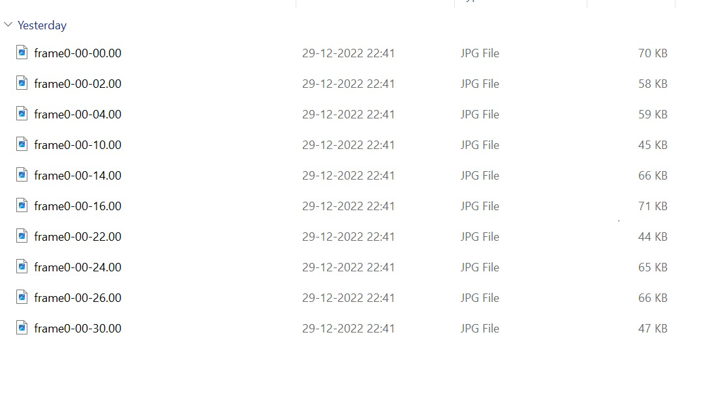
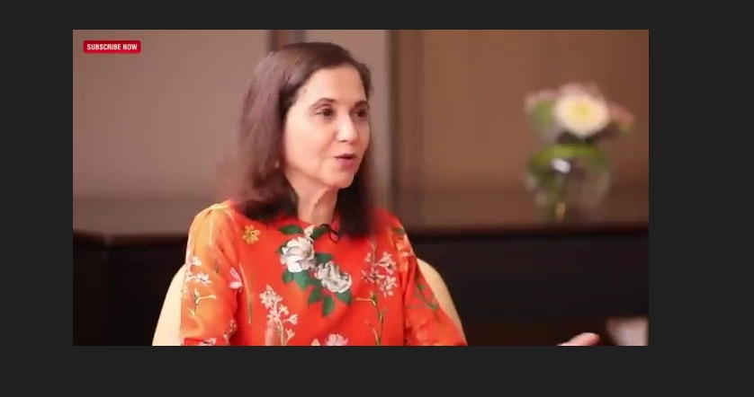

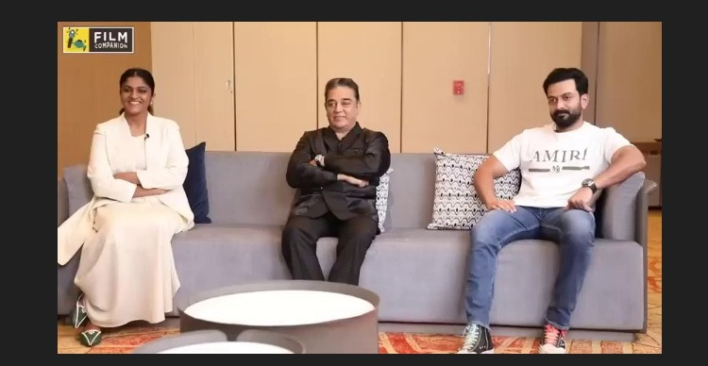
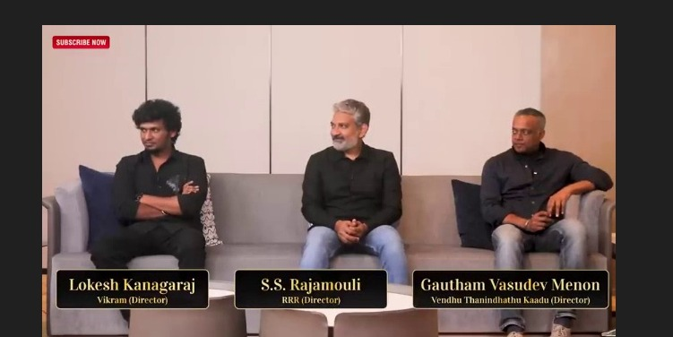

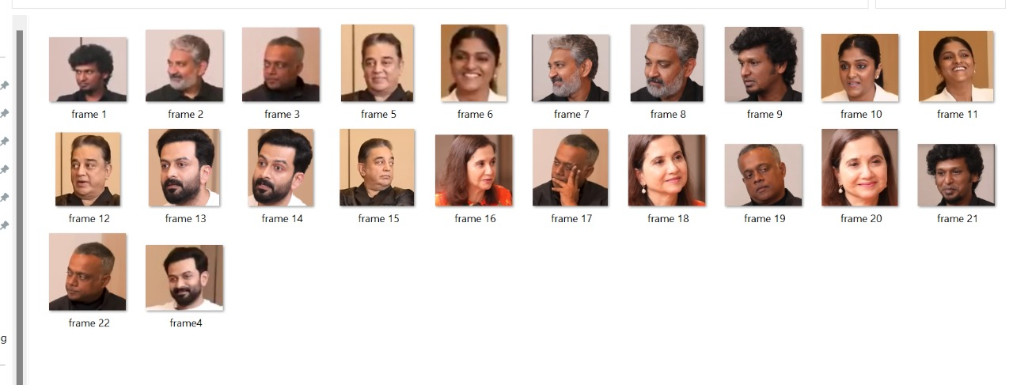
Cropping of faces

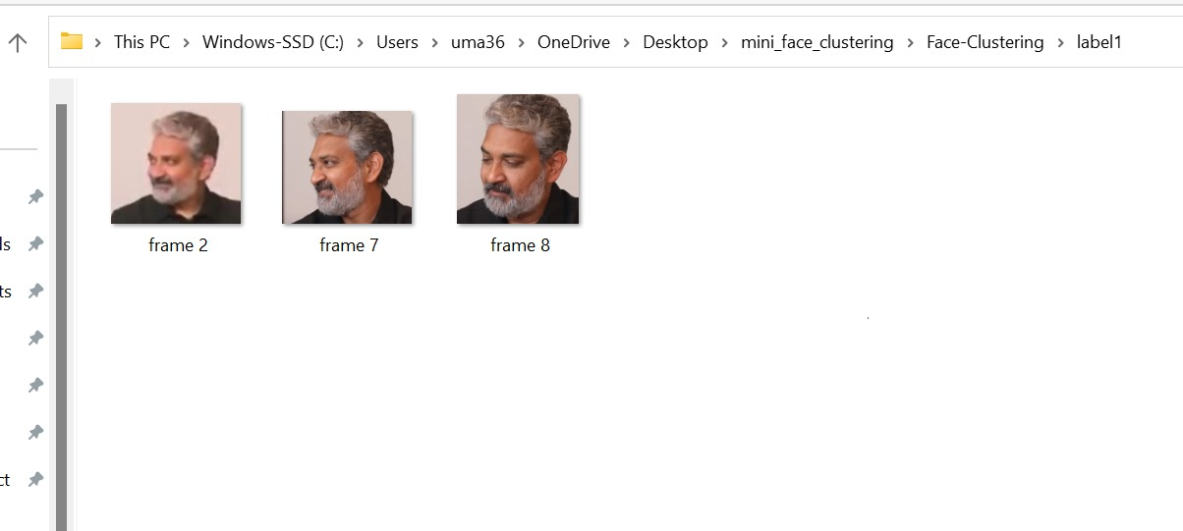
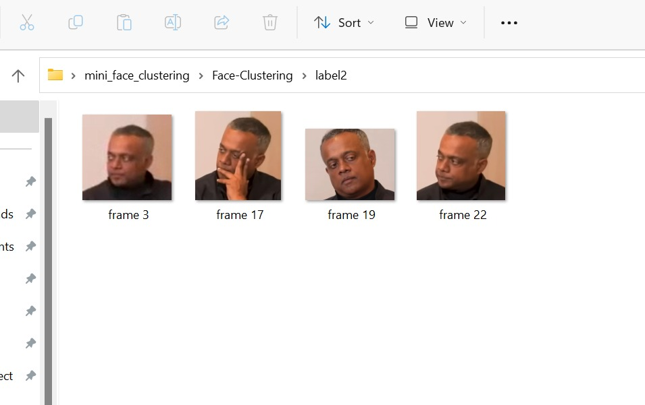
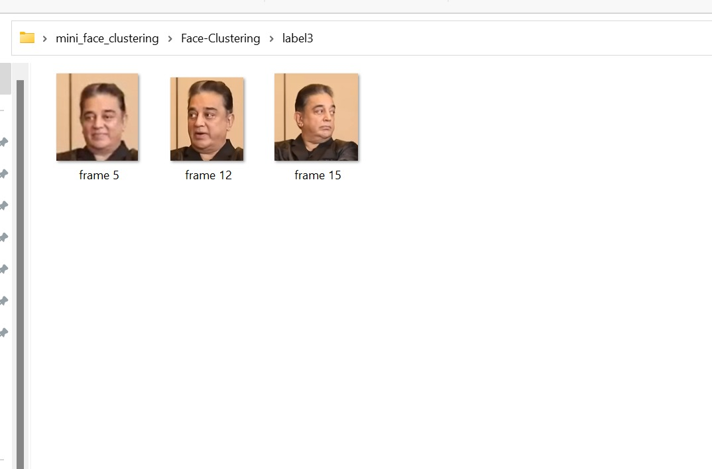
Clustering of faces

OUTCOMES
> We learned Languages like HTML and also explored different kinds of libraries and modules in Flask and got to know their implementation and working.
> We have learnt how to implement GUI using CSS.
> We have also got to know about modules like sql.connector and various components present in those modules.

CONCLUSION
By end of this project, we were able to cluster the faces and by this the task becomes easy for classifying of faces and identification much easier.

FUTURE SCOPE
In future recreating of faces will be implemented by using clustering of faces and clustering,cropping has been done independently where we will combine and implement further.

GITHUB:
https://github.com/pellivila-umadevi/clustering_of_faces.git

