Assignment 2

Due Date Oct 8th

Please use the data provided below for solving the following questions.

1. (2 points) Without the use of ‘GROUP BY’ write a query to obtain the following:
   1. Sum of invoice_total

SELECT SUM(INVOICE_TOTAL) FROM INVOICES

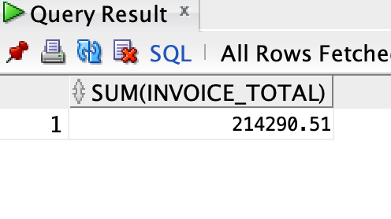

* 1. Average invoice_total to three decimal digits only

SELECT ROUND(AVG(INVOICE_TOTAL),3) FROM INVOICES

* 1. Count of distinct vendors

SELECT COUNT(DISTINCT VENDOR_ID) FROM INVOICES

* 1. Standard Deviation of invoice_total

SELECT ROUND(STDDEV(INVOICE_TOTAL),3) FROM INVOICES

1. (2 points) Write a query that joins *Employees* and *Projects* tables and returns all matching rows (i.e. only employees that have projects assigned and only projects that have employees assigned) and use table alias in the query.
   1. Update the select to only return the employee_id, first and last name, and the project number.
   2. Sort the data by project number so we group employees by project.

SELECT e.EMPLOYEE_ID, e.LAST_NAME, e.FIRST_NAME, j.PROJECT_NUMBER

FROM EMPLOYEES e

JOIN PROJECTS j on e.EMPLOYEE_ID = j.EMPLOYEE_ID

ORDER BY j.PROJECT_NUMBER DESC;

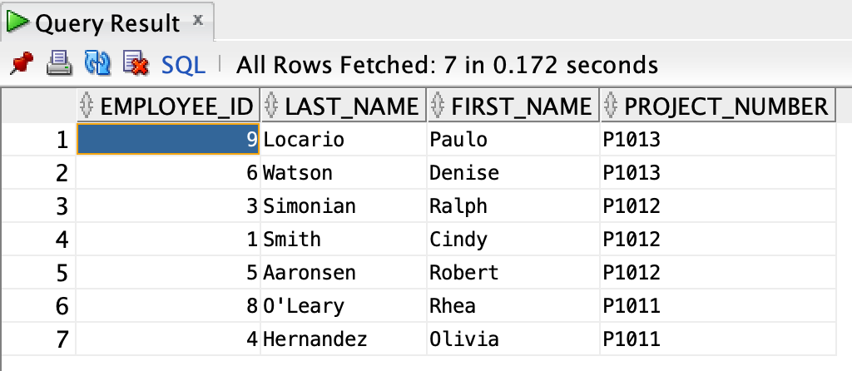

1. (2 points) Write a query that returns vendor_id, invoice_number, invoice_due_date, payment_date from the invoices table but only for invoices that have a payment date.

SELECT VENDOR_ID, INVOICE_NUMBER,INVOICE_DUE_DATE,PAYMENT_DATE

FROM INVOICES

WHERE PAYMENT_DATE IS NOT NULL;

1. (2 points) Write a query that generates a single column with a distinct list of vendor_ids from the *Vendors* table. Similarly write a query that pulls the distinct list of vendors from the *Invoices* table.
   1. Using the command ‘MINUS’ command, find the difference between the two.
   2. Explain the result of the MINUS

SELECT DISTINCT VENDOR_ID FROM VENDORS

MINUS

SELECT DISTINCT VENDOR_ID FROM INVOICES;

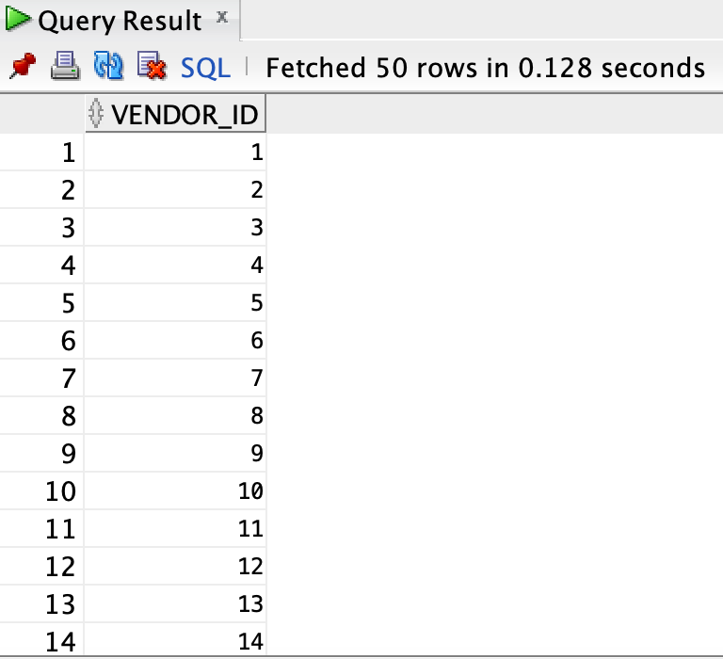

The usage of MINUS in this query will result in a list of VENDOR_ID values from the VENDORS table that do not exist in the INVOICES table.

1. (2 points) First find the average list price for all the products on the *Products* table. Using this query as a subquery, find all order_items records where the item_price is greater that the average calculated in the previous query.

SELECT * FROM ORDER_ITEMS

WHERE ITEM_PRICE > (SELECT AVG(LIST_PRICE) FROM PRODUCTS)

