Recording of Rubric Tests

ScreenPrint of Test 1 (Accept a directory path or file as input)

ScreenPrint of Test 2 (Use regex to detect common secret patterns)

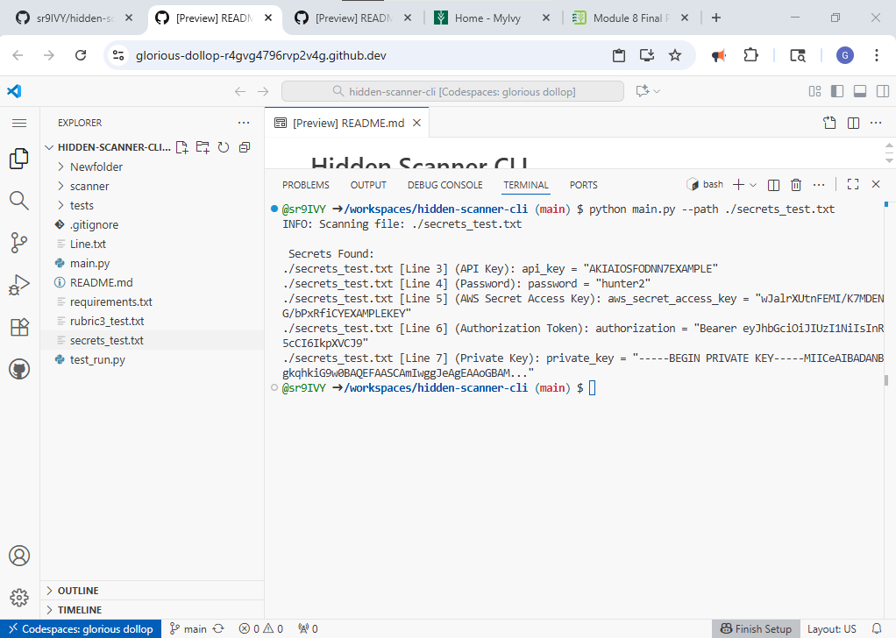

ScreenPrint of Test 3 (Output report of findings (filename, line number, matched string)

ScreenPrint of Test 4 (Include logging and a clear CLI interface (argparse))

