K L UNIVERSITY
I/IV B Tech - I Trimester

Farmers Market Price and Sales Tracker
Java Project Report
Course | 26SC1101E PSPJ
Faculty | A Swathi
Section | 12
Project Number | 26
Team Member 1 | Vishnupriya Aakarapu 2620040052
Team Member 2 | Sraagvi Polavarapu 2620040085
Submitted as part of the Java programming project evaluation

1 Abstract
The Farmers Market Price and Sales Tracker is a console-based Java application that organizes produce prices, quantities, daily sales, remaining stock, and revenue. The program uses parallel one-dimensional arrays for product information and a two-dimensional array for three days of sales. It calculates the total quantity sold for every product, determines the remaining stock, classifies prices and stock levels, and identifies the highest-earning product.
The project demonstrates fundamental Java concepts in a practical agricultural setting. All operations are handled through static methods, so no explicit object creation or instance reference is required. The final report gives farmers or market coordinators a clear summary of sales performance and available produce.

Project Objectives
- Store product names, prices, produced quantities, and daily sales in arrays.
- Calculate total sales, remaining stock, and revenue using arithmetic operators.
- Use conditional statements to classify price, stock, and overall sales performance.
- Apply for, while, and do while loops for repeated processing.
- Divide the program into reusable static methods without explicit object creation.

System Overview
Component | Description
Input data | Product names, price per kilogram, quantity produced, and sales for three days
Processing | Totals, subtraction of sold stock, multiplication for revenue, comparisons, and accumulation
Output | Daily sales table, product-wise report, stock status, price category, and final summary

2 Advantages and Disadvantages
The program is designed as a small academic tracker. Its strengths come from simple calculations and transparent data structures, while its limitations mainly result from using fixed arrays instead of permanent storage or interactive input.
Advantage | Explanation
Easy sales calculation | Automatically totals daily quantities and computes revenue, reducing manual arithmetic.
Clear stock visibility | Shows the quantity remaining and labels low or exhausted stock.
Simple comparison | Identifies the product that generated the highest revenue.
Organized data | Uses 1D and 2D arrays to keep related market information together.
Beginner friendly | Uses only core Java concepts that are easy to explain during a viva.
Disadvantage | Explanation
Fixed data | Product values are written inside the program and must be edited before every new report.
Limited capacity | The current arrays contain four products and three sales days.
No permanent storage | Closing the program does not preserve records in a file or database.
Console interface | The output is text based and does not provide buttons, charts, or forms.
Basic validation | The demonstration assumes that all quantities and prices are valid and non-negative.

3 Implementation Details

Concepts Used
Java Element | Purpose in the Project
Data types | String, int, double, boolean, and char store names, quantities, prices, status, and currency code.
Operators | Addition, subtraction, multiplication, comparison, assignment, and increment operators perform calculations.
Conditional statements | if, else if, and else classify prices, stock, and overall performance.
One-dimensional arrays | Store product names, prices, produced quantities, and calculated revenue.
Two-dimensional array | Stores sales as product rows and day columns.
For loop | Adds daily sales and displays the sales matrix.
While loop | Searches the revenue array for the highest-earning product.
Do while loop | Creates the product-wise report for every product.
Static methods | Separate calculations and display tasks without creating class instances.

Program Algorithm
1. Initialize data: Store product details and three days of sales in arrays.
2. Display daily sales: Use nested for loops to print the two-dimensional sales table.
3. Calculate product totals: Add the three daily values using calculateTotalSold.
4. Calculate stock and revenue: Subtract sold quantity from produced quantity and multiply sales by price.
5. Classify results: Use conditional statements to display price category and stock status.
6. Find the best product: Use a while loop to locate the largest revenue value.
7. Display final summary: Print total quantity sold, market revenue, top product, and overall performance.

Sample Data
Produce | Price Production and Daily Sales
Tomato | Rs 42.50 | 100 kg | Sales 25, 30, 20 kg
Potato | Rs 28.00 | 120 kg | Sales 35, 40, 25 kg
Carrot | Rs 55.00 | 80 kg | Sales 20, 18, 22 kg
Onion | Rs 36.50 | 110 kg | Sales 30, 28, 32 kg

4 Java Source Code
The complete program is shown below. It uses static methods and array initializers, with no explicit class-object construction and no instance-reference keyword.
1 public class FarmersMarketTracker {
2
3 // Calculates the total quantity sold for one product.
4 public static int calculateTotalSold(int[] dailySales) {
5 int totalSold = 0;
6
7 for (int day = 0; day < dailySales.length; day++) {
8 totalSold = totalSold + dailySales[day];
9 }
10
11 return totalSold;
12 }
13
14 // Calculates income earned from one product.
15 public static double calculateRevenue(int quantitySold, double pricePerKg) {
16 return quantitySold * pricePerKg;
17 }
18
19 // Displays whether the remaining stock is sufficient.
20 public static void displayStockStatus(int remainingStock) {
21 if (remainingStock == 0) {
22 System.out.println("Stock Status : OUT OF STOCK");
23 } else if (remainingStock <= 10) {
24 System.out.println("Stock Status : LOW STOCK");
25 } else {
26 System.out.println("Stock Status : SUFFICIENT STOCK");
27 }
28 }
29
30 // Displays whether the selling price is low, moderate, or high.
31 public static void displayPriceCategory(double price) {
32 if (price < 30) {
33 System.out.println("Price Category : Low");
34 } else if (price <= 60) {
35 System.out.println("Price Category : Moderate");
36 } else {
37 System.out.println("Price Category : High");
38 }
39 }
40
41 // Finds the product that earned the highest revenue using a while loop.
42 public static int findHighestRevenueProduct(double[] revenue) {
43 int highestIndex = 0;
44 int index = 1;

45
46 while (index < revenue.length) {
47 if (revenue[index] > revenue[highestIndex]) {
48 highestIndex = index;
49 }
50 index++;
51 }
52
53 return highestIndex;
54 }
55
56 // Displays the daily sales stored in a two-dimensional array.
57 public static void displayDailySales(String[] products, int[][] sales) {
58 System.out.println("\n========== THREE-DAY SALES ==========");
59 System.out.printf("%-12s %-8s %-8s %-8s%n",
60 "Product", "Day 1", "Day 2", "Day 3");
61
62 for (int product = 0; product < products.length; product++) {
63 System.out.printf("%-12s", products[product]);
64
65 for (int day = 0; day < sales[product].length; day++) {
66 System.out.printf(" %-8d", sales[product][day]);
67 }
68
69 System.out.println();
70 }
71 }
72
73 public static void main(String[] args) {
74 // Data types and one-dimensional arrays
75 String farmerName = "Green Valley Farm";
76 String[] products = {"Tomato", "Potato", "Carrot", "Onion"};
77 double[] pricePerKg = {42.50, 28.00, 55.00, 36.50};
78 int[] quantityProduced = {100, 120, 80, 110};
79 double[] revenue = {0.0, 0.0, 0.0, 0.0};
80
81 // Two-dimensional array: rows represent products and columns represent days.
82 int[][] dailySales = {
83 {25, 30, 20},
84 {35, 40, 25},
85 {20, 18, 22},
86 {30, 28, 32}
87 };
88
89 boolean marketOpen = true;
90 char currencySymbol = 'R';
91 int totalQuantitySold = 0;
92 double totalMarketRevenue = 0.0;
93
94 System.out.println("==============================================");
95 System.out.println(" FARMERS' MARKET PRICE AND SALES TRACKER");
96 System.out.println("==============================================");

97 System.out.println("Farmer/Market : " + farmerName);
98 System.out.println("Market Open : " + marketOpen);
99 System.out.println("Currency Code : " + currencySymbol + "s (Rupees)");
100
101 displayDailySales(products, dailySales);
102
103 System.out.println("\n========== PRODUCT-WISE REPORT ==========");
104
105 int product = 0;
106
107 // A do-while loop displays at least one product report.
108 do {
109 int sold = calculateTotalSold(dailySales[product]);
110 int remaining = quantityProduced[product] - sold;
111 double productRevenue = calculateRevenue(sold, pricePerKg[product]);
112
113 revenue[product] = productRevenue;
114 totalQuantitySold += sold;
115 totalMarketRevenue += productRevenue;
116
117 System.out.println("\nProduct : " + products[product]);
118 System.out.printf("Price per kg : Rs. %.2f%n", pricePerKg[product]);
119 System.out.println("Quantity Ready : " + quantityProduced[product] + " kg");
120 System.out.println("Quantity Sold : " + sold + " kg");
121 System.out.println("Stock Left : " + remaining + " kg");
122 System.out.printf("Revenue : Rs. %.2f%n", productRevenue);
123
124 displayPriceCategory(pricePerKg[product]);
125 displayStockStatus(remaining);
126
127 product++;
128 } while (product < products.length);
129
130 int bestProduct = findHighestRevenueProduct(revenue);
131
132 System.out.println("\n============= FINAL SUMMARY =============");
133 System.out.println("Total Quantity Sold : " + totalQuantitySold + " kg");
134 System.out.printf("Total Revenue : Rs. %.2f%n", totalMarketRevenue);
135 System.out.println("Top-Earning Produce : " + products[bestProduct]);
136 System.out.printf("Highest Revenue : Rs. %.2f%n", revenue[bestProduct]);
137
138 if (totalMarketRevenue >= 10000) {
139 System.out.println("Overall Performance : Excellent sales");
140 } else if (totalMarketRevenue >= 5000) {
141 System.out.println("Overall Performance : Good sales");
142 } else {
143 System.out.println("Overall Performance : Sales need improvement");
144 }
145
146 System.out.println("==========================================");
147 }
148 }

5 Output Screenshots
The following console views show the program output for the sample data. The calculated values are consistent with the array entries and formulas used in the source code.
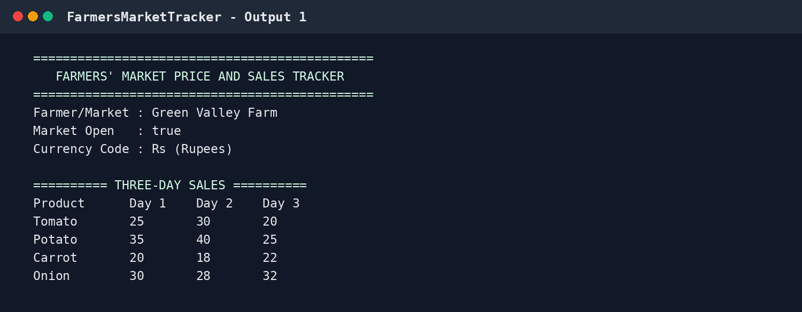
Figure 1 Market details and three-day sales table

Output Screenshots Continued
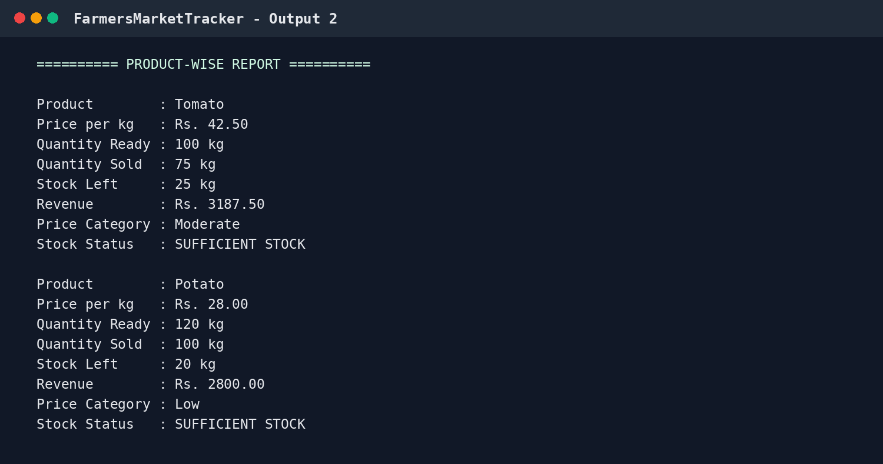
Figure 2 Product-wise report for tomato and potato
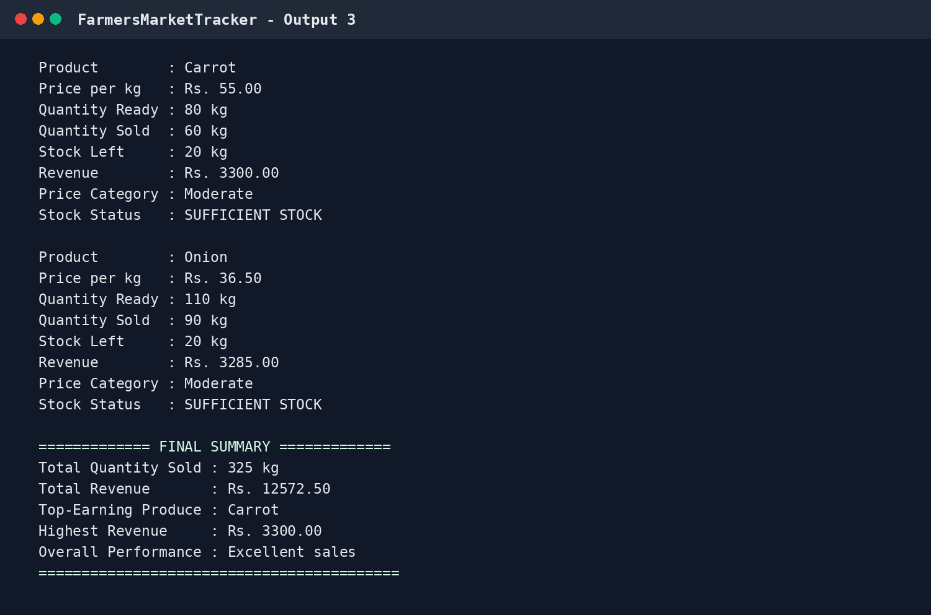
Figure 3 Remaining product reports and final sales summary

6 Conclusion and Future Work

Conclusion
The Farmers Market Price and Sales Tracker successfully calculates and presents essential market information using core Java programming concepts. For the sample data, the program records 325 kg of total sales and Rs 12,572.50 in total revenue. Carrot becomes the top-earning product with revenue of Rs 3,300.00. The project therefore demonstrates how arrays, methods, loops, operators, and conditional statements can solve a realistic record-keeping problem in a structured way.

Future Work
- Accept product details and sales figures through keyboard input or a graphical form.
- Allow the farmer to add any number of products and sales days dynamically.
- Save reports in a text file, CSV file, or database for future reference.
- Add input validation to prevent negative prices, quantities, or sales above available stock.
- Generate weekly and monthly charts for revenue, demand, and unsold produce.
- Create a web or mobile interface that can be used directly at a farmers market.

Final Result
Measure | Result
Total quantity sold | 325 kg
Total revenue | Rs 12,572.50
Top-earning produce | Carrot
Highest product revenue | Rs 3,300.00
Overall performance | Excellent sales

