Logisim Design Guide for an 8-Bit Register with Load Enable
Purpose: build and test the D flip-flop circuit shown in the project presentation.
The register stores one 8-bit word. A load-enable signal selects whether each bit takes new input data or keeps its current value. The shared clock captures the selected value on its rising edge.

One-bit circuit
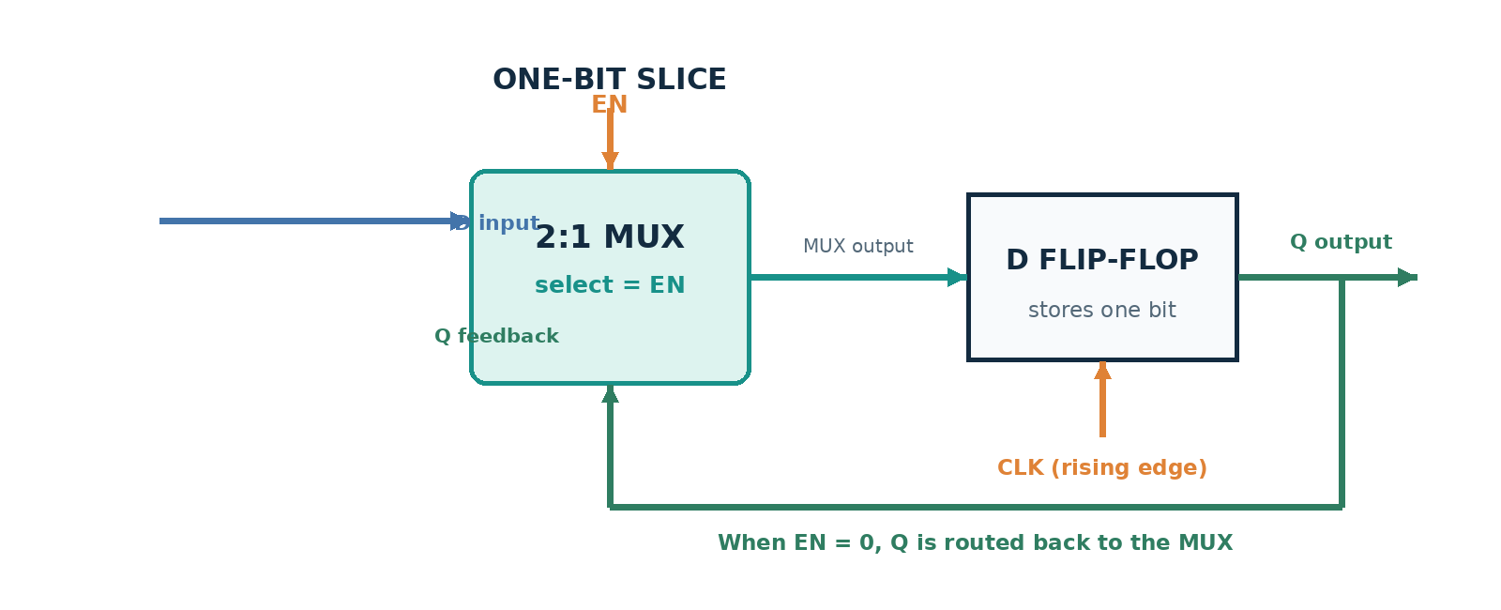
Figure 1. One bit of the register. Repeat this slice for bits 7 through 0.

What one bit does
A 2:1 multiplexer sits before each D flip-flop. One MUX input receives Dᵢ, the incoming bit. The other receives Qᵢ, the bit already stored. EN selects between these inputs. At the rising clock edge, the flip-flop stores the selected value.
Qᵢ(next) = (EN AND Dᵢ) OR (NOT EN AND Qᵢ(current))
EN | Selected MUX input | Qᵢ after rising edge
0 | Qᵢ feedback | Keeps its current value
1 | Dᵢ input | Loads the new input bit

The Complete Eight-Bit Circuit
The full register uses eight matching bit slices. All slices share EN and CLK, so the word updates together. Each output feeds back to its own MUX.
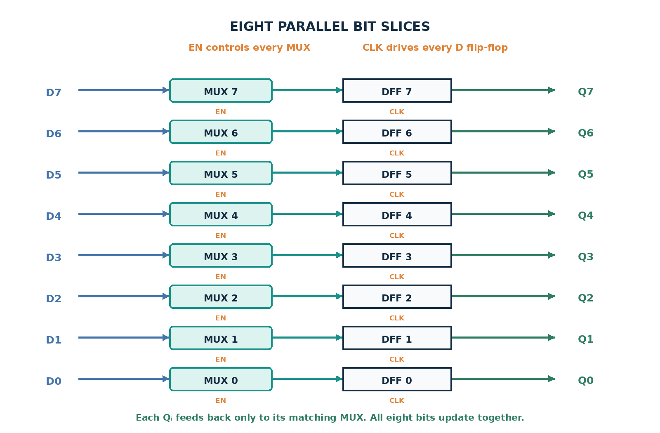
Figure 2. Eight parallel MUX and D flip-flop pairs.

Build it in Logisim
- Place eight D flip-flops and eight 2:1 multiplexers.
- Wire D7 to the MUX for bit 7, then continue through D0 to the MUX for bit 0.
- For each bit, connect its Q output back to the other input of its own MUX.
- Connect each MUX output to the D input of its matching flip-flop.
- Connect EN to the select input of all eight MUXes.
- Connect one shared clock to all eight flip-flops. Label the outputs Q7 through Q0.

Test the circuit
Test | EN | D[7:0] | Expected Q[7:0]
Load at rising edge 1 | 1 | 10110110 | 10110110
Change D, then hold at edge 2 | 0 | 00111100 | 10110110
Load at rising edge 3 | 1 | 00111100 | 00111100

