Lifestage Benefits Optimization
Solution Design & Demonstration Strategy
In response to VA Performance Work Statement VA-26-00077490
Department of Veterans Affairs — Office of the Chief Technology Officer
Prepared by Ad Hoc
Internal capture working document — draft for review
August 18, 2026

Executive Summary
VA-26-00077490, Lifestage Benefits Optimization, asks contractors to modernize three connected parts of the VA.gov Benefits Portfolio at once: the Lifestage forms experience for Pension, burial, and dependents management; document services that extract and validate data from supporting evidence (the CAVE capability); and secure third-party routing that lets physicians and other third parties complete forms like VA Form 21-2680 without paper or mail. The PWS treats these as one system, not three separate efforts — a claimant's data has to move cleanly from an interview-style form, through evidence upload and extraction, through third-party participation where required, into a validated structured record that downstream systems and adjudicators can trust.
This document lays out Ad Hoc's proposed solution design for that end-to-end system and the strategy for demonstrating it credibly in a capture conversation. Rather than describing the approach only in prose, we built a working proof-of-concept spanning all three problem areas — a Veteran interview flow, mocked AI-assisted extraction with confidence scoring, secure single-use third-party routing, schema-validated structured data, and a staff observability dashboard — to pressure-test the design and produce the process, data-flow, and interface illustrations included in this document. The screens shown throughout are captured directly from that working prototype, not hand-drawn mockups, so what you see here is something we already know functions end to end.
The remainder of this document covers: our reading of the PWS and VA's stated vision and desired outcomes; the solution strategy and how each capability maps to specific PWS language; the proposed architecture and technology approach; process-flow and information/data-flow diagrams for the end-to-end system; illustrative UI wireframes; and a short note on what the proof-of-concept validated and what remains open for VA collaboration once under contract.

1. Understanding the Requirement

1.1 Background and Purpose
VA's Digital Modernization Vision, set in 2017, calls for self-service tools on par with top private-sector companies — an experience that “feels like navigating TurboTax, not filling out a form.” VA-26-00077490 ties directly to that vision, with three overarching goals: reduce the average time to complete a benefits claim, increase customer satisfaction, and increase the quality and reliability of VA services.
The PWS identifies three interlocking problem areas within the Benefits Portfolio, and this demonstration addresses all three together rather than in isolation:
- Benefits forms and the Lifestage forms experience (PWS 1.2.1, 1.2.4) — Pension, burial, and dependents-management forms (21P-527EZ, 21P-530EZ, 21P-534EZ, 21-686c, 21-674, 21-0538, and related supplemental forms) that are hard to find, ask for redundant information, and leave claimants uncertain about required evidence.
- Benefits data intake and automation (PWS 1.2.2, 2.3.2) — a lack of consistent intake patterns, structured-data standards, and reliable submission pathways, which limits automation and increases processing errors across forms.
- Document services: real-time data validation and third-party routing (PWS 1.2.3, 2.3.3) — intelligent extraction from unstructured evidence (birth/marriage certificates, decrees, financial statements) and a still-unfinished capability for physicians or other third parties to complete forms like the 21-2680 digitally rather than by mail.
The PWS is explicit that these are compounding problems: a Veteran who doesn't know a dependent's status has changed, or whose evidence is misread, or whose physician's exam is stuck in the mail, ends up in the same place — a delayed or incorrect award, or unnecessary debt to VA from an overpayment. The desired outcomes named in PWS 3.2 make the bar concrete: zero silently-failed submissions, zero claims kicked back for incomplete or out-of-date information, and — implicitly through the Document Services and Benefits Intake objectives in PWS Addendum B — structured, auditable, observable data at every step.

1.2 VA's Stated Vision
Three vision statements from PWS Section 3.1 anchor the solution design directly:
- Benefits intake and automation vision: a unified, modern framework where every submission produces clean, structured data that supports the Veteran from application through claim resolution.
- Document services vision: Veterans submit supporting documents and third-party forms entirely online, with intelligent extraction and real-time validation, and third-party steps are “fully digital and transparent.”
- Lifestage forms experience vision: Veterans can easily find, complete, and submit Pension, burial, and dependent-management forms through one intuitive experience, with dependent records kept current and data structured well enough to support automated decisioning.
Read together, these three visions describe a single claimant journey — which is exactly what the proof-of-concept was built to demonstrate, rather than three disconnected feature demos.

1.3 Cross-Cutting Requirements That Shape the Design
Two requirements outside the three headline problem areas materially shape the architecture, and both are addressed directly in this design:
- Data Governance (PWS 2.3.2): a shared, versioned schema/data-dictionary, validation rules, and mapping specifications used consistently across intake, validation, and downstream consumers — not a bespoke schema per form.
- Submission Reliability and Observability (PWS 2.3.2): transaction tracing (the PWS calls out Kafka-based messaging specifically), monitoring, and operational dashboards so a Veteran-submitted record can be tracked end to end and failures are visible rather than silent.

2. Solution Strategy

2.1 Design Principles
- One claimant journey, not three products. The interview, evidence review, and third-party step are one continuous flow with one underlying record, matching how PWS 3.1 describes the end state.
- Structured data first. Every field the claimant confirms, every extracted value, and every third-party submission is validated against one published, versioned schema before it is persisted — directly answering PWS 2.3.2 Data Governance.
- Nothing fails silently. Every meaningful step in the journey emits a traced event, surfaced live on a staff dashboard, so a stuck or failed submission is visible immediately rather than discovered later — directly answering PWS 2.3.2 Submission Reliability and Observability and the “zero claims fail” outcome in PWS 3.2.
- Third-party participation as a reusable pattern, not a one-off. The routing capability (secure single-use link, status tracking, e-signature capture) is built as a generic pattern so it is credible as the reusable service PWS 2.3.3.2 calls for, not a feature specific to one form.
- Design validated in code, not just slides. Because the PWS is evaluating a delivery partner, not just a design vendor, we built the interaction design as working software so reviewers can see real behavior — extraction confidence scores that vary by field, a live status change when a physician completes their portion, a dashboard that updates in real time.

2.2 Capability Mapping
Each capability in the proof-of-concept traces to specific PWS language:
PWS requirement | Demonstrated capability | Illustrated by
Lifestage forms experience — unified, intuitive interview (1.2.4, 3.1.4) | Conversational multi-step interview for Veteran, claimant, dependents, and Aid & Attendance screening | Figures 3–6
Real-time data extraction and validation (1.2.3, 2.3.3.1) | Mocked AI/CAVE-style extraction of uploaded evidence with per-field confidence scores and a review/correct step | Figure 7
Third-party routing (1.2.3, 2.3.3.2) | Secure single-use link issued to a physician; portal for completing VA Form 21-2680 and e-signing; live status returned to the claimant | Figures 8, 10
Data Governance (2.3.2) | Single versioned schema (data dictionary) validating intake, extraction, and third-party data alike; published for downstream reuse | Figure 13
Submission Reliability and Observability (2.3.2) | Transaction trace log across intake, extraction, routing, and validation events; live operational dashboard | Figures 12–13
Delivery and Monitoring Report (5.2) | Dashboard metrics (completion rates, extraction confidence, third-party completion) as the seed of a recurring reporting artifact | Figure 12

3. Proposed Architecture and Technology Approach
The proof-of-concept was built as a modern, server-rendered web application so that the interaction design, data model, and event tracing could all be demonstrated together rather than mocked separately. The stack was chosen for fit with VA.gov's own direction (React-based, TypeScript, API-driven) and for how quickly it lets a small team iterate during a capture or early-delivery phase:
- Next.js (React, TypeScript) — server-rendered pages for the Veteran interview, physician portal, and staff dashboard, with API routes handling extraction, routing, and submission logic. This mirrors the component-based, accessible patterns already used across VA.gov.
- Zod schema validation — the single data-dictionary/schema referenced throughout PWS 2.3.2, used to validate every submission at intake, after extraction, and after third-party completion, with a generated JSON Schema published for downstream and cross-team reuse.
- Postgres (Neon) for structured, durable storage — every submission, dependent, evidence record, and third-party request persisted as validated structured data, queryable by the staff dashboard and available to simulated downstream systems.
- Event-sourced transaction trace — a lightweight trace-event log recorded at each step (intake, extraction run, routing, validation, submission), standing in for the Kafka-based tracing PWS 2.3.2 calls for, and directly powering the observability dashboard.
- Vercel for hosting — fast preview and production deployments suited to an iterative, sprint-based delivery model, with GitHub as the source of truth for code and documentation as PWS 2.3.1's “Documentation and Knowledge Transfer” requirement calls for.
This is a proof-of-concept architecture built to validate the design, not a proposed production system — a production build would sit inside VA.gov's actual platform, authentication, and hosting environment (including migrating or integrating with CAVE in VA ARCHES per PWS 2.3.3.1) and would go through VA's own security and accessibility review rather than standing alone.

4. End-to-End Process Flow
The diagram below traces the full claimant journey modeled in the proof-of-concept: from the start of the Lifestage interview, through evidence upload and AI-assisted extraction, through optional secure third-party routing for a physician exam, to a validated, persisted, and observable submission.
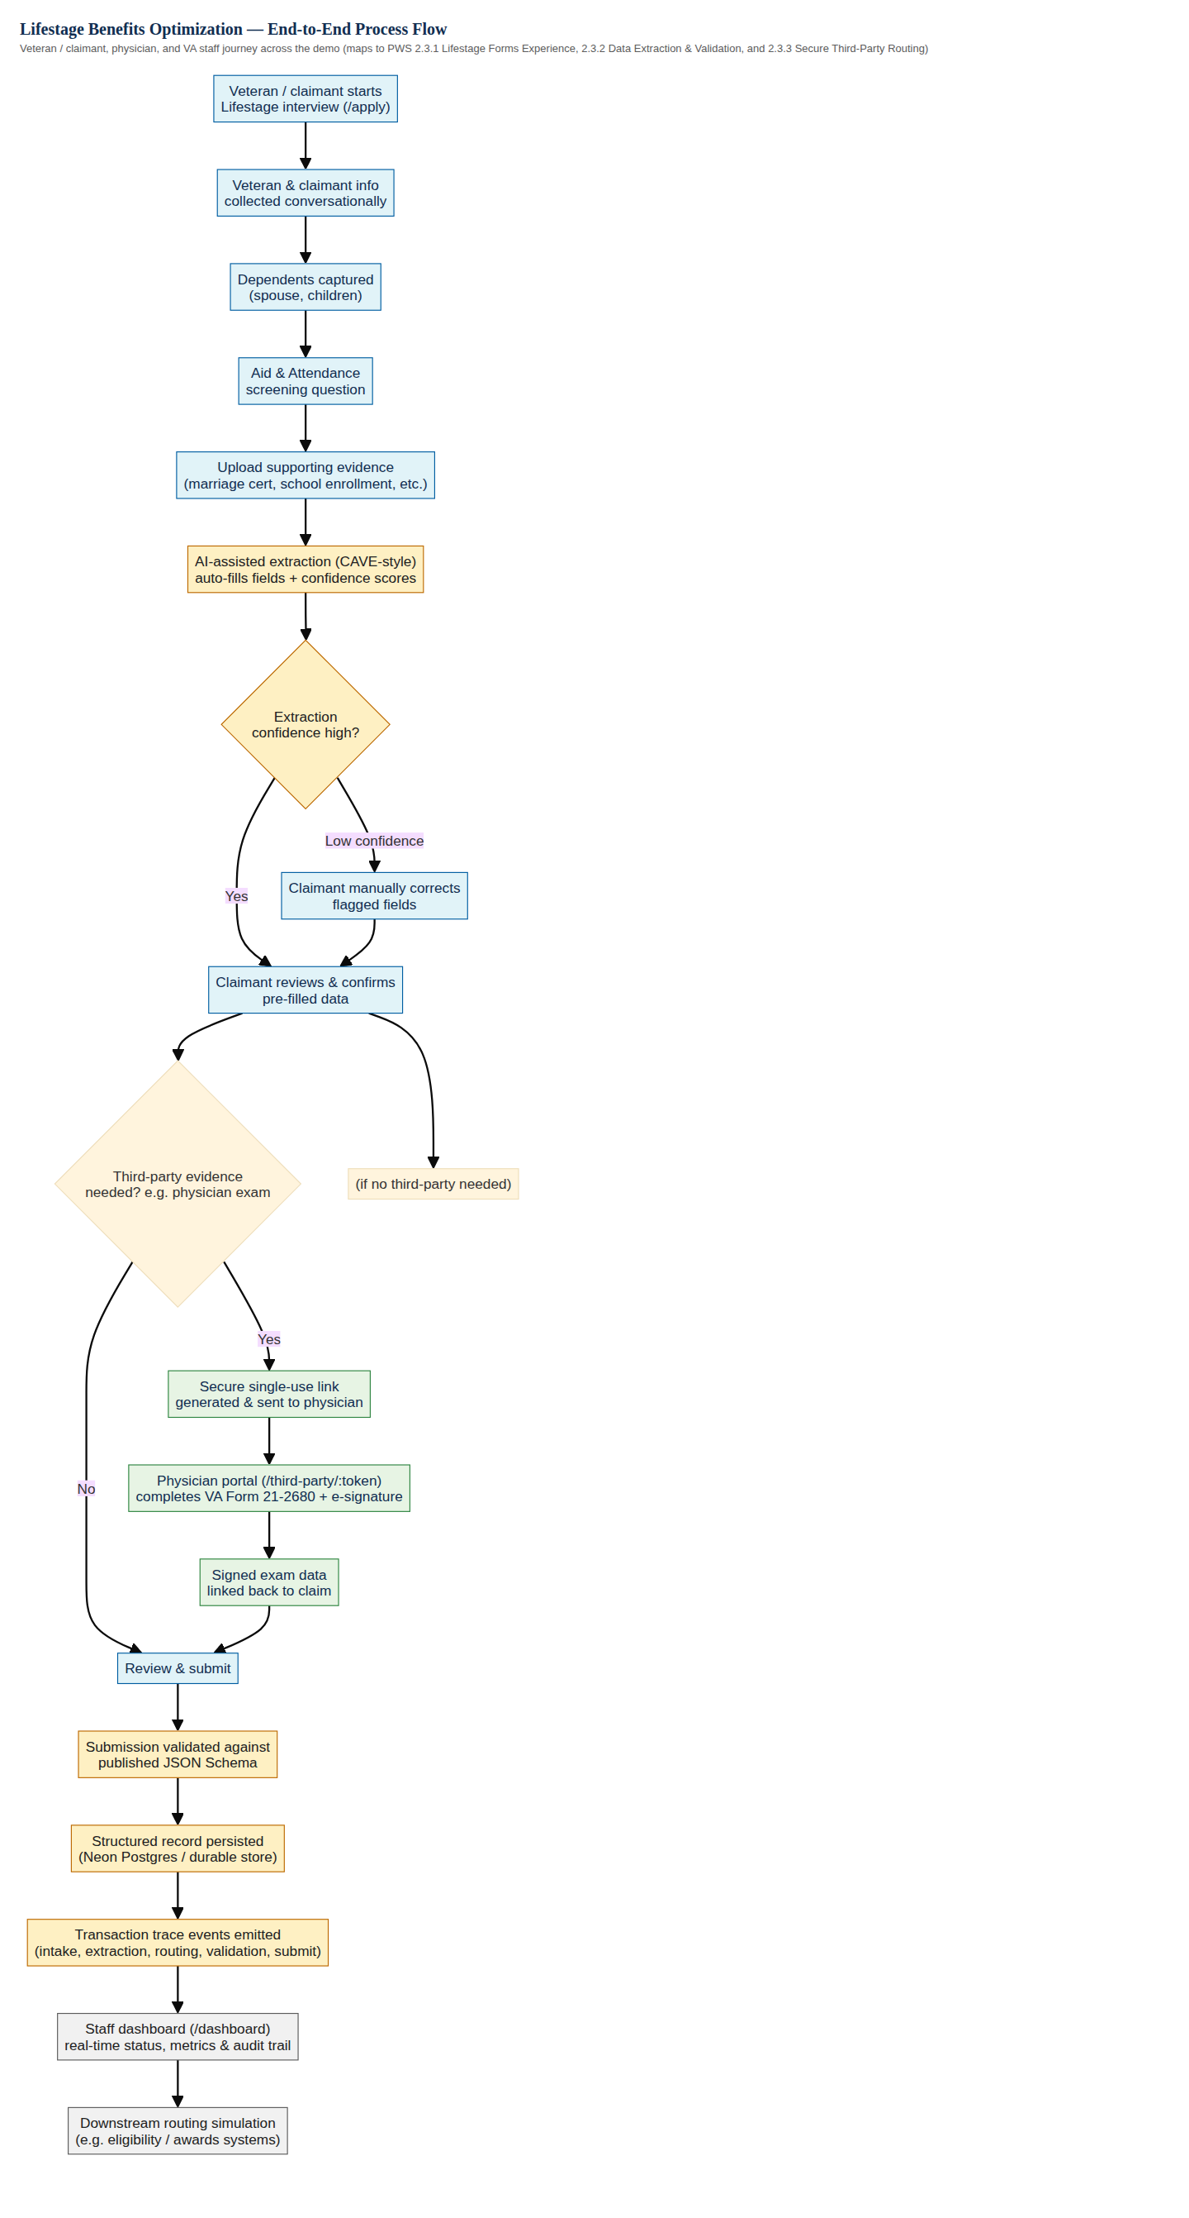
Figure 1. End-to-end process flow — Veteran/claimant, physician, and VA staff journey.

5. Information and Data Flow
This second diagram isolates the structured-data path underneath that journey — how a piece of information moves from an uploaded document or a claimant's answer, through the shared schema validator, into persistent storage and the transaction trace log, and out to the staff dashboard and simulated downstream systems. This is the diagram most directly responsive to PWS 2.3.2's Data Governance and Submission Reliability and Observability language.
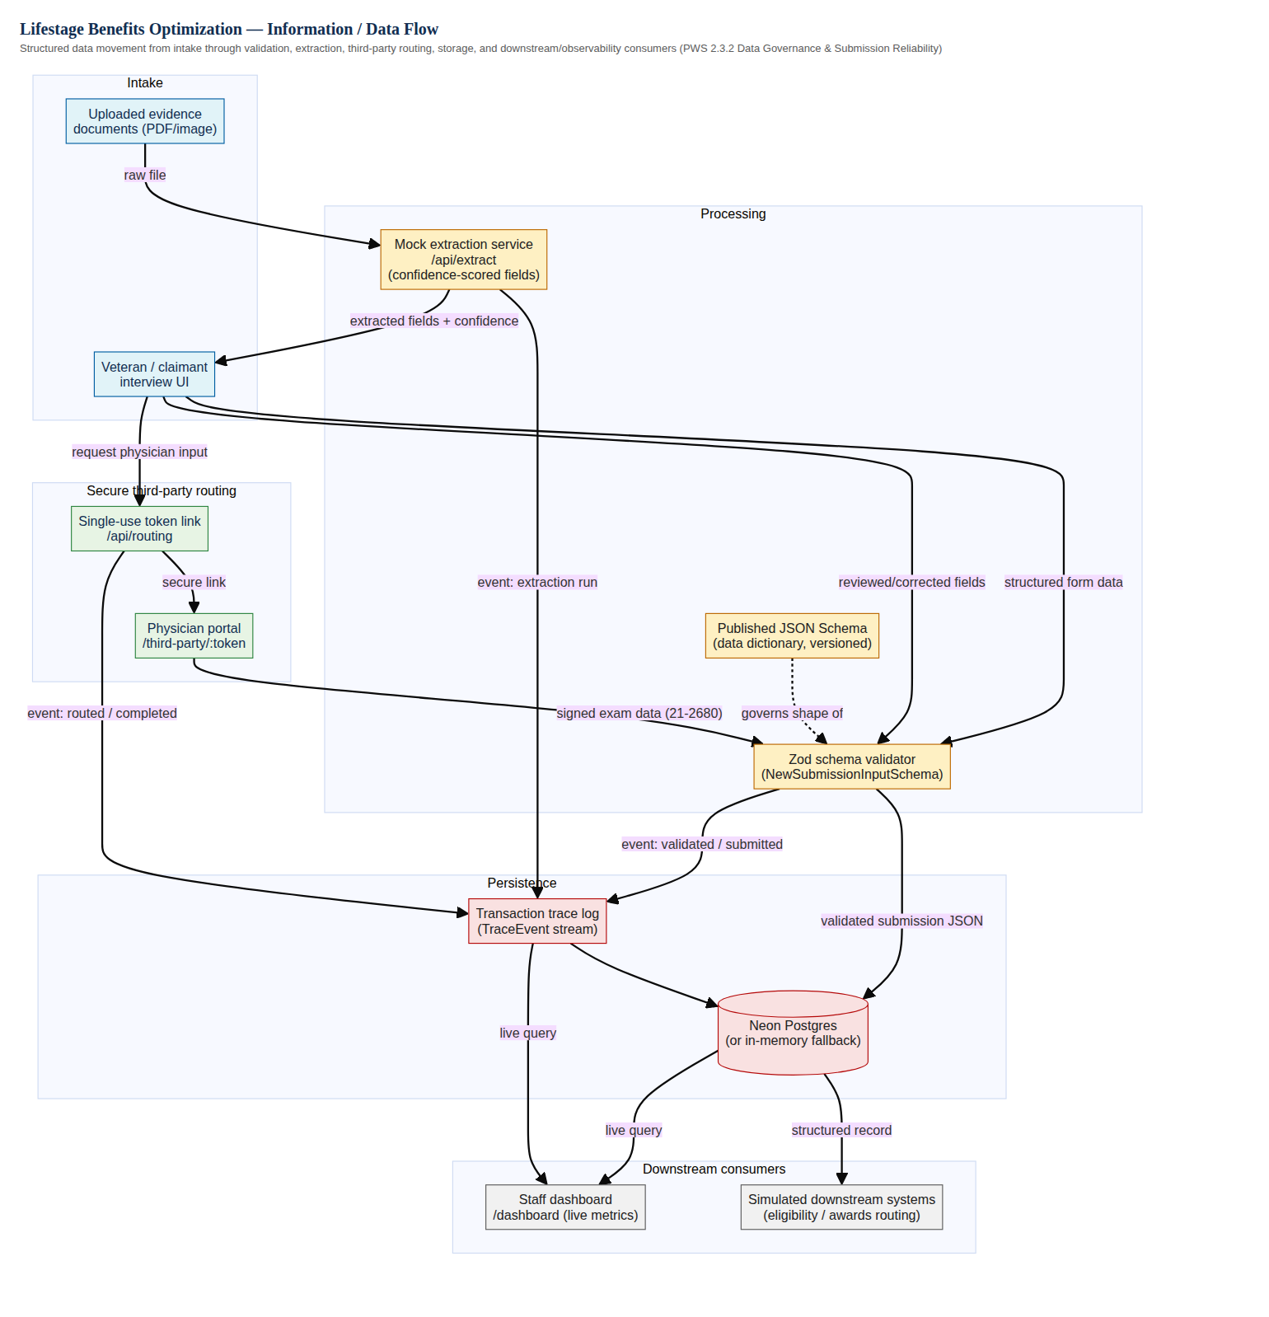
Figure 2. Information/data flow — structured data from intake through validation, storage, and downstream consumption.

6. Illustrative UI Wireframes
The screens below are captured directly from the working proof-of-concept described in Section 3 — they represent one concrete interpretation of the Lifestage experience, extraction/validation review, third-party routing, and staff observability, styled in a VA.gov-inspired visual language. They are meant to ground conversation with VA about interaction design, not to represent final, VA.gov Design-System-compliant production screens.
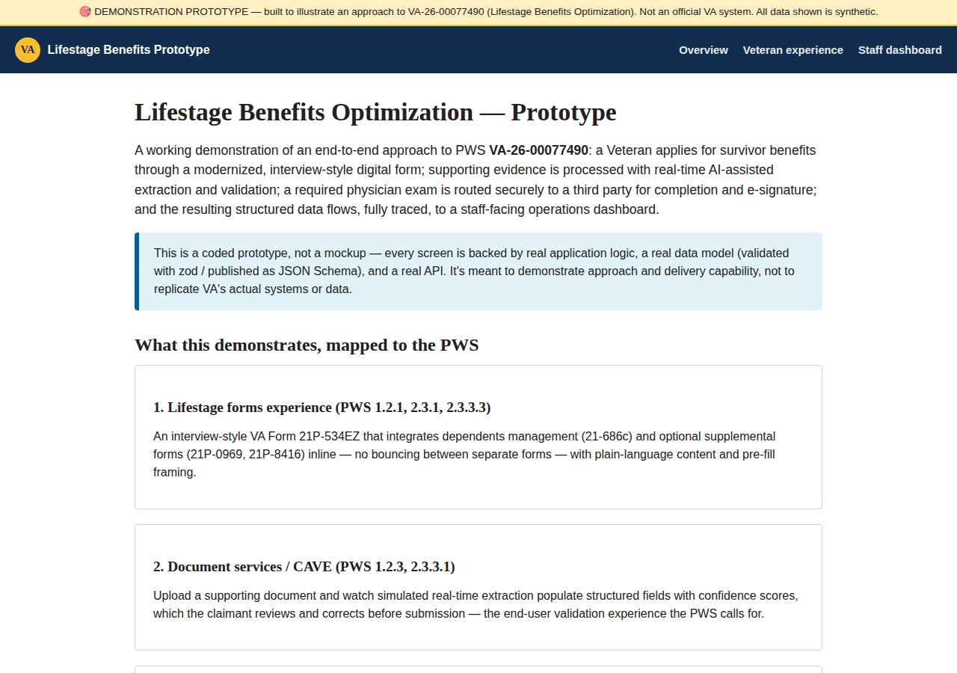
Figure 3. Landing page framing the four capability areas the demo addresses.
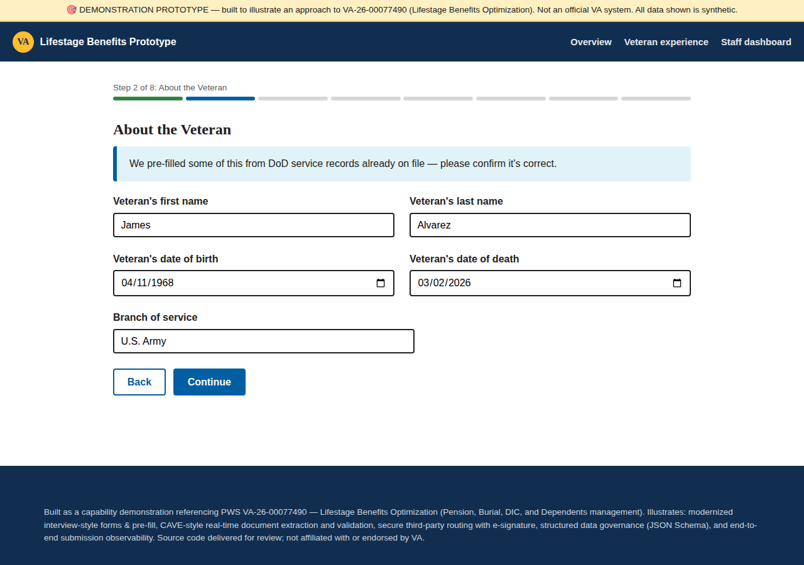
Figure 4. Veteran information step of the Lifestage interview.
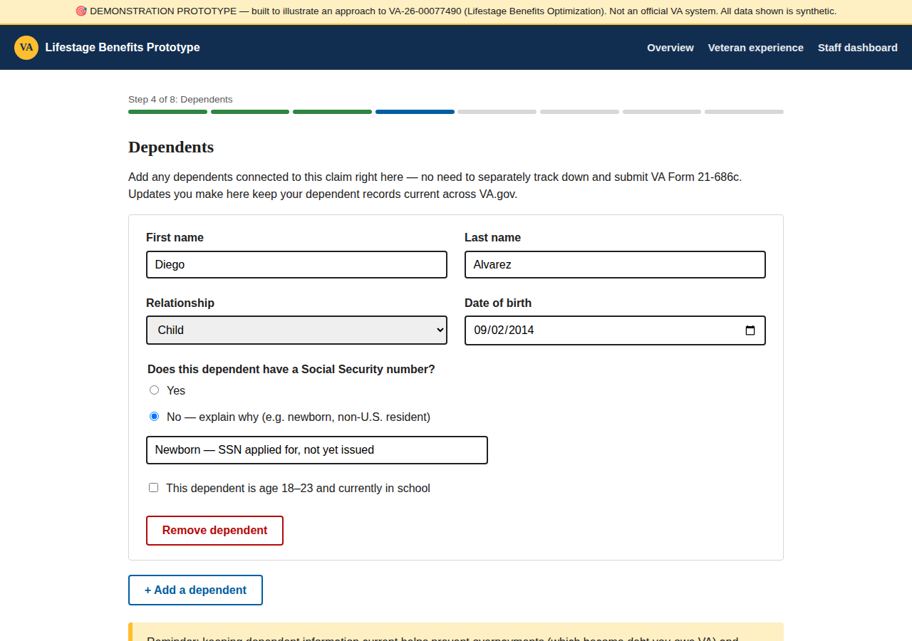
Figure 5. Dependents capture — adding a dependent inline within the interview.
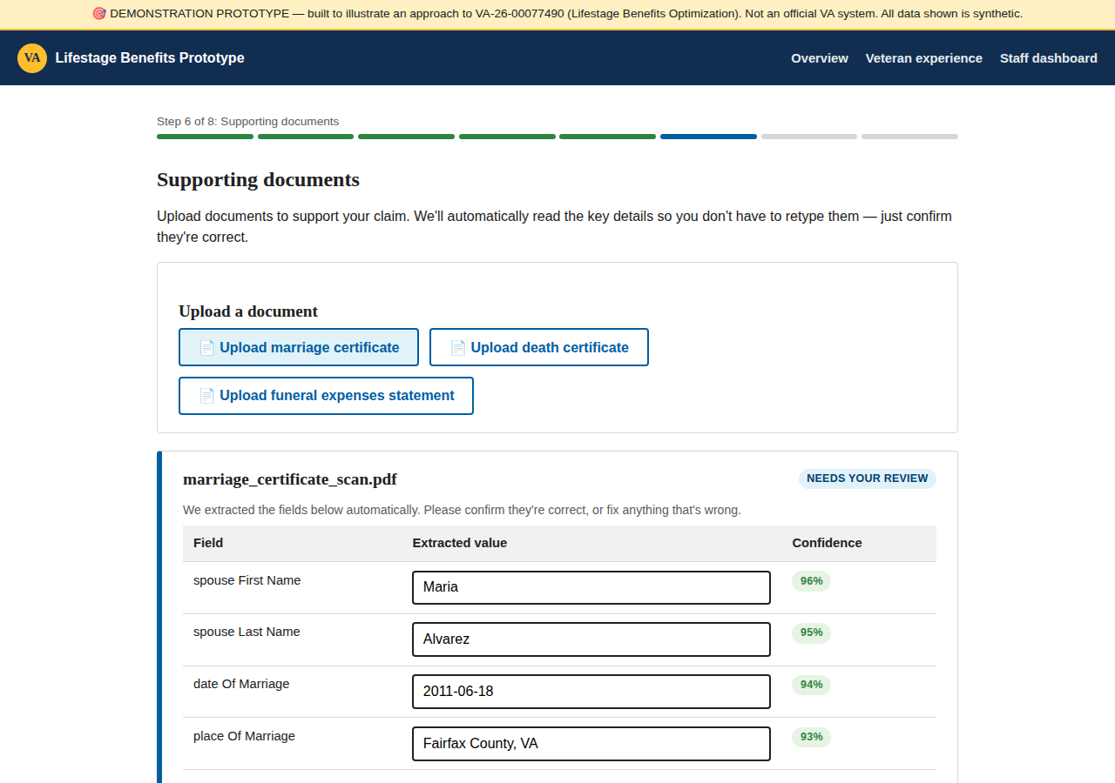
Figure 6. Evidence upload with AI-assisted extraction and per-field confidence scoring.
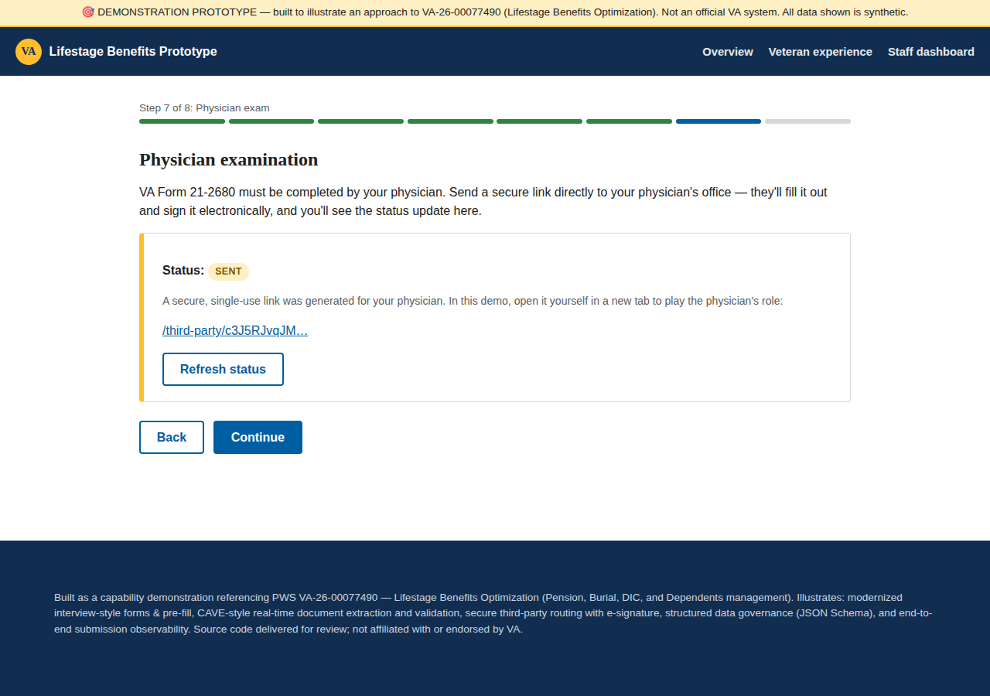
Figure 7. Initiating secure third-party routing to a physician from within the interview.
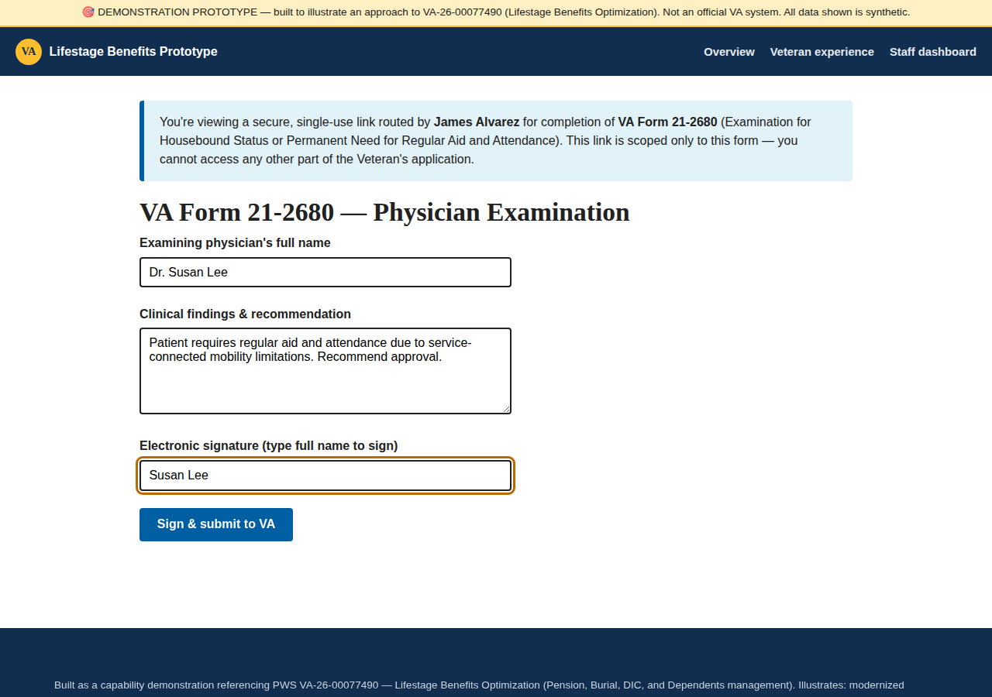
Figure 8. Physician portal — completing VA Form 21-2680 and e-signing via a single-use secure link.
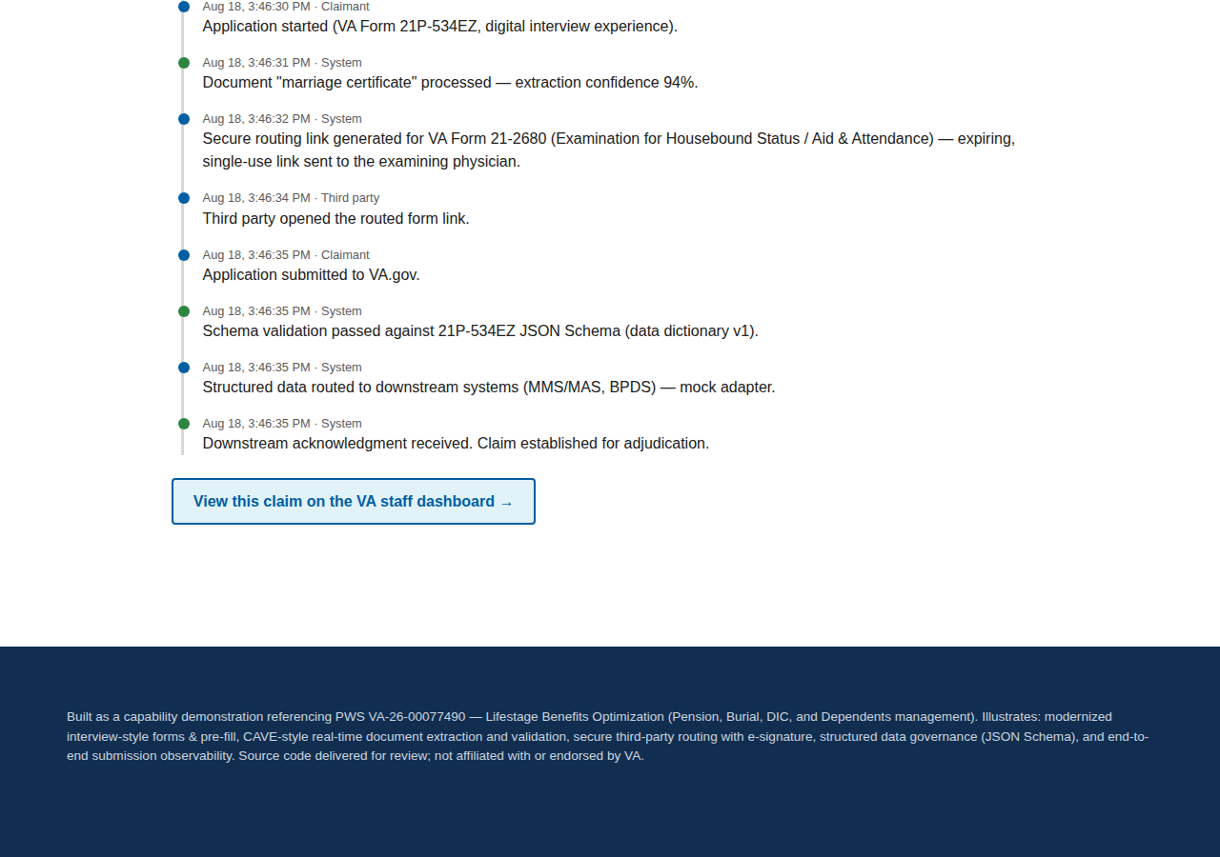
Figure 9. Submission confirmation shown to the claimant.
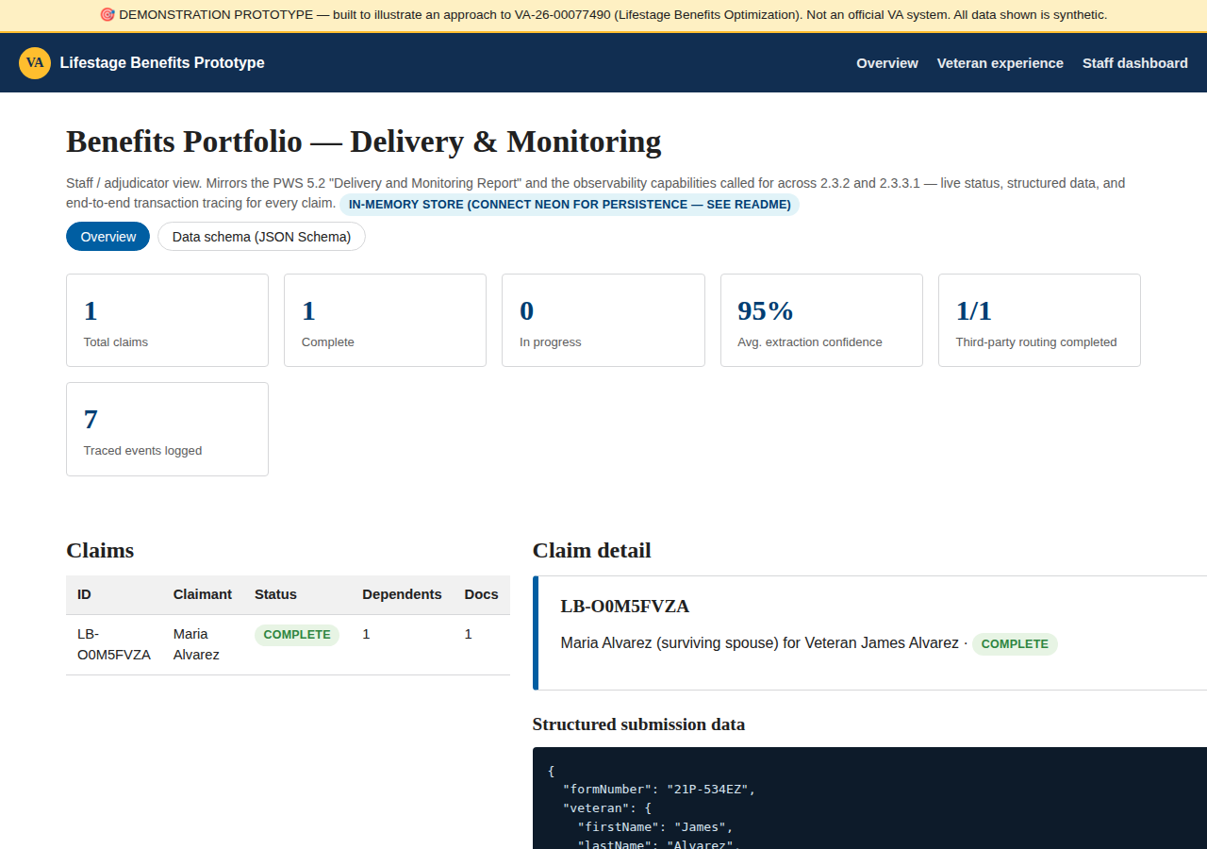
Figure 10. Staff observability dashboard — live claim status, metrics, and transaction trace (sample data).
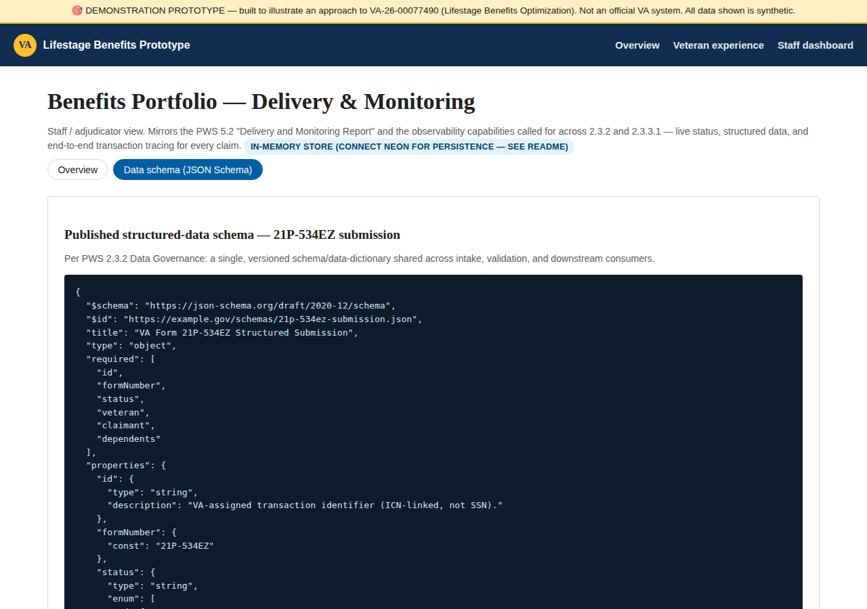
Figure 11. Published JSON Schema view — the shared data dictionary referenced throughout Section 2.3.2 of the PWS.

7. What the Proof-of-Concept Validated
Building this as working software, rather than static mockups, let us confirm several design decisions behave the way we intended rather than just describing them:
- The interview, extraction-review, and third-party steps compose into one continuous flow backed by a single evolving record, rather than separate hand-offs between disconnected tools.
- A single schema can validate data at three different entry points — direct claimant input, extracted-then-corrected fields, and third-party-submitted data — without three separate validation code paths.
- Transaction tracing at each step is enough to reconstruct, after the fact, exactly what happened to a given submission and when — which is what the staff dashboard's trace view surfaces.
- A secure, single-use link is sufficient to let a physician complete a form without a VA.gov account, while still tying that submission back to the correct claim.
What this proof-of-concept intentionally does not attempt: real OCR/ML extraction (the extraction step is a deterministic mock standing in for CAVE), VA.gov's actual authentication and identity-proofing (Login.gov/ID.me, ICN-based identity per PWS 8.1), the official VA.gov Design System component library, integration with real downstream systems (BGS, MMS/MAS, BPDS), or a real Kafka deployment. Each of these is a known, bounded next step for a funded engagement rather than an open design question — the proof-of-concept exists to validate the shape of the solution, not to shortcut VA's own security, accessibility, and integration processes.

8. Implementation Phases and Claude Code Build Guide
The proof-of-concept in this document was built the same way we would recommend building toward a production system: in small, independently shippable phases, using Claude Code as the day-to-day engineering tool inside a normal GitHub/Vercel/Neon workflow. This section lays out that phasing and gives the concrete Claude Code prompts and terminal commands an engineer would run for each phase, including adding Google authentication to gate the staff-facing dashboard — a capability the original proof-of-concept intentionally left out (see Section 7) because its audience was a capture conversation, not a shared, credentialed tool.
One important scoping note: Google OAuth here is a pragmatic way to restrict who can reach a shared staff dashboard during development and internal review — a small, known set of Ad Hoc and VA reviewer accounts. It is not a proposal to use Google as the Veteran-facing identity provider. Production VA.gov authentication for Veterans and claimants runs through Login.gov/ID.me and VA's ICN-based identity model per PWS 8.1.9, and any real staff/adjudicator tool would ultimately sit behind VA's own SSO rather than Google.

8.1 Phased Delivery Plan
Each phase is scoped to ship independently and build on the last:
Phase | Objective | Key Claude Code activities | Exit criteria
0. Environment & account setup | Stand up the accounts and secrets everything else depends on | Manual, console-driven — GitHub repo, Vercel project, Neon project, Google Cloud OAuth client | Accounts created; credentials captured; nothing committed to source
1. Scaffold, repo & CI wiring | A running app with a repo and a deploy pipeline before any feature work | Claude Code scaffolds the Next.js app, initializes git, pushes to GitHub, links Vercel | A "hello world" preview deploys automatically on every pull request
2. Google authentication | Gate the staff-facing surface behind sign-in | Claude Code adds Auth.js with a Google provider and route-protection middleware | Only allow-listed Google accounts reach /dashboard; public routes stay open
3. Data layer on Neon | Replace the in-memory store with durable, structured Postgres storage | Claude Code adds a Postgres-backed store, a migration script, and environment-specific DATABASE_URL wiring | Local, preview, and production all read/write validated data in Neon
4. Lifestage forms experience | The core Veteran/claimant interview | Claude Code builds the multi-step wizard — veteran info, claimant info, dependents, Aid & Attendance | The full interview flow persists a valid draft submission
5. Extraction & validation | Turn uploaded evidence into structured, reviewable data | Claude Code adds the upload step, an extraction endpoint, and a confidence-scored review/correct UI | An uploaded document produces fields the claimant can review and correct
6. Secure third-party routing | Let a physician complete a form without a VA.gov or Google account | Claude Code adds single-use token issuance, a public physician portal, and e-signature capture | A physician can complete and sign; status reflects back on the claimant's side
7. Observability & delivery reporting | Make claim status and system health visible to staff | Claude Code adds transaction-trace events and the staff dashboard's live metrics | Staff can see live status and metrics matching the PWS 5.2 report shape
8. Hardening, CI/CD & handoff | Make the app safe to hand off or extend | Claude Code adds an accessibility pass, a GitHub Actions check, and setup documentation | CI is green on main; a documented runbook exists; credentials are rotated for handoff

8.2 Step-by-Step Build With Claude Code
Each phase below shows the manual setup (where one exists), the prompt(s) given to Claude Code, and any terminal commands run alongside it. Prompts are written the way an engineer would actually type them — plain instructions, not code.

8.2.1 Phase 0 — Environment & Account Setup (manual)
- GitHub — create an empty private repository (via github.com, or gh repo create ad-hoc/lifestage-benefits-demo --private) that Claude Code will push the scaffolded app into.
- Vercel — create a project and, once code exists, link it to the GitHub repo (Import Git Repository in the Vercel dashboard, or vercel link) so every push gets a preview deployment and merges to main promote to production.
- Neon — create a Neon project and a main database branch in a region close to the Vercel deployment; copy the pooled connection string for later steps.
- Google Cloud — in Google Cloud Console under APIs & Services > Credentials, create an OAuth 2.0 Client ID (Web application) and add authorized redirect URIs for local, preview, and production domains (e.g. http://localhost:3000/api/auth/callback/google and the equivalent Vercel URLs). Note the Client ID and Client Secret.
These four steps are console-driven and can't be automated by Claude Code — OAuth consent screens and account creation require a human in the browser. Everything after this point is a Claude Code prompt or a terminal command.

8.2.2 Phase 1 — Scaffold, Repo & CI Wiring
$ claude
> Scaffold a Next.js 14 App Router project in TypeScript named
> lifestage-benefits-demo, with ESLint, and an app/ directory
> (no src/ wrapper). Initialize git and add a .gitignore suited
> to Next.js.
$ gh repo create ad-hoc/lifestage-benefits-demo --private --source=. --push
$ vercel link
$ vercel git connect
> Add a GitHub Actions workflow that runs `npm run lint` and
> `npm run build` on every pull request targeting main.

8.2.3 Phase 2 — Google Authentication
> Add Auth.js (NextAuth v5) with a single Google OAuth provider.
> Add middleware that protects every route under /dashboard and
> redirects signed-out users to the sign-in page. In the signIn
> callback, only allow Google accounts on the adhocteam.us domain.
$ openssl rand -base64 32 # AUTH_SECRET
$ vercel env add GOOGLE_CLIENT_ID
$ vercel env add GOOGLE_CLIENT_SECRET
$ vercel env add AUTH_SECRET

8.2.4 Phase 3 — Data Layer on Neon
$ neonctl projects create --name lifestage-benefits-demo
$ neonctl connection-string --pooled
> Replace the in-memory store in lib/store.ts with a Postgres-backed
> implementation using the pg package, falling back to in-memory only
> when DATABASE_URL is unset. Add scripts/init-db.mjs to create tables
> from the shapes in lib/schema.ts, and a `db:init` npm script that
> runs it.
$ vercel env add DATABASE_URL production
$ vercel env add DATABASE_URL preview
$ npm run db:init
Neon's official Vercel integration can additionally provision a fresh database branch for every preview deployment, matching Neon branches to Vercel previews one-to-one — worth enabling once Phase 1's CI wiring is in place.

8.2.5 Phase 4 — Lifestage Forms Experience
> Build the Veteran/claimant interview at app/apply as a multi-step
> client-side wizard — veteran info, claimant info, dependents, and
> an Aid & Attendance screening question — saving a draft submission
> via POST /api/submissions and PATCH /api/submissions/[id], each
> validated against the schema in lib/schema.ts.

8.2.6 Phase 5 — Extraction & Validation
> Add an evidence-upload step to the interview and a POST /api/extract
> route that returns confidence-scored field extractions for the
> uploaded document type. Add a review screen where the claimant can
> accept or correct each extracted field before continuing.

8.2.7 Phase 6 — Secure Third-Party Routing
> Add POST /api/routing to issue a single-use, expiring token tied
> to a submission, and a public page at app/third-party/[token]
> (outside the Google-auth middleware) where a physician can review
> the request, enter findings, and submit an e-signature. Add
> GET/POST handlers under /api/routing/[token] for status and
> completion.

8.2.8 Phase 7 — Observability & Delivery Reporting
> Record a TraceEvent at each meaningful step — intake, extraction,
> routing, validation, submission — and build a staff dashboard at
> app/dashboard, behind the Google-auth middleware, showing live
> totals, average extraction confidence, and a per-claim transaction
> trace.

8.2.9 Phase 8 — Hardening, CI/CD & Handoff
> Add an automated accessibility check (axe-core) to the test suite,
> write a README covering setup, environment variables, and
> architecture decisions, and add a note on rotating the Google OAuth
> and Neon credentials before handoff.
$ git checkout -b release/v1
$ git push origin release/v1
$ gh pr create --fill
Merging to main promotes the linked Vercel production deployment automatically; no separate deploy step is needed once Phase 1's GitHub/Vercel connection is in place.

9. Why This Approach
PWS 5.2 asks the awarded contractor for a recurring Delivery and Monitoring Report that shows real progress in plain language, with links to monitoring data — not a static status update. The dashboard and trace log in this proof-of-concept are a direct, working preview of that reporting artifact. More broadly, this design responds to the PWS's own framing: forms usability, data intake, and document services are not separate contract line items to VA — they are one claimant experience, and VA is evaluating whether a contractor understands that. Demonstrating the connective tissue between those three areas in working software, rather than describing it in three separate proposal sections, is the core of Ad Hoc's proposed approach to this opportunity.
This document and the proof-of-concept behind it are intended as an internal working artifact to sharpen Ad Hoc's capture conversations and, eventually, technical volume content for VA-26-00077490 — not a deliverable to VA.

