## The British college

Component2: Laravel Route /View

Submitted by: smith shrestha

Date: 2020/12/9

Evidences:

- Laravel Installation 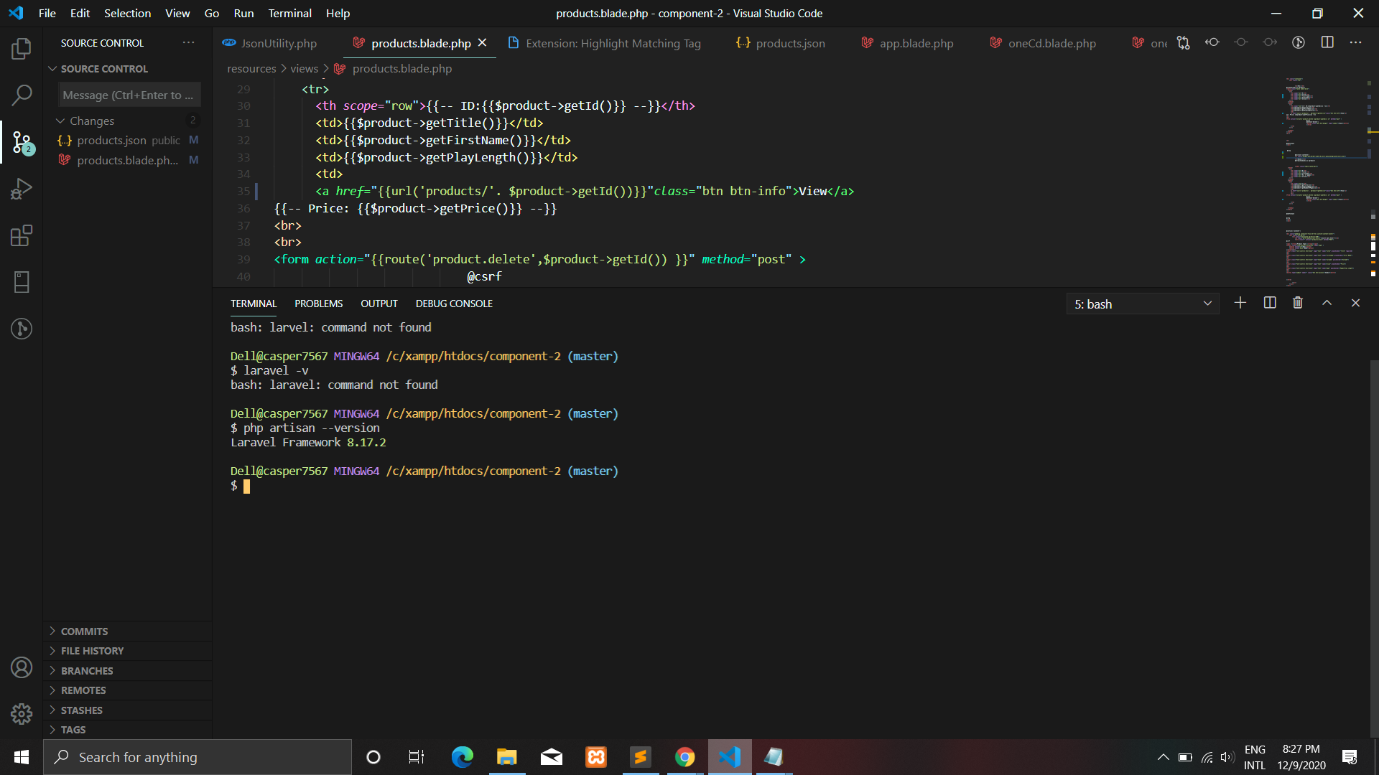

- Laravel Routing

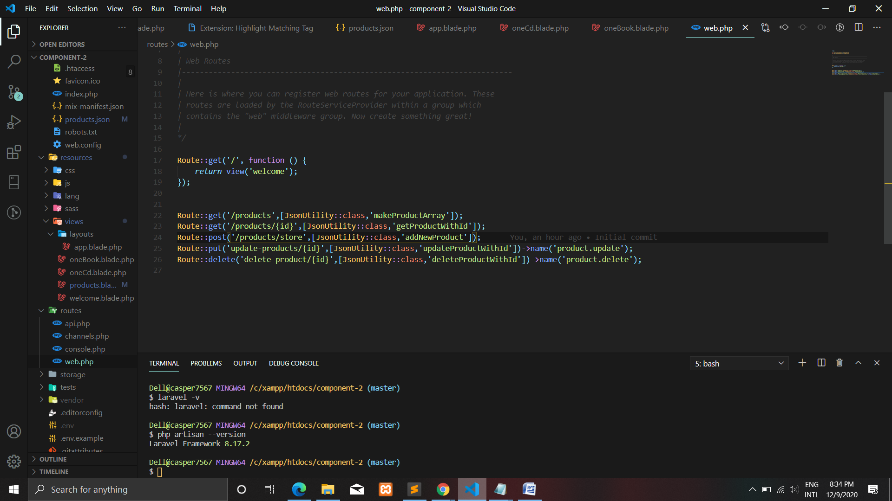

- Version Control

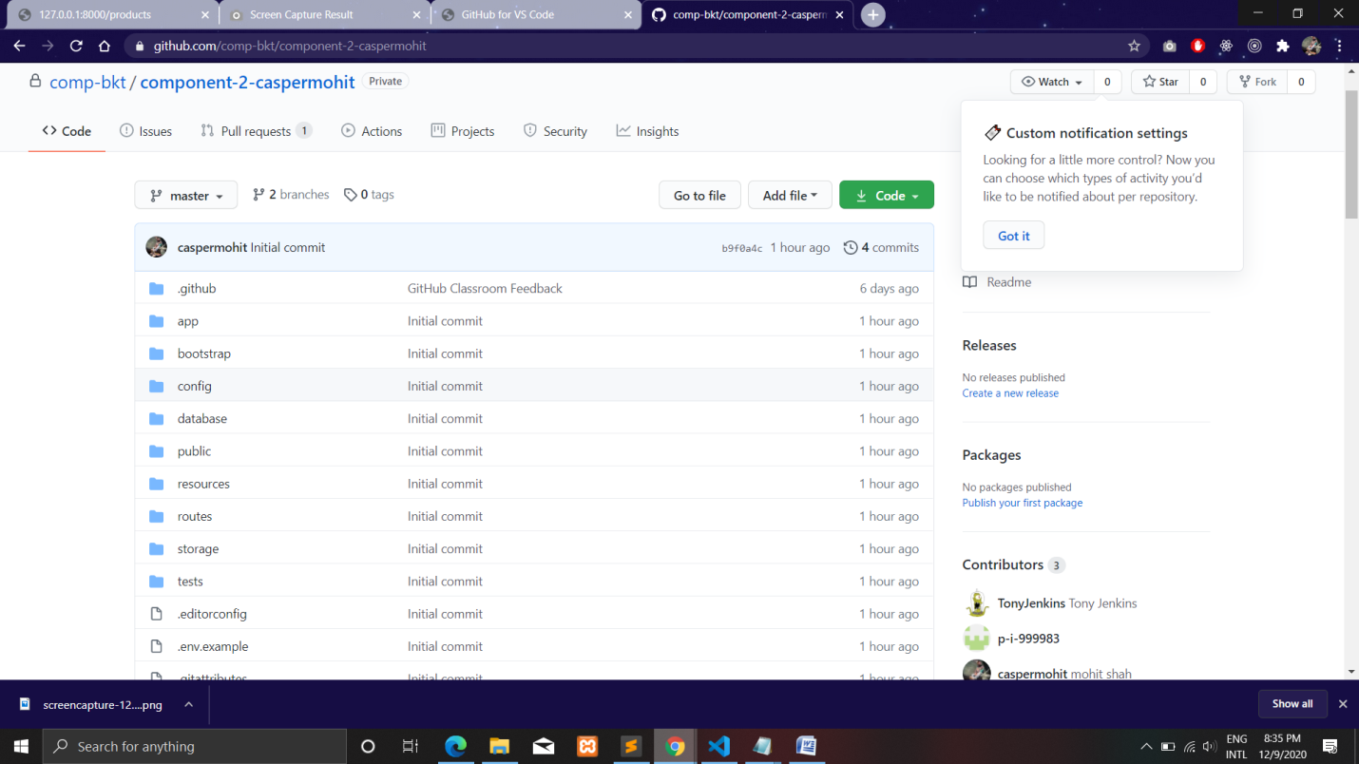

- View Templates

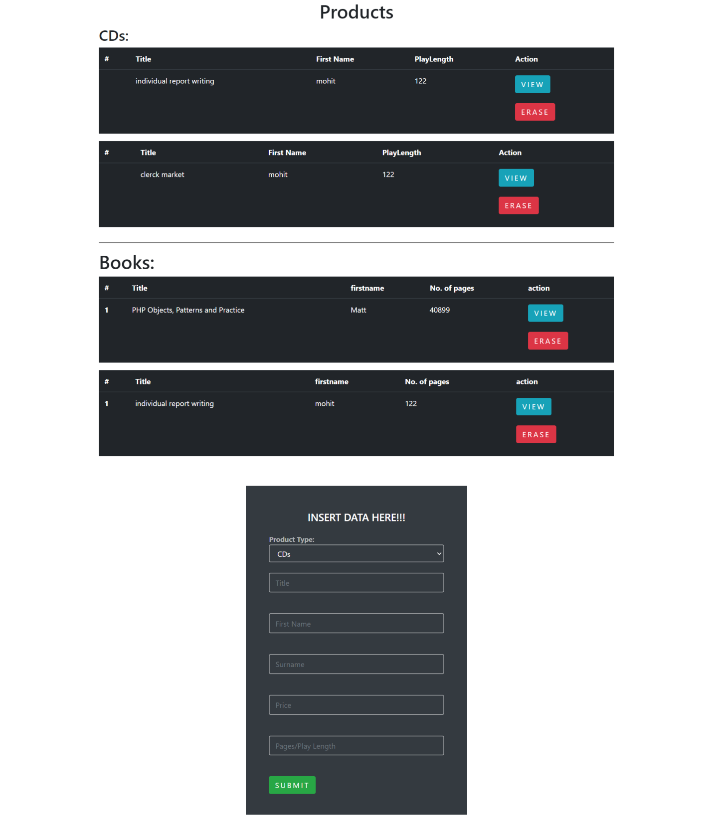

- HTTP Requests (

GET 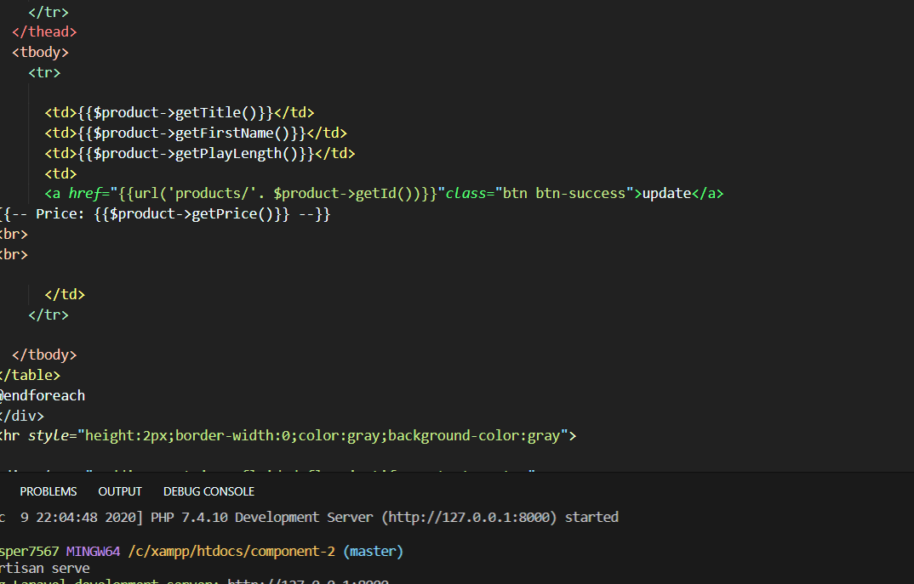

POST

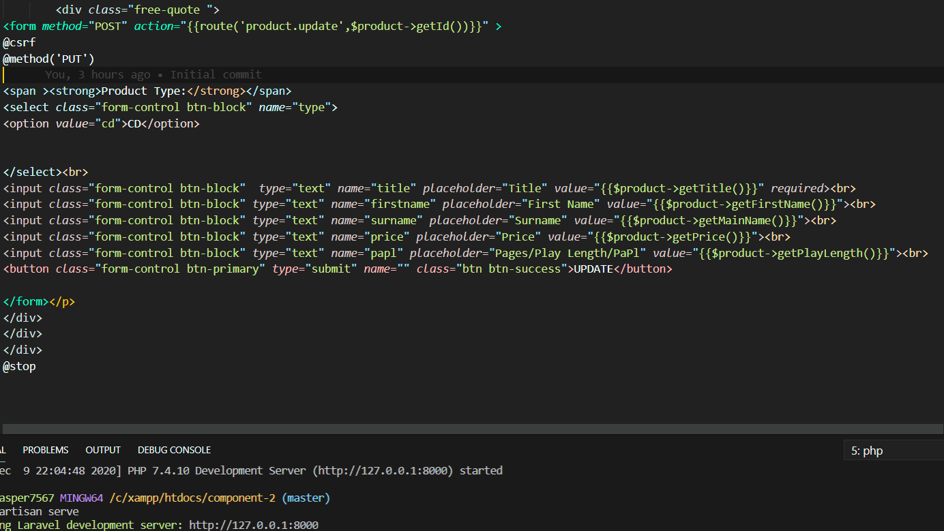

'PATCH or PUT'



DELETE

