Reliability-Aware Transfer Learning for Robust and Explainable UAV-Based Aquatic Plant Classification
A realistic, publication-oriented image-processing pipeline aligned with CNN, transfer learning, training optimization, feature visualization, and Grad-CAM

Recommended direction | Robust and Explainable Transfer Learning for UAV-Based Aquatic Plant Classification
Core task | 14-class aquatic plant classification using the provided Train/Test folders
Main contribution | Accuracy + robustness + uncertainty/calibration + Grad-CAM-based explanation, instead of only model comparison
15-day rule | Keep segmentation optional. Complete the classification reliability study first; add segmentation only if time remains.

Paper Idea
Build a reliable aquatic-plant classifier from UAV images using transfer learning, then test whether it still works under blur, noise, brightness changes, and other image degradations.
Use VGG16, ResNet50, and EfficientNet-B0 as main models. After classification, add confidence calibration + selective prediction so uncertain images can be rejected for human review instead of forcing a wrong answer. Finally, use Grad-CAM to show which plant regions influenced the prediction.

Core idea - “Can UAV aquatic-plant classification be accurate, robust, trustworthy, and explainable in real-world conditions?”

Core Novelty / Contribution
Contribution | What you actually test
Reliability beyond accuracy | Evaluate not only classification accuracy but also how performance degrades under realistic image corruptions.
Robustness audit | Test blur, noise, brightness/contrast changes, JPEG compression, and partial occlusion at controlled severity levels.
Confidence calibration | Check whether predicted confidence actually matches correctness using ECE, Brier score, NLL, and reliability diagrams.
Selective prediction | Allow the system to reject low-confidence images for human review instead of forcing a possibly wrong species label.
Explainable validation | Use Grad-CAM to examine whether correct and incorrect predictions focus on meaningful plant regions rather than irrelevant background.

Research Objectives
- RO1: Develop and compare transfer-learning models for 14-class aquatic plant recognition from UAV imagery.
- RO2: Measure model robustness under realistic image degradations that may occur during UAV-based monitoring.
- RO3: evaluate whether model confidence is calibrated and identify high-confidence errors.
- RO4: develop a selective prediction mechanism that sends uncertain cases for review.
- RO5: use Grad-CAM to analyze the visual regions influencing correct and incorrect species predictions.

Research Questions
- RQ1: Which transfer-learning architecture provides the best balance between accuracy, macro-F1, and computational efficiency for the 14 species?
- RQ2: How strongly does performance deteriorate under blur, noise, illumination change, compression, and occlusion?
- RQ3: Are the model probabilities well calibrated, or does the classifier become overconfident on difficult images?
- RQ4: Can selective prediction improve reliability by rejecting uncertain samples?
- RQ5: Do Grad-CAM explanations indicate that predictions are based on visually relevant plant regions?

Final Strong Pipeline

Phase A — Dataset Audit
- Verify all 14 Train/Test class folders and count images per class.
- Check unreadable/corrupt images and image dimensions.
- Visualize 3-5 samples per class.
- Check class imbalance.
- Check exact duplicates and near-duplicates between Train and Test if feasible.

Phase B — Preprocessing
- Resize all images to one model input size (e.g., 224×224).
- Convert to RGB and normalize with ImageNet statistics.
- Use augmentation only on the training data: horizontal flip, small rotation, random crop, modest brightness/contrast jitter.
- Create a validation split from Train only; never tune using the official Test set.

Phase C — Baseline & Transfer Learning
- Custom CNN as the simple teacher-aligned baseline.
- VGG16 as a direct transfer-learning baseline.
- ResNet50 as a stronger residual baseline.
- EfficientNet-B0 as the main candidate model.
- Train classifier head first, then fine-tune deeper layers.

Phase D — Training Optimization
- Cross-entropy loss; use class weights only if imbalance is meaningful.
- AdamW optimizer.
- Learning-rate scheduler.
- Early stopping using validation macro-F1 or validation loss.
- Save the best checkpoint for each model.

Phase E — Standard Evaluation
- Accuracy, macro precision, macro recall, macro-F1, weighted-F1.
- Per-class precision/recall/F1.
- 14×14 confusion matrix.
- One-vs-rest ROC-AUC if probabilities are stable.
- Parameter count and inference time for efficiency comparison.

Phase F — Robustness Audit
- Create corrupted copies of the untouched Test images.
- Corruptions: Gaussian blur, Gaussian noise, brightness shift, contrast reduction, JPEG compression, partial occlusion.
- Use 3 severity levels to keep the workload realistic in 15 days.
- Measure accuracy and macro-F1 at each corruption/severity.
- Report mean robustness score and performance drop from clean Test.

Phase G — Calibration & Uncertainty
- Collect softmax probabilities from the best model.
- Apply temperature scaling using the validation set only.
- Report Expected Calibration Error (ECE), Brier score, NLL, and reliability diagram.
- Compare confidence distributions for correct vs. incorrect predictions.

Phase H — Selective Prediction
- Use maximum calibrated probability or predictive entropy as the uncertainty score.
- Reject predictions below a confidence threshold.
- Report coverage, selective accuracy, and selective risk.
- Plot risk-coverage or accuracy-coverage curve.

Phase I — Explainability
- Generate Grad-CAM for representative correct predictions from all/most classes.
- Generate Grad-CAM for important misclassifications.
- Compare high-confidence correct, high-confidence wrong, and low-confidence cases.
- Discuss whether attention lies on leaves/flowers/plant body or background.

Phase J — Final Error Analysis
- Identify the most confused species pairs from the confusion matrix.
- Link difficult cases to blur, occlusion, lighting, visual similarity, or background.
- Show 6-10 representative failure cases.
- Discuss limitations and deployment implications for UAV wetland monitoring.

Minimum vs. Strong Version
Component | Must Finish | Optional if Time Remains
Dataset audit | Yes | Near-duplicate similarity visualization
Custom CNN + VGG16 + ResNet50 + EfficientNet-B0 | Yes | ConvNeXt or MobileNetV3
Confusion matrix + class-wise metrics | Yes | Per-class ROC curves
Robustness testing | Yes | More corruption types / 5 severity levels
Calibration | Yes | MC Dropout / deep ensemble
Selective prediction | Yes | Conformal prediction
Grad-CAM | Yes | Quantitative saliency-mask overlap
Segmentation | No | U-Net + plant-focused classification

Recommended Model Set
Do not waste time training 10-15 architectures. Use four models with clear roles:
Model | Role in paper
Custom CNN | Simple baseline directly aligned with coursework.
VGG16 | Teacher-aligned transfer-learning baseline.
ResNet50 | Strong residual CNN comparison.
EfficientNet-B0 | Recommended main model because it is comparatively efficient and strong for transfer learning.

Experiments You Should Report
E1 — Clean benchmark: Compare all four models on the untouched Test set.
E2 — Fine-tuning ablation: Frozen backbone vs. fine-tuned best backbone.
E3 — Robustness benchmark: Evaluate the best 2 models across six corruptions × three severity levels.
E4 — Calibration: Before vs. after temperature scaling.
E5 — Selective prediction: Accuracy/risk as low-confidence images are rejected.
E6 — Grad-CAM failure analysis: Correct, wrong, and uncertain predictions.

Essential Figures and Tables
Figures | Tables
1. Class distribution | 1. Dataset summary
2. Example images from 14 classes | 2. Clean classification benchmark
3. Proposed reliability pipeline | 3. Per-class results
4. Training/validation curves | 4. Robustness comparison
5. Confusion matrix | 5. Calibration results
6. Robustness vs. severity plot | 6. Selective prediction results
7. Reliability diagram | 7. Ablation study
8. Risk/accuracy–coverage curve
9. Confidence: correct vs. incorrect
10. Grad-CAM examples / failure cases

15-Day Execution Schedule
Day | Task
Day 1 | Dataset audit, class counts, corrupt-image check, sample visualization.
Day 2 | DataLoader/preprocessing/augmentation pipeline; make train-validation split.
Day 3 | Train Custom CNN and VGG16.
Day 4 | Train ResNet50 and EfficientNet-B0.
Day 5 | Fine-tune best 2 models; save checkpoints.
Day 6 | Clean Test evaluation; metrics, confusion matrix, class-wise results.
Day 7 | Create corruption generator and corrupted Test sets.
Day 8 | Run robustness experiments and produce robustness plots.
Day 9 | Calibration: temperature scaling, ECE, Brier, NLL, reliability diagram.
Day 10 | Selective prediction and risk/coverage analysis.
Day 11 | Grad-CAM generation and failure-case analysis.
Day 12 | Ablations, timing/parameter count, final result tables.
Day 13 | Write Introduction, Related Work, Dataset, Methodology.
Day 14 | Write Results, Discussion, Limitations, Conclusion; assemble figures/tables.
Day 15 | Final checking: reproducibility, references, formatting, grammar, plagiarism/AI-style cleanup, final PDF.

Phase A — Dataset Integrity and Leakage Control

Workflow Pipeline
Original Dataset (1,468 files)
↓
Dataset Integrity Audit
↓
Cross-partition duplicates detect
↓
Original Test split rejected for final evaluation
↓
Deduplication Check
↓
Unique images & Exact duplicates removed
↓
Near-Duplicate Audit
↓
Leakage-Free Unique Image Pool
↓
Stratified Split
70% / 15% / 15%
↓

│ Train │ Validation │ Test │
│ 70% │ 15% │ 15% │
↓
Train + tune only using
Train/Validation
↓
LOCK Test
↓
Final Test Evaluation

- Count of class –
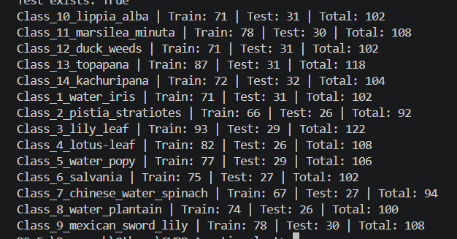
- Class Disribution –
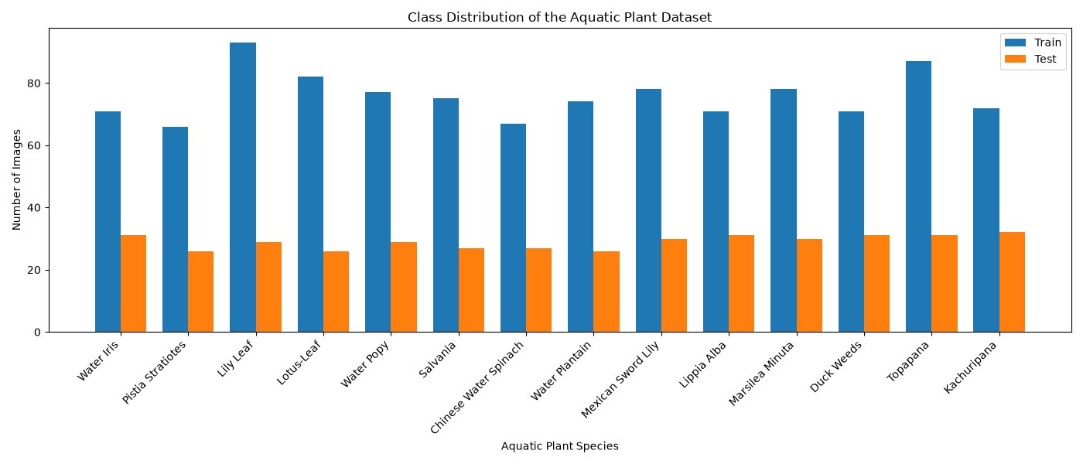
- Image resolution & Corrupted image check ---

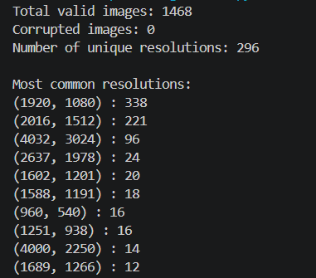

- visualize representative images from all 14 classes ---
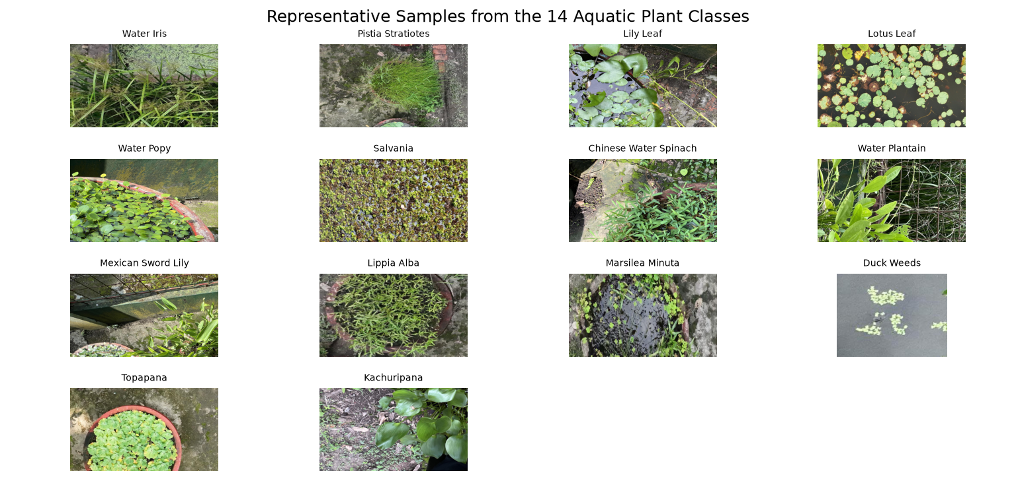
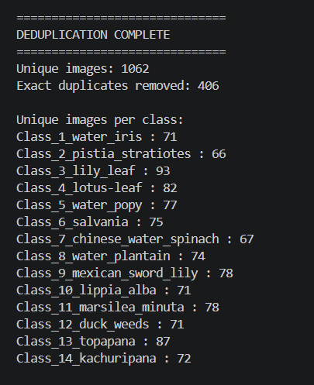
- Duplication Check and Clean duplicate dataset –

- Original Train–Test Split Validation
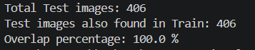

- Near duplicate Audit –
Total images checked: 1062
Near-duplicate pairs found: 77
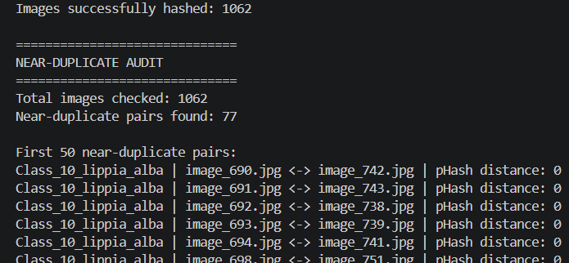

- SSIM Verification –
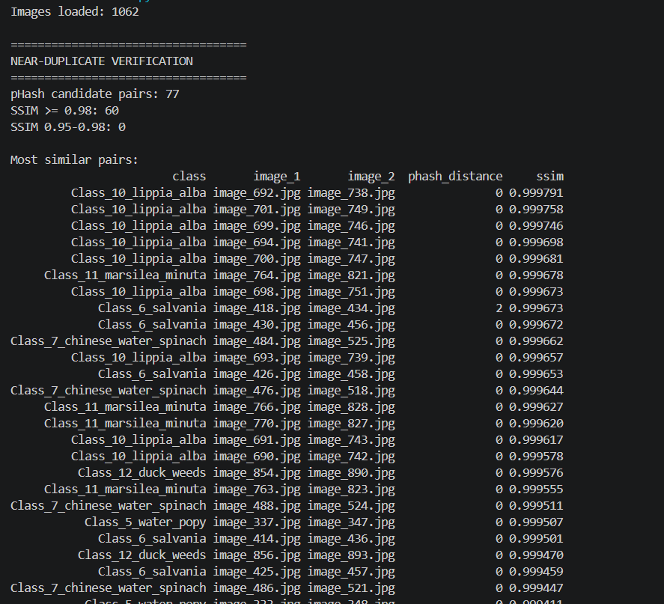
- Near Duplicate Grouping
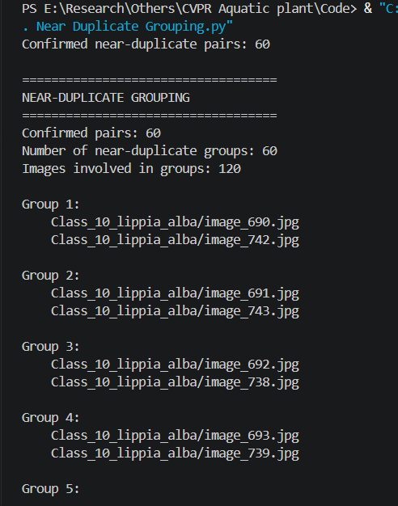

- Final Group aware split
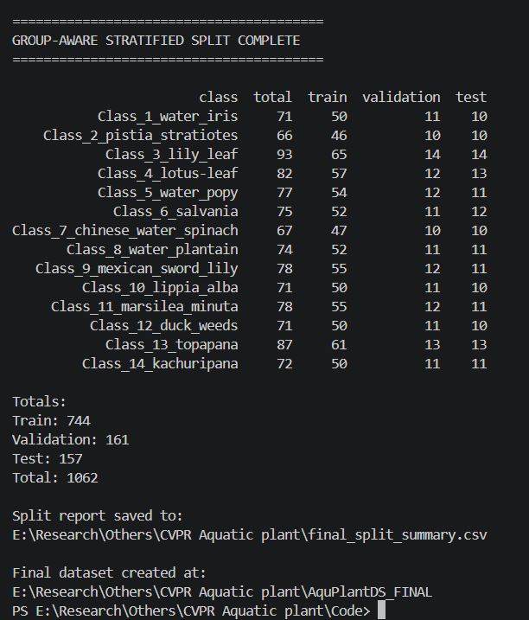

- Final Leakage Verification
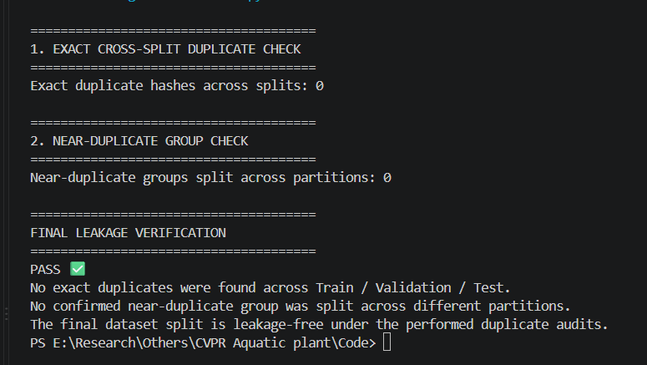

PHASE B — PREPROCESSING & DATA PIPELINE
AquPlantDS_FINAL (Train: 744, Validation: 161, Test: 157)
↓
1. Verify Folder Structure
↓
2. Read Class Names
14 classes
↓
3. Set Reproducibility
Random seed = 42
↓
4. Define Input Size
224 × 224
↓
5. Training Preprocessing
├── Resize
├── Random Horizontal Flip
├── Small Rotation
├── Random Resized Crop
├── Mild Brightness / Contrast Jitter
├── Convert to Tensor
└── ImageNet Normalization
↓
6. Validation Preprocessing
├── Resize
├── Convert to Tensor
└── ImageNet Normalization
↓
7. Test Preprocessing
├── Resize
├── Convert to Tensor
└── ImageNet Normalization
↓
8. Create PyTorch ImageFolder Datasets
↓
9. Create DataLoaders
├── Train → Shuffle = True
├── Validation → Shuffle = False
└── Test → Shuffle = False
↓
10. Verify Dataset Counts
├── Train = 744
├── Validation = 161
└── Test = 157
↓
11. Verify Batch Shape
Example:
[32, 3, 224, 224]
↓
12. Visualize Augmented Training Samples
↓
13. Check Class Mapping
↓
14. Compute Class Weights
↓
15. Decide Whether Class Weights Are Needed
↓
16. Freeze Test Data Pipeline
↓
PHASE B COMPLETE

- Data Pipeline verification –
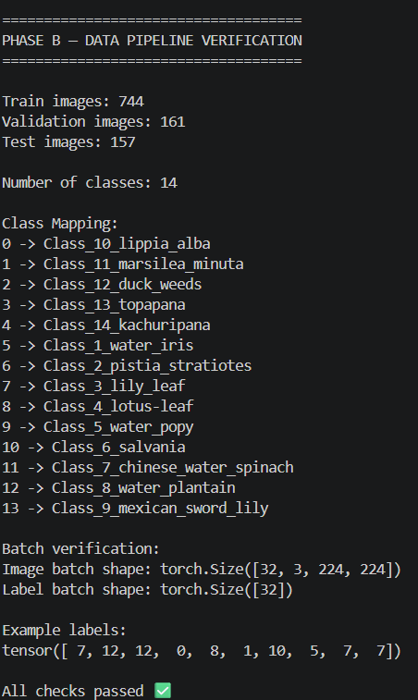

- Augmented Sample Visualization
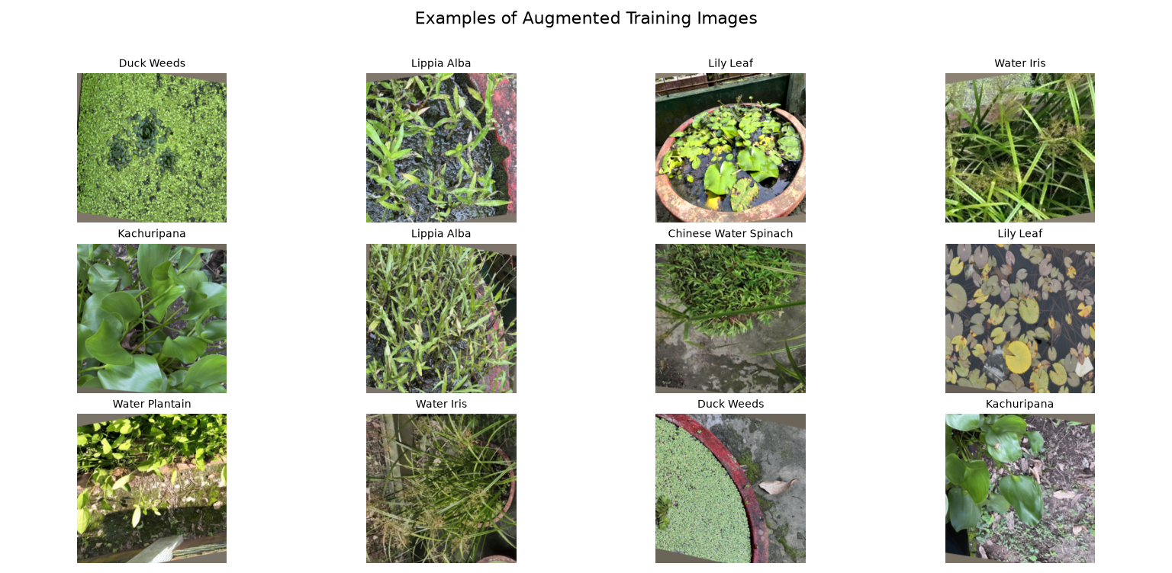
- Class Balance Analysis
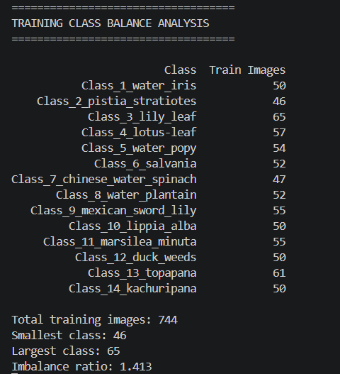
- Final Preprocessing Configuration
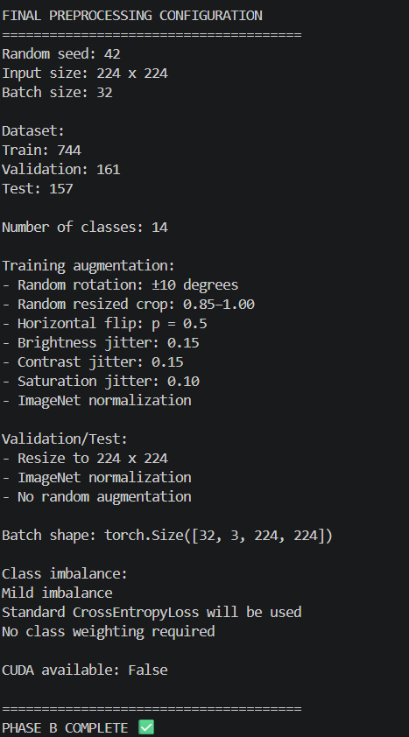
PHASE C — BASELINE & TRANSFER LEARNING

Kaggle Setup + GPU Verification
↓
Dataset Path + DataLoader Reconstruction
↓
Custom CNN Baseline
↓
VGG16 Transfer Learning
↓
ResNet50 Transfer Learning
↓
EfficientNet-B0 Transfer Learning
↓
Validation Comparison
↓
Select Best Two Models
↓
Fine-Tune Best Two
↓
Save Models + Phase C Results
↓
PHASE C COMPLETE

Custom CNN Baseline

- Data Pipeline
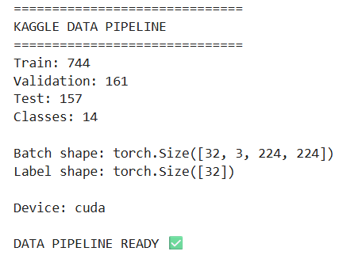
- Loss, optimizer, scheduler
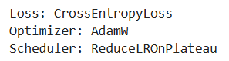

- Custom Based CNN Result
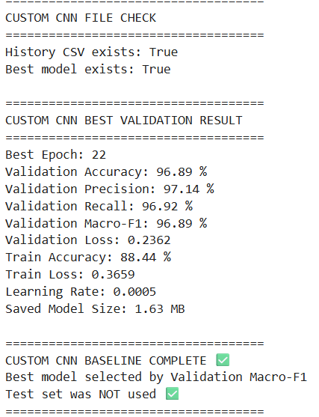
- Imports + settings
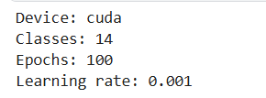
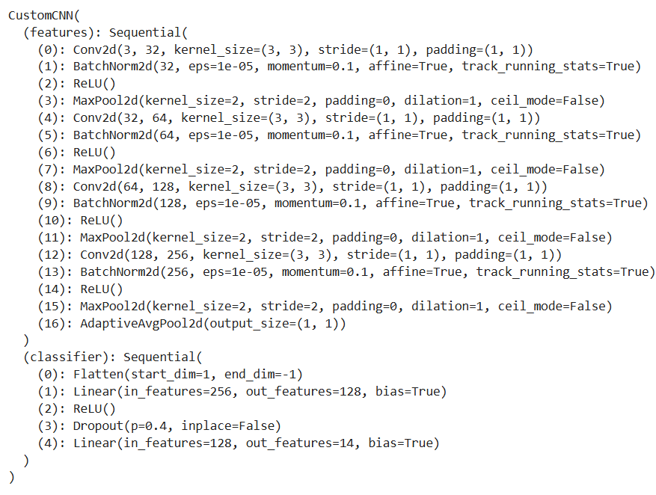
- Custom CNN
VGG16

- Dataset Check
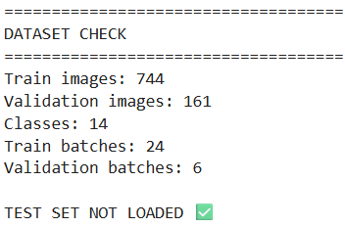

- Parameter Info
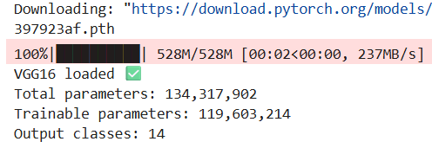

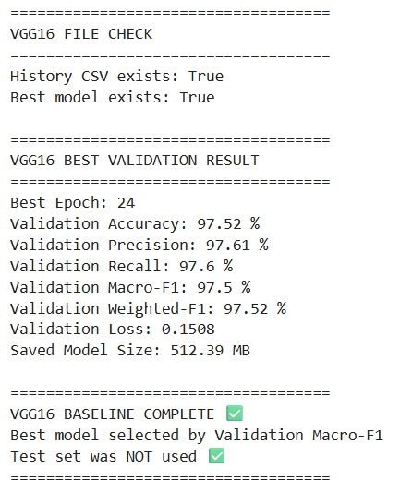
- Summary Stage-1

- Training Configuration
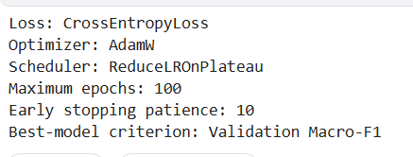

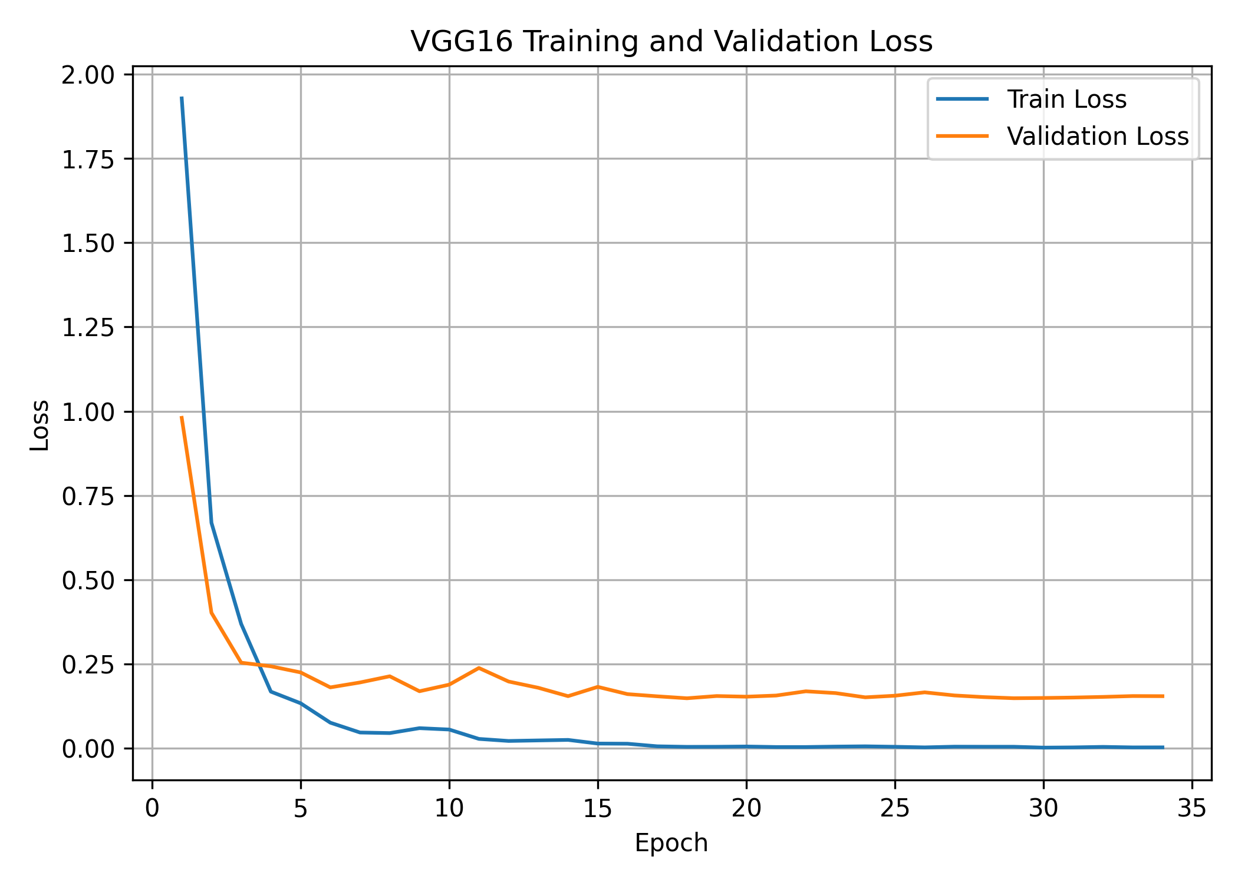
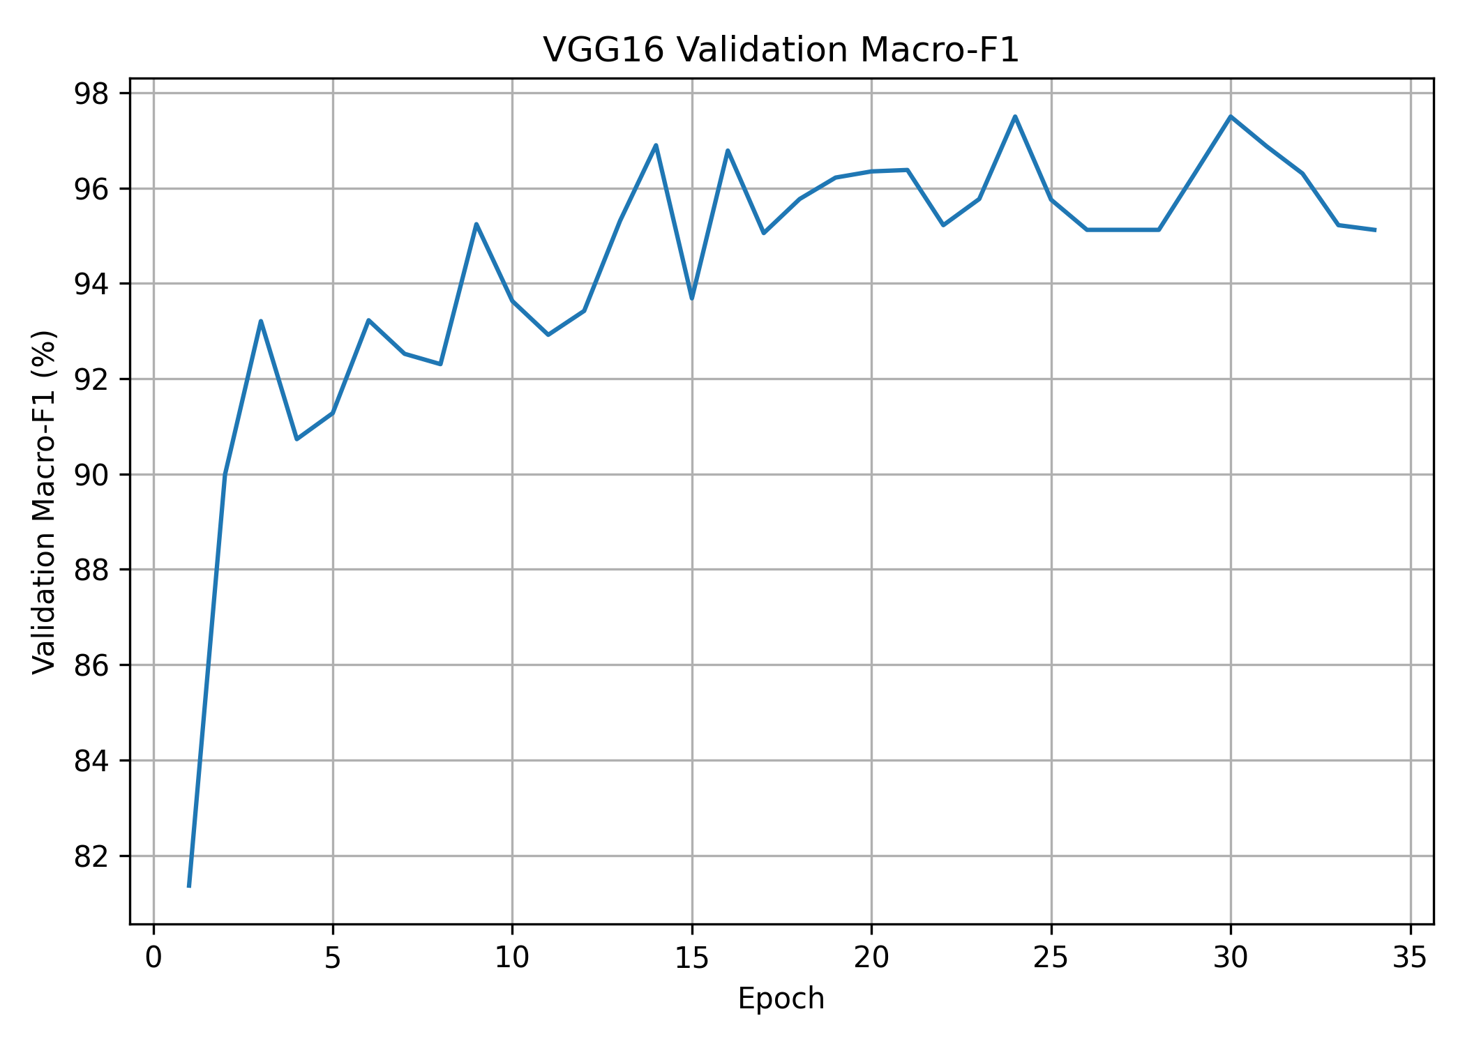
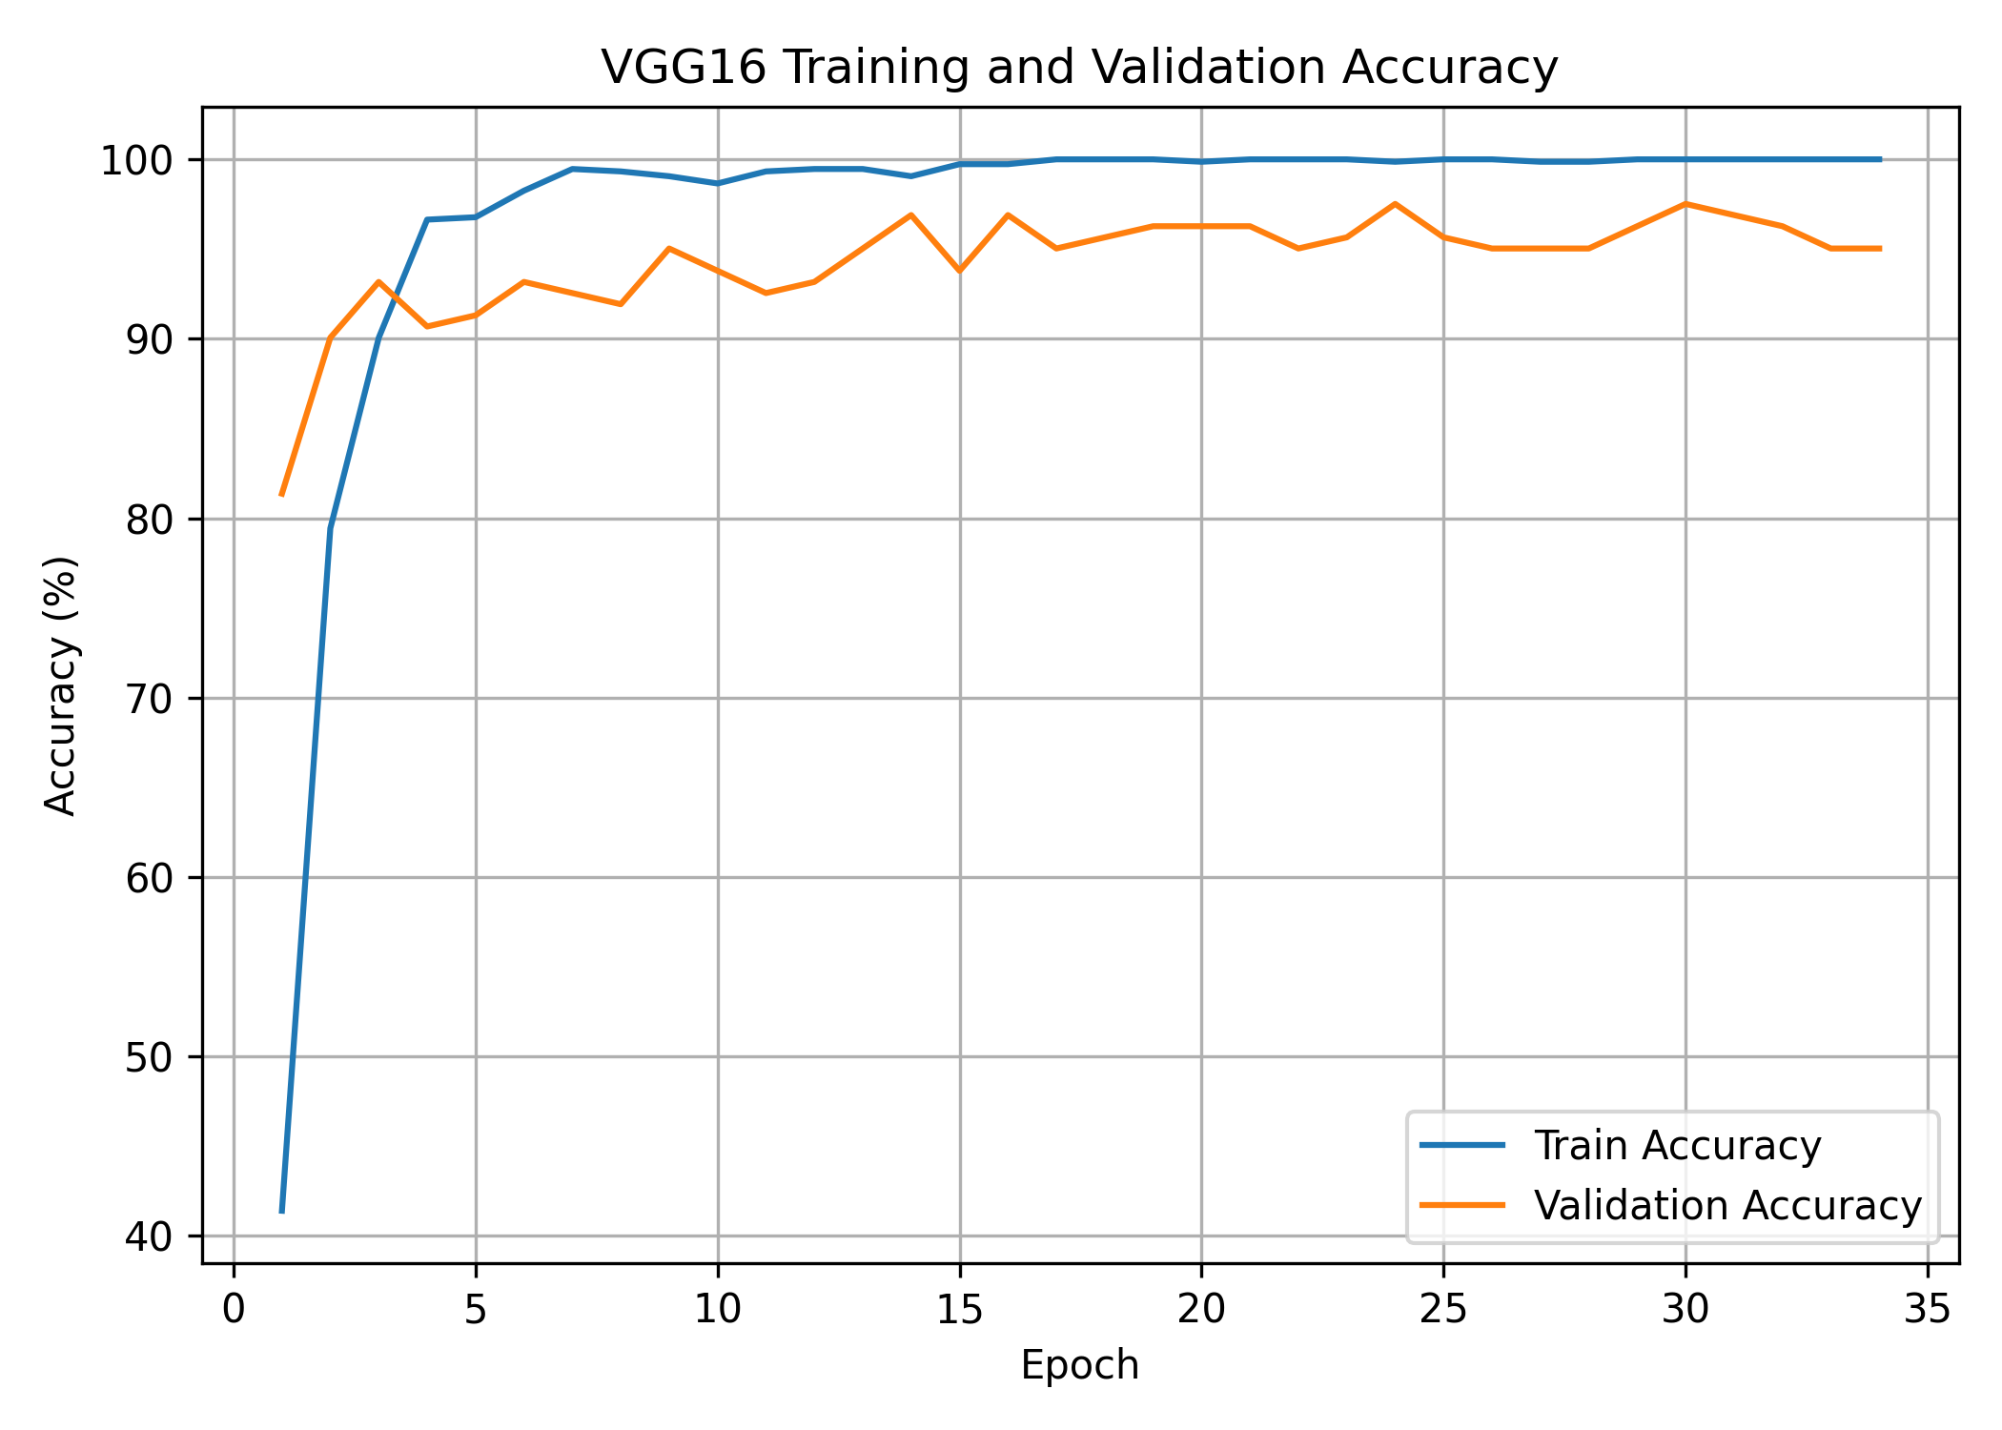

ResNet50
- Backbone Result
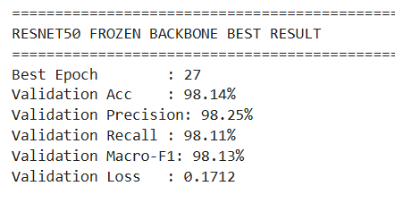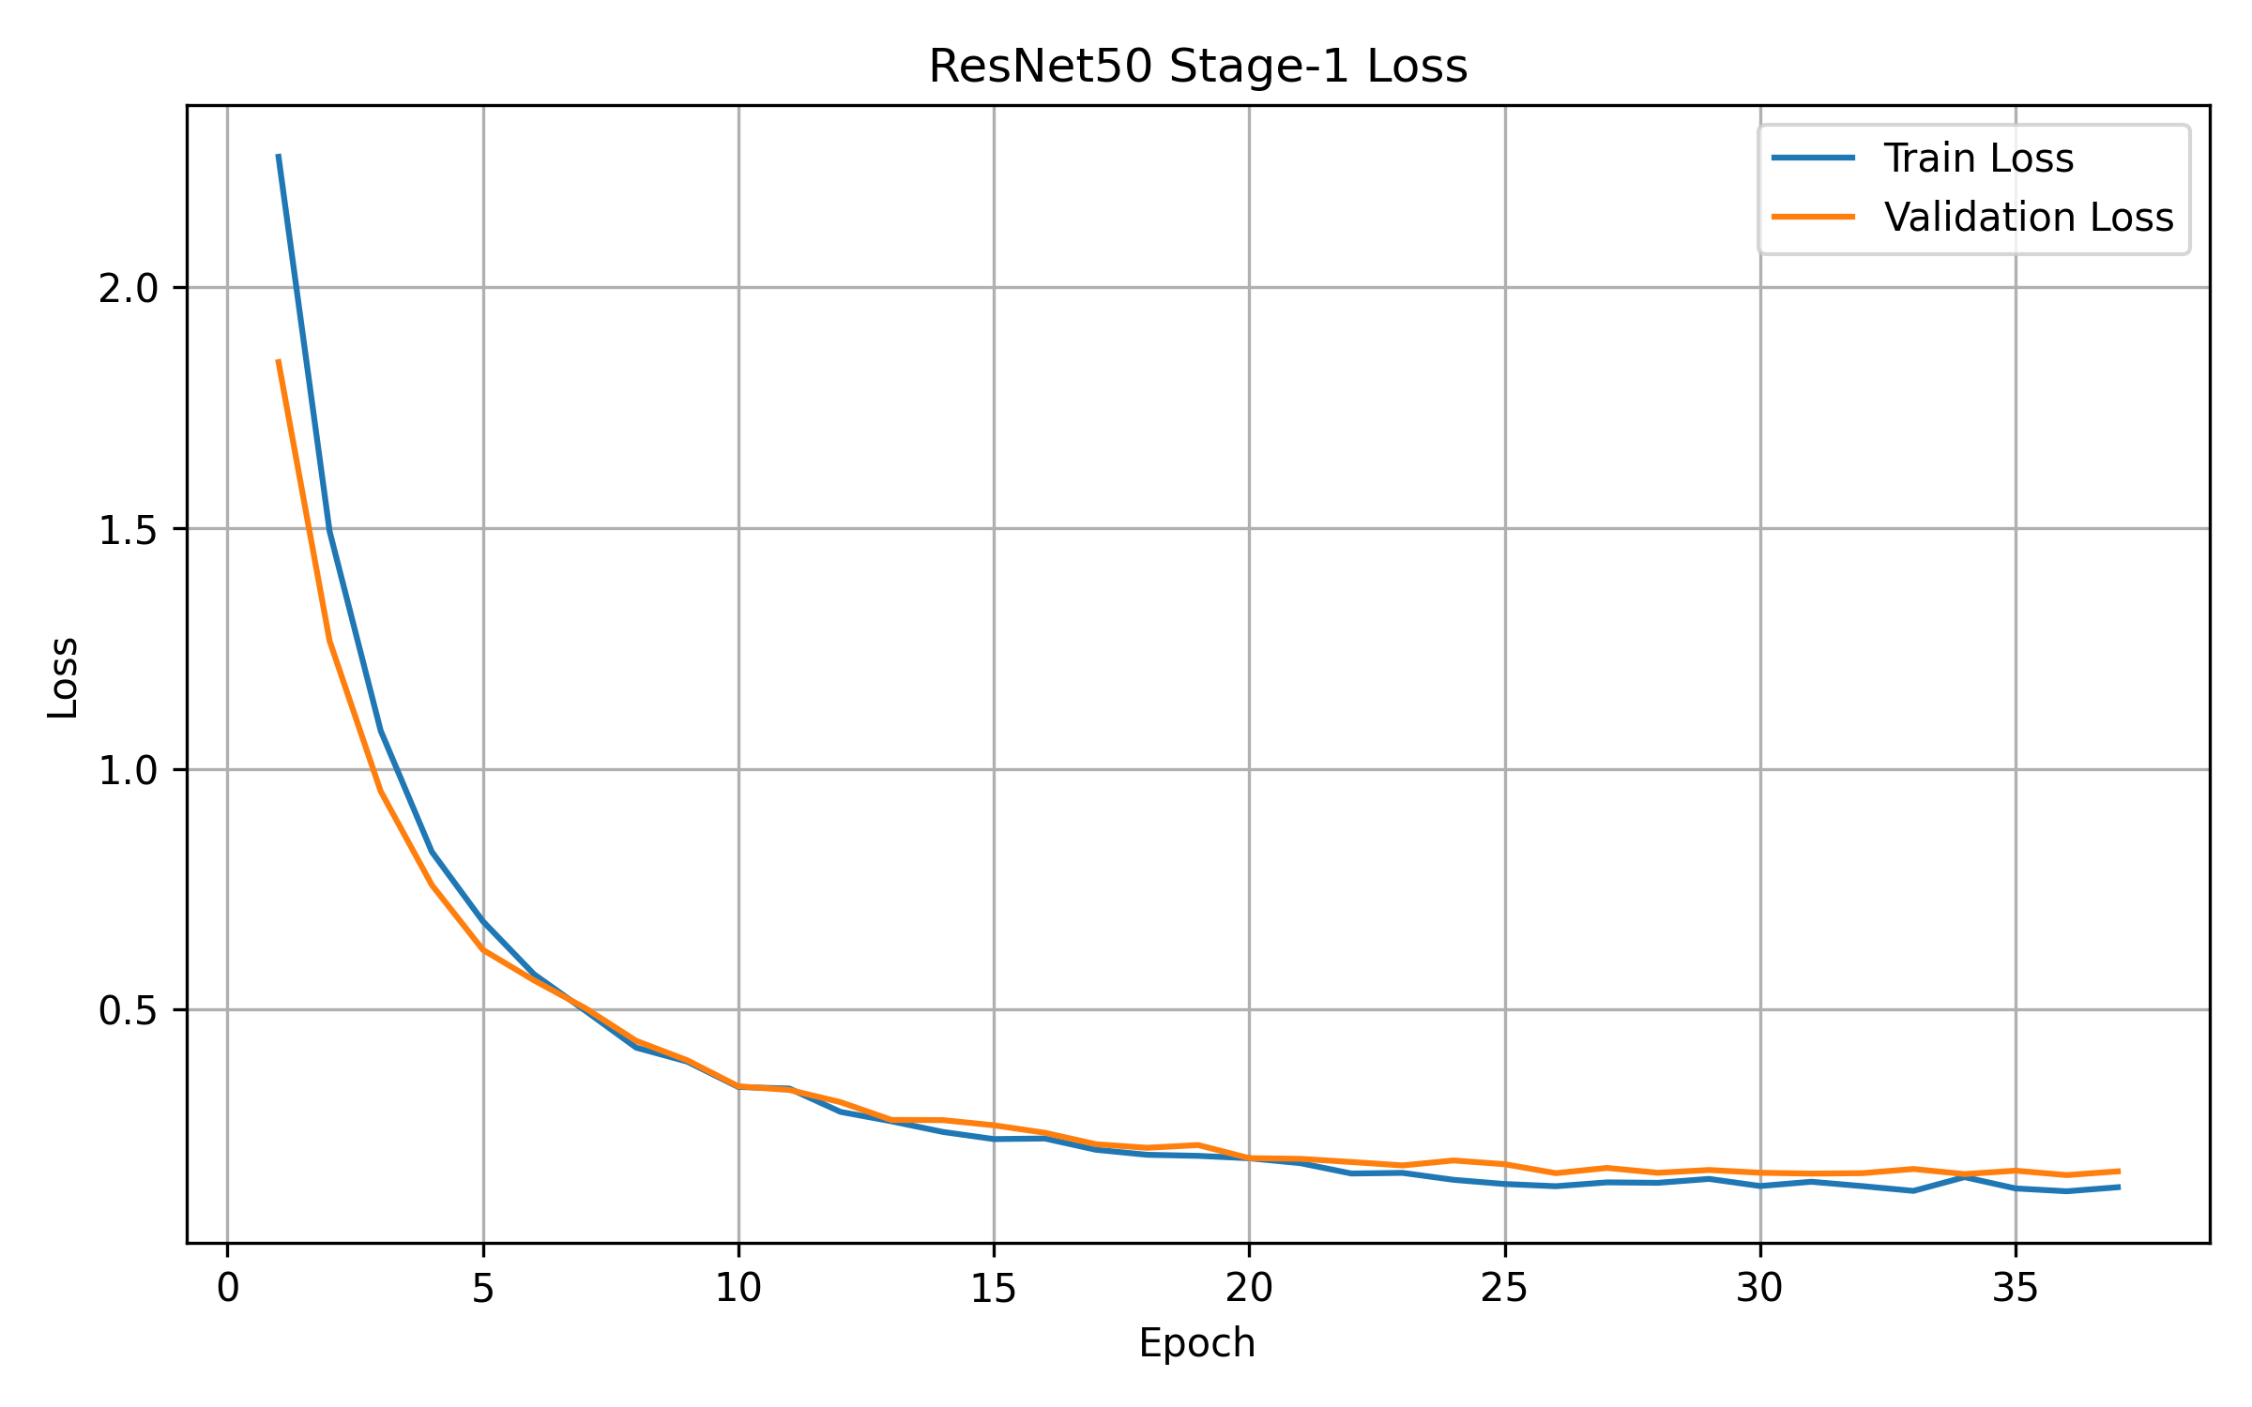
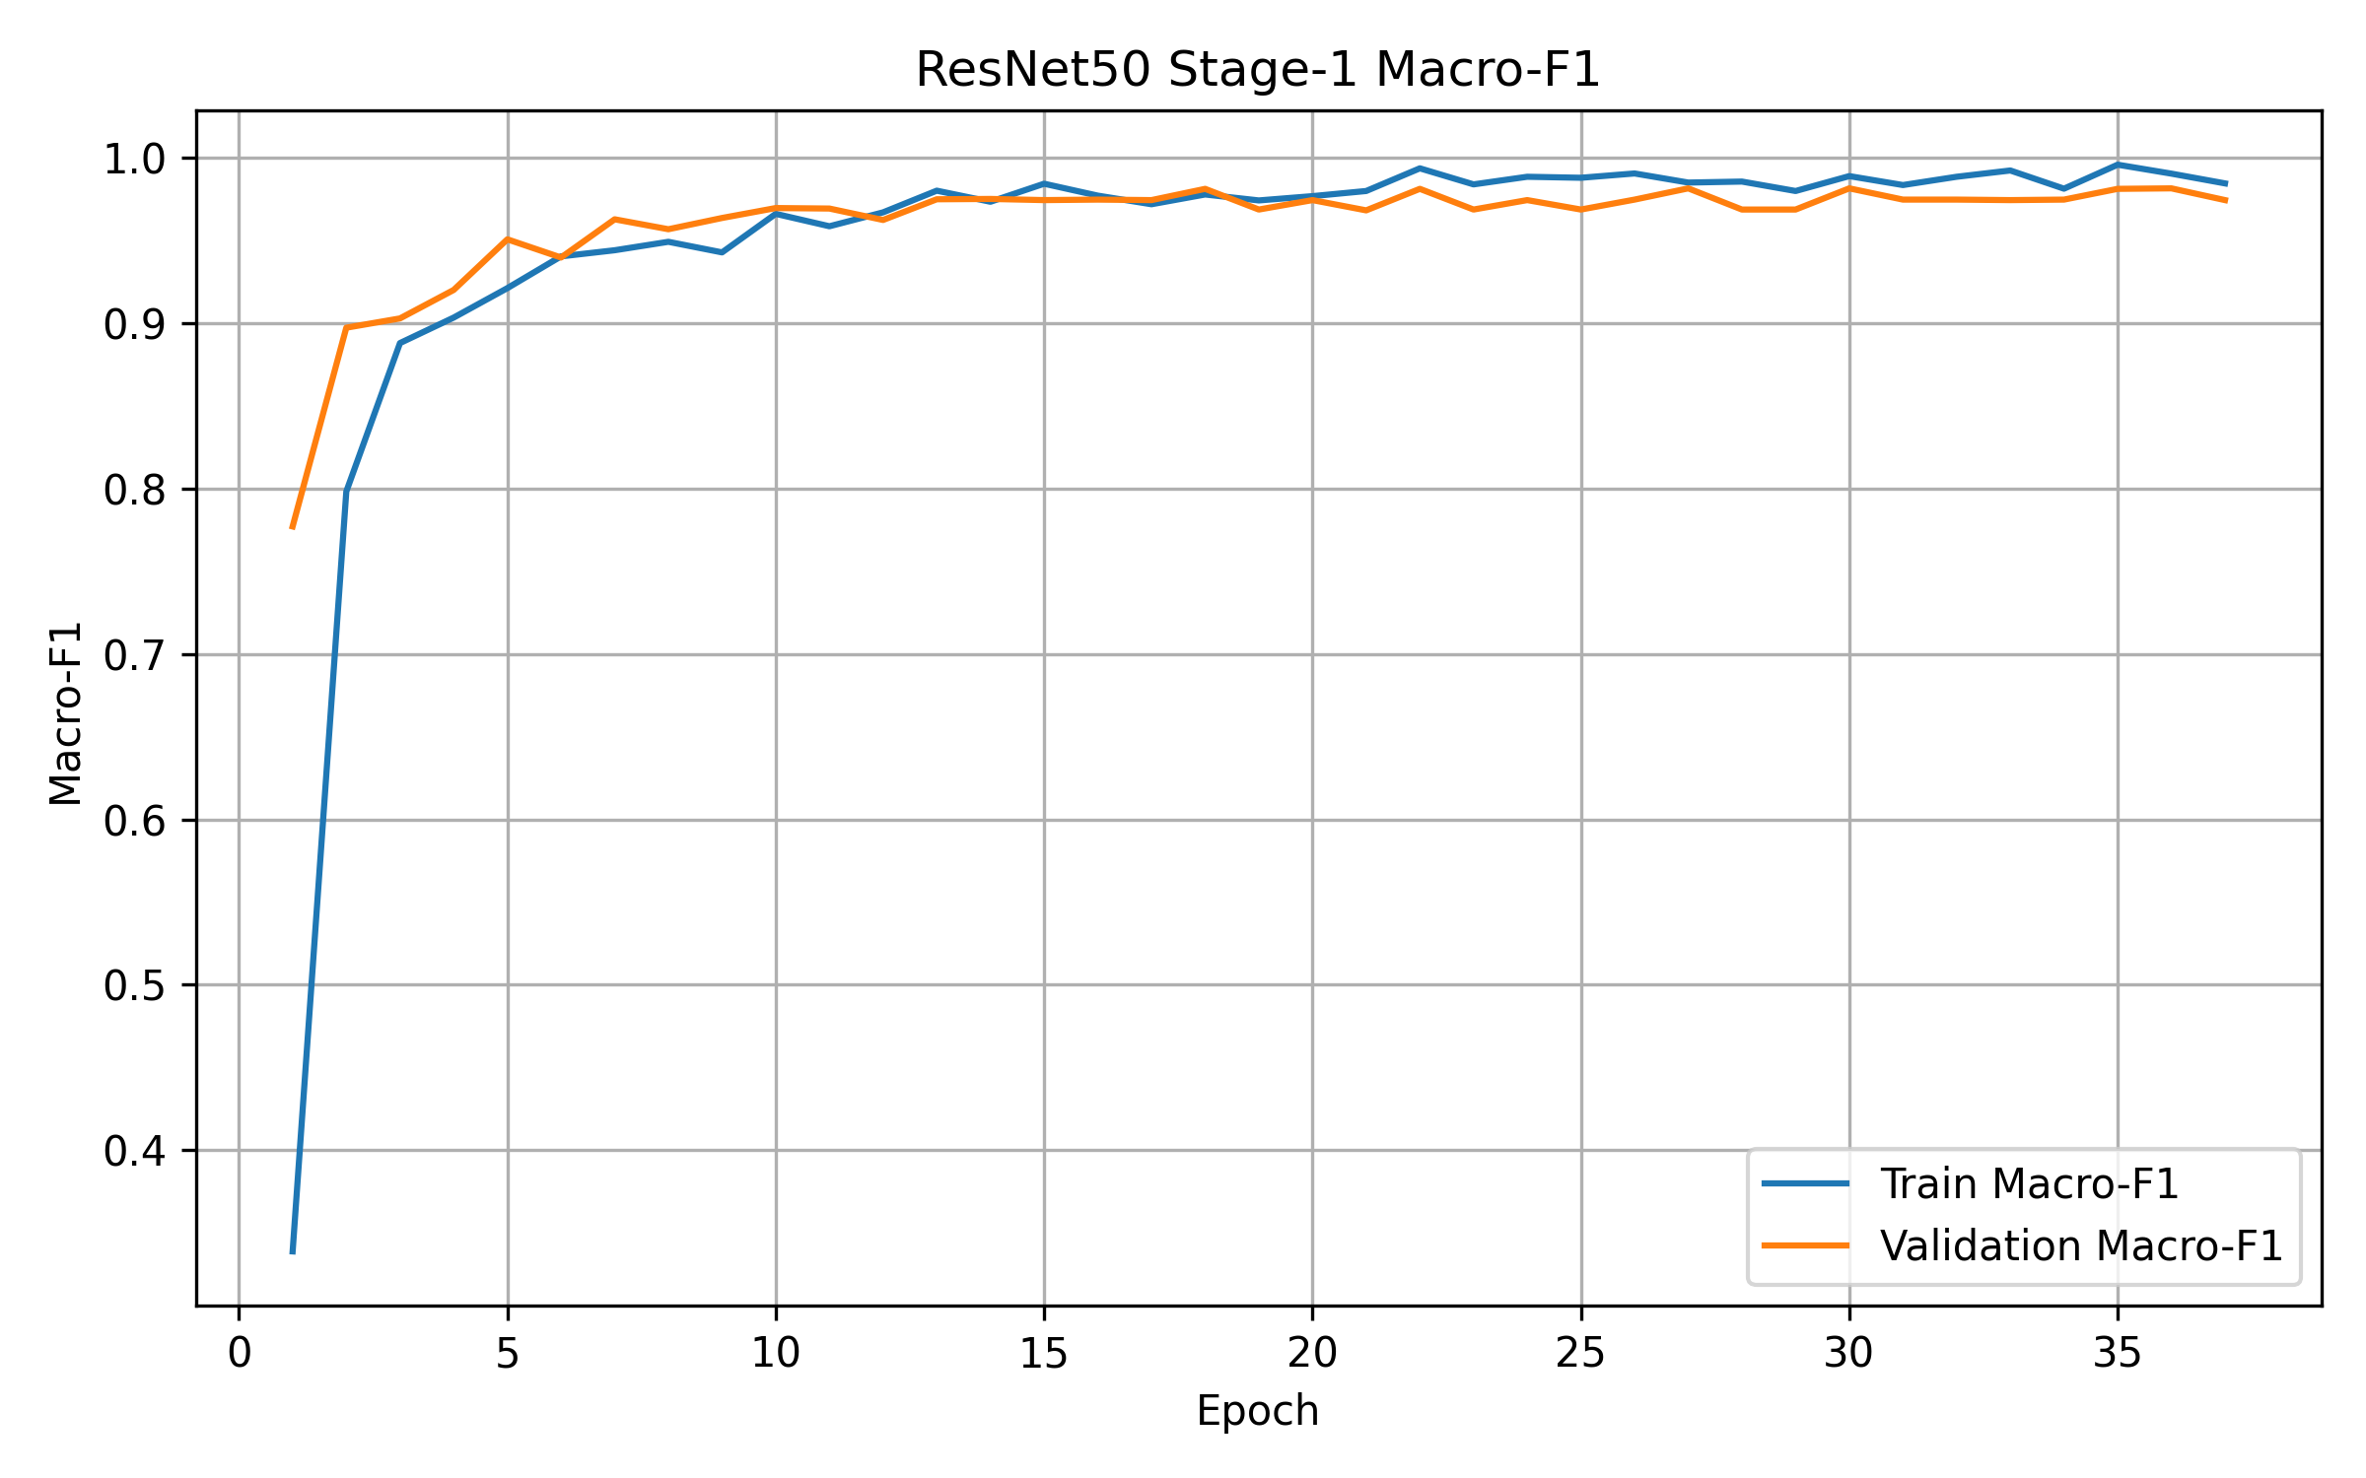

EfficientNet-B0
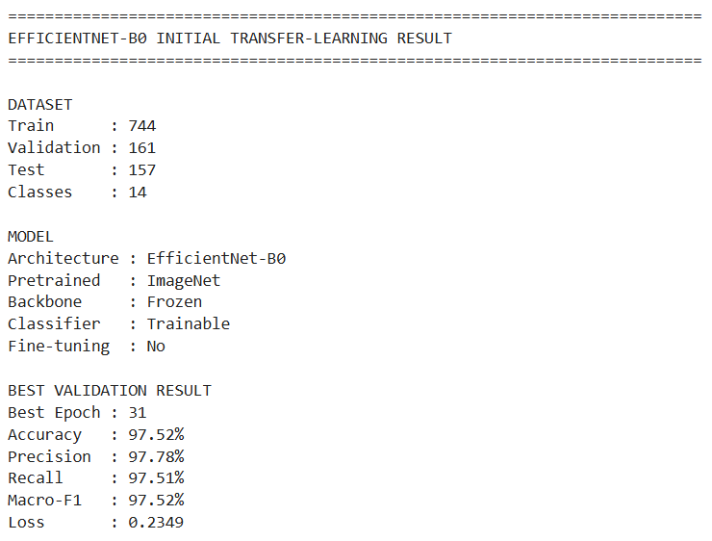
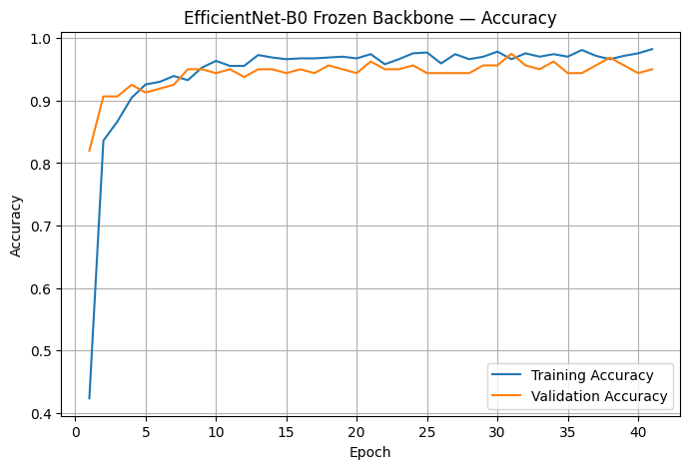
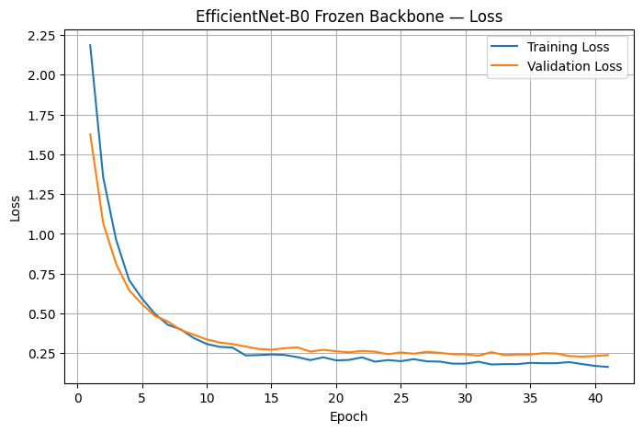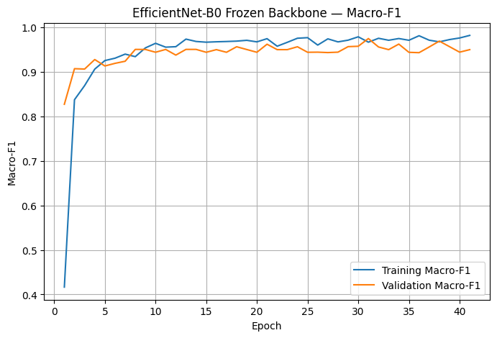
Validation Comparison
Rank | Model | Val Accuracy | Precision | Recall | Macro-F1 | Val Loss
1 | ResNet50 | 98.14% | 98.25% | 98.11% | 98.13% | 0.1712
2 | EfficientNet-B0 | 97.52% | 97.78% | 97.51% | 97.52% | 0.2349
3 | VGG16 | 97.52% | 97.61% | 97.60% | 97.50% | 0.1508
4 | Custom CNN | 96.89% | 97.14% | 96.92% | 96.89% | 0.2362

selected models --
1. ResNet50 — 98.14% Macro-F1
2. EfficientNet-B0 — 97.52% Macro-F1

EfficientNet-B0 (Fine Tuning)
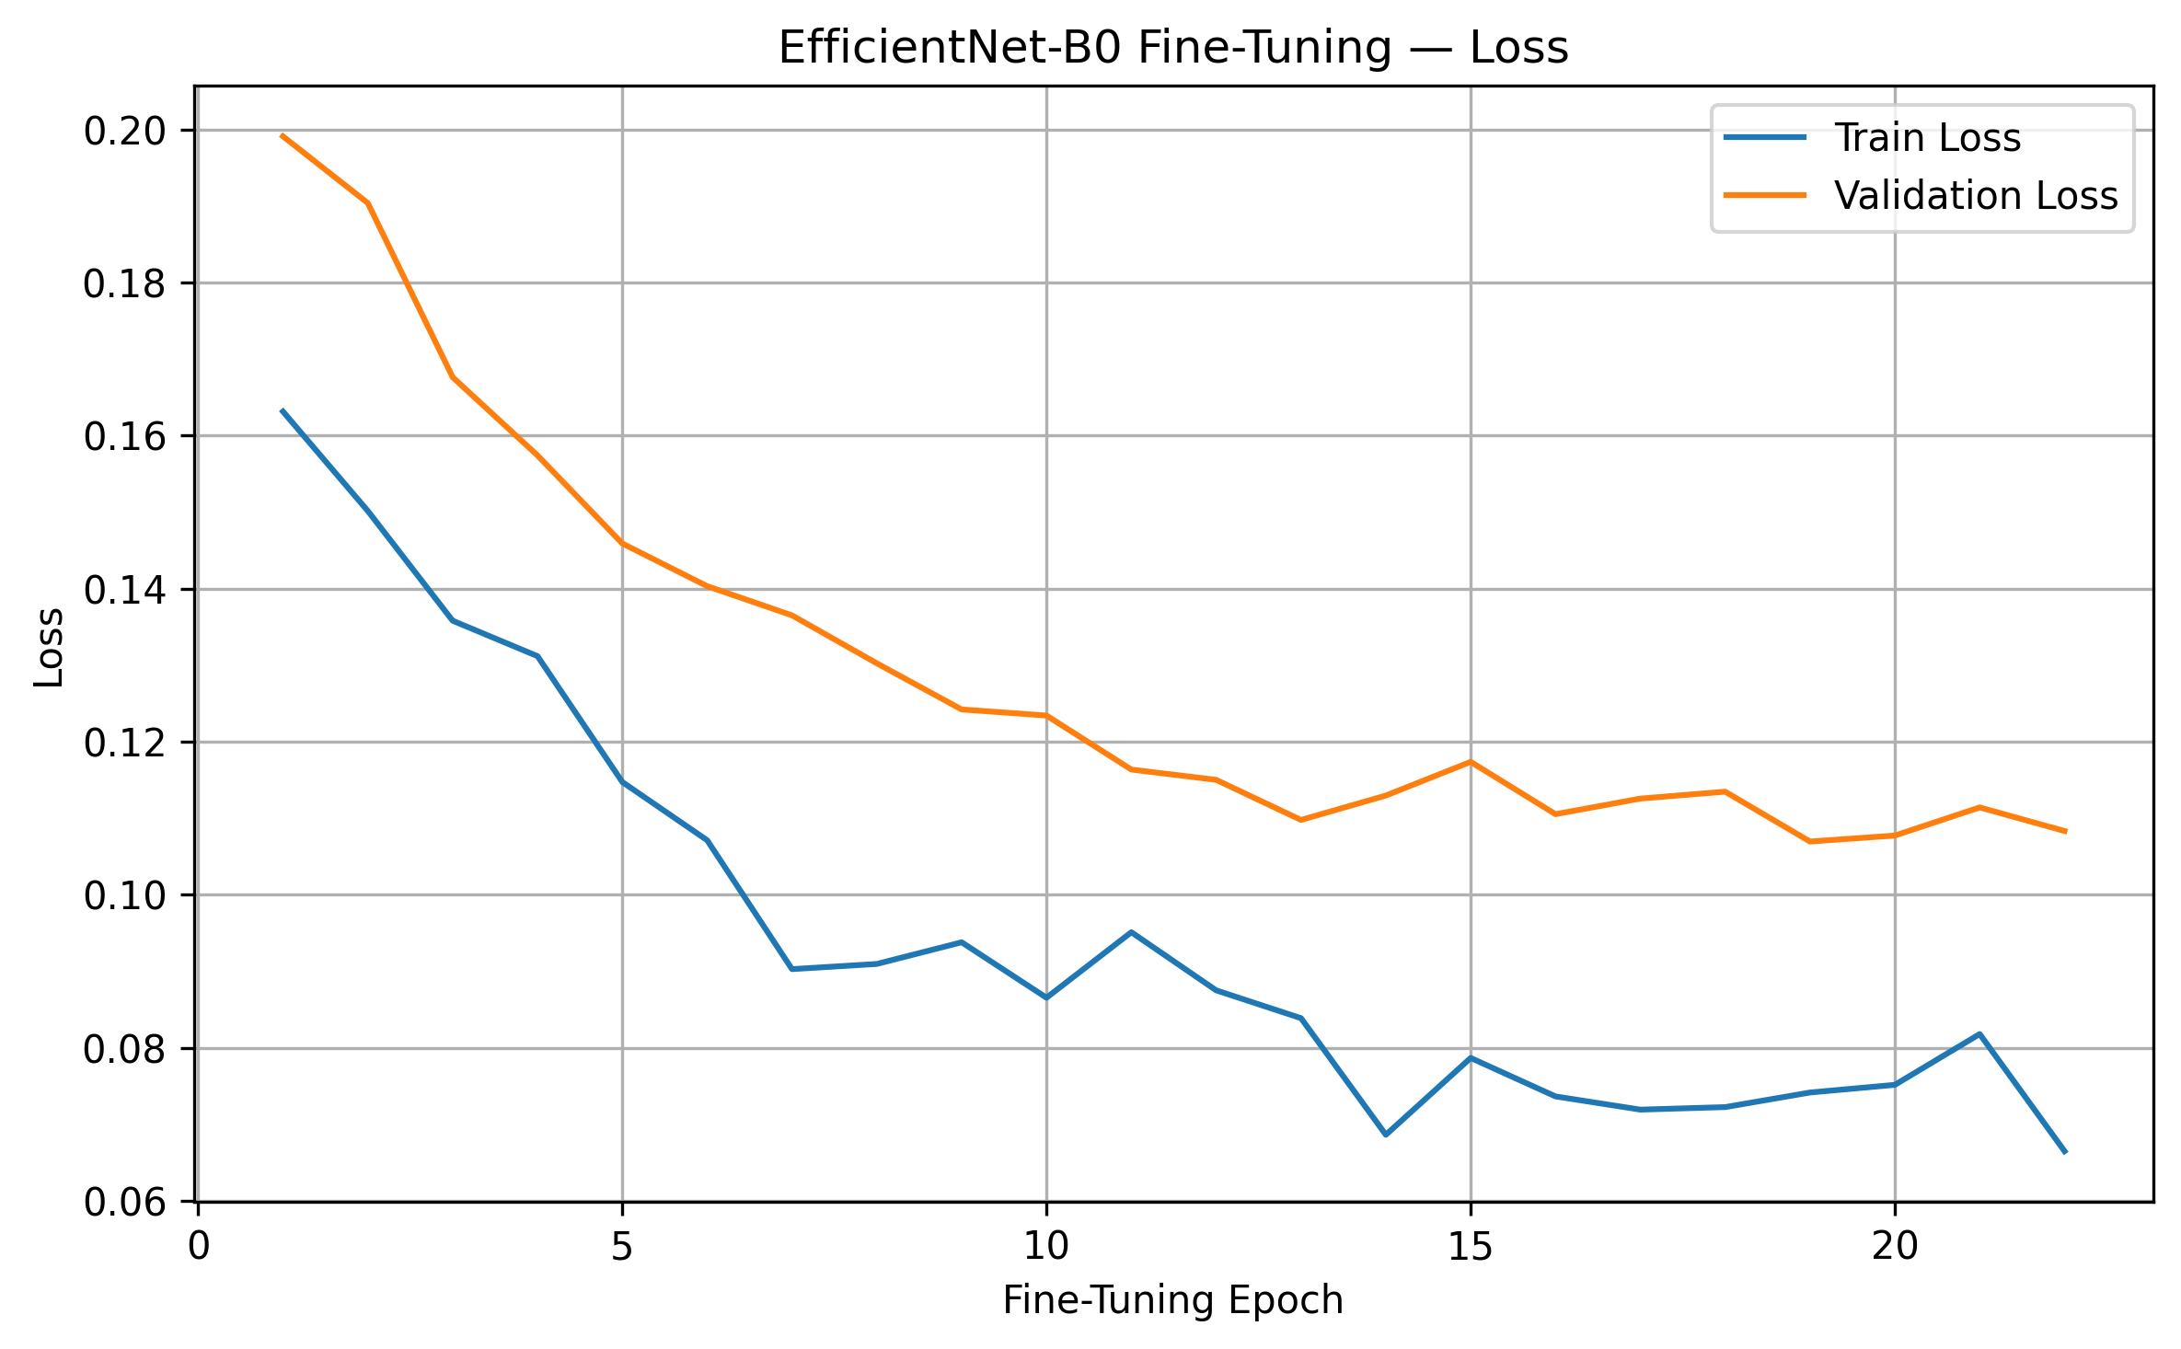
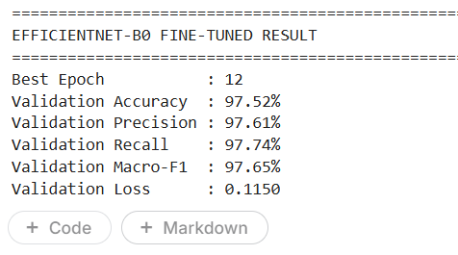
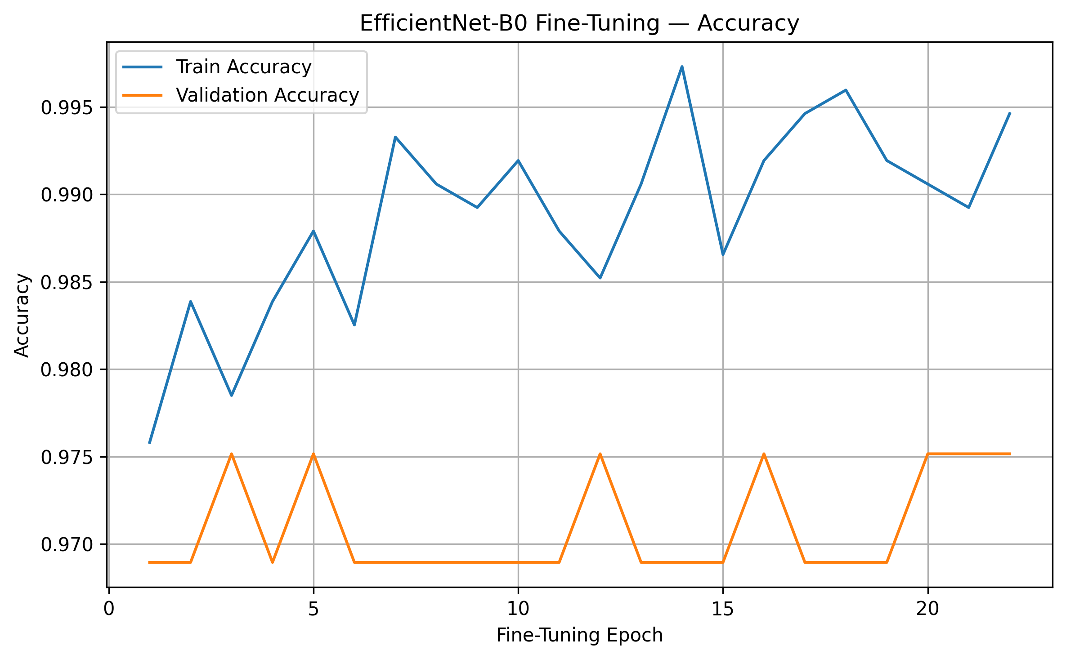

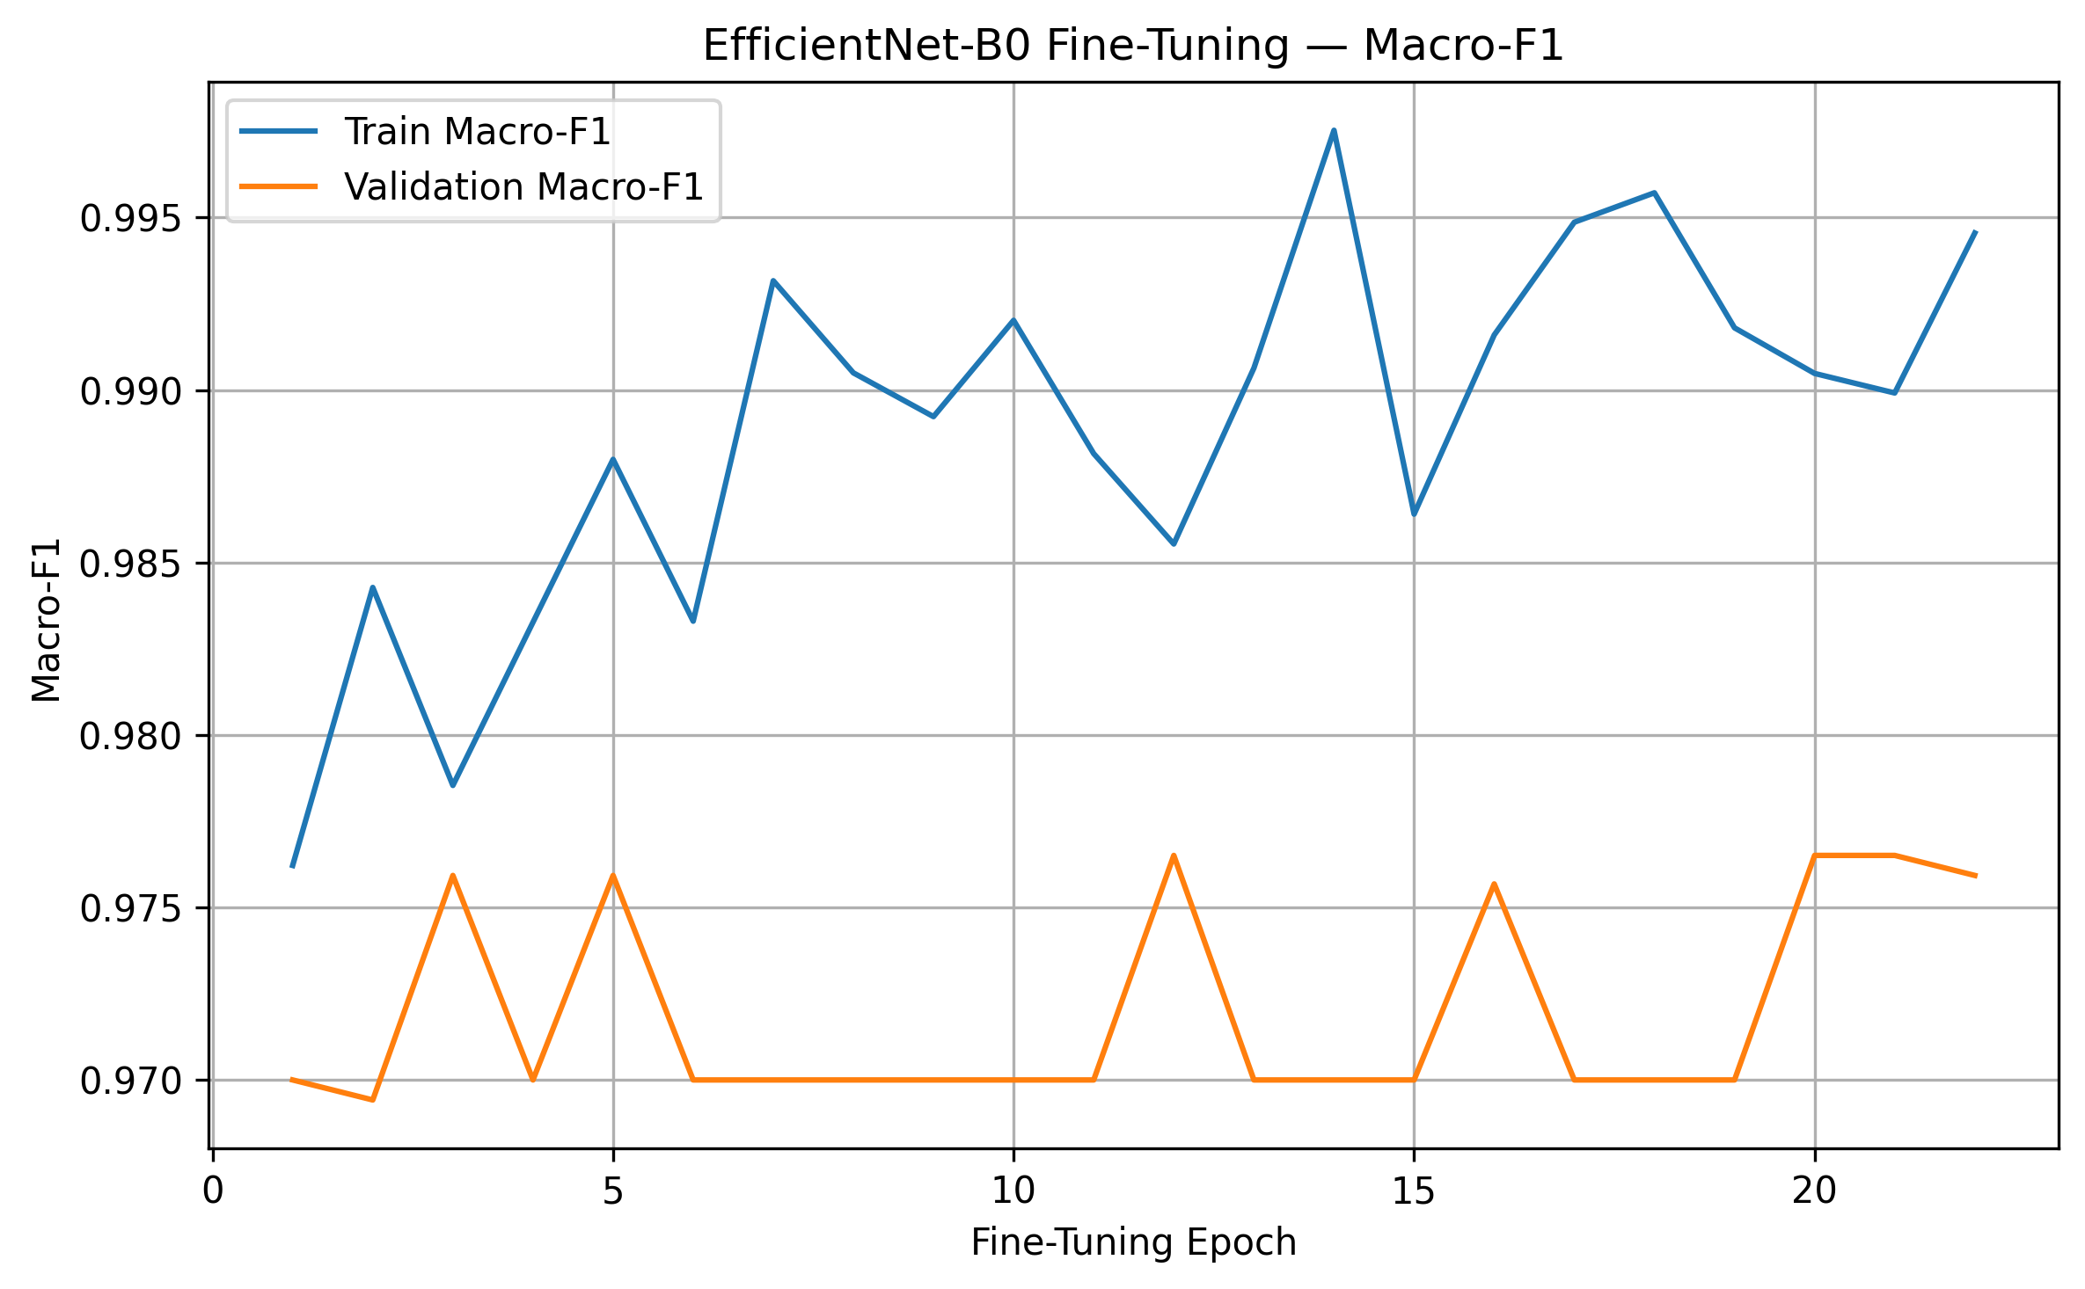

ResNet50 (Fine Tuning)
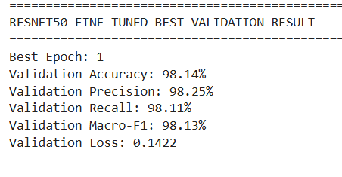
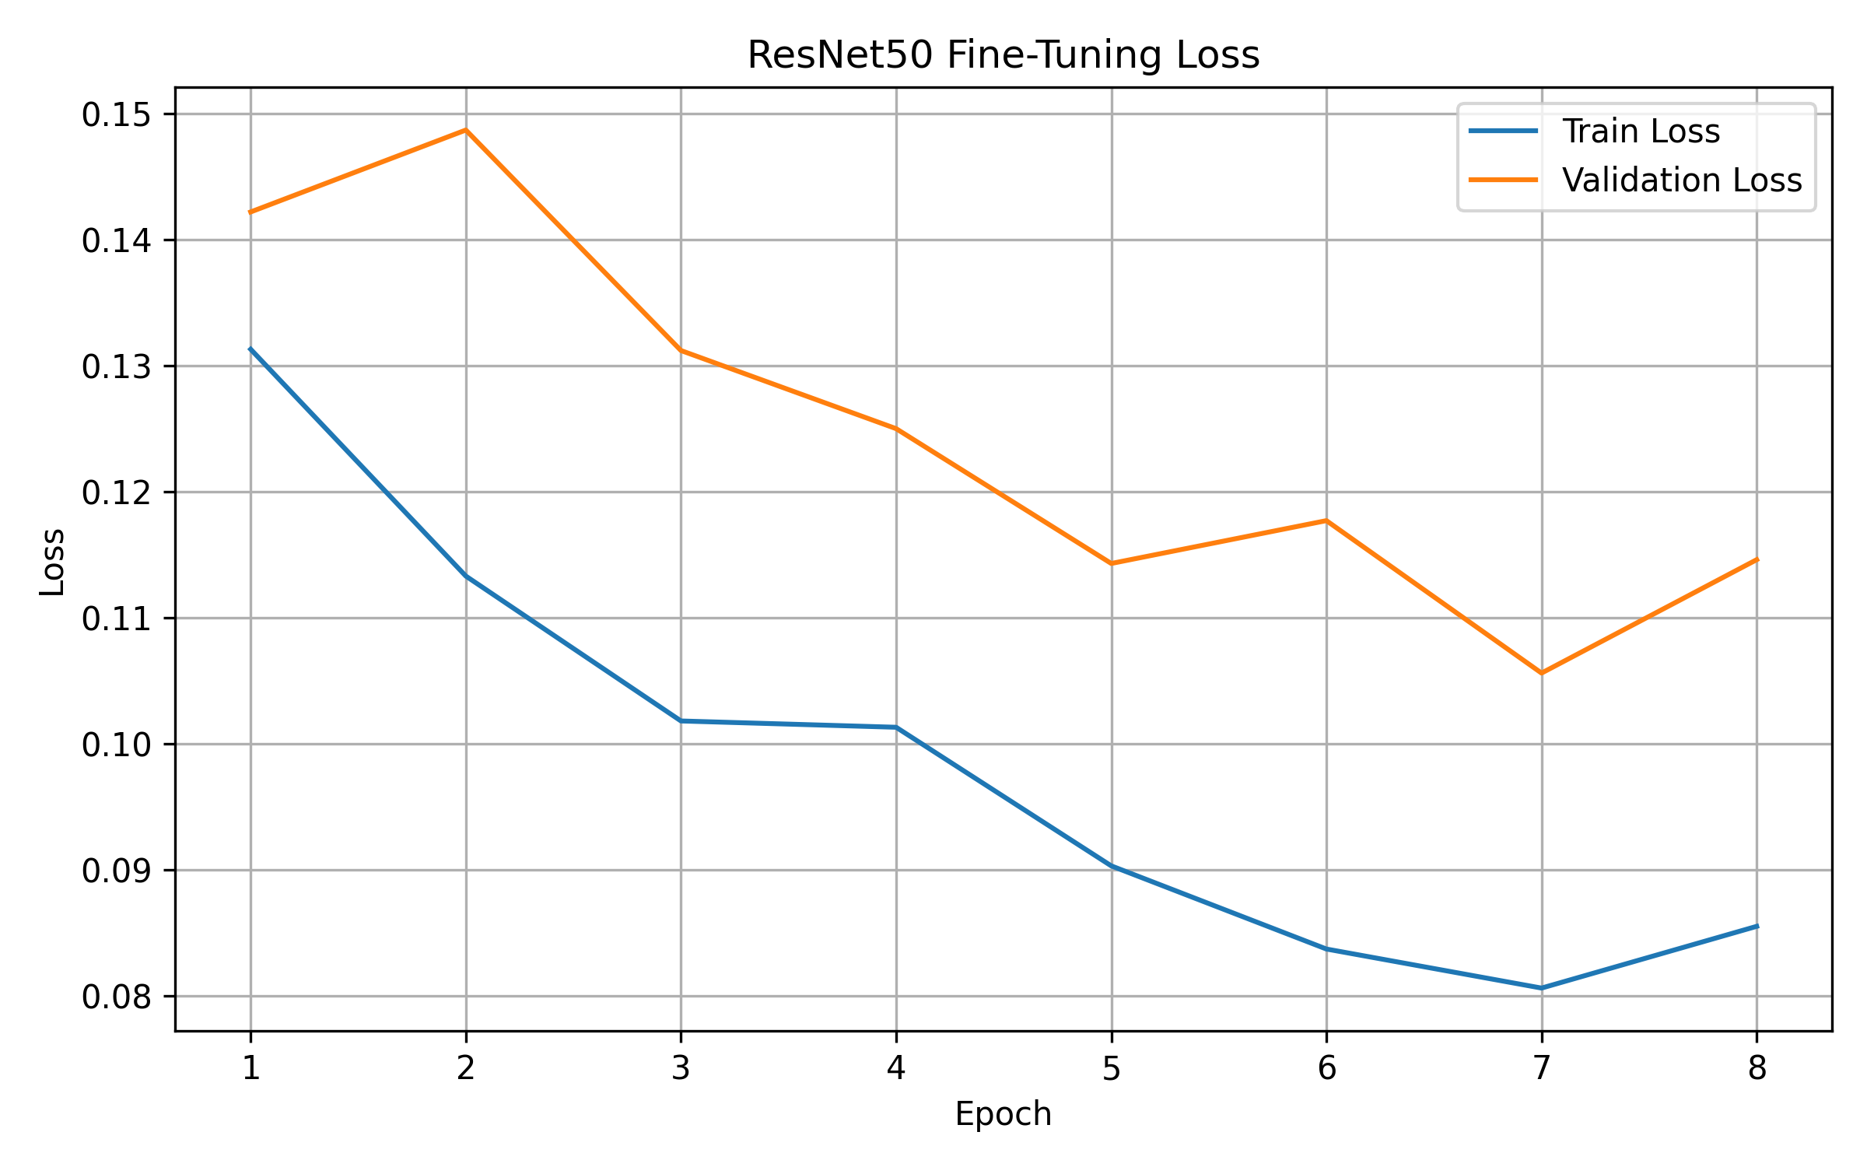
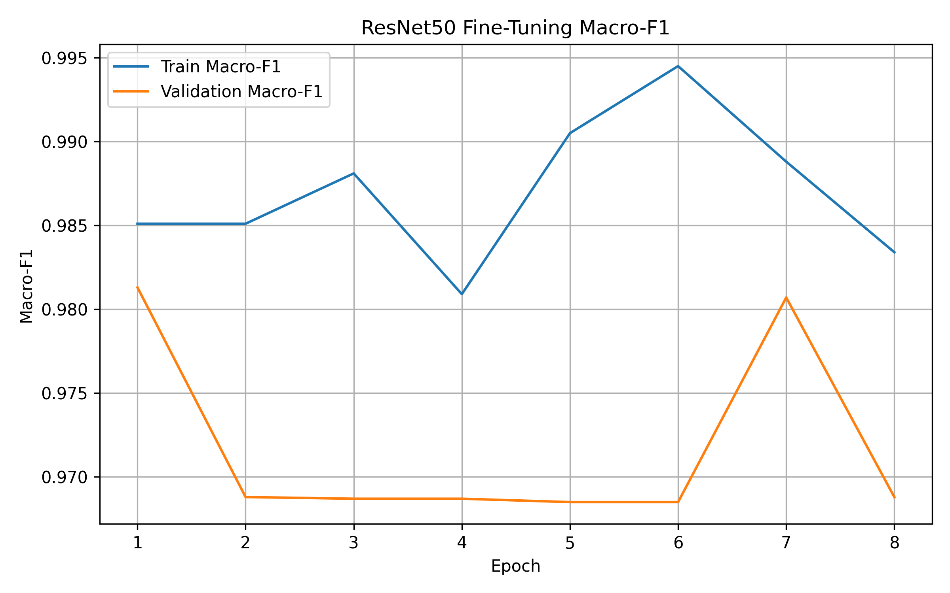

Phase D – Locked Test Evaluation
Phase C completed
↓
Top-2 models selected using Validation results
↓
ResNet50 + EfficientNet-B0
↓
Load untouched locked Test set (157 images)
↓
Load saved checkpoints
↓
Evaluate Frozen + Fine-tuned versions
↓
Calculate final Test metrics
↓
Generate class-wise results
↓
Generate confusion matrices
↓
Save image-level predictions + probabilities
↓
Compare Frozen vs Fine-tuned
↓
Identify common class-confusion errors
↓
Save all Phase-D outputs in one ZIP
Phase E: Robustness Evaluation
Phase D completed
↓
Final models fixed
ResNet50 Fine-tuned
EfficientNet-B0 Fine-tuned
↓
Locked Test set = 157 images
↓
Create synthetic corruptions
↓
6 corruption types × 3 severity levels
↓
Evaluate both models
↓
Accuracy + Macro-F1
↓
Measure performance drop from clean Test
↓
Calculate robustness summary
↓
Corruption/severity plots + tables
↓
Save Phase-E ZIP

Phase F -- Calibration & Uncertainty Evaluation
Load final ResNet50 + EfficientNet-B0
↓
Load Validation = 161 images
Load locked Test = 157 images
↓
Collect raw logits
↓
Uncalibrated confidence evaluation
↓
ECE + NLL + Brier Score
↓
Fit Temperature Scaling on Validation ONLY
↓
Apply learned T to locked Test logits
↓
Recalculate ECE + NLL + Brier
↓
Reliability diagrams
↓
Confidence/error analysis
↓
Save Phase-F artifacts ZIP

Phase G -- Selective Prediction / Risk–Coverage Analysis
Phase F calibrated probabilities
↓
Use calibrated max-softmax confidence
↓
Rank Test predictions by confidence
↓
Progressively abstain on low-confidence images
↓
Measure Coverage
↓
Measure Selective Accuracy / Risk
↓
Risk–Coverage curve
↓
AURC
↓
Threshold analysis
↓
Save tables + plots + Phase-G ZIP

Phase H — Grad-CAM Explainability Workflow
Final fine-tuned models ResNet50 + EfficientNet-B0
↓
Locked Test set
↓
Load Phase G reliability information
↓
Select representative samples
├── High-confidence correct
├── Low-confidence correct
└── High-confidence error
↓
Generate Grad-CAM
↓
For correct cases: Original image + Predicted-class Grad-CAM
↓
For incorrect cases: Original image + Predicted-class Grad-CAM + True-class Grad-CAM
↓
Explain ALL Test errors
ResNet50 = 6 errors
EfficientNet-B0 = 7 errors
↓
Analyze visual attention patterns
- plant-centered attention
- diffuse attention
- background influence
- competing regions
- visually similar species
↓
Link explanations with confidence
and uncertainty

Phase I — Final Error / Failure Analysis Workflow
Phase D
Clean Test errors
+
Phase E
Corruption robustness failures
+
Phase F
Calibration / uncertainty
+
Phase G
Selective prediction
+
Phase H
Grad-CAM explanations
↓
Build unified failure table
↓
For every important error record:
- true class
- predicted class
- model
- confidence
- entropy
- whether both models failed
- corruption sensitivity if relevant
- selective prediction status
- Grad-CAM observation
↓
Find recurring failure patterns
├── Shared errors between both models
├── Repeated class-confusion pairs
├── High-confidence errors
├── Low-confidence errors
├── visually similar classes
├── possible background/context influence
└── corruption-sensitive categories
↓
Compare ResNet50 vs EfficientNet-B0
↓
Determine practical failure types
↓
Create final failure taxonomy
↓
Generate final tables + figures
↓
Write final interpretation
↓
Phase I complete

