**Project Report on Library Management System**

The LibraryManagementSys(LMS) is a library management application for monitoring and controlling the transactions in library. This project is designed and coded in ‘netbeans 8.0.2’ and the database management system is handled by MySQL 5.6. This is a java swing application. This LMS application focuses on the basic operations in a library like searching books, checkout and check in of books, adding new borrower and fine management.

The application as the following six main modules:

* Library management System home page: LMSHome.java
* Search books in library database: LMSSearchBook.java
* Check out books facility: LMSCheckOutBooks.java
* Check in books facility: LMSCheckInBooks.java
* Add new borrowers to the database: LMSAddBorrower.java
* Control Fines: LMSFineManagement.java

The common module is:

* LMSUpdateFines.java

The functionalities of each of the modules are described below:

* **Library Management System Home page:**

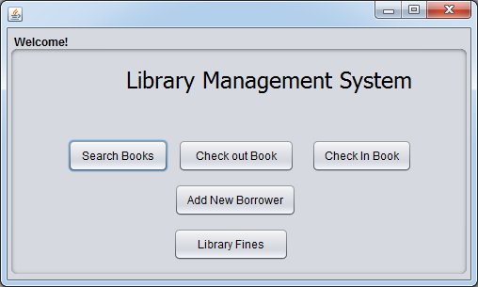

This is the main page for this application which provides all the navigation option s for different functionalities. This has five buttons which will direct the user to search book page, book checkout page, book check in page, add new borrower page and library fine management page.

* **Search Book page:**

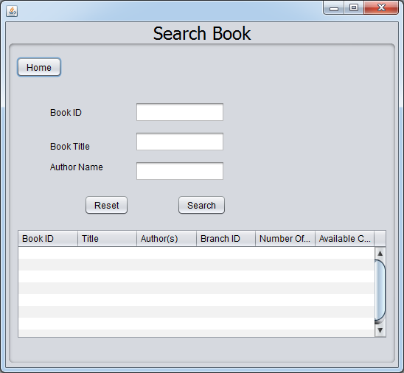

User will reach this page upon clicking the search books button on the home page. The ‘Home’ button will take the user to the main menu. Through this page the user can search any book present in the library using any combination of book id, book title and author name. If the record exists upon clicking the ‘Search’ button the books will be displayed in the table with the availability, otherwise appropriate message will be displayed.

* **Check out book page:**

User will reach this page upon clicking ‘Check out Book’ button on the home page. Books can be checked out by providing correct book id, branch id and card no and clicking the ‘Check Out’ button. If any of the required fields are absent or does not have correct value in it appropriate message will be displayed. None of the users can check out more than 3 books. If the borrower has outstanding fines, he will not be allowed to check out books and appropriate message will be displayed.

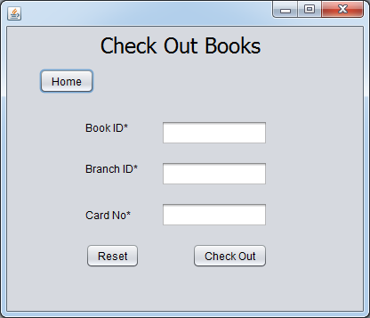

* **Check in Books page:**

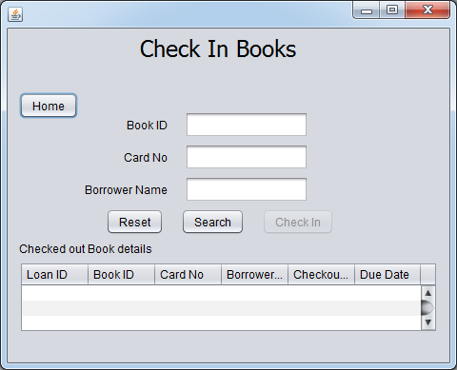

User will reach this page upon clicking ‘Check In Book’ button on the home page. User can search the borrowed books from database by providing correct values to the following three fields, book id, card number and borrower name (partial name allowed). If valid record exists in database for the entered details the records will be displayed in the table (on clicking ‘Search’ button) otherwise appropriate message will be displayed.

User can select any of the records displayed in the table to proceed with the check in. On clicking any table rows the ‘check in’ button will be activated. Books will be checked in with current date as the check in date.

* **Add new borrower:**

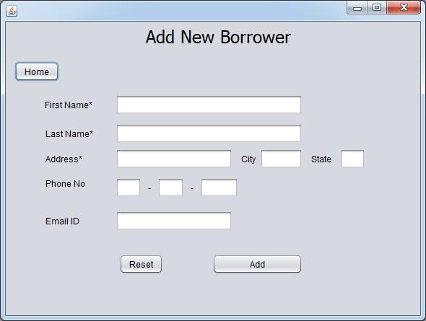

User will reach this page on clicking the ‘Add New Borrower’ button on the home page. User can do a successful add operation by inputting first name, last name and address field provided there is no existing user with the same combination of these three fields. The city, state, email-id and phone number field s are optional. Appropriate message will be displayed if user already exists.

* **Library Fines page:**

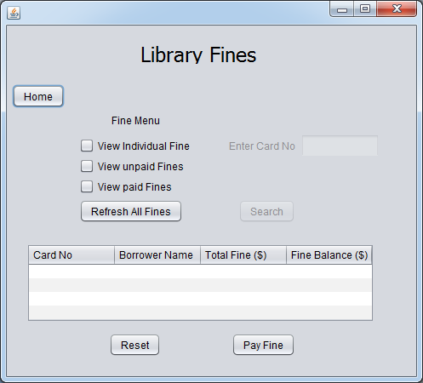

User can navigate to the page on clicking the ‘Library Fines’ page on the home page.

The ‘Refresh All Fines’ lets the user update all possible fines in the library database. There are three combo boxes which displays the library fines with different options.

On clicking ‘View Individual Fines’, user will be allowed to enter his card number and enables the ‘Search’ button. On clicking the ‘Search’ button all fine details for the user will be displayed in the table. User can select a fine row to ‘Pay Fine’. If user has not checked in a book he/she will not be able to pay fine for the book.

‘View unpaid Fines’ enables the search button and on clicking ‘Search’ it shows all the unpaid fine sin the database. User can select any of the rows and pay fine, given book is already checked in.

‘View paid Fines’ enables the search button and on clicking ‘Search’ it shows all the unpaid fine sin the database.

**Design justification of the application:**

Library Management system application has MySql database for database management. The tables used are:

BOOK

BOOK_AUTHOR

BOOK_COPIES

BOOK_LOANS

LIBRARY_BRANCH

FINES

The front end is built in JFrame. Each frame has a home button to reach the main menu and reset button that resets all the input and outfields to initial condition.

‘Check out Book’ frame has the functionality to check out books from library. On successful check out a new entry is created in BOOK_LOANS table with auto generated loan id and due date as 14 days from the current date. The available book count is decreased by 1 in BOOK_COPIES table.

In ‘Check In Books’ frame the ‘check in button is enabled once a record is selected from the borrowed book search result. FINES table will be updated when a book is checked in with check in date greater than the due date.

For the ‘Library Fines’ frame, a common java module has been created called LMSUpdateFines.java. This module is called whenever the FINES table has to be updated. When an existing book fines record is present in FINES table, it updates the FINES table otherwise inserts a new row to the table.