PRT 582 Assignment 1

**Student Name:** Syed Rafay Mukhtar

**Student ID:** S330705

# Main Github link:

<https://github.com/srafay/semester-hangman>

# CODE

Code can be accessed through the Github link:

<https://github.com/srafay/semester-hangman/blob/master/main.py>

# Test Cases

Test cases link:

<https://github.com/srafay/semester-hangman/blob/master/test.py>

# Program ScreenshotsC:\Users\The Chosen One\Desktop\program screenshots\9.jpegC:\Users\The Chosen One\Desktop\program screenshots\8.jpegC:\Users\The Chosen One\Desktop\program screenshots\7.jpegC:\Users\The Chosen One\Desktop\program screenshots\6.jpegC:\Users\The Chosen One\Desktop\program screenshots\5.jpegC:\Users\The Chosen One\Desktop\program screenshots\4.jpegC:\Users\The Chosen One\Desktop\program screenshots\3.jpegC:\Users\The Chosen One\Desktop\program screenshots\2.jpegC:\Users\The Chosen One\Desktop\program screenshots\1.jpegRunning Tests of the program

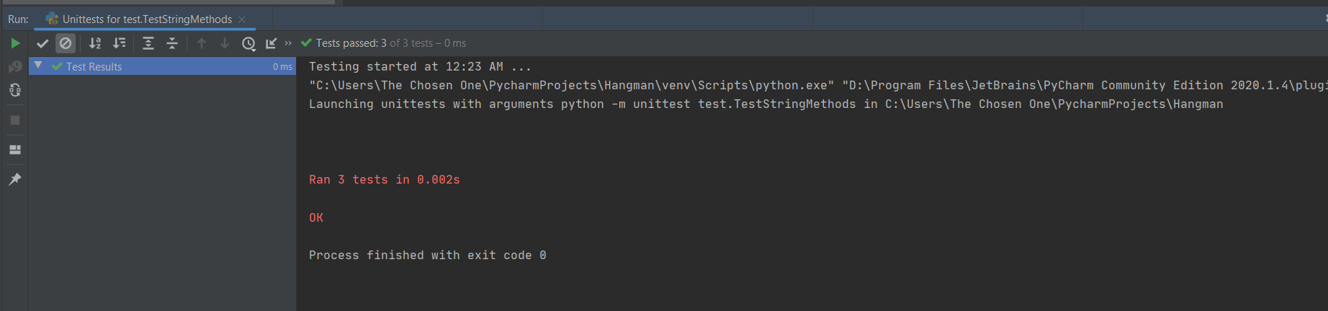

# Refactoring