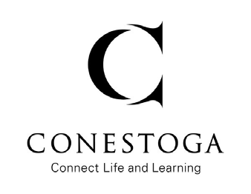**Conestoga College Institute of Technology and Advanced Learning** 299 Doon Valley Drive, Kitchener, ON N2G 4M4 Canada,

⦁ Phone: 519-748-5220 ⦁ www.conestogac.on.ca

Dear, Click or tap here to enter text.

As part of the Computer Programming Development (CAD) Graduate Certificate Program at Conestoga College students are required to complete a capstone project.

**What is a Capstone?**

This is a consulting project that all students complete; it allows students to apply their learning and knowledge through practical application. This also allows an employer to complete an software application project that is currently outstanding.

**Project Purpose**

The capstone project provides students with hands-on experience using the application of learned software through the development of website with database in the back-end or a mobile application.

**What are the employer's responsibilities?**

If interested in the capstone project, you as the employer would be responsible for the following:

* meeting with students so they can prepare a proposal that you will approve in connection with the course faculty;
* providing students with relevant company information to complete the project; and
* completing feedback sheets (provided by the students) for both the presentation and the final report.

Wrap up paragraph….introduce your team and request or confirm a meeting…

If you have any questions, please feel free to contact me at …

Sincerely,