DecisionStream Observability Evidence Pack
From black box to explainable production system. Covers tasks 1 to 16 of the AI FDE Observability Challenge.

System and Business Flow (Task 1)

Purpose
DecisionStream approves, rejects or refers loan cases to manual review. One endpoint carries the whole business flow.

Request path
Step | Component | File | Behaviour
1 | API | app/main.py | POST /case-application, validates the body with Pydantic
2 | Identity | app/services/identity.py | Always passes. Sleeps 50 ms, or 820 ms for CASE-1042 and CASE-2048
3 | Customer lookup | app/services/data_service.py | Scans data/customers.csv. Unknown customer returns 404
4 | Risk model | app/services/risk_model.py | Linear score from config/model_config.json (current). CASE-1042 gets a simulated timeout and one retry
5 | Decision rules | app/services/decision.py | score < 0.45 APPROVE, < 0.70 REVIEW, otherwise REJECT
6 | Audit | app/services/audit.py | Appends one JSON line to data/audit_log.jsonl

Scoring formula
score = base + (amount / income) × debt_weight + foreign_penalty, capped at 0.99.
The penalty applies when country != "IN".

Model configuration
Parameter | risk-2.0 (previous) | risk-2.1 (current)
base_score | 0.18 | 0.22
debt_weight | 0.35 | 0.45
foreign_country_penalty | 0.12 | 0.18

Only current is read at runtime. previous exists for reference and rollback.

Data stores
- customers.csv holds 5 customers (segment, tenure, KYC status, region).
- audit_log.jsonl is the only persisted decision evidence.

Simulated faults
The code injects faults by case ID, so they are deterministic.
- Slow identity for CASE-1042 and CASE-2048.
- Model timeout and retry for CASE-1042.

Downstream systems
None are called. Identity and the model are in-process stand-ins for an identity provider and a model endpoint.

Business outcomes
Three decisions exist. REVIEW is terminal in this service. No human-review hand-off event exists, so human intervention cannot be traced.

Observability Baseline and Gap Register (Tasks 2 and 3)
Baseline was captured by running the unmodified repo with the 10-case workload (baseline_run.log).

Baseline inventory
Signal | What existed | What was missing
Logs | JSON lines through event() | Timestamp, service name, severity, automatic trace or case context
Traces | span.start and span.end log lines | Parent IDs, stored traces, attributes, any query path
Metrics | 5 counters and 2 last-value gauges | Labels, histograms, percentiles, windows, export format
AI telemetry | One model.result log line | Per-attempt tokens, cost, retry metric, model-latency distribution
Business events | business.decision log line | Rule version, thresholds, link to the audit record
Audit | 5 fields per decision | Retry count (dropped for CASE-1042), score, tokens, inputs, rule version, span link

Measured baseline (10 cases)
- Counters: case_requests 10, model_calls 11, approve 7, review 2, reject 1.
- Gauges: last_case_latency_ms 220.7, last_case_tokens 1350. Both belong to the last request and say nothing about CASE-1042.
- Trace IDs seen for CASE-1042 in the logs: two (7c12f737… and 96faef1e…).

Gap register
ID | Gap | Evidence | Risk | Severity
G1 | Identity span not on the request trace | identity.py called span() without trace_id; CASE-1042 produced two trace IDs | The slowest hop is invisible from the request trace | High
G2 | No latency distribution | Only last_case_latency_ms | P95 and SLO burn cannot be computed | High
G3 | PII and financials in logs | model.result logged customer_income and requested_amount; case.received logged customer_id | Privacy and regulatory exposure | High
G4 | Retry evidence missing from audit | audit.py skips model_retry_count when case_id == "CASE-1042" | Cannot prove what the model did for the disputed case | High
G5 | Audit lacks decision provenance | 5 fields only | Decision cannot be reconstructed or defended | High
G6 | Tokens and cost not aggregated | Gauge holds the last request only | Inference spend cannot be explained or capped | Medium
G7 | model.retry log has no trace or span ID | Event emitted without correlation | Retry cannot be tied to a request | Medium
G8 | Counters have no labels | No model version, decision or status dimension | Model-update impact cannot be sliced | Medium
G9 | No model-change signal | No event or hash for the active config | A "recent update" cannot be dated or proven | Medium
G10 | Error paths barely measured | 400 and 404 raise before any latency record | Error rate and error budget cannot be computed | Medium
G11 | No alerts, runbook or dashboard | Empty folders | Nobody is told when the service degrades | Medium
G12 | Model-quality drift not observable | No score distribution | A threshold-crossing model update goes unseen | Medium

Production risks if left as is
- A customer dispute like CASE-1042 cannot be answered from telemetry.
- A model update can shift decisions with no alarm.
- Inference cost cannot be attributed.
- Personal and financial data sits in plain-text logs.

KPIs, SLIs, SLOs and Error Budgets (Task 4)

Business KPIs
KPI | Definition | Why it matters
Decision mix | Share of APPROVE, REVIEW, REJECT by model version | A shift after a model change is the earliest sign of drift
Manual-review load | REVIEW count per day | Drives operations headcount
Cost per decision | Model tokens × price / decisions | Controls inference spend
Time to decision | Request latency | Customer experience

SLIs and SLOs
Window is a rolling 28 days unless stated. The service evaluates cumulative values since process start through GET /slo.
SLI | Measurement | SLO | Source metric
Availability | 1 − (5xx responses / all responses) | 99.5% | http_requests_total{status}
Latency | P95 of /case-application duration | ≤ 500 ms | http_request_duration_ms
Model retry rate | Cases with a retry / cases decided | ≤ 2% | cases_with_retry_total, decisions_total
Audit completeness | Audit records / decisions | 100% | audit_records_total
Model latency | P95 of risk_model.invoke | ≤ 400 ms | model_invoke_duration_ms
Identity latency | P95 of identity dependency | ≤ 150 ms | dependency_duration_ms

Why these targets
- A normal case takes about 225 ms, so 500 ms leaves room for load and still catches the 1.3 s incident pattern.
- A 2% retry budget tolerates rare timeouts and flags a degrading model endpoint early.
- Audit completeness has no budget because a missing record is a compliance failure.

Error budget
Availability 99.5% over 28 days allows 0.5% failed requests.
- At 100,000 requests per 28 days the budget is 500 failed requests.
- Burn rate 1 spends the budget exactly over the window.
- A burn rate of 14.4 for 1 hour (2% of the budget) pages. A burn rate of 6 for 6 hours opens a ticket.
- /slo reports error_budget_remaining as 1 − (5xx / allowed).

Latency budget decomposition (normal case)
Hop | Budget
Identity | 50 ms observed, 150 ms ceiling
Customer lookup | under 5 ms
Model | 160 ms observed, 400 ms ceiling
Rules and audit | under 5 ms

Limits of the implementation
- Percentiles come from fixed buckets, so they report the upper bucket bound (500 ms objective aligns with a bucket edge).
- Windows are cumulative since start. A production exporter needs rolling windows.

Telemetry and Correlation Model (Tasks 5 to 8)

Identifiers
ID | Format | Created | Carried by
trace_id | 32 hex, W3C compatible | Request start, or taken from an incoming traceparent | Context variable, every log line, every span, audit record, X-Trace-Id response header
span_id | 16 hex | Each span | Context variable, logs, audit record
parent_span_id | 16 hex | Inherited | Span record and log lines
case_id | Business key | Request body | Context variable, logs, spans, audit
customer_ref | 12 hex SHA-256 prefix of customer_id | At log time | Logs only
input_hash | SHA-256 of the full request | At audit time | Audit record

How correlation works
- app/observability/context.py holds trace_id, span_id and case_id in context variables.
- span() reads the context, so no function needs to pass trace_id by hand. This closes G1.
- event() stamps every log line with timestamp, service, version and the context IDs. This closes G7.
- GET /traces/{trace_id} and GET /cases/{case_id}/traces return the stored spans.

Tracing (Task 6)
Span tree for one request.
POST /case-application
├─ identity.verify dependency=identity-provider
├─ customer.lookup store=customers.csv
├─ risk_model.invoke model_version, tokens, retry_count, cost_usd
│ ├─ risk_model.attempt.1 tokens, outcome, retry_reason
│ └─ risk_model.attempt.2
├─ decision.rules rules_version, decision, risk_score
└─ audit.write
Test test_single_trace_covers_whole_request asserts one root and no orphans.

Logging and PII (Task 7)
Field | Treatment
income, amount, customer_income, requested_amount | Dropped from logs
customer_id | Replaced by customer_ref
country, requested_product | Kept (low sensitivity, needed for diagnosis)

redact() runs inside event(), so new log calls inherit the protection. Raw income and amount stay out of the audit log too. The audit log stores input_hash instead.

AI telemetry (Task 8)
Metric | Labels | Purpose
model_calls | model_version | Attempts, including retries
model_tokens_total | model_version | Consumption
model_wasted_tokens_total | model_version | Tokens spent on attempts that were discarded
model_cost_usd_total | model_version | Spend (assumed $0.01 per 1k tokens, edit config/model_config.json)
model_retries_total | model_version, reason | Retry behaviour
model_attempt_duration_ms, model_invoke_duration_ms | model_version | Latency distribution
risk_score histogram | model_version | Drift in score distribution
decisions_total | decision, model_version | Decision mix by model version

A service.start event records the model version, previous version and config hash, which closes G9.

Fault injection
app/faults.py gates the seeded faults. DECISIONSTREAM_FAULTS=off disables them. When a fault fires it logs fault.injected, increments faults_injected_total{fault} and sets fault_injected on the span.

Metrics format
GET /metrics serves Prometheus text format. GET /metrics-snapshot keeps its original counters and gauges keys and adds histograms with P50, P95 and P99.

Production Health View (Task 9)
production_health.html is generated by python scripts/build_dashboard.py from docs/artifacts/evidence/evidence.json. In production the same panels read from /metrics and /slo.

Layout
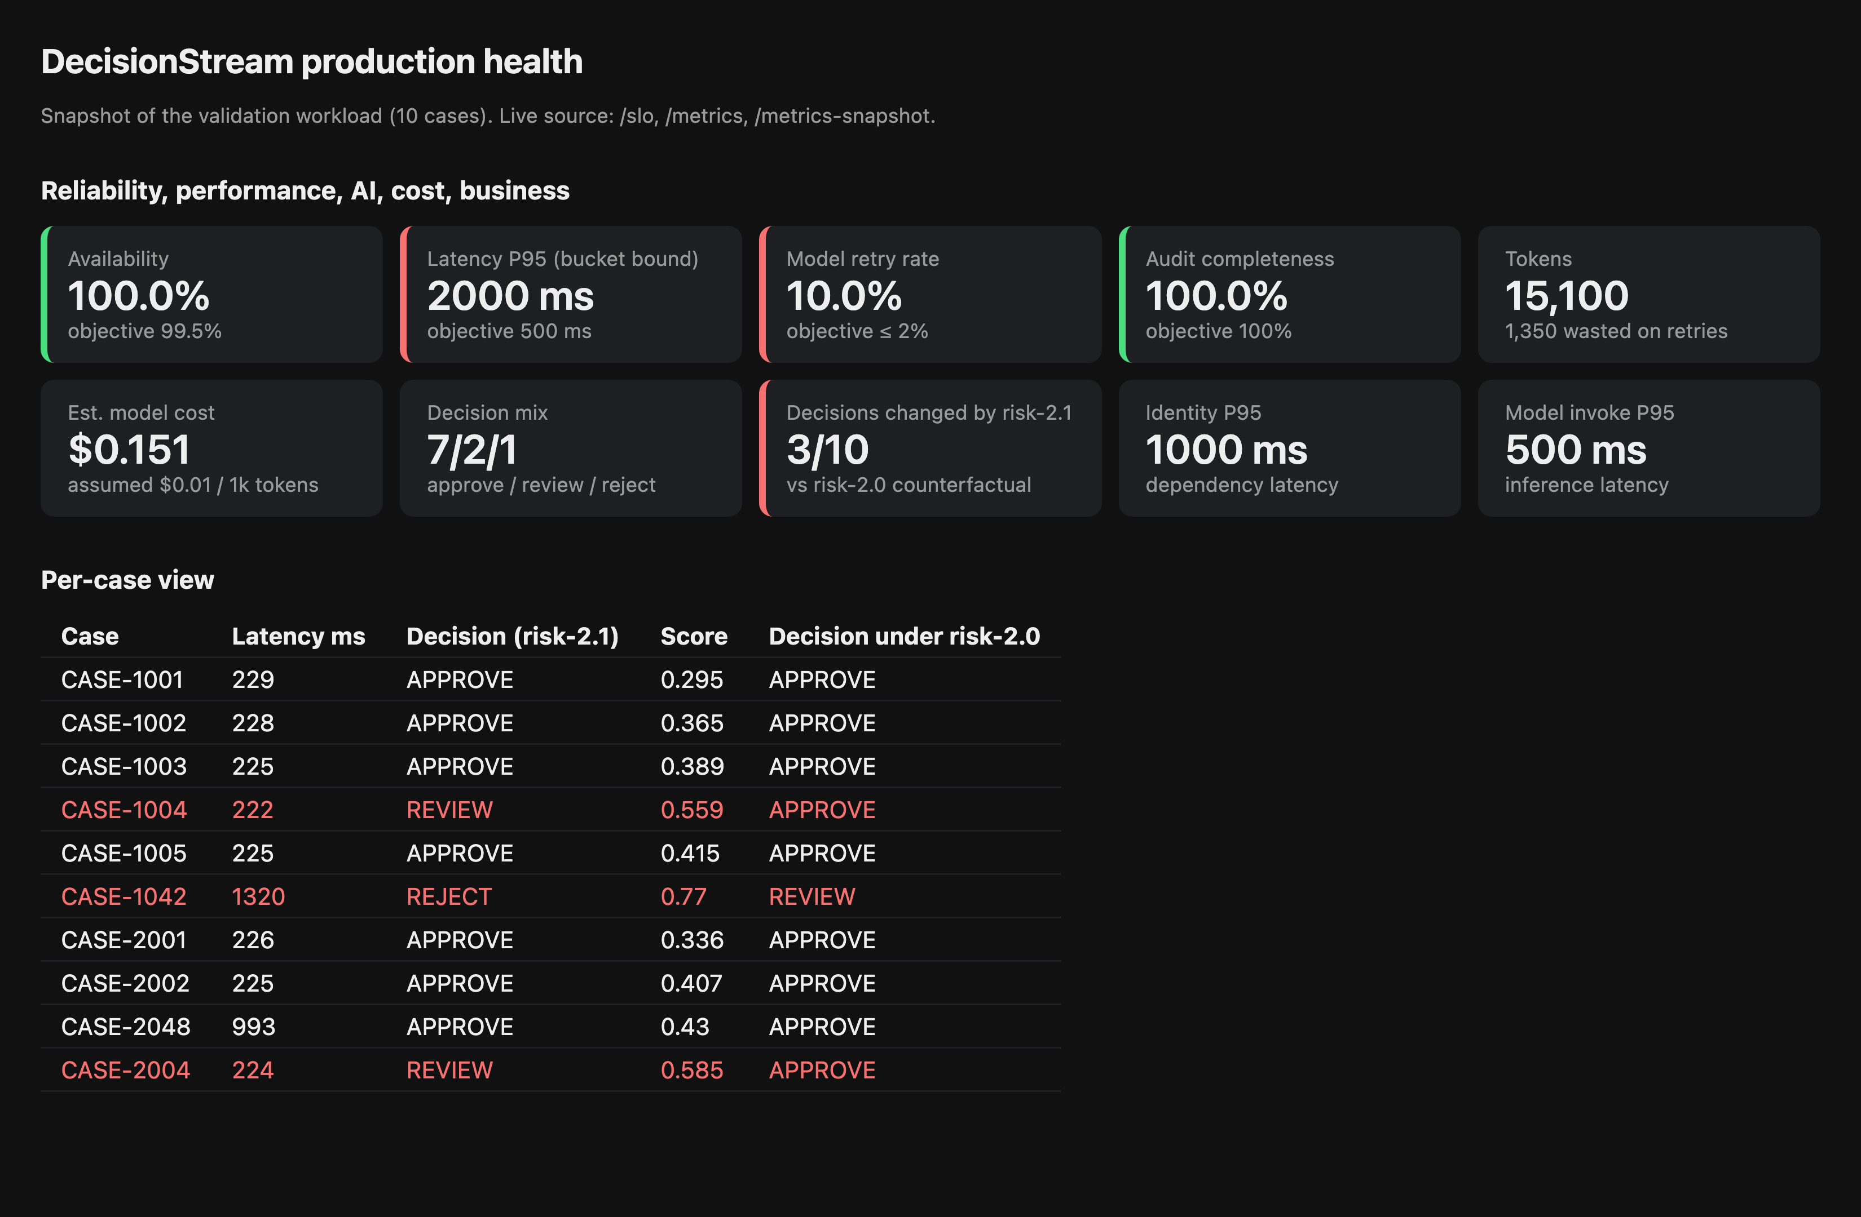
Row | Panel | Source | Healthy
Reliability | Availability, error budget | http_requests_total{status} | ≥ 99.5%
Performance | Request P50, P95, P99 | http_request_duration_ms | P95 ≤ 500 ms
Performance | Identity and model P95 | dependency_duration_ms, model_invoke_duration_ms | ≤ 150 ms, ≤ 400 ms
AI quality | Retry rate, score distribution | model_retries_total, risk_score | retry ≤ 2%, stable distribution
AI quality | Decision mix by model version | decisions_total | Within ±10 points of the prior version
Cost | Tokens, wasted tokens, USD | model_tokens_total, model_wasted_tokens_total, model_cost_usd_total | Wasted tokens ≤ 5%
Business | Approve, review, reject counts | decisions_total | Review share under 15%
Compliance | Audit completeness, audit write failures | audit_records_total, audit_write_failures_total | 100%, 0
Security and privacy | PII lint result | CI test test_logs_are_correlated_and_redacted | Passing
Drill-down | Trace lookup by case | GET /cases/{id}/traces, GET /traces/{id}

Incident 01 Investigation, CASE-1042 (Tasks 10 and 11)

Summary
CASE-1042 had two separate problems with two separate causes.
- It was slow because of a slow identity check and a model retry.
- It was rejected because the risk-2.1 model update raised its score above the reject threshold. The retry did not change the score.

Claims from the customer and operations
Claim | Verdict
Took much longer than usual | Confirmed. 1,318 ms against about 225 ms for a normal case (5.9×)
Rejected after a recent model update | Confirmed. Score 0.77 under risk-2.1 against 0.608 under risk-2.0, which is REVIEW
Higher inference consumption | Confirmed. 2,950 tokens against 1,350 (2.2×)
Cannot reconstruct from telemetry | Confirmed. See gaps G1, G4, G7

Observed evidence
Source is the unmodified service log (docs/artifacts/evidence/baseline_run.log) unless stated.
- E1. Identity span finished in 825 ms under a different trace ID (96faef1e…) from the request (7c12f737…).
- E2. risk_model.attempt.1 ran 165 ms and emitted model.retry with reason timeout.
- E3. risk_model.attempt.2 ran 321 ms.
- E4. model.result reported 2,950 tokens and score 0.77 under risk-2.1.
- E5. business.decision reported REJECT. The root span lasted 1,314 ms.
- E6. The audit record for CASE-1042 has no model_retry_count. Records for other cases would carry it.
- E7. model_config.json holds risk-2.0 and risk-2.1 with different weights.
- E8. CASE-2048 also had a slow identity span (≈820 ms), no retry, and finished in 991 ms.

Timeline (offsets from request start, from the repaired trace `96527278…`)
Offset ms | Event
0 | Request received, identity.verify starts
825 | Identity passes
826 | customer.lookup completes in 0.8 ms
827 | risk_model.invoke starts, attempt 1 starts
992 | Attempt 1 ends with a retry (1,350 tokens spent) and attempt 2 starts
1,316 | Attempt 2 ends (1,600 tokens), score 0.77
1,317 | Rules return REJECT, audit written
1,318 | Response sent

Critical path
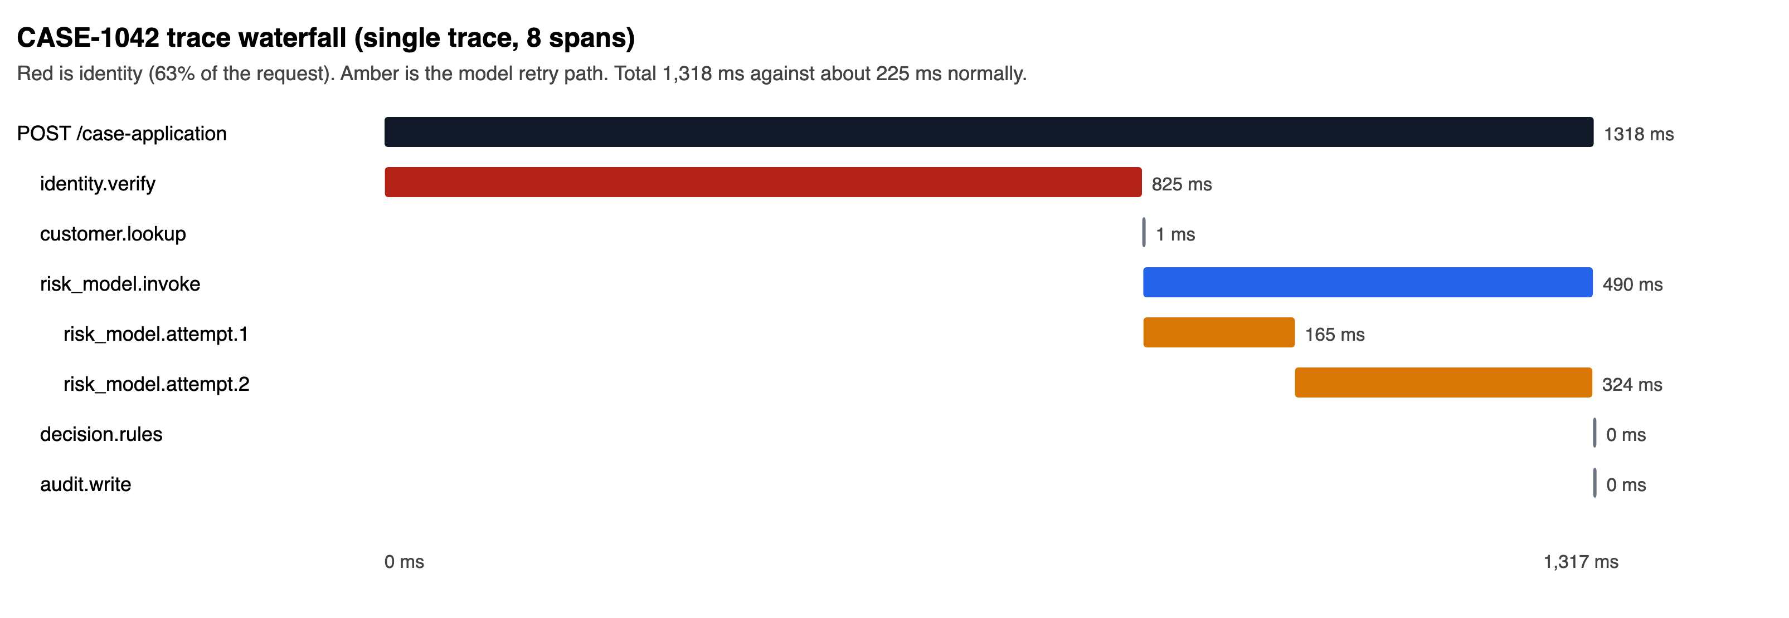
Root (1,318 ms) → identity.verify (825 ms, 63%) → model invoke (490 ms, 37%) → attempt 2 (324 ms).

Where the extra time went
Component | Normal | CASE-1042 | Excess
Identity | 50 ms | 825 ms | +775 ms (71%)
Model | 160 ms | 490 ms | +330 ms (30%)
Total | 225 ms | 1,318 ms | +1,093 ms

The two excess figures add to slightly more than the total excess because normal-case figures are rounded.

Root cause
Question | Answer | Basis
Why slow? | Identity dependency latency first, model retry second | E1, E2, E3, E8
Why retried? | Attempt 1 was marked timeout | E2 (see inference I1)
Why rejected? | risk-2.1 weights raise the score for this applicant's debt ratio (1.22) | Calculation below
Why costly? | A discarded first attempt cost 1,350 tokens on top of 1,600 | E2, E4

Calculation for the applicant (amount 1,100,000, income 900,000, country IN, debt ratio 1.2222).
- risk-2.1 gives 0.22 + 1.2222 × 0.45 = 0.770, so REJECT (≥ 0.70).
- risk-2.0 gives 0.18 + 1.2222 × 0.35 = 0.608, so REVIEW.

Inference, kept apart from evidence
- I1. The "timeout" label cannot be verified. Attempt 1 ended at 165 ms, shorter than any normal timeout, and no timeout threshold is recorded. In the code the retry is hard-wired to this case ID, so it is a simulated fault.
- I2. The identity delay is also hard-wired by case ID. In production the cause would sit inside the identity provider and need that provider's telemetry.
- I3. The update date is unknown. The repo has no deployment record. Only the two config versions are evidence.
- I4. The retry did not alter the score. The same formula runs on whichever attempt succeeds, so a first-attempt success would still have rejected.

Business impact
Measure | risk-2.0 | risk-2.1
Workload decisions (approve / review / reject) | 9 / 1 / 0 | 7 / 2 / 1
Decisions changed by the update |  | 3 of 10 (CASE-1004, CASE-1042, CASE-2004)
CASE-1042 outcome | REVIEW | REJECT
CASE-1042 cost (assumed $0.01 per 1k tokens) |  | $0.0295 against $0.0135 normal

- Customer impact. A customer who would have gone to manual review received an automatic rejection.
- Portfolio impact. The update moved three of ten cases to a stricter outcome. Two were Singapore cases (the new foreign penalty) and one was a high debt-ratio case (the new debt weight).
- Operations impact. Manual review load rose from 1 to 2 cases in the workload.
- Missing evidence. No ground truth exists, so the telemetry cannot say whether risk-2.1 is more accurate or only stricter.

Recommended actions
- Re-run CASE-1042 under risk-2.0 for a human reviewer and decide the customer outcome.
- Hold the model update behind a decision-mix check before promotion.
- Add timeout threshold, retry budget and provider telemetry for identity and model calls.
- Replace hard-coded fault injection with a switch that is logged when active.

Alerting, Escalation and Runbooks (Task 13)
Alert rules live in alert_rules.yml. Severity page wakes the owner, severity ticket opens work for the next business day.

Severity and ownership
Severity | Meaning | Response | Escalates to
Page | Customers harmed now, or compliance evidence at risk | 15 min acknowledge | Engineering manager after 30 min
Ticket | Degradation with budget left | Next business day | Owner team lead after 3 days

Thresholds
Alert | Threshold | Severity | Owner
Error budget burn | 5xx > 7.2% for 5 min (burn 14.4) | Page | platform-oncall
Latency P95 | > 500 ms for 10 min | Page | platform-oncall
Model retry rate | > 2% for 15 min | Ticket | ml-oncall
Wasted token share | > 5% for 30 min | Ticket | ml-oncall
Decision mix shift | Reject share moves > 10 points vs same hour yesterday | Page | ml-oncall
Audit write failure | Any in 5 min | Page | compliance-oncall
Identity P95 | > 150 ms for 10 min | Ticket | platform-oncall

First five minutes for any page
- Open the production health view and note which SLO is red.
- Pick a recent affected case. Call GET /cases/{case_id}/traces, then GET /traces/{trace_id}.
- Read the slowest span on the critical path.
- Check service.start in logs for the model version and config hash.
- Post the trace ID in the incident channel.

A1 Error budget burn
- Check case_errors{reason} to see which failure dominates.
- 404 spikes point to a customer data problem. 500s point to a code or disk fault.
- Roll back the last deploy if errors began after it.

A2 Latency SLO
- Compare dependency_duration_ms (identity) with model_invoke_duration_ms. The larger one is the cause.
- In Incident 01, identity contributed 71% of the excess.
- Raise a ticket with the identity provider owner if identity is slow. Check retry rate if the model is slow.

A3 Model retries
- Filter model_retries_total by reason.
- Open a trace with attempt=2 and compare attempt durations.
- Confirm the timeout threshold with the model provider.

A4 Token cost
- Divide model_wasted_tokens_total by model_tokens_total.
- Cap retries at one per request if cost climbs.

A5 Decision mix shift
- Compare decisions_total by model_version.
- If the shift follows a model change, roll the config current back to the previous entry and restart. Then ask for a review of the new weights.
- Route the affected cases to manual review.

A6 Audit failure
- Check disk space and file permissions on data/audit_log.jsonl.
- Stop accepting decisions if audit cannot be written. An unaudited decision is a compliance breach.
- After repair, rebuild missing records from logs using trace_id.
- Run python scripts/verify_audit.py. A failure names the first tampered line. Escalate it as a security incident.

A7 Identity latency
- Compare identity.verify durations across cases in recent traces.
- Contact the identity provider owner with two trace IDs.

After the incident
- Write the timeline from the trace.
- Record root cause, impact and the budget spent.
- Add a regression check to scripts/validate_recovery.py.

Decision Provenance, Audit Evidence and Readiness Gate (Tasks 14 and 15)

Provenance chain for one decision
Question | Where the answer lives
What was asked? | input_hash (SHA-256 of the full request) in the audit record
Who or what handled it? | trace_id and span_id link the audit record to the stored trace
Which model and settings? | model_version, config_hash, service_version
What did the model do? | model_retry_count, retry_reason, tokens, cost_usd, per-attempt spans
What did it score? | risk_score
Which rules decided? | rules_version plus thresholds in decision.py
What was the outcome? | decision, reason, ts
Did a human intervene? | Not recorded (see residual gaps)

Audit schema change
- Schema version 3 adds 14 fields to the original 5, including prev_hash and record_hash. Old records keep their shape.
- Each record hashes its body together with the previous record's hash. Editing or deleting a record breaks every later link.
- python scripts/verify_audit.py checks the chain and exits 1 on tampering. Legacy records before the chain are counted but cannot be verified.
- The exclusion that dropped retry evidence for CASE-1042 is removed.
- Raw income, amount and customer ID are absent. input_hash proves the input without storing it.
- audit_records_total and audit_write_failures_total make completeness measurable.

Evidence completeness
Check | Result
Every decision writes an audit record | Yes, audit_completeness SLO 100% in validation
Audit record joins to a trace | Yes, test_audit_persists_retry_evidence_for_incident_case
No raw PII in audit | Yes, test_audit_holds_no_raw_pii
Historical CASE-1042 records have retry evidence | No. Two pre-fix records for CASE-1042 stay incomplete

Production readiness gate
Capability | Status | Evidence
Detect failures | Pass in code, not yet wired | SLO endpoint and alert rules exist, no alert delivery is deployed
Trace a transaction | Pass | One trace per request, orphan-free test
Measure AI quality | Partial | Score distribution and decision mix exist, no ground-truth accuracy
Measure cost | Pass with assumption | Price is a placeholder
Protect sensitive data | Pass | Redaction tests
Prove controls operated | Pass with limit | Audit is hash-chained and verifiable. Truncating the file's tail is undetectable without an external anchor
Recover safely | Partial | Rollback by config edit is documented, not automated

Verdict
Conditional go for a pilot. Production go needs the blockers below.

Blockers
- Export traces, metrics and logs to a durable backend. Today they live in process memory and reset on restart.
- Anchor the audit chain tail outside the file (write-once store or periodic signed checkpoint), so tail truncation is detectable.
- Replace the placeholder token price with the contracted rate.
- Record the human decision for REVIEW cases.
- Run more than one worker only after metrics move to a shared backend. Per-process counters would split.
Closed since the first assessment: fault injection is a logged flag (DECISIONSTREAM_FAULTS), 422 failures are metered, and the audit log is hash-chained.

Recovery Validation and Final Evidence Pack (Task 16)

What was re-run
python scripts/validate_recovery.py replays CASE-1042 and a healthy workload. Result is 14 of 14 checks passing (evidence/recovery.json). pytest -q passes 21 tests (6 original, 15 new). python scripts/verify_audit.py verifies the audit chain.

Before and after
Question | Before | After
Trace IDs for CASE-1042 | 2 | 1, with 8 connected spans
Identity span on the request trace | No | Yes
Logs carry trace, span, case, timestamp | No | Yes
Income and amount in logs | Yes | No
Latency percentiles | None | P50, P95, P99 from histograms
Tokens and cost over time | Last request only | Counters by model version
Retry visible in metrics | No | model_retries_total{reason}
Retry in audit for CASE-1042 | No | Yes
Audit fields per decision | 5 | 19 (including hash chain)
Audit tamper evidence | None | Hash chain, scripts/verify_audit.py
Fault injection | Silent, hard-coded | Switchable, logged, counted (faults_injected_total)
Validation failures (422) | Unmetered | case_errors{reason=validation_failed}
SLO status | Not computable | /slo
Alerts, runbook, dashboard | None | Provided
Model change visible | No | service.start event, config_hash in audit

SLO recovery
Scenario | Availability | Latency P95 | Retry rate | Audit completeness
Incident replay | MET | BREACHED | BREACHED | MET
Healthy workload (8 cases) | MET | MET (250 ms bucket) | MET | MET

The breach is detected for the incident and clears on healthy traffic. The simulated faults for CASE-1042 and CASE-2048 are still in the code, so the incident case stays slow. Remediation here covers observability, not the fault.

Business behaviour preserved
test_business_behaviour_unchanged and the original six tests confirm CASE-1042 still returns REJECT, score 0.77, risk-2.1.

Artifact index
Task | File
1 | docs/discovery/01-system-and-business-flow.md
2, 3 | docs/observability/00-baseline-and-gaps.md
4 | docs/observability/02-sli-slo-error-budget.md
5 to 8 | docs/observability/03-telemetry-and-correlation-model.md, app/observability/, app/services/
9 | dashboards/README.md, dashboards/production_health.html
10, 11 | docs/artifacts/incident-01-investigation.md
12 | Code changes listed below
13 | runbooks/README.md, runbooks/alert_rules.yml
14, 15 | docs/artifacts/provenance-and-readiness.md
16 | This file, docs/artifacts/evidence/

Code changes (Task 12)
File | Change
app/observability/context.py | New. Request context variables
app/observability/logging.py | Auto context, timestamp, redaction
app/observability/tracing.py | Parent IDs, attributes, trace store
app/observability/metrics.py | Labels, histograms, Prometheus text
app/observability/slo.py | New. SLO evaluation
app/services/identity.py | Joins request trace, records dependency latency
app/services/risk_model.py | Token, cost, retry, latency, score metrics
app/services/decision.py | Rule version and thresholds as constants
app/services/audit.py | Provenance fields, retry evidence always written, hash chain, verify_chain()
app/faults.py | New. Switchable fault injection with log and metric
app/main.py | Context setup, X-Trace-Id, traceparent, error and latency metrics, 422 handler, new endpoints
config/model_config.json | Added pricing block
tests/ | conftest.py isolates state, test_observability.py adds 15 tests

Residual risk
See blockers in provenance-and-readiness.md.

