Nikto Web Server Scanning Report

Aim
To perform a basic web-server security scan using the Nikto tool and examine the reported server information, HTTP responses, and potential security-related findings for the specified websites.

Procedure
- Open the Linux terminal in the authorized lab environment.
- Run a Nikto scan against the first target website using the command shown in the screenshot: `nikto -h www.zoho.com -Tuning x`.
- Observe the target IP address, hostname, port, server information, and messages reported by Nikto.
- Run a second scan against the other target website using the command shown in the screenshot: `nikto -h www.certifiedhacker.com -Cgidirs all`.
- Review the findings and scan-status messages, including HTTP response behavior, server-banner information, and any errors encountered during scanning.
- Capture the terminal output and include it in the report for documentation.

Screenshot
The following screenshot shows the terminal commands and Nikto scan output for both target websites.
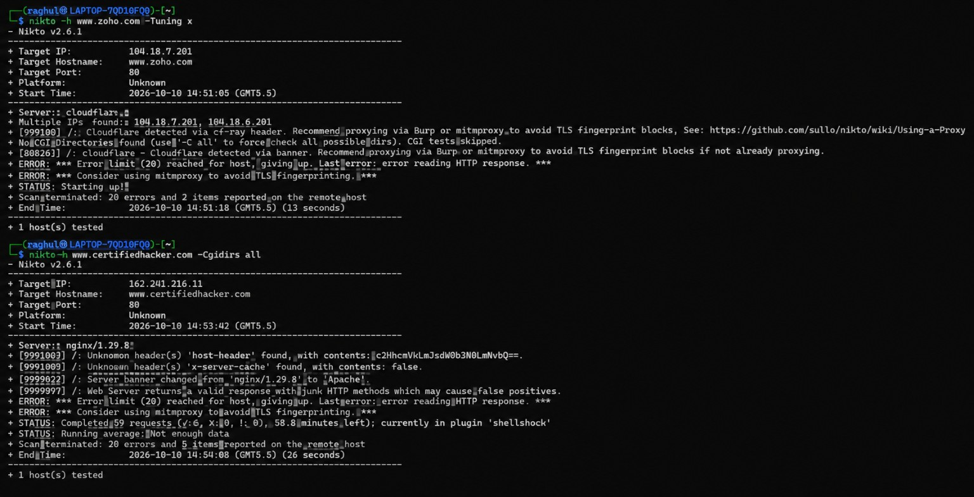

Result
Nikto was used to scan the two websites, and the terminal output displayed server details and several observations. The scan of www.zoho.com reported Cloudflare detection and multiple IP addresses. The scan of www.certifiedhacker.com reported server-banner and HTTP-method-related observations. Both scans also encountered HTTP-response errors and reached the configured error limit. These results are preliminary scan observations, not proof that a vulnerability is exploitable. Any further testing should be performed only with explicit authorization from the website owner.

