NMAP HOST DISCOVERY AND BASIC SCANNING

AIM
To use Nmap host-discovery and basic scanning options to check whether the target 192.168.1.1 is reachable and to identify any TCP ports reported as open.

PROCEDURE
- Open a terminal on a system with Nmap installed. Perform scans only on systems or networks for which you have permission.
- Use the -Pn option to skip host discovery and treat the target as online: nmap -Pn 192.168.1.1.
- Use the -sn option for a host-discovery scan without a port scan: nmap -sn 192.168.1.1.
- Use the -n option to disable DNS name resolution: nmap -n 192.168.1.1.
- Use the -PR option to attempt ARP discovery on a local Ethernet network: nmap -PR 192.168.1.1.
- Review the output, noting host status, discovered ports, and any command syntax errors or incomplete scans.

SCREENSHOTS
Screenshot 1:
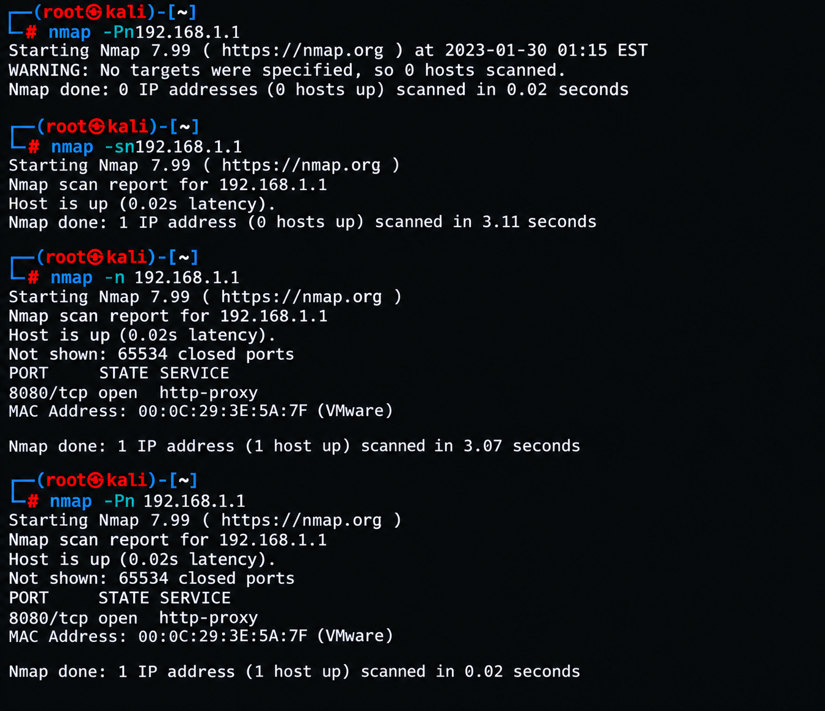
Screenshot 2:
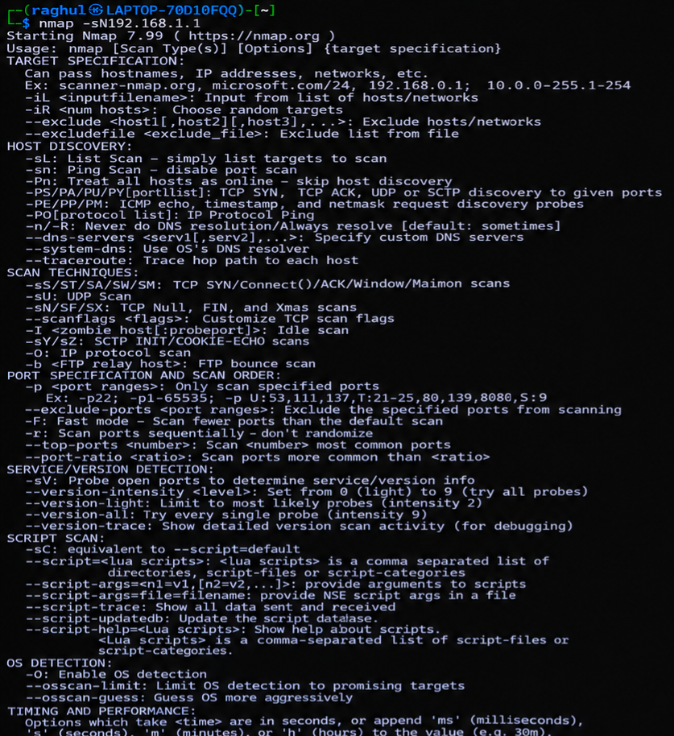
Screenshot 3:

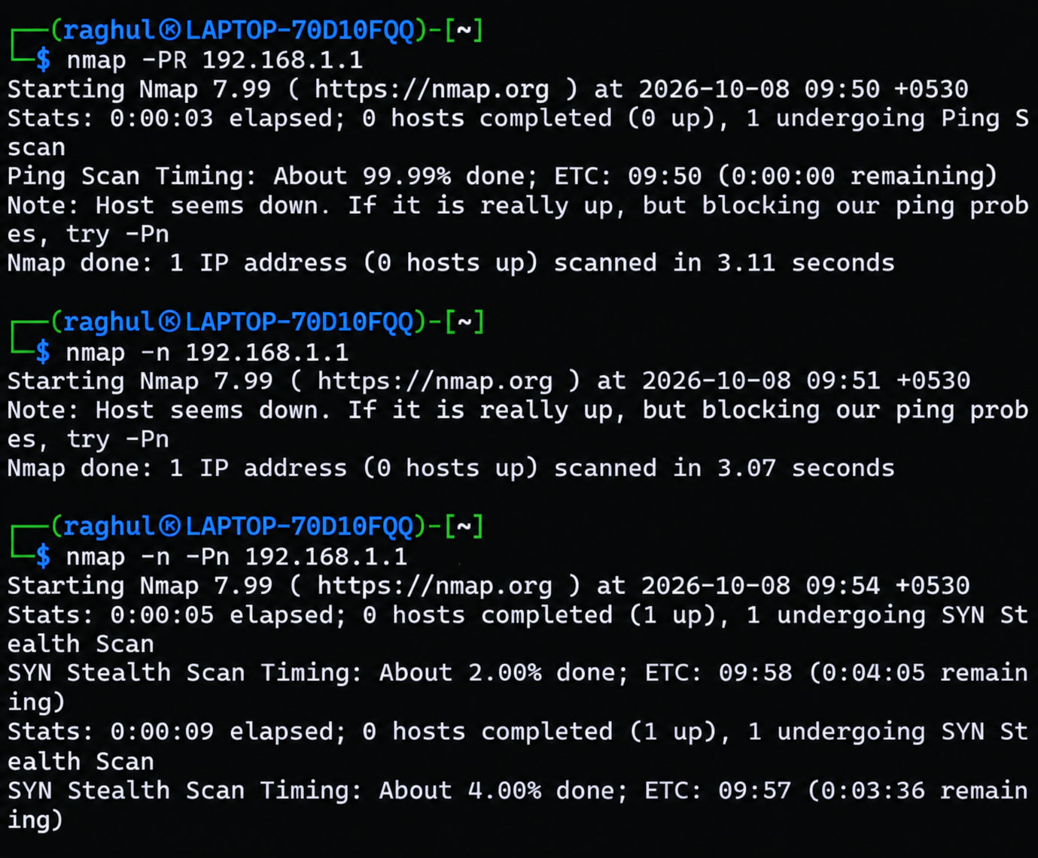

RESULT
The screenshots demonstrate the use of Nmap options for host discovery and basic scanning. In the completed scan that detected the host, 192.168.1.1 was reported as up and TCP port 8080 was open (http-proxy). Some other attempts did not detect the host, and one command failed because of incorrect spacing. Correct command syntax and an appropriate discovery method are required for consistent results.

