NMAP PORT SCANNING

AIM
To perform basic network reconnaissance using Nmap by testing selected TCP ports and observing the results of SYN, TCP connect, ACK, and UDP scans on the specified targets.

PROCEDURE
- Open the terminal on the system where Nmap is installed.
- Run a SYN scan against the target 192.168.1.1 using: nmap -sS 192.168.1.1
- Run a TCP connect scan against the same target using: nmap -sT 192.168.1.1
- Scan TCP ports 22, 80, and 443 on 172.29.99.181 using: nmap -p 22,80,443 172.29.99.181
- Run an ACK scan against 192.168.1.1 using: nmap -sA 192.168.1.1
- Run a UDP scan against 192.168.1.1 using: nmap -sU 192.168.1.1
- Record the host status and the reported state of each port. Perform scans only on systems or networks for which you have permission.

SCREENSHOTS
Screenshot 1: TCP port scan and ACK/UDP scan results.
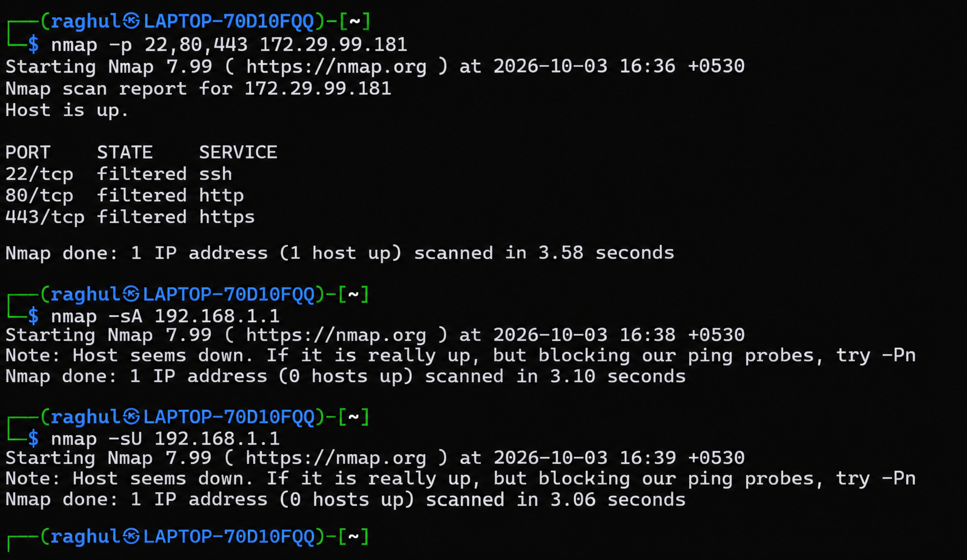
Screenshot 2: SYN/TCP connect scan and TCP port scan results.
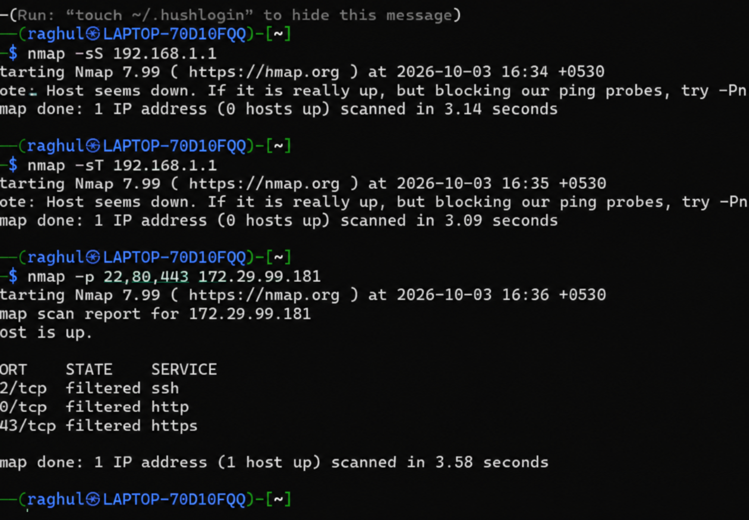

RESULT
Nmap scanning was carried out successfully and the outputs were recorded. The target 192.168.1.1 was not detected as up during the scans, while 172.29.99.181 was reachable but ports 22, 80, and 443 were filtered. These results suggest checking host availability, routing, and firewall rules before drawing further conclusions.

