HYDRA FTP LOGIN TEST
Aim, Procedure and Result

Aim
To demonstrate how THC-Hydra reports FTP login attempts against a test FTP server using a provided username list and password list, in an authorized lab environment.

Procedure
- Open the terminal in the authorized lab system.
- Prepare the username list (user.txt) and password list (passwords.txt) for the test.
- Run the Hydra command against the lab FTP server at 192.168.1.101, using the FTP service and verbose output.
- Observe the terminal output for attempted credentials, connection errors, and the final status.
- Stop and troubleshoot the test if repeated connection errors occur; confirm the FTP service is reachable and that testing is authorized before trying again.

Screenshot

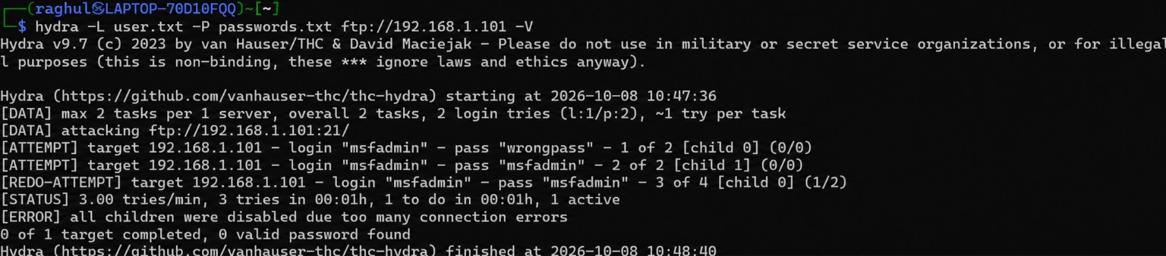

Result
The test did not complete successfully. Hydra attempted FTP login combinations for 192.168.1.101, but the output reported: “all children were disabled due to too many connection errors.” The final status was “0 of 1 target completed, 0 valid password found.” Therefore, no valid password was identified. The FTP service or network connection should be checked in the authorized lab before repeating the test.

