WEB RECONNAISSANCE USING THE HARVESTER

1. Aim
To perform passive, publicly available information gathering for the domain www.zoho.com using theHarvester, identify the types of information it can collect, and review the scan output while noting the limitations caused by missing or invalid API credentials.

2. Procedure
- Open the terminal in the authorized lab environment where theHarvester is installed.
- Run theHarvester against the target domain with a limited result count and the selected data sources. The command shown in the lab output is: theHarvester -d www.zoho.com -l 300 -b all -f test
- Allow the tool to query its configured sources. It reads API credentials from /etc/theHarvester/api-keys.yaml.
- Observe the terminal messages. Several integrations report missing API keys, and some report invalid credentials. As a result, those sources may be skipped or provide limited results.
- Review the summary produced by the run. The captured output reports 13 ASNs, 15 interesting URLs, and 41 IP addresses.
- Check the other summary fields. The output reports no LinkedIn users, LinkedIn links, email addresses, people, or hosts found.
- Record the limitations and interpret the results cautiously. An IP address or ASN in the output is not, by itself, proof of a vulnerability or compromise.
- Save the output for the practical record and ensure the activity is performed only on systems and domains for which testing is authorized.

3.Screenshot
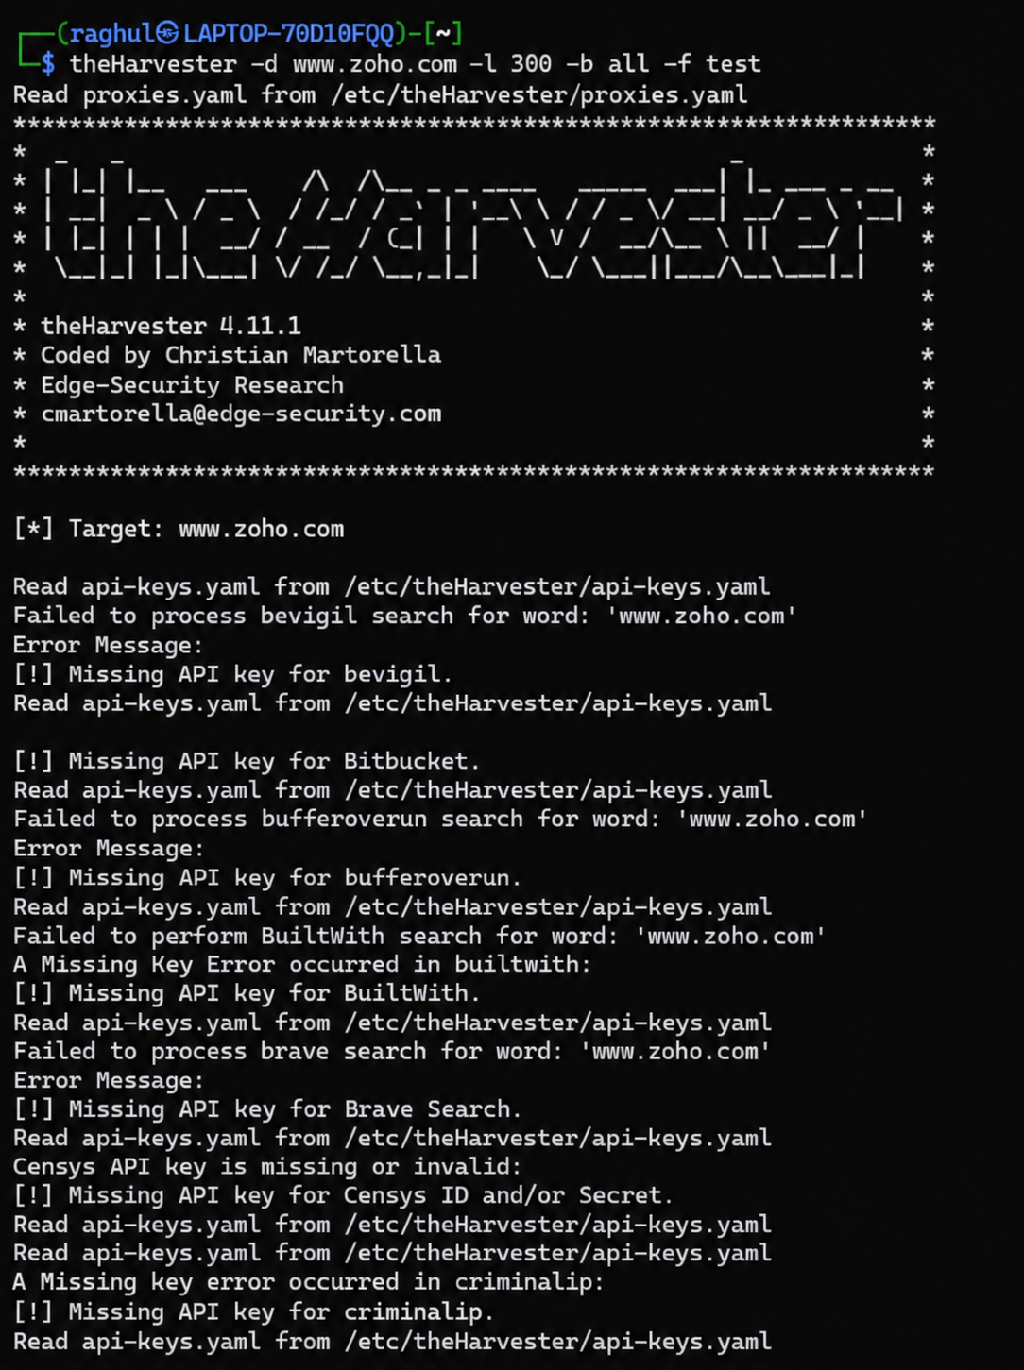
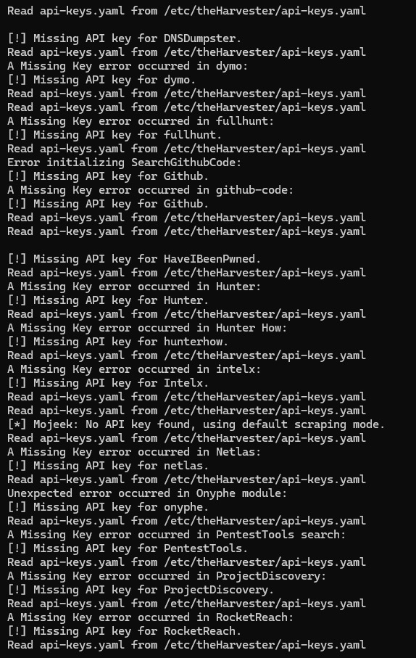

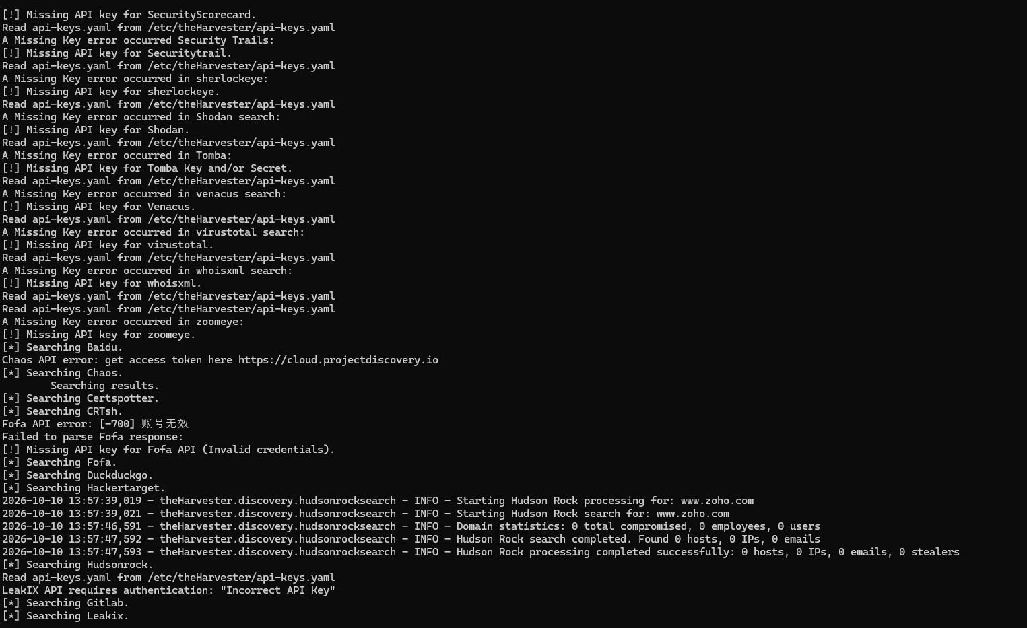
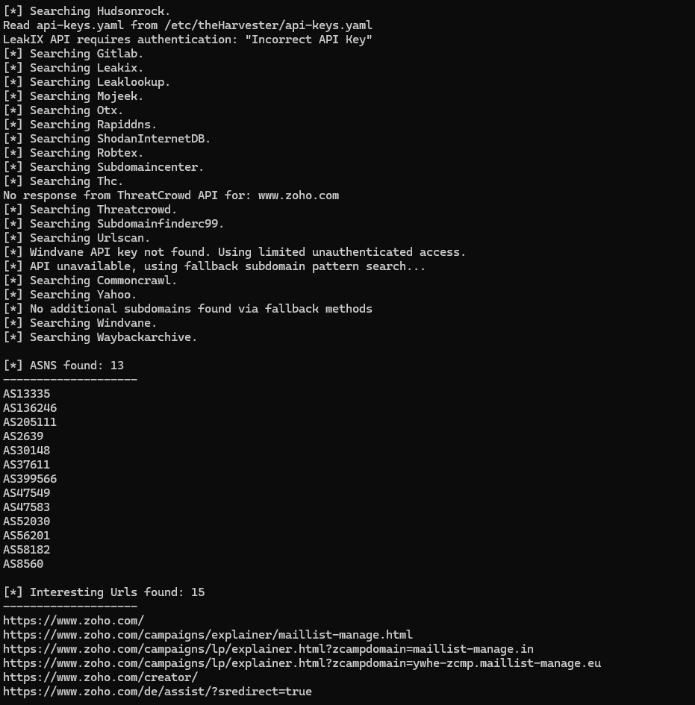
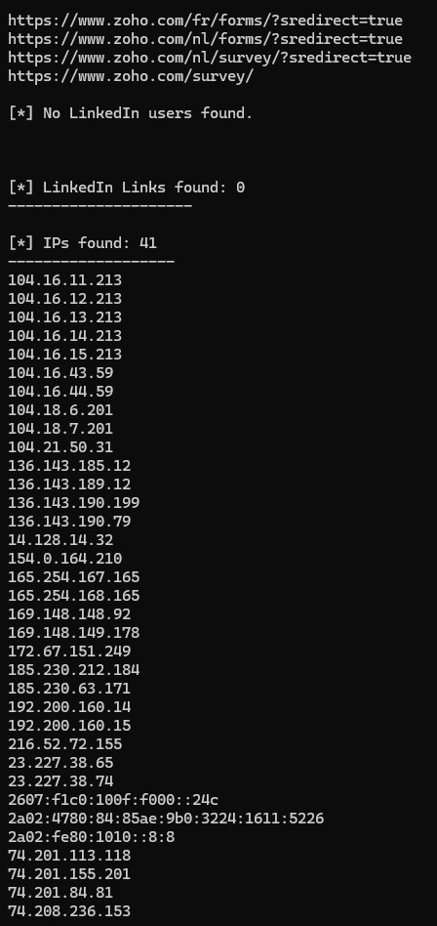
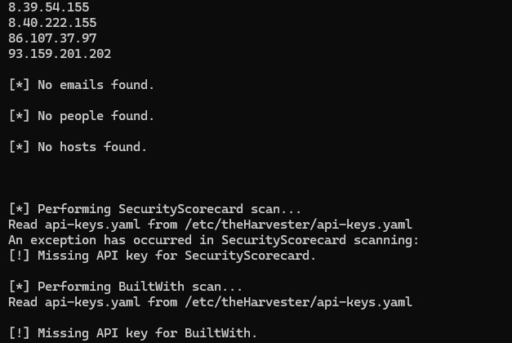
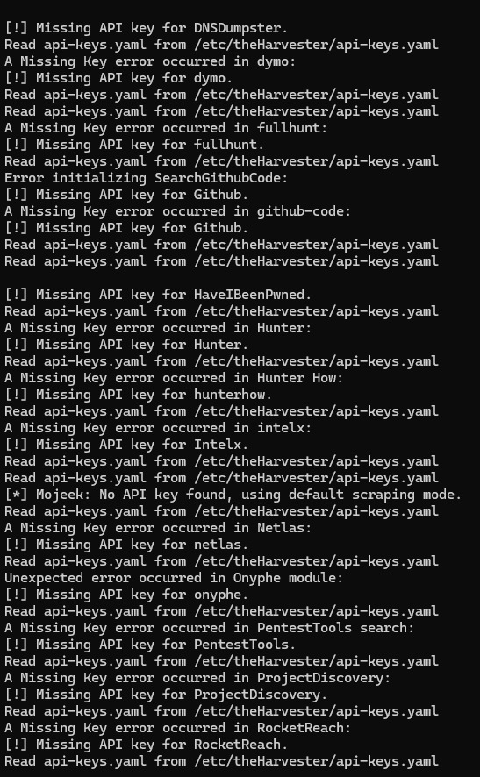
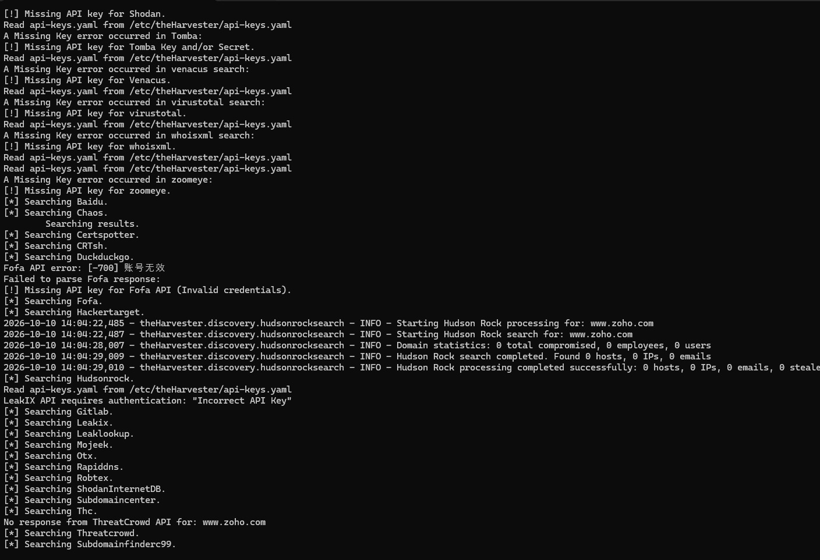
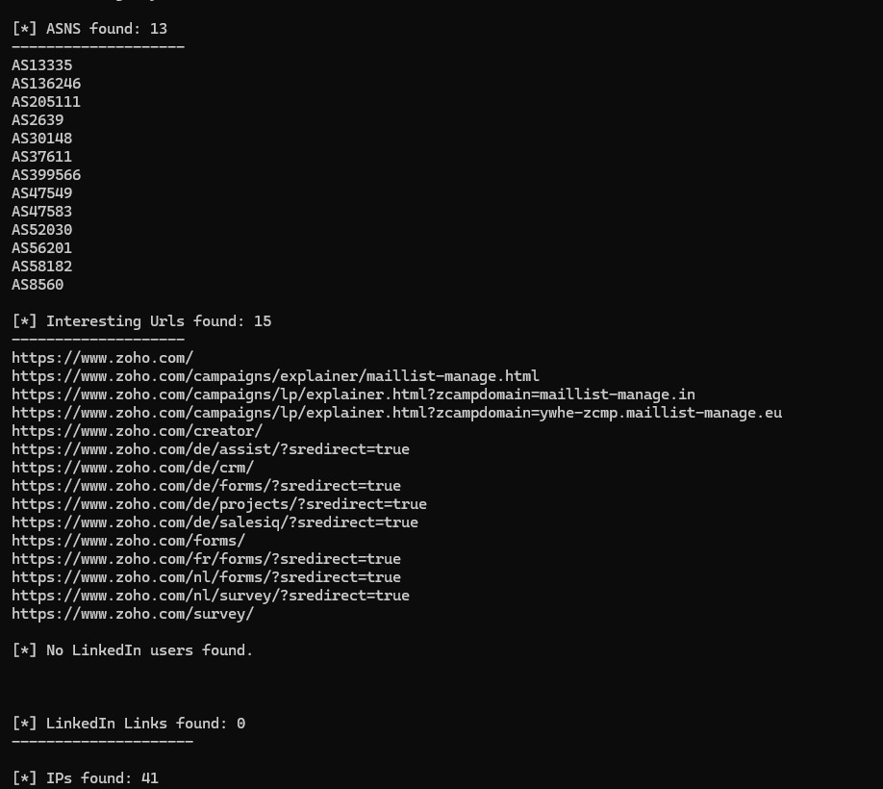
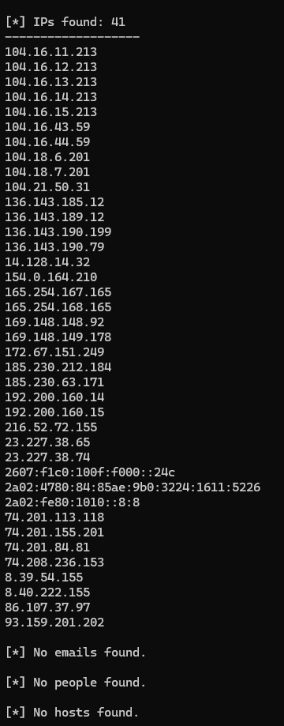

4. Result
TheHarvester was executed for www.zoho.com and returned publicly discoverable reconnaissance data. According to the captured output, it identified 13 ASNs, 15 interesting URLs, and 41 IP addresses. It did not find email addresses, people, hosts, LinkedIn users, or LinkedIn links in this run. Many data sources could not be used because their API keys were missing or invalid, so the results are incomplete and should not be treated as an exhaustive inventory or as evidence of a security weakness.

