ASSIGNMENT 4

Saima Rahmanzai

2021-04-21

# Markdown Basics

## Favorite Foods

**My Favorite Foods**

1. Chipotle
2. Sushi
3. Pizza
   * Margherita Pizza

## Images

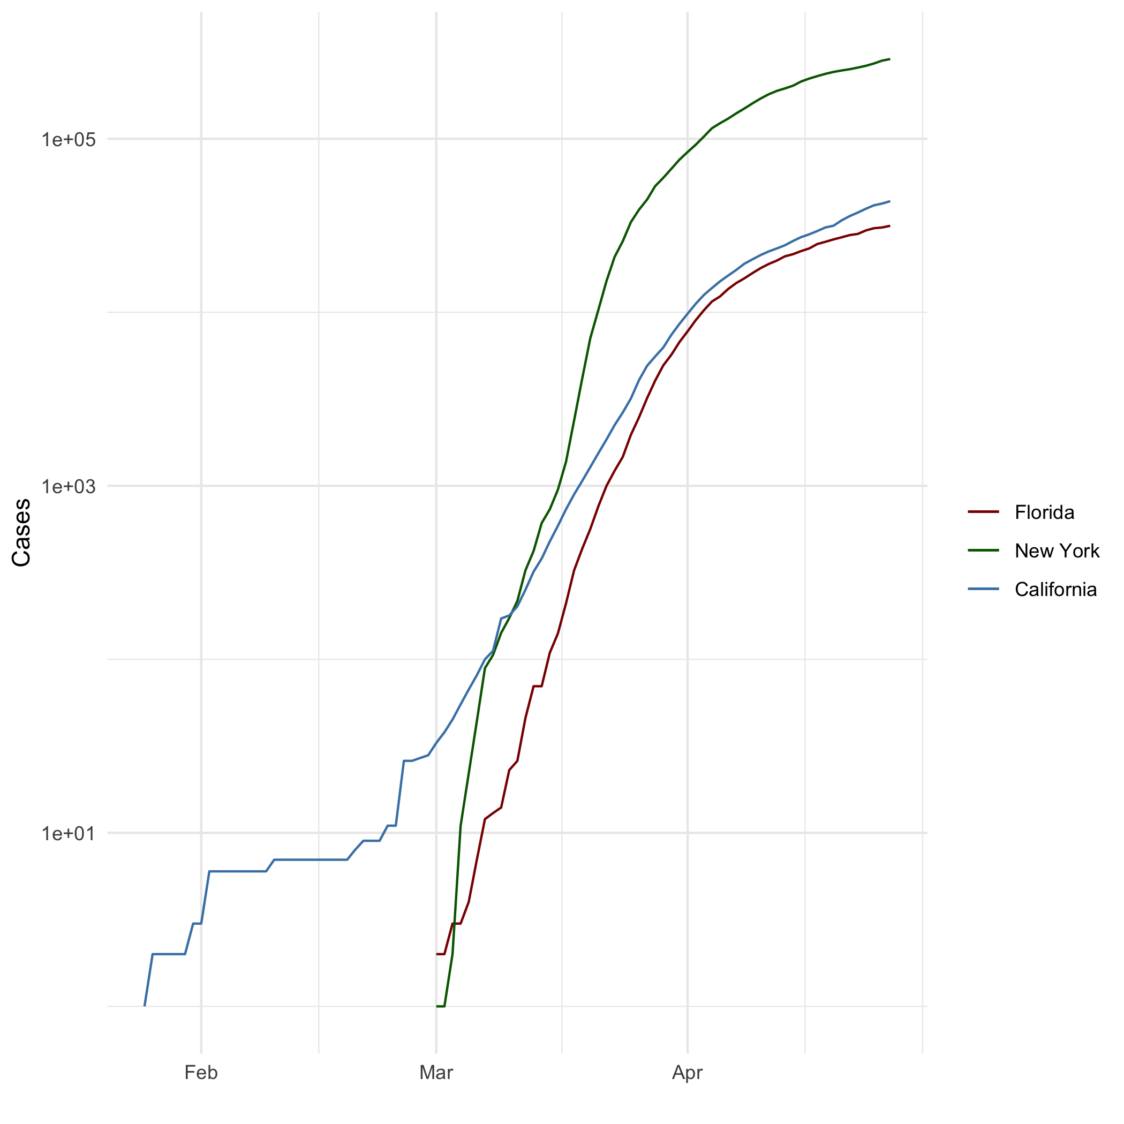

## Add a Quote

**Best Golf Quotes**

A “gimme” can best be defined as an agreement between two golfers, neither of whom can putt very well.

Golf is a game where the ball always lies poorly and the player always lies well.

Many a golfer prefers a golf cart to a caddy because the cart cannot count, criticize or laugh.

Golf is a lot of walking, broken up by disappointment and bad arithmetic. www.sportsfeelgoodstories.com/golf-quotes

## Add an Equation

*LaTex Formatted Equations*

$$a^{2}+b^{2}=c^{2}$$

$$a^{2}=b^{2}+c^{2}$$

## Add a Footnote

This is a footnote[1]

## Add Citations

* R for Everyone
* Discovering Statistics Using R

(Lander 2014) (Field, Miles, and Field 2012)

# Inline Code

‘data.frame’: 3039 obs. of 5 variables: $ date : Date, format: “2020-01-21” “2020-01-22” … $ state : chr “Washington” “Washington” “Washington” “Illinois” … $ fips : int 53 53 53 17 53 6 17 53 4 6 … $ cases : int 1 1 1 1 1 1 1 1 1 2 … $ deaths: int 0 0 0 0 0 0 0 0 0 0 … date state fips cases deaths 6 2020-01-25 California 6 1 0 10 2020-01-26 California 6 2 0 14 2020-01-27 California 6 2 0 18 2020-01-28 California 6 2 0 22 2020-01-29 California 6 2 0 26 2020-01-30 California 6 2 0 date state fips cases deaths 247 2020-03-01 New York 36 1 0 262 2020-03-02 New York 36 1 0 277 2020-03-03 New York 36 2 0 294 2020-03-04 New York 36 11 0 314 2020-03-05 New York 36 22 0 339 2020-03-06 New York 36 44 0 date state fips cases deaths 243 2020-03-01 Florida 12 2 0 256 2020-03-02 Florida 12 2 0 271 2020-03-03 Florida 12 3 0 287 2020-03-04 Florida 12 3 0 305 2020-03-05 Florida 12 4 0 326 2020-03-06 Florida 12 7 2 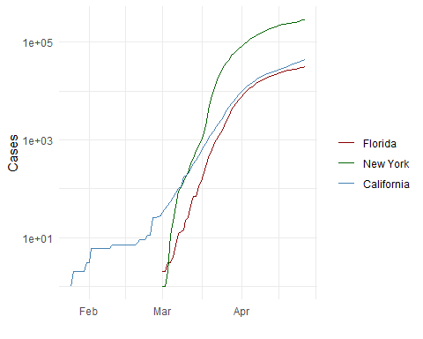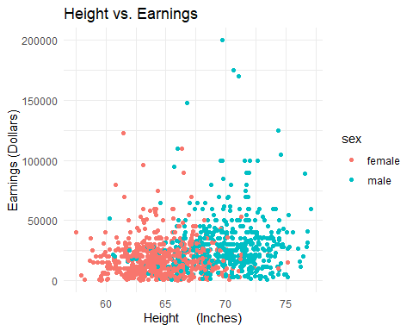

# Tables

# One Ring to Rule Them All

|  |  |  |  |  |
| --- | --- | --- | --- | --- |
| Name | Race | In Fellowship? | Is Ring Bearer? | Age |
| Aragon | Men | Yes | No | 88 |
| Bilbo | Hobbit | No | Yes | 129 |
| Frodo | Hobbit | Yes | Yes | 51 |
| Sam | Hobbit | Yes | Yes | 36 |
| Sauron | Maia | No | Yes | 7052 |

## Knitr Table with Kable

setwd("C:\\Users\\Saima\\Class_Assignments\\dsc520")  
characters_df <- read.csv("data/characters.csv")

setwd("C:\\Users\\Saima\\Class_Assignments\\dsc520")  
characters_df <- read.csv("data/characters.csv")  
knitr::kable(characters_df, caption = "Table with kable")

Table with kable

|  |  |  |  |  |
| --- | --- | --- | --- | --- |
| ï..Name | Race | In.Fellowship. | Is.Ring.Bearer | Age |
| Aragon | Men | Yes | No | 88 |
| Bilbo | Hobbit | No | Yes | 129 |
| Frodo | Hobbit | Yes | Yes | 51 |
| Sam | Hobbit | Yes | Yes | 36 |
| Sauron | Maia | No | Yes | 7052 |

## Pandoc Table

## Warning: package 'pander' was built under R version 4.0.5

|  |  |  |  |  |
| --- | --- | --- | --- | --- |
| Ã¯..Name | | Race | | In.Fellowship. | | Is.Ring.Bearer | | Age |
| Aragon | Men | Yes | No | 88 |
| Bilbo | Hobbit | No | Yes | 129 |
| Frodo | Hobbit | Yes | Yes | 51 |
| Sam | Hobbit | Yes | Yes | 36 |
| Sauron | Maia | No | Yes | 7052 |

# References

Field, A., J. Miles, and Z. Field. 2012. *Discovering Statistics Using r*. SAGE Publications. <https://books.google.com/books?id=wd2K2zC3swIC>.

Lander, J. P. 2014. *R for Everyone: Advanced Analytics and Graphics*. Addison-Wesley Data and Analytics Series. Addison-Wesley. <https://books.google.com/books?id=3eBVAgAAQBAJ>.

1. Here is the footnote.