ASSIGNMENT 4

Saima Rahmanzai

2021-04-09

# Markdown Basics

## Favorite Foods

**My Favorite Foods**

1. Chipotle
2. Sushi
3. Pizza
   * Margherita Pizza

## Images

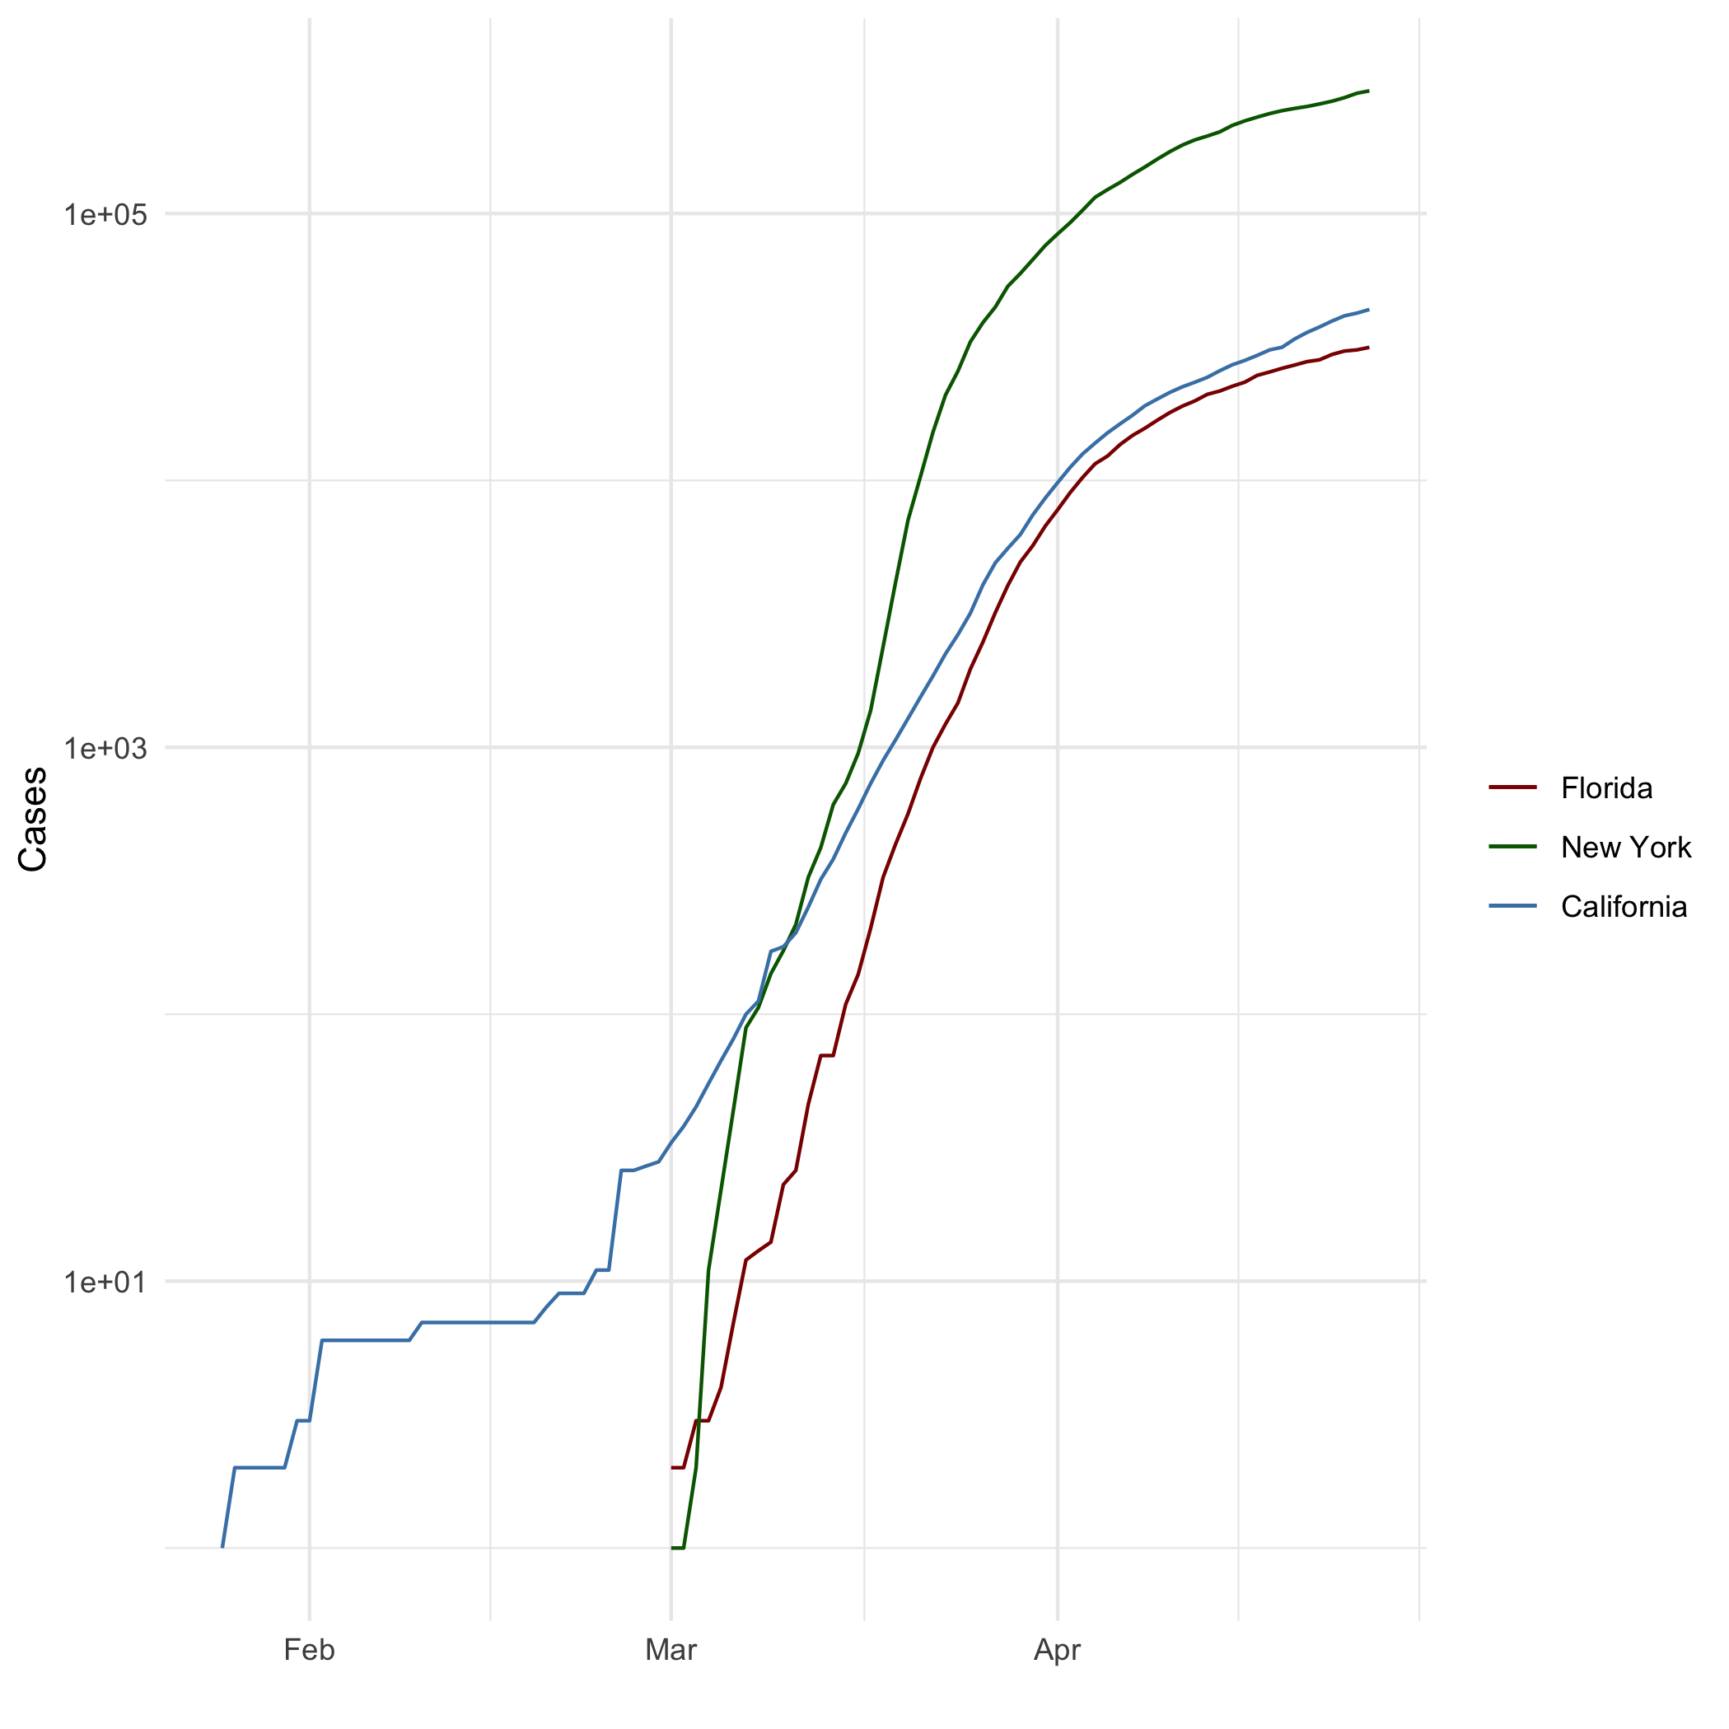

## Add a Quote

**Best Golf Quotes**

A “gimme” can best be defined as an agreement between two golfers, neither of whom can putt very well.  
Golf is a game where the ball always lies poorly and the player always lies well.  
Many a golfer prefers a golf cart to a caddy because the cart cannot count, criticize or laugh.  
Golf is a lot of walking, broken up by disappointment and bad arithmetic. www.sportsfeelgoodstories.com/golf-quotes

## Add an Equatio>n

*Regular Equation*

$$a^{2}+b^{2}=c^{2}$$

*LaTex Formatted Equation* \[ a^2 = b^2 + c^2 \]

## Add a Footnote

This is a footnote[1]

## Add Citations

* R for Everyone
* Discovering Statistics Using R

(**RforEveryone?**) (**DiscoveringStatisticsUsingR?**)

# Inline Code

## NY Times COVID-19 Data

## R4DS Height vs Earnings

# Tables

## Knitr Table with Kable

## Pandoc Table

# References

1. Here is the footnote.