**ProxyInet *(*** [***https://192.168.50.180/index.html***](https://192.168.50.180/index.html) ***)***

***SVN URL:*** svn://ravsoft-svn/external/r&d/ProxyiNet

1. Open putty and login to below VM :

192.168.50.180

root / pa$$word180s

2. Go to below path :

/root/RAVSoft_tools/ProxyiNet

3. Run the proxyinet app :

docker-compose up -d

4. Verify, proxyinet docker pods are running fine:

docker ps

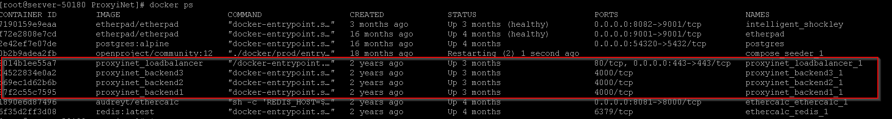

5. Stop the app:

docker-compose down

Other notes:

systemctl start docker

systemctl restart network

**EtherCalc: *(*** [***http://192.168.50.180:8081/***](http://192.168.50.180:8081/) ***)***

- git repo : https://github.com/audreyt/ethercalc

- Deployment :

cd /root/RAVSoft_tools/EtherCalc (this directory has docker-compose file)

docker-compose up -d

**EtherPad: *(*** [***http://192.168.50.180:8082/***](http://192.168.50.180:8082/) ***)***

- git repo : https://github.com/ether/etherpad-lite/tree/develop

- Deployment :

docker pull etherpad/etherpad

docker run -d -p 8082:9001 etherpad/etherpad