Attack of the Killer Bears

Data Analytics Boot Camp

Project 1

Team Members:

Geoffrey Holland

Karsten Olsen

Sarah Raisian

David Winton

**Overview**

People are told that bears are dangerous, but how often do bear attacks occur? Who are the primary victims? How do they die? Where (in North America) do they occur? Have these deaths declined over time? Curiosity on the statistics of fatal bear killings, the team used a dataset to find answers to some of these questions.

**Data**

The dataset used is from Data.World[1] called “north_america_bear_killings.csv” that consists of 166 victims and 14 features describing their death. The features include: Name, Age, Gender, Date, Year, Type(Wild or Captive), Location, Description, Type of Bear, Hunter (Boolean value), Grizzly (Boolean value), Hikers (Boolean value), Only One Killed (Boolean value).

There were 2 missing values of the Age feature – so for analyzing the victim exploration, the team dropped these values. In addition, there was the Grizzly Boolean feature that is a type of brown bear. Therefore, for analyzing the type of bear, Grizzly was included and should be understood as a subset of brown bear.

To analyze the data, the team used various packages in Python using Jupyter to cultivate visual findings to the questions listed above.

**Analysis**

Who Dies from Bear Killings?

The short answer is adult men between the ages of 40 and 60. In every age category there were more males that died than females.

Outside of our one elderly lady who apparently had an unfortunate run in with a bear in 2001 in New Mexico at the ripe age of 93. Out of 166 recorded deaths, 22 occurred while participating in a wilderness relate activity. 16 people died while hunting, while another 6 died while hiking. There was 1 woman hunting, and 1 woman hiking.

Aside from scrubbing the data this was pretty straight forward. Deciding the best way to visualize the important information without too many colorful and overwhelming graphs was the hard part.

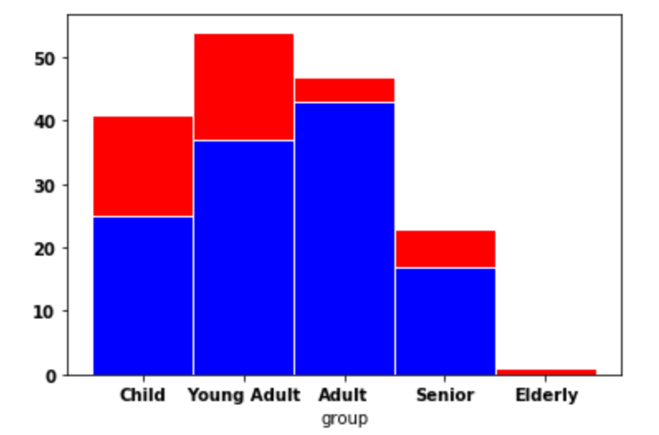

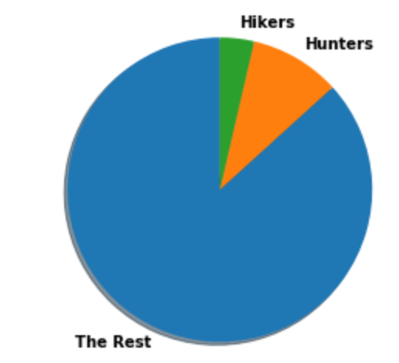

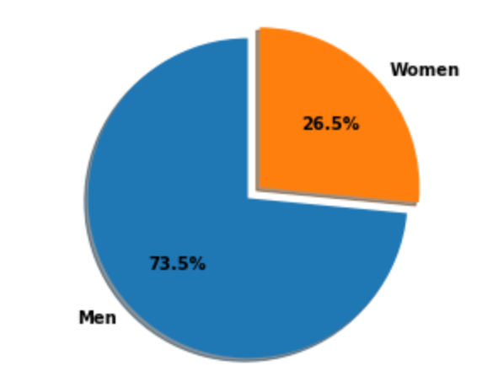

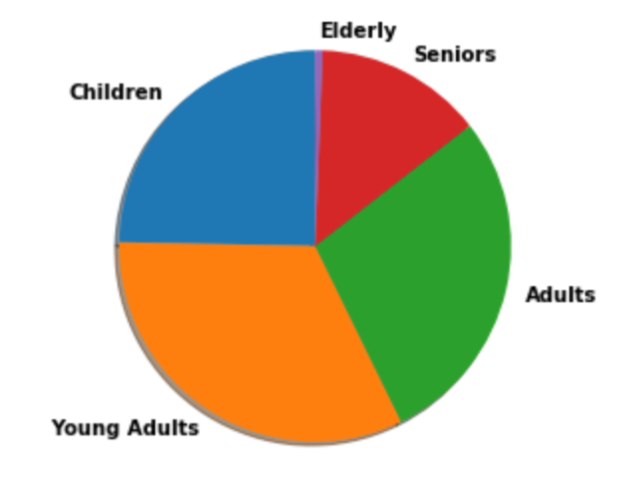

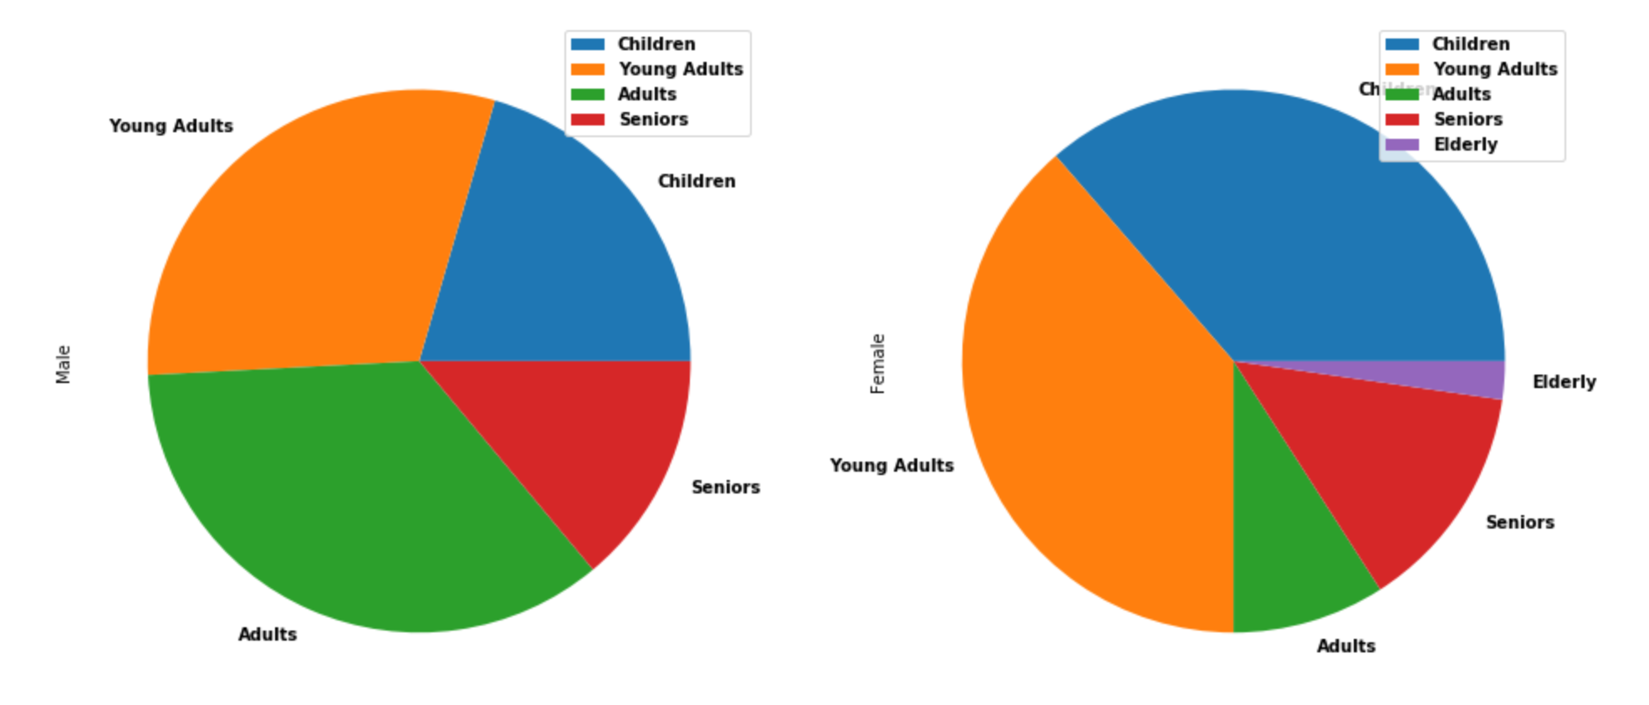

How Do They Die?

The victims in the dataset were majority killed by brown bears including grizzly bears at 48.2%, slightly higher than black bears at 45.8%. Polar bears only accounted for 6% of the killings, mostly because populations are not as dense where the polar bears live.

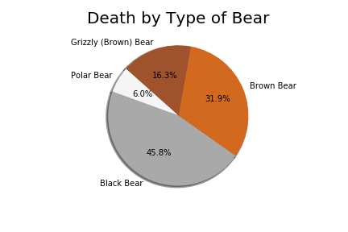

Not surprisingly, most bear killings occur in the wild (83.1%) as opposed to captive deaths (from “pet” bears or zoo captivity).

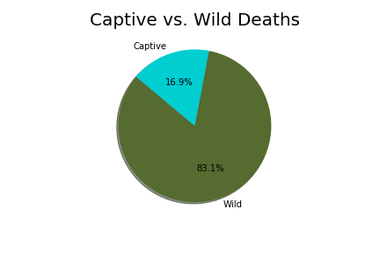

Most identified deaths were from people hunting, suggesting they were out seeking secluded area with other animals or even seeking out the bears. The “Other” category could be further identified using text mining techniques to seek further answers to what the victims were doing when they died.

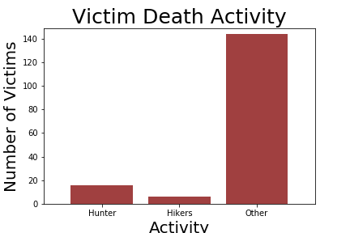

Have Killings Decreased Over Time?

The team looked at the total death count by year to see if there is a noticeable trend over time. As the graph below shows, it seems that total deaths have increased. There could be a few reasons for this, such as overall population increase, travel convenience to secluded areas (easier to travel to national parks, zoos, or hiking/hunting areas), and better data tracking statistics with the evolution of technology.

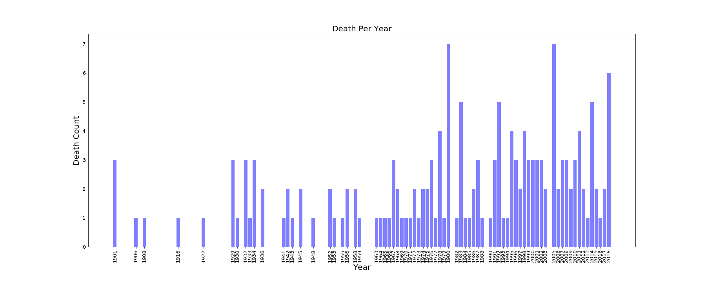

Another way to analyze death count over time is how it spreads throughout the year. Deaths occur mostly during May through October, most likely when bears are not in hibernation and when people are outside enjoying nature the most during the year.

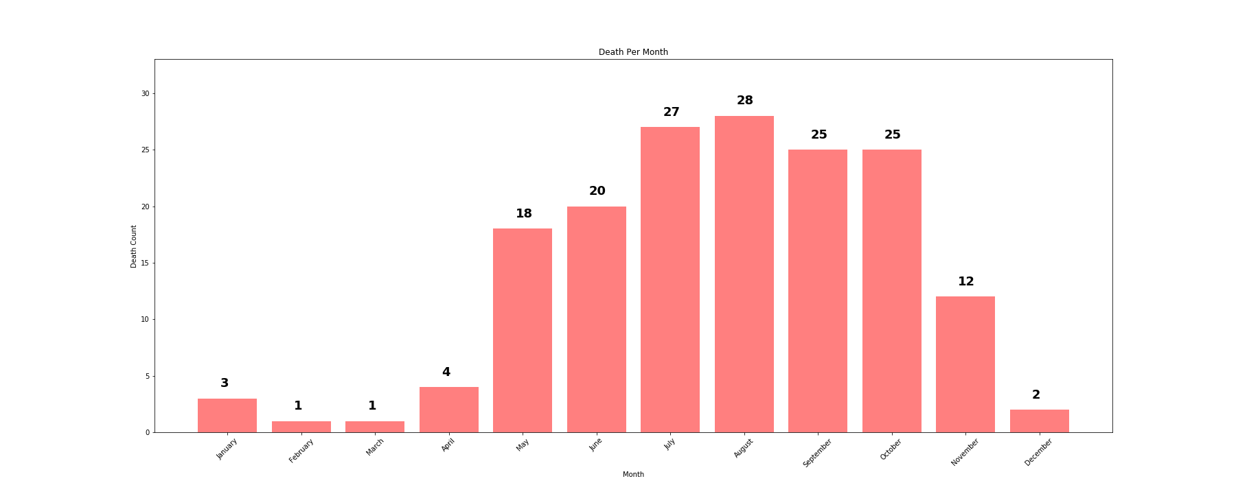

One more thing the team wondered was if deaths from bears in captivity has changed. Relatively, it has decreased in frequencies, suggesting (regardless of increase population and attendance) zoos have increased safety measures with bears in captivity or fewer zoos have bears in captivity.

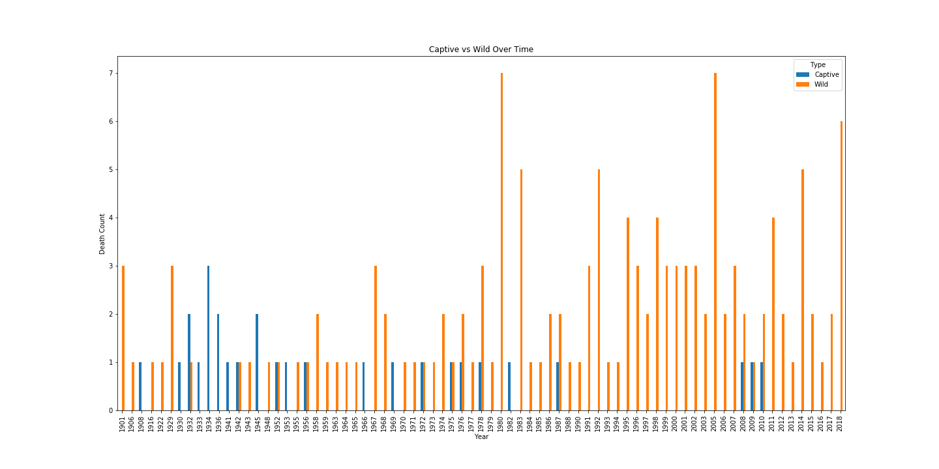

Where Do They Occur?

Most of the bear killings recorded in the dataset were near Glacier National Park, Montana or Yellowstone National Park. The graphs below only record locations with 2 or more deaths to see recurring deaths. Most of these deaths occur north in Alaska or Canada, and could occur in National Parks because of the tourism attraction to areas where bears live.

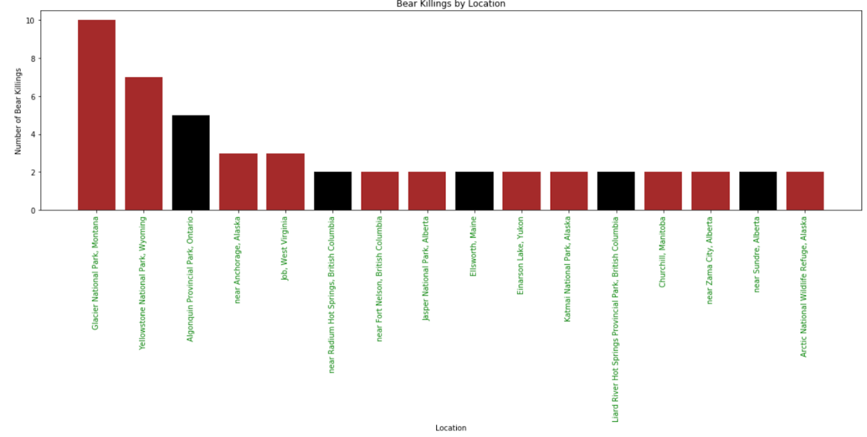

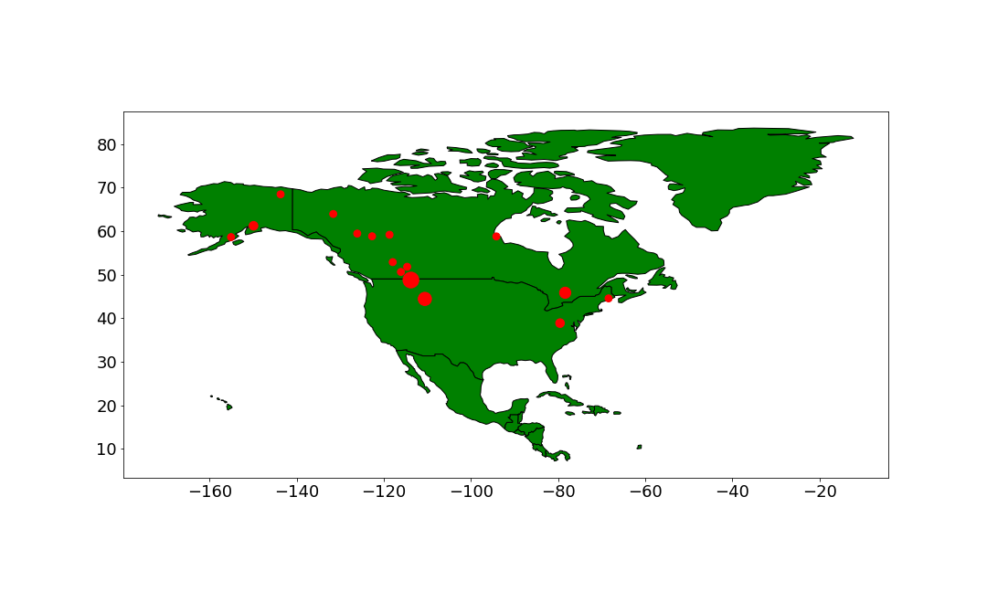

**Summary**

People understand that bears are dangerous, but sometimes face unlucky fates when they encounter them both in the wild and in captivity. Deciding the best way to visualize the important information without too many colorful and overwhelming graphs was the most difficult part.

Adult men between the ages of 40 and 60 are the majority of the deceased, and in every age category there were more males that died than females. This may be because men are more often seeking outside activities such as hiking, camping, or hiking where bears habitat. Out of the 16 hunters, one was a woman and 1 out of 6 hikers was female.

The type of bear that kills most frequently from the dataset are brown bears, closely ahead of black bears. According to bearsmart.com[2], black bears are the most common within this region and can provide reason to the higher recorded deaths. Although polar bears are massive and possibly the most dangerous, they live in Arctic areas with fewer population densities. Wild deaths occur more often and looking at death count over the years, occur more often as time passes­— most likely correlated with population increase. Captive deaths recorded have not increased however, possibly signifying zoos increasing safety in zoos. When people are outside the most (May-October) and when bears are not hibernating gives no surprise to the seasonal trend of increased bear killings.

Most bear killings occur in the northern area of North America, more specifically Canada, although the highest death count is in Glacier National Park, Montana. Out of the top 16 locations, 5 are national parks or wildlife refuge site that may relate to more people seeking these areas that bears live in.

1. *https://data.world/ajsanne/north-america-bear-killings/file/north_america_bear_killings.csv
2. http://www.bearsmart.com/about-bears/north-americas-bears/