Guidelines for Shop and Bill application

0.0 Introduction

This document provides the general guidelines to be followed during a project. The guidelines are broadly divided into Application, Data, Logic, UI (user interface) and Coding guidelines.

* 1. Document History

This section captures the changes made to this document, in particular, when the changes were made (“Date” in DD-MM-YYYY format), who made the changes (“Editor”) and the specific changes made by the Editor (“Changes Done”).

* Editor : Vivek

Date : 23-07-2014

1.0 Application Guidelines

The following are the general guidelines to be followed for the development of the application.

NOTE:

* All text in quotes “” are to be literally used (without the quotes),
* The ‘+’ symbol indicating concatenation.
* Text between angle brackets <> are merely placeholders that are to be replaced (along with the brackets) by the appropriate names.
* Numbers such as 1, 1.1, etc. within the <> are merely indicative of a series, and are to be removed along with the brackets.

1.1 Files and Folders Naming Convention

1. All files and folders are in lower case and must have no spaces in their names (use underscore if required). EXCEPTION is allowed for the files and folders under the third party “lib” folder.
2. Avoid non-alphanumeric characters in the names of the files and folders.
3. Try to use Single word name for every files or folders.
4. JS file name are same as the view file name.

1.2Application Folder Structure

The following folder structure is to be followed for the application.

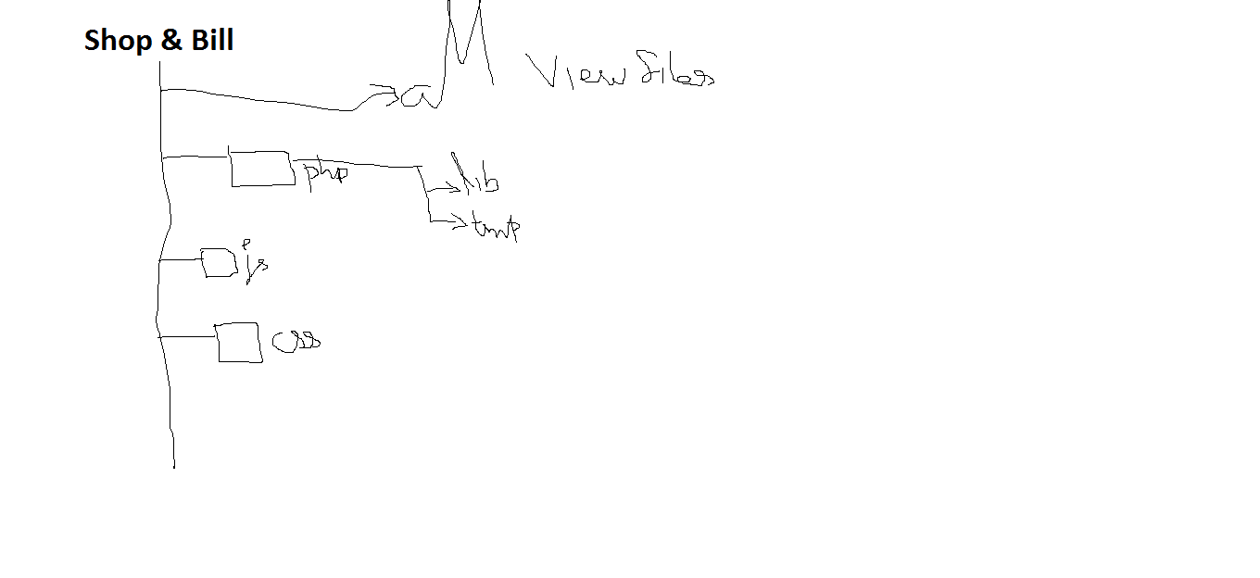

2.0 DATA GUIDELINES

The following are the general guidelines to be followed for specifying the data of the application.

2.1 Database Naming Convention

1. All table name and columns are also in lower case,
2. Primary and Foreign key columns should end in “id”.
3. Columns of type datetime should end in “dt”.
4. Columns of type flag should end in “flag”.
5. Columns storing paths should end in “url”.
6. Only the identifier and name columns (and maybe other columns that are used in JOINs) can have the table name as prefix. All other columns should not have table name as prefix.
   1. Data Types

The data types that are allowed to be used for different columns are as noted below:

|  |  |
| --- | --- |
| Data Type | Usage |
| Int | For identifiers– columns ending in “id” |
| Varchar(20) | For constant values, simple status |
| Varchar(100) | For small strings, such as name, code, etc. – these are received using Text Fields in the user interface |
| Varchar(250) | For longer strings, such as description – these are received using Text Area Fields in the user interface |
| Varchar(500) | For storing URLs – columns ending in “URL” |
| Varchar(1000) | For comma separated lists (CSL) |
| Text | For large text such as HTML text – these are received using HTML Text Field in the user interface |
| Float | For storing currency values such as amount, price, and quantity like 1.2kg etc. <When a currency value is stored, there MUST be additional column named “currency” storing the symbol of the currency in which the value is specified>. |
| DateTime | For storing dates and/or time – these are received using Calendar and Time Fields. These are columns ending in “DT”. |
| Char(1) | For specifying a flag using two values ‘T’ (true) or ‘F’ false. These are columns ending in “flag” |
|  |  |
|  |  |
|  |  |
|  |  |
|  |  |
|  |  |