1. Creating and Renaming Files/Directories
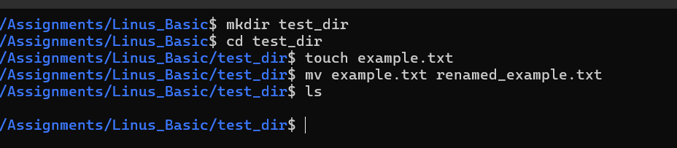
2. Viewing File Contents
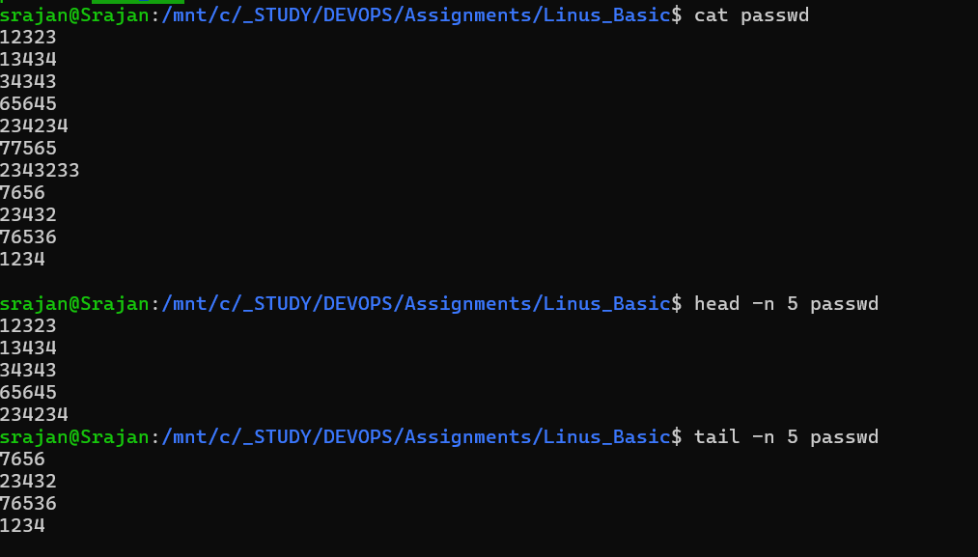
3.Searching for Patterns
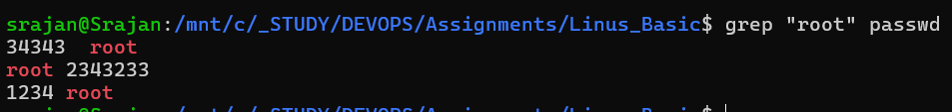
4. Zipping and Unzipping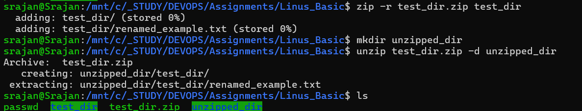
5. Downloading Files
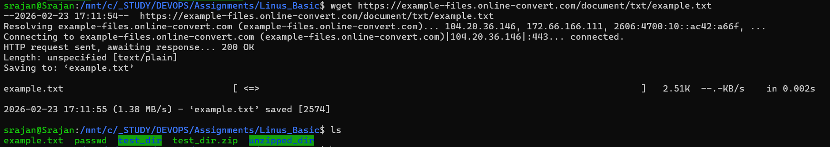
6. Changing Permissions
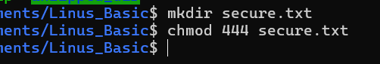
7. Working with Environment Variables

