Data:

4 Pollutants - [ *Chloroform, Benzene, Lead PM2.5 LC, Arsenic PM2.5 LC* ]

All the cities in [***Texas***] State

Period of Data: Years [*2009 to 2014*]

## Data Acquisition:

Converted the data frames from R into CSV files, and then loaded into neo4j:

*#Load the City Data into the node: "City"*

load csv with headers from "file:C:/Users/Suman/Documents/city-data.csv" as city create (a:City {cityname:city.city, statename: city.state })

*#Load the Pollutant Data into the node: "Pollutant"*

load csv with headers from "file:C:/Users/Suman/Documents/pollutant-data.csv" as pollutant create (b:Pollutant {code:pollutant.code, name: pollutant.name })

*#Establish relationship between City <--- Observations ---> Pollutant*

load csv with headers from "file:C:/Users/Suman/Documents/observation-data.csv" as observation match (a: City {cityname: observation.city, statename: observation.state}), (b: Pollutant {code: observation.code}) create (a) - [r:Observations {year: observation.year, measurement: observation.measurement}] -> (b)

match (a:**City**) return (a)

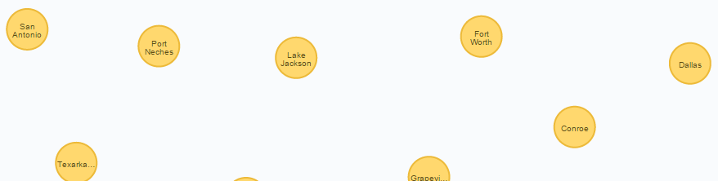

match (b:**Pollutant**) return (b)

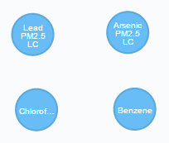

(a:City) - [:**Observations**] -> (b: Pollutant) 🡺 Observations has ‘**year’** and ‘**measurement’**

match (n) return (n)

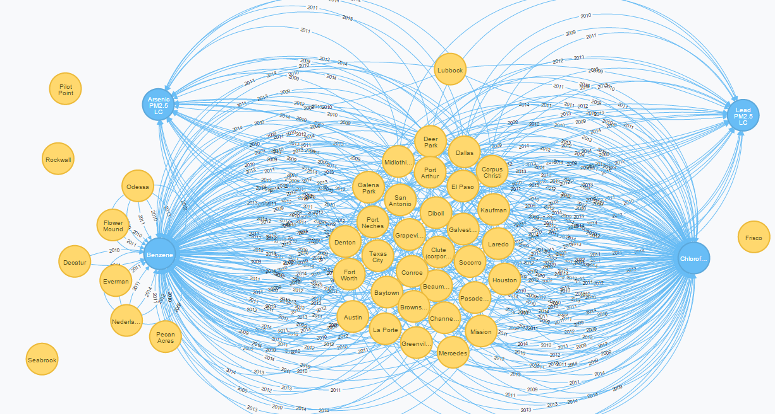

## Data Analysis:

*#Dispaly the pollutant data 'Lead PM2.5 LC' in Dallas:*

match p = (a:City) - [r1:Observations] -> (b:Pollutant) where a.cityname='Dallas' and a.statename='Texas' and b.name='Lead PM2.5 LC' return p

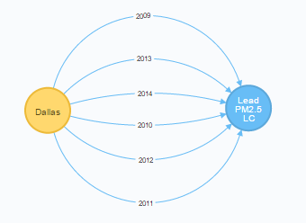

*#Explore* ***All*** *of Dallas Polllution Data*

match p = (a:City) - [r1:Observations ] -> (b:Pollutant) where a.cityname = 'Dallas' and a.statename='Texas' return a,b

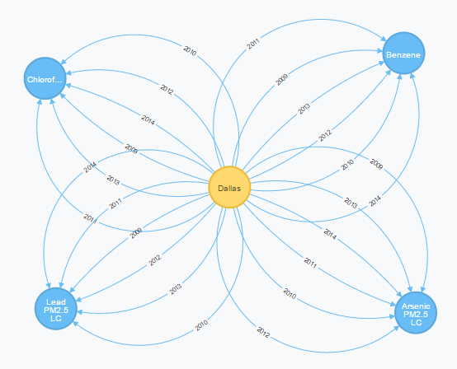

Dallas shows the presence of all **4** pollutants for all 6 years

*#Explore all of the Austin, Houston Polllution Data*

match p = (a:City) - [r1:Observations ] -> (b:Pollutant) where a.cityname IN ['Austin','Houston'] and a.statename='Texas' return a,b

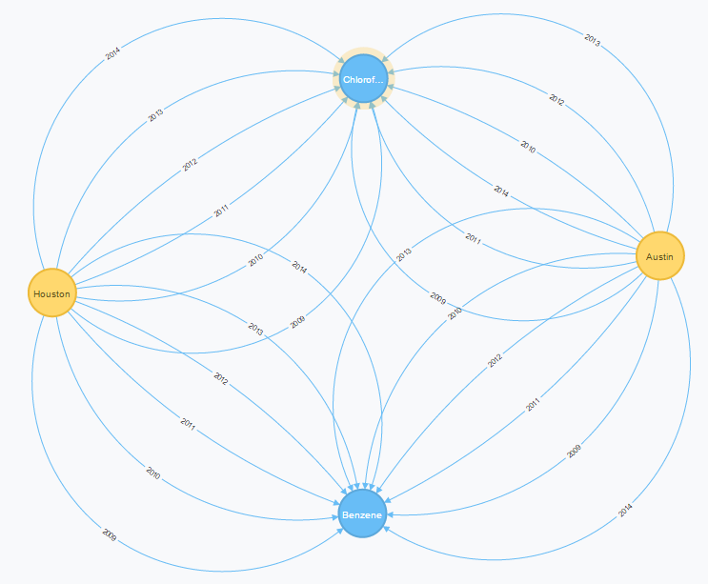

Unlike Dallas, the cities Austin and Houston shows the presence of **2** pollutants for all 6 years.

*#Dispaly top 5 Cities in Texas with highest measurement for the pollutant data - 'Lead PM2.5 LC' :*

match p = (a:City) - [r1:Observations] -> (b:Pollutant) where a.statename='Texas' and b.name='Lead PM2.5 LC' return a.cityname as City, max(r1.measurement) as Lead_PM2_5_Annual_Measure order by Lead_PM2_5_Annual_Measure desc limit 5

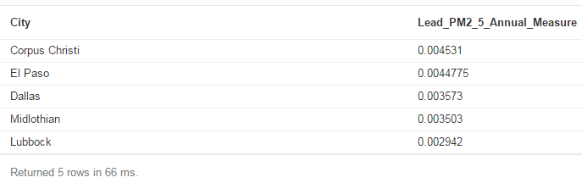

*#Display ALL the Cities with the presence of* ***all 4 hazardous pollutants*** *in the year* ***2014***

match (a:City) - [r1:Observations { year: '2014'} ] -> (b:Pollutant) with a.cityname as City, count(r1) as PollutantCount where PollutantCount = 4 return City, PollutantCount;

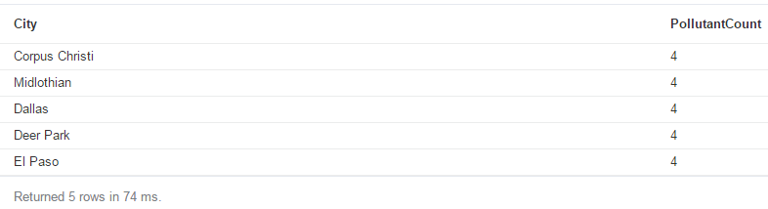

*#Display the Cities in Texas with* ***absolutely NO presence*** *of these 4 hazardous pollutants in the last 6 years [ 2009-14]*

match (a:City) where NOT (a)-[:Observations]->() return a

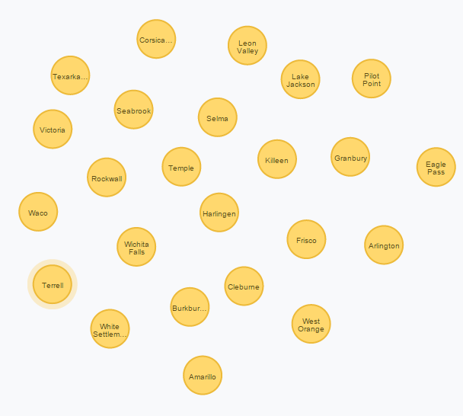

--Returns 24 Cities out of 62 ==> which is **38.7% of Texas**.