**Defects-**

**Defect Summary**- 404 error screen is appeared after clicking on Goal tab, website logo, Get Started button.

**1st Observation-:**

**Actual**- When User click on ‘Our Approach tab in menu bar and then click on Goal tab, 404 error screen is appeared.

**Expected**- After click on Goal tab, 404 error screen should not be appear.

Steps To Reproduced-

1. User login to personalnutrition.com website.
2. User navigated to Home page/Goal tab.
3. Then User clicked on Our Approach tab in menu bar.
4. Then User click on Goal tab, 404 error screen is shown.

When user select Our approach tab-

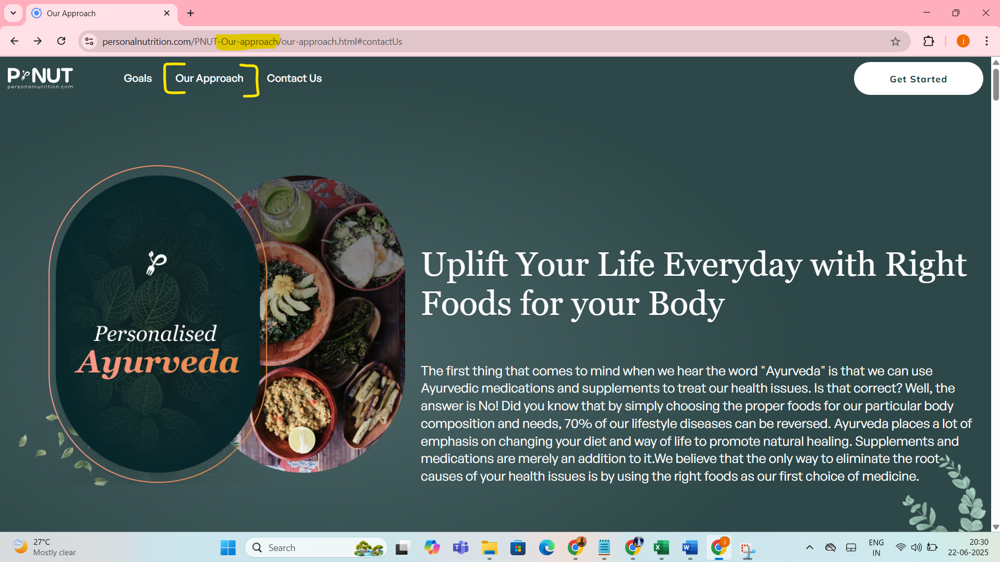

And then User clicked on Goal tab-

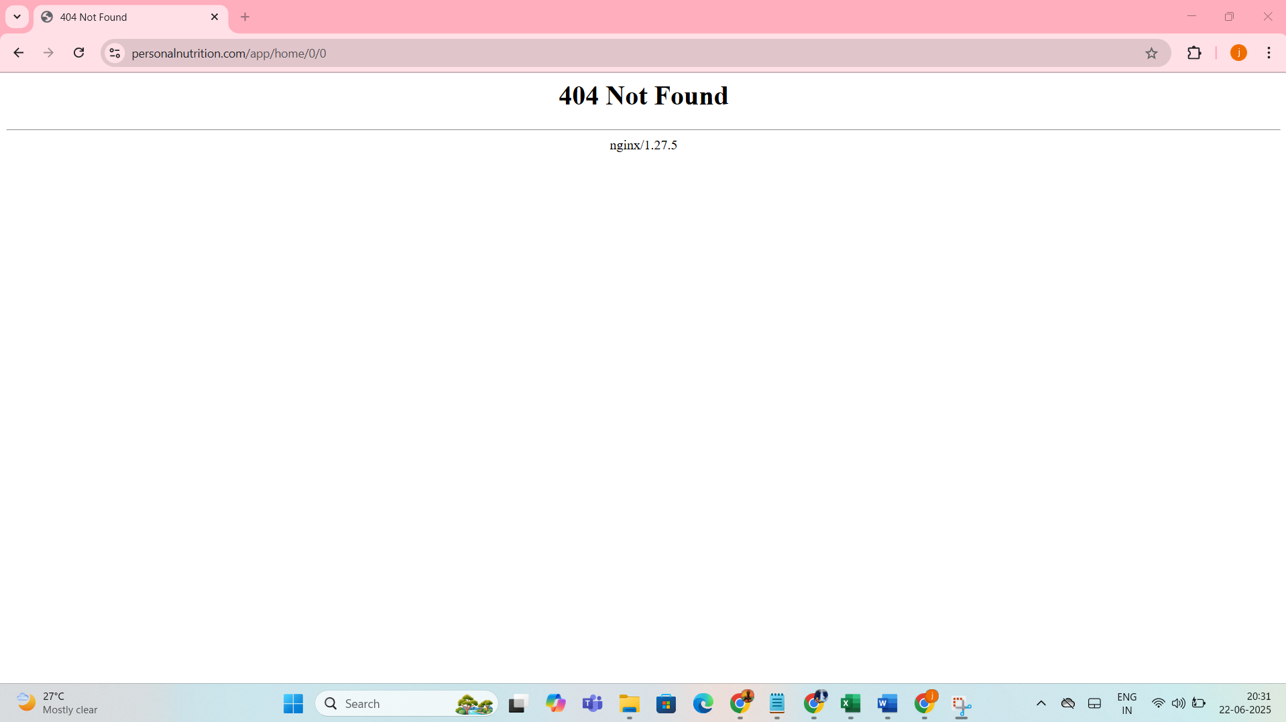

2nd Observation-

Actual- When User select Goal tab, user navigated to goal page, but menu bar is disappeared.

Expected- Menu bar should not be disappeared.

Steps to Reproduced-

1. User login to personalnutrition.com website.
2. User navigated to Home page/Goal tab.
3. After navigated to Goal page, menu bar is disappeared.
4. User facing difficulty to navigate back to home page.

