Financial News Sentiment Analysis Pipeline
An end-to-end MLOps pipeline that classifies financial news into Positive, Negative, or Neutral sentiments. This project demonstrates the transition from a research model (Fine-tuned DistilBERT) to a production-ready API.
- Overview
This repository contains a high-performance REST API designed to process financial text. Unlike general sentiment models, this pipeline is optimized for financial terminology (e.g., "bearish," "surged," "guidance").
- Dataset & Model Details
The underlying model is a DistilBERT-base-uncased transformer, fine-tuned on financial text to capture industry-specific nuances.
Training Data (Financial PhraseBank)
Total Instances: 4,840 labeled sentences.
Content: Sentences from financial news articles (e.g., earnings reports, mergers, market trends).
Labels:
Positive: Indicating growth, exceeding expectations, or market gains.
Neutral: Factual statements or scheduled corporate events.
Negative: Indicating losses, lawsuits, or economic downturns.
Class Distribution: The dataset contains a realistic mix, with a high volume of neutral statements to reflect real-world financial reporting.
- Model Selection : Why DistilBert ?
For this pipeline, DistilBERT was chosen over the standard BERT model for several production-related reasons:
Latency: DistilBERT is 60% faster than BERT-base, ensuring our /predict endpoint remains responsive under load.
Resource Efficiency: It has 40% fewer parameters and a smaller memory footprint, significantly reducing Docker image size and cloud hosting costs.
Performance Retention: It retains roughly 97% of BERT's language understanding capabilities, making it the "sweet spot" for financial sentiment tasks where millisecond speed matters.
- Key Features
Core Model: Fine-tuned DistilBERT (Transformer) specialized for financial sentiment.
Backend: Built with FastAPI for high-speed, asynchronous inference.
Containerization: Fully Dockerized to ensure environment consistency across any machine.
Observability: Integrated logging to track prediction history, confidence scores, and latency.

- Architecture
The pipeline follows a modular microservice pattern:
Client Interface: Uses FastAPI’s interactive Swagger UI for real-time testing.
API Layer: An asynchronous FastAPI web server handling request validation via Pydantic
Inference Engine: A fine-tuned DistilBERT transformer that processes text inputs on the CPU
Logging System: A multi-handler logger that captures metadata (sentiment, confidence, latency) into api_usage.log
Response: returned with sentiment and confidence
Deployment: The entire stack is encapsulated in a Docker container for environment parity.

- Technology Stack
Language: Python 3.11
AI/ML: HuggingFace Transformers, PyTorch
API Framework: FastAPI, Uvicorn, Pydantic
Infrastructure: Docker
Monitoring: Python Logging Library (File & Stream handlers)

- Getting Started
Prerequisites
- Docker Desktop installed
- Git installed
A . Build the Image
Navigate to the project root and build the Docker container:
docker build -t financial-ai-api .
B. Run the Service
Run the container and map the port. Volume is used to persist logs from the container to the local machine:
docker run -p 8000:8000 -v "${PWD}:/app" financial-ai-api

- API Usage
Once the container is running, the home page looks like:
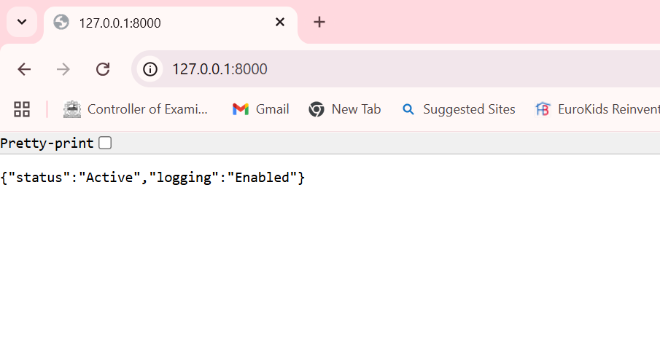
The interactive documentation is available at: URL: http://127.0.0.1:8000/docs
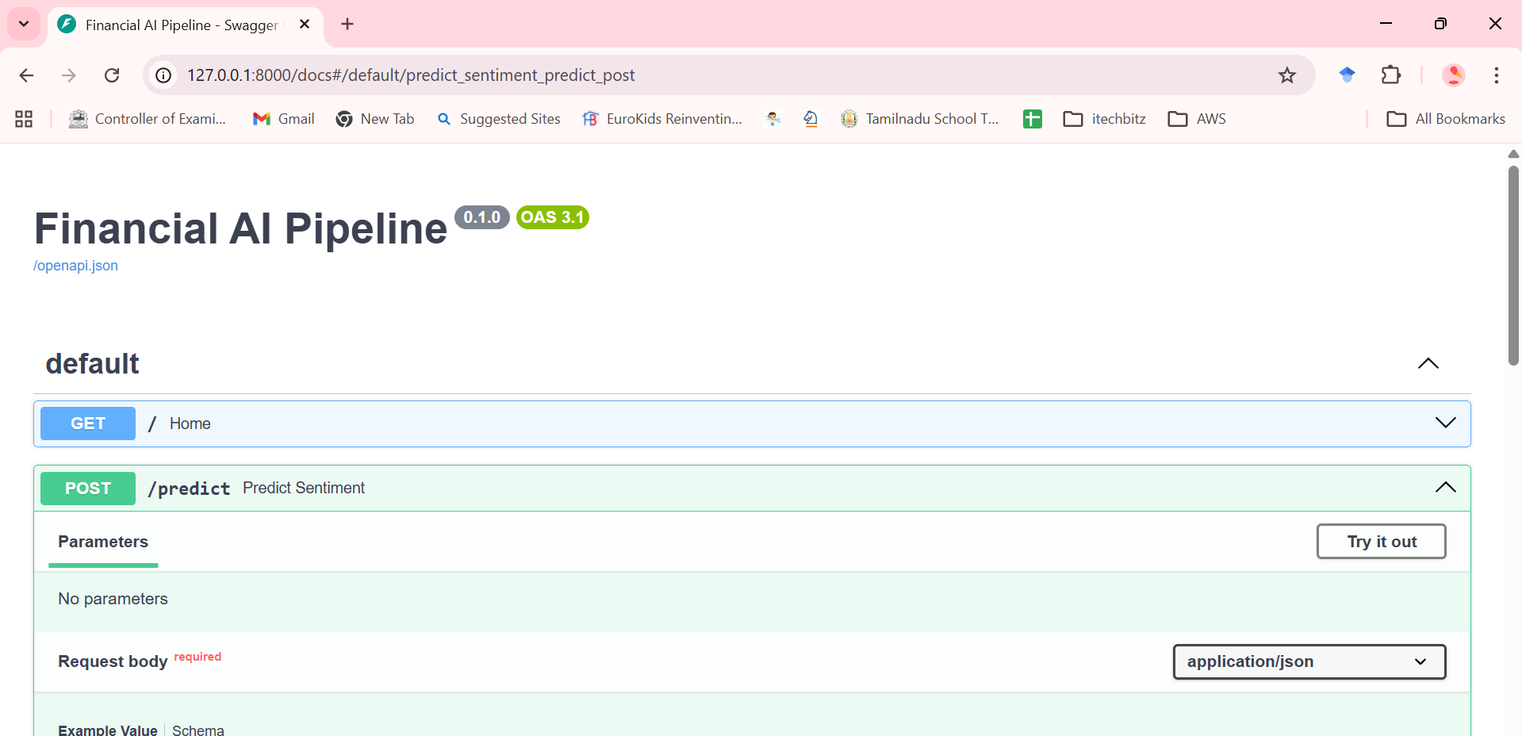

To make prediction: click POST -> click Try it out -> then enter the string in Request Body
For the given input string:
Request Body:
{Trading remained relatively flat during the morning session as investors awaited the upcoming employment data from the Bureau of Labor Statistics}.
The model prediction:
Response:

{
"sentiment": "Negative",
"confidence": 0.7355,
"status": "Success"
}

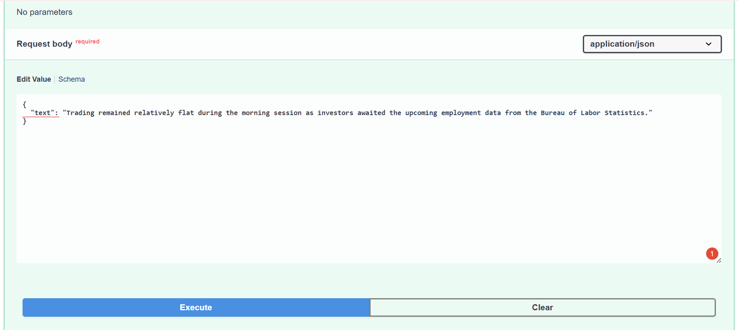
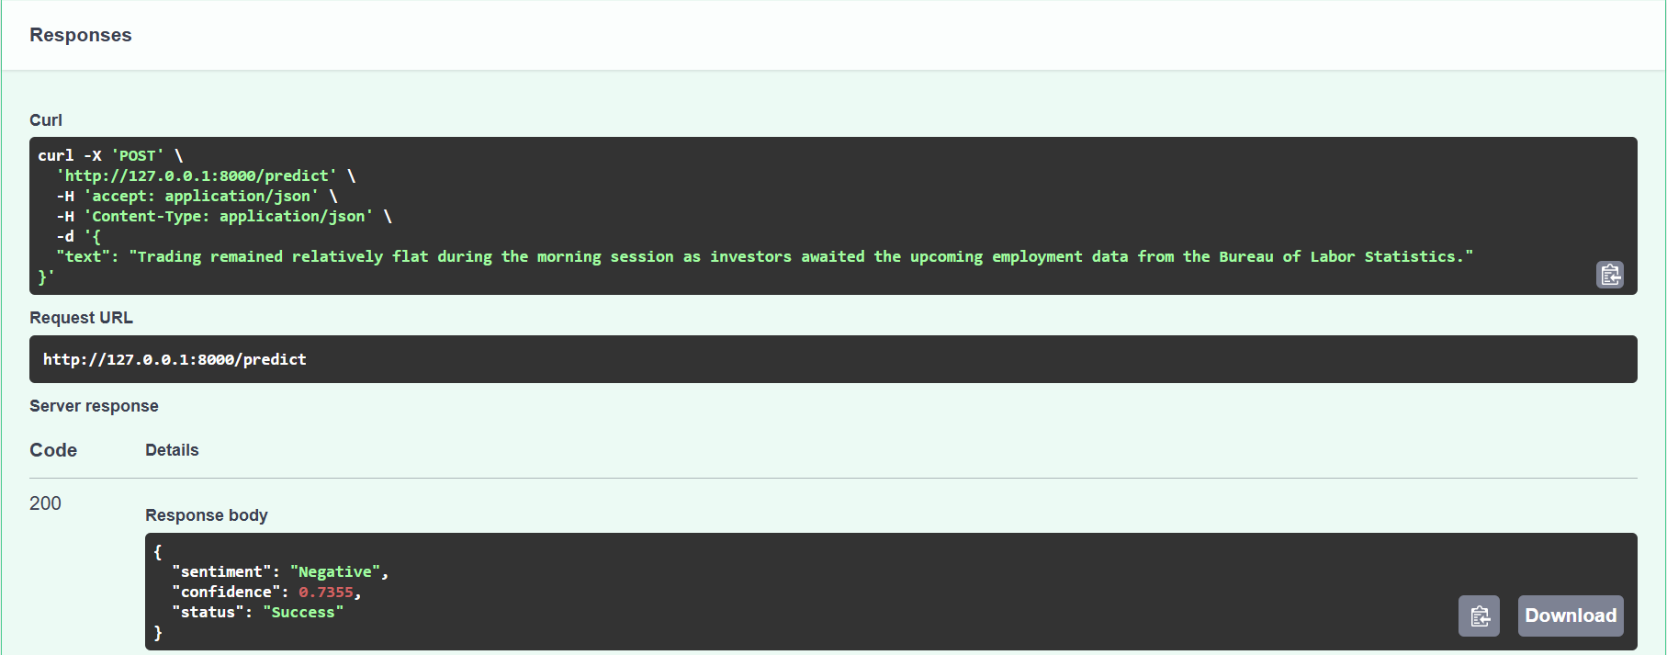

- Logging and Monitoring
The system automatically generates an api_usage.log file. The details I had logged are as follows:
- Timestamp: When the prediction occurred.
- Input Metadata: Snippet of the processed text.
- Model Output: Predicted label and confidence level.
- Latency: Time taken for the inference to complete.
- Project Structure:
app.py # FastAPI application & Logging logic
Dockerfile # Container configuration
requirements.txt # Project dependencies
model_final/ # Fine-tuned DistilBERT model weights
api_usage.log # (Auto-generated) Production logs
- Performance Metrics
Based on production logs, the model demonstrates high certainty on clear-cut financial signals:
    - Predictive Confidence
- Strong Positive/Neutral Signals: Achieved confidence scores of 97.9% (Revenue Surge) and 99.1% (Central Bank schedules).
- Edge Case Handling: Identified complex "Airline Recovery" news with 95.7% confidence.
- Observation: The model shows lower confidence (56%) on dense numerical earnings comparisons, highlighting an area for future fine-tuning with more quantitative financial reports.

    - Operational Latency
The logging system tracked the time taken from the moment the API received the text to the moment the prediction was returned (Inference Latency):
- Average Inference Speed: 105ms – 120ms per request.
- Cold Start Latency: A one-time spike of 1.3s – 1.9s was observed during the initial model loading phase, which is standard for Transformer models on CPU-based containers.
- Optimized Throughput: By utilizing FastAPI’s asynchronous architecture, the service remains non-blocking, allowing for high-frequency prediction requests.
Because I used FastAPI instead of Flask, the system is "Asynchronous." This means while the model is busy processing one news, the API can already start receiving the next one, preventing a traffic jam of data.

- Challenges
1. The Environment Consistency Problem
Challenge: The model worked in Google Colab but failed on my local machine due to library version mismatches (PyTorch/Transformers).
Solution: Implemented Docker to containerize the environment, ensuring the exact same versions of Python and torch are used regardless of where the app is deployed.

2. Port Mapping & Networking
Challenge: Encountered ERR_ADDRESS_INVALID when trying to access the API via the container's internal IP.
Solution: Configured explicit port forwarding (-p 8000:8000) and mapped the host's localhost to the container's 0.0.0.0 listener.

3. Data Persistence in Containers
Challenge: Log files (api_usage.log) were being deleted every time the container was stopped or rebuilt.
Solution: Used Docker Bind Mounts (Volumes) to link the container's log directory to the host machine, ensuring persistent monitoring data even after container restarts.

