Steps to run

1. Run the main.py as python main.py

It will train and store the model.

For experimentation, the latest model is considered as production

1. Connect with mlflow

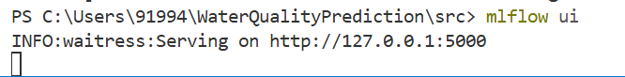

This will make:

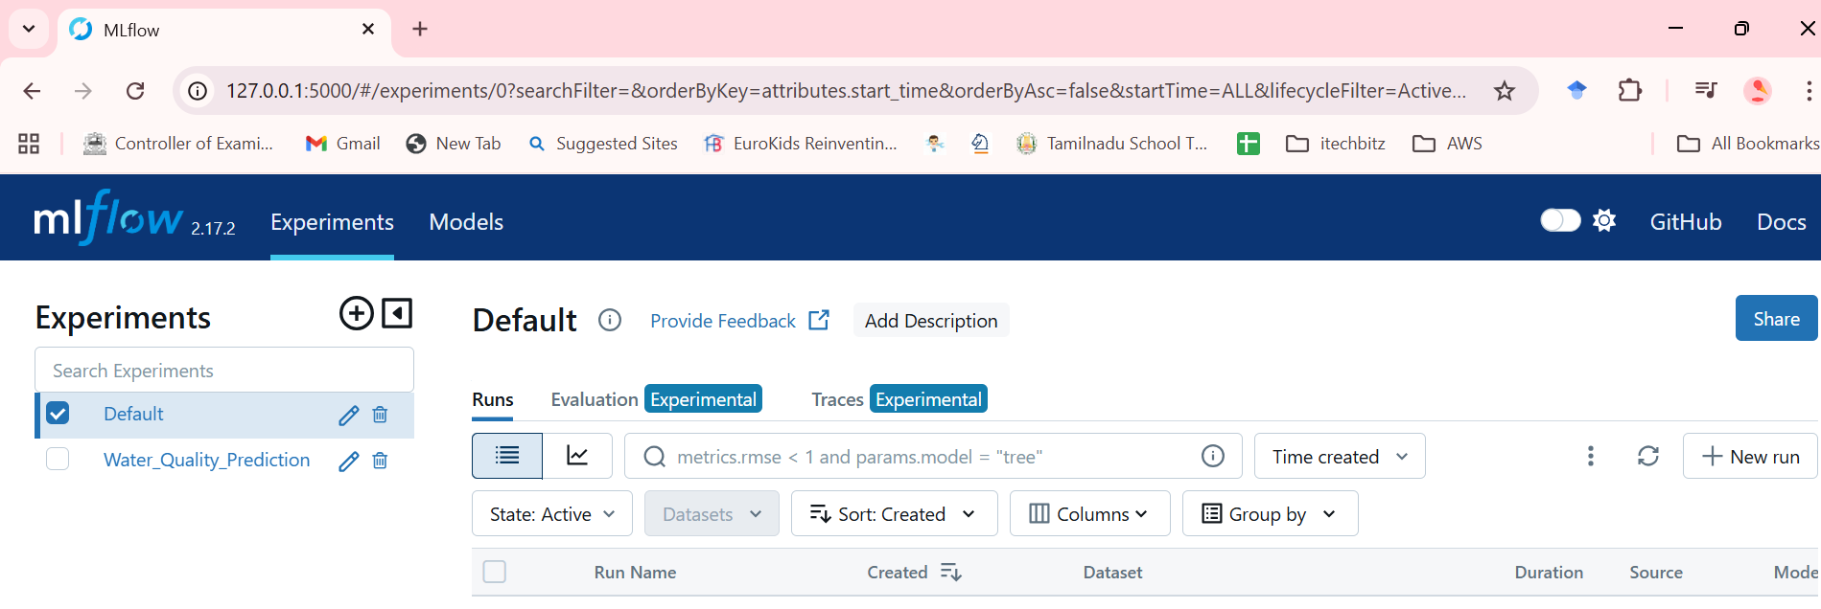

1. Then, run the flasapp.py as

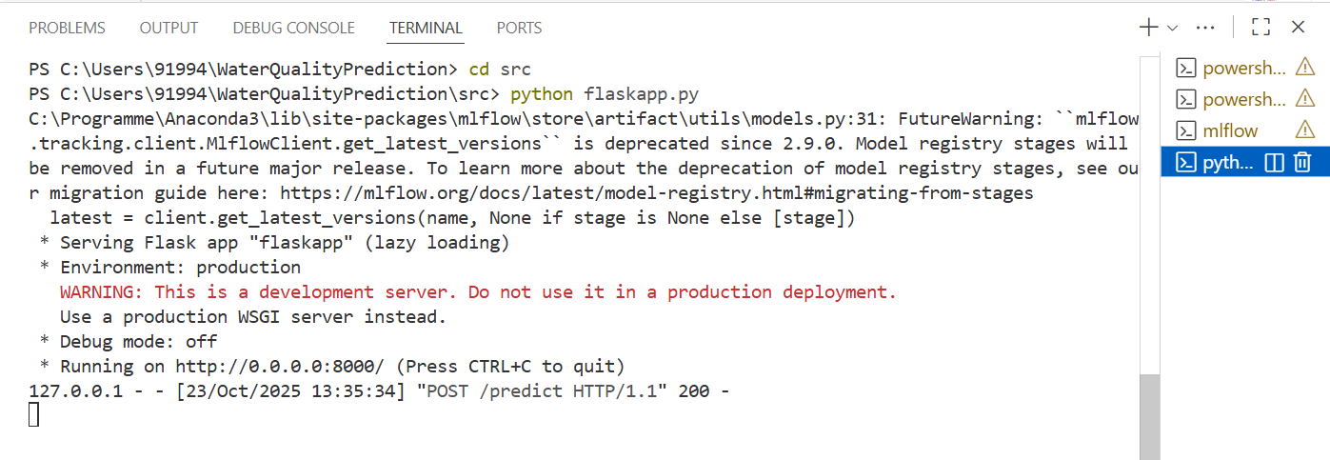

1. Open Postman:

Send the post request as json. Choose raw, post, and type the URL before **Send**

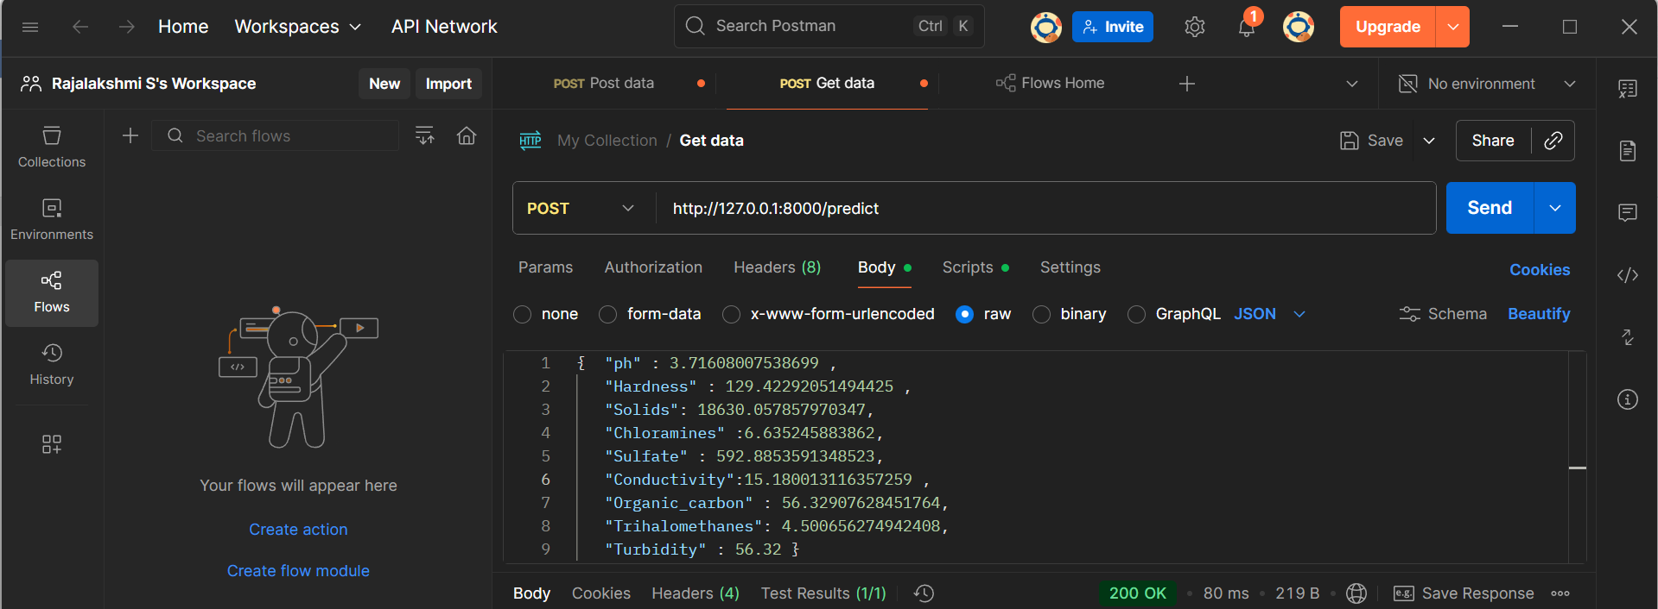

On clicking send, the response will be seen as:

