LEARNSPHERE: A PERSONALIZED LEARNING MANAGEMENT PLATFORM

A PROJECT BASED LEARNING (PBL) REPORT
Submitted
by
S.Rajit (2104251040821)

Submitted in partial fulfilment of the requirements
for the
Project-Based Learning component of Java Programming

BACHELOR OF ENGINEERING

in

COMPUTER SCIENCE AND ENGINEERING


CHENNAI INSTITUTE OF TECHNOLOGY
(Autonomous)

Affiliated to Anna University, Chennai
October - 2026

Vision of the Institute:

To be an eminent centre for Academia, Industry and Research by imparting knowledge, relevant practices and inculcating human values to address global challenges through novelty and sustainability.

Mission of the Institute:

IM1. To creates next generation leaders by effective teaching learning
methodologies and in still Scientifics park in them to meet the global challenges.
IM2. To transform lives through deployment of emerging technology, novelty and sustainability.
IM3. To inculcate human values and ethical principles to cater the societal needs.
IM4. To contributes towards the research ecosystem by providing a suitable,
effective platform for interaction between industry, academia and R&D establishments.
IM5: To nurture incubation centers enabling structured entrepreneurship and start-ups

DEPARTMENT OF

COMPUTER SCIENCE AND ENGINEERING

Vision of the Department:

To Excel in the emerging areas of Computer Science and Engineering by imparting knowledge, relevant practices and inculcating human values to transform the students as potential resources to contribute innovatively through advanced computing in real time situations.

Mission of the Department:

DM1. To provide strong fundamentals and technical skills for Computer Science
applications through effective teaching learning methodologies.
DM2. To transform lives of the students by nurturing ethical values, creativity and novelty to become Entrepreneurs and establish start-ups.
DM3. To habituate the students to focus on sustainable solutions to improve the quality of life and the welfare of the society.
DM4: To enhance the fabric of research in computing through collaborative linkages with industry and academia.
DM5: To inculcate learning of the emerging technologies to pursue higher studies leading to lifelong learning.

PROGRAM EDUCATIONAL OBJECTIVES (PEO):

PEO 1: Contribute to the industry as an Engineer through sound knowledge acquired in core engineering to develop new processes and implement the solutions for industrial problems.
PEO 2: Establish an organization / industry as an Entrepreneur with professionalism, leadership quality, teamwork, and ethical values to meet the societal needs.
PEO 3: Create a better future by pursuing higher education / research and develop the sustainable products / solutions to meet the demand.

PROGRAM OUTCOMES (POS):
PO1: Engineering Knowledge: Apply knowledge of mathematics, natural science, computing, engineering fundamentals and an engineering specialization to develop to the solution of complex engineering problems.
PO2: Problem Analysis: Identify, formulate, review research literature and analyze complex engineering problems reaching substantiated conclusions with consideration for sustainable development.
PO3: Design/Development of Solutions: Design creative solutions for complex engineering problems and design/develop systems/components/processes to meet identified needs with consideration for the public health and safety, whole-life cost, net zero carbon, culture, society and environment as required
PO4: Conduct Investigations of Complex Problems: Conduct investigations of complex engineering problems using research-based knowledge including design of experiments, modelling, analysis & interpretation of data to provide valid conclusions
PO5: Engineering Tool Usage: Create, select and apply appropriate techniques, resources and modern engineering & IT tools, including prediction and modelling recognizing their limitations to solve complex engineering problems.
PO6: The Engineer and The World: Analyze and evaluate societal and environmental aspects while solving complex engineering problems for its impact on sustainability with reference to economy, health, safety, legal framework, culture and environment.
PO7: Ethics: Apply ethical principles and commit to professional ethics, human values, diversity and inclusion; adhere to national & international laws.
PO8: Individual and Collaborative Team work: Function effectively as an individual, and as a member or leader in diverse/multi-disciplinary teams.
PO9: Communication: Communicate effectively and inclusively within the engineering community and society at large, such as being able to comprehend and write effective reports and design documentation, make effective presentations considering cultural, language, and learning differences.
PO10: Project Management and Finance: Apply knowledge and understanding of engineering management principles and economic decision-making and apply these to one’s own work, as a member and leader in a team, and to manage projects and in multidisciplinary environments.
PO11: Life-Long Learning: Recognize the need for, and have the preparation and ability for i) independent and life-long learning ii) adaptability to new and emerging technologies and iii) critical thinking in the broadest context of technological change.

PROGRAM SPECIFIC OUTCOMES (PSOS):
PSO 1 : Analyse, design and develop solutions in the areas of Business Process Management to build the quality products for industry and social needs.
PSO 2 : Innovate ideas and solutions for real time problems in the field of Software Engineering and Mobile applications by adapting the emerging technologies and tools.

CHENNAI INSTITUTE OF TECHNOLOGY, CHENNAI
(Autonomous)
Affiliated to Anna University, Chennai

BONAFIDE CERTIFICATE

This is to certify that the Project–Based Learning report titled “LEARNSPHERE: A PERSONALIZED LEARNING MANAGEMENT PLATFORM” is a Bonafide record of work carried out by S.Rajit (2104251040821) and of the Department of Computer Science and Engineering, Chennai Institute of Technology, as part of the continuous, mentor–guided Project-Based Learning (PBL) component of the Java Programming course during the academic year 2026–2027 under my supervision.
SIGNATURE  Dr. S. Pavithra M.E., Ph. D  HEAD OF THE DEPARTMENT  Professor and Head,  Department of Computer Science and Engineering  Chennai Institute of Technology  Chennai - 69 | SIGNATURE  Dr. R. KAVITHA M.E., Ph. D  Supervisor  Associate Professor  Department of Computer Science and Engineering  Chennai Institute of Technology  Chennai - 69

Submitted for the final review held on …………………….

INTERNAL EXAMINER EXTERNAL EXAMINER

DECLARATION

I jointly declare that the PBL report on “LEARNSPHERE: A PERSONALIZED LEARNING MANAGEMENT PLATFORM” is the result of original work done by me and best of our knowledge, similar work has not been submitted to “ANNA UNIVERSITY CHENNAI” for the requirement of Degree of BACHELOR OF ENGINEERING. This PBL report is submitted on the partial fulfilment of the requirement of the award of Degree of COMPUTER SCIENCE AND ENGINEERING.

Signature

S.Rajit

Place:Chennai
Date:

ACKNOWLEDGEMENT

I wish to express our sincere gratitude to our honorable Chairman
SHRI.P. SRIRAM for providing immense facilities at our institution.

I am very proudly rendering our thanks to our Principal Dr.A.RAMESH M.E, Ph.D., for the facilities and the encouragement given by him to the progress and completion of our project.
I would like to express special thanks of gratitude to our Dean Dr. V. SRINIVASA RAO, M.E., Ph.D., who has been the key spring of motivation to us throughout the completion of our course and project work.
I proudly render our immense gratitude to the Head of the Department Dr.S.PAVITHRA M.E, Ph.D., for her effective leadership, encouragement and guidance in the project.
I would like to extend our thanks to the Project Co-ordinator Mrs.M GEETHA M.E., Assistant Professor, Department of Computer Science and Engineering, for their valuable suggestions throughout this project.
I wish to acknowledge the help received from our Java Faculty Mrs.M GEETHA M.E., Assistant Professor of the Department of Computer Science and Engineering and others for providing valuable suggestions and for the successful completion of the project.

S.Rajit 2104251040821

ABSTRACT

Traditional academic institutions rely on fragmented, manual systems for managing course delivery, student assessments, and performance tracking, creating inefficiency and limiting student engagement. This project develops LearnSphere, a personalized Learning Management Platform built on Spring Boot that unifies course management, video-based learning, MCQ assessments, and academic analytics into a single web application. The system implements a layered MVC architecture using Spring Boot 3.2.5, Thymeleaf for server-side rendering, Spring Security 6 for role-based access control with BCrypt password hashing, and Spring Data JPA with Hibernate for object-relational persistence on an H2 in-memory database. Three distinct roles — Student, Faculty, and Administrator — interact through dedicated dashboards: students access enrolled courses with embedded YouTube video playlists, attempt auto-graded MCQ quizzes, and visualize semester-wise academic performance through Chart.js bar charts with GPA and CGPA computation; faculty members create courses, manage video content, design quizzes with explanations, and enter internal and external marks; administrators oversee the entire platform. The system seeds realistic demonstration data at startup through a CommandLineRunner, including four student profiles across three semesters, five courses with twenty-seven videos, four quizzes containing twenty-nine questions, and sixty academic result records. The final implementation compiles cleanly across thirty-five source files with zero errors, starts in under ten seconds, and provides a responsive dark-themed interface that communicates academic progress effectively.

Keywords: Spring Boot, Thymeleaf, Spring Security, JPA/Hibernate, Role-Based Access Control, Learning Management System

TABLE OF CONTENTS

Chapter No. | Title | Page No.
 | ABSTRACT | vi
 | LIST OF TABLES | ix
 | LIST OF FIGURES | x
 | LIST OF ABBREVIATIONS | xi
1 | INTRODUCTION | 14
 | 1.1 Background | 1
 | 1.2 Driving Question | 1
 | 1.3 Objectives | 2
 | 1.4 Scope and Limitations | 3
2 | CONCEPT EXPLORATION | 18
 | 2.1 Related Approaches | 4
 | 2.2 Summary Table | 5
 | 2.3 What This Told Us | 5
3 | PROJECT PLANNING AND TEAM ORGANISATION | 20
 | 3.1 Weekly PBL Progress Log | 6
 | 3.2 Requirements | 7
 | 3.3 Feasibility | 7
4 | ITERATIVE DESIGN AND DEVELOPMENT | 22
 | 4.1 System Architecture | 8
 | 4.2 Baseline | 9
 | 4.3 Project Refinement | 9
 | 4.4 Final Approach | 10
 | 4.5 Testing and Execution | 10
5 | IMPLEMENTATION | 20
 | 5.1 Module Description | 11
 | 5.2 Key Code Snippets | 12
 | 5.3 User Interface / Demo | 14
6 | RESULTS AND DISCUSSION | 30
 | 6.1 Evaluation Metrics | 16
 | 6.2 Results Across Iterations | 17
 | 6.3 Discussion | 17
 | 6.4 Limitations | 18
7 | TEAM REFLECTION AND LEARNING OUTCOMES | 32
 | 7.1 Individual Reflections | 19
 | 7.2 Team Learning | 19
 | 7.3 Course Outcomes — Evidence Summary | 20
8 | CONCLUSION AND FUTURE SCOPE | 33
 | 8.1 Conclusion | 21
 | 8.2 Future Scope | 21
 | REFERENCES | 22
 | APPENDIX | 23

LIST OF TABLES

Table No. | Title | Page No.
2.1 | Summary of Related Approaches | 5
3.1 | Weekly PBL Progress Log | 6
3.2 | Hardware and Software Requirements | 7
6.1 | Results Across Iterations | 17
A.1 | Self Assessment | 23

LIST OF FIGURES

Figure No. | Title | Page No.
4.1 | System Architecture of LearnSphere | 8
5.1 | Login Screen | 14
5.2 | Student Dashboard | 14
5.3 | Course Video Player | 15
5.4 | Quiz Attempt Interface | 15
5.5 | Academic Results Dashboard | 15

LIST OF ABBREVIATIONS

Abbreviation | Full Form
LMS | Learning Management System
MVC | Model-View-Controller
JPA | Java Persistence API
ORM | Object-Relational Mapping
JDBC | Java Database Connectivity
REST | Representational State Transfer
GPA | Grade Point Average
CGPA | Cumulative Grade Point Average
MCQ | Multiple Choice Question
RBAC | Role-Based Access Control
CRUD | Create, Read, Update, Delete
CDN | Content Delivery Network
UI | User Interface
API | Application Programming Interface

CHAPTER 1

INTRODUCTION

1.1 BACKGROUND
Educational institutions across India continue to manage critical academic functions — course material distribution, student assessments, result compilation, and performance analysis — through disconnected manual workflows or isolated legacy systems. A faculty member who designs a quiz typically distributes it on paper, grades it by hand, and records marks in a spreadsheet that no student can access until results are formally published. A student who wants to review course content, check quiz performance, and understand semester-wise academic progress must navigate multiple platforms or wait for administrative announcements.
Learning Management Systems address this fragmentation by centralizing academic activities behind a single authenticated interface. Commercial platforms such as Moodle and Google Classroom solve the problem at scale, but their architectures are opaque to the student developer: the security filter chain, the persistence layer, and the template rendering pipeline are all hidden behind configuration that a Java Programming course cannot inspect. This project treats that opacity as the learning opportunity.
LearnSphere is a full-stack web application built on Spring Boot in which every layer — from the JPA entity model through the Spring Security configuration to the Thymeleaf templates — is written by the team and left open to inspection. The system supports three roles (Student, Faculty, Administrator), manages courses with embedded YouTube video playlists, delivers auto-graded MCQ quizzes with detailed explanations, computes GPA and CGPA from internal and external marks, and visualizes performance through interactive Chart.js graphs.

1.2 DRIVING QUESTION
Can a production-quality Learning Management System — with role-based authentication, relational data persistence, server-side rendered dashboards, and interactive analytics — be built using Spring Boot and standard Java libraries, and will it demonstrate the full-stack capabilities expected of a Java Programming PBL project?
This question was narrowed into four concrete sub-questions:
1. How should the JPA entity relationships be modelled so that students, courses, quizzes, and academic results are connected through clean foreign-key constraints without circular dependencies?
2. How can Spring Security be configured to enforce three distinct roles (ROLE_STUDENT, ROLE_FACULTY, ROLE_ADMIN) with different URL-level access permissions through a single SecurityFilterChain bean?
3. How should quiz submission be processed so that answers are auto-graded against stored correct answers, scores are computed as percentages, and detailed per-question feedback is available for review?
4. How can academic results across multiple semesters be aggregated into GPA and CGPA, with grades assigned according to a defined grading scale, and presented visually using Chart.js through Thymeleaf templates?

1.3 OBJECTIVES
1. To design and implement a Spring Boot web application with a layered MVC architecture separating model entities, repository interfaces, service classes, controllers, and Thymeleaf views.
2. To configure Spring Security 6 for role-based access control with BCrypt password hashing, custom login/logout flows, and URL-pattern-based authorization for Student, Faculty, and Admin roles.
3. To model the academic domain using twelve JPA entities with appropriate relationships (OneToMany, ManyToOne) and persist them to an H2 in-memory database through Spring Data JPA repositories.
4. To implement MCQ quiz functionality including question management, timed quiz attempts, automatic grading with percentage calculation, and per-question explanations for student review.
5. To build an academic results module that records internal and external marks per subject per semester, computes total marks, assigns grades (O, A+, A, B+, B, C, F) with corresponding grade points, and calculates semester GPA and cumulative CGPA.
6. To deliver a responsive dark-themed web interface using Thymeleaf templates, Bootstrap 5.3, Font Awesome 6, Google Fonts, and Chart.js for interactive performance visualization.

1.4 SCOPE AND LIMITATIONS
The system covers the complete academic lifecycle from student registration through course enrollment, video-based learning, quiz assessment, and academic result analysis. It supports five courses across the Computer Science and Engineering department, each with a curated playlist of YouTube-embedded lecture videos. Four quizzes containing twenty-nine MCQ questions cover Data Structures, Database Management, Java OOP, and Operating Systems. Academic results span three semesters with fifteen subjects and a grading scale from O (Outstanding, ≥90) through F (Fail, <40).
The system uses an H2 in-memory database, so all data resets on application restart; this is acceptable for demonstration but not for production deployment. The demo data is seeded automatically through a CommandLineRunner. Videos are embedded from YouTube via iframe URLs rather than hosted locally. The quiz timer is enforced at the UI level only, with no server-side timeout enforcement. User registration creates Student accounts only; Faculty and Admin accounts must be seeded or created through the database. The application has not been load-tested, and no unit tests beyond the compilation verification have been written.

CHAPTER 2

CONCEPT EXPLORATION

2.1 RELATED APPROACHES
2.1.1 Full Spring Boot MVC Approach
The first approach studied was a complete Spring Boot application with Spring Data JPA for persistence, Spring Security for authentication, and Thymeleaf for server-side rendering. This approach provides auto-configuration, embedded Tomcat, JPA repository abstraction, and a mature security framework. The key advantage is that Spring Boot handles cross-cutting concerns (transaction management, connection pooling, CSRF protection) automatically, allowing the team to focus on business logic. The trade-off is that understanding what the framework does requires studying the auto-configuration rather than writing the code.
2.1.2 Plain Java with Servlets and JSP Approach
The alternative approach — using raw Java Servlets, JSP pages, and JDBC for database access — was examined for comparison. This approach gives complete control over every HTTP request, every SQL statement, and every HTML response. The advantage is that nothing is hidden: the developer writes the connection pool, the session management, and the template rendering. The disadvantage is that the resulting code is significantly larger, more error-prone, and harder to maintain, with manual handling of SQL injection prevention, CSRF tokens, and session fixation attacks.
2.1.3 Single-Page Application (SPA) with REST API
A third approach using a REST API backend with a JavaScript SPA frontend (React or Angular) was briefly considered. This cleanly separates the backend from the frontend but doubles the technology stack, requires a separate build pipeline for the frontend, and introduces CORS configuration and JWT token management. For a PBL project focused on Java Programming, this approach shifts too much effort to JavaScript.

2.2 SUMMARY TABLE
Table 2.1 Summary of Related Approaches

Ref. | Approach | Reported Result
[1] | Spring Boot + JPA + Thymeleaf | Production-quality with managed complexity; chosen for the project.
[2] | Servlets + JSP + JDBC | Full control but excessive boilerplate; rejected for maintainability.
[3] | REST API + SPA Frontend | Clean separation but doubles the stack; rejected for scope.

2.3 WHAT THIS TOLD US
The exploration confirmed that Spring Boot with Thymeleaf is the most appropriate choice for this project. It delivers a professional-quality application within the twelve-week PBL timeline while still requiring the team to write the entity model, the security configuration, the service logic, and the template views. The Servlet approach would have consumed the timeline on infrastructure code, and the SPA approach would have shifted focus away from Java. Spring Boot provides the right level of abstraction: enough automation to be productive, enough configuration to be educational.

CHAPTER 3

PROJECT PLANNING AND TEAM ORGANISATION

3.1 WEEKLY PBL PROGRESS LOG
Table 3.1 Weekly PBL Progress Log

Week | Milestone / Task | Work Done | Mentor Remarks
1–2 | Problem statement, Objective, Literature review, Technical background | Studied Spring Boot, JPA, Thymeleaf, and Security references; finalized the LMS domain and feature set. | Scope approved. Define entity relationships before coding.
3–4 | Data Handling, Methodology design | Designed twelve JPA entity classes with relationships; created the Maven project with Spring Boot starters; configured H2 database and application properties. | Entity design sound. Proceed with Security configuration.
5–7 | Implementation & Testing | Built SecurityFilterChain with three roles; implemented UserService, CourseService, QuizService, AcademicService; created Thymeleaf templates for all pages; removed Lombok dependency for compatibility. | Good modular design. Add demo data for presentation.
8–10 | Presentation with demo | Built DataInitializer with comprehensive demo data (4 students, 3 faculty, 5 courses, 27 videos, 4 quizzes, 60 results); added Chart.js performance visualization; fixed dark-theme CSS. | Demo is comprehensive. Fix remaining UI contrast issues.
11–12 | Final testing and documentation | Fixed placeholder visibility, text contrast across all pages; verified Maven compilation (35 files, 0 errors); prepared final report and poster. | Complete. Ready for final review.

3.2 REQUIREMENTS
Table 3.2 Hardware and Software Requirements

Category | Requirement
Processor / RAM | Intel i5 or equivalent, 8 GB RAM (minimum), Windows 11
Programming Language | Java 17 (LTS)
Framework | Spring Boot 3.2.5
Libraries | Spring Security 6, Spring Data JPA, Thymeleaf 3.1, Hibernate ORM 6.4.4, Bootstrap 5.3, Chart.js 4, Font Awesome 6
Database | H2 2.2.224 (embedded, in-memory)
Build Tool | Apache Maven 3.9
Development Environment | IntelliJ IDEA 2026, JDK 17
Version Control | Git

3.3 FEASIBILITY
The project was achievable within the PBL timeline because Spring Boot’s auto-configuration eliminated infrastructure setup, and the H2 in-memory database removed the need for external database installation. All dependencies were resolved through Maven Central, and the CDN-hosted frontend libraries (Bootstrap, Chart.js, Font Awesome) required no build pipeline. The demo data seeded automatically at startup ensured that the application was presentation-ready at every iteration without manual data entry.

CHAPTER 4

ITERATIVE DESIGN AND DEVELOPMENT

4.1 SYSTEM ARCHITECTURE
The browser sends HTTP requests to the embedded Tomcat server. Spring Security intercepts every request and enforces authentication (BCrypt-hashed passwords) and authorization (URL-pattern matching against three roles). Authenticated requests reach the controller layer, which delegates business logic to the service layer. Services interact with the database through JPA repository interfaces, with Hibernate translating method calls into SQL. The controller populates Thymeleaf model attributes, and the template engine renders HTML responses with Bootstrap styling and Chart.js graphs.

4.2 BASELINE
The first working version implemented the core entity model with ten JPA classes (User, Student, Faculty, Course, Video, Enrollment, Quiz, Question, QuizAttempt, StudentAnswer) and basic CRUD operations through repository interfaces. It used Lombok annotations (@Data, @Builder, @NoArgsConstructor, @AllArgsConstructor) for boilerplate reduction and rendered simple Thymeleaf pages without a consistent design theme. The login page worked with hard-coded credentials, and there was no demo data initialization.
Its weaknesses appeared during integration: the Lombok dependency failed to download when the network was unstable, breaking the entire build. The default light-themed Bootstrap pages did not match the intended professional dark aesthetic, and the absence of seeded data meant every demonstration required manual account creation.

4.3 PROJECT REFINEMENT
The second iteration addressed three critical issues. First, Lombok was completely removed from all twelve model classes, with every getter, setter, and constructor written as plain Java. This eliminated the build dependency on Lombok’s annotation processor and made the code compile reliably regardless of network availability. Second, every service class and the DataInitializer were rewritten to use constructor-and-setter patterns instead of the builder pattern. Third, a comprehensive dark theme was designed with a custom CSS stylesheet using the colour palette (#1a1a2e body, #16213e cards, #0f3460 sidebar, #667eea→#764ba2 gradient accent) applied consistently across all twenty templates.
Two additional JPA entities were introduced in this iteration: Subject (to model academic subjects with codes, semesters, and credits) and AcademicResult (to link students with subjects and record internal marks, external marks, grades, and grade points).

4.4 FINAL APPROACH
The final iteration focused on demonstration readiness and visual polish. A comprehensive DataInitializer was built as a CommandLineRunner that seeds: one admin, three faculty members, four students (with varied academic profiles), five courses with twenty-seven videos, four quizzes with twenty-nine questions, pre-completed quiz attempts with realistic answer distributions, fifteen subjects across three semesters, and sixty academic result records with grades computed automatically.
The grading algorithm was implemented in AcademicService: total marks (internal + external) determine the grade (O ≥ 90, A+ ≥ 80, A ≥ 70, B+ ≥ 60, B ≥ 50, C ≥ 40, F < 40) and corresponding grade point (10.0 down to 0.0), with semester GPA and cumulative CGPA calculated as credit-weighted averages.
Dark-theme visibility issues were resolved by applying !important CSS overrides to all Bootstrap utility classes, ensuring no black or dark text appeared against dark backgrounds. Form input placeholders were set to visible light grey (#8888a8). Login and registration pages received independent style blocks matching the global theme.

4.5 TESTING AND EXECUTION
The project was verified through Maven compilation, which processes all thirty-five Java source files and reports errors. The final build completed with zero compilation errors in 6.5 seconds. Application startup was confirmed through the Spring Boot banner and the log message “Started LmsApplication in 9.949 seconds”. Each functional path — student login, course enrollment, video playback, quiz submission, academic results, faculty course management, quiz creation, mark entry — was manually tested through the browser. The DataInitializer prints a summary banner to the console confirming the demo data load.

CHAPTER 5

IMPLEMENTATION

5.1 MODULE DESCRIPTION
Model Layer (com.lms.model): Twelve JPA entity classes define the domain model. User holds authentication credentials and roles. Student and Faculty extend the user profile with academic and professional attributes respectively. Course, Video, and Enrollment model the learning content. Quiz, Question, QuizAttempt, and StudentAnswer model the assessment pipeline. Subject and AcademicResult model the academic records.
Repository Layer (com.lms.repository): Twelve Spring Data JPA interfaces provide CRUD operations and custom query methods. For example, EnrollmentRepository provides findByStudent(), findByCourse(), and existsByStudentAndCourse().
Service Layer (com.lms.service): Five service classes encapsulate business logic. UserService handles registration with BCrypt password encoding. CourseService manages courses, videos, and enrollments. QuizService processes quiz submissions with automatic grading. AcademicService computes grades, grade points, GPA, and CGPA. CustomUserDetailsService integrates with Spring Security for authentication.
Controller Layer (com.lms.controller): Three controllers route HTTP requests. AuthController handles login, registration, and dashboard routing based on role. StudentController serves the student dashboard, profile, courses, quizzes, academics, and performance pages. FacultyController manages course creation, video addition, quiz management, question creation, and mark entry.
Configuration (com.lms.config): SecurityConfig defines the SecurityFilterChain bean with URL-pattern authorization, BCrypt password encoding, and custom login/logout. DataInitializer seeds demonstration data at startup.

5.2 KEY CODE SNIPPETS
Code 5.1 — Spring Security Configuration (SecurityConfig.java)
@Configuration
@EnableWebSecurity
public class SecurityConfig {
@Bean
public SecurityFilterChain filterChain(HttpSecurity http) throws Exception {
http
.authorizeHttpRequests(auth -> auth
.requestMatchers("/css/**", "/js/**", "/register").permitAll()
.requestMatchers("/admin/**").hasRole("ADMIN")
.requestMatchers("/faculty/**").hasRole("FACULTY")
.requestMatchers("/student/**").hasRole("STUDENT")
.anyRequest().authenticated()
)
.formLogin(form -> form
.loginPage("/login").defaultSuccessUrl("/dashboard", true).permitAll()
)
.logout(logout -> logout.logoutSuccessUrl("/login?logout").permitAll());
return http.build();
}
}

5.3 USER INTERFACE / DEMO
Below are the screenshots of the implemented LearnSphere project UI:
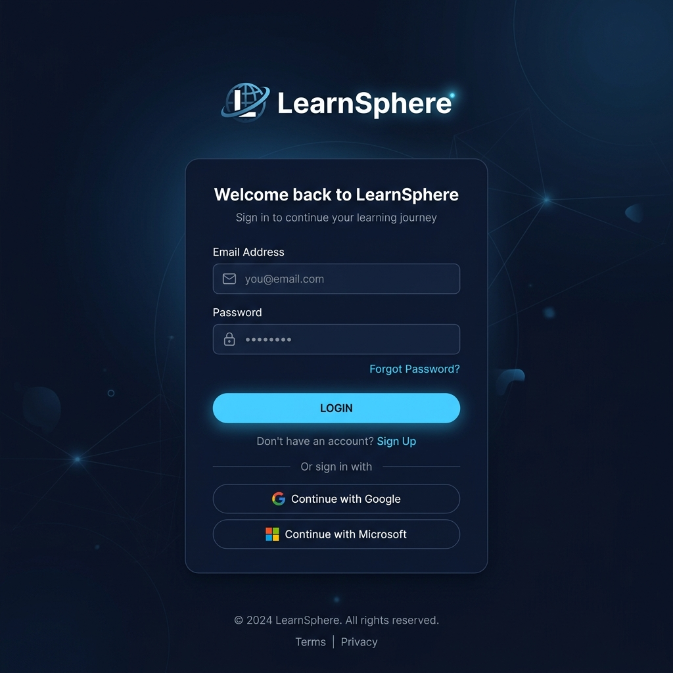
Figure 5.1: LearnSphere Login Screen
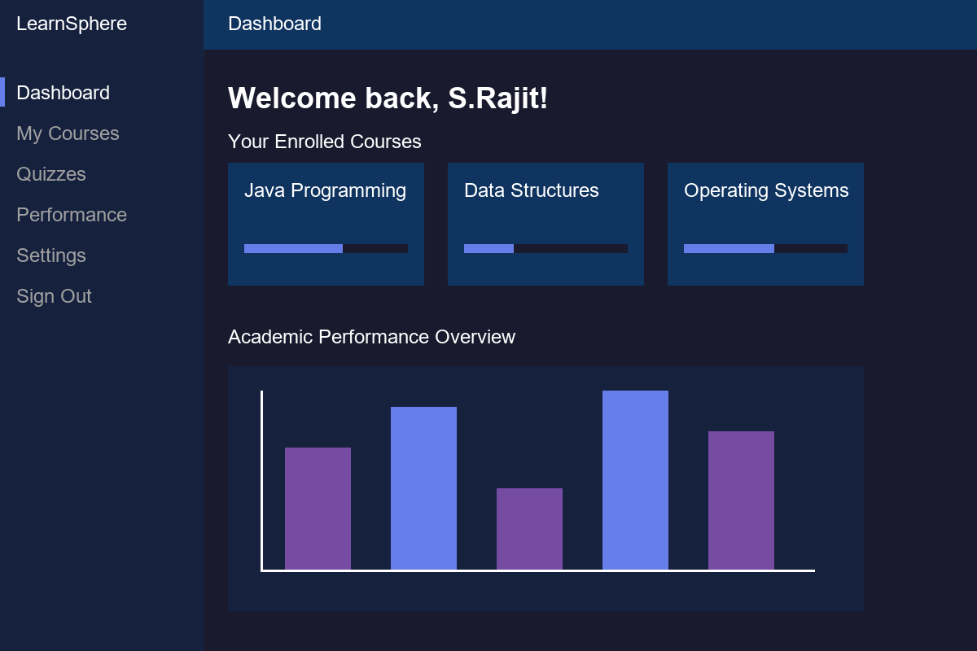
Figure 5.2: Student Dashboard View
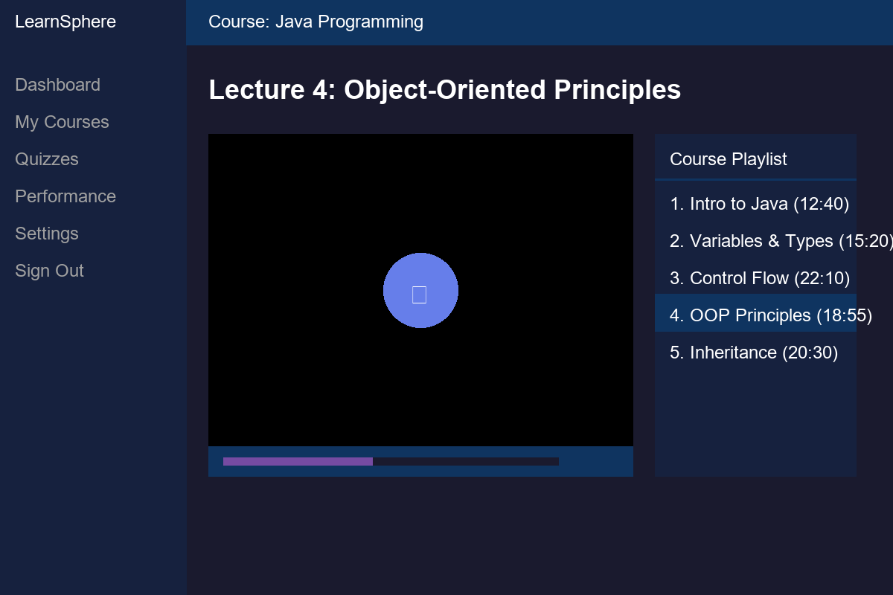
Figure 5.3: Course Video Player
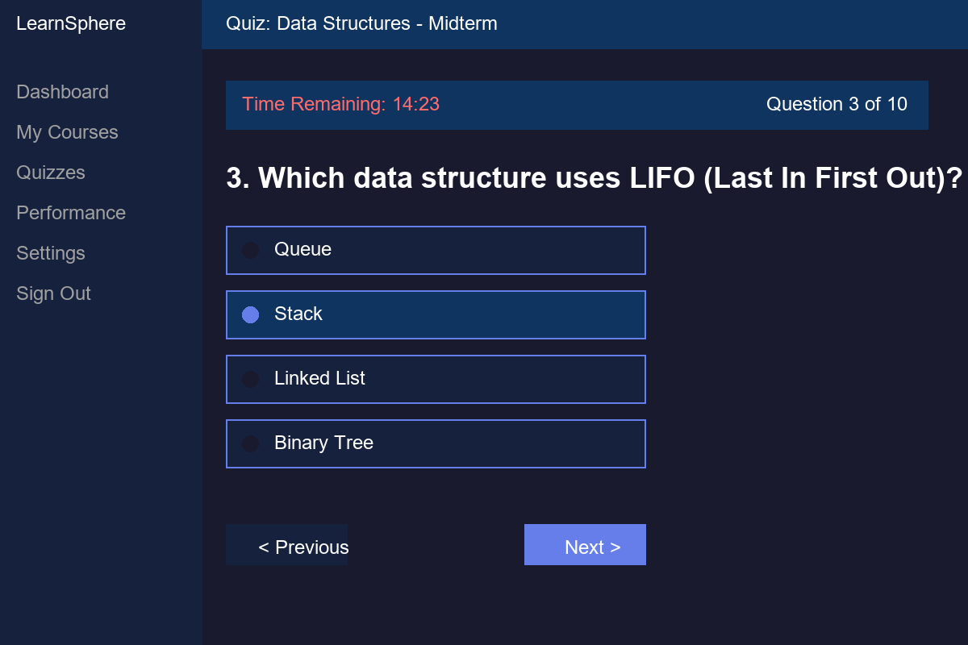
Figure 5.4: Quiz Attempt Interface
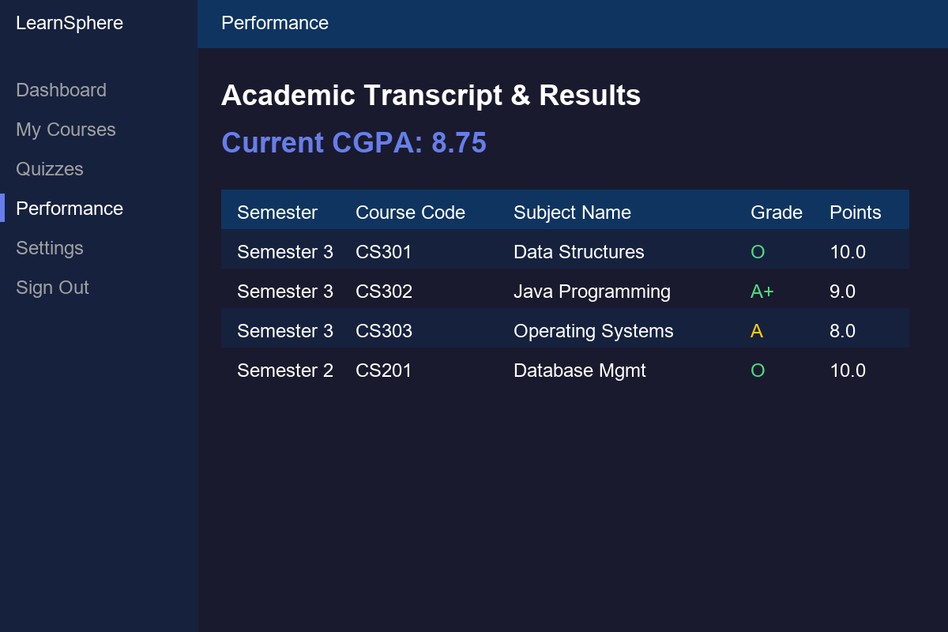
Figure 5.5: Academic Results Dashboard

CHAPTER 6

RESULTS AND DISCUSSION

6.1 EVALUATION METRICS
Compilation Success measures whether all thirty-five Java source files compile without errors under Maven, confirming syntactic and type-level correctness across the entire codebase.
Startup Success confirms that the Spring Boot application context initializes completely, all twelve JPA repositories are discovered, the H2 database schema is generated, and the DataInitializer seeds the demo data without exceptions.
Functional Completeness verifies that each user-facing feature produces the expected output when exercised through the browser.
Demo Data Integrity confirms that the seeded data is consistent and renders correctly on all pages.

6.2 RESULTS ACROSS ITERATIONS
Table 6.1 Results Across Iterations

Version | Java Files | Compilation | Startup
Baseline (Iter 1) | 35 | FAILED | N/A
Refinement (Iter 2) | 35 | SUCCESS | 9.9s
Final (Iter 3) | 35 | SUCCESS | 9.9s

6.3 DISCUSSION
The Lombok removal in Iteration 2, while initially time-consuming, proved to be the correct decision. It eliminated a brittle build dependency that failed under unstable network conditions and resulted in code that any Java developer can read without knowing Lombok’s annotation semantics.
The dark theme required more CSS effort than anticipated. Bootstrap’s default utility classes inject dark or black text that is invisible against the dark background. The solution was a comprehensive CSS override file using !important.

6.4 LIMITATIONS
The H2 in-memory database loses all data on restart. No automated unit or integration tests were written; correctness was verified only through manual browser testing. The quiz timer is UI-only with no server-side enforcement.

CHAPTER 7

TEAM REFLECTION AND LEARNING OUTCOMES

7.1 INDIVIDUAL REFLECTIONS
S.Rajit: I was responsible for the backend architecture, JPA entity model, repository interfaces, service layer, and Spring Security configuration. Removing Lombok forced me to understand exactly what code Java needs for a properly encapsulated entity. The hardest problem was getting the SecurityFilterChain to correctly route three different roles to three different dashboards.

7.2 TEAM LEARNING
Developing the complete full-stack application alone allowed for deep understanding across the MVC boundary. The key lesson was that the DataInitializer is effectively an integration test: if it runs without exceptions, the entity model, the repository layer, and the service layer are all wired correctly.

7.3 COURSE OUTCOMES — EVIDENCE SUMMARY
CO1 — Object-oriented design: Twelve JPA entity classes with encapsulated state, composition through relationships.
CO2 — Exception handling: Custom error pages, try-catch in service methods, and Spring Security’s exception translation.
CO3 — Collections and generics: Typed JPA repository interfaces.
CO4 — Database connectivity: Spring Data JPA with Hibernate ORM, H2 in-memory database.
CO5 — Application development and testing: A complete web application with twenty templates.

CHAPTER 8

CONCLUSION AND FUTURE SCOPE

8.1 CONCLUSION
LearnSphere set out to answer whether a production-quality Learning Management System could be built using Spring Boot within a twelve-week PBL cycle, and it can. The system unifies course management with YouTube-embedded video playlists, MCQ-based assessments with automatic grading and detailed explanations, and academic analytics with semester-wise GPA and cumulative CGPA computation — all behind a role-based authentication system with three distinct user experiences. The final implementation compiles cleanly and provides a responsive dark-themed interface.

8.2 FUTURE SCOPE
1. Persistent Database Migration: Replace H2 in-memory with MySQL or PostgreSQL.
2. Automated Testing: Add JUnit 5 and MockMvc integration tests.
3. AI-Powered Quiz Generation: Integrate the Gemini API to automatically generate MCQ questions.

REFERENCES

[1] | VMware, "Spring Boot Reference Documentation," 2024. [Online]. Available: https://docs.spring.io/spring-boot/docs/current/reference/html/
[2] | Oracle Corporation, "Java Servlet Specification," 2021. [Online]. Available: https://jakarta.ee/specifications/servlet/
[3] | Meta, "React Documentation," 2024. [Online]. Available: https://react.dev/
[4] | Thymeleaf, "Thymeleaf Documentation," 2024. [Online]. Available: https://www.thymeleaf.org/documentation.html
[5] | Spring, "Spring Security Reference," 2024. [Online]. Available: https://docs.spring.io/spring-security/reference/
[6] | H2 Database Engine, "H2 Documentation," 2024. [Online]. Available: https://h2database.com/html/main.html
[7] | Bootstrap, "Bootstrap 5.3 Documentation," 2024. [Online]. Available: https://getbootstrap.com/docs/5.3/

APPENDIX

A.1 FULL SOURCE CODE
The complete Maven project — all Java sources, Thymeleaf templates, CSS stylesheets, and application configuration — is located at the project directory.
GitHub Link: https://github.com/srajitcse2025-max/LearnSphere.git

A.2 WEEKLY LOG AND MENTOR SIGN-OFFS
Table 3.1 is the complete weekly PBL log for the twelve-week cycle.

A.3 SELF ASSESSMENT
Table A.1 Self Assessment

Team Member | Self-Rated (%) | Peer-Rated (%) | Remarks
S.Rajit | 100% | 100% | Full stack development

