WEEK 1 ASSIGNMENT
DESIGN PATTERN
Adapter Pattern
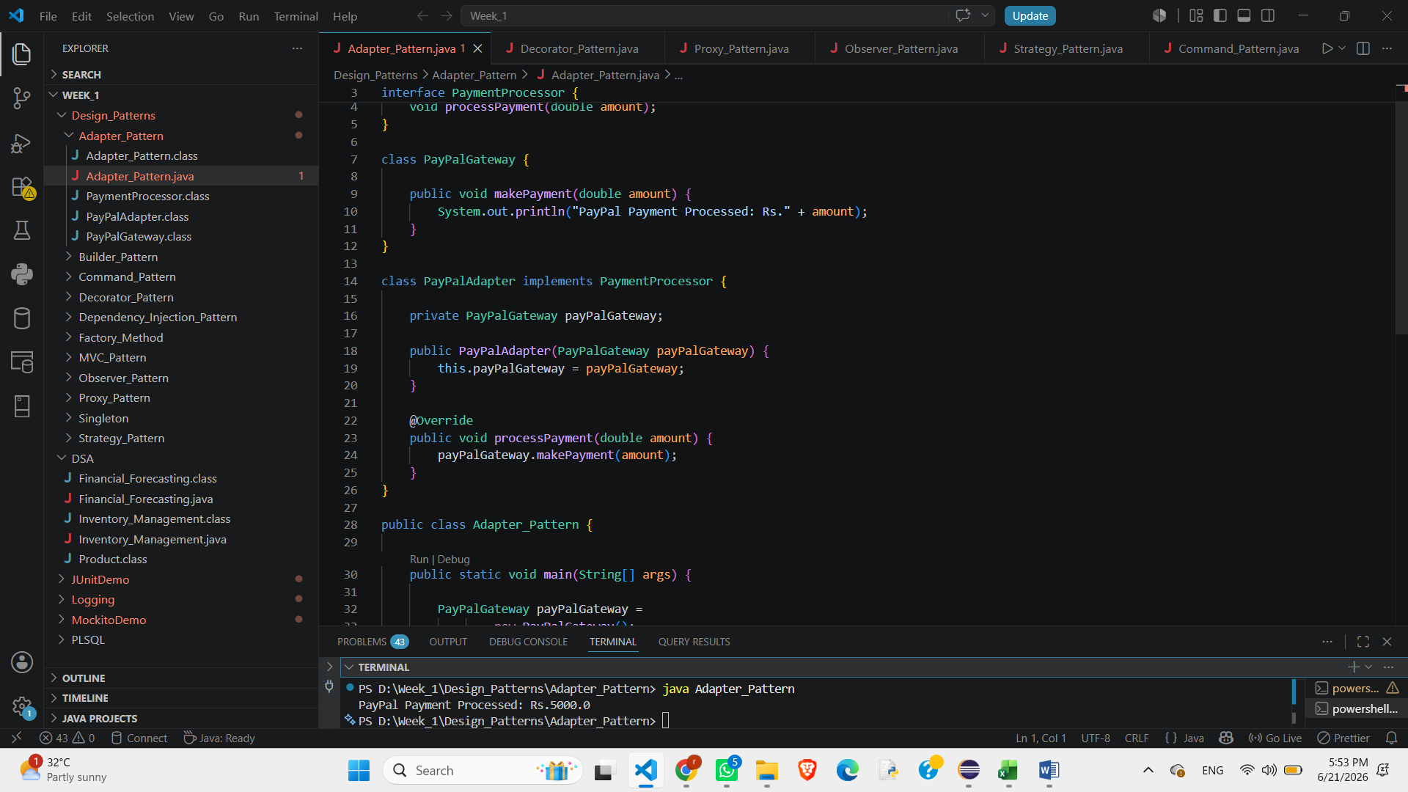
Builder Pattern
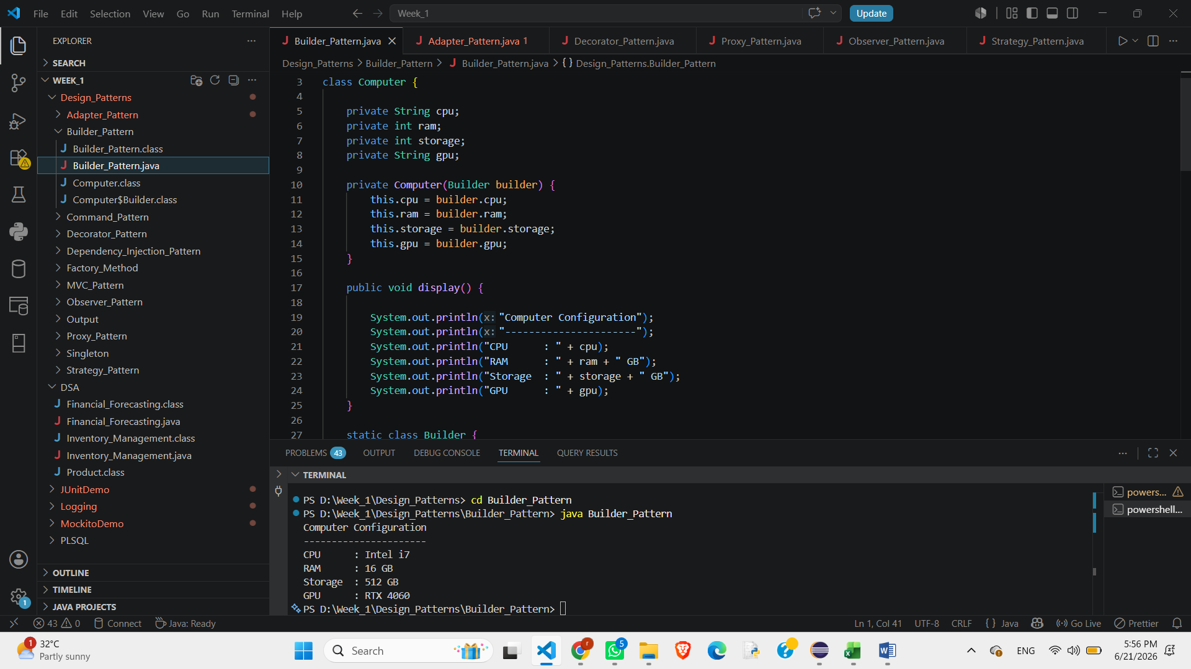
Command Pattern
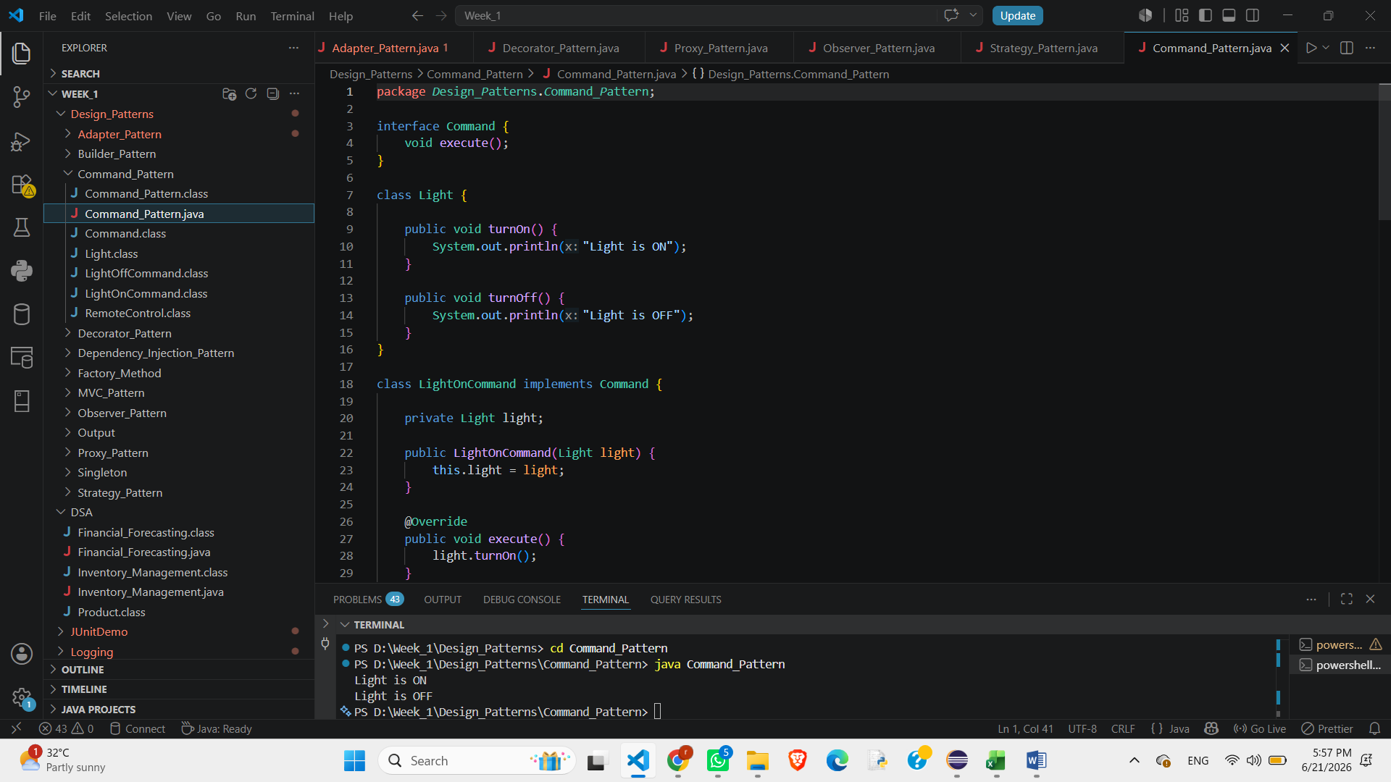C

Decorator Pattern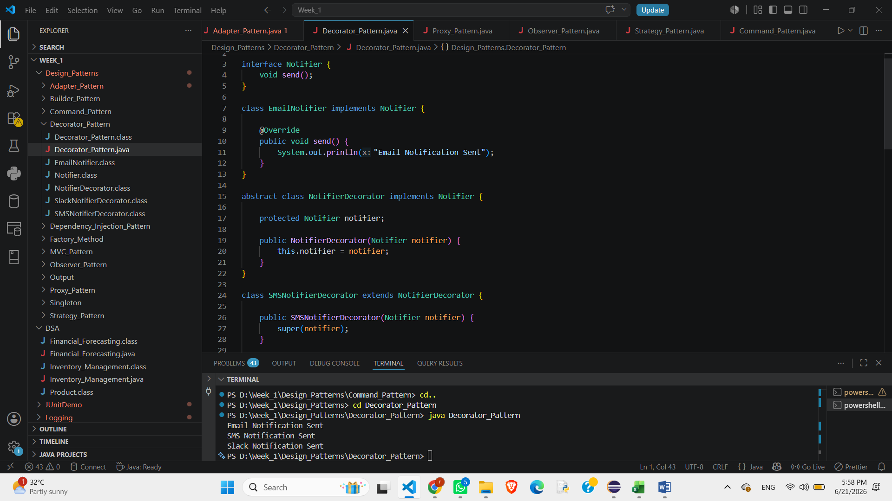

Dependency Injection Pattern
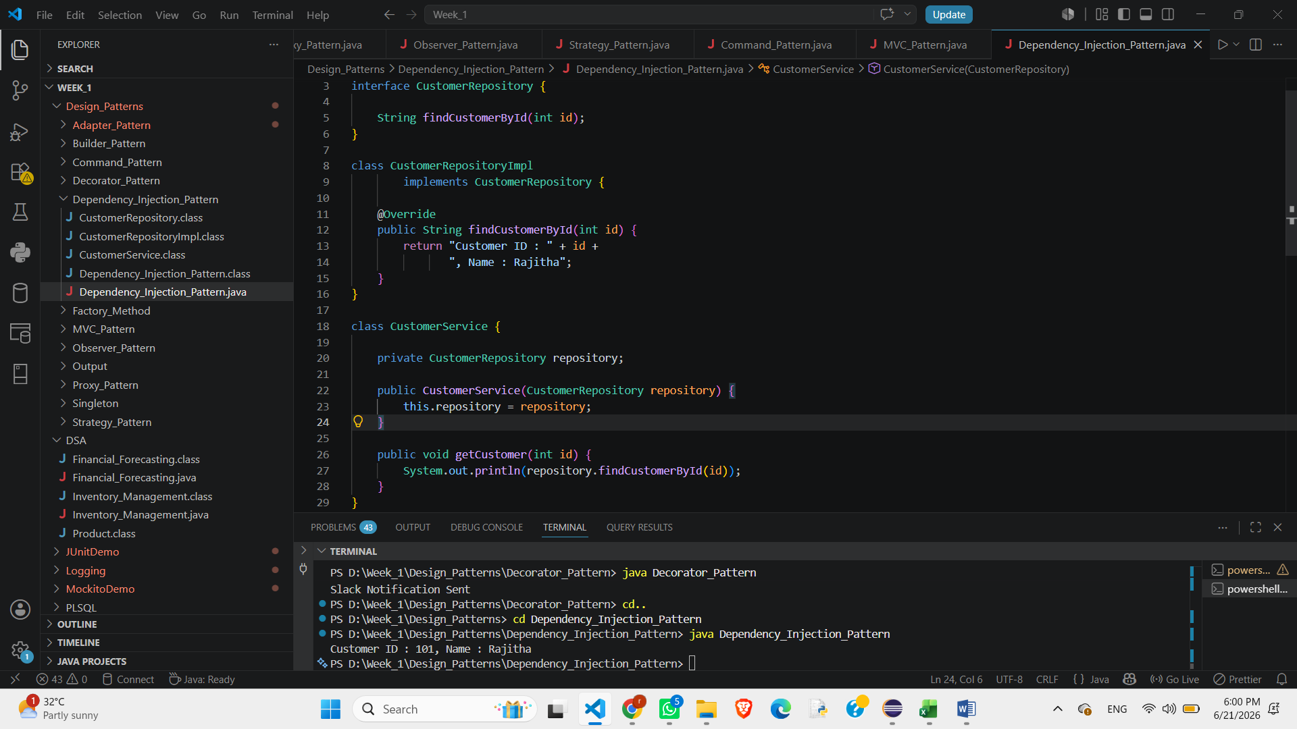

Factory Method Pattern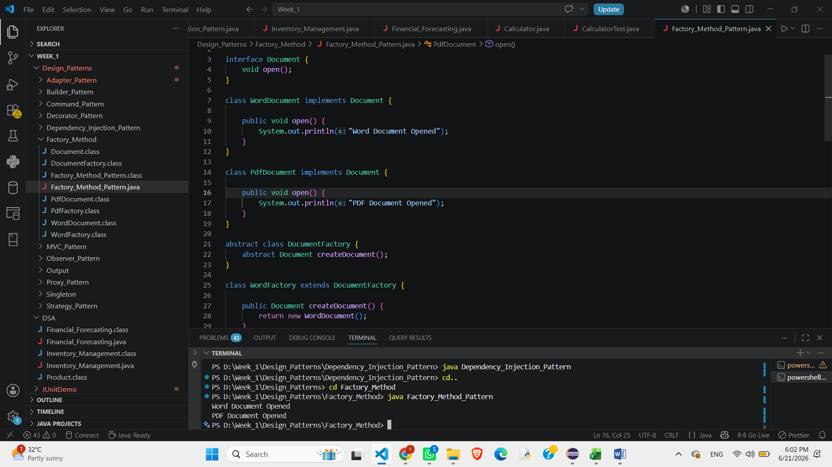

MVC Pattern

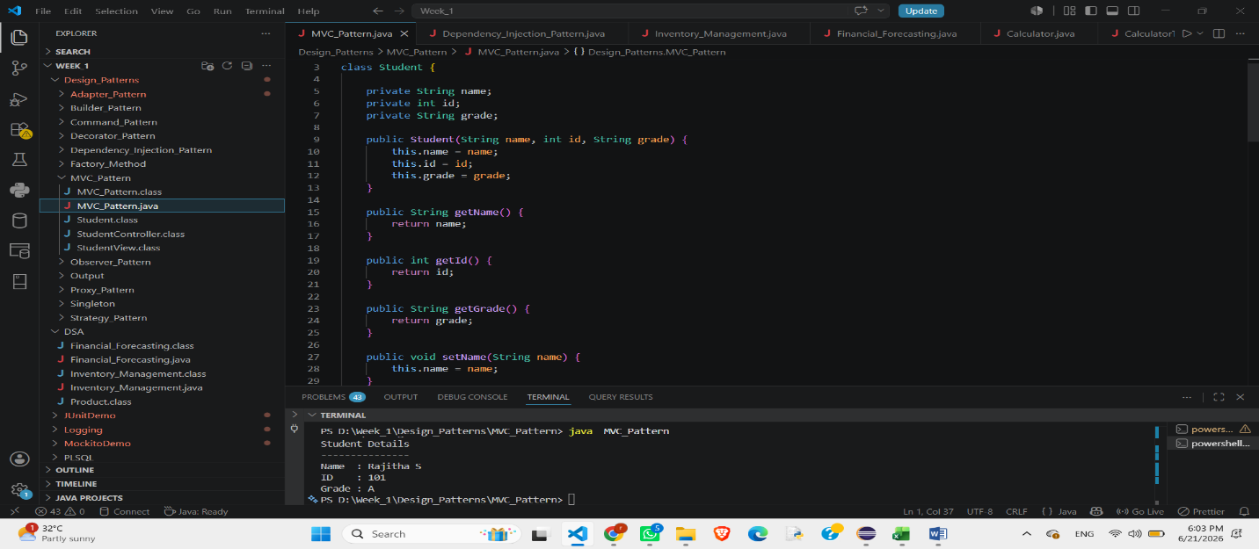

Observer Pattern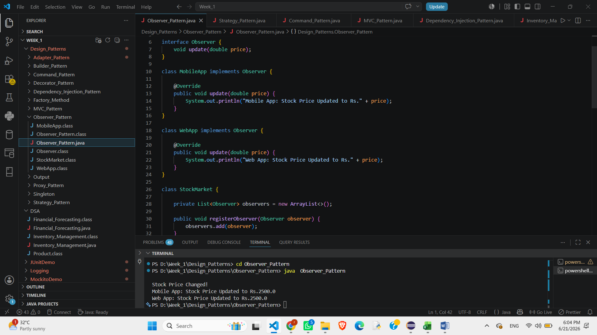

Proxy Pattern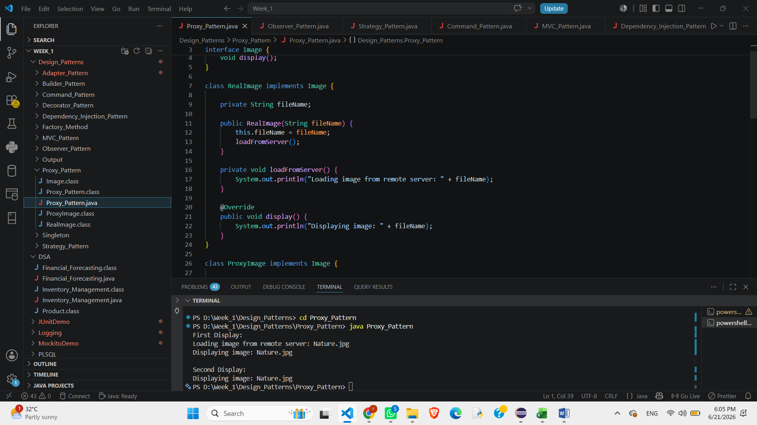
Singleton Pattern

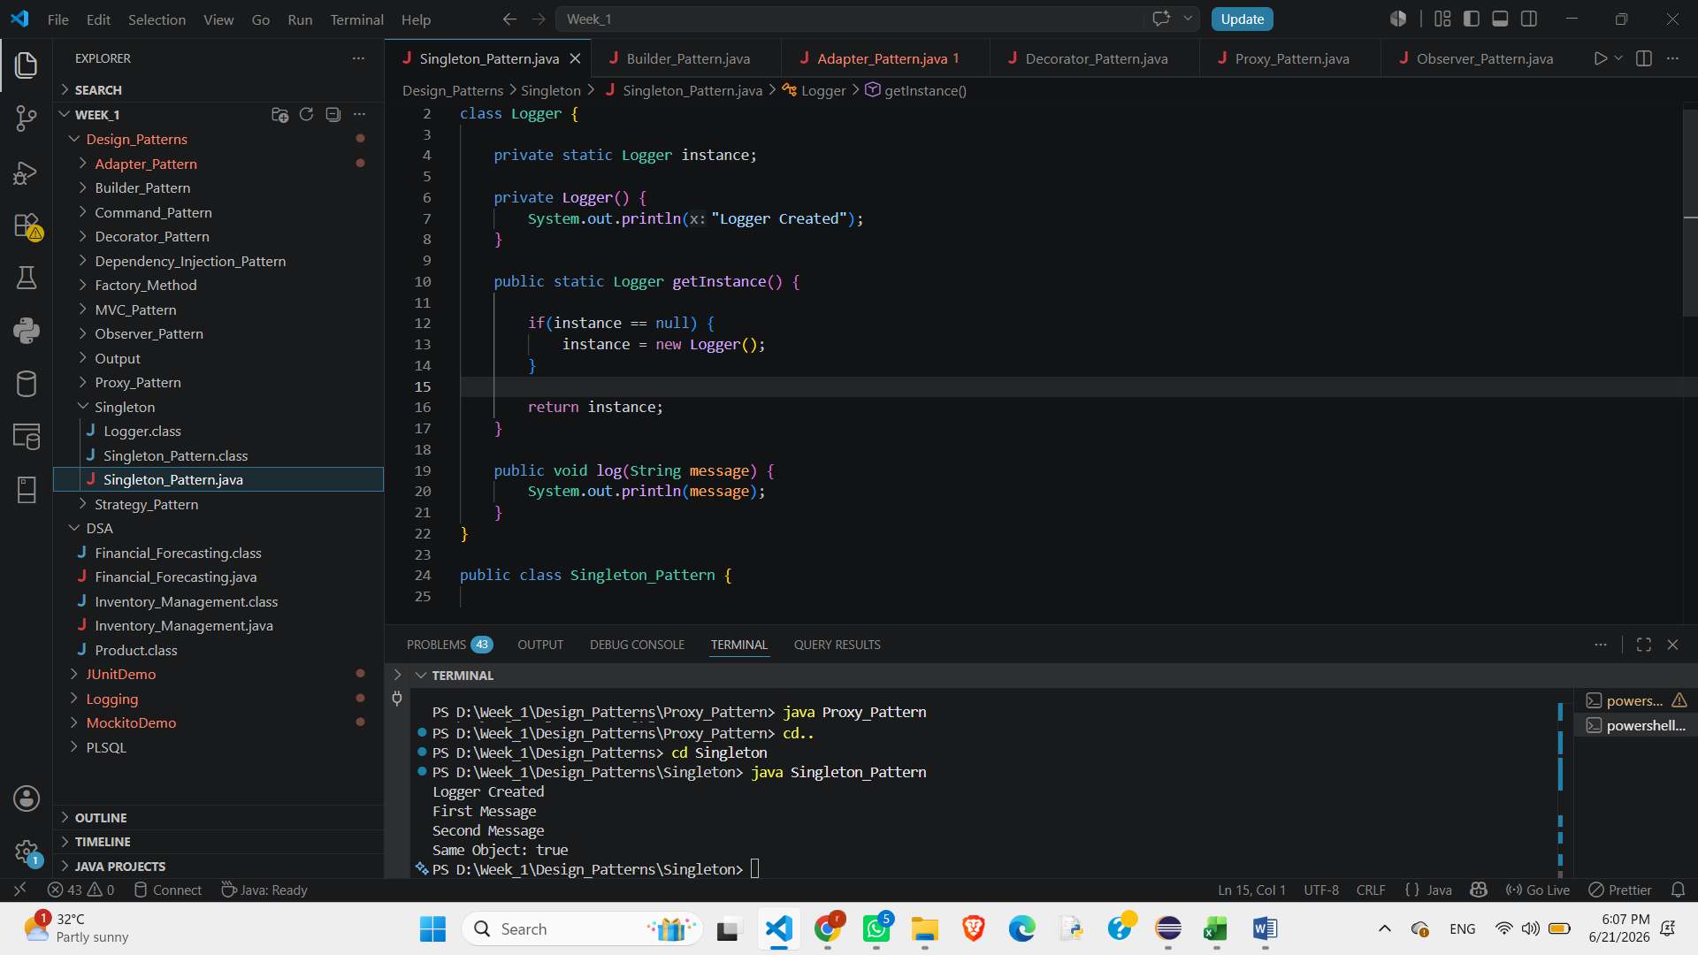

Strategy Pattern
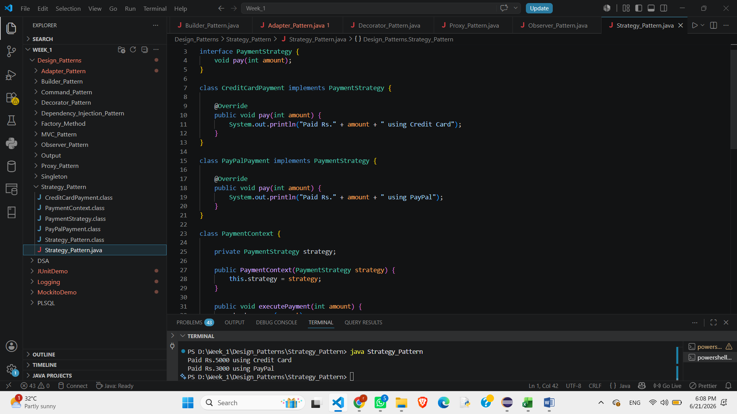

DATA STRUCTURES AND ALGORITHMS (DSA)
Financial Forecasting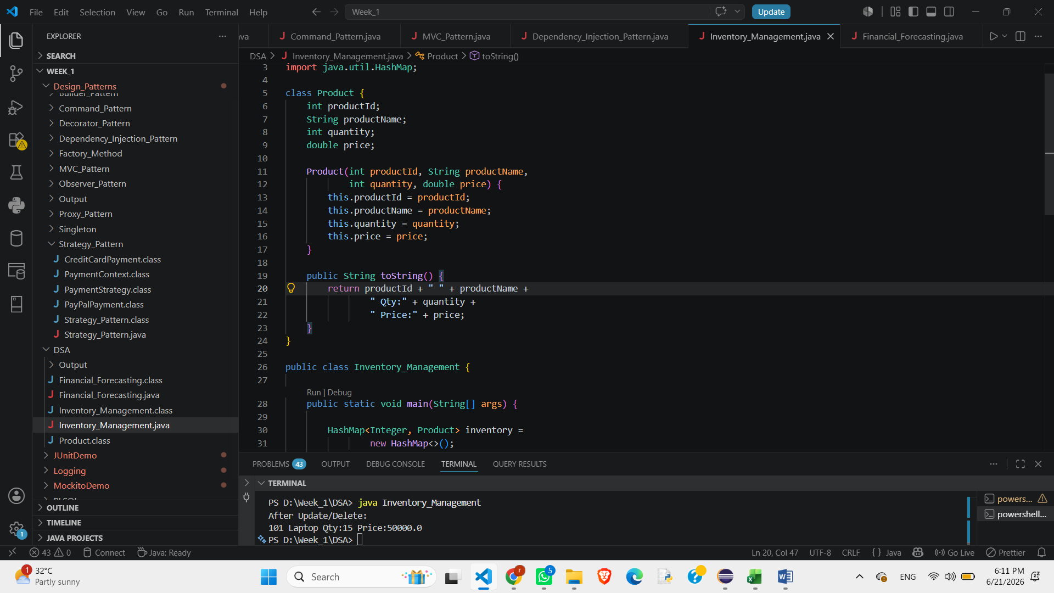
Ecommerce Inventory
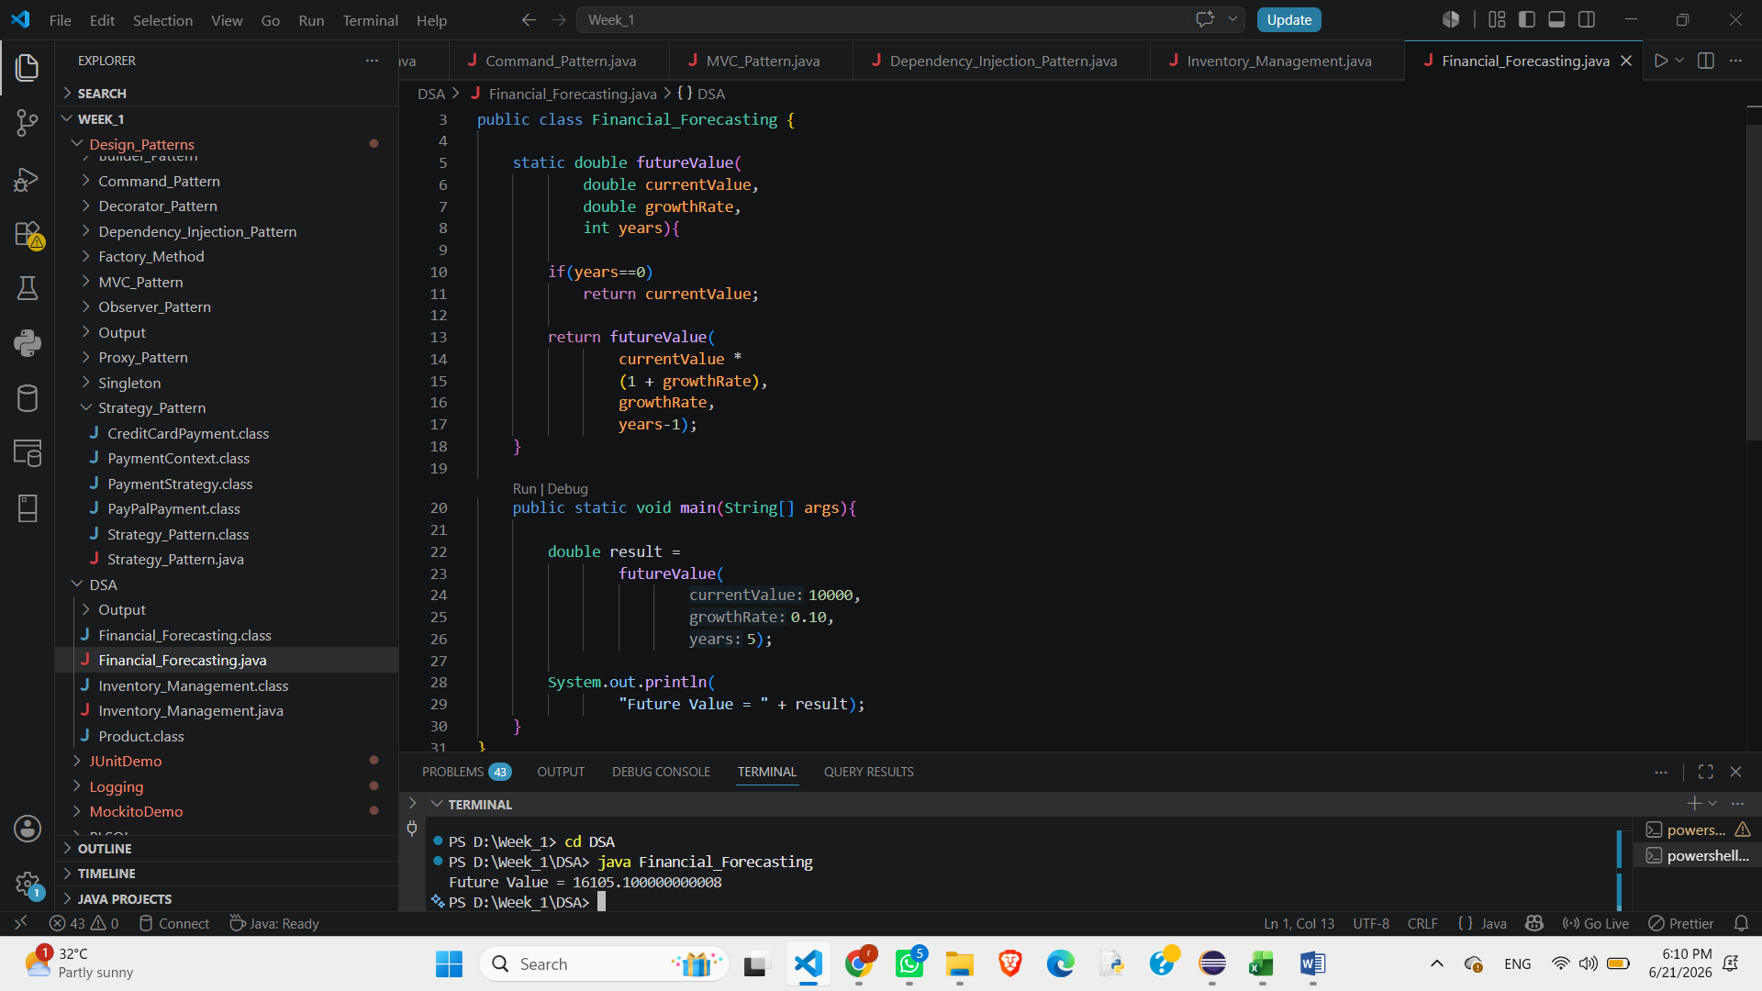
JUNIT TESTING EXERCISES
Arrange Act Assert Pattern(AAA) & Test fixtures in JUNIT
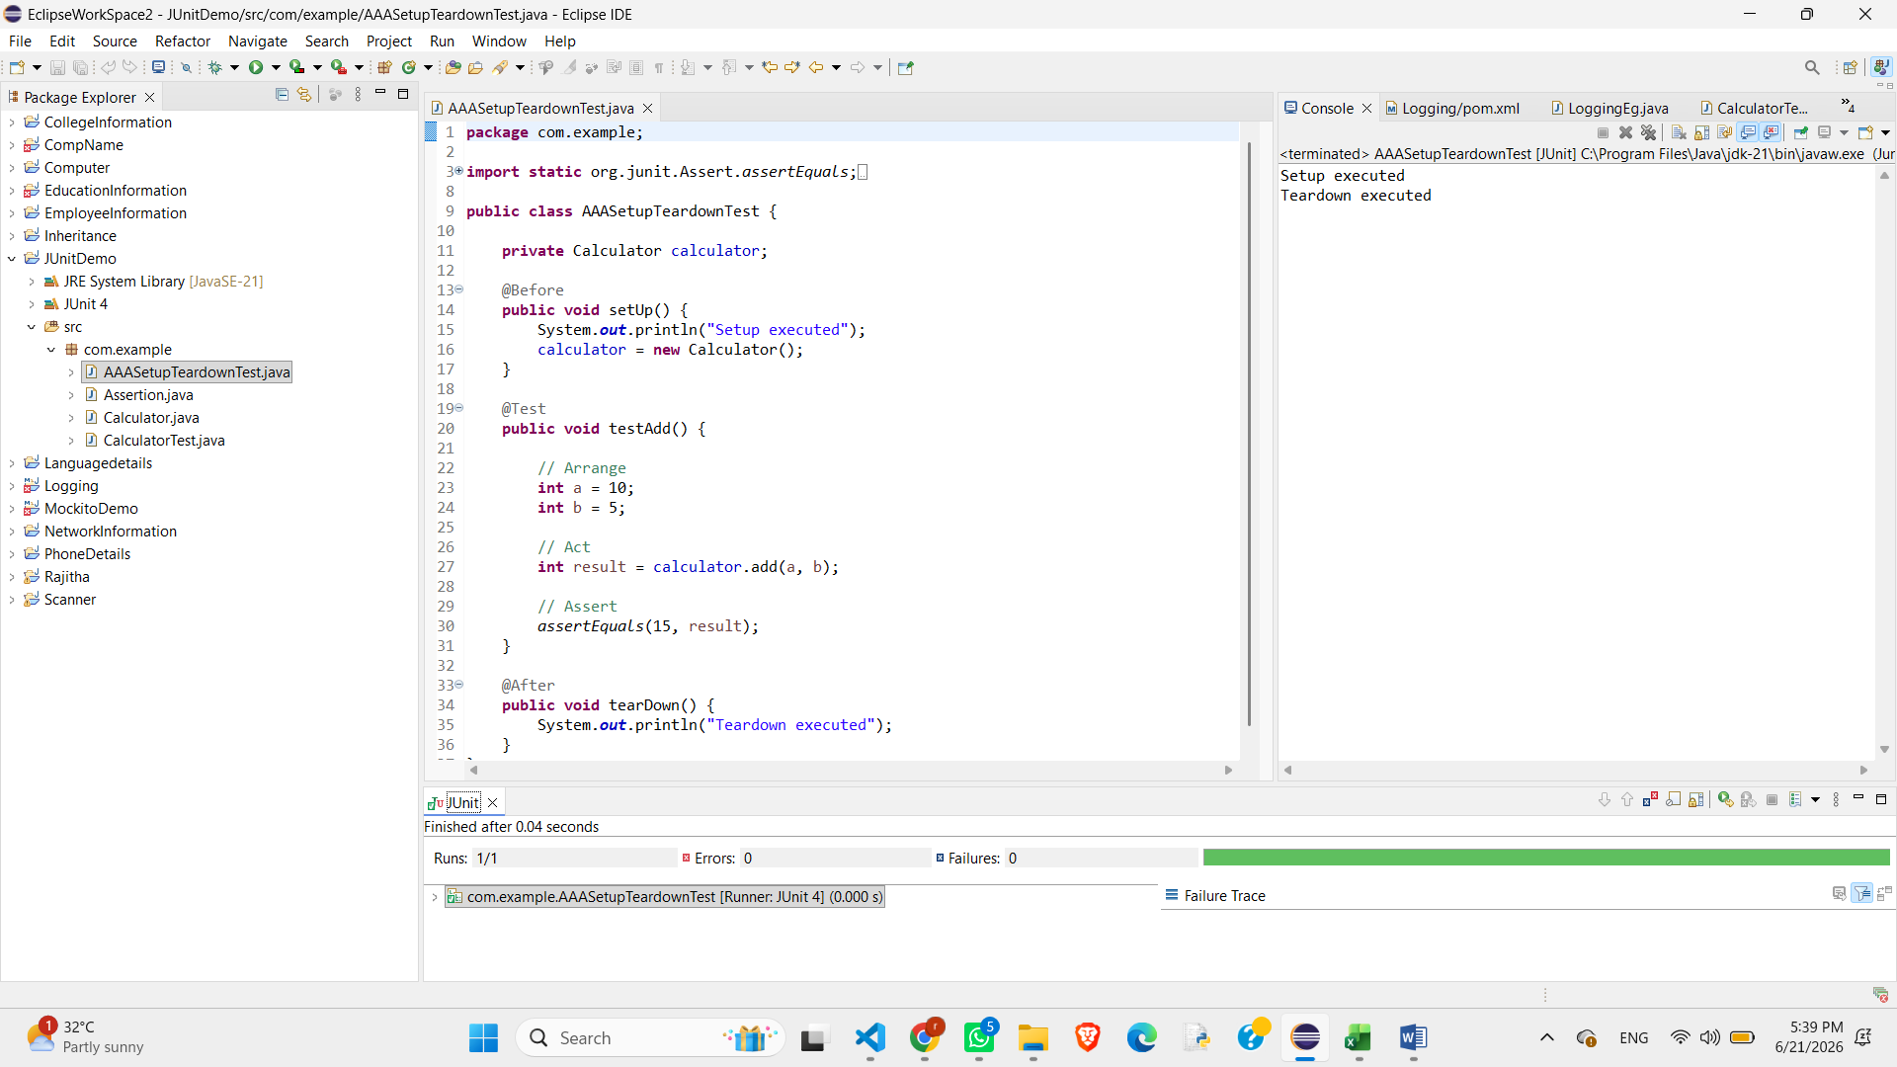

Assertion in JUNIT
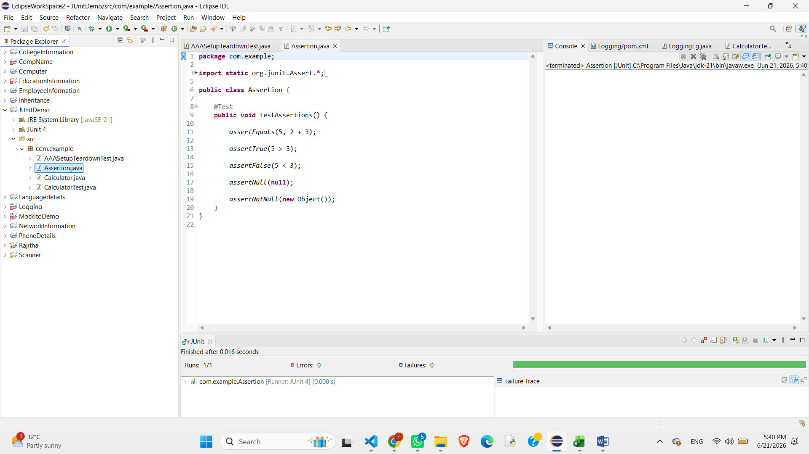
Setting up of JUNIT with Example
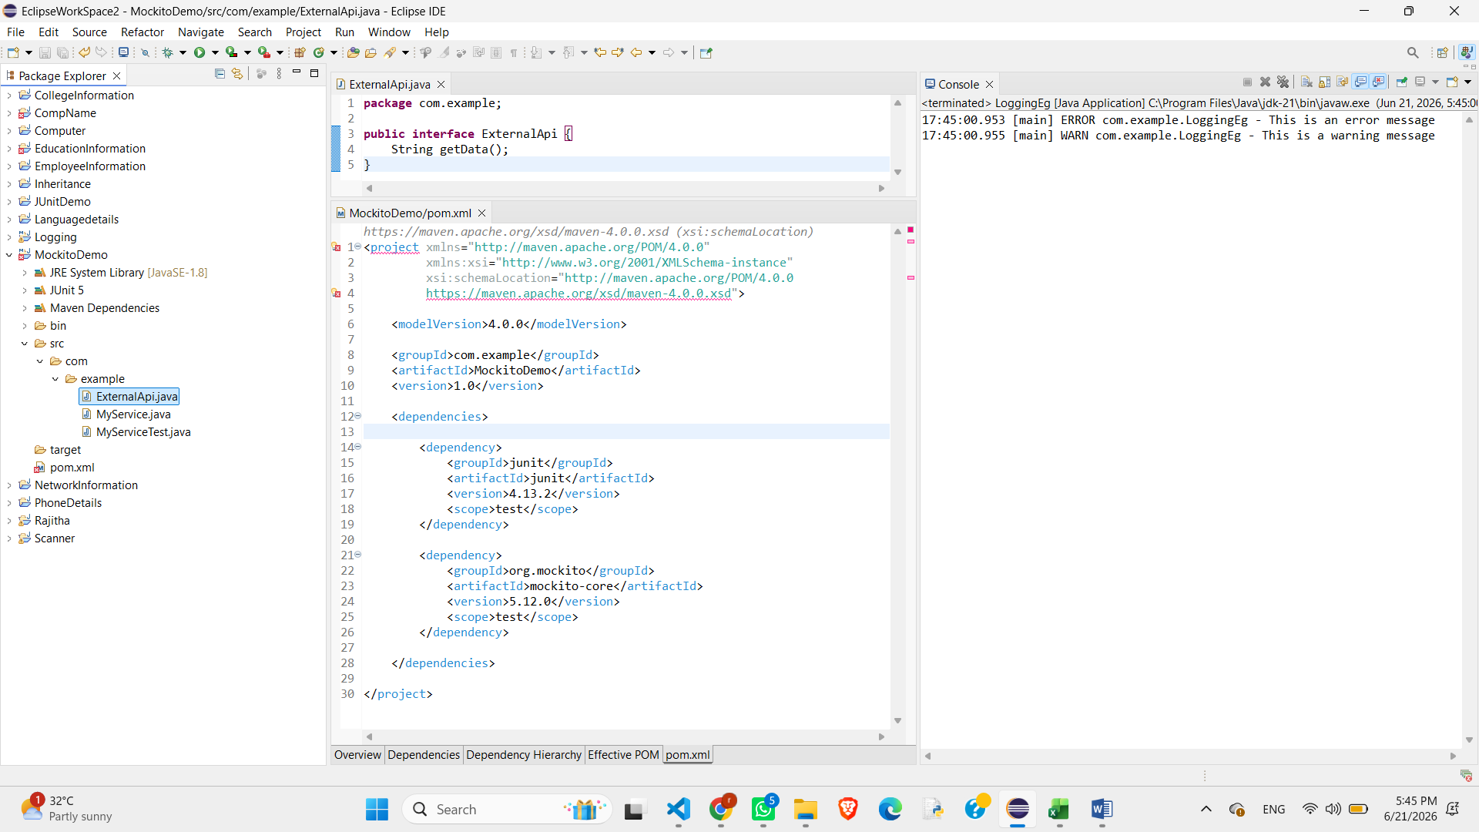

MOCKITO EXERCISES
Verifying Interactions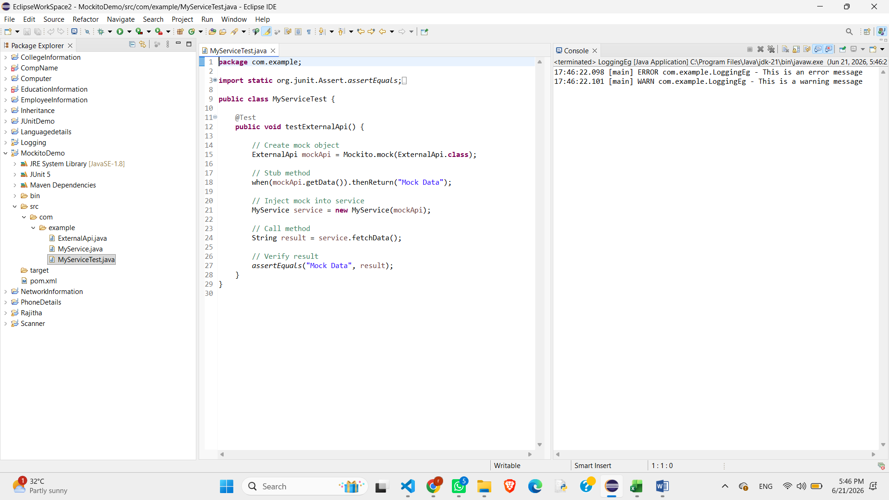
Mocking and Scrubbing

SL4J LOGGING EXERCISES
Logging error messages and warning levels
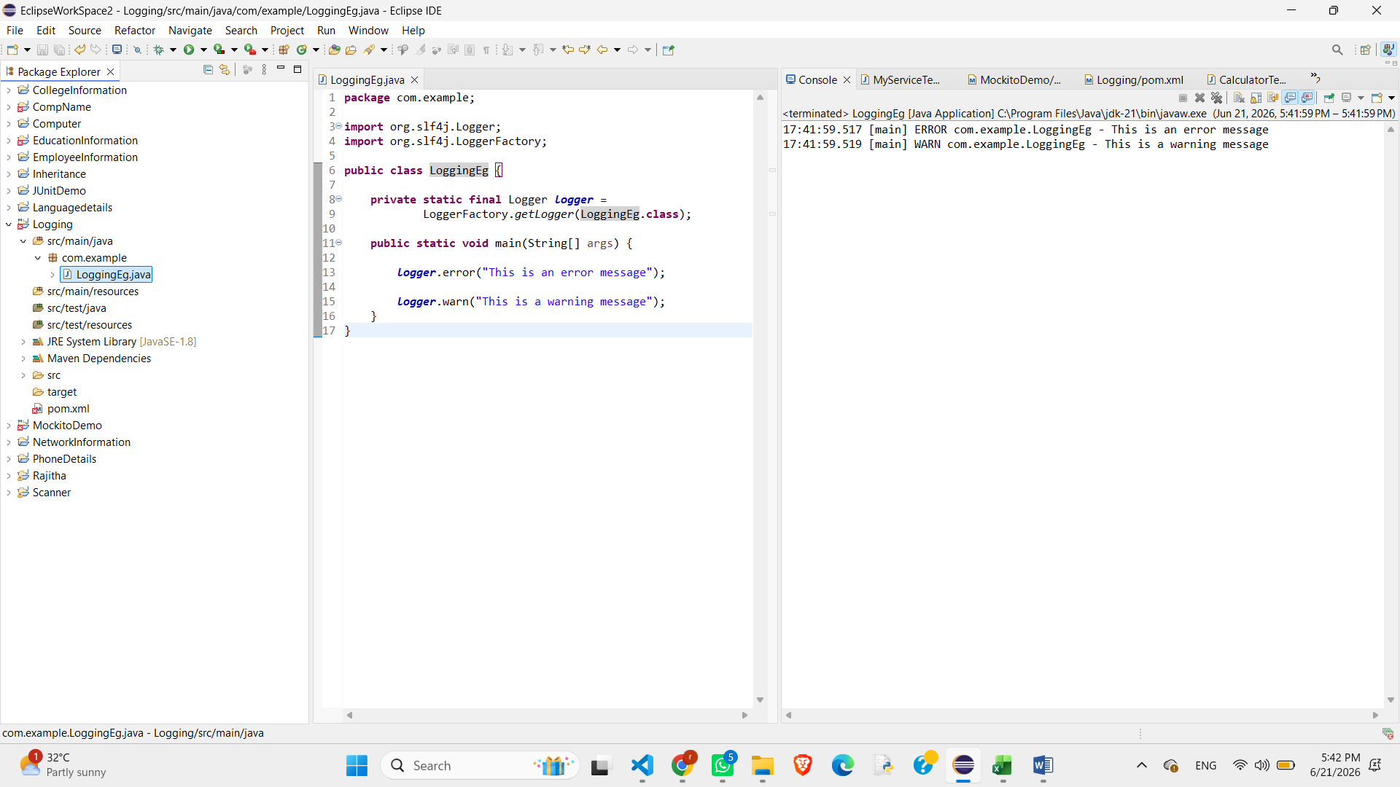

PL?SQL
Control Structures
Scenario 1: The bank wants to apply a discount to loan interest rates for customers above 60 years old.

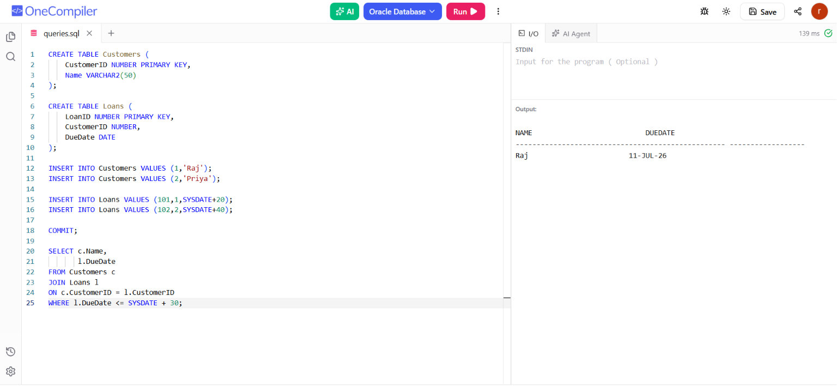
Scenario 2: A customer can be promoted to VIP status based on their balance.
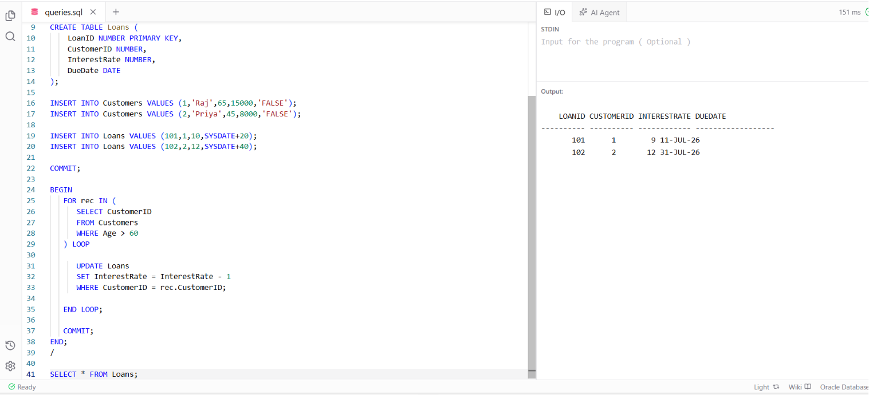
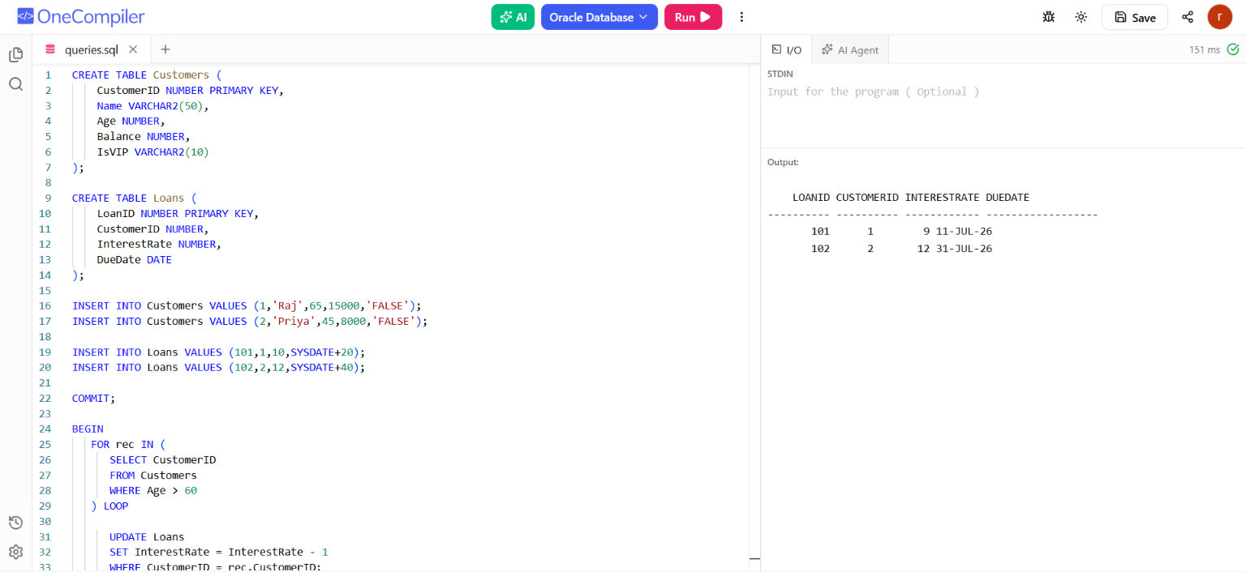

Scenario 3: The bank wants to send reminders to customers whose loans are due within the next 30 days.

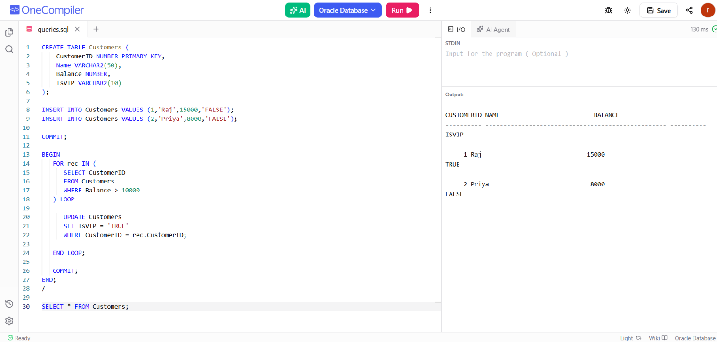
Stored Procedures
Scenario 1: The bank needs to process monthly interest for all savings accounts.
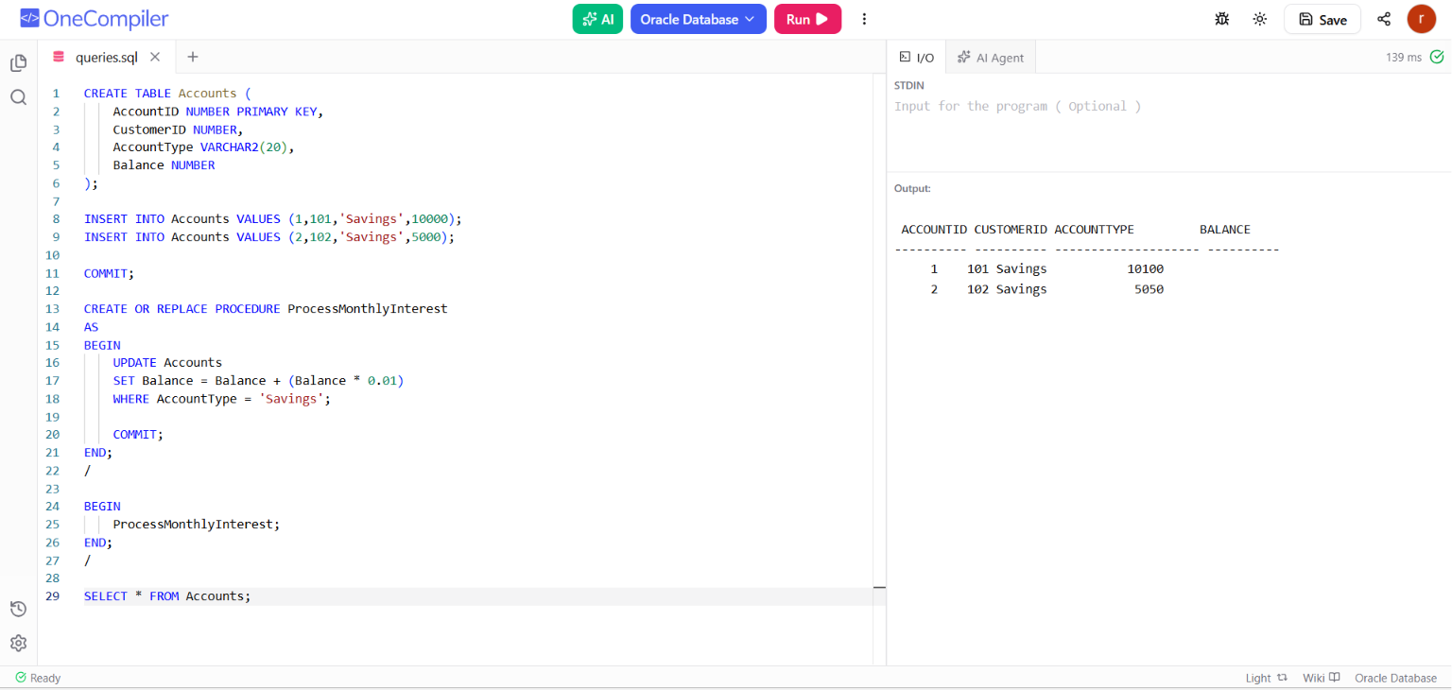

Scenario 2: The bank wants to implement a bonus scheme for employees based on their performance.
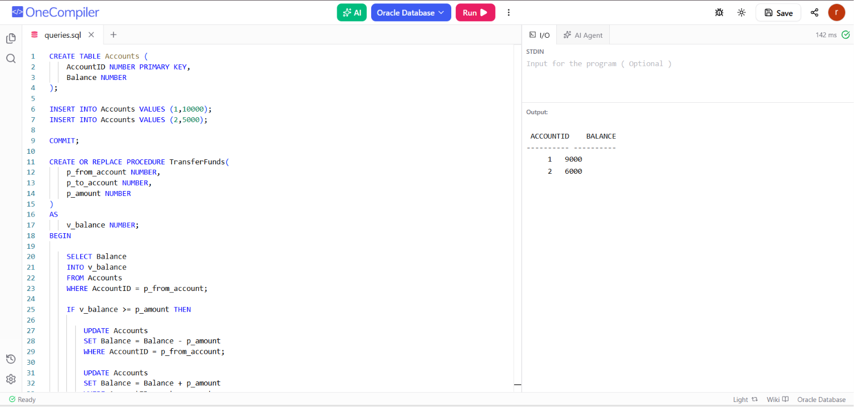

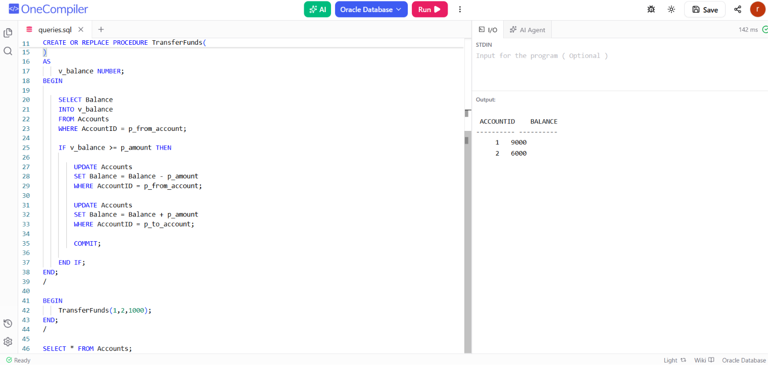
Scenario 3: Customers should be able to transfer funds between their accounts.

