Unary Relationships (Entity of same entity type related to each other
Binary Relationships>
Strong v Weak Entity>
Ternary Relationships + Card. Const.
Cardinality constraint - # of instances of the relationship

Modeling Multiple Relationships
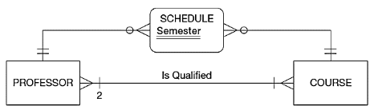
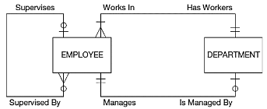

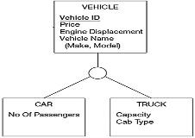
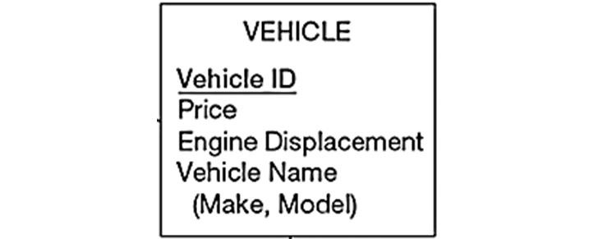
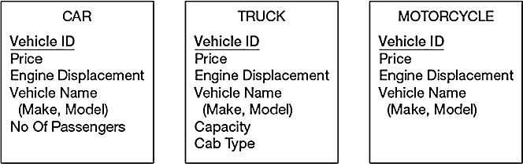



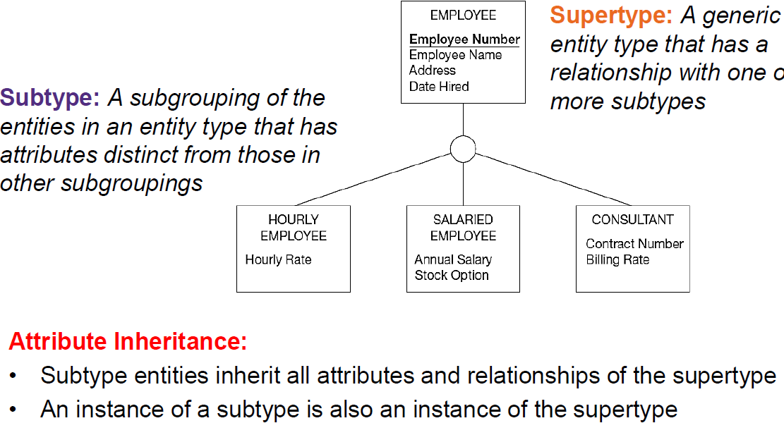
Enhanced Entity Rel Model

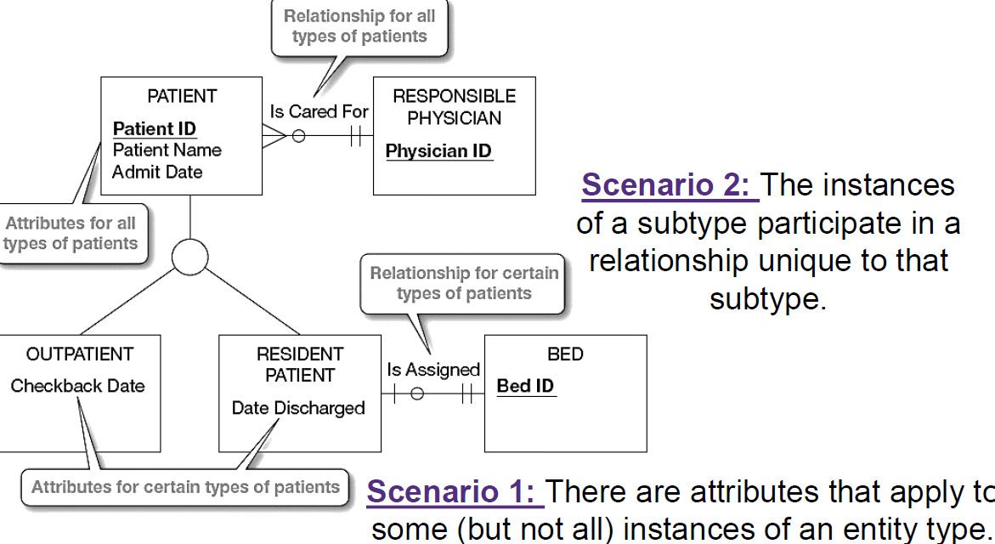
<Generalization – def supertype from subtype

Specialization – def subtype from super

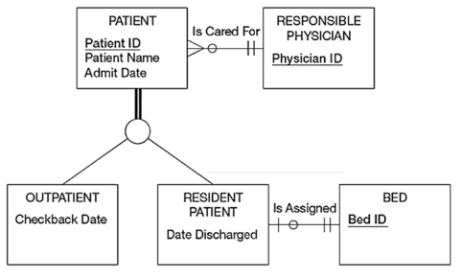


Total Specialization – super must be at least one of the subtype options
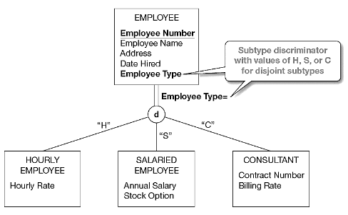
Partial Specialization – supertype can be sub but does not have to
Disjoint Constraint– super cannot be multi subtypes (Pt cant be outP and InP) @ same time
Disjoint Discriminator – simple attribute w/ unique vals indicating subtype
Steps to design EER

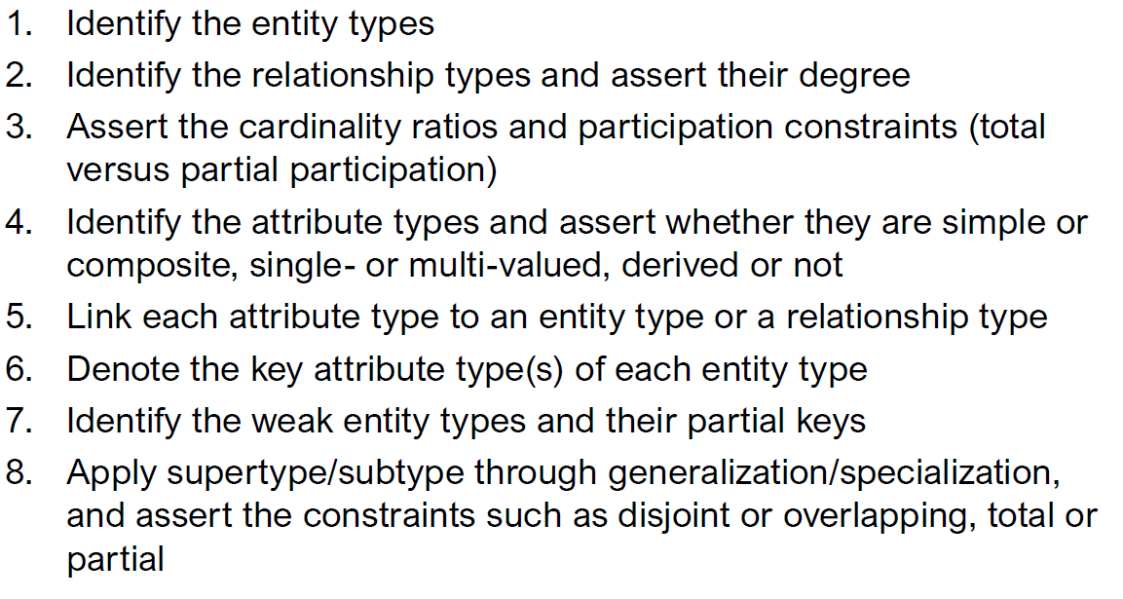
Overlapping Constraint– super may be one or more subtypes

Overlapping Discriminator – composite attribute whose subparts pertain to different subtypes. Each subpart contains a Boolean value to indicate whether the instance belongs to the associated subtype

