Screenshot of the Home page:Fig a

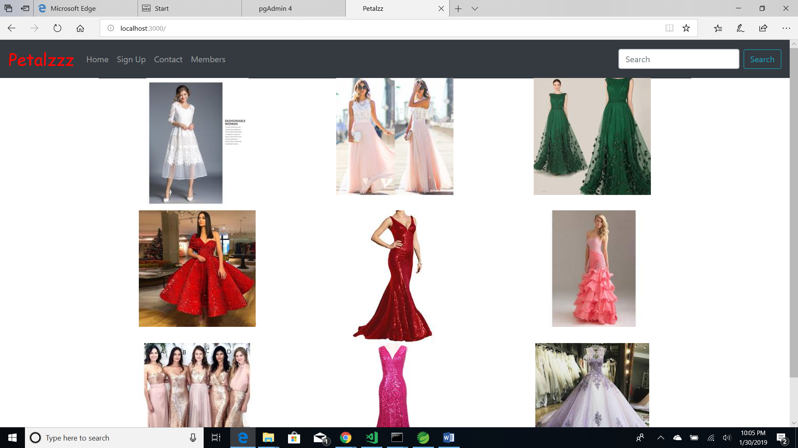

Screenshot of the Tab Sign up:Fig b

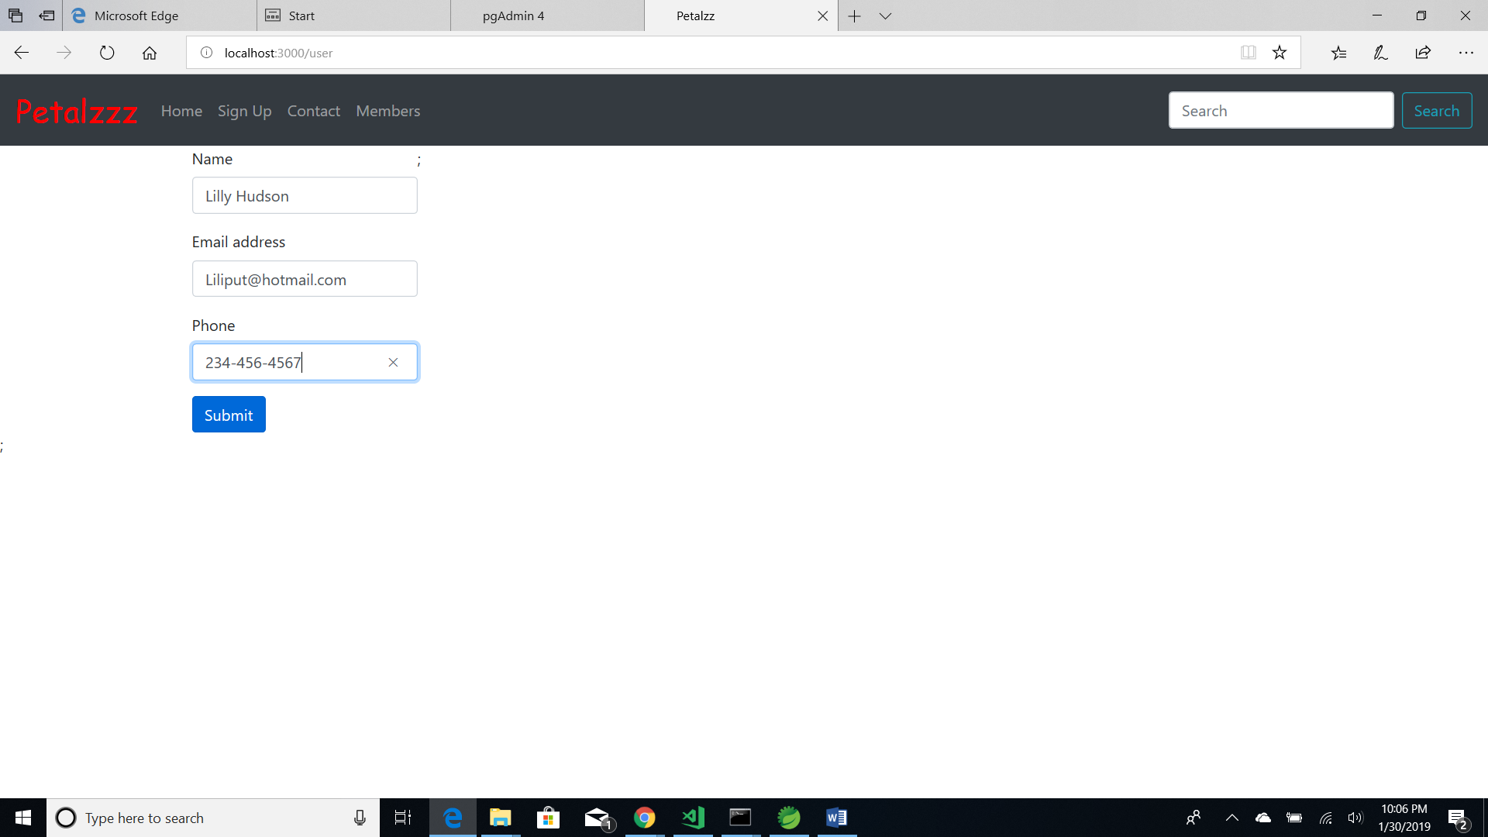

This screenshot of the tab ”Members”, displays the list of members who signed up their details in the sign up tab:Fig c

