Java Training Assignments

Version 1.0

Java Training Assignements 1.0

Document Information
Document Name | Java Training Assignments
Date (dd-mon-yy) | 15-July-2025
Prepared By | Abdur Rahman
Prepared For | Elemica Solution Pvt Ltd.

Document Control Information
Action | Name | Role | Version # | Date (dd-mon-yy)
Review
Approval

Table of Contents

ASSIGNMENT #1 4
ASSIGNMENT #2 5
ASSIGNMENT #3 6
ASSIGNMENT #4 7
ASSIGNMENT# 5 7
ASSIGNMENT #6 8
ASSIGNMENT #7 11

ASSIGNMENT #1

Topics Covered: Java I/O, String.

Write a java program that accepts details (item name, item type, item prize) of different items from
Command line and outputs the item name, item prize, sales tax liability per item, final prize (sales tax + item prize) to the console. The input should be accepted with following command line options:

-name <first item name>
-price <price of first item>
-quantity <quantity of first item>
-type <type of first item>

The following functionalities/behavior is expected:

- All options other than item name can come in any order i.e. after -name you can have -price, -type option. Item type is a mandatory option.

- The system should provide functionality to add more than one items i.e. Once the details of first item is entered it should display a message saying:

Do you want to enter details of any other item (y/n):

Appropriate behavior is required to be implemented as per user input for this question.

- Make use of java's object oriented capabilities for implementing this business logic.

- Item type can have 3 possible values raw, manufactured and imported.

- Tax rules for the 3 types are as follows:

raw: 12.5% of the item cost

manufactured: 12.5% of the item cost + 2% of (item cost + 12.5% of item cost)

imported: 10% import duty on item cost + a surcharge (surcharge is: Rs. 5 if the final cost after applying tax & import duty is up to Rs. 100, Rs. 10 if the cost exceeds 100 and up to 200 and 5% of the final cost if it exceeds 200).

Real Life Scenario:
Inventory management system.

Key Points:

- Use Java’s I/O capabilities to accept input from users.
- Use Java’s String functionalities to parse input strings.
- Coding conventions should be followed.
- Proper validation / info messages should be thrown on console.
- Do appropriate exception handling where ever required.
- Where ever required please write comments in the code to make it more understandable.

ASSIGNMENT #2

Topics Covered: Java Serialization, Sorting.

Write a menu driven command line java program that provides the following menu options:
- Add User details.
- Display User details.
- Delete User details
- Save User details.
- Exit

The option (1) should ask for the following user details. All the following details are mandatory and the program should perform the required validations (like blank data, integer value for age, roll number etc). Roll Number is a key to identify the uniqueness among the students.
- Full Name
- Age
- Address
- Roll Number
- Set of courses he is interested to enroll. There are total 6 courses (Course A, B, C, D, E and F). It is mandatory for each student to choose 4 out of 6 courses.

Once the validations are passed the user details should be added to an in memory data structure. The data structure should always keep the records sorted in ascending order. By default the records should be sorted on full name. If name is same for two students then sorting should be based on the roll number.

The option (2) should display the user details in the following format. Also the user should be provided with an option to sort the results (either in ascending or descending order) based on name, roll number, age, address.

---------------------------------------------------------------------------------------------------------------------------------
Name Roll Number Age Address Courses
---------------------------------------------------------------------------------------------------------------------------------
A 43 1 22 A, GGn A, C, D, E

The option (3) should ask for roll number and delete the student details corresponding to that roll number. Throw a proper user friendly message in case the roll number entered by the user does not exist.

The option (4) should save the in memory details of all the users to a disk. Use java’s serialization capabilities to serialize the in memory data to disk. If user terminates the program after choosing this option the user’s data should be saved to disk and next time the user runs the program the in memory collection should be pre populated with data already stored on the disk.

The option (5) should terminate the program but before termination it should ask the user if he wants to save his latest changes (additions, deletions of users) to disk.

Key Points:
- Use Java’s serialization mechanism to save user details to disk.
- Use Java’s comparable and comparator interfaces for sorting.
- Coding conventions should be followed.
- Proper validation / info messages should be thrown on console.
- Student Info, course info, serialization code and command line menu code should be encapsulated in separate independent java classes.
- Where ever required please write comments in the code to make it more understandable.

ASSIGNMENT #3

Topics Covered: Java Collections.

Design a Data Structure using Java’s Collection Framework that represents a dependency graph.
Dependency Graph is an acyclic multi root directional graph with the exception of a root node, which has no parents.

Real Life Scenario:
Family Tree

Terminology used:
- Parent: For edge A->B, A is a parent of B. There may be multiple parents for a child.
- Child: For edge A->B, B is a child of A. There may be multiple children of a parent.
- Ancestor: parent or grand-parent or grand-grand-parent and so on
- Descendant: child or grand-child or grand-grand-child and so on

Basically the data structure should allow you to store the parent child relationship and this can go to the nth level.

Design:
The node information, which we will store, is:
- Node Id --- This has to be unique.
- Node Name. Need not be distinct.
- Additional Information --- In the form of a key value pairs and this can be different for each node.

Operations:
- Get the immediate parents of a node, passing the node id as input parameter.
- Get the immediate children of a node, passing the node id as input parameter.
- Get the ancestors of a node, passing the node id as input parameter.
- Get the descendants of a node, passing the node id as input parameter.
- Delete dependency from a tree, passing parent node id and child node id.
- Delete a node from a tree, passing node id as input parameter. This should delete all the dependencies of the node.
- Add a new dependency to a tree, passing parent node id and child node id. This should check for cyclic dependencies.
- Add a new node to tree. This node will have no parents and children. Dependency will be established by calling the 7 number API.

Key Points:
- Use Java’s collection framework to implement Family Tree.
- Proper validation / info messages should be thrown on console.
- Do appropriate exception handling where ever required.
- Where ever required please write comments in the code to make it more understandable.

ASSIGNMENT #4

Topics Covered: Java Multithreading and JDBC.

Develop a multi-threaded java program where one thread reads the data from the database, details of an Item from an oracle table. This thread builds an in-memory object, stores it in a collection. Simultaneously another thread should fetch already created Item objects from this collection and calculate the tax as per rules detailed in assignment#1 update the tax value in appropriate Item attribute and store it in a different collection. Finally print out the item details to console as detailed in assignment #1.

Implement such that the performance is optimal and thread race/dead lock is avoided.

Real Life Scenario:
Producer consumer mechanism.

Key Points:
- Please make sure your database is setup and you are able to access it before starting with implementation of this assignment.
- Use Java’s multithreading support for implementation.
- Proper validation / info messages should be thrown on console where ever required.
- Do appropriate exception handling where ever required.
- Where ever required please write comments in the code to make it more understandable.

ASSIGNMENT# 5

Topics Covered: JSP/Servlets and Hibernate.

Develop an image management utility. The utility begins by presenting a login screen that looks like this:

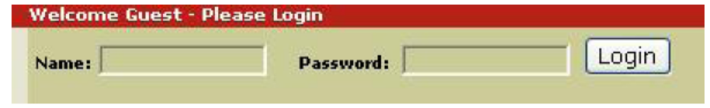

The user would enter a username and password for authentication. Upon clicking the Login button, the submitted username / password should be verified (authenticated) against existing users information in the database.

If the username/password is invalid, the user would be brought back to the above screen, with an appropriate message displayed.

Upon successful authentication, the user would be presented with a screen as follows:

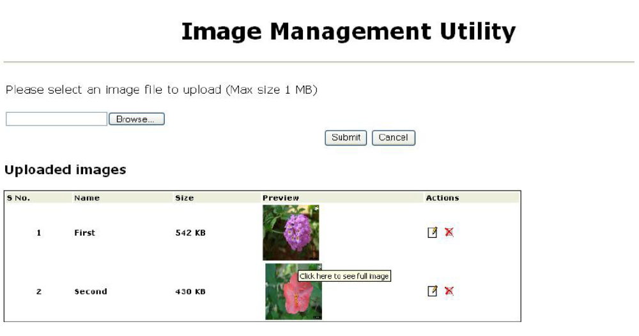

Constraints
- Max size of a single uploaded file should be 1 MB
- Max size of all uploaded files should be 10 MB
-  User should be allowed to edit (change the uploaded image’s attributes viz. name, image source) and delete the image.
-  Also display the total size of the uploaded images at the bottom of the listing.
Design appropriate data model and object model to represent the problem.

Key Points:
- Please install Tomcat and its eclipse plug-in before starting with the implementation. (To verify the installation make sure you are able to start the tomcat from eclipse and see the messages on console.)
- Follow the Java Coding conventions while writing the code.
- Proper validation / info messages should be thrown on console where ever required.
- Do appropriate exception handling where ever required.
- Where ever applicable show the validations and error messages in case of exception to the user on the screen.
- Make use of JavaScript for client side validations.
- Where ever required please write comments in the code to make it more understandable.
- While writing APIs no SQL scripts should be used instead use Hibernate POJOs and HQL.

ASSIGNMENT #6

Topics Covered: Struts, Spring & Hibernate.

Make a student enrollment system where a student can enroll for one or more course. The Student Enrollment system should provide basic CRUD functionalities. For each Student UI is required to enter marks for the courses he has enrolled for.

Make a login screen as shown in previous assignment. Once you login into the system the following options are displayed on the browser window.

Student Enrollment System

Click on your option:

Student Enrollment
Courses Marks
Logout

All the three options are Clickable and clicking on these take you to next screen as explained in following sections.

Student Enrollment:

Shows a list of already enrolled students:

---------------------------------------------------------------------------------------------------------------------------------
Roll No. Name DOB Course Action
---------------------------------------------------------------------------------------------------------------------------------
1. Tom Hanks 12-04-1978 J2EE Edit/Delete
2. Jim Carry 15-04-1977 Dot Net Edit/Delete

---------------------------------------------------------------------------------------------------------------------------------
<<Add Button>> <<Go Back>>

Clicking on Add button should open a screen to enter following details of students:

Enrollment No: <Auto Generated>
First Name:
Last Name:
Date of Birth:
Address:
Course : <Show a drop down with options>

The student can opt for one of the following courses:

Java J2EE
Dot Net
C++, C#
Software Testing.

Courses Marks

The enter marks screen should be like this:

---------------------------------------------------------------------------------------------------------------------------
Roll No. Name Courses Marks Action
---------------------------------------------------------------------------------------------------------------------------
1. Tom Hanks J2EE 60 Edit/Delete
Dot Net 70

2. Jim Carry Dot Net 82 Edit/Delete
Software Testing 78

<<Enter Marks>> <<Go Back>>

Please note since a student can apply for more than one course, therefore there can be more than one courses and its marks for each of the student. However, there is only button for edit/delete for each student.

Clicking on Enter Marks button should open the following screen:

---------------------------------------------------------------------------------------------------------------------------------
Please select the student from drop down whose marks you want to enter.

Select Student: <<Drop Down containing students list>>

---------------------------------------------------------------------------------------------------------------------------------

Note : Only students whose marks are not entered yet should be shown in drop down.

On selecting a student name from drop down his/her courses should be displayed:

---------------------------------------------------------------------------------------------------------------------------------
Student: Tom Hanks

Courses : <<Course1>> <<Text Box for marks>>
<<Course2>> <<Text Box for marks>>

<<Submit Button>> <<Cancel>>

---------------------------------------------------------------------------------------------------------------------------------

Clicking on submit button should take you back to screen where marks listing is shown.

Key Points:
- Please install Tomcat and its eclipse plug-in before starting with the implementation. (To verify the installation make sure you are able to start the tomcat from eclipse and see the messages on console.)
- Follow the Java Coding conventions while writing the code.
- Proper validation / info messages should be thrown on console where ever required.
- Do appropriate exception handling where ever required.
- Where ever applicable show the validations and error messages in case of exception to the user on the screen.
- Make use of Javascript for client side validations.
- Make sure you don’t write any Java Code in JSPs instead make use of Struts Tag libraries.
- While writing APIs no SQL scripts should be used instead use Hibernate POJOs and HQL.
- Where ever required please write comments in the code to make it more understandable.
- Use Spring for dependency injection.

ASSIGNMENT #7

Topics Covered: All Java Training Topics.
Project that will cover all core java and advance java topics.

