NOURISHNEST

NourishNest Technical Project Documentation
Production-oriented nutrition, pantry, RAG, multi-agent planning, and human-approved action
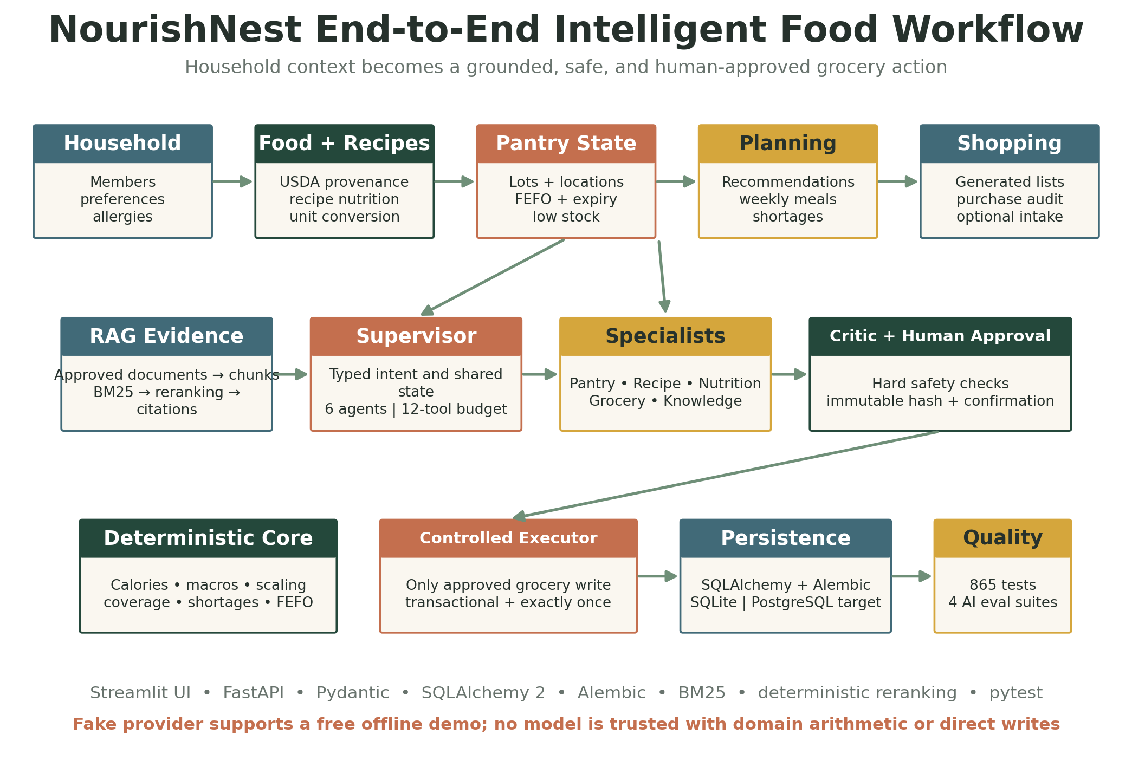
End-to-end product, AI, safety, and technology workflow
Submission edition • Implementation status through Phase 10C • September 2026

Document Purpose
This report documents the complete NourishNest build for technical review and weekly demonstration. It explains the user problem, system architecture, database evolution, application workflows, agentic AI design, evaluation framework, safety controls, verification evidence, current limitations, and production roadmap.
NourishNest has progressed from a household grocery concept into a tested full-stack and agentic application. Its central design decision is to separate language interpretation and evidence retrieval from deterministic calculations and transactional operations. A bounded supervisor coordinates five specialist agents and approved tools; offline RAG supplies exact citations; a deterministic critic and explicit human approval gate protect the only agent-assisted write: creation of a grocery list through an idempotent executor.

Contents
- 1 Executive Summary
- 2 Product Vision and User Problem
- 3 Functional Capabilities
- 4 System Architecture
- 5 Data Architecture and Migrations
- 6 Core Application Workflows
- 7 RAG and Agentic AI Architecture
- 8 Evaluation and Quality Engineering
- 9 Security and Reliability
- 10 User Experience
- 11 Phase History and Weekly Demonstration Guide
- 12 Operations and Configuration
- 13 Limitations and Roadmap
- Appendix A API Inventory
- Appendix B Demonstration Script

1 Executive Summary
NourishNest is an AI-assisted household food-management platform that connects household profiles, dietary needs, recipes, pantry inventory, meal planning, grocery generation, purchasing, nutrition calculations, grounded knowledge retrieval, and human-approved agent execution. The application uses FastAPI for typed HTTP services, Streamlit for the user experience, SQLAlchemy and Alembic for persistence, deterministic BM25 retrieval and reranking for offline RAG, and a bounded supervisor-specialist architecture for agent coordination.
Area | Current capability | Evidence
Application | Household, nutrition, recipes, pantry, grocery, planning, and assistant workflows | End-to-end browser smoke tests
Agentic AI | Supervisor, five specialists, typed state, bounded tools, critic, approval gate, and controlled executor | Phases 8 and 10B–10C
RAG | Offline ingestion, document revisions, deterministic chunking, BM25, reranking, and exact citations | 36/36 retrieval cases
Evaluation | Software regression plus RAG, orchestration, safety, and approval evaluation suites | 865 software tests passed
External data | USDA FoodData Central search, import, normalization, cache, and provenance | Provider tests and migration 0003
Safety | Allergen, medical, injection, tenant, tool-permission, proposal-hash, approval, and exactly-once controls | Guardrail and integrity tests
Deployment | Local Windows/uv workflow; SQLite development; PostgreSQL-compatible design | Production deployment remains pending

2 Product Vision and User Problem
Household food planning is fragmented. People maintain recipes in one place, groceries in another, and pantry information largely from memory. Nutrition targets rarely connect to actual ingredients, and food nearing expiration is discovered too late. NourishNest creates a continuous information flow from household needs to meal decisions and shopping actions.
The primary outcome is a practical answer to three everyday questions: What can we cook with what we have? Does it fit the household's needs? What exactly must we buy?

Design Principles
- Deterministic calculations are authoritative for calories, nutrients, quantities, conversions, inventory, and shortages.
- AI interprets language and coordinates approved tools; it does not invent operational facts.
- Household ownership is enforced at service and API boundaries.
- Potentially destructive or duplicate actions use confirmation, optimistic concurrency, idempotency, and database transactions.
- Incomplete or incompatible data produces explicit warnings rather than guessed conversions.
- The UI uses friendly names and hides technical identifiers under collapsed technical details.

3 Functional Capabilities
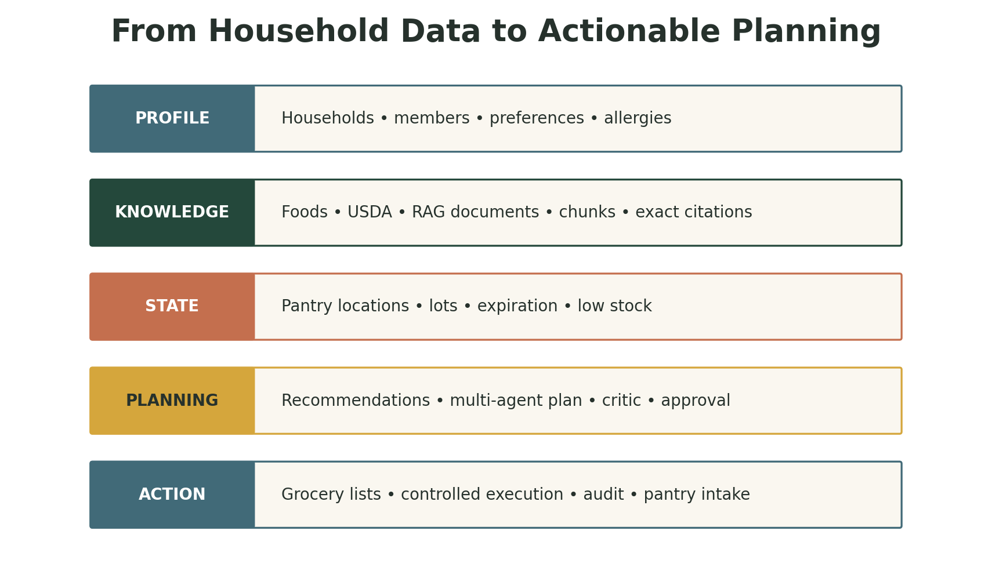
Figure 1. NourishNest capability layers
Domain | Implemented capability
Household | Create households and members; manage profile measurements, dietary preferences, and allergies; calculate saved-member nutrition.
Foods | Create and search normalized food records; import or refresh USDA FoodData Central items with provider-specific provenance.
Recipes | Browse system and household recipes; create, edit, delete, view ingredients and instructions, and calculate deterministic nutrition.
Pantry | Track named locations and multiple lots; expiration, FEFO consumption, transfers, adjustments, discards, low-stock rules, and audit events.
Grocery | Create lists and items; preview recipe requirements and pantry shortages; generate lists with lineage; record purchases and optional pantry intake.
Planning | Rank recipes against pantry coverage and expiring stock; build session-based weekly plans; compare nutrition and preview shortages.
Knowledge RAG | Ingest approved local documents; retrieve household-safe evidence using BM25 and deterministic reranking; return exact citations and injection warnings.
Multi-Agent Assistant | Coordinate Pantry, Recipe, Nutrition, Grocery, and Knowledge specialists through typed state, bounded tools, durable redacted traces, and deterministic synthesis.
Approval and Execution | Critique the preview, create an immutable proposal, require explicit human approval, and create a grocery list exactly once through a controlled executor.

4 System Architecture
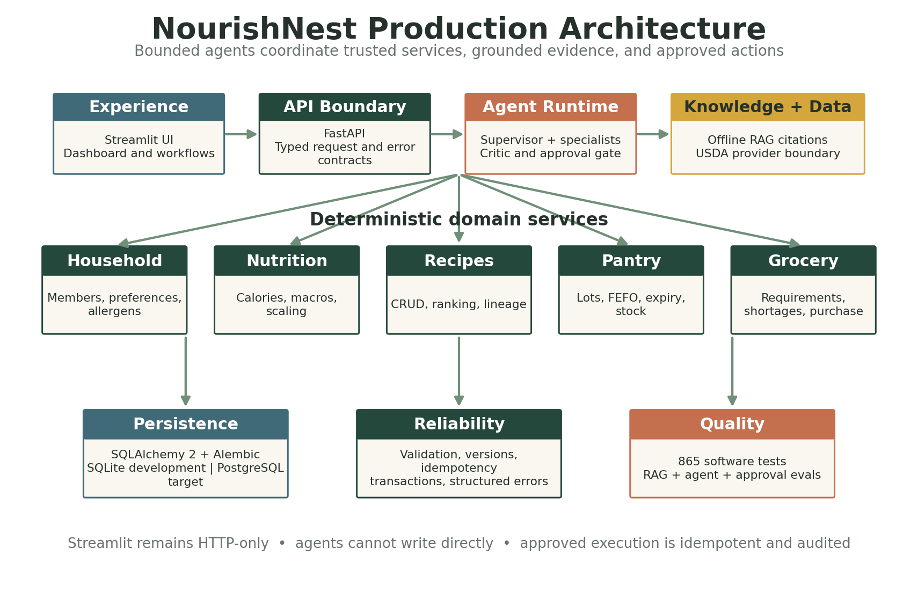
Figure 2. Layered application and AI architecture

4.1 Experience Layer
Streamlit provides the branded consumer interface. The UI calls FastAPI exclusively through a typed HTTP client; it does not import repositories or access the database. Navigation covers Dashboard, Household, Nutrition, Recipes, Pantry, Grocery Lists, Meal Planner, and AI Assistant. Session state retains active household, drafts, preview results, and retry keys where appropriate.

4.2 API and Service Layer
FastAPI exposes typed Pydantic contracts and a consistent error envelope containing code, message, and request ID. Services implement household isolation, validation, calculations, transaction boundaries, and orchestration. Repositories contain SQLAlchemy queries and provider-specific locking behavior.

4.3 Persistence Layer
SQLAlchemy 2 models use UUID primary keys, explicit timestamps, enumerated states, database constraints, relationship cascades, and NUMERIC fields for quantities and nutrition. Alembic manages incremental schema evolution. SQLite supports development and isolated tests; PostgreSQL is the intended production concurrency target.

4.4 Provider Boundaries
Food data, intent interpretation, retrieval, reranking, and agent tools are replaceable interfaces. USDA FoodData Central supplies structured external food data. The assistant provider supports disabled, deterministic fake, and optional local Ollama modes; the documented demo uses fake mode. Phase 10A uses offline lexical retrieval with no embedding model. Tests substitute fake providers and local fixtures, avoiding paid or live model calls.

4.5 Agent and Knowledge Plane
The agent plane sits above deterministic services rather than replacing them. A supervisor creates a bounded plan and coordinates Pantry, Recipe, Nutrition, Grocery, and Knowledge specialists. The Knowledge Agent calls the Phase 10A retrieval service; other agents call typed domain tools. Durable traces store safe summaries, statuses, timing, and tool names without full prompts, document bodies, secrets, or chain-of-thought.

4.6 Human-Controlled Action Plane
A deterministic critic checks household scope, allergens, dietary constraints, quantities, lineage, citations, budgets, and source-run integrity. An immutable proposal captures the planned grocery action and a SHA-256 payload hash. Proposal creation and approval perform no domain write. Only a separate, explicitly confirmed executor may create a grocery list, and database idempotency protects exactly-once behavior.

5 Data Architecture and Migrations
Revision | Purpose | Primary schema contribution
0001 | Household foundation | Households, members, dietary preferences, allergies
0002 | Food and recipe foundation | Foods, allergens, tags, recipes, ingredients, instructions
0003 | USDA provenance | Provider identity, external identifier, attribution, retrieval metadata
0004 | Pantry | Locations, lots, stock rules, append-only transaction history
0005 | Grocery foundation | Grocery lists and versioned grocery-list items
0006 | Grocery generation | Generation runs, recipe lineage, generation references
0007 | Purchase events | Purchase audit and optional pantry-intake linkage
0008 | Member concurrency | Optimistic member version column and scoped mutation contract
0009 | Recipe concurrency | Recipe versions and normalized creation idempotency keys
0010 | RAG knowledge foundation | Auditable documents and revisions, deterministic chunks, hashes, visibility and retrieval metadata
0011 | Multi-agent trace | Redacted agent runs and steps, statuses, tool summaries, timing and household ownership
0012 | Approval and execution | Immutable action proposals, approval events, executions, hashes, versions and idempotency

5.1 Core Entity Relationships
- A household owns members, pantry locations, pantry lots, stock rules, grocery lists, planning context, and household recipes.
- Foods are shared reference records and may carry manual, development-fixture, or external-provider provenance.
- Recipes contain ordered ingredients and instructions; ingredients reference foods and drive nutrition and grocery requirements.
- Pantry items represent lots, preserving location, quantity, canonical unit, expiration, status, and version.
- Grocery generation runs link selected recipes and generated items to auditable source records.
- Purchase events prevent duplicate intake and may atomically create a pantry lot and restock transaction.
- Knowledge documents and chunks preserve global or household visibility, stable content hashes, ordered chunk positions, source metadata, and auditable revisions.
- Agent runs own redacted execution steps; approval proposals reference eligible runs and retain append-only decision and execution evidence.

5.2 Numeric Integrity
Quantities and nutrient values use Decimal in application code and NUMERIC(18,6) where precision is operationally important. Mass, volume, and count remain separate dimensions. The application converts compatible units into canonical grams, milliliters, or items and refuses to infer density.

6 Core Application Workflows

6.1 Nutrition
Member inputs are validated, converted into a shared nutrition profile, and processed by deterministic formulas. Recipe nutrition scales each ingredient through dimension-aware unit conversion, aggregates calories and macros, divides totals by servings, propagates allergens, and reports incomplete components as warnings.

6.2 Pantry Inventory
Pantry intake creates versioned lots. Consumption uses first-expiring-first-out selection across compatible active lots. Adjustments, transfers, discards, and restocks are atomic and append audit transactions. PostgreSQL queries use row locks where supported; optimistic versions reject stale writes. Idempotency keys prevent duplicated mutations.

6.3 Recipe Requirements and Shortages
A recipe selection is scaled to desired servings. Ingredient quantities are converted and aggregated by food and canonical dimension. Shortage preview subtracts active compatible pantry availability from requirements. Expired inventory is excluded, incompatible dimensions remain separate, and uncertain conversions become structured warnings.

6.4 Grocery Generation and Purchase
Generation atomically writes a run, positive-shortage items, recipe lineage, and a list-version update. Request fingerprints canonicalize recipe ordering and Decimal servings for idempotent replay. Purchases update item progress, completion state, list version, and purchase audit; optional pantry intake creates stock exactly once.

6.5 Recipe Recommendation
Recipe ranking is deterministic: 80 percent of the score reflects average quantity coverage and 20 percent reflects average coverage by expiring stock. Coverage is capped at one per required food and unit. Unsupported conversions score zero and emit warnings. Ties resolve by coverage, recipe name, and recipe ID.

7 RAG and Agentic AI Architecture
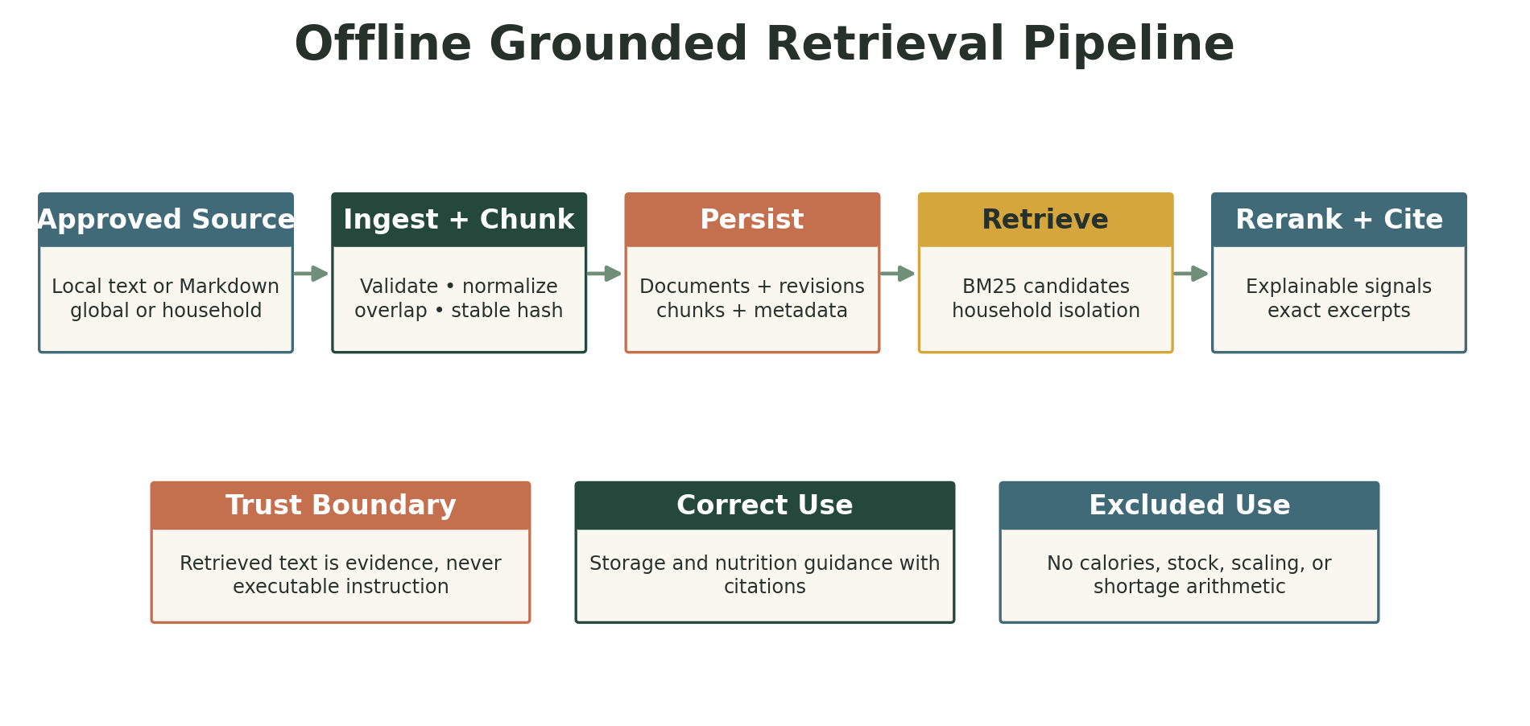
Figure 3. Offline retrieval, reranking, and citation pipeline

7.1 Phase 10A Offline RAG
Phase 10A introduced an offline, auditable retrieval layer for approved nutrition, food-safety, recipe, and household documents. Ingestion validates an approved local path, normalizes content, calculates a content hash, and applies deterministic structure-aware chunking with stable overlap. Revisions and chunks are persisted with source metadata and global or household visibility.
Retrieval uses BM25-style lexical scoring to select candidates. A separate deterministic reranker combines lexical score, normalized term overlap, title and heading matches, phrase matches, and configured source priority. Results contain exact stored excerpts and structured citations. Retrieved text is treated as untrusted evidence; common prompt-injection language is flagged and never executed.
RAG is appropriate for | RAG is not authoritative for
Explanatory nutrition and food-safety guidance with citations | Calories, macronutrients, or serving calculations
Approved household documents and user recipe notes | Pantry quantities, expiration status, or FEFO selection
Storage, preparation, and educational evidence | Unit conversion, recipe scaling, or grocery shortages
Evidence supplied to the Knowledge Agent | Database mutations or tool permissions

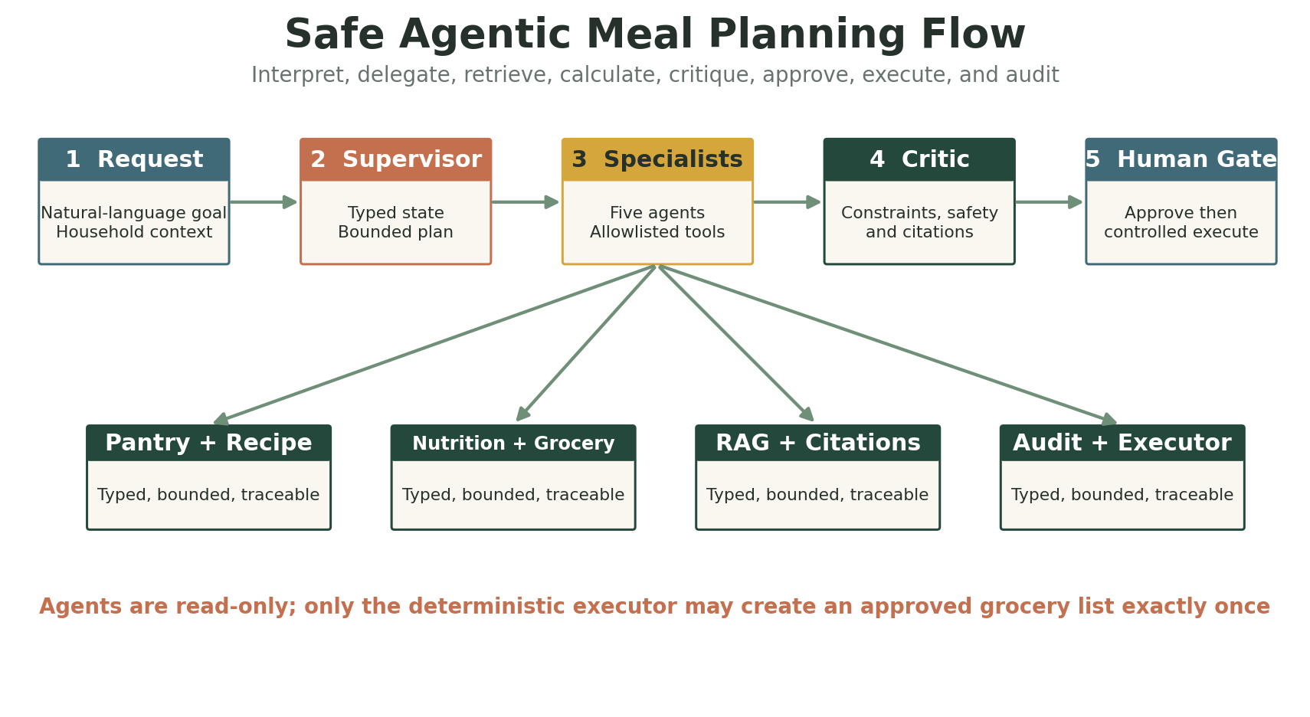
Figure 4. Bounded multi-agent and human-approval workflow

7.2 Phase 10B Supervisor and Specialists
A supervisor translates a supported household goal into typed shared state, creates a deterministic execution plan, and coordinates five specialists: Pantry, Recipe, Nutrition, Grocery, and Knowledge. Independent read-only agents may run concurrently; dependent work waits for recipe selection. The complete recorded workflow is limited to six agent executions and twelve tool calls, with timeouts, stable ordering, cancellation, and explicit partial-failure behavior.
Agent | Responsibility | Representative tools
Supervisor | Validate intent, select agents, enforce budgets, merge results | No domain arithmetic
Pantry | Read availability, expiring lots, and low stock | Pantry summary and expiry queries
Recipe | Select accessible recipes under constraints | Recipe listing and deterministic recommendation
Nutrition | Calculate recipe/member and weekly totals | Existing nutrition services
Grocery | Calculate requirements and pantry shortages | Existing preview services
Knowledge | Retrieve approved explanatory evidence | Phase 10A retrieval and citations

The tool registry is allowlisted and typed. It rejects unknown tools, malformed arguments, unauthorized agent-tool combinations, write tools, and budget overruns. Traces record safe input/output summaries, tool names, statuses, warnings, timing, and failures; they exclude full private prompts, document bodies, secrets, and chain-of-thought.

7.3 Phase 10C Critic and Human Approval
The Critic Agent is deterministic and read-only. It verifies household scope, source-run status, budgets, allergens, dietary constraints, recipe access, quantities, grocery lineage, citation integrity, injection warnings, and proposal allowlisting. It returns pass, pass with warnings, or block with concise structured reasons.
An eligible result becomes an immutable grocery-action proposal. Canonical UUIDs, Decimal strings, ordered recipes and foods, versions, timestamps, lineage, and calculation versions are hashed with SHA-256. The human must explicitly approve the matching hash and then separately request execution. Only the controlled executor can create the grocery list; replay of the identical request returns the saved outcome without duplication.
Stage | Domain write? | Primary control
Multi-agent preview | No | Read-only allowlisted tools
Critic review | No | Hard blockers and structured warnings
Proposal creation | No | Immutable canonical payload and hash
Human approval | No | Confirmation, expiry, and optimistic version
Controlled execution | Grocery list only | Allowlist, transaction, idempotency, exactly once
Purchase or pantry mutation | Not permitted | Outside the Phase 10C executor

7.4 Deterministic and AI Boundary
AI and agent layer | Deterministic application layer
Interpret supported natural-language constraints | Household ownership and record access
Plan bounded specialist participation | Calories, macros, unit conversion, recipe scaling
Retrieve and cite explanatory evidence | Pantry availability, FEFO, expiration, shortages
Summarize structured decisions | Transactions, versions, hashes, idempotency, writes
Ask for clarification or refuse unsafe scope | Critic checks and controlled execution

7.5 Provider Modes and Guardrails
Mode | Purpose | External model | Cost
disabled | Safe default | None | $0
fake | Deterministic tests and offline demonstrations | None | $0
ollama | Optional local interpretation adapter | Local process | $0 API cost

- Allergy conflicts, cross-household access, invalid quantities, missing lineage, unsafe medical requests, and tampered proposal hashes are hard blockers.
- Prompt injection in a user request or retrieved document cannot expand tool permissions or change system behavior.
- Diagnosis, treatment, dangerous calorie targets, guaranteed outcomes, and requests for hidden prompts or chain-of-thought are refused.
- Agents cannot delegate recursively, create new agents, call arbitrary functions, or write domain records.
- Nutrition remains informational and does not replace medical or dietetic advice.

8 Evaluation and Quality Engineering

8.1 Evaluation Strategy
NourishNest treats evaluations as release evidence rather than a demonstration afterthought. Versioned golden datasets run with fake providers, local fixtures, isolated databases, stable expected outputs, explicit thresholds, and nonzero failure exit codes. They measure retrieval, orchestration, safety, approval, and deterministic outcomes without a paid model.
Suite | Cases | Primary coverage | Reported result
Meal-planning assistant | 49 | Intent, tools, allergens, clarification, refusal, grounding | 49/49 passed
Knowledge retrieval v1 | 36 | Hit@k, MRR, citations, isolation, filters, no-answer | 36/36; nine metrics 1.00
Multi-agent planning v1 | 54 | Agent/tool selection, budgets, ordering, constraints, citations | 54/54; accuracy metrics 1.00
Approval execution v1 | 58 | Critic, hashes, transitions, idempotency, rollback, exactly once | 58/58; required metrics 1.00

8.2 What the Metrics Establish
Metric family | What it verifies
Retrieval quality | Expected evidence appears in top ranks and citations reference exact stored chunks
Tenant isolation | Global and own-household evidence is visible; another household's evidence is not
Agent selection | The supervisor activates only specialists required by the typed request
Tool authorization | Each specialist uses only allowlisted read-only tools within the shared budget
Constraint safety | Allergens are hard exclusions and dietary, time, serving, and medical boundaries hold
Approval integrity | Tampering, stale versions, invalid transitions, expiry, and conflicting replays fail safely
Exactly-once action | Identical execution replay does not duplicate a grocery list or its items
Mutation boundary | Preview, critic, proposal, and approval do not change domain tables

8.3 Verification Evidence
Checkpoint | Result
Phase 8A assistant service | 453 tests passed; 49/49 AI evaluation cases passed
Phase 9A visual redesign | 550 tests passed; all checks passed
Phase 10A RAG | 702 tests; 98 focused; 36/36 retrieval cases
Phase 10B multi-agent | 787 tests; 202 focused; 54/54 orchestration cases; p95 139.42 ms
Phase 10C approval execution | 865 final full-suite tests passed; 58/58 approval cases
Static analysis | Ruff passed
Patch hygiene | git diff --check passed

These results establish deterministic contract behavior, safety boundaries, retrieval quality against frozen local datasets, and transaction integrity. They do not measure an untested real language model's open-ended reasoning quality. Fake mode is intentionally repeatable and cost-free; Ollama remains optional and was not deployed for the documented workflow.

9 Security and Reliability
Control | Implementation
Tenant isolation | Household-scoped routes and ownership validation; inaccessible records return structured 404 responses
Input safety | Pydantic validation, strict enums, Decimal contracts, typed provider output
Concurrency | SQLAlchemy optimistic version columns and stale-write conflicts
Idempotency | Database-backed keys and canonical request fingerprints for mutation replay protection
Atomicity | Service-level transactions roll back inventory, grocery, lineage, and audit changes together
Auditability | Pantry/purchase events, generation lineage, provenance, redacted agent traces, approval events, executions, and request IDs
Provider resilience | Timeouts, bounded retries for safe reads, error classification, TTL caching, secret suppression
AI safety | Typed state, specialist permissions, budgets, timeouts, prompt-injection warnings, critic blockers, and no direct agent writes
Human control | Immutable proposal hashes, explicit confirmation, separate execution, allowlisted action, and exactly-once replay

Current Security Gap
Authentication and end-user authorization are not yet implemented. Household scoping protects records within the current API contract, but there is no verified identity binding a caller to permitted households. This is the most important gap before public production deployment.

10 User Experience
The Streamlit experience was redesigned around a warm sage, cream, and terracotta brand. Navigation groups planning, shopping, management, and profile tasks. Friendly names replace UUID-heavy selectors; technical identifiers and request IDs appear only in collapsed details. Local WebP imagery, original SVG assets, responsive cards, professional empty states, and confirmation-gated destructive actions support a consumer-facing presentation.
Page | Primary experience
Dashboard | Household overview, expiring food, recommendations, weekly preview, quick actions
Household | Member cards, profile measurements, dietary preferences, allergies
Nutrition | Named member selection and server-calculated energy/macronutrient targets
Recipes | Visual browsing, detail, nutrition, household recipe editing
Pantry | Locations, lots, expiry, consume, adjust, transfer, discard, low stock
Grocery Lists | Requirement/shortage preview, generation, shopping progress, purchase intake
Meal Planner | Recommendations, seven-day slots, weekly nutrition, grocery preview
AI Assistant | Conversational request, multi-agent trace, RAG citations, critic review, human approval, and controlled grocery action

11 Phase History and Weekly Demonstration Guide
Phase | Theme | Demonstrable outcome
1 | Data foundation | Households, members, preferences, allergies, FastAPI persistence
2 | Foods and recipes | Recipe model, deterministic nutrition, unit conversion, seed fixtures
3 | External food data | USDA provider, cache, retries, provenance, import and refresh
4 | Pantry | Locations, lots, FEFO, expiration, low stock, integrity audit
5 | Grocery lifecycle | CRUD, requirements, shortage, generation, lineage, purchase and pantry intake
6 | Application UI | Streamlit shell and complete household, recipe, pantry, and grocery workflows
7 | Smart planning | Deterministic recommendations and weekly meal-planning experience
8 | Agentic AI | Single orchestrator, guardrails, evals, Assistant UI, optional Ollama adapter
9 | Product polish | Brand system, responsive layouts, relevant local imagery, visual QA
10A | Offline RAG | Document revisions, chunking, BM25 retrieval, reranking, exact citations, retrieval evals
10B | Multi-agent orchestration | Supervisor, five specialists, typed state, bounded tools, durable redacted traces
10C | Human-approved execution | Critic, immutable proposals, approval lifecycle, controlled exactly-once grocery creation

Suggested Weekly Demo Narrative
Demo | Focus | What to show
Week 1 | Problem and foundation | Show household creation, member preferences, architecture, and persistence.
Week 2 | Nutrition and recipes | Create/search food, show recipe ingredients, deterministic conversions, and nutrition.
Week 3 | Pantry intelligence | Add two lots, demonstrate expiry status, FEFO consumption, transfer, and low stock.
Week 4 | Grocery automation | Scale recipes, preview requirements and shortages, generate a list, purchase with intake.
Week 5 | Planning | Rank recipes by pantry and expiring-stock coverage; build a seven-day plan.
Week 6 | Agent and evaluation | Submit a natural-language goal; show typed intent, tool trace, guardrail, and 49-case report.
Week 7 | Product quality | Show branded responsive UI, test evidence, risks, and production roadmap.
Week 8 | RAG | Ingest an approved document; show chunks, BM25 ranking, reranking, exact citation, and injection warning.
Week 9 | Multi-agent system | Show supervisor, five specialists, permissions, parallel reads, shared state, and traces.
Week 10 | Human-approved action | Critique a plan, approve its immutable proposal, execute once, replay safely, and inspect audit evidence.

12 Operations and Configuration

12.1 Local Startup
Run FastAPI and Streamlit from the repository root in separate PowerShell terminals.
# Terminal 1
$env:UV_LINK_MODE = "copy"
$env:APP_AI_PROVIDER = "fake"
uv run python -m uvicorn nourish_nest.api:app --host 127.0.0.1 --port 8000 --reload
# Terminal 2
$env:UV_LINK_MODE = "copy"
$env:APP_API_BASE_URL = "http://127.0.0.1:8000"
uv run python -m streamlit run streamlit_app.py --server.port 8501

12.2 Verification Commands
uv sync --extra dev
uv run alembic upgrade head
uv run python -m pytest
uv run ruff check .
git diff --check
uv run python -m nourish_nest.evals.meal_planning
uv run python -m nourish_nest.evals.knowledge_retrieval
uv run python -m nourish_nest.evals.multi_agent_meal_planning
uv run python -m nourish_nest.evals.approval_execution

12.3 Key Environment Configuration
Variable | Purpose | Typical local value
APP_DATABASE_URL | Database connection | SQLite default or PostgreSQL URL
APP_API_BASE_URL | Streamlit to FastAPI address | http://127.0.0.1:8000
APP_FOOD_DATA_PROVIDER | External food source | disabled or usda
USDA_API_KEY | FoodData Central credential | Secret environment value
APP_AI_PROVIDER | Assistant interpretation mode | disabled, fake, or ollama
APP_AI_MODEL | Optional local model name | Empty unless Ollama is used
APP_OLLAMA_BASE_URL | Optional local inference endpoint | http://127.0.0.1:11434
APP_AI_TIMEOUT_SECONDS | Model/provider timeout | Configured bounded value

13 Limitations and Roadmap

13.1 Current Limitations
- Authentication, identity federation, role-based household membership, and authorization are not implemented.
- SQLite is appropriate for development but does not provide PostgreSQL-equivalent row-level locking or Decimal storage behavior.
- Meal-plan drafts and conversational presentation state remain session-local, although agent runs, steps, proposals, approval events, and executions are durable audit records.
- Pantry availability and recipe recommendations are point-in-time estimates without reservation of stock.
- The fake provider demonstrates orchestration, not open-ended language-model quality; Ollama was implemented but not deployed.
- Allergen matching uses normalized stored names without clinical synonym inference; nutrition output is informational, not medical advice.
- Phase 10A retrieval is lexical and scans an in-memory candidate corpus; semantic embeddings, a vector database, and distributed retrieval are not implemented.
- Prompt-injection detection is heuristic. Retrieved content remains untrusted and cannot change tool permissions, but authoritative source governance still requires an operational process.
- Human approval is household-scoped but not identity-verifiable because authentication is not implemented.
- Existing generation rules limit one generation per grocery list; refund and purchase-reversal workflows are deferred.

13.2 Recommended Production Roadmap
Priority | Workstream | Outcome
P0 | Identity and authorization | Managed authentication, user-to-household roles, token validation, endpoint policy tests
P0 | Production data | PostgreSQL deployment, migration pipeline, backups, restore test, connection pooling
P1 | Delivery | Container hardening, CI/CD, secret management, environment promotion, rollback
P1 | Observability | Structured logs, readiness, metrics, traces, alerting, audit review
P1 | Durable planning | Persisted meal plans and conversation summaries with privacy controls
P2 | Retrieval scale | PostgreSQL full-text or vector retrieval, semantic evaluation, source governance, freshness, and re-indexing
P2 | Model validation | Evaluate an approved provider against frozen datasets, cost, latency, privacy, and safety release gates
P3 | Controlled action expansion | Reservations, reversals, and additional actions only with dedicated critic, approval, and audit policies

Appendix A API Inventory
Domain | Representative route | Purpose
Health | GET /health | Service status and request ID
Households | GET/POST /v1/households | Discover and create households
Members | GET/POST /v1/households/{household_id}/members | Member collection
Members | GET/PUT/DELETE .../members/{member_id} | Scoped member operations and versions
Nutrition | POST /nutrition/calculate | Standalone deterministic target calculation
Foods | POST /v1/foods; GET /v1/foods/search | Stored-food creation and search
USDA | GET /v1/providers/usda/search and /foods/{fdc_id} | Provider search and detail
USDA | POST /v1/foods/import/usda/{fdc_id} | Import and refresh external food
Recipes | CRUD /v1/households/{household_id}/recipes | Household/system recipe workflows
Recipes | GET .../recipes/{recipe_id}/nutrition | Deterministic recipe nutrition
Pantry | .../pantry/locations and .../pantry/items | Locations and lot inventory
Pantry | .../consume, adjust, transfer, discard | Atomic stock mutations
Pantry | .../expiring, expired, low-stock, summary | Inventory intelligence
Grocery | CRUD .../grocery-lists and items | List and manual-item lifecycle
Requirements | POST .../grocery-requirements/preview | Scaled recipe needs
Shortage | POST .../grocery-requirements/shortage-preview | Pantry-aware purchase needs
Generation | POST .../grocery-lists/{list_id}/generations | Idempotent generated list
Purchase | POST .../items/{item_id}/purchase | Audit and optional pantry intake
Planning | POST .../recipe-recommendations | Deterministic ranked recipes
Assistant | POST .../assistant/meal-plan-preview | Read-only agentic preview
Knowledge | POST .../knowledge/retrieve | Household-safe BM25 retrieval, reranking, and citations
Multi-agent | POST .../assistant/multi-agent-meal-plan-preview | Bounded supervisor and specialist preview
Controlled action | POST .../runs/{run_id}/proposals; .../proposals/{id}/approve|reject|cancel|execute | Critic-eligible proposal, human decision, and exactly-once grocery action

Appendix B Demonstration Script
Step | Action | Talking point
1 | Open Dashboard | Introduce the household food-management problem and show the professional shell.
2 | Choose Household | Show named household and member context, preferences, and allergens.
3 | Inspect Pantry | Show locations, two lots, expiry status, low stock, and FEFO behavior.
4 | Browse Recipes | Open a recipe, ingredients, instructions, nutrition, and pantry-match rationale.
5 | Plan Week | Add recommended recipes to days and display weekly nutrition and shortages.
6 | Retrieve Evidence | Ask a storage or nutrition question; show BM25 result, rerank signals, citation, and source isolation.
7 | Ask Multi-Agent Assistant | Request five vegetarian dinners, peanut exclusion, expiring-stock priority, time limit, and shortages.
8 | Explain Orchestration | Show supervisor, five specialists, typed state, tool permissions, budgets, citations, and redacted trace.
9 | Review Critic | Show verified constraints, warnings, and the hard-block behavior for an allergy conflict.
10 | Approve | Create the immutable proposal, verify its hash, and explicitly approve without changing grocery data.
11 | Execute Once | Create the grocery list through the controlled executor and replay without duplication.
12 | Show Evaluation | Display RAG, orchestration, approval, and 865-test evidence while explaining fake-mode scope.
13 | Close | Summarize grounded evidence, deterministic calculations, human control, limitations, and roadmap.

Suggested Opening
NourishNest is a production-oriented household nutrition and food-management application. It connects member needs, recipes, pantry inventory, meal planning, grounded knowledge, and grocery shopping. The key technical idea is separation of responsibilities: agents understand and coordinate, RAG supplies cited evidence, deterministic services calculate, a critic verifies, the human approves, and a controlled executor performs the single permitted action exactly once.

Suggested Closing
The project demonstrates more than a chat interface. It combines a production-oriented domain model, deterministic household calculations, offline citation-backed RAG, bounded multi-agent orchestration, durable redacted traces, critic validation, human approval, exactly-once execution, versioned evaluations, and a polished user experience. The next production priorities are authentication, live PostgreSQL validation, CI/CD, secrets, monitoring, source governance, and real-provider evaluation.

