1. ggplot(data = new) + geom_point(aes(x = EndTerm, y = Total, color = PastwithCS, shape = factor(Midterm)), size = 2)

# LINEAR MODEL

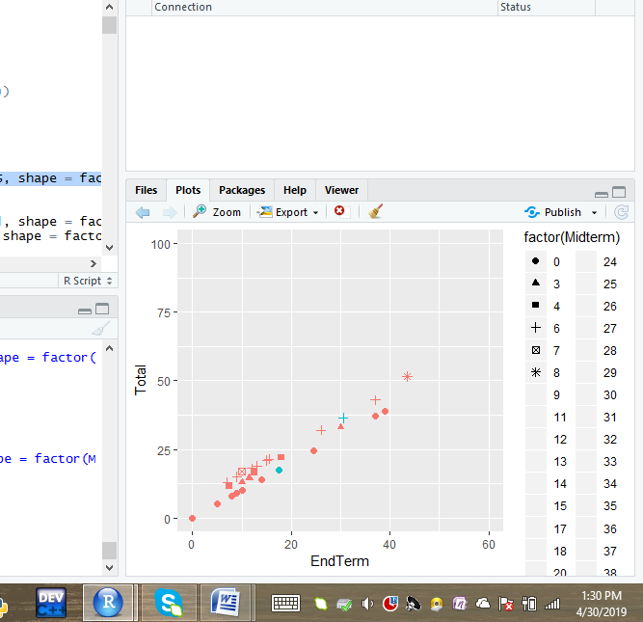

2. ggplot(data = new) + geom_bar(mapping = aes(x = Midterm, fill = PastwithCS), position = "dodge

#NO MODEL FITS HERE

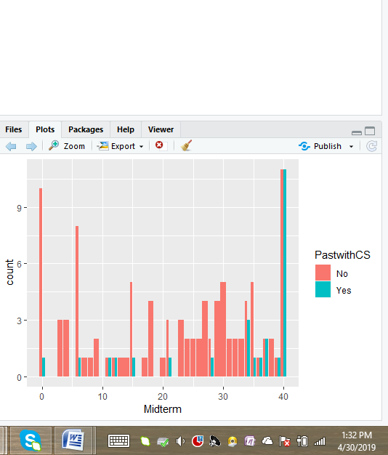

3. p <- ggplot(data = new, mapping = aes(x=Helpful, y=Midterm)) + geom_point(size=1)

p <- p + geom_smooth(method="loess", se=FALSE, span=1/10)

print(p)

p <- ggplot(data = new, mapping = aes(x=Total, y=Midterm)) + geom_point(size=1)

p <- p + geom_smooth(method="loess", se=FALSE, span=1/10)

print(p)

#LINEAR MODEL(TO SOME EXTENT)

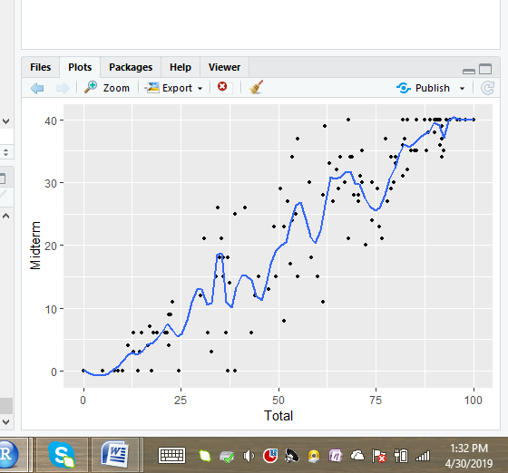

4. data.frame(value = c(NA, NA, NA, rnorm(1000,0,1))) %>% ggplot() +

geom_histogram(mapping = aes(x = value), bins = 50)

#QUADRATIC MODEL FITS HERE

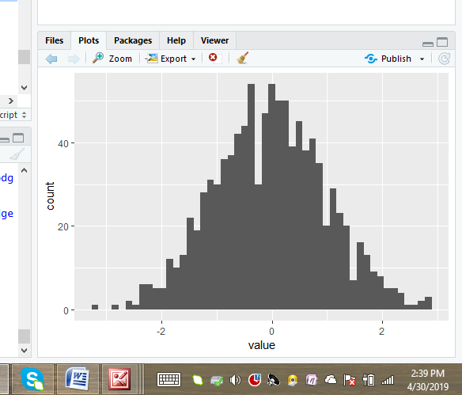

5. ggplot(data = new, mapping = aes(x = Total, y = PastwithCS, color = EndTerm)) +

geom_count()

ggplot(data = new, aes(x = Midterm, y = EndTerm, colour = )) +

geom_boxplot()

#NO MODEL FITS HERE

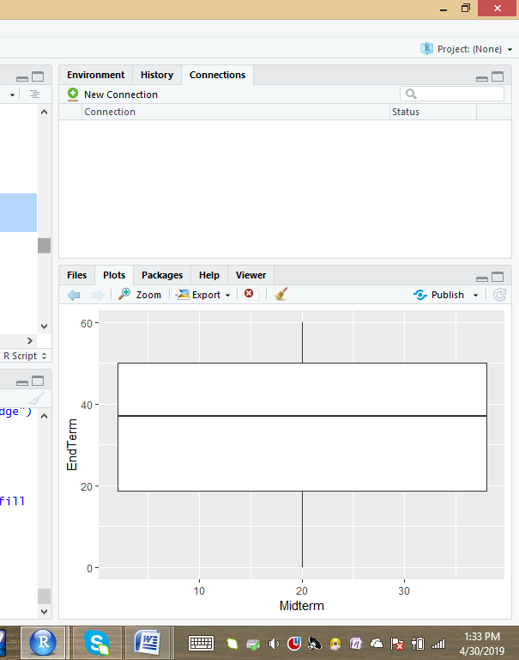

6.ggplot(data = new, mapping = aes(x =Total, y = Helpful)) +geom_point() + geom_abline() + coord_fixed()

ggplot(data = new, mapping = aes(x =Total, y = EndTerm)) +

geom_point() +

geom_abline() +

coord_fixed()

#LINEAR MODEL FITS HERE

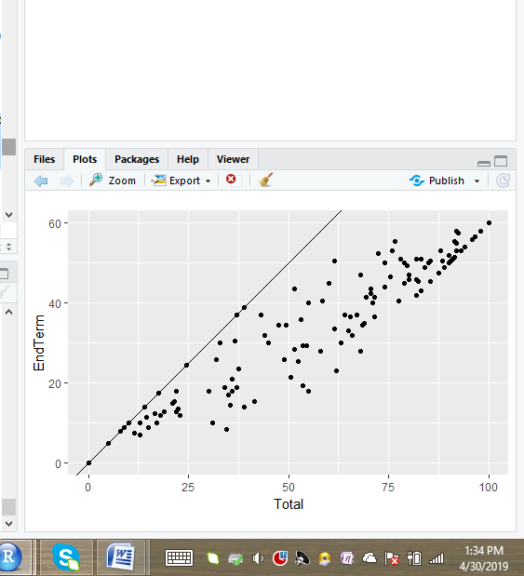

7.new %>% group_by(Helpful) %>% summarize(median_y = median(Midterm),min_y = min(EndTerm),

max_y = max(Total)) %>%ggplot() +geom_pointrange(mapping = aes(x =Helpful, y = median_y, ymin = min_y, ymax = max_y)) +labs(y = 'depth')

#MODEL PARALLEL TO Y AXIS(Y=MX+C)

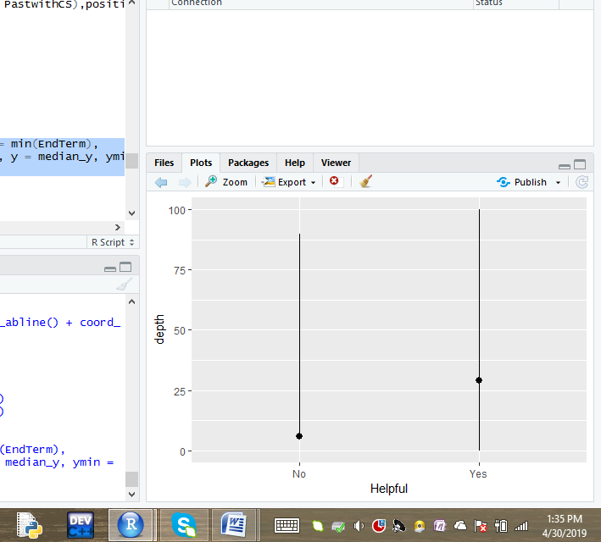

8. ggplot(data=new, mapping = aes(x=log(Midterm),y=Total, color=EndTerm)) + geom_text(aes(label=Helpful), size = 3)

ggplot(data=new, mapping = aes(x=log(Midterm),y=Total, color=EndTerm)) + geom_text(aes(label=Serial), size = 3)

ggplot(data=new, mapping = aes(x=log(Midterm),y=Total, color=EndTerm)) + geom_text(aes(label=PastwithCS), size = 3)

#EXPONENTIAL MODEL

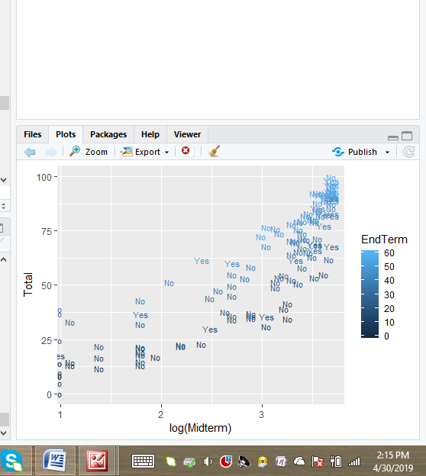

#EXPONENTIAL MODEL

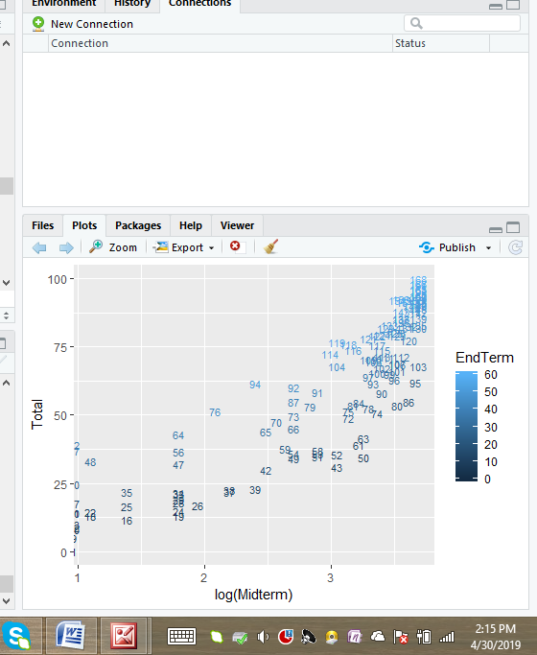

9. new%>% count(Total, EndTerm) %>% ggplot(mapping = aes(x = Total, y = Total)) + geom_tile(mapping = aes(fill = n)) +labs(title = "Better than x = Helpful, y = Midterm")

#LINEAR MODEL

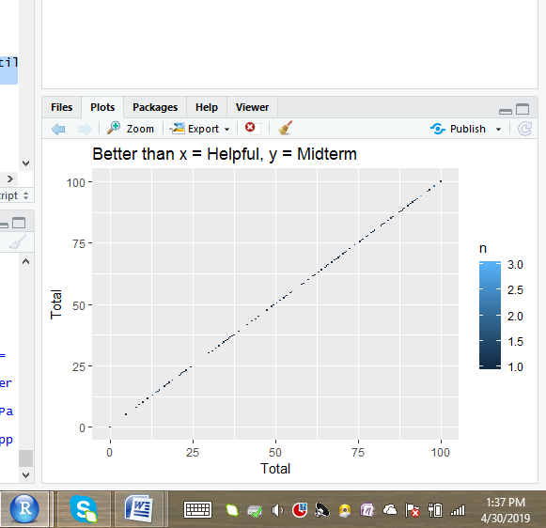

10 . new %>% filter(Midterm>20 ) %>% ggplot(aes(x = PastwithCS)) + geom_density(aes(color = cut_width(Total, 51)))

#NO MODEL FITS HERE

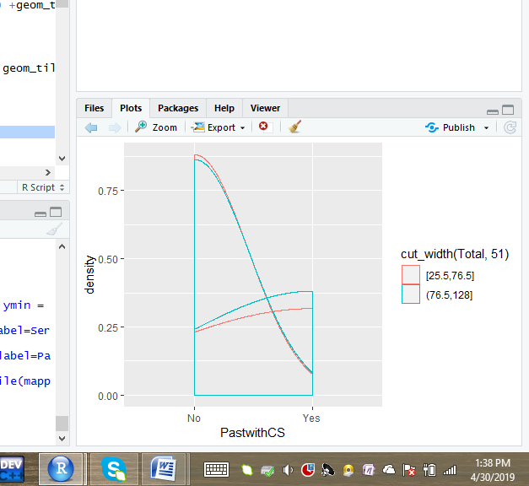

11. new %>% ggplot() + geom_boxplot(aes(x = cut_number(Total, 53), y = EndTerm, color = Helpful))

#LOGARITHMIC MODEL

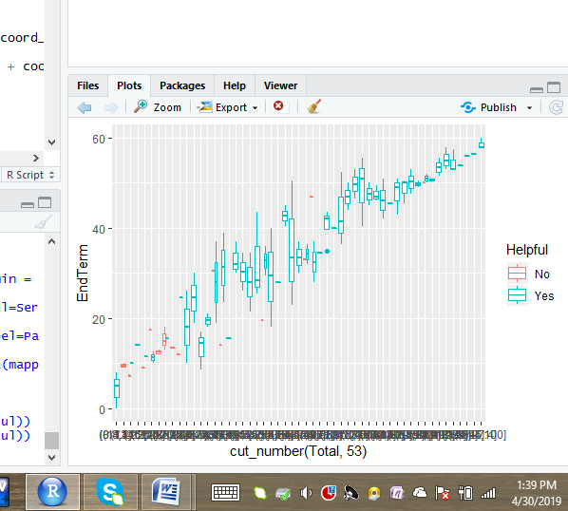

12 . ggplot(data = new) +

geom_smooth(mapping = aes(x = Total, y = EndTerm, colour = Helpful),show.legend = FALSE )

# LINEAR MODEL FITS HERE

