You will see below icon in your desktop

1)click on below blue icon

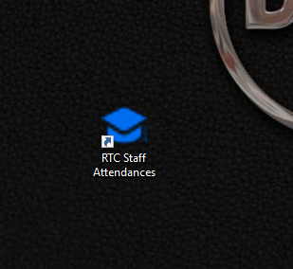

2)after clicking on blue icon, then appear login form in browser

3)enter your username and password(RTC email without [using@.rtc.bt](mailto:using@.rtc.bt) eg;sonamchophel),

then click on login button

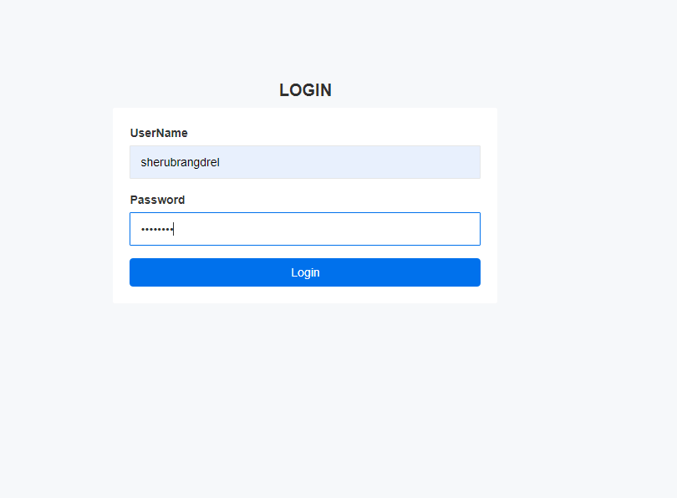

4) After login you will redirect to homepage

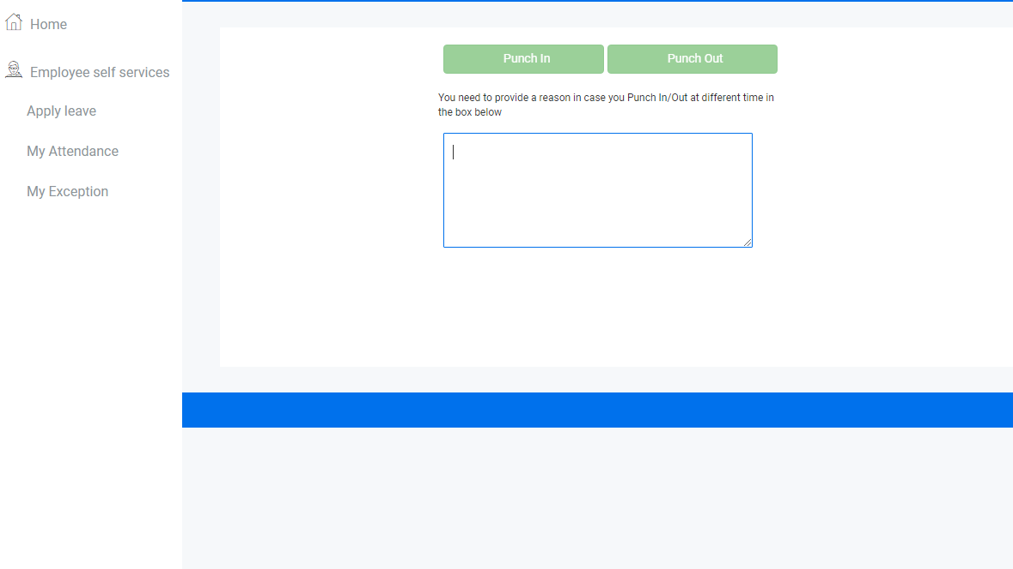

5) Click on Punch in button to sign in, button will disable if you login in different time(if you are late to punch in),to enable punch in button you should provide the genuine reason.

6) Click on Punch out button to sign out, button will disable if you login in different time(if you are require early punch out ),to enable punch in button you should provide the genuine reason.

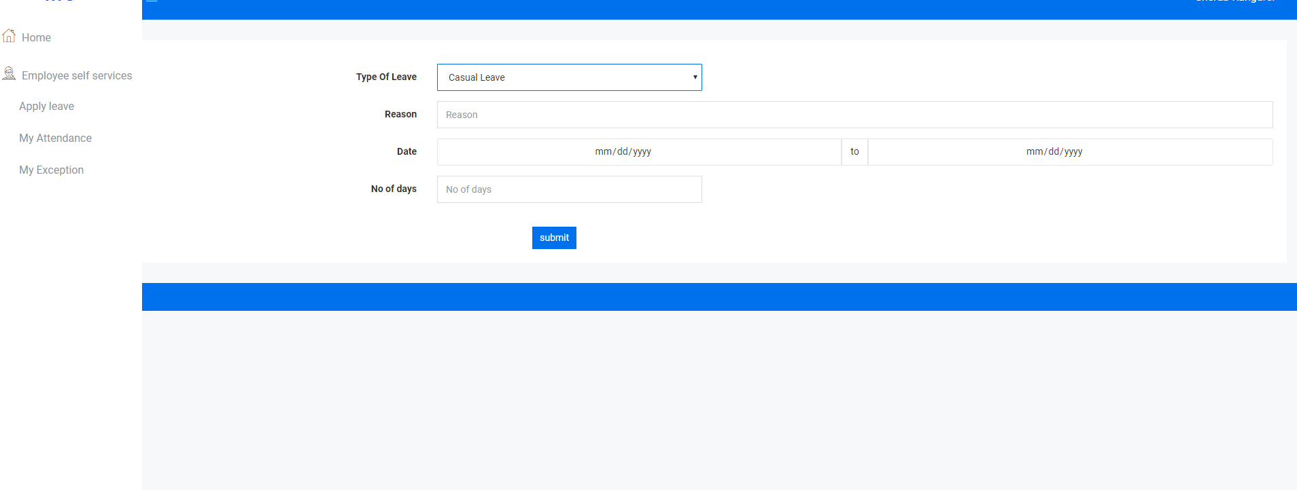

7) If you want to apply leave, You can click to Apply leave menu

8)Fill up the leave details to above text boxes.

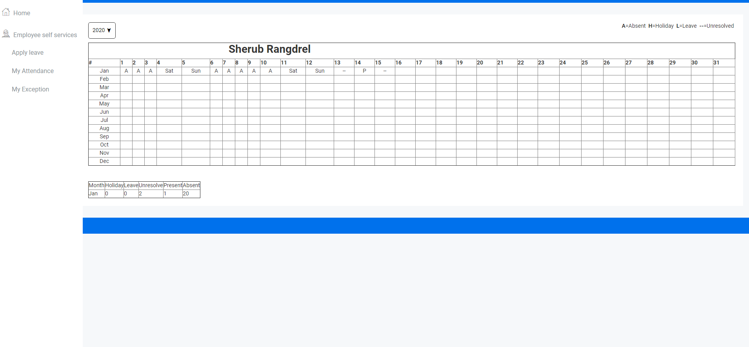

9) Click to My Attendance you can able view your attendance

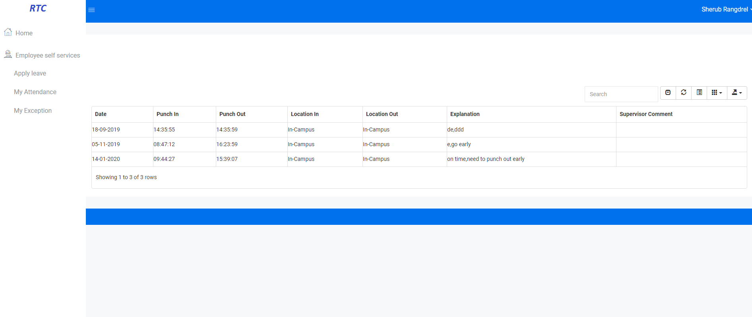

11)Click to My exception will know your late sign in and early sign out

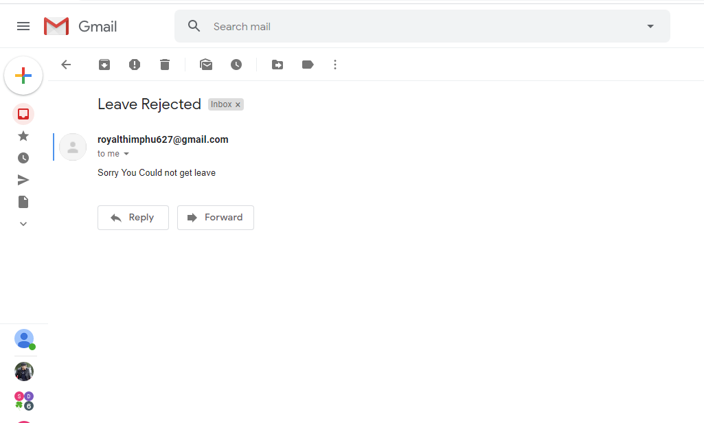

12)If Your leave is approve or reject by superiors ,You will get mail like above.

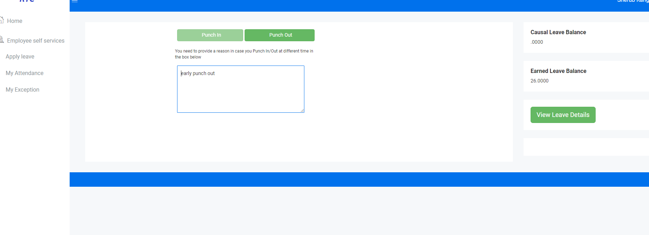

13) Click to view leave details button you will get you’re approved leave history.

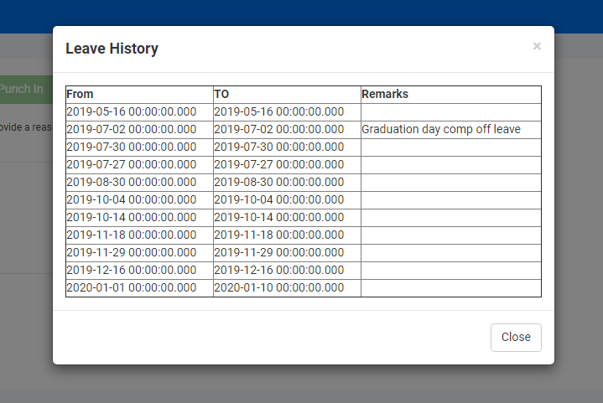

For supervisors

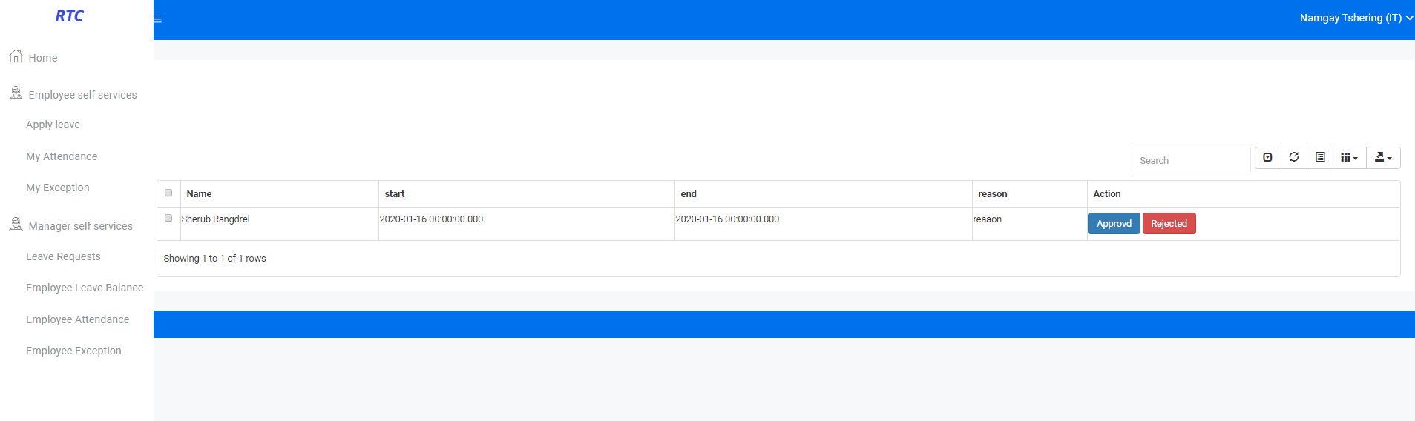

14)click to Leave request ,supervisors will get leave request list apply from employee under him/her.

15)supervisor will click to reject /approved button for employee leave applied .

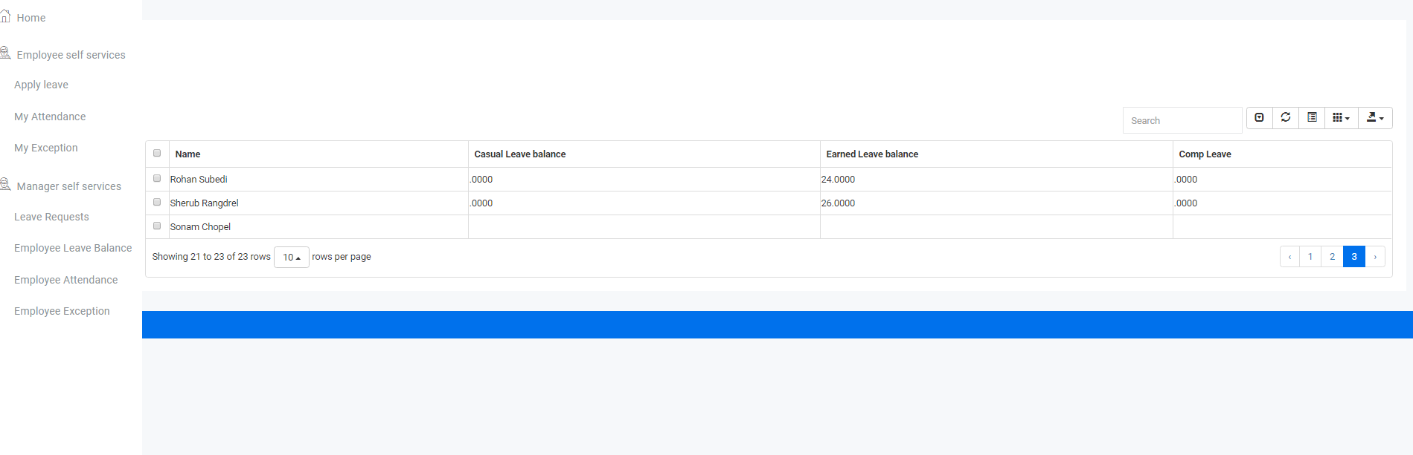

17)click to Employee leave balance will get leave balance for employee under particular supervisor

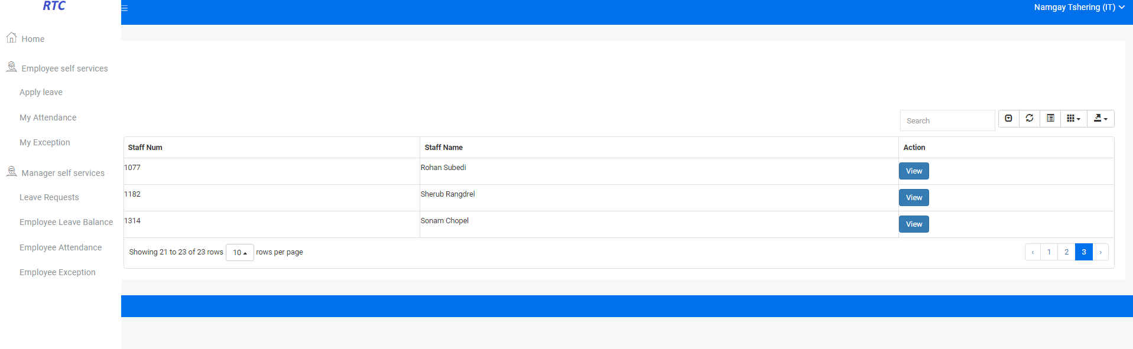

18) Click to Employee Attendance or Employee Exception you will get staff list under particular supervisor .

19) Click to view button to get employee attendance record or employee exception