Stephen Ranger
Thesis Update #3

Level of Detail

There are a number of systems in place for this work including the TreeStructure and Earth classes. Each implements a level of detail algorithm for modifying what is rendered based on the location of the scene’s camera.

Tree Structure

The TreeStructure is split into a number of cells each with its own child cells. The Octree is defined by a single cube and then split into eight identical child cubes and each child into eight more, etc. The Icosatree is also split into child cells but defined slightly different. First, the root cell is unused aside from being the root of the tree and is defined as an axis-aligned bounding box containing its child cells. The first level of cells are split into twenty equilateral triangular prisms and each child from there on is split into eight more triangular prisms; four along the top prism face and four along the bottom, split through the center.
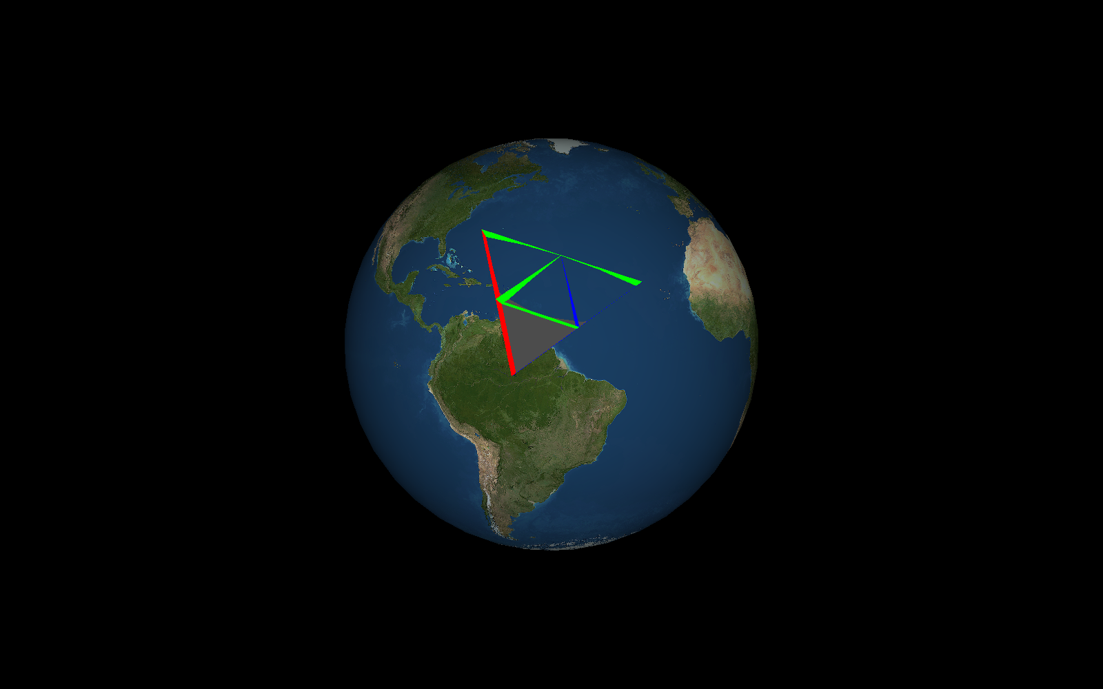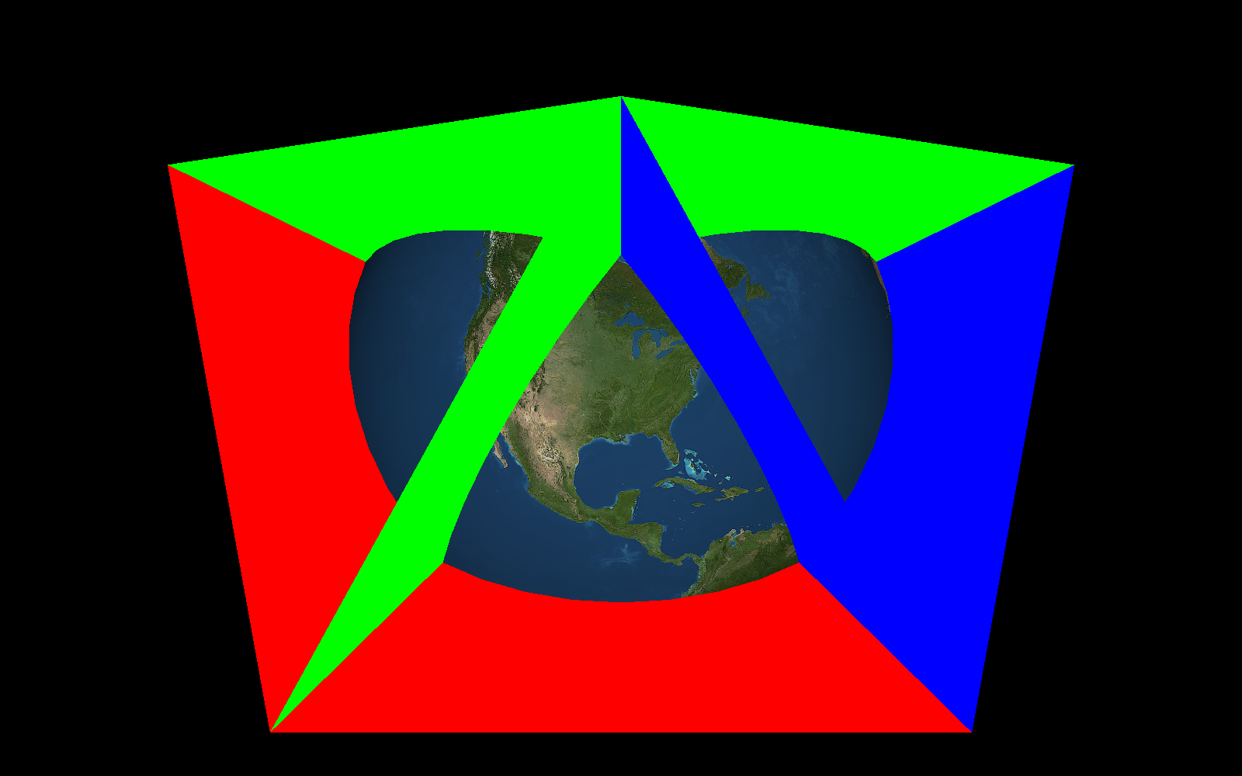
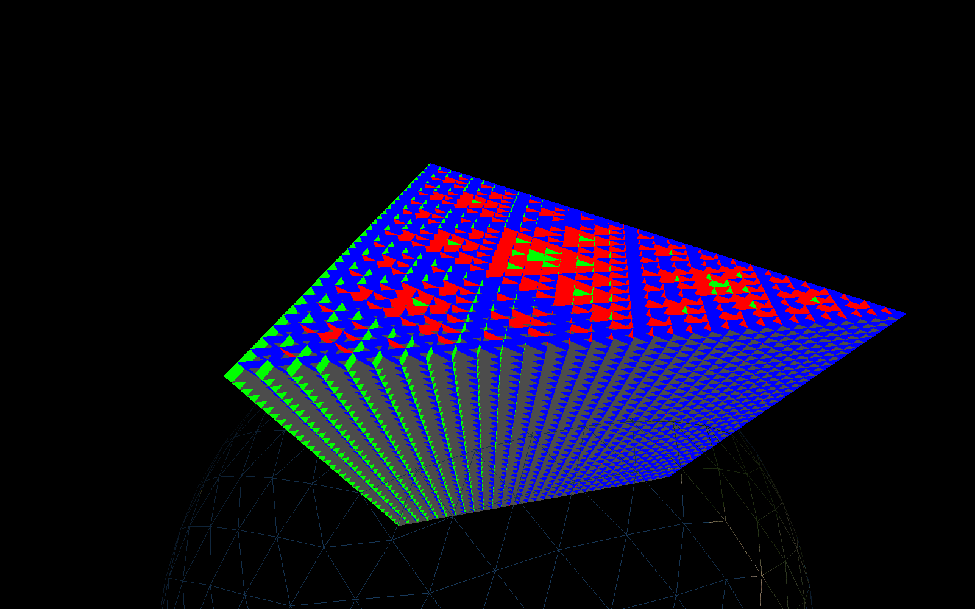

The cells of the tree are used for storing the point data but also as bounding volumes for frustum culling when using the visualization application. Initially, an axis-aligned bounding box is used for culling and, if it passes, the triangular prism itself is used. If it is out, it is not rendered, if it intersects the frustum, it is included and culling checks continue with its children (if they exist), and if it is completely inside the frustum, all its child cells are assume inside as well.
Then, level of detail is computed. If a cell exceeds a certain on-screen area threshold, it will be rendered. If it then exceeds another, larger, threshold, its children are then checked. This allows the tree itself to determine which points are rendered and, since a subcell insert algorithm is used, we can guarantee that at any level in the tree, the point density will be consistent for every other cell at that level.

Earth

The Earth, similarly, splits its geometry into a quadtree; the surface initially being split into a number of base nodes 30 degrees longitude by 30 degrees latitude square. Then, as each nodes’ on-screen area increases, it is split into four child nodes. This also includes texturing and digital elevation data which is accessed per node or per vertex. The image tiles support a generic 4K global texture by default and the default texture coordinates are for this imagery. However, using JVM flags “osm.server” or “stamen.server”, the user can define where OpenStreetMap tiles or Stamen terrain tiles should be accessed from. These URL’s can also be customized by inserting a set of prefix domains to use for load balancing ie. http://{a,b,c}.tile.openstreetmap.org which will alternate between the listed subdomains when requesting tile images. Also, a local cache directory can be defined for storing tiles for later use with the JVM flag “image.cache”. Similarly, digital elevation data in the DEM3 format are supported and are used for calculating node vertex altitude values (offsets from the ellipsoid). The directory containing the DEM3 files can be defined by the JVM flag “dem3.directory” and upon initializing the class a catalog file will be placed in this directory containing a mapping of lon/lat indices to file names for quick access as the DEM3 directory is queried recursively and does not need to be flattened.

