Wearable Lumbar Movement Risk Monitor
Participant Pack
Imperial College London

This pack contains four sections, which you will complete in order:
Part 1: Participant Information Sheet — please read in full before proceeding.
Part 2: Screening Questionnaire — please complete and sign.
Part 3: Consent Form — please initial each statement and sign.
Part 4: Incidental Findings Preferences — please complete and sign.

If you have any questions at any point, please ask the researcher before signing.

PART 1 — PARTICIPANT INFORMATION SHEET

Study title: Wearable Lumbar Movement Risk Monitor: comparing IMU-only and IMU + sEMG classification of trunk movement risk patterns in healthy adults
Principal investigator: Kiara Rao, MEng Electrical and Electronic Engineering, Imperial College London
Contact: kkr21@ic.ac.uk / sudiksha.rao@gmail.com
Supervisor: Kristel Fobelets, Department of Electrical and Electronic Engineering, Imperial College London
What is this study about?
This project is building a wearable sensor system that can identify movement patterns associated with higher spinal load during everyday tasks like bending and lifting. Four motion sensors are attached along the spine and up to four adhesive muscle sensors are placed on the lower back and abdomen. Participants perform a series of trunk movements while the sensors record data.
This is an engineering study, not a clinical one. It does not diagnose or treat back pain. The system detects movements that exceed thresholds from published biomechanics research, which have been linked to higher spinal load in workplace settings. All participants are healthy adults with no current back pain.
Who is running this?
This is a fourth-year individual project at Imperial College London, Department of Electrical and Electronic Engineering, supervised by a member of academic staff. It has no commercial funding.
What would I need to do?
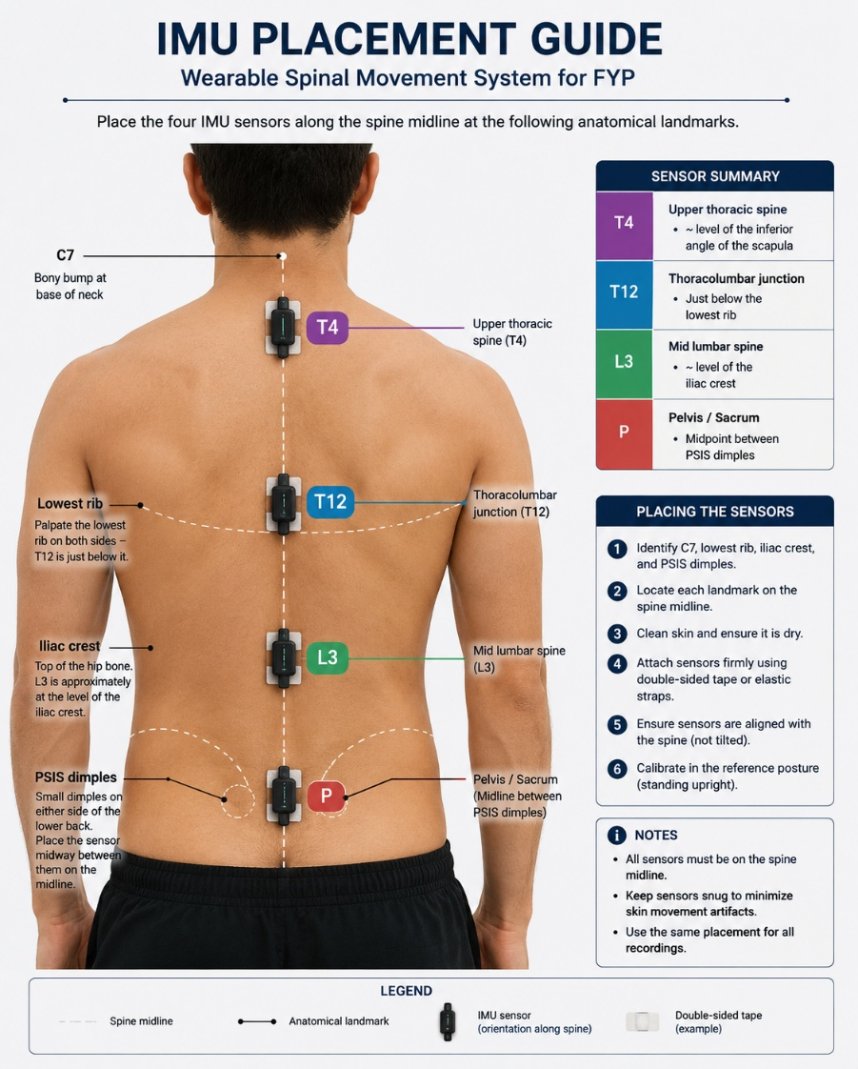
If you agree to take part, you attend one session of approximately one hour at Imperial College London.

Demonstration (~5 minutes)
Before any sensors are fitted, the researcher demonstrates every movement task in full so you know exactly what each one looks like and what is expected of you.
Sensor setup (~5 minutes)
Four small motion sensors and up to four adhesive muscle-activity sensors are attached to your lower back and trunk. Sensors are secured using Leukotape® medical strapping tape, with a piece of foam underneath each sensor to protect your skin. They are positioned at specific locations along your spine from your sacrum (base of your spine) to your upper back. The diagram below shows the sensor positions.
Warm-up (~2 minutes)
Light walking in place or gentle trunk circles to prepare your muscles.
Baseline recording (~8 minutes)
You stand quietly for 60 seconds while the system records a reference. You then perform three comfortable self-paced forward bends. If muscle sensors are fitted, you hold a brief back-extension position three times (5 seconds each) so the system can calibrate the muscle readings to you personally.
Movement sequence (~30 minutes)
You work through a series of trunk movements. These are performed at your own pace and within your comfortable range. You can stop any task at any time.
Continuous repetition block (~8 minutes)
At the end of the main sequence, you perform 20 continuous forward bends at your own comfortable pace. You can pause or stop at any point.

The movement sequence includes:
• Forward bending with good posture (hip-hinge pattern)
• Forward bending with the lower back doing more of the work
• Fast forward bending
• Upper-back-led forward bending
• Side bending (left and right)
• Trunk rotation (left and right)
• Picking up a light object from directly in front
• Picking up a light object from 45° to the side
• Sitting to standing (normal and fast pace)
• 20 continuous forward bends at your own pace (final block)

Session display
A session recorder shows on screen throughout the entire session. It displays the total time elapsed, the current stage you are on, and counts your repetitions automatically. You can always see how far through the session you are.

Do I have to take part?
No. Taking part is entirely voluntary. You can withdraw at any point during the session without giving a reason and without any consequences.
What are the risks?
The movement tasks are comparable to everyday activities. You may feel mild muscular fatigue during the 20-repetition bending block at the end. The adhesive patches can occasionally cause mild skin irritation. The foam padding under each sensor minimises any skin pressure.
If you experience any discomfort, tell the researcher and the task will be paused or stopped immediately. You will not be asked to push through discomfort. The researcher monitors a comfort score throughout the session.
Will my information be kept confidential?
Yes. You will be assigned a numeric ID. No data files will contain your name. You will not be identifiable in any output.
Data are stored on an encrypted device, accessible only to the researcher and supervisor. They are retained for one year after the project is submitted, then deleted securely. Your data will not be shared with any third parties.
You can ask for your data to be deleted at any time before they are anonymised and incorporated into group results.
What happens with the results?
Findings are written up as part of an engineering project report. You will not be identifiable in any output.
A summary of findings is available on request after the project is submitted. Contact the researcher at the email address at the top of this sheet.
Who do I contact if I have concerns?
For questions about the study: kkr21@ic.ac.uk
For concerns about the conduct of the study: Department Ethics Committee

PART 2 — SCREENING QUESTIONNAIRE

Please answer each question honestly. Your answers are used only to check whether it is safe for you to take part. They will not be linked to your name in any data file.

Participant ID: |  | Date of screening:

Section A: Basic Eligibility
# | Question | Yes | No
1 | Are you aged 18 to 50? | ☐ | ☐
2 | Are you able to stand and bend forward without support or assistance? | ☐ | ☐
If you answered No to either question above, please speak with the researcher before continuing.
Section B: Medical History
Tick Yes if any of the following apply to you.
# | Question | Yes | No
3 | Have you had an episode of back pain in the last 6 weeks? | ☐ | ☐
4 | Have you ever had spinal surgery? | ☐ | ☐
5 | Have you ever been told you have a disc herniation or disc prolapse? | ☐ | ☐
6 | Have you ever been told you have spinal stenosis? | ☐ | ☐
7 | Do you currently have any numbness, tingling, or weakness in your legs or feet? | ☐ | ☐
8 | Are you currently pregnant? | ☐ | ☐
9 | Do you have any known skin allergies or sensitivity to adhesive tape or ECG electrodes? | ☐ | ☐
10 | Is there anything else about your health that you think the researcher should know before you take part? | ☐ | ☐
If you answered Yes to any of questions 3 to 9, you may not be eligible to take part. Please speak with the researcher before continuing.
Section C: Current Physical State
How would you rate your current lower back discomfort, if any? (0 = none, 10 = worst imaginable) | ___ / 10
Have you done vigorous exercise in the last 24 hours? | Yes / No

Section D: Declaration
I confirm that my answers above are accurate to the best of my knowledge. I understand that the researcher will use them to determine whether it is safe for me to take part.

Name (print): |  | Date:

Signature:

FOR RESEARCHER USE ONLY

Screening outcome: ☐ Eligible ☐ Not eligible ☐ Eligible with modifications
Notes:

Researcher signature: |  | Date:

PART 3 — CONSENT FORM

Study title: Wearable Lumbar Movement Risk Monitor
Principal investigator: Kiara Rao, Imperial College London
Version: 1.0, April 2026

Please read each statement carefully. If you agree, write your initials in the right-hand column. If you do not understand or agree with any statement, speak with the researcher before signing.

# | Statement | Initials
1 | I have read and understood the Participant Information Sheet for this study (version 1.0, April 2026).
2 | I have had the opportunity to ask questions and received answers I am satisfied with.
3 | I understand that my participation is voluntary and that I can withdraw at any time, without giving a reason, and without any consequences.
4 | I understand that I can ask for my data to be deleted at any time before they are anonymised and incorporated into group results.
5 | I agree to the researcher attaching four motion sensors and up to four adhesive muscle-activity sensors to my lower back and trunk using Leukotape® medical tape with foam padding, at specified positions along my spine.
6 | I confirm that I have completed the screening questionnaire accurately and have disclosed any health information relevant to my participation.
7 | I understand that the session involves trunk movement tasks and that I must tell the researcher immediately if I experience discomfort.
8 | I agree for my anonymised movement and muscle activity data to be stored and used for this research project and any resulting academic outputs.
9 | I understand that my name will not appear in any output from this research and that I will not be identifiable in any published results.
10 | I agree to take part in this study.

Optional
# | Statement | Initials
11 | I am willing to be contacted about future studies related to this research (my contact details will be stored separately from my study data).

Participant
Name (print): |  | Date:

Signature:

Researcher
Name (print): |  | Date:

Signature:

This completed form will be retained by the researcher in a secure location. Please keep your copy of the Participant Information Sheet for your records.

PART 4 — INCIDENTAL FINDINGS PREFERENCES

IMPORTANT NOTICE — PLEASE READ CAREFULLY
The researcher conducting this study is not a medical professional. This is an engineering project, not a clinical assessment.
The wearable system records movement kinematics and muscle activity. It classifies movements against thresholds drawn from published biomechanics research. It does not diagnose, predict, or treat any medical condition, and its output cannot be interpreted as clinical results.
On rare occasions, a participant's movement data may look notably different from expected (for example, an unusually restricted range of motion or consistently atypical muscle activation). If this happens, the researcher may informally flag this to you — purely as an observation from an engineering dataset, not as a medical opinion.
If you have any concerns about your back health or movement, please consult a qualified healthcare professional.

Your Preferences
Please answer the questions below so the researcher knows how to proceed should anything unexpected appear in your data.
1. Would you like to be informed if your movement data appears notably different from what is typically expected?
(This would be informal feedback only — not medical advice, not a diagnosis, and not a clinical finding.)
☐ Yes — please let me know informally, with the understanding that this is an engineering observation only.
☐ No — I do not wish to be informed.

2. If yes — how would you prefer to receive this information?
☐ Verbally, at the end of the session.
☐ By email after the session (at the address I provide separately).

3. Is there anything else you would like the researcher to know or take into account? (e.g. a known pre-existing movement limitation, relevant injury history, or any other context that did not come up in the screening questionnaire.)
Please write your response in the box below:

Declaration
I confirm that I have read and understood the notice above, and that my answers reflect my genuine preferences. I understand that any informal feedback from the researcher is an engineering observation only, and I will seek professional medical advice independently if I have any health concerns.

Name (print): |  | Date:

Signature:

