DIGITAL IMAGE PROCESSING
ASSIGNMENT 4

BY
M V S SRAVAN
201531197

QUESTION 1:
A) Image restoration

CODE

clc;
close all;
clear all;
Img=im2double(imread('/home/ramarohitreddy.g/sravandip/Assign4_imgs/restore_01.jpg'));
figure
imshow(Img);
IG=fftshift(fft2(Img));
a=0.0005;
b=0;
S=size(Img);
T=0.75;

for u=1:S(1)
for v=1:S(2)
H(u,v)=T*sin(pi*(u*a + v*b))*exp(-pi*(u*a + v*b)*i)/((u*a + v*b)*pi);
end
end
K=0.05;
F=H.*(conj(H));
S=F./(F+K);

H=S*(1./H);
I=IG.*H;
I=ifft2(ifftshift(I));
figure
imshow(uint8(I));

CODE2:
i1 = imread('Assign4_imgs/restore_01.jpg');
%imshow(log(1+abs(fftshift(fft2(i1)))), []);

% estimates for length of motion blur
LEN = 30; THETA = 0; NSR = .0275;
PSF = fspecial('motion', LEN, THETA);

restored = deconvwnr(i1, PSF, NSR);
imwrite(restored, 'restored01.jpg');

RESULTS:

ORIGINAL IMAGE deblur image

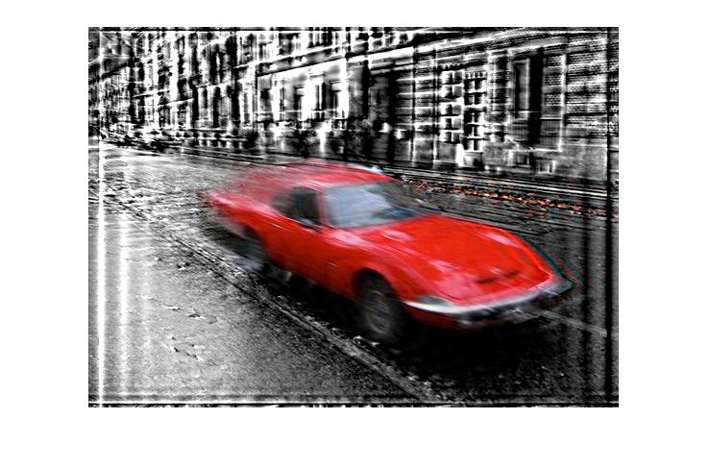
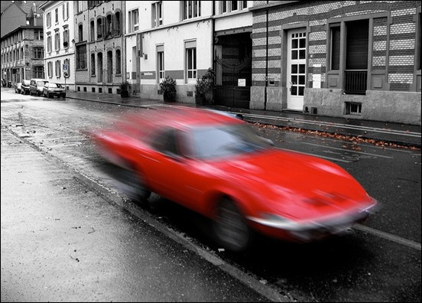

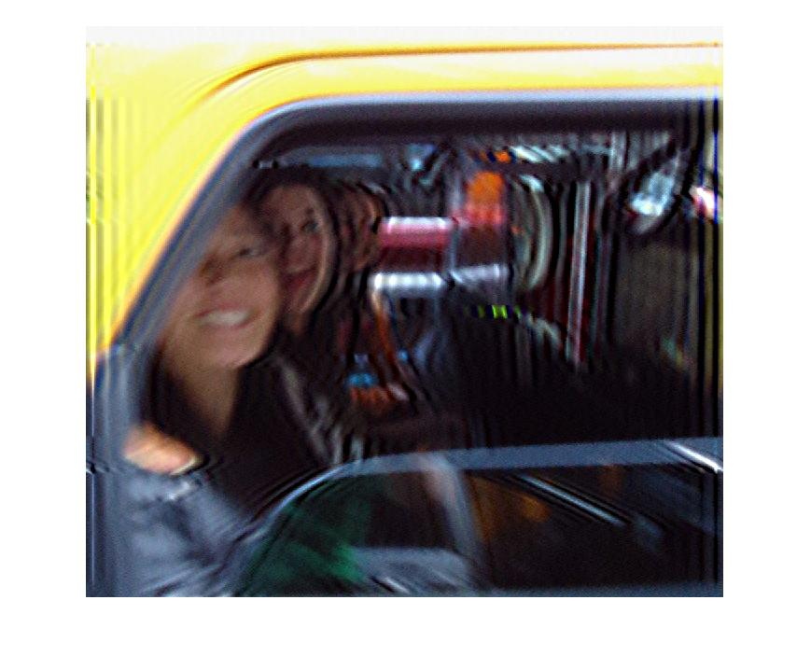
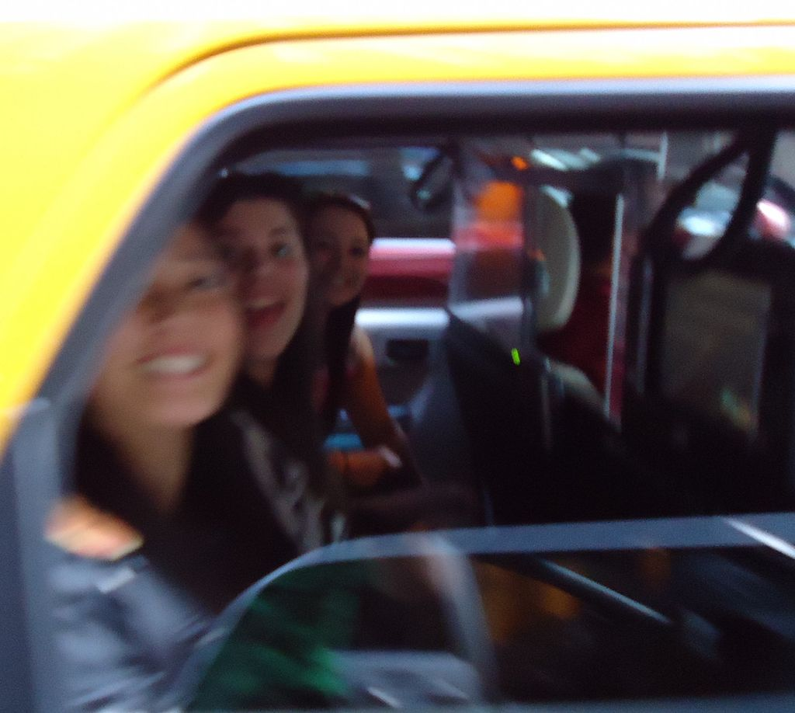

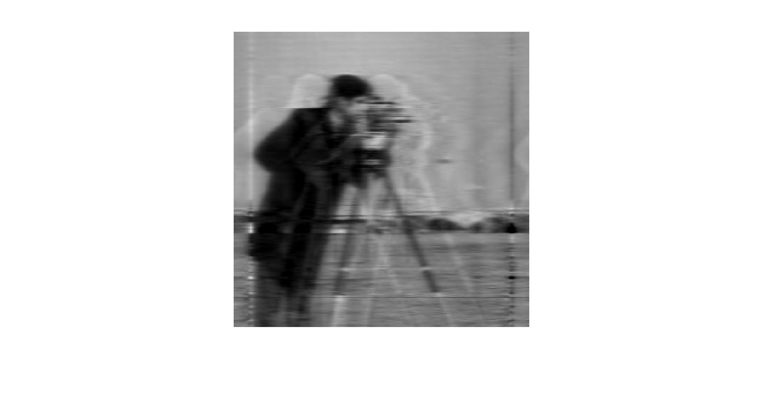
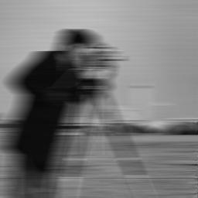

B) Image compression

CODE

AllWindows
function [R, mse] = allWindowsDFT(image, scale)
clc;

I = imread(image);

classicalQuantization

[rows, cols] = size(I);

R = ones(size(I));

rows = rows/8;
cols = cols/8;
i = 1;
for u = 1:rows
j = 1;
for v = 1:cols
J = I(i:i+7,j:j+7);
FD = dct2(J);
imq = quantization(FD, Q, scale);
im = dequantization(imq, Q, scale);

cim = idct2(im);
R(i:i+7,j:j+7) = cim;
j = j+8;
end
i = i+8;
end
subplot(1, 2, 1)
imshow(uint8(I))
subplot(1, 2, 2)
imshow(uint8(R))
end

Finalrun.m
image=('/home/ramarohitreddy.g/sravandip/Assign4_imgs/Uncompressed_02.BMP');
scale=2;
allWindowsDFT(image, scale);

RESULTS:

1)DCT compression

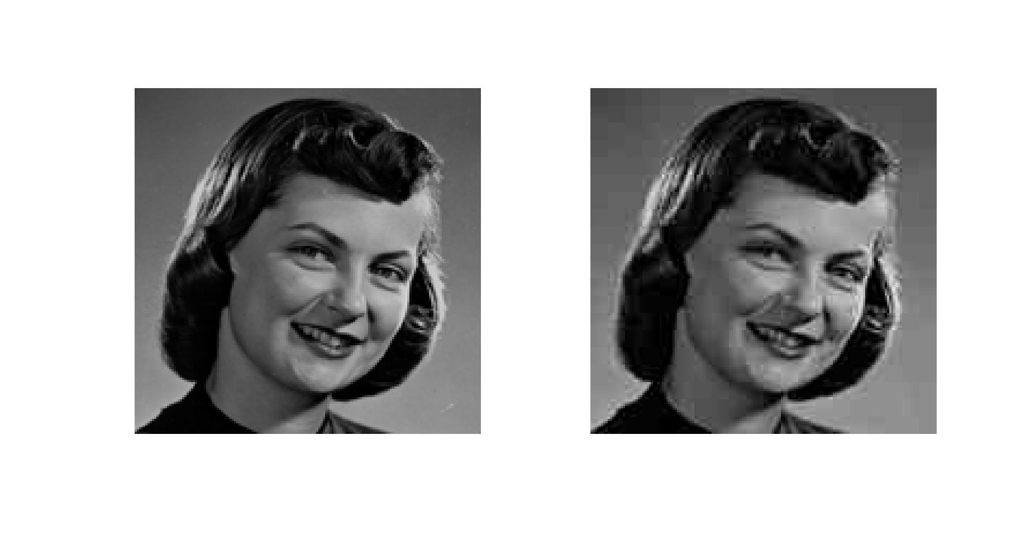
ORIGINAL IMAGE COMPRESSED IMAGE

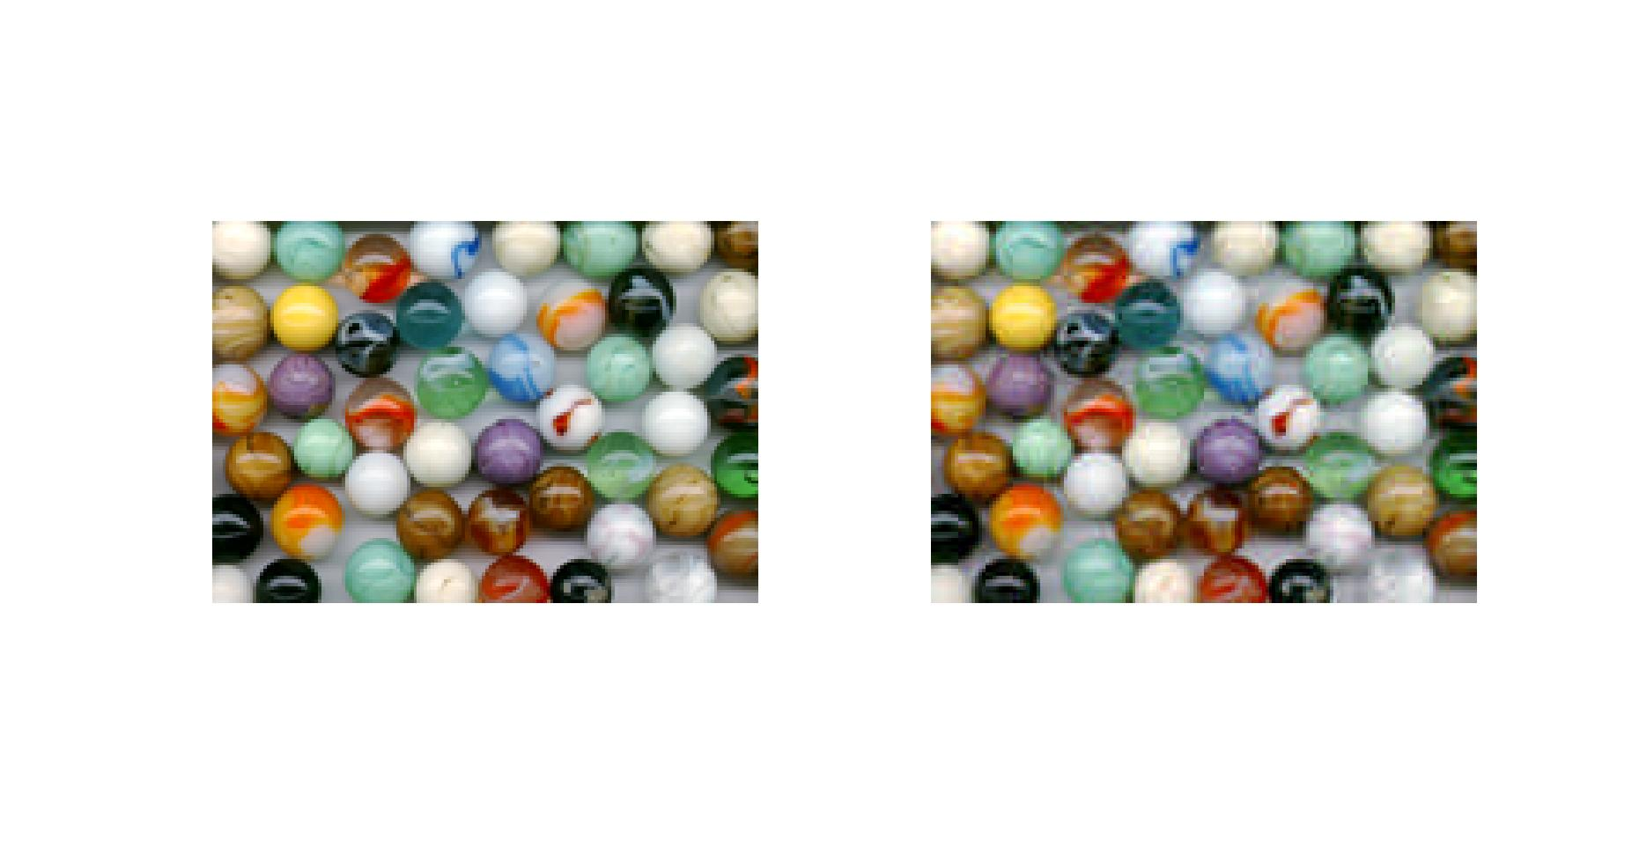

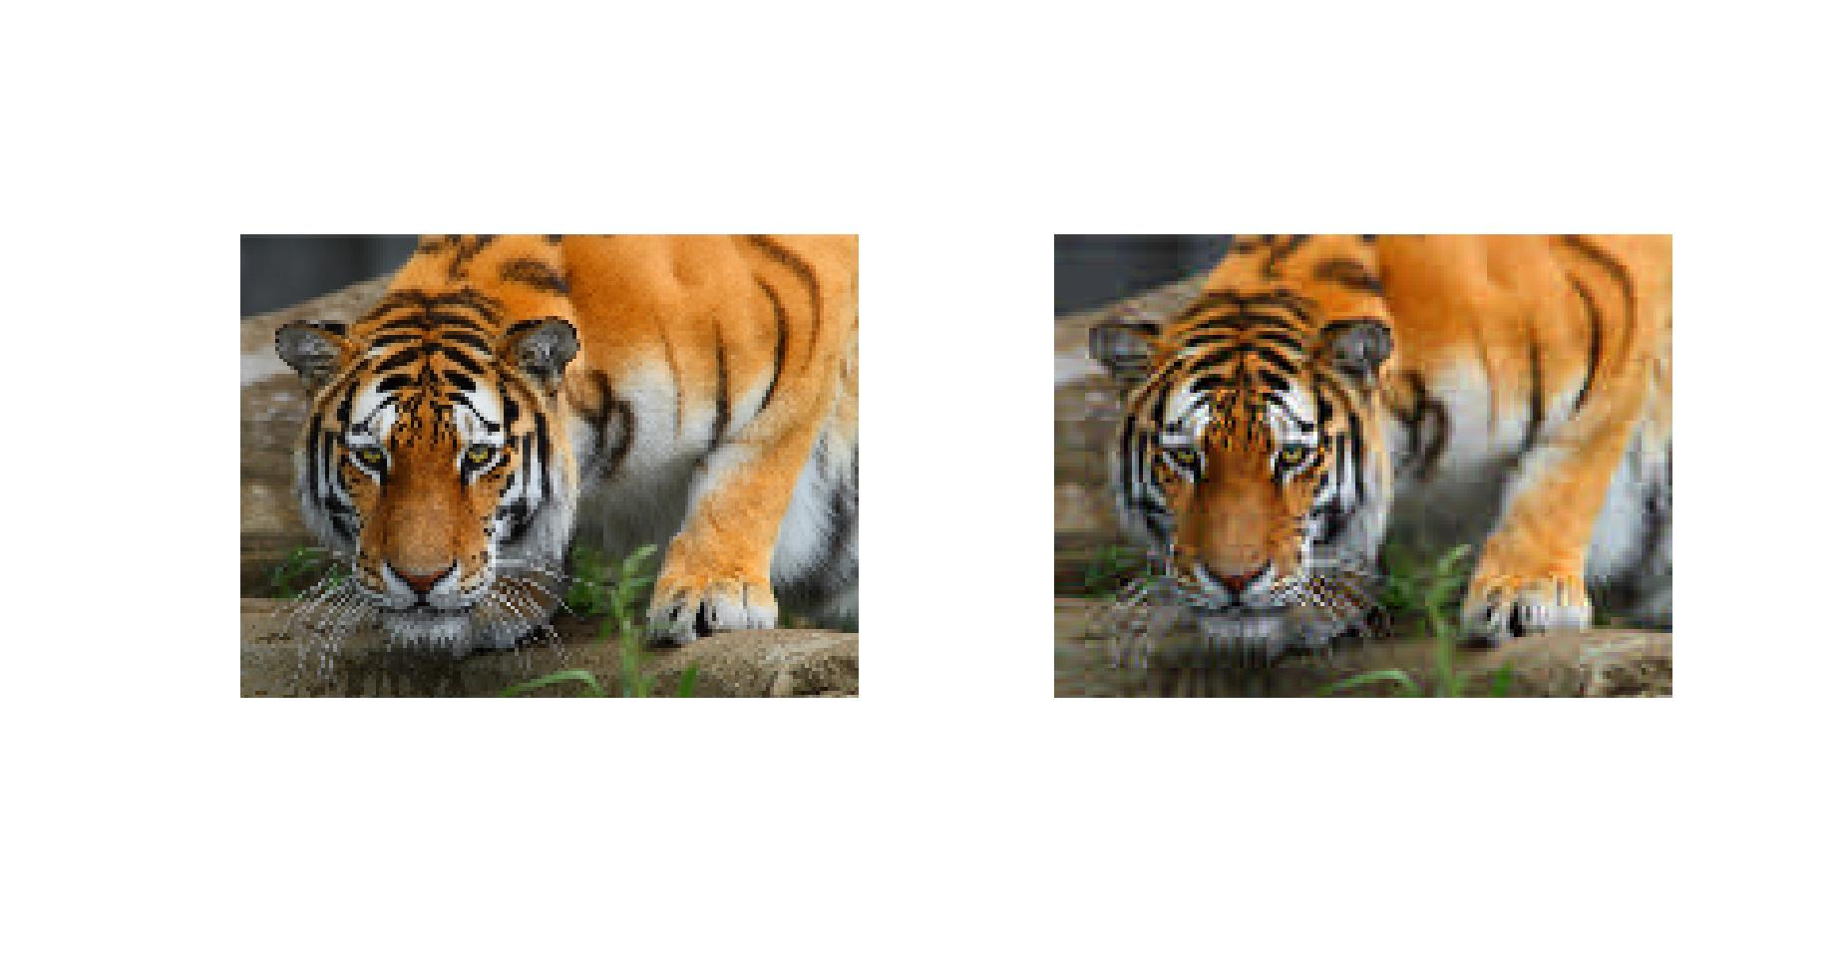

2)FFT compression

RESULTS:

ORIGINAL IMAGE COMPRESSED IMAGE
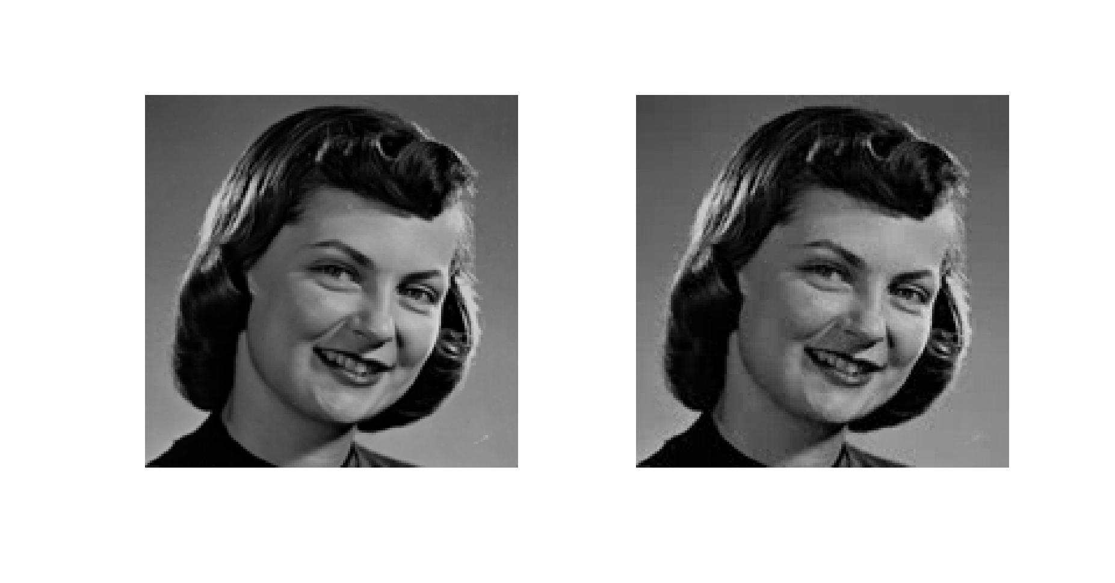

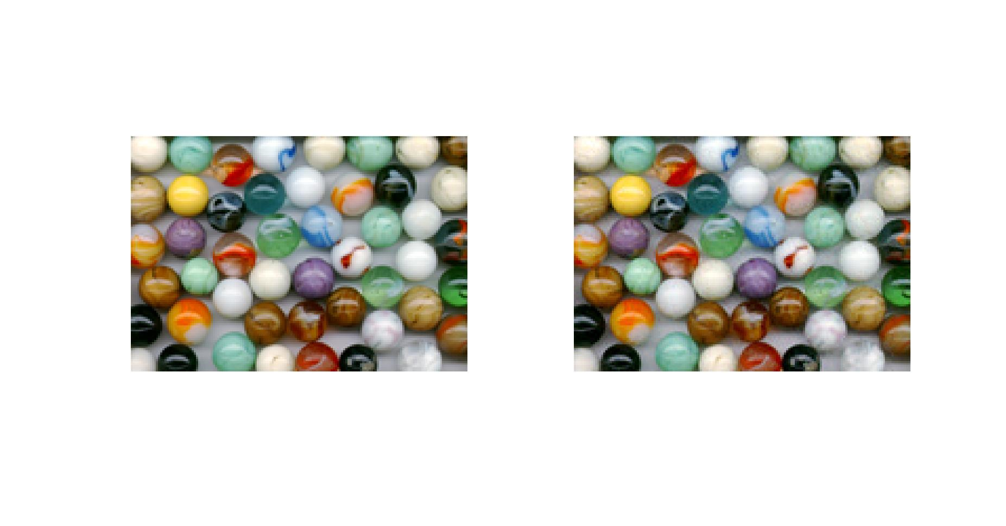
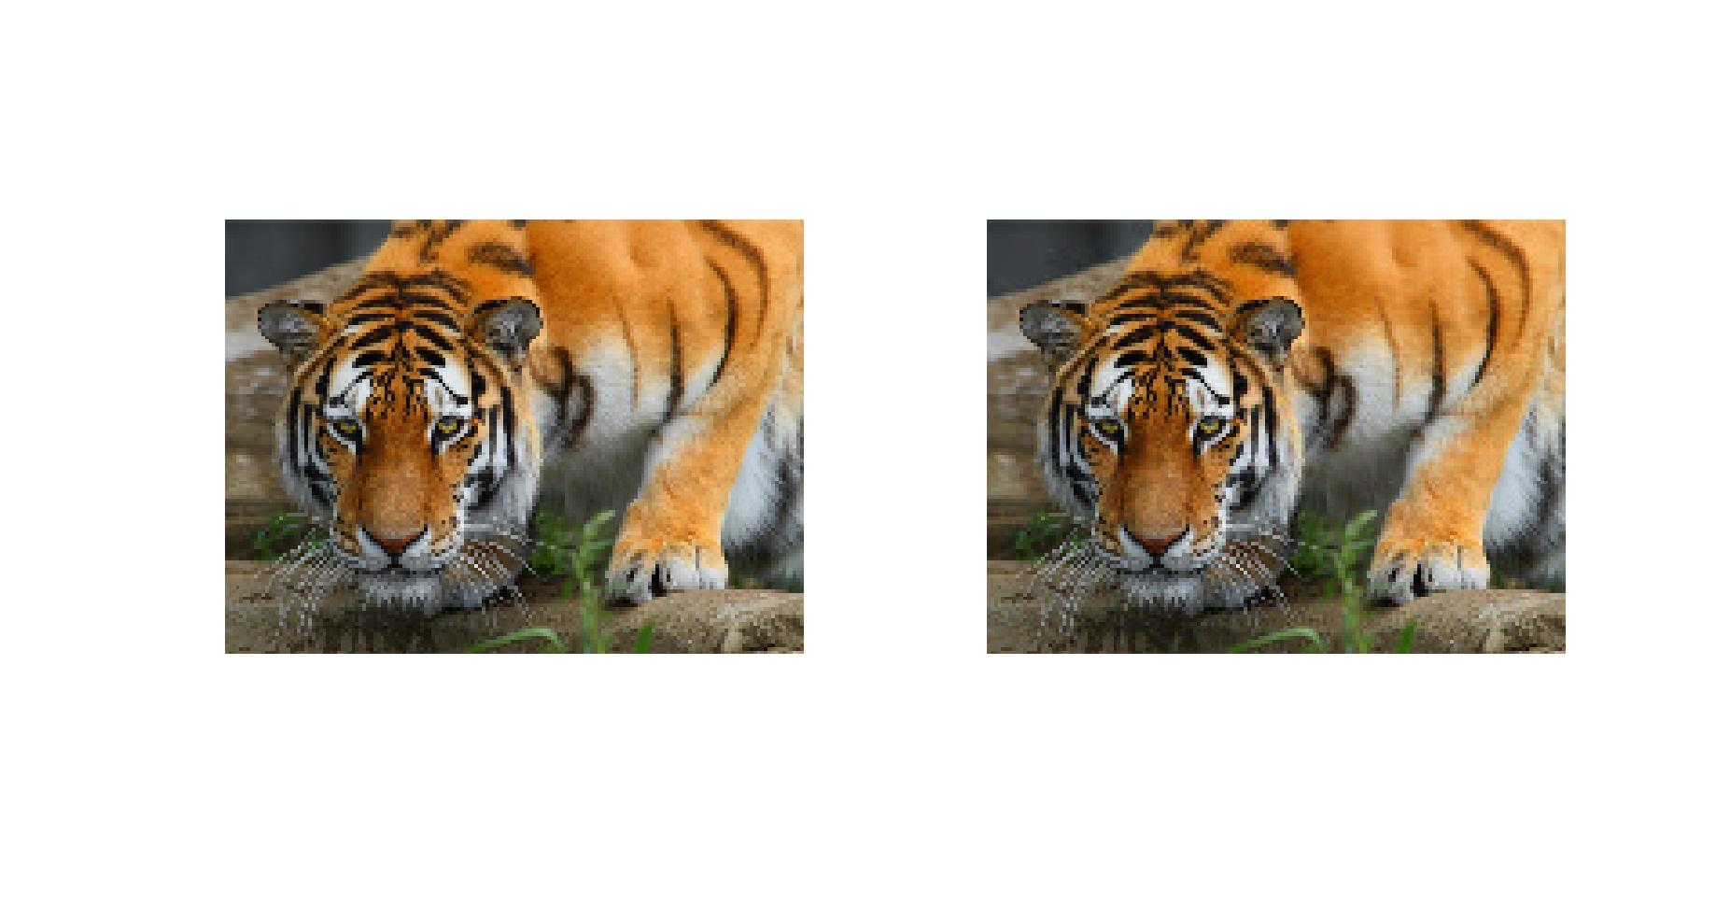

3)wavelet transform
CODE:
clc;
clear all;
close all;

I=imread('/home/ramarohitreddy.g/sravandip/Assign4_imgs/Uncompressed_02.BMP');
Iycbcr=rgb2ycbcr(I);
figure
imshow(I);
title('Original Image');

A=[16 11 10 16 24 40 51 61;
12 12 14 19 26 58 60 55;
14 13 16 24 40 57 69 56;
14 17 22 29 51 87 80 62;
18 22 37 56 68 109 103 77;
24 35 55 64 81 104 113 92;
49 64 78 87 103 121 120 101;
72 92 95 98 112 100 103 99
];

I=double(I);
A1=(1.0).*A;

for c=1:3
for i=1:8:size(I,1)
for j=1:8:size(I,2)
matrix=I(i:i+7,j:j+7,c);
matrix=matrix-127.0;
F=hadamard(8,'double');
B=(matrix)*F;
C=B./A1;
D=round(C);
I2(i:i+7,j:j+7,c)=D;
end
end
end

I2=double(I2);
for c=1:3
for i=1:8:size(I2,1)
for j=1:8:size(I2,2)
matrix=I2(i:i+7,j:j+7,c);
matrix1=matrix.*A1;
B=(matrix1)*inv(F);
C=B+127.0;
I3(i:i+7,j:j+7,c)=C;
end
end
end

%disp(I3);
figure
imshow(uint8(I3));
title('Decompressed image');

a=size(I,1)*size(I,2)*size(I,3);
r=(double(I3)-double(I)).^2;
sum1=sum(r(:));
rms=sqrt((sum1)./(a));
disp(abs(rms));

Results
Original Image Decompressed Image

